MARK 201 sec. E
January - April 2012 Katelyn Good
Chapter 1
Marketing: Creating and Capturing Costumer Value

Marketing:
process by which companies create costumer values an build strong costumer relationships to capture value form costumers in return

The Marketing Process:

- Needs, Wants and Demands
Need - state of felt deprivation
Want - human needs shaped by culture and individual personalities
Demands - wants that are backed by buying power

Market offering
combination of products, services, information or experiences offered to a market to satisfy a want or need
Market Myopia
focusing only on existing wants and losing sight of underlying consumer needs
Markets
set of actual and potential buyers of a product

- Customer-driven marketing strategy - Who will we serve, how will we be different?
Marketing management:
the art and science of choosing target markets and building profitable relationships
Marketing segmentation
division of a market into distinct groups of buyers with the same need, characteristics and behaviours.
Target Marketing
Evaluating which segments will be profitable and going after that one
Demarketing
marketing to reduce demand temporarily/permanently; not to destroy demand but to reduce

- Integrated Marketing Program - Product, Price, Place, Promotion
Set of 4 P's the firm uses to implement its marketing strategy.

Customer Relationship Management (CRM)
overall process of building and maintain profitable customer relationships by delivering superior customer value and satisfaction

- Build Profitable Relationships
Customer-Perceived Value
difference between total customer value and customer cost
Customer Satisfaction
products perceived performance matches buyer's expectation

- Carefully select more profitable customers --Target fewer, more profitable customers

- Relating more deeply and interactively and personally by creating 2-way relationships through blogs, websites, online communities and social networks

Partner Relationship Management:
involves working closely with partners inside and outside the company to bring greater value to customers
inside: function area interacting with customers electronically or cross-functional
outside: how marketers connect with suppliers, channel partners, competitors

Supply Chain:
stretches from raw materials to components to final products to final buyers

- Capture Value from Costumer in Return - Costumer profits + costumer equity
Share of the customer
portion of the customers purchasing that a company gets in its product categories
Customer Equity
total combined customer lifetime values of all the company's customers

Building the Right Relationships with the Right Customers
Treating customers as assets that need to be managed.
1. Butterflies
Good-fit, high profitability, short-term
2. True Friends
Good-fit, highest profitability, long-term
3. Strangers
Little-fit, lowest profit potential, short term
4. Barnacles
Limited-fit, low profit potential, long term

Marketing Management Orientations
1. Production Concept
Consumers will favour products that are available and highly affordable
2. Product Concept
Consumers will favour products with the most quality, performance or features. Continuous product improvements
3. Selling Concept
Consumers will not buy enough unless it undertakes large-scale selling and promotion effort
4. Marketing Concept
Achieving organizational goals depends on knowing the needs and wants of the target market and deliver to desired satisfactions better then the competitors
5. Societal Marketing
Company should consider
consumer wants,
company requirements,
consumer long-term interests
society long-term interests

The Changing Marketing Landscape

1. Digital Age
Advances in computers, telecommunications, information, transportation
- customer research, product developing, distribution, new advertising tools, 24/7internet
2. Rapid Globalization
Geographical and cultural distance have shrunk
- Greater market coverage, more options for purchasing/manufacturing, increases competition
3. Ethic and Social Responsibility
Marketers need to take great responsibilities for their actions
4. Non-for-profit Marketing
Organizations are realizing the importance of strategic marketing
- Government, colleges, hospitals churches, performing arts

Chapter 2
Company and Marketing Strategy:
Partnering to build Customer Relationships

Strategic planning:
Process of developing and maintaining a strategic fit of the company's objectives ans capabilities and the changing market opportunities.

Steps in Strategic Planning:

- Define the Company Mission

Mission Statement:
Is the organizations purpose.
It acts as an invisible hand that guides the people in the organization
Market-Orientated: based on satisfying the basic customer needs

- Set Objectives and Goals

Business Objectives
- Build profitable customer relationships
- Invest in research
- Improve Profits
Marketing Objectives
- Increase market share
- Create local Partnerships
- Increase Promotion

- Design Business Portfolio

Business Portfolio:
collection of businesses and products that make up a company.
-best business portfolios are ones that fit the company's strengths/weaknesses to the opportunities in the environment.

Portfolio Analysis:
major activity in strategic planning whereby management evaluates the products and businesses that make up a company

Strategic Business Unit (SBU):
a unit of the company that has a separate mission and objectives.
- Company division
- Product within a division
- Single Product or Brand

Analyzing the Business Portfolio
1. Indentify the key SBU
2. Evaluate attractiveness (How Profitable)
3. Decide how much to support each SBU Growth-share matrix

Stars:
- High Growth, High Share.
- Heavy investment required
- Once growth slows becomes Cash Cow
Cash Cows
- Low Growth, High Share
- Money gained used to pay bills for other investments
Question Marks
- High growth, Low Share.
- High investment needed to keep share.
- Management must decide which to keep to become stars or phase out
Dogs
-Low growth, Low Share.
- Maintain themselves but are do not promise large amounts of cash.

Problems with Matrix
- difficult defining SBU's
- time consuming and expensive
- focuses on current instead of future.

- Planning and Marketing and Functional Strategies

Product/Marketing Expansion Grid:
tool for identifying a company's growth opportunities by

1. Market Penetration
- Increasing sales in current market with current product.
2. Market Development
- Indentifying or creating new markets for current product.
3. Product Development
- New/modified products to current markets
4. Diversification
- Acquiring or creating new businesses outside the company's current product and market
Downsizing:
Reducing the business portfolio by eliminating business units/products that are no longer profitable

Value Chain:
- series of departments that carry out value-creating activities.
anyone that adds value to a product by designing, producing, marketing, delivering

Value Delivery Network:
- made up of company suppliers, distributers and ultimately customers who partner with each other to improve performance of the entire system.
Marketing Strategy and the Marketing Mix

Marketing Segmentation:
The division of a market into distinct groups of buyers with the same need, characteristics and behaviours. who might require separate products or marketing mixes
Market Segment:
Group of consumers who respond in similar ways to a given set marketing efforts
Market Targeting
Process of evaluating the market segments attractiveness and deciding which one to enter.
Market Positioning
Arranging the product to offer a clear, distinctive and desirable place relative to the competitors products in the minds of the target market.

The Marketing Mix
Set of controllable tactical marketing tools
1. Product - Consumer Solution
2. Price - Consumer Cost
3. Place - Convenience
4. Promotion - Communication

Managing the Marketing Effort

1. SWOT Analysis
Strength --> understanding strengths (Internal/Micro)
Weaknesses -->analyzing weaknesses (Internal/ Micro)
Opportunities -->finding opportunities (External/ Macro)
Threats --> minimizing threats (External/ Macro)
Microenvironment:
actors close to the company that effect the ability to serve
- the comp, suppliers, intermediaries, customer markets, competitors, public
Macro environment:
Larger societal forces that effect the microenvironment
- demographics, economic, natural, technological, political, cultural

2. Planning
Plans include;
- Executive summary, analysis of current situation, objectives, target and positioning, budgets and controls

3. Implementation
Process that turns strategies and plans into marketing actions that accomplaish strategic marketing objectives

4. Control
Evaluating the results of marketing strategies and plans and taking corrective actions. Marketing Return on Investment (ROI) net return of investment/ cost of invest.
Chapter 3
Analyzing the Marketing Environment

Marketing Environment:
actors and forces outside marketing that affect marketing management's ability to build and maintain successful relationships with customers

SWOT Analysis
the goal is to match a company strength to attractive opportunities in the environment, while eliminating or overcoming weaknesses and threats

Strength --> understanding strengths (Micro)
Weaknesses -->analyzing weaknesses (Micro)
Opportunities-->finding opportunities (Macro)
Threats --> minimizing threats (Macro)

Microenvironment: - "PICCCS"
actors close to the company that effect the ability to serve its customers, the company, suppliers, intermediaries, customer markets, competitors, publics
Marketing Intermediaries
- Help the company to promote, sell and distribute its products to final buyers
- Resellers
- Physical Distribution Firms
- Marketing service agencies
- Financial intermediaries
Suppliers
- provide resources to produce goods and services
- treated as partners to provide customer value
The Company
- top management
- Finance
- Purchasing
- Operations
- Accounting

Publics
- Any group that has actual or potential interest in or impact on an organizations ability to achieve their objectives
- Financial, Media, Government, Citizen-action, local, general, internal publics
Competitors
- Firms must gain strategic advantage by positioning their offering against competitors offerings
Consumer Markets (5)
- Consumer
- Business
- Reseller
- Government
- International

Macroenvironment: - " DESC PLNT"
Larger societal forces that effect the microenvironment, economic, natural, technological, political, cultural

Demographic Environment
- The study of human populations in terms of size, density, location, age, gender, race, occupation and other stats
- Important because it involves people and people make up the market
- Trends include; age, family structure, geographic population shifts, educational characteristics and population diversity.
Age Structure of the Population
- Baby boomers (1946-1964).
Aging population = declining health, technology related to aging MRI CAT scan, disposable income
- Generation X (1965-1976).
high divorce rate
cautious economic outlook
less materialistic
family comes first
lag behind on retirement savings

- Millennial (1977-2000)
comfortable with technology
includes tweens, teens, and young adults

Generational Marketing
Important in segmenting people by lifestyle of life state instead of age
When you look at a person's lifestyle it impacts their purchasing power
More people;
- divorcing or separated
- choosing not to marry/ marry later
- Marrying without intending to have kids
- Increased number of women working/ stay-at-home dad

Increased Diversity
Markets are becoming more diverse both nationally and internationally
- Ethnicity
- Gay, Lesbian -> more disposable income, no kids, more time to work
- Disabled

Natural Environment
involves the natural resources that are needed as inputs by marketers or that are affected by marketing activities - make market "green" "recyclable"
Trends;
- shortages of raw materials
- increased pollution
- increase government intervention
- environmentally sustainable strategies

Political Environment
consists of law, government agencies, and pressure groups that influence or limit various organizations and individuals in a given society

- Legislation regulates business
- Increased legislation
- Changing government agency enforcement
- Increased emphasis on ethics
- Socially responsible behaviour
- Cause-related marketing

Economic Environment
consists of factors that affect consumer purchasing power and spending patterns

- Industrial economies are richer markets
- Subsistence economies consume most of their own agriculture and industrial outputs
- Changes of income
Value marketing involves way to offer financially cautious buys greater value
right combination of service and quality at a fair price
- Ernest Engel - Engel's Law
- Purchasing Power. How much people spend/save
- As Income rises;
- % on food declines
- % spent on housing is constant
- % spent on saving increases
- Anything that is not a necessity goes up.

Cultural Environment
institutions and other forces that affect a society's basic values, perceptions or behaviours

Core Beliefs and Values
persistent and passed on from parents to children and are reinforced by schools, churches businesses and governments
Secondary beliefs and Values
more open to change, includes people's views of themselves, others, organizations, society, nature and the universe.

Shifts in Secondary Beliefs
- People's view of themselves
- do-it-yourselfers - recent movers
- adventurers
- View of others
- more "cocooning"
- View of organizations
- View of society
- Patriots defend
- Reformers want to change
- Malcontents want to leave it
- View of nature
- some feel ruled by it, in harmony with it, seek to master it
- View of universe
- renewed interest in spirituality

Technological Environment
most dramatic force in changing the marketplace
creates new products and opportunities
safety of new product always a concern
Chapter 5
Managing Marketing Information to Gain Customer Insight:

Customer Insight:
- Fresh and deep understanding into customer needs and want
- Difficult to obtain - Not obvious, customer unsure of behaviour (not honest/ don't know what you looking for)
- Derived from better information and more effective use of existing information

Customer Insight Team:
- All company functional areas
- Use insights to create more value for their customers
- Customer controlled could present problem

Marketing Information System (MIS): "ADDRII"
Consists of people and procedures for
- Assessing information needs
- Provides information to the company's marketing and other managers and external partners (i.e. suppliers, resellers, marketing service agencies)

- Developing needed information
Marketers obtain information from:

1. Internal Data - CHEAP, QUICK, EASY
electronic collection o consumer and market information obtained from data sources within the company network. Stored within the organizations info system:
- Accounting system
- Operations/Production
- Sales reporting System
- Past research studies
May not be in a useable form for the decision to be made
May be incomplete or inappropriate to a particular situation

2 .Marketing Intelligence
Systematic collection and analysis of publicly available information about consumers, competitors and developments in the market place. (ex. monitoring you-tube)

3. Marketing Research
Systematic design, collection, analysis and reporting of data relevant to a specific marketing situation facing an organization

1. Developing Market Research
- defining the Problem and Research Objectives
-Exploratory Research: preliminary info that will help define problem/suggest hypothes
-Descriptive Research: better describe marketing problems, situations or markets
(i.e. market potential for a product or demographics and attitudes of consumers)
-Casual Research: research to test hypotheses about cause-and-effect relationships

2. Developing the Research Plan
- Spells out the specific research approaches, contact methods, sampling plans and other instruments to gather data
- outlines sources of existing data
Secondary Data
information that already exists somewhere, having been collected for another purpose - obtained more quickly and less expensive
Primary Data
information gathered for the special research plan

3. Research Approaches
Observational Research
gathering primary data by observing relevant people, actions and situations
Ethnographic Research
sending trained observers to watch and interact with consumers in their natural environment
Survey Research
most widely used method from primary research.
best for descriptive information: knowledge, attitudes, preferences and buying behaviour
- flexible
- people can be unable or unwilling to answer
- gives misleading or pleasing answers
- privacy concerns
Experimental Research
best for gathering casual information - cause-and-effect relationships

Online Research
Disadvantages:
- Restricted internet access
- Not sure who is answering
Advantages:
- Low Cost
- Speed
- Higher response rates
- Good for hard to reach groups

Contact Methods:
Focus Groups: 6-10 people with trained monitor
Challenges: expensive, difficult to generalize from small group, not always open/honest

Sample:
Segment of the population selected for marketing research to represent the population as a whole. Who is being surveyed?how many? how should we chos?

4. Research Instruments
Questionnaires
Most common. Administered person-person, by phone or online. Flexible. Wording and ordering of questions very important.
Close-ended Questions: includes all possible answers, subjects must make choices among them - answers are easier to interpret and tabulate
Open-ended Questions: Respondents answer in own words
- useful in exploratory research

5.Implementing the Research Plan
a. Collecting the information
b. Processing the information
c. Analyze the information
d. Interpret findings
6.Intrepreting and Reporting the Findings
a. Draw Conclusions
b. Report to Management

- Helping decision makers use the information for customers
Customer Relationship Management (CRM):
consists of sophistication software and analytical tools that integrate customer information from all sources, analyze it in depth and apply results to build stronger customer relationships

Information Distribution
entering information into a database and making it available in a time-useable manner
Intranet --> provides information to employees and other stakeholders
Extranet --> provides information to key customer and suppliers

Other Marketing Information Consideration
1.Marketing research in Small Businesses and Non-profit Organizations
2. International Market Research
3. Public Policy and Ethic
4. Customer privacy
5. Misuse of Research findings
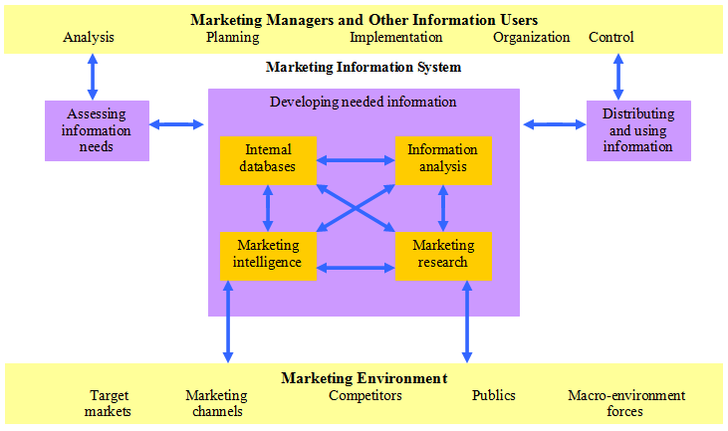

Chapter 6
Consumer Markets and Consumer Buyer Behaviour

Model of Consumer Behaviour:

Consumer Buyer Behaviour:
The buying behaviour of the final consumers
Individuals and households who buy goods and services for personal consumption
Consumer Markets
All of the personal consumption of final consumers
INSERT MODEL

Characteristics Affecting Consumer Behaviour
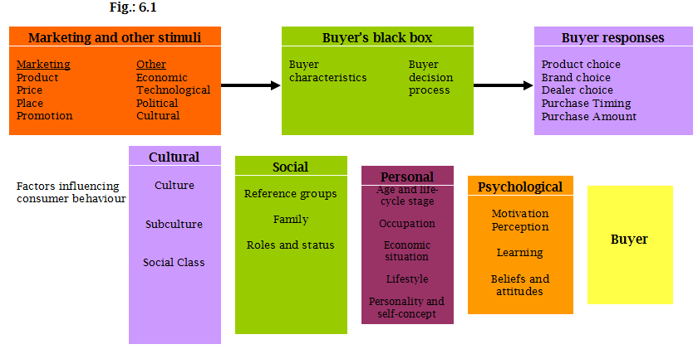
1. Culture
Learned values, perceptions, wants, and behaviours form family and other important institutions
Subculture
groups of people within a culture with shared value systems based on common life experiences and situations
ex. regional, founding nations, ethnic, and mature consumers
Social Class
Society's relatively permanent and ordered divisions whose members share similar values, interest and behaviours
Measured by a combination of occupation, income, education, wealth and other variable
2. Social
Groups and Social Networks
Membership Groups -> direct influence and to which a person belongs(family,friends)
Aspirational Groups -> groups an individual wishes to belong to (want to be nhlplayr)
Reference Groups -> external influence that serve as direct or indirect points of comparison in forming a person's attitude or behaviour

Word-of-Mouth Influence and Buzz Marketing
opinion leaders: people within a reference group who because of special skills, knowledge or personality exert social influence on others (influential's or leading adopters)
- Marketers identify them and use them as 'brand ambassadors'

Online Social Networks
online communities where people socialize or exchange information and opinions
- blogs, social networking sites virtual worlds

Family
Most important consumer-buying organization in society

Roles and Status
Groups, families, and clubs, and organizations that a person belongs to that can define role and social status

3. Personal
Age and Life-Cycle
5 Life-Stages
Youth | Under 18
Getting Started - first experiences | 18-35
Builders - peak earning years, borrow more than invest | 35-50
Accumulators - worry about saving for retirement and investing wisely | 50-60
Preservers -maximize retirement income and maintain a desired income | Over 60

Occupation
Affects the goods and services bought by consumer

Economic Situation
Affects product choice. Marketers of income-sensitive goods watch trends;
personal income, saving and interest rates

Lifestyle
Person's pattern of living as expressed in his or her psychographics.
Measures a consumers AIO (activities, interests and opinions) to capture information about a person's pattern of acting and interacting in the environment

Personality and Life Concept
Personality:
the unique psychological characteristics that lead to consistent and lasting responses to the consumer's environment

Brand Personality:
specific mix of human traits that may be attributed to a particular brand. People are likely to choose brands with personalities that match their own

4. Psychological
Motivation
Motive: a need that is sufficiently pressing to direct a person to seek satisfaction

Motivational Research :
qualitative research designed to probe consumers hidden subconscious motivations

Perception
process by which people select, organize a d interpret information to form a meaningful picture of the world from three perceptual processes
1. Selective Attention
Tendency for people to screen out most of the information to which they are exposed
2. Selective Distortion
Tendency to interpret information in a way that will support what they already believe
3. Selective Retention.
Tendency to remember good points made about a brand they favour and forget good points about competing brands

Learning
Change in an individual's behaviour arising from experience.
Occurs through interplay of:
drives, stimuli, cues, responses and reinforcements

Beliefs and Attitudes
Belief:
A descriptive thought that a person holds about something based on; knowledge, opinion and faith Attitudes:
Person's relatively consistent evaluations, feelings, and tendencies toward an object or idea

Types of Buying Decision Behaviour
2 Factors = Consumer involvement and Difference between Brands
1. Complex Buying Behaviour (expensive, risky, purchased infrequently)
- High Involvement.
- Significant differences between brands.
2. Dissonance-reducing Buying Behaviour (Buying carpet expensive self-expressive)
- High Involvement.
- Few differences between brands.
3. Habitual Buying Behaviour (doesn't care)
- Low Involvement.
- Few differences between brands. like Salt
4. Variety-Seeking Buying behaviours (switches brands all the time)
- Low Involvement.
- Significant difference between brands.

The Buyer Decision Process "NIEPP"

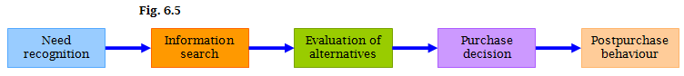
1. Need Recognition
Occurs when the buyer recognizes a problem or need triggered by;
- Internal Stimuli - thirst hunger sex
- External Stimuli - advertisement, friend bought
2. Information Search
a. Personal Sources = Family and Friends
b. Commercial Sources = Advertising, Internet
c. Public Sources = Mass media, Consumer organizations
d. Experiential Sources = Handling, Examining, Using the product
3. Evaluation of Alternatives
- How the consumer process information to arrive at brand choices.
- Highlight features that are your products strengths in the information stage. if these benefit the consumers here is where your product will stand out
4. Purchase Decisions
- The act by the consumer to buy the most preferred brand. Affected by:
a. Attitudes of others
b. Unexpected situational factors
5. Post-purchase Behaviour
Customer Satisfaction: key to building profitable relationships with consumers - to keeping and growing consumers and reaping their customer lifetime value

The Buyer Decision Process for NEW Products "AIETA"
Adoption Process
Mental process an individual goes through form first learning about an innovation to final regular use
Awareness->Interest->Evaluation->Trial-> Adoption

Individuals Differences of Innovativeness
Innovators
- venturesome, try new products
- relatively younger, better educated

Early Adaptors
- guided by respect
- leaders adapt new products early but carefully

Early Majority
- Deliberate

Late Majority
- Sceptical

Laggards
- Tradition bound
Marketing efforts should be directed toward Innovators and Early Adaptors

Influence on Product Characteristics on Rate of Adoption
Relative Advantage
degree to which the innovations appears superior to existing products
Compatibility
degree to which the innovation fits the values and experiences of potential consumers
Complexity
degree to which the innovation is difficult to understand or use.
Divisibility
degree to which the innovation may be tried on a limited bases
Communicability
degree to which the results of using the innovation can observed or described to others

Chapter 8
Consumer Driven Marketing Strategy
Creating Value for Target Markets

Market Segmentation:
Dividing the markets into smaller groups with distinct needs, characteristics and behaviours that might require separate marketing strategies or mixes
Market Targeting
Process of evaluating each market segment's attractiveness and selecting one or more segments to enter. -Designing a value proposition for this costumer to meet their needs
Differentiation
Actually differentiating the market offering to create superior customer value
- How do we compare to other brands
Positioning
Arranging for a market offering to occupy a clear, distinctive and desirable place relative to competing products in minds of the target consumers

Market SEGEMENTATION:

- Segmenting Consumer Markets
Defines and refines our segments
a. Geographic
Divides market into different geographical units;
nations, regions, provinces, countries, cities, neighbourhoods
b. Demographic
Divides market into groups based on variables;
age, gender, family size, family life cycle, income, occupation, education, religion, race, generation and nationality - CENSUS BASIC INFO about people

- Age and life-cycle segmentation
offering different products or using different marketing approaches for different age and life-cycle
- Gender
divides markets into groups based on gender
- Income
divides markets into different income groups

c. Psychographic
Divides buyers into different groups based in social class, lifestyle or personality

d. Behavioural MOST IMPORTANT
Divides buyers into groups based on
consumer knowledge, attitudes, uses, or response to a product

- Occasions - ex. Valentines Day
groups according to occasions when buyers get the idea to buy, actually make their purchase pr use the purchased item
- Benefits sought- ex. Caffeine in coke, safety in cars
groups according to the different benefits that consumers seek from a pro
- User status- ex.
segments markets into nonusers, ex-users, potential users, first-time users, and regular users of a product
- Usage Rate - ex. frequent flyer use planes alot
divides market into light, medium, or heavy product users
- Loyalty status - ex. whether or not they stick to same airline
divides market by consumer loyalty. Loyalty to brand, stores or company
Multiple Segmentation
used to identify smaller better-defined target groups.
EX -> Geodemographic segmentation
divides groups into consumer lifestyle patterns

- Segmenting Business Markets
Business markets can be segmented into the same variables as consumer markets +
- Customer Operating Statistics
- Purchasing Approaches - ex Bulk, Delivery
- Situational Factors - ex. located restrictions
- Personal Characteristics

- Segmenting International Markets
a. Geographic location
b. Economic Factors - Global Economy
c. Political-legal Factors - Country Stability
d. Cultural Factors - Can we design a product that works for them
Intermarket (cross-market) segmentation
divides consumers into groups with similar needs and buying behaviours even though they are located in different countries

- Requirements for successful segmentation " MASDA"
a. Measurable
The size, purchasing power, and profiles of segments can be measured
b. Accessible
Market segments can be effectively reached and served
c. Substantial
Market seems large or profitable enough to serve
d. Differentiable
Segments are conceptually distinguishable and respond differently to different marketing mix elements and programs
e. Actionable
Effective programs can be designed for attracting and serving the segments

Market TARGETING

- Selecting Target Market Segments
Target Market consists of a set of buyers who share common needs or characteristics that the company decides to serve

- Evaluating Target Market Segments
- Size and Growth - is it growing how do we capture
- Structural Attractiveness - competitors
- Company Objectives and Resources - means, objectives of comp who do we want to be

- Target Market Strategies
a. Undifferentiated (MASS ) Marketing
Targets the whole market with one offer - WALMART everyone low prices
-focuses on common needs rather than on what is different

b. Differentiated (segmented) Marketing
Targets several different segments and designs separate offers for each
- Goal to achieve higher sales and stronger position
- More expensive ten undifferentiated marketing
- NIKE all sports all people. Different types of Laundry detergent

c. Concentrated (niche) marketing
Targets large share of one or a few segments or niches
- Limited company resources
- Knowledge of the market
- more effective and efficient
- BURTON on snowboards. women are large market want niche of this market.

d. Micromarketing
Practice of tailoring products and marketing programs to suit the tastes of specific individuals and local customer groups
- Local (Grocery stores, pizza) or individual marketing
- one-to-one, mass costimization, markets-of-one
-NIKE design your own sneakers. Tailoring products to individual needs

Choosing a Target Market Depends on:
- Company resources
- Product variability
- Product life-cycle stage
- Market variability
- Competitor's marketing strategies

Socially Responsible Target Marketing:
- Benefits customer with specific needs
- Concern for vulnerable segments
-Children--> alcohol, cigarettes, internet abuse

DIFFERENTATION and POSITION
Product Positioning
the way the product is defined by consumers on important attributes- the place the product occupies in the consumer's minds relative to competing products
- Perceptions, Impressions, Feelings...main benefit in your head is what they want to display ex car-> sturdy, adventurous

Choosing a Differentiation and Positioning Strategy

Competitive Advantage
advantage over competitors gained by offering greater customer value, either through lower prices or providing more benefits that justify higher prices

- Identify a set of differentiating competitive advantages upon which to build position
1. Product Differentiation
differentiated on quality, features, performance, style, design, durability, service, personnel, image, price, value and demand
2. Service Differentiation
differentiated on speedy, convenient or carefully delivered
3. Channel Differentiation
differentiated through the way they design their channel's coverage, expertise and performance
4. People Differentiation
hiring and training people better - ex genius bar apple
5. Image Differentiation
perceived difference based on a strong distinctive image conveying the products distinctive benefits and positioning. State farm=sophisticated, Geicho= humour
- Choosing the right competitive advantages
- Important
- Distinctive
- Superior
- Communicable
- Perceptive
- Affordable
- Profitable
- Selecting an overall positioning strategy THEN
- Effectively communicate and deliver the chosen position to the market

Value proposition
is the full mix of benefits upon which a brand in positioned

Chapter 9
Products, Services, and Brands;
Building Customer Value

Product: Anything that can be offered in a market for attention, acquisition, use or consumption that might satisfy a need or a want
Services: Any activity or benefit that one party can offer to another that is essentially intangible and does not result in the ownership of anything
Expenditures: represent what buying the product or service will do for the customer

Levels of products and Services
1. Core Customer Value
- Core benefit - what is the customer really buying?
2. Actual Product
- product and service features, design, quality, brand name and packaging
3. Augmented Product
- must build this around the core benefit and actual product by offering additional services and benefits. ex warranty packages, instructions, quick repair services, toll- free number and website to use if they have

What is a Product:
Products and services fall into two broad classes based on the types of consumers that use them: consumer products and industrial products.

Consumer Products
Product bought by final consumers for personal consumption
- Convenience Product
P/S that customers buy frequently, immediately and within a minimum comparison and buying efforts ex. Newspapers, Candy, Fast food
- Shopping Product
P/S that customers compare carefully on sustainability, quality, price and style
ex. Furniture, Cars and Appliances
- Specialty Product
P/S with unique characteristics or brand identification for which a significant group of buyers is willing to make a special purchase effort.
ex. Medical services, designer clothes, Rolex watches
- Unsought
the consumer wither does not know about or knows about but does not normally think of buying ex. life insurance blood donations

Business Products
Product bought by individuals and organizations for further processing or for use in conducting a business. The distinction between consumer and business products is the purpose
1. Materials and Parts
Raw materials and manufactured materials and parts. sold directly to business users.

2. Capitals Items
Aid in the buyers production or operations items that last a very long time; machinery.
    - Installations: buildings and fixed equipment
    - Accessory equipment: not installed; portable factory equipment, tools, office equipment, tables, chairs, computers
    - Supplies & services: lawyers, accountants…

3. Supplies and Services
- Operating supplies (lubricants, coal, paper pencils)
- Repair and maintenance items (paint, nails and brooms)
- Business services ( window cleaning computer repair)
- Business advisory services ( Lawyers, accountants, advertising

Organizations, Persons, Places and Ideas:
Organizational Marketing
consists of activities undertaken to create, maintain, or change attitudes and behaviours of target consumers towards an organization. "sell the organization itself".
ex. Both profit and not-for-profit organizations use this. Either to create an image or raise funds

Person Marketing
consists of activities undertaken to create, maintain, or change attitudes and behaviours of target consumers toward particular people. Politicians, engineers, entertainers, sport figures, doctors lawyers use it to build their reputation. Businesses, charities and other organizations use well-known personalities to help sell their products or cases.
ex. Rachel Ray - name on cookware, cookbooks, tv shows, media empire a national magazine

Place Marketing
consists of activities undertaken to create, maintain, or change attitudes and behaviours of target consumers toward particular places. Cities, provinces, regions, even entire nations compete to attract tourists, new residents, conventions, company offices and factories

Social Marketing
The use of commerical marketing concepts and tools in programs designed to influence individuals' behaviours to improve their well-being and that of society.
Public health campaign to reduce smokin, alcoholism, drug abuse and obesity

Product and Service Decisions
Marketers make product and services decisions at 3 three levels:
1. Individual product and service decisions, 2. Product line decisions, and 3. Product mix decisions.

1. Individual Product and Service Decisions:
Product and Service Attributes: developing a product or service involves defining the benefits that it will offer. These benefits are communicated and delivered by product attributes, such as quality, features, and style and design.

- Product quality: the ability of a product to perform its functions; it include the product’s overall durability, reliability, precision, ease of operation and repair, and other valued attributes.
Creates customer value and satisfaction
- Product features: are a competitive tool for differentiating the company’s product from competitors’ products.
- Product style and design: design is a larger concept than style. Style simply describes the appearance of a product, styles can be eye-catching or yawn producing. Good design contributes to a product’s usefulness as well as to its looks. Begins with a deep understanding of customer needs - OXO apple peeler
Branding:
A name, term, sign, symbol, or design, or a combination or these, intended to identify the goods or services of one seller or group of sellers and to differentiate them from those of competitors.
- Helps consumer identify products that might benefit them, quality and consistency.
- Gives the sellers many advantages - story built around product, legal protection, segmenting markets

Packaging:
The activities of designing and producing the container or wrapper for a product.
- Primary function - hold and protect the product.
- Now used to attract attention, describe product and make sale.
Packing is sellers last and best chance to influence buyers

Labelling:
- The label identifies the product or brand such as the name.
- Describes several things about the product - who, where, when it was made, its contents, directions.
- Promotes the brand and supports its positioning and connect with consumers
- Can be misleading, fail to describe important ingredients or saftey issues

Product Support and Services
- Companies usually offer support services , repairs etc.

2. Product Line Decisions:
- Product line: a group of products that are closely related because they function in a similar manner are sold to the same customer groups, are marketed through the same types of outlets, or fall within given price ranges.
ex Nike has several lines of athletic shoes, Marriott offers any lines of hotels
- Expanding the Product Line:
Product line length: number of items in a line. managers need to assess each products sales and profits and understand how each item contributes to overall performance
- BMW - moving people from x3 to x5or7 . HP makes printers as well as cartridges. Gap different stores that offer different price clothes

Line Fillings: adding more items within the present range of the line.
Line Stretching: company lengthens its product line beyond its current range. Up, down or both

3. Product Mix Decisions:
Product mix: the set of all product lines and items that a particular seller offers for sale.

Width: number of different products line the company carries
Length: total number of items a company carries within its product lines
Depth: number of different versions offered of each product in the line
Consistency: How closely related the various products lines are in end se, in production requirements, in distribution channels

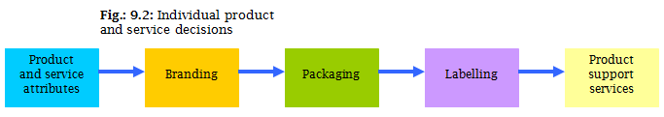

Branding Strategy; Building Strong Brands:
Brand Equity: the positive differential effect that knowing the brand name has on customer response to the product or service.

Building Strong Brands:
1. Brand Positioning: marketers need to position their brands clearly in target customers’ minds. They can position brands at any of three levels.
- Product Attributes. Least desirable level for brand positioning, as competitors can easily copy attributes.
- Benefits: can be better positioned by associating its name with a desirable benefit.
- Beliefs and Values. The strongest brands go beyond attribute or benefit positioning. Position based on beliefs and values
- When positioning a brand, the marketer should establish a mission for the brand and a vision of what the brand must be and do. A brand is the company’s promise to deliver a specific set of features, benefits, services, and experiences consistently to the target market.
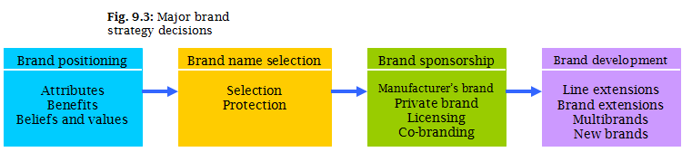

2. Brand Name Selection:
a good name can add greatly to a product’s success.
- it should suggest something about the product’s benefits and qualities.
- it should be easy to pronounce, recognize, and remember.
- the brand name should be distinctive
- it should be extendable
- the name should translate easily into foreign languages
- it should be capable of registration and legal protection.

3. Brand Sponsorship:
a manufacturer has 4 sponsorship options.
- Manufacturer’s Brands created by manufacturer have long dominated the retail scene.
- Private Brands: a brand created and owned by a reseller of a product or service.
- Licensing: uses previously created names or symbols for a fee
- Co-branding: the practice of using the established brand names of two different companies on the same product.

4. Brand Development:
a company has 4 choices when it comes to developing brands.
- Line extension: extending an existing brand name to introduce additional items in a given product category under the same brand name, such as new flavours, forms, colors, added ingredients, or package sizes.
- Brand extension: extending an existing brand name to new or modified product categories.
- Multi-brands: additional brands introduced into the same product categories
- New Brands: brands created when entering a new product category for which none of the current brand names are appropriate
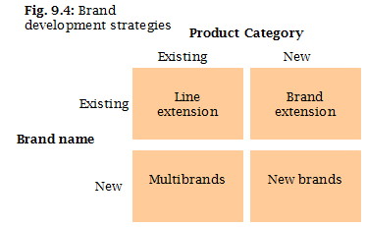

Services Marketing:

1. Nature and Characteristics of a Service:
a company must consider 4 special service characteristics when designing marketing programs:
  - Intangibility: a major characteristic of services—they cannot be seen, tasted, felt, heard, or smelled before they are bought
  - Inseparability: they are produced and consumed at the same time and cannot be separated from their providers
  - Variability: their quality may vary greatly, depending on who provides them and when, where, and how.
  - Perishability: they cannot be stored for later sale or use.

2. Marketing Strategies for Service Firms:
The Service-Profit Chain: that links service firm profits with employee and customer satisfaction. Consists of 5 links:
    - Internal service quality: superior employee selection and training, a quality work environment, and strong support for those dealing with customers, which results in…
    - Satisfied and productive service employees: more satisfied, loyal, and hard-working employees, which results in…
    - Greater service value: more effective and efficient customer value creation and service delivery, which results in…
    - Satisfied and loyal customers: satisfied customers who remain loyal, repeat purchase, and refer other customers, which results in…
    - Healthy service profits and growth: superior service firm performance.

3. Internal Marketing:
service firm must orient and motivate its customer contact employees and supporting service people to work as a team to provide customer satisfaction. Must precede external marketing

4. Interactive Marketing:
Service quality depends heavily on the quality of the buyer-seller interaction during the service encounter
- Service Differentiation
Create competitive advantage from the offer ( distinctive features), delivery (able and reliable contact people, environment or process) and image ( symbols and branding)of the service
- Service Quality
Delivering consistently higher quality than its competitors. Varies depending on interactions between employees and customers
- Service Productivity
Refers to the cost side of marketing strategies for service fims
- Employee recruiting, hiring or training
- Service quality and quantity strategies

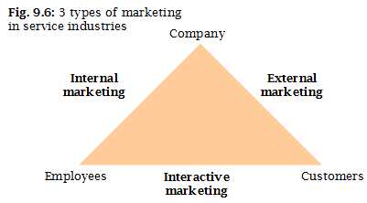

Chapter 10
New Product Development and
Product Life-Cycle Strategies

New Product Development Strategy:
Two ways to Obtain New Products
- Acquisition:
Buying of a whole company, a patent, or a license to produce someone else's product
- New Product Development
Original products , product improvements, product modifications, and new brands developed from the firm's own research and development

Reasons for New Product Failure
- Priced to high (perception)
- Ineffective promotion
- Management influence
- High development Costs
- Competition

- Overestimating market size
- Poor design (must be strong early)
- Incorrect positioning (stereotyping)
- Wrong timing

Major Stages in Development
- Idea generation
A systematic search for new product ideas. Find ideas from:
  - Internal Idea Sources: the company's own formal research and development, management and staff and intrapreneurial programs
  - External Idea Sources: outside the company such as customers’ feedback, from their questions and complaints, competitors, distributers and suppliers.

- Idea screening:
Screening new-product ideas in order to spot good ideas an drop poor ones as soon as possible. R-W-W. Is it real, can we win, is it worth doing?

- Concept development and testing:
Take this idea into consumer terms; try to make a picture.
  - Product idea: is an idea for a possible product that the company can see itself offering to the market.
  - Product concept: is a detailed version of the idea stated in meaningful consumer terms
  - Product image: is the way consumers perceive an actually or potential product.
  - Concept testing: testing new product concepts with a group of target consumers to find out if the concepts have strong consumer appeal.

- Marketing strategy development:
Designing an initial marketing strategy for introducing the product into the market.
Statement must include;
  - Description of target marketing
  - Value Proposition - based on target market needs
  - Sales and Profit Goal -price, distribution and marketing product. Price, how you think you are going to distribute it, and your marketing budget, need to be determined.

- Business analysis:
A review of sales, costs, and profit projections for a new product to find out whether these factors satisfy the company’s objectives. Review sales profits; try to determine if they make sense, and then put it into a context to whether they satisfy the company’s mission; is this the direction the company wants to take?

- Product development:
The creation and testing of one or more physical versions by the R&D or engineering departments. Requires an increase in investments.

- Test marketing:
Stage at which the product and marketing program are introduced into more realistic marketing settings. Provides the marketer with experience in testing the product and entire m program before full introduction.
- Standard Test Marketing:
throw it in the market
- Controlled Test Marketing:
Find some isolated area which doesn’t have that much influence from the outside world. Market to a smaller region rather than going nationally; make your mistakes on a smaller level.
- Simulated Test Marketing:
Second-life - fake store. Shelf appeal, do you go for the product, many variables integrated
Advantages: less expensive, faster, restricts customer access
Disadvantages: not considered to be reliable and accurate due to the controlled setting
No Testing when:
- simple line extension
- copy of competitor project
- low costs
- management confidence
Test when:
- new product with large investment
-uncertainty about product or marketing program

- Commercialization:
Introducing a new product into the market; When/ where to launch. Planned market rollout

Successful new-product development should
1. Customer centered
2. Team centered
3. Systematic

Managing New-Product Development:

1. Customer-centered New Product Development:
Finding new ways to solve customer problems and create more customer satisfying experiences
2. Sequential New-Product Development
Company departments work closely together individually to complete each stage of the process before passing it along to the next department or stage
- Increased control in risky or complex projects
- Can be dangerously slow

3. Team Based New-Product Development
Company department work closely together in cross-functional teams, overlapping in the product-development process to save time and increase effectiveness
4. Systematic New-Product Development
innovative development approach that collects, reviews, evaluates and manages new-product ideas. - creates n innovation-oriented culture and yields a large number of new products

Product Life-Cycle :
the course of a product’s sales and profits over its lifetime. It involves five distinct stages:
- Stage 1: Product development:
Begins when the company finds and develops a new-product idea. During this stage, sales are zero and the company’s investment costs increase.

- Stage 2: Introduction:
Period of slow sales growth as the product is introduces in the market. Profits are nonexistent in this stage because of the heavy expenses of product introduction.
  - Low sales
- Objective is to create product awareness and trial
- Offer a basic product
- Use cost-plus pricing
- Build selective distribution
- Build product awareness among early adopters/ dealers
- Use heavy sales promotion to entice trial
  - High cost per customer
  - Negative profits
  - Innovator customers
  - Few competitors

Example: if I am the only one who sells DVD players, all I have to do is convince you to buy a DVD player; I don’t have to convince you to buy mine because I’m the only one who sells DVD players. Example now 3D T.V's, electric cars.

- Stage 3: Growth:
- Objective is to maximize market share
- Offer product extension, service and warranty
- Price to penetrate market
- Build intensive distribution
- Build awareness and interest in the mass market
- Reduce sales promotion to take advantage of heavy consumer damage

  - Rapidly rising sales
  - Average cost per customer
  - Rising Profits
  - Customers - early adopters
  - Growing number of customers
  - Promotion and manufacturing
costs gain economies of scale

- Step 4: Maturity:
Slowdown in sales growth because the product has achieved acceptance by most potential buyers. CASH COW
  - Slows down in sales as the peak
- Objective is to maximize profit while defending market share
- Diversity product brand and models
- Price to match or beat competitors
- Build more intensive distribution
- Stress brand differences and benefits
- Increase sales promotion to encourage brand switching

  - Low cost per customer
  - High Profits
  - Customers - middle majority
  - Growing number of customers
  - Substitute products are introduced,
stable, competition beginning to decline
  - Increased promotion
and R&D to support sales and profits

Maturity Modifying Strategies
1. Market Modifying
Tries to increase the consumption of the current product
- looking for new users and market segments or inventing new uses for existing products
2. Product Modifying
Changes characteristics of the product quality, features, style or packaging to attract new users and to inspire more usage
3. Modifying the Marketing Mix
Involves improving sales by changing one or more of the marketing mix elements
- Offer new or improved services to buyer
- Cut prices to attract new users and competitors customers
- Launch better advertising campaign or aggressive sales promotion
- Move into new marketing channels - online in other stores etc.

- Step 5: Decline:
- Objective is reduce expenditure and milk the brand
- Phase out weak items
- Cut prices
- Selective distribution - phase out unprofitable outlets
- Reduce advertising to level needed to retain hardcore loyalists
- Reduce sales promotion to minimal level

  - Declining sales
  - Low cost per customer
  - Declining Profits
  - Customers - Laggards
  - Declining competitors

Chapter 11
Pricing
Price
Amount of money charged for a product or service. or the sum of the values that consumers exchange for the benefits of having or using the product or service
Only element of the marketing mix that produces revenue.

Factors to Consider when Setting Prices:

Customer Perceptions of Value
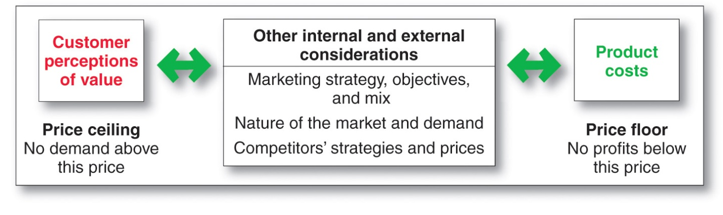Pricing Approaches
1. Cost based pricing:
Product driven
Design a product -> determine costs-> Set price based on cost-> convince buyers of pro value
2. Value-based pricing:
Price based on the buyers’ perceptions of value, not the seller’s cost.
Customer driven. It has to do with the perceived value of the product is

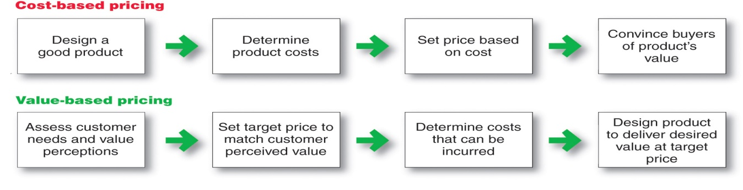
3. Good-Value Pricing
The right combination of quality and good service to fair price
-Existing brands are being redesigned to offer for quality fir a given price or the same quality for less price
a. Everyday Low Pricing (EDLP)
Involves charging a constant everyday low price with few or temporary price discounts
Can bargain to buy in large quantity - Walmart
b. High-Low Pricing
Involves charging higher prices on an everyday based but running frequent promotions to lower prices temporarily on selected items

4. Value Adding Pricing
Attaches value-added features and services to differentiate offers, support higher prices and build pricing power.
Pricing power is the ability to escape price competition and to justify higher prices and margins without losing market share

Company and Product Costs
Cost-Based Pricing
Setting prices based on the costs of producing, distributing and selling the product plus a fair rate of return for its effort and risk
Variable Costs
Costs that vary with the level of production
- Packaging and Raw materials

Fixed Costs
Are the costs that do not vary with production or sales level.
- Rent, Heat, Interest, Executive Salaries

Total costs
Average Costs
Cost associated with a given level of output

Sum of Fixed Costs + Variable Costs
for any given level of production

Costs at Different Levels of Production
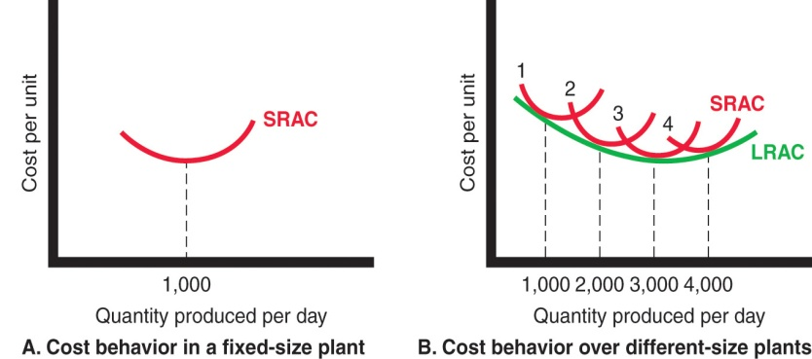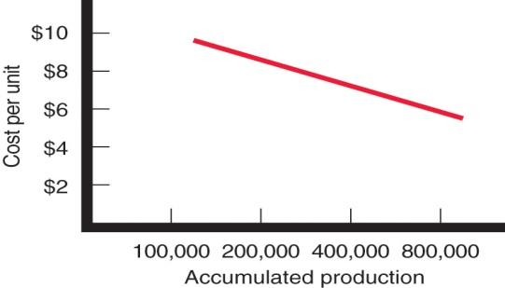

Experience or learning curve is when average cost falls as production increases because fixed costs are spread over more units

Cost-Plus Pricing
Adds a standard mark-up to the cost of the product
Benefits
Disadvantages
- Ignores demand and competitors prices

- Sellers certain about costs
- Prices are similar in industry prices competition is minimized
- Consumers feel it is fair

Break-Even Analysis and Target Profit Pricing
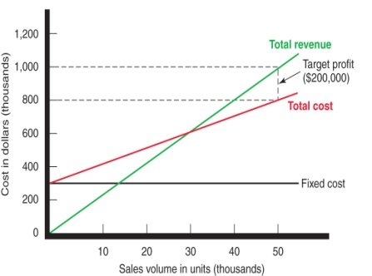
Break-Even Pricing
Price at which total costs = total revenue --> No profit

Target Profit Pricing
Price at which the firm will break even or make the profit its seeking

Other Internal and External Factors that Effect Pricing
Customer perception of value set upper limits for prices. Costs set the lower limits

Target Costing
Starts with an ideal selling price based on consumer value considerations and then targets costs that will ensure that the price is met. Organizations should consider:
- Who should set the price
- Who can influence the price
- Must understand the relationship between price and demand for its products

4 Types of Competition
1. Pure Competition
market consists of many buyers and sellers trading in a uniform commodity -all the same thing
2. Monopolistic Competition
market consists many buyers and sellers who trade over a range of prices. Clothing, Computers
3. Oligopolistic Competition
market consists of few sellers who are highly sensitive to each others' pricing and marketing strategies. Ex. Telephone Service Providers
4. Pure Monopoly
Market consists of one seller. Very rare controlled by state - HydroQuebec, Microsoft

The Demand Curve
shows the number of units the market will buy in given period at different prices
- Normally, Demand and Price are inversely related
- Higher price = Lower Demand
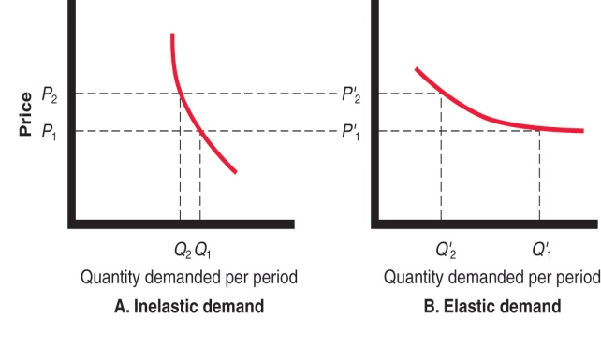
- For Prestige luxury goods, higher price can equal higher demand when consumers perceive higher prices as higher quality

Price Elasticity of Demand
Illustrates response of demand to a change in price
Ed= %∆Q / %∆P
Inelastic Demand =
Hardly changes when there is a small change in price
Elastic Demand =
Demand changes greatly when there is a small change in price

Competitors Strategies
- Comparison of offering in terms of customer values
- Strength of Competitors
- Competition Pricing Strategies
- Customer Price Sensitivity

Affecting Price Decisions
1. Economic Conditions
2. Reseller's Response to Price
3. Government
4. Social Concerns

Pricing Strategies
Market-Skimming Pricing
Strategy with high initial pricing to skim maximum revenues from the segments willing to pay the high price
- Quality and image must support the product
- Buyers must want the product at the price
- cost of producing the product in small volumes should not cancel the advantages of higher prices
- Competitors should not be able to enter the market easily
Market-Penetration Strategy
Sets a low initial price in order to attract a large number of buyers and large market share
- Price sensitive market
- Inverse relationship of production and distribution cost to sales growth
- low prices must keep competition out of the market

Strategy | Description
Product Line Pricing | Takes into account the cost difference between products in the line, customer evaluation of their features and competitors prices
Optional-Product Pricing | Takes into account optional or accessory products along with the main product
Captive-Product Pricing | Involves products that must be used along with the main product
By-Product Pricing | Refers to products with little or no value produced as a result of the main product. Producers will seek little or no profit other than the cost to cover storage and delivery
Product Bundle | Combines several products at a reduced price
Two-Part Pricing | Involves breaking the price into: fixed fee, variable usage fee

Discount and Allowance Pricing
Reduces prices to reward customer responses to such as paying early or promoting the product
Discounts: straight reductions in price on purchases during a stated period of time
Allowance: promotional money paid by manufacturers to retailers in return for an agreement to feature the manufacturer's product in some way

Segmented Pricing
Used when a company sells a product at two or more prices even thought the difference is not based on cost
Types of Segmented Pricing
1. Customer segment pricing
When different customer pay different prices for the same product/service.
EX. Student discount, Senior Citizen
2. Product-form segment pricing
Different versions of the product are priced differently,not according to differences in cost
EX. Adding nice stuff on labels
3. Location Pricing
Product sold in different geographical areas is priced differently even though the cost is the same
4. Time Pricing
Varies by season, the month, the day, and even the hour
EX. Vacation places, touristic, booking flight on the day of.
To be effective must be:
- market must be segmentable
- segments must show different degrees of demand
- watching the market cannot exceed the extras revenue obtained from the price differenc
- Must be legal

Price Adjustment Strategies

Strategy | Description
Psychological Pricing | Sellers consider psychology of prices and not just simply economics ex. $299.99 seems less than 300.
Reference Pricing | Prices that buyers carry in their minds and refer to when looking at a given product. noting current prices, remember past, assessing the buying situation (festivals, events). differs from person to person
Promotional Pricing | Prices are temporarily priced below list price or cost to increase demand  Loss Leaders: products sold below cost to attract customers  Special Event Pricing: attract customers during certain seasons or event  Cash Rebates: given to customer who buy products with specified time  Low-interest financing, Longer warrantees and Free maintenance:  lower the customers "total" cost
Geographical Pricing | Used for customers in different parts of the country or world  FOB-origin Pricing (Free on board):  Goods are delivers to the carrier and the title and responsibility passes to customers  Uniformed-delivered Pricing  Company charges the same price + freight to all customer regardless of the location  Zone Pricing  Sets up two+ zones where customers within a given zone pay a single total price  Basing-Point  Selects a given city as a "basing point" and charges all customers the freight cost associated form that city to their location  Freight-absorption  Seller absorbs all or part of the actual freight charges as an incentive to attract business in competitive markets
Dynamic Pricing | When prices are adjusted continually to meet characteristics and needs of individual customers and situation. EX. Airlines, Auction
International Pricing | When prices are set in specific country based on country-specific factors - Blackberry already 30% off in India.  - Economic conditions  - competitive condition  - Laws and regulations  - Infrastructure  - Company Marketing Objectives

Price Changes
- Price cuts occur due to:
  - Excess capacity
  - Increase market share
- Price increase from:
  - Cost inflation
  - Overdemand
  - Lack of supply
Buyers Reaction
Increase
- prodcut is hot
- company greedy
Price cuts
- new models with be available
models ar enot selling well
quality issues
Responding to Price Changes

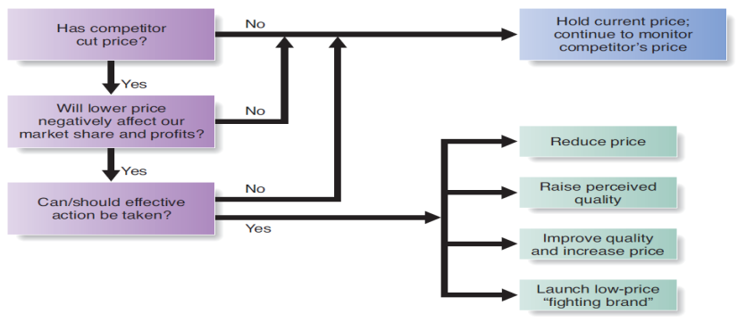
Pricing within channel Levels
Price fixing: Sellers must set prices without talking to competitors
Predatory pricing: Selling below cost with the intention of punishing a competitor or gaining higher long-term profits by putting competitors out of business

Pricing Across Channel Levels
Retail (or resale) price maintenance is when a manufacturer requires a dealer to charge a specific retail price for its products
Deceptive pricing occurs when a seller states prices or price savings that mislead consumers or are not actually available to consumers
- Scanner fraud failure of the seller to enter current or sale prices into the computer system
- Price confusion results when firms employ pricing methods that make it difficult for consumers to understand what price they are really paying
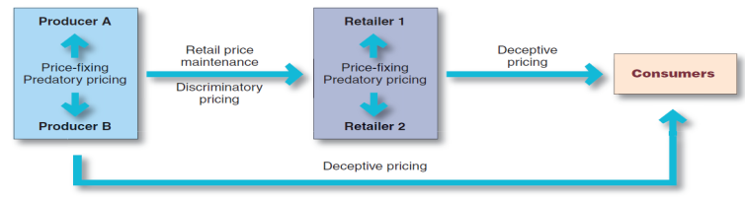

Chapter 14
Integrated Marketing
Communications Strategy

The Promotion Mix "APPSD"
1. Advertising
Any paid form of non-personal presentation and promotion of ideas, goods, or services by an identified sponsor
- Broadcast (tv, radio), print, internet, outdoor
- Don't know when encountering message, cheapest form.
2. Sales Promotion
Short-term incentives to encourage the purchase or sale of a product or service
- Discounts, coupons, displays, demonstrations
3. Public Relations
Involves building good relations with the company's various publics by obtaining favourable publicity, building up a good corporate image and handling or heading off unfavorable rumors, stories, and events
- Press releases, sponsorships, special events, web pages
4. Personal Selling
Personal presentation by the firm's sales force for the purpose of making sales and building customer relationships
- Sales presentation, trade show, incentive programs

5. Direct Marketing
Involves making direct connections with carefully targeted individual consumers to both obtain an immediate response and cultivate lasting customer relations - through the use of direct mail, telephone, email, the INTERNET
- Catalogues, Telemarketing, Kiosks

Integrated Marketing Communications
Integration by the company of its communication channels to deliver a clear, consistent, and compelling message about the organization and its product
The New Landscape: consumers are better informed there is more communication, less mass marketing and changing technology.

A View of the Communication Process
Integrated marketing communications involves identifying the target audience and shaping a well-coordinated promotional program to obtain the desires audience response. Marketers are moving toward viewing communications as managing the customer relationship over time.
- Because consumers differ, communications programs need to be developed for specific segments, niches, and even individuals.
- Sender: the party sending the message to another party
- Encoding: the process of putting ought into symbolic form
- Message: the set of symbols that the sender transmits
- Media: the communication channels through which the message moves from sender to receiver
- Decoding: the process by which the receiver assigns meaning to the symbols encoded by the sender
- Receiver: the party receiving the message sent by another party
- Response: the reactions of the receiver after being exposed to the message.
- Feedback: the part of the receiver’s response communicated back to the sender
- Noise: the unplanned static or distortion during the communication process, which results in the receiver’s getting a different message than the one the ender sent
- For a message to be effective, the sender’s encoding process must mesh with the receiver’s decoding process. Thus, the best messages consist of words and other symbols that are familiar to the receiver.
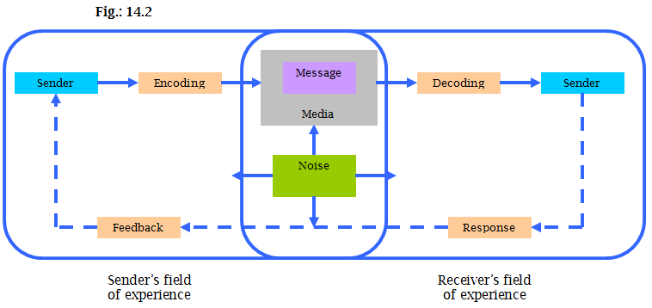

Steps in Developing Effective Communication
- Identifying the Target Audience
  - A marketing communicator starts with a clear target audience in mind. The audience may be potential buyers or current users, those who make the buying decision or those who influence it. What, when where, who, and how will we say it?
- Determining the Communication Objectives:
  - Buyer Readiness Stages: the stages consumers normally pass through on their way to purchase. These stages include:
  - awareness, knowledge, liking, preference, conviction, and purchase.
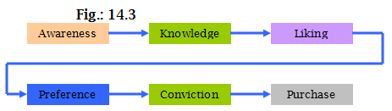

3. Designing a Message
  - Having defined the desired audience response, the communicator turns to developing an effective message. AIDA MODEL
get Attention
hold Interest
arouse Desire
obtain Action
  - Message Content: the communicator must figure out an appeal or theme that will produce the desired response. There are three type of appeals:
    - Rational appeals: relate to the audience’s self-interest. They show that the product will produce the desired benefits.
    - Emotional appeals: attempt to stir up either negative or positive emotions that can motivate purchase. Communicators may use positive emotional appeals, such as love, pride, joy, and humour.
    - Moral appeals: are directed to the audience’s sense of what is “right” and proper”. They are often used to urge people to support social causes, such as a cleaner environment, better race relations, equal right for women, and aid to the disadvantaged.
  - Message Structure: the communicator must also decide how to handle three messages structure issues.
    - Whether to draw a conclusion or leave it to the audience
    - Push forth the strongest arguments first or last. Presenting them first gets strong attention buy may lead to an anticlimactic ending.
    - Present a one-sided arguments (mentioning only the product’s strengths - Politics) or a two-sided argument (touting the product’s strengths while also admitting its shortcomings). Usually a one-sided argument is more effective in sales presentations except when audiences are highly educated or likely to hear opposing claims or when the communicator has a negative association to overcome.
  - Message Format: the marketing communicator also needs a strong format for the message. To attract attention, advertisers can use novelty and contrast; eye-catching pictures and headlines; distinctive formats; message size and position; and colour, shape, and movement. If the message is to be carried over the radio, the communicator has to choose words, sounds, and voices.

4. Choosing Media: the communicator now must select channels of communication: personal and non-personal
  - Personal Communication Channels: channels through which two or more people communicate directly with each other, including face to face, person to audience over the telephone, or through the mail.
    - **Word-of-mouth influence: personal communication about a product between target buyers and neighbours, friends, family members, and associates.
    - Buzz marketing: cultivating opinion leaders and getting them to spread information about a product or service to others in their communities
    - Opinion Leaders: people within a reference group who, because of their special skills, knowledge, personality or other characteristics exerts social influence on others
  - Non-personal Communication Channels: media that carry messages without personal contact or feedback, including major media, atmospheres and events.
    - Major Media: Print broadcast, display and online media
    - Atmospheres: designed environments that create or reinforce the buyer's leanings toward buying a product
    - Events: staged occurrences that communicate messages to target audiences. Press conference, grand openings, exhibits, public tours

5. Selecting the Message Source: in either personal or non-personal communication, the message’s impact on the target audience is also affected by how the audience views the communicator. Messages delivered by highly credible sources are more persuasive.
    - Celebrities: Athletes, entertainers
    - Professionals: healthcare providers

6. Collecting Feedback: after sending the message, the communicator must research its effect n the target audience. This involves asking the target audience members whether they remember the message, how any times they saw it, what points they recall, how they felt about the message, and their past and present attitudes toward the product and company. The communicator would also like to measure behaviour resulting from the message – how many people bought a product, talked to others about it, or visited the store.

Setting the Total Promotion Budget and Mix
Setting the Overall Budget
There are 4 common methods used to set the total budget for advertising:
  - Affordable Method: setting the promotion budget at the level of management thinks is affordable, ignores the effect of promotion on sales
  - Percentage-of-Sales Method: setting the promotion budget at a certain percentage of current or forecasted sales or as a percentage of the unit sales price.
    - Easy to use and helps management think about the relationship between promotion selling, price and profit
    - Wrongly views sales as the cause rather than the result of promotion
  - Competitive-parity Method:
setting the promotion budget to match competitors’ outlays.
    - Argument: represents collective wisdom of the industry and prevents promotion wars
    - Except: companies differ greatly, each has its own special promotion need, and there is no practical evidence suggesting it successfully prevents promotion wars
  - Objective-and-Task Method: sets the budget based on what the firm wants to accomplish with promotions by
(1) defining specific objectives
(2) determining the tasks that must be performed to achieve these objectives
(3) estimating the costs of performing these tasks.
Forces management to spell out assumptions about the relationship between dollars spent and promotion results, but is difficult to use

Setting the Overall Communication Mix
we now look at the factors that influence the marketer’s choice of promotion tools:
The Nature or Each Promotion Tool: each promotion tool has unique characteristics and costs. Marketers must understand these characteristics in selecting their mix of tools:
    - Advertising:
    - Reaches masses of geographically dispersed buyers at a relatively low cost per exposure
    - It enables the seller to repeat a message many times.
    - Advertising is also very expressive – it allows the company to dramatize its products through the artful use of visuals, print, sound, and color. Advertising also has shortcomings. Although advertising reached many people, it is impersonal and cannot be as directly persuasive as can company salespeople.
    - Personal Selling:
    - most effective tool at certain stages of the buying process, particularly in building up buyers’ preferences, convictions, and actions.
    - involves personal interaction between two or more people, so each person can observe the other’s needs and characteristics and make quick adjustments.
    - Sales Promotion:
    - includes a wide assortment of tools – coupons, contests, cents-off deals, premiums, and others – all of which have many unique qualities.
    - attract consumer attention, offer strong incentives to purchase, and can be use to dramatize product offers and to boost aging sales.
    - Public Relations:
    - very believable – news stories, features, sponsorships, and events seem more real and believable to readers than ads do. Public relations can also reach many prospects who avoid salespeople and advertisements – the message gets to the buyers as “news” rather than as a sales-directed communication.
    - Direct Marketing: although there are many forms of direct marketing – telephone marketing, direct mail, online marketing, and others – they all share four distinctive characteristics:
      - Non-public: the message is normally directed to a specific person
      - Immediate and customized: messages can be prepares very quickly and can be tailored to appeal to specific consumers.
      - Interactive: it allows a dialogue between the marketing team and he consumer, and message can be altered depending on the consumer’s response.

Promotion Mix Strategies:
    - Push Strategy: a promotion strategy that calls for using the sales for and trade promotion to push the product through channels. The producer promotes the product to wholesalers the wholesalers promote to retailers, and the retailers promote to consumers.
    - Pull Strategy: a promotion strategy that calls for spending a lot on advertising and consumer promotion to build up consumer demand. If the strategy is successful, consumers will ask their retailers for the product, the retailers will ask the wholesalers and the wholesalers ill ask the producers.
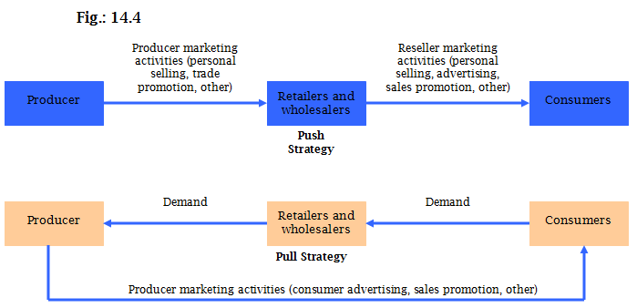

- Integrating the Promotion Mix: having set the promotion budget and mix, the company must now take steps to see that all of the promotion mix elements are smoothly integrated.
  - Analyze trends – internal and external – that can affect the company’s ability to do business: look for areas where communications can help the most. Determine the strengths and weaknesses of each communications function. Develop a combination of promotional tactics based on these strengths and weaknesses.
  - Audit the pockets of communications spending throughout the organization: itemize the communications budgets and tasks and consolidate these into singly budgeting process. Reassess all communication expenditures by product, promotional tool, stage of the life cycle, and observed effect.
  - Identify all contact points for the company and its brands: work to ensure that communication at each point are consistent with the overall communications strategy and that communications efforts are occurring when, where, and how customers want them.
  - Team up in communications planning: engage all communications functions in joint planning. Include customers, suppliers, and other stakeholders at every stage of communications planning.
  - Create compatible themes, tones, and quality across all communications media: make sure each element carries the company’s unique primary messages and selling points. This consistency achieves greater impact and prevents the unnecessary duplication of work across functions.
  - Create performance measures that are shared by all communication elements: develop systems to evaluate the combined impact of al communications activities.
  - Appoint a director responsible for the company’s persuasive communications efforts: this move encourages efficiency by centralizing planning and creating shared performance measures.
Socially Responsible Marketing Communication
In shaping the promotion mix, a company must be aware of the large body of legal and ethical issues surrounding marketing communications. Most marketers work hard to communicate openly and honestly with consumers and resellers.
Advertising and Sales Promotion: by law, companies must avoid false or deceptive advertising. Advertisers must not make false claims, such as suggesting that a product cures something when it does not. They must avoid ads that have the capacity to deceive, even though no one actually may be deceived.
Personal Selling: a company’s salespeople must follow the rules of “fair competition”. To avoid bait-and-switch practices, salespeople’s statements must match advertising claims.
Chapter 15
Advertising and Public Relations

Advertising
any paid form of non-personal presentation and promotion of ideas, goods, or services by an identified sponsor.
Developing and Advertising Programs:
1. Setting Advertising Objectives; specific communication task to be accomplished with a specific target audience during a specific period of time

  - Advertising objective
objectives can be classified by primary purpose:
    - Informative advertising: is used heavily when introducing a new product category. In this case, the objective is to build primary demand.
    - Comparative advertising: directly or indirectly compares the brand with one or more other brands
    - Persuasive advertising: becomes more important as competition increases. Here, the company’s objective is to build selective demand.
    - Reminder advertising: is important for mature products – it keeps consumers thinking about the product.

2. Setting the Advertising Budget.
Dollars and other resources allocated to a product or company advertising problem
Factors to consider:
    - Product Life Cycle Stage
New Product require larger budgets
Mature Products require lower budgets
    - Market Share:
Building or taking market share = larger budget
Markets with heavy competition or high advertising clutter= larger budget
Undifferentiated brands = larger budgets

3. Developing Advertising Strategy:
Strategy by which the company accomplishes its objectives consists of two major elements:

  - Creating the Advertising Message: no matter how big the budget, advertising can succeed only if advertisements gain attention and communicate well.

    - Breaking through the Clutter: just to gain and hold attention, today’s advertising messages must be better planned, more imaginative, more entertaining, and more rewarding to consumers.
Many advertisers now see themselves as creating “advertainment” - ads that are both persuasive and entertaining. MADISON & VINE - Hollywood and madison av
    - 1. Message Strategy:
First step in creating effective advertising messages is to plan a message strategy – to decide what general message will be communicated to consumers. - developing an effective message strategy begins with identifying consumer benefits
    - 2. Creative Concept.
Idea that will bring the message strategy to life and guide specific appeals to be used in an advertising campaign- Meaningful, Believable, Distinctive

    - 3. Message Execution: the advertiser now has to turn the big idea into an actual ad execution that will capture the target market’s attention ad interest.
The creative team must find the best style, tone, words, and format for executing the message. Any message can be presented in different execution styles, such as the following:
      - Slice of life: this style shows one or more “typical” people using the product in a normal setting.
      - Lifestyle: this style shows how a product fits in with a particular lifestyle
      - Fantasy: This style creates a fantasy around the product or its use
      - Mood or image: this style builds a mood or mage around the product, such as beauty, love, or serenity.
      - Musical: this style sows one or more people or cartoon characters singing about the product
      - Personality symbol: this style creates a character that represents the product.
      - Technical expertise: this style shows the company’s expertise in making the product
      - Scientific evidence: this style presents survey or scientific evidence that the bran is better or better liked than one or more other brands.
      - Testimonial evidence or endorsement: this style features a highly believable or likable source endorsing the product.
      - The advertisers also must choose a
Tone for the ad (Positive or negative)
Attention-getting words.
Format (Illustration, Headline, Copy)

4. Selecting Advertising Media: the major steps in media selection are:

    - 1. Deciding on Reach, Frequency, and Impact:
Reach: is a measure of the percentage of people in the target market who are exposed to the ad campaign during a given period of time.
Frequency: how many times the average person in the target market is exposed to the message
Impact: qualitative value of a message exposure through a given medium.

    - 2. Choosing Among Major Media Types:

    - 3. Selecting Specific Media Vehicles: involves presenting the media effectively and efficiently to the target customer and consider the messages
- Impact, Effectiveness and Cost
Narrowcasting: focuses the message on selected market segments
Lower costs, targets more effectively, engages customers better
    - 4. Deciding on Media Timing: the advertiser must also decide how to schedule the advertising over the course of a year.
- Seasonality
- Pattern of Advertising
Continuity - scheduling within a given period
Pulsing - scheduling unevenly within a given period

5. Evaluating Advertising:
    - 1. Return on Advertising Investment:
net return on advertising investment divided by the costs of the investment
    - 2. Communication Effects:
    - indicates whether the ad and media are communicating the ad message well and should be tested before or after the ad runs - copy testing
    - 3. Sales and Profits Effects:
Compares past sales and profits with past expenditures or through experiments

6. Other Advertising Considerations: in developing advertising strategies and programs, the company must address two additional questions.
First, how will the company organize its advertising function – who will perform which advertising tasks? Second, how will the company adapt its advertising strategies and programs to the complexities of international markets?
  - Organizing for advertising:
    - Advertising agency: a marketing services firm that assists companies in planning, preparing, implementing, and evaluating all or portions of their advertising programs.
    - International advertising decisions:
Standardization: Lower costs, greater coordination, more consistent image, ignores cultural differences
"Think Globally, Act Locally" - Develop global ad strategies, adapt local ad programs
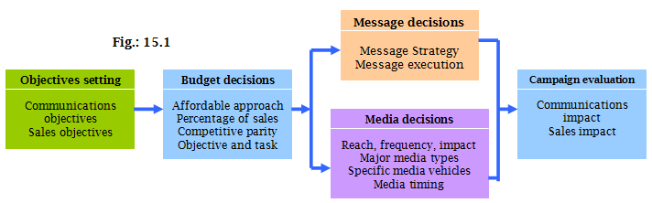

Public Relations
Involves building good relations with the company’s various public by obtaining favourable publicity, building up a good “corporate image”, and handling or heading off unfavourable rumours, stories, and events.
Public relations departments may perform any or all of the following functions:

- Press relations or press agency: creating and placing newsworthy information in the news media to attract attention to a person, product, or service
- Product publicity: publicizing specific products
- Public affairs: building and maintaining national or local community relations
- Lobbying: building and maintaining relations with legislators and government officials to influence legislation and regulation
- Investor relations: maintaining relationships with shareholders and others in the financial community
- Development: public relations with donors or members of not-for-profit organizations to gain financial or volunteer support.

- The Role and Impact of Public Relations:
- Lower cost than advertising. The company does not pay for the space or time in the media.
- Stronger impact on public awareness then advertising

Chapter 16
Personal Selling and Sales Promotion

Personal Selling
Personal presentation by the firm's sales force for the purpose of making sales and building the customer relationships

The Nature of Personal Selling
Today, most salespeople are well-educated, well-trained professionals who work to build and maintain long-term customer relationships. They listen to their customers; assess customer needs, and organize the company’s efforts to solve customers’ problems.
Salesperson: an individual acting for a company by performing one or more of the following activities: prospecting, communicating, servicing, and information gathering.

The Role of the Sales Force
Personal selling involves two-way, personal communication between salespeople and individual customers – whether face to face, by telephone, though video or Web conference, or by other means. Personal selling can be more effective than advertising in more complex selling situations, and people are often the essential element in building strong customers relationships. Salespeople an probe customers’ thoughts to learn more about their problems, then adjust the marketing offer and presentation to fit the special needs of each customer.
The role of personal selling varies from company to company; some firms have no salespeople at all. The sales force serves as a critical link between a company and its customers, in many cases, salespeople serve both masters – the seller and the buyer. They Represent;
1. The company to customers - sell products by approaching customers, presenting their products, answering objections, negotiating prices and terms, and closing sales.
2. Represent customers to the company - learns customer needs
3. Working closely with the marketing - to develop customer value

Managing the Sales Force
Sales force management: the analysis, planning, implementation, and control of sales force activities.
Designing Sales Force Strategy and Structure
- Sales Force Structure: a company can divide up sales responsibilities along any of several lines.
  - Territorial sales force structure: a sales force organization that assigns each salesperson to an exclusive geographic territory in which that salesperson sells the company’s full line.
Defines sales persons job, fixes accountability, lowers sales expenses, improve relationship building and selling effectiveness
  - Product sales force structure: salespeople specialize in selling only a portion of the company’s products or lines. Improves knowledge, can lead to territorial conflicts
  - Customer sales force structure: specialize in selling only to certain customers or industries - improves customer relationships
  - Complex sales force structure: when a company sells a wide variety of products to many types of customers over a broad geographic area combines several types of sales force structures.
Salespeople can be specialized by customer and territory; by product and territory; by product and customer; or by territory, product, and customer.

Sales Force Size:
Salespeople are one of the most productive and expensive assets. Increase in the sales force can increase sales and costs.
WORKLOAD approach:
grouping accounts into different classes to determine the number of salespeople needed

- Other Sales Force Strategy and Structure Issues:
  - Outside sales force (or field sales force): outside salespeople who travel to call on customers
  - Inside sales force: inside salespeople who conduct business from their office via telephone or through visits from prospective buyers.
  - Team selling: using teams of people from sales, marketing, engineering, finance, technical support, and even upper management to service large, complex accounts.
Recruiting and Selecting Salespeople
- Careful Selection and training increases sales performance
- Poor selection increases recruiting and training costs - lost sales and disrupts customer relationships
Supervising and Motivating
The goal for supervision is to work smart by doing the right things in the right way. The goal for motivation is to encourage sales people to work hard and energetically toward sales force goals. Tools;
- Training
- Sales Meetings
- Live Sales Presentation
- Service Accounts
Sales morale can be increased by
- organizational climate
-Sales Quota - standards that state the amount a salesperson should sell and how sales should be divided among the company's products
- positive incentives
Compensation is made up of several elements – a fixed amount (salary), a variable amount( bonuses based on sales performance), expenses, and fringe benefits

1. Annual Call plan - shows which customers and prospects to call on in which months and which activities to carry out
2. Sales force automation systems: computerized sales force operations for more efficient order-entry transactions, improved customers service, and better salesperson decision-making support.
Evaluating Salespeople
1. Sales Reports weekly or monthly work plans and longer-term territory marketing plans.
2.Call Reports
3. Expense Reports - Write up and repaid wholly.
Addition information comes from personal observation, customer surveys, and talks with other salespeople.
The Personal Selling Process
Selling process: the goal is to get new customers and obtain orders from them.
Steps in the Selling Process
- Prospecting and Qualifying
Prospecting: identifies qualified potential customers through referrals from; customers, suppliers, dealers
Qualifying: indentifying the good customers and screening out poor ones by looking at: financial ability, volume of business, special needs, location, possibilities for growth.
- Pre-approach
Pre-approach: the process of learning as much as possible about a prospect, including needs, who is involved in the buying and the characteristics and styles of the buyer before making the sales call.
Objectives-> qualify the prospect, to gather information or to make an immediate sale. Approach-> which might be a person visit, a phone call, or a letter .
- Approach
Approach: the process where the sales person meets and greets the buyer and gets the relationship off to a good start, it involves;
Appearance
Opening lines: should be positive to build goodwill from the beginning of the relationship. This opening might be followed by some key questions to learn more about the customer’s needs or by showing a display or sample to attract the buyer’s attention and curiosity
Follow-up remarks.

The most important attribute is for the sales person to LISTEN!
- Presentation and Demonstration
Presentation: the salesperson tells the product story “benefit story” to the buyer, presenting customer benefits and showing how the product solves the customers problems.
need satisfaction approach: Buyers want solutions and salespeople should listen and respond with the right products and services to solve the problems.
GOOD TRAITS: empathy, good listening, honesty, dependability, thoroughness, and follow-through.
BAD TRAITS: Pushy, Late, Deceitful, Disorganized, Unprepared

- Handling Objections
Handling objections: the step in the selling process in which the salesperson resolve problems that are logical psychological or unspoken. Seeks out, clarifies, and overcomes customer objections to buying.

- Closing
Closing: the selling process in which the salesperson recognizes signals from the buyer physical actions, comments, and questions - to close the sale. The salesperson may offer the buyer special reasons to close, such as a lower price, or an extra quantity at no charge

- Follow-Up
Follow-up: the last step in the selling process in which the salesperson follows up after the sale to ensure customer satisfaction and repeat business.
Sales Promotion
Short-term incentives to encourage purchases or sales of a product or service. Managers are under pressure to increase current sales, companies face more competition, brands offer less differentiation, advertising efficiency has declined, consumers have become more deal orientated.

1. Consumer Promotions
Urge short-term customer buying, enhance long-term relationships
Examples Sale Promotion Tools:
Samples, coupons, cash refunds, price packs, premiums, advertising specialties, point-of-purpose promotions (displays and demonstrations that take place a the point of sales).
Contests, sweepstakes and games - give the customer a chance to win something

2. Trade Promotions
Carry new items, more inventory, buy in advance, advertise products, more shelf space
Example Sale Promotion Tools:
Discount off list price, allowance, free goods for featuring or buying a certain amount, push money, free speciality advertising items - pens calendars etc.

3. Sales Force Promotions
more sales force support for new or current products, sales people to sign u new accounts
4. Business Promotions

Chapter 17
Direct and Online Marketing

Direct Marketing
Direct marketing: direct communications with carefully targeted individual consumers – the use of telephone, ail, fax, email, the Internet, and other tools to communicate directly with specific consumers.

Benefits and Growth of Direct Marketing
For buyers, direct marketing is convenient, easy to use, and private. From the comfort of their homes or offices, they can browse mail catalogues or company websites at any time of the day or night. Direct marketing gives buyers ready access to a wealth or products and information, at home and around the globe. Finally, direct marketing is immediate and interactive – buyers can interact with sellers by phone or on the seller’s website to create exactly the configuration of information, products, or services they desire, and then order them on the spot.
For sellers, direct marketing is a powerful tool for building customer relationships. Using database marketing, today’s marketers can target small groups or individual consumers, tailor offers to individual needs, and promote these offers through personalized communications. Direct marketing can also be timed to reach prospects a just the right moment. Because of its one-to-one, interactive nature, the Internet is an especially potent direct marketing tool.

Customer Databases and Direct Marketing
Customer database: an organized collection of comprehensive data about individual customers or prospects, including geographic, demographic, psychographic, and behavioural data.
The database can be used to locate good potential customers tailor products and services to the special needs of targeted consumers, and maintain long-term customer relationships.

Forms of Direct Marketing
The major forms of direct marketing include: personal selling, telephone marketing, direct mail marketing, catalogue marketing, direct-response television marketing, kiosk marketing, and online marketing.
- Telephone Marketing: using the telephone to sell directly to customers. Properly designed and targeted telemarketing provides many benefits, including purchasing convenience and increased product and service information. However, the explosion in unsolicited telephone marketing has annoyed many consumers.
- Direct-Mail Marketing: sending an offer, an announcement, a reminder or other item to a person at a particular address. Direct mail is well suited to direct, one-to-one communication. It permits high target-market selectiviy, can be personalized, is flexible, and allows easy measurement of results.
- Catalogue Marketing: direct marketing through print, video or electronic catalogues that are mailed to select customers, made available in store, or presented online.
- Direct-Response Television Marketing: direct marketing via television, including direct-response television advertising or infomercials and home shopping channels. Direct response TV commercials are usually cheaper to make and the media purchase is less costly. Moreover, results are easily measured, unlike most media campaigns, direct-response ads always include a toll-free number or Web address, making is easier for marketers to measure the impact of their pitches.
- Integrated Direct Marketing: direct-marketing campaigns that use multiple vehicles and multiple stages to improve response rates and profits. In such campaigns, the marketer seeks to improve response rates and profits by adding media and stages that contribute more to additional sales than to additional costs.

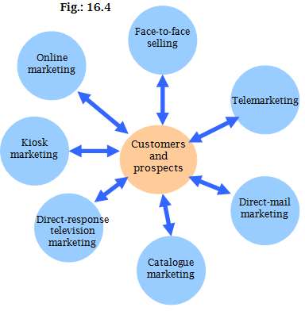

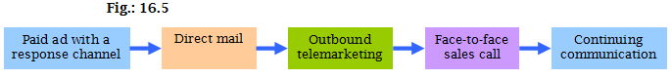

Public Policy and Ethical Issues in Direct Marketing
The aggressive and sometimes shady tactics of a few direct marketers can bother or harm consumers, giving the entire industry a black eye. Abuses range from simple excesses tat irritate consumers to instances of unfair practices or even outright deception and fraud.
- Irritation, Unfairness, Deception, and Fraud
Direct-marketing excesses sometimes annoy or offend consumers. Most of us dislike direct-response TV commercials that are too loud, too long, and too insistent.
- Invasion of Privacy
  - Consumer consent: knowledge and consent must be obtained from consumers before a firm can collect, use, or disclose consumers’ personal information
  - Limitations: a firm may collect only the information appropriate for the purposes for which it is being gathered. Also, a firm may use the information only for the purpose for which it was gathered. A firm may not transfer the information to a third party without the permission of the individual.
  - Accuracy: a firm must ensure that the information it gathers is recorded accurately, it must appoint an employee to be responsible for this.
  - Right to access: individuals have the right to know what information is being held about them. They can also demand that error in their personal information be rectified and may request that heir personal information be withdrawn from a firm’s database.

Chapter 19
Global Marketing

Restrictions on Trade between Nations:
Tariff: is like a tax. There could be taxes imposed on certain categories of products by countries. When the country imposes these duties it does this for:
- Provide a competitive advantage to the domestic industries, because imported stuff is more expensive because for the duties.
- Generates income.
Quota: limitson the amount of foreign imports a country will accept in certain product categories to conserve on foreign exchange and protect domestic industry and employment
Embargo or boycott: totally bands imports from certain countries.
Exchange controls are a limit on the amount of foreign exchange and the exchange rate against other currencies
Nontariff trade barriers are biases against bids, restrictive product standards, or excessive regulations
- Economic communities are free trade zones
- European Union (EU)
- North American Free Trade Agreement (NAFTA)
- European Free Trade Association (EFTA)
World Trade Organization - connect business people with other business executives
- Enforces GATT rules
- Mediates disputes
- Imposes trade sanctions
Economic Environment Industry structure
- In subsistence economies, the vast majority of people engage in simple agriculture
  - Offer few market opportunities
- Raw material exporting economies are rich in one or more natural resources but poor in other ways
  - Good markets for large equipment, tools and supplies, and trucks
- In industrializing economies manufacturing accounts for 10 to 20 percent of the country’s economy. Morooco India
- Industrial economies are major exporters of manufactured goods, services, and investment funds. Canada us
  - Rich markets for all sorts of goods

Deciding how to enter a market
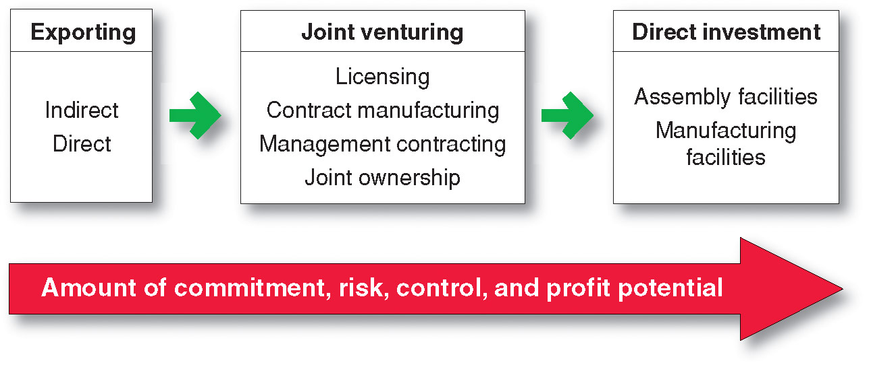
Exporting is when the company produces its goods in the home country and sells them in a foreign market. It is the simplest means involving the least change in the company’s product lines, organization, investments, or mission.
Indirect exporting involves working through independent international marketing intermediaries.
- Less involvement, less risk
Direct exporting is when the firm handles its own exports.
- Greater involvement, greater risk, greater potential return
- Can be done through:
  - Set up a domestic export department
  - Set up an overseas sales branch
  - Send home-based sales people abroad
  - Export through foreign-based distributors or agents
Joint venturing is when a firm joins with foreign companies to produce or market products or services
- Licensing
- Contract manufacturing
- Management contracting
- Joint ownership
Joint venturing differs from exporting in that the company joins with a host country partner to sell or market abroad

