1st Objectives
- Functional areas of operation
- Business process vs business function
- Kinds of data that each main functional area produces
- Kinds of data that each main functional area needs
- Integrated information systems and why they are important
Chapter 1
Introduction
Enterprise Resource Planning (ERP) programs: Core software used by companies to coordinate information in every area of business
- Help manage companywide business processes
- Use common database and shared management reporting tools
Business process: Collection of activities that takes some input and creates an output that is of value to the customer
Functional Areas of Operation
1- Marketing and Sales (M/S)
2- Supply Chain Management (SCM)
3- Accounting and Finance (A/F)
4- Human Resources (HR)
Business functions: Activities specific to a functional area of operation
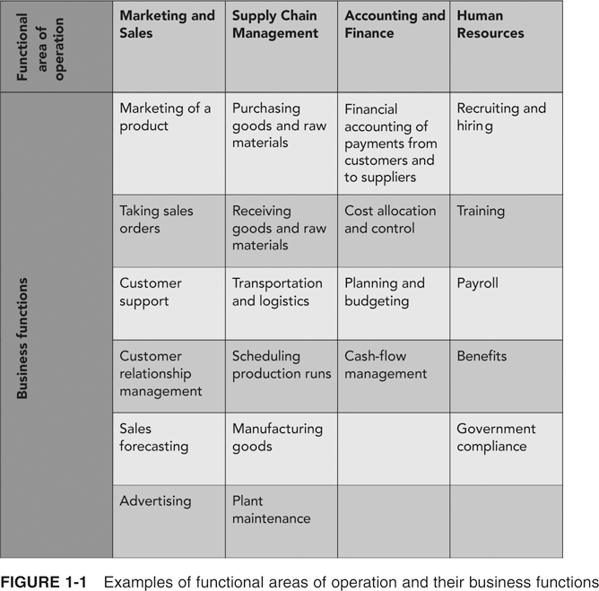
- Functional areas are interdependent – They each require data from each other. Integration also contributes to improvements in communication and workflow. Each area’s information system depends on data from other functional areas.
- Better integration leads to better CCC (coordination, collaboration, and cooperation)
- Information system (IS): Computers, people, procedures, and software that store, organize, and deliver information
Business Processes
- Collection of activities that takes one or more kinds of input and creates an output that is of value to customer. The customer for a business process may be a traditional external customer (the person who buys the finished product), or it may be an internal customer (such as a colleague in another department).
- Thinking in terms of business processes helps managers to look at their organization from the customer’s perspective
Functional Area Information Systems
- Businesses take inputs (resources) in the form of material, people, and equipment, and transform these inputs into goods and services (outputs) for customers.
- Effectively managing these inputs and business processes requires accurate and up-to-date information. Example, A Pull System
- Information systems maintain relationships between all functional areas and processes
Marketing
- Inputs for Marketing and Sales: Customer data, Order data, Sales trend data, Per-unit cost, and Company travel expense policy
- Outputs for Marketing and Sales: Sales strategies, Product pricing, and Employment needs
Supply Chain
- inputs for Supply Chain Management: Product sales data, Production plans, Inventory levels, Layoff and recall company policy
- Outputs for Supply Chain Management: Raw material orders, and Packaging orders, Resource expenditure data, Production and inventory reports, and Hiring information
Accounting and Finance
- inputs for Accounting and Finance: Payments from customers, Accounts receivable data, Accounts payable data, Sales data, Production and inventory data, and Payroll and expense data
- Outputs for Accounting and Finance: Payments to suppliers, Financial reports, and Customer credit data
Human Resources
- inputs for Human Resources could include the following: Personnel forecasts, and Skills data
- Outputs for Human Resources could include the following: Regulation compliance, Employee training and certification, Skills database, and Employee evaluation and compensation

2nd Objective
- Identify the factors that led to the development of Enterprise Resource Planning (ERP) systems
- Describe the distinguishing modular characteristics of ERP software
- Discuss the pros and cons of implementing an ERP system
After completing this chapter, you will be able to:
- Identify the factors that led to the development of Enterprise Resource Planning (ERP) systems
- Describe the distinguishing modular characteristics of ERP software
- Discuss the pros and cons of implementing an ERP system
- Summarize ongoing developments in ERP
Introduction
- Efficient, integrated information systems are very important for companies to be competitive
- An Enterprise Resource Planning (ERP) system can help integrate a company’s operations
  - Acts as a company-wide computing environment
  - Includes a database that is shared by all functional areas
  - Can deliver consistent data across all business functions in real time
The Evolution of Information Systems
- Silos:
  - Information systems configuration used until recently
  - Companies had unintegrated information systems that supported only the activities of individual business functional areas
- Current ERP systems evolved as a result of:
  - Advancement of hardware and software technology
  - Development of a vision of integrated information systems
  - Reengineering of companies to shift from a functional focus to a business process focus
ERP Software Emerges: SAP and R/3
- SAP’s goals:
- Develop a standard software product that could be configured to meet the needs of each company
- Data available in real time
- Users working on computer screens, rather than with voluminous printed output
SAP ERP Software Implementation
- Not all companies that use SAP use all of the SAP ERP modules
- Company’s level of data integration is highest when it uses one vendor to supply all of its modules
- Configuration options allow the company to customize the modules it has chosen to fit the company’s needs
- Features of SAP ERP
  - First software that could deliver real-time ERP integration
  - Usability by large companies
  - High cost
  - Automation of data updates
  - Applicability of best practices
    - Best practices: SAP’s software designers choose the best, most efficient ways in which business processes should be handled
The Significance and Benefits of ERP Software and Systems
- More efficient business processes that cost less than those in unintegrated systems
- Easier global integration
- Integrates people and data while eliminating the need to update and repair many separate computer systems
- Allows management to manage operations, not just monitor them
- Can dramatically reduce costs and improve operational efficiency
Questions about ERP
How much does an ERP system cost?
- For a Fortune 500 company, software, hardware, and consulting costs can easily exceed $100 million. Large companies can also spend $50 million to $100 million when it is time to upgrade to a newer version of their ERP software.
- Size of the ERP software corresponds to the size of the company it serves
- Need for new hardware that is capable of running complex ERP software
- Consultants’ and analysts’ fees
- Time for implementation causes disruption of business
- Training costs both time and money
Should every business buy an ERP package?
- Some of a business’s operations, and some segments of its operations, might not be a good match with the constraints of ERP
- Sometimes, a company is not ready for ERP
- ERP implementation difficulties result when management does not fully understand its current business processes and cannot make implementation decisions in a timely manner
Is ERP software inflexible?
- Many people claim that ERP systems, especially the SAP ERP system, are rigid
- Options for customization offered by SAP ERP
  - Numerous configuration options that help businesses customize the software to fit their needs
  - Programmers can write specific routines using Advanced Business Application Programming (ABAP)
- Once an ERP system is in place, trying to reconfigure it while retaining data integrity is expensive and time-consuming
What return can a company expect from its ERP investment?
- ERP eliminates redundant efforts and duplicated data; can generate savings in operations expense
- ERP system can help produce goods and services more quickly
- Company that doesn’t implement an ERP system might be forced out of business by competitors that have an ERP system
- Smoothly running ERP system can save a company’s personnel, suppliers, distributors, and customers much frustration
- Cost savings and increased revenues occur over many years
  - Difficult to put an exact dollar figure to the amount accrued from the original ERP investment
- ERP implementations take time
  - Other business factors may be affecting the company’s costs and profitability
  - Difficult to isolate the impact of the ERP system alone
- ERP systems provide real-time data
  - Improve external customer communications
How long does it take to see a return on an ERP investment?
- Return on investment (ROI): assessment of an investment project’s value
  - Calculated by dividing the value of the project’s benefits by the project’s cost
- ERP system’s ROI can be difficult to calculate
- Peerstone Research study shows that 63% of companies that performed the calculation reported a positive ROI for ERP, and most companies felt that nonfinancial goals were the reason behind their ERP installations
Why do some companies have more success with ERP than others?
- Usually, a bumpy rollout and low ROI are caused by people problems and misguided expectations, not computer malfunctions
  - Executives blindly hoping that new software will cure fundamental business problems that are not curable by any software
  - Executives and IT managers not taking enough time for a proper analysis during planning and implementation phase
  - Executives and IT managers skimping on employee education and training
  - Companies not placing ownership or accountability for the implementation project on the personnel who will operate the system
  - Unless a large project such as an ERP installation is promoted from the top down, it is doomed to fail
  - ERP implementation brings a tremendous amount of change for users
- For many users, it takes years before they can take advantage of many of an ERP system’s capabilities
- Most ERP installations do generate returns
Customer Relationship Management
- Companies without a good connection between their workers and their customers run the risk of losing business
- Customer relationship management (CRM) software can help companies streamline their interactions with customers
- On-demand CRM: software and computer equipment reside with CRM provider
Core CRM Activities
- One-to-one marketing, Sales force automation (SFA), Sales campaign management, Marketing encyclopedias, and Call center automation
SAP’s CRM Software
- Examples of tools that provide CRM functionality within the SAP ERP system
  - Contact management tool: To make sure that information about sales contacts is available throughout the organization
  - Sales activity manager: Supports a strategic and organized approach to sales activity planning and can help make sure that follow-up activities are accomplished
- Employing a separate CRM system that communicates with the ERP system
- SAP ERP system processes business transactions and provides much of the raw data for CRM
- SAP’s Business Warehouse: system for reporting and analysis of transactional data
- Advanced Planner and Optimizer (APO): system that supports efficient planning of the supply chain
- SAP’s view of CRM is to provide a set of tools to manage the three basic task areas, or jobs:
  - Marketing, sales, and service
- Four phases of the cultivation of customer relationship:
  - Prospecting, Acquiring, Servicing, and Retaining
- Contact Channels
- Marketing and Campaign Management
- Campaign Execution Activity Management
- Campaign Analysis tool

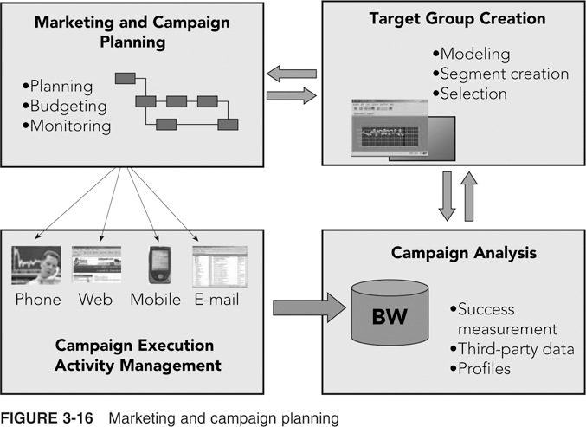
The Benefits of CRM
- Lower costs
- Higher revenue
- Improved strategy and performance measurement
3rd Objective
- Steps in the production planning process
- How a structured process for Supply Chain Management planning enhances efficiency and decision making
- How production planning data in an ERP system can be shared with suppliers to increase supply chain efficiency
Production Overview
- Three general approaches to production
  - Make-to-stock items: made for inventory (the “stock”) in anticipation of sales orders
  - Make-to-order items: produced to fill specific customer orders
  - Assemble-to-order items: produced using a combination of make-to-stock and make-to-order processes
The Production Planning Process
- Three important principles for production planning:
  - Work from sales forecast and current inventory levels to create an “aggregate” (“combined”) production plan for all products
  - Break down aggregate plan into more specific production plans for individual products and smaller time intervals
  - Use production plan to determine raw material requirements
The SAP ERP Approach to Production Planning
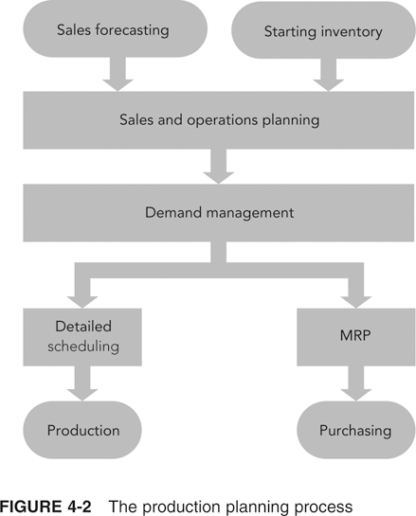
Sales Forecasting
- SAP’s ERP system takes an integrated approach
- Whenever a sale is recorded in Sales and Distribution (SD) module, quantity sold is recorded as a consumption value for that material
- Simple forecasting technique
- Use a prior period’s sales and then adjust those figures for current conditions
- To make a forecast for Fitter Snacker:
- Use previous year’s sales data in combination with marketing initiatives to increase sales
Sales and Operations Planning
- Sales and operations planning (SOP)
- Input: sales forecast provided by Marketing
- Output: production plan designed to balance market demand with production capacity
    - Production plan is the input to the next step, demand management
- In SAP ERP, sales forecast can be made using:
  - Historical sales data from the Sales and Distribution (SD) module
  - Input from plans developed in Controlling (CO) module
- CO module
  - Profit goals for company can be set
  - Sales levels needed to meet the profit goals can be estimated
- Rough-cut planning: common term in manufacturing for aggregate planning
  - Disaggregated to generate detailed production schedules
- Once SAP ERP system generates a forecast, the planner can view the results graphically
- Rough-cut capacity planning applies simple capacity-estimating techniques to the production plan to see if the techniques are feasible
- Disaggregating the sales and operations plan
  - Companies typically develop sales and operations plans for product groups
  - SAP ERP system allows any number of products to be assigned to a product group
  - Sales and operation plan disaggregated
    - Production plan quantities specified for the group are transferred to the individual products that make up the group
Demand Management
- Links the sales and operations planning process with detailed scheduling and materials requirements planning processes
- Output: master production schedule (MPS)
  - Production plan for all finished goods
- For Fitter Snacker, MPS is an input to detailed scheduling, which determines what bars to make and when to make them
Materials Requirements Planning (MRP)
- Determines required quantity and timing of the production or purchase of subassemblies and raw materials needed to support MPS
- Bill of material (BOM): list of the materials (including quantities) needed to make a product
- Lead times and lot sizing
  - Lead time: cumulative time required for the supplier to receive and process the order, take the material out of stock, package it, load it on a truck, and deliver it to the manufacturer
  - Lot sizing: determining production quantities and order quantities
- MRP record: standard way of viewing the MRP process on paper
- MRP list shows results of MRP calculations
- MRP process creates planned orders to meet dependent requirements
- Stock/Requirements List shows:
  - Planned orders
  - Purchase requisitions (PurRqs)
  - Purchase orders (POitem)
- Planner can convert a planned order to a purchase order from Stock/Requirements List by double-clicking the planned order line
- Integrated information system allows Purchasing to make the best decision on a vendor based on relevant, up-to-date information
- Once Purchasing employee decides which vendor to use, the purchase order is transmitted to vendor
  - System can be configured to fax order to vendor, transmit it electronically through EDI (electronic data interchange), or send it over the Internet
Detailed Scheduling
- Detailed plan of what is to be produced, considering machine capacity and available labor
- One key decision in detailed production scheduling
  - How long to make the production runs for each product
  - Production run length requires a balance between setup costs and holding costs to minimize total costs to the company
- Fitter Snacker uses repetitive manufacturing
- Repetitive manufacturing environments usually involve production lines that are switched from one product to another similar product
  - Production lines are scheduled for a period of time, rather than for a specific number of items
- Production runs should be decided by evaluating the cost of equipment setup and holding inventory
- Integrated information system simplifies this analysis
  - Automatically collects accounting information that allows managers to better evaluate schedule trade-offs in terms of costs to company
Providing Production Data to Accounting
- In the manufacturing plant, ERP packages do not directly connect with production machines
- Data can be entered into SAP ERP through a PC on the shop floor, scanned by a barcode reader, or entered using a wireless PDA
- Radio frequency identification (RFID) technology simplifies data collection
- In an integrated ERP system, the accounting impact of a material transaction can be recorded automatically
- Once FS accepts shipment, Receiving must notify SAP ERP system of the arrival and acceptance of the material
  - Goods receipt transaction
- Receiving department must match goods receipt with purchase order that initiated it
- When receipt is successfully recorded, SAP ERP system immediately records the increase in inventory levels for the material
ERP and Suppliers
- Fitter Snacker is part of a supply chain
  - Starts with farmers growing oats and wheat
  - Ends with a customer buying an NRG bar from a retail store
- ERP systems can play a key role in collaborative planning
- Working with suppliers in a collaborative fashion requires trust among all parties
  - Company opens its records to its suppliers
  - Suppliers can read company’s data because of common data formats
- Advantages
  - Reductions in paperwork
  - Savings in time
  - Other efficiency improvements
The Traditional Supply Chain
- Supply chain: all activities that occur between the growing or mining of raw materials and the appearance of finished products on the store shelf
- Traditional supply chain
  - Information is passed through the supply chain reactively as participants increase their product orders
  - Inherent time lags cause problems
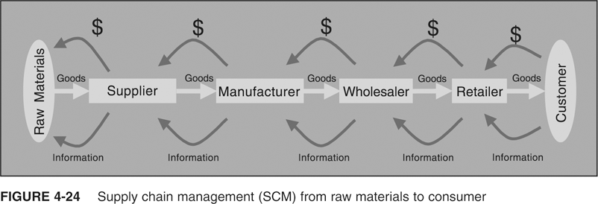
- EDI and ERP
  - Before ERP systems were available, companies could be linked with customers and suppliers through electronic data interchange (EDI) systems
  - Well-developed ERP system can facilitate SCM
    - Needed production planning and purchasing systems already in place
  - With ERP system, sharing production plans along the supply chain can occur in real time
The Measures of Success
- Performance measurements
- Metrics, and Show the effects of better supply chain management
- Cash-to-cash cycle time
- Time between paying for raw materials and collecting cash from customer
- SCM costs
- Include cost of buying and handling inventory, processing orders, and information systems support
- Initial fill rate
- Percentage of the order that the supplier provided in the first shipment
- Initial order lead time
- Time needed for the supplier to fill the order
- On-time performance
- If supplier agreed to requested delivery dates, tracks how often supplier actually met those dates

