Vision Essentials
Properties of Light
- Light travels as a wave
- Amplitude – the height of each wave
  - Greater the amplitude, more light reflected, object appears brighter
- Wavelength – the distance between peaks
  - Variations affect colour perception
  - Smaller wavelengths = higher frequency
  - Larger wavelengths = lower frequency
    - We can see from 360(violet)-750nm(red), “visible spectrum”
    - Ultraviolet spectrum < 360 nm, bees can see this
    - Infrared spectrum > 750 nm, snakes can see this
- Purity – affects perception of saturation or richness of the colours
  - Light made of a single wavelength = pure light. Perceived colour = completely saturated
  - What we usually see is a mixture of wavelengths = desaturated

Physical Light Property | Our Psychological Perception
Amplitude | Brightness
Wavelength | Colour
Purity | Saturation

The Eye
- light passes through cornea – begins focusing process
- light passes through pupil
- light passes through the lens
- light passes through vitreous humor
- light finally lands on retina
Eye Part | Description
Cornea | Transparent window at front of the eye. Does much of the work, roughly 80% of the focusing power of the eye.
Sclera | White part of the eye, tougher membrane
Pupil | Round window seen as a black dot, in the centre of your eye
Iris | Controls the size of your pupil. Consists of a band of muscles controlled by the brain. If not enough light, pupil dilates, if too much light, pupil constricts.
Lens | Transparent structure that does the final focusing of light onto the retina at the back of the eye
Vitreous Humor | Clear jelly-like substance that comprises most of the inside of the eye chamber
Retina | Neural tissue that lines the back of the eye
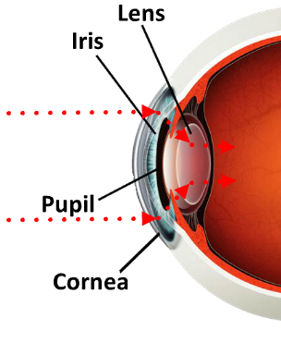
The Lens
- curvature of lens causes image to be shown upside-down and reversed, but the brain fixes this mistake
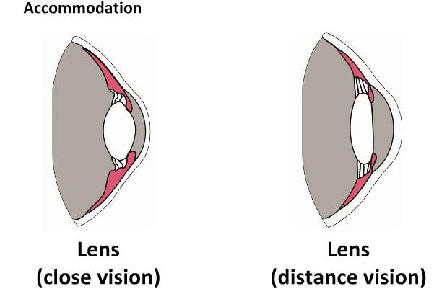
- the lens is a flexible piece of tissue, can be altered by muscles
- when looking at something nearby, lens gets fatter and rounder
- when looking at something far away, lens gets thinner and elongated

This change in shape of lens to focus is called accomadation.

The Retina
- physical stimulus of light is first translated into neural impulses
- retina is a paper thin sheet that covers the back of the eye
- has 3 layers of complex network of neural cells

Retinal Layer 1 – Photoreceptors
- layer at the very back of the of the eye
- responsible for translating physical stimulus of light into neural signal brain can understand
- photoreceptors are near the retina because that’s where they get their nutrients from, which is a layer of cells at the back of the eye called retinal pigment epithelium(RPE)
- without the RPE the photoreceptors would die

Photoreceptors – Rods and Cones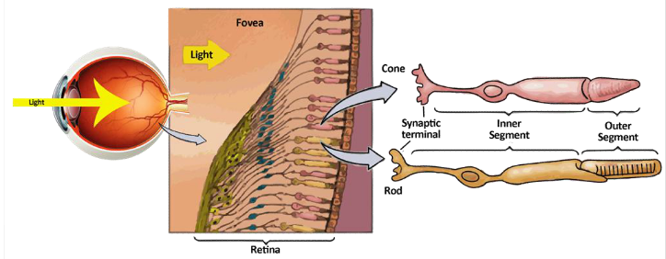
- Rods
  - 125 million
  - lower light intensity, night vision
  - can’t distinguish colour
  - poor visual acuity
  - increased arrangement surrounding the fovea, the periphery
  - good for periphery vision
- Cones
  - 6 million
  - used for high light intensities, day vision
  - can distinguish colour
  - good visual acuity(sharpness of detail)
  - concentrated in fovea (tiny spot in the middle of the retina)
  - can see well close up with good acuity

Bipolar and Ganglion Cells
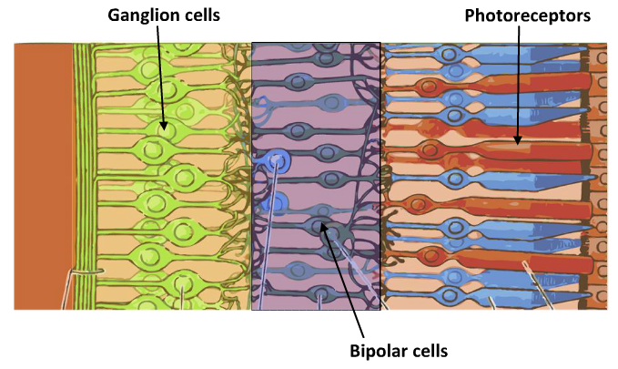
- photoreceptors send information to the next layer of cells in the retina called bipolar cells
- then, bipolar cells send their information to the next layer, the ganglion cells
- the ganglion cells collect info from a larger segment of the retina, and the axons of all these cells converge on one point in the eye, the optic disc, which leaves the eye and joins the optic nerve, which travels to the brain
- the optic disc has no photoreceptors, therefore it is our blind spot

Summary
- light enters eye
- passes ganglion cells, bipolar cells, and strike photoreceptors on retina
- light converted to a neural signal
- sent from photoreceptors to bipolar cells to ganglion cells whose axons make up the optic nerve

Overview of Light Through Retina
Processing in the Retina
- horizontal cells and amacrine cells are cells in the retina that allow areas within a retinal layer to communicate with each other
- allow info from nearby photoreceptors to combine their info
- info from over 130 million rods and cones travel along only 1 million axons in the optic nerve
- some of the visual processing is done before signal is sent to the brain

Receptive Field in the Retina
- think of photoreceptors in retina being divided into groups, and information from each group is put together to make 1 signal that affects the ganglion cell down the line
- in the fovea, the photoreceptor “group” for a specific ganglion cell represents a small area of the image
- since each cone in the fovea is directly linked to the brain, a lot of the detail is preserved and more visual sharpness occurs in the fovea
- more often, input from many rods and cones is combined into one neural signal for one retinal ganglion cell
- the groups get larger as we move towards the periphery of the eye
- the collection of rods and cones in the retina that when stimulated affects the firing of a particular ganglion cell is called the receptive field of that retinal ganglion cell
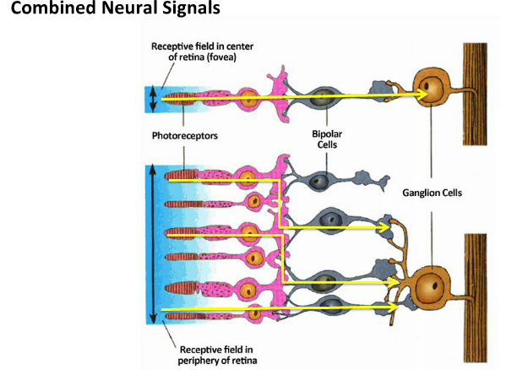

Conclusion:

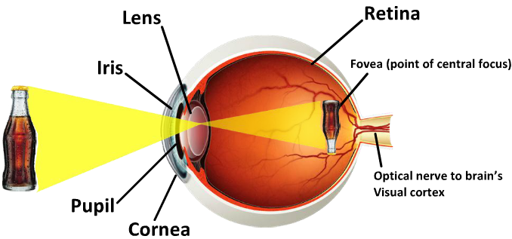

Visual Pathways
Visual Fields and Hemispheres
- right and left halves of our visual field are actually processed by the contralateral side of our brain
- visual input from right visual field travels along optic nerve to left hemisphere and visual input from left visual field travels along optic nerve to the right hemisphere
- a visual field sends info to both eyes, each hemisphere receives info from both eyes
- before reaching their respective hemispheres, the axons from the inner region(nasal) of each retina, have to cross over to the opposite hemisphere
- the point at which the optic nerves from the inside half of each eye cross over to the opposite hemisphere is called the optic chiasm
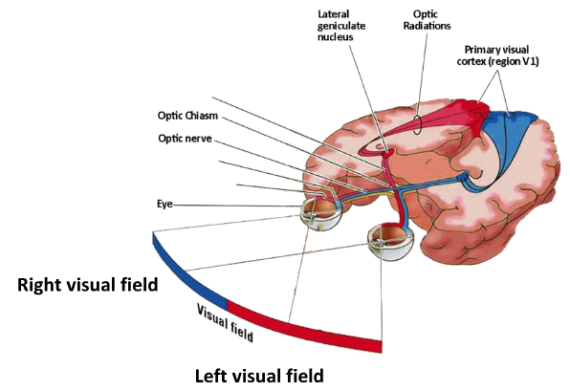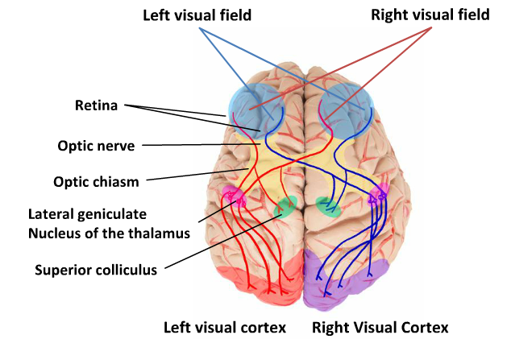

- info from each visual field arrives in opposite hemisphere, at which point, optic nerve fibres split and travel along two pathways
- most of the retinal or ganglion cell axons travel along the main pathway and synapse in the lateral geniculate nucleus(LGN), part of the thalamus that receives visual info
- after being processed there, visual signals are sent to areas in the occipital lobe that make up the primary visual cortex

Main Pathway: Occipital Lobe
- over 20 cortical areas that process visual information, but most of the research done on visual processing concentrated on area V1 of occipital lobe aka primary visual cortex
- visual processing areas in the occipital lobe outside of the striate cortex are known as the extrastriate cortex

Primary Visual Cortex
- the receptive field of the LGN is made up of many ganglion cells
- receptive field of a single V1 cell is a combination of the receptive fields of many LGN cells

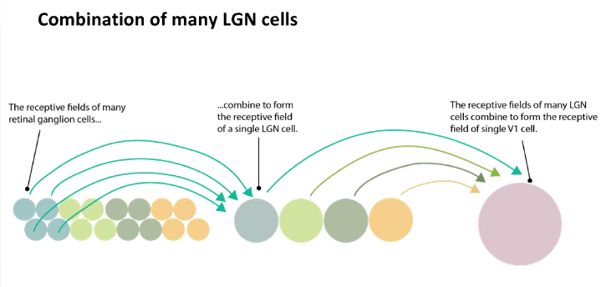
- receptive fields from the retina are arranged in a topographical map in the primary visual cortex
- large cluster of ganglion cells feeds into one V1 cell
- neighbouring locations in the retina project to neighbouring locations in the visual cortex

Dorsal and Ventral Streams of the Extrastriate Cortex
Two Streams for Processing Information:
Dorsal Stream
- The “where pathway” – processes where objects are
- Depth and motion
- From the extrastriate cortex to the parietal lobe
Ventral Stream
- The “what pathway” – what the object is
- Colour and form
- From the extrastriate cortex to the temporal lobe
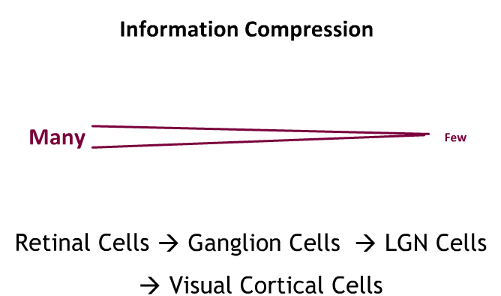

- Fewer as the arrows go down

Evolution of the Eye
Light Sensitive Patch – what worms and jellyfish have
Curved “Cup” Eye – what clams have, direction of light can be sensed
Crude Lens – process visual input at different distances
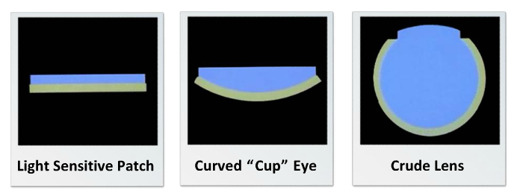

Cumulative Selection:
- small changes were made to the existing eye, and then new small changes were made to the modified eye, increasing sophistication of the eye
- an evolutionary process wherby new adaptations are layered upon old adaptations

Costs and Benefits of the Eyes:
- in order for an organ to evolve any modification must outweigh the metabolic costs to the system of growing and maintaining the modification
- survival and reproductive advantages seem obvious
- makes it easier for individuals to find food, shelter, a mate, avoid predators, and other dangers

Different Eye Designs for Different Environments
Compound Eyes
- found in insects and crabs
- eyes made up on an arrangement of individual tubular units called ommatidia
  - that each point in a slightly different direction to gather the light that lays directly in front of it
- good at detecting movement, but only at a close distance
Simple Eye
- vertebrates and molluscs(squid, octopus)
- eyeball, lens, retina

Size of Eyes
- Two functions of the eyes:
  - Resolution(acuity)
  - Sensitivity(ability to get enough light)
- Larger eyes better at both, bigger eyes in species that need better eyesight

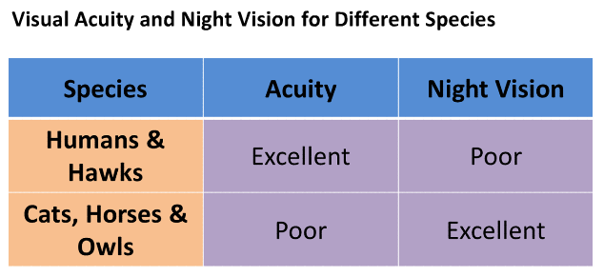

Eye Placement
- Laterally directed eyes
  - Eyes on either side of head
  - excellent total view, can scan for predators without having to turn head
  - two separate fields of view
  - Depth perception is poor
- Field of View
  - Eyes directed towards the front
  - Narrow total view
  - Single field of view
  - Lots of binocular overlap, so excellent depth perception

Eye Development
- Least developed sense at birth
  - 2nd prenatal month – eyes formed
  - 6th prenatal month – reacts to light, random firing of retinal cells
- Newborn Period
  - Weak lens muscles
  - Single field of view
  - Immature photoreceptors
  - Very low acuity
  - Inconsistent pupil reaction
- By 3 Months
  - Almost adult – like focusing

Immaturities in the Brain
- Low cell density in retina
- Cells are immature, especially in the fovea
- By 11 years – visual brain area development complete

Visual Infant Acuity
- At birth, visual acuity poor, details that a newborn can see at 20 feet same as adult at 600 feet
- 6 months, baby 20 feet, adult 100 feet
- one year, close to adult levels
- don’t full reach adult acuity until 4-6 years of age

