Assignment 2: Practicing with Functions, Loops, and Random Variables

Name: Sarah Zayoun
Date: February 17th 2012
T.A.: Mounib Khanafer
Step 1
A program shall be created to play two games. The first one is to guess the number first then roll the two dice. The second game is to guess a number that is randomized by the computer.
Step 2
Program product
Game
User Input
Game Number

Program
Correct
Too High
Too Low
User Input
Game

Algorithm
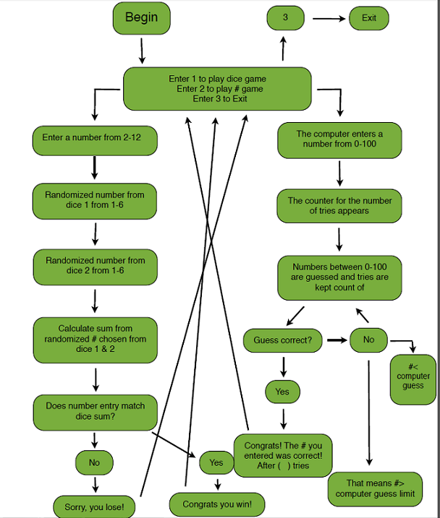

Pseudo Code

Main function
Repeat
Print choose 1 for dice game or 2 for guessing game
Read value into userInput
If userinput=1
Read dice function
Else
Read guessing game function
Else
Exit

Dice function
Read value into userInput
Print”Enter a number from 2 to 12 ”
Read random value into dice1 and dice 2
Assign dice1+dice2 each from a number between 1 and 6
If userInput=totalNumber
Print “you won”
Else
Print “you lose”

Guessing game function
repeat

Read value into userInput, computerassigned number and tries
Assign # to tries
Assign random to computerassignedNumber
Print”Guess a number between 0 and 100”
If userInput>computerassignednumber
Print”too high”
Else
Print”too low”
While userInput=/=computerassigned number
Print “number of tries” Congratulations! You won!

Implimentation
#include <stdio.h>
#include <stdlib.h>
#include <time.h>

//main function
void main ()
{
int userInput;
do {

void dice(void);
void guessingGame(void);

printf("Enter 1 to play the dice game.\nEnter 2 to play the Guess the number Game.\nEnter 3 to Exit this program:\n ");
scanf("%d", &userInput);

if(userInput==1)
dice();

else if(userInput==2)
guessingGame();

} while(userInput!=3);

}

//dice function
void dice ()

{
//The chosen number between 2-12
int userInput;
printf("Enter a number of your choice between 2 and 12: \n");
scanf("%d", &userInput);

int dice1,dice2;
//Rolling the Dice and the results
dice1=1+rand()%6;
dice2=1+rand()%6;

int totalNumber;
totalNumber=dice1+dice2;
printf("------------->>>> %d\n", totalNumber);
//The concluding statement of the game
if(userInput==totalNumber)
printf("Congratulations, You win! \n");

else
printf("Sorry, You lose this round.\n");

}

//Guessing the Randomized number game

void guessingGame ()

{
int userInput, computerNumber, tries;
tries=0;
srand(time(0));
computerNumber=0+rand()%101;
while(userInput!=computerNumber)
{

tries++;

//guessing the number randomly chosen
printf("The computer has randomly selected a number between 0-100 Can you guess what number it is?: \n");
scanf("%d", &userInput);

printf("Enter Guess%d:\n", tries);

//results if too high, too low, or correct
if (userInput>computerNumber)
printf("too high\n");

if(userInput<computerNumber)
printf("too low\n");

} printf("Congrtatulations.The number you entered was correct after %d: tries \n", tries);

}

Verification

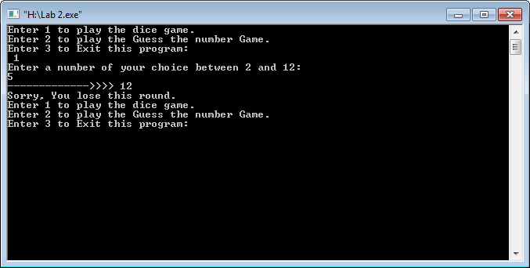
Dice Game:

Guessing Game:

Guessing Game:
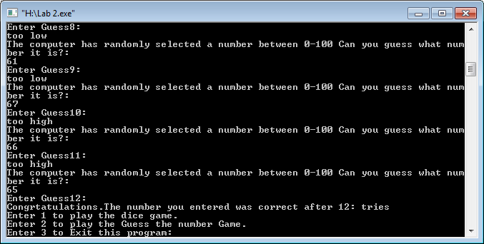

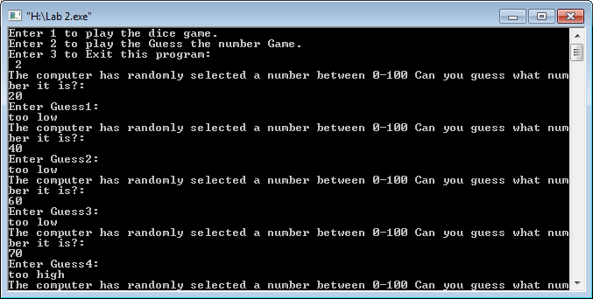

Exit:

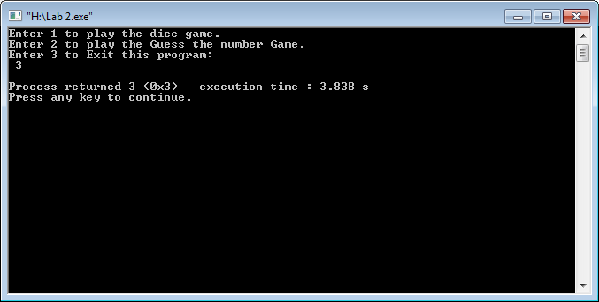
Exit:

