Experiment 1: Thin Layer Chromatography

By:

CHM 1321

Lab TA:

Date

University of Ottawa

Procedure:
Part A: identifying the components of an unknown mixture using TLC
- 10 mL of 2:8 mixture of ethyl acetate and hexanes was added to the developing jar
- Approximately 10 mg of unknown compound sample number 64 was added to 2 mL of
- dichloromethane
- Sample was spotted as small as possible in the sample and co-spot lane of two TLC’s
- 2 mL of the reference sample benzophenone was placed in another test tube and spotted as small as possible on the reference and co-spot lane of one of the TLC’s
- 2 mL of the reference sample biphenyl was placed in another test tube and spotted as small as possible on the reference and co-spot lane of the other TLC’s
- Both TLC’s were placed in separate developing jars and were left there until the solution reached around 1 cm from the top of the TLC plate.
- The visible spots were circled and then the R_{f} values were calculated.
Part B: Effect of solvent on TLC
- Using the same steps as above, more TLC’s were prepared using two different solutions in the developing jar.
- TLC plates were treated and the differences in the developing jar solutions could be seen under the UV light
Part C: Ratio of compounds
- Vial labeled XX was taken and used as the sample that was used to compare to reference compounds to figure out what compound was in the unknown compound
- Pictures of the TLC’s were taken in order to compare the percent composition of the sample
Observations:
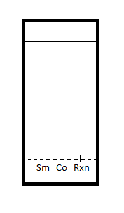
Figure: 1
Figure: 2
Solvent systems:
Ethyl acetate: hexane 2:8
Diol Product:
R_{f} = 0.87
Sample:
#64 with biphenyl
Solvent systems:
Ethyl acetate: hexane 2:8
Diol Product:
R_{f} = 0.75 R_{f} =0.56
Sample:
#64 with benzophenone

Figure: 4
Figure: 3

Solvent systems:
Ethyl acetate
Diol Product:
R_{f} = 0.86
Sample:
#64 with benzophenone
Solvent systems:
Ethyl acetate
Diol Product:
R_{f} = 0.88
Sample:
#64 with biphenyl

Figure: 6
Figure: 5

Solvent systems:
Hexane
Diol Product:
R_{f} =0.80 R_{f} = 0.11
Sample:
#64 with benzophenone
Solvent systems:
Hexane
Diol Product:
R_{f} = 0.47
Sample:
#64 with biphenyl

Figure: 8
Figure: 7

Solvent systems:
Ethyl acetate: Hexane 9:1
Diol Product:
R_{f} =
Sample:
XX with ORTO
Solvent systems:
Ethyl acetate: Hexane 8:2
Diol Product:
R_{f} =
Sample:
XX with ORTO

Figure: 10
Figure: 9

Solvent systems:
Ethyl acetate: Hexane 9:1
Diol Product:
R_{f} =
Sample:
XX with PAMA
Solvent systems:
Ethyl acetate: Hexane 9:1
Diol Product:
R_{f} =
Sample:
XX with META

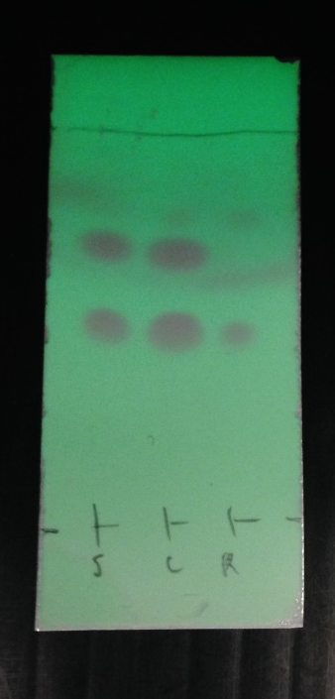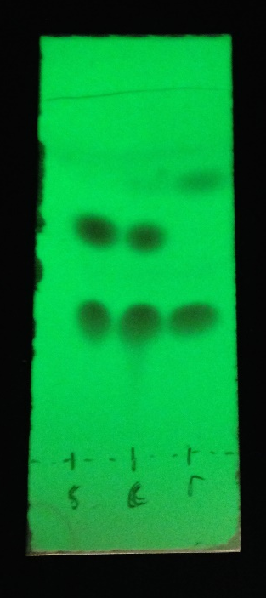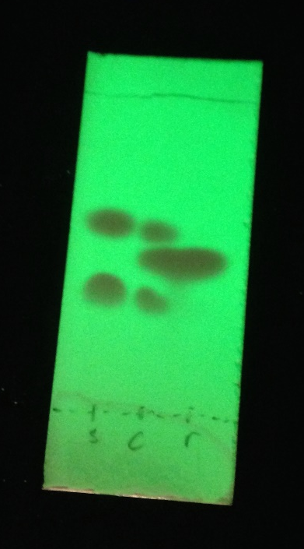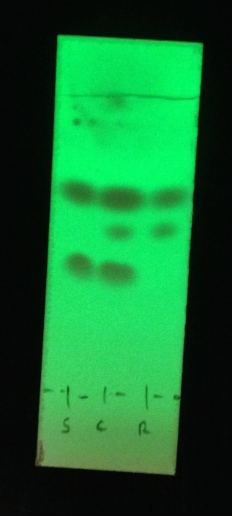
ORTO ORTO META PAMA

Calculations:

Discussion:
-For part A unknown sample 64 must be biphenyl. When ran on the same TLC plate, they came up with the exact same R_{f} value. This means that the unknown sample must contain buphenyl and because there was only one point in each of the columns then that means that the unknown sample is likely to be biphenyl or another molecule with the same polarity as biphenyl. When tested next to the benzophenone, the R_{f} values did not match up, which tells us that we can be sure that that is not in the unknown sample.
- this similarity in R_{f} values is due to the polarity of the molecule, just because the two tests came up with the same R_{f} doesn’t prove that it is the same molecule, it only proves that it is the same polarity. This could mean that the unknown sample could be something different however they both have the same substituents.
- in part B, we are testing out the effect of the solute on the TLCs. For one set we used ethyl acetate and for the other, hexane was used. The hexane clearly shows a lower R_{f} value than the ethyl acetate and can be explained due to the difference in polarity as explained in question 1.
-some reasons for error in this experiment include
- It was quite possible that the drops could have been different sizes. There were some capillary tubes that were substantially bigger than others making some of the drops way too big and sometimes even too small. This variation in drop size can change the darkness of the points which when put into Image J, the areas will be affected by that, and therefore the percent composition will also be affected
- The plate was left in too long or not long enough. This could affect the accuracy of your measurements
- The plate may have been touching the side of the developing jar. This could have made the liquid on the inside of the jar get absorbed from the side as well as from the bottom making more dots appear.
- The picture may have been taken where there is a light gradient from the top to the bottom of the TLC. This would affect your results whenever you put it into Image J, you would get more of a sloped line rather than a straight line at the bottom.
When figuring out the percent composition it is an estimate as to what the actual percent composition is. The quality of the picture and the droplet size affect the overall percent composition. The overall percent composition is approximately 55% PAMA and 45% ORTO. This was determined because there was a compound in the PAMA that matched s compound in the sample which made up on average 55% of the sample. Similarly there was a compound in ORTO that matched up to the other compound in the unknown mixture.

Questions:
- Increasing the polarity of the solvent system affects the results of a TLC by attracting polar compounds more than a solvent system that is less polar. This effect makes the slower moving polar compounds move faster up the plate. In other words, increasing the polarity of the solvent system will increases the R_{f} values. Even though this still is not quite as fast as a non-polar compound, this raises the points that you see. As seen in the differences in Figure 3 and Figure 5, the only difference is the solvent system and the points are almost half way further down the TLC when hexane was used as the solvent than when ethyl acetate was used. As ethyl acetate is more polar than hexane mixture then increasing the polarity of the solvent system moves the points further up the TLC.
- A) In the first set of compounds, the compound that would have the smallest R_{f} value would be benzyl alcohol. This is because this compound has an alcohol as a substituent which is higher than the aldehyde of benzaldehyde and the keytone group on the benzyl acetate.

B) In the second set of compounds the aniline would have the smallest R_{f} value. This is because the amine group is more polar than the other substituents on the N,N-dimethylaniline and the naphthalene which doesn’t even have substituents.

C) In the last set of compounds, the most polar compound is the benzoic acid. This is the most polar because it has a carboxylic acid as a substituent while the benzophenone has an aldehyde and the biphenyl is an aromatic. The carboxylic acid is the most polar and therefore the slowest.

Conclusion:
In conclusion, the unknown sample number 64 was found to be biphenyl. Also the more polar the solvent system is, the faster the compound will move up the plate, therefore, the compound will move further up the plate. Finally, by comparison to ORTO, META and PAMA, the unknown sample XX was found to contain approximately 55% PAMA and 45% ORTO.

