Chapter 1 Review Questions:

Lab 01.1 review questions (page 4)

1. d

2. c

3. c

4. a, c

5. c

Lab 01.2 review questions (page 7):

1. b

2. d

3. d

4. False

5. Subnet mask

Lab 01.3 (page 9):

1. b

2. a

3. c

4. d

5. netsh firewall set icmpsetting 8

Lab 01.4 (page 11):

1. b

2. a, b

3. True

4. slmgr.vbs -rearm

5. b

Lab 01.5 review questions (page 12):

1. a

2. a, b

3. False

4. Security Information

5. d

1%)
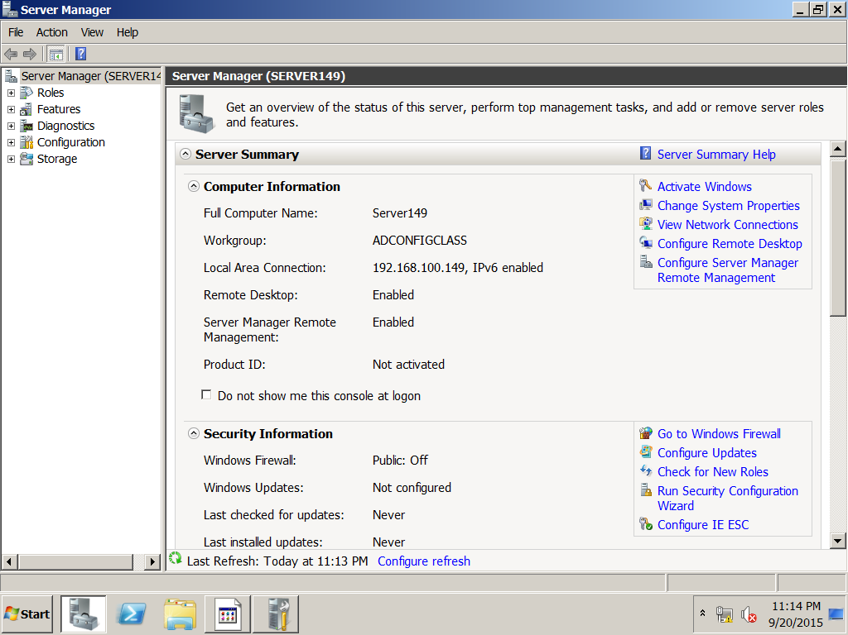
2%)
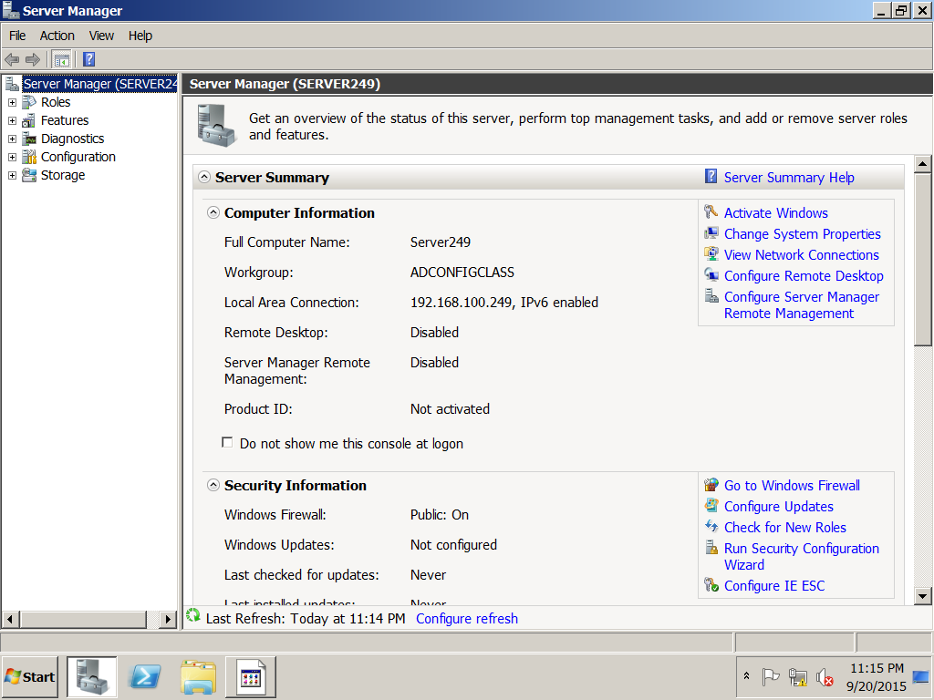

3%)
Server149 snapshot
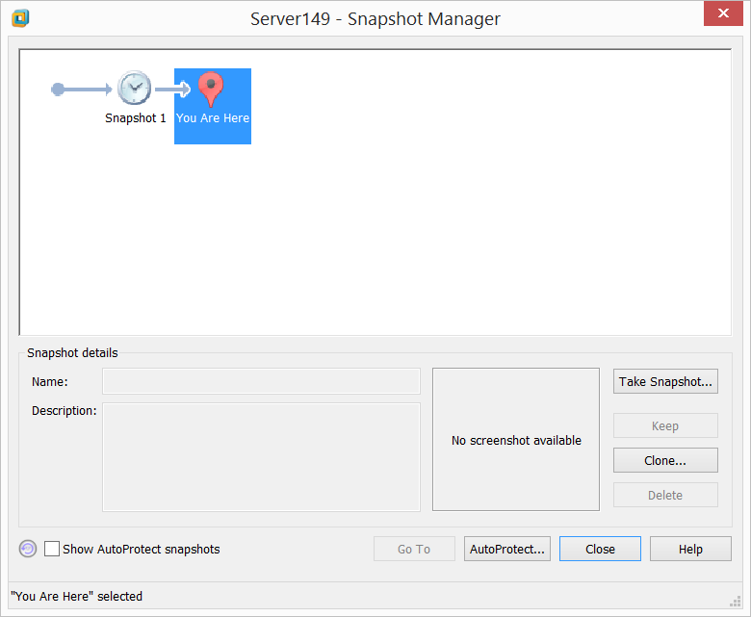
Server249 snapshot
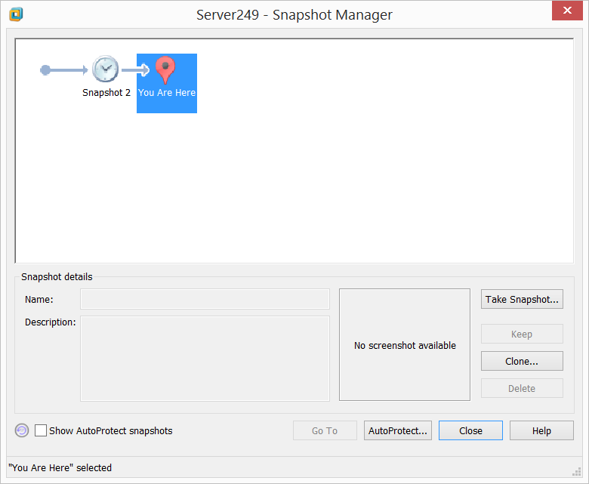

ServerCore49 snapshot
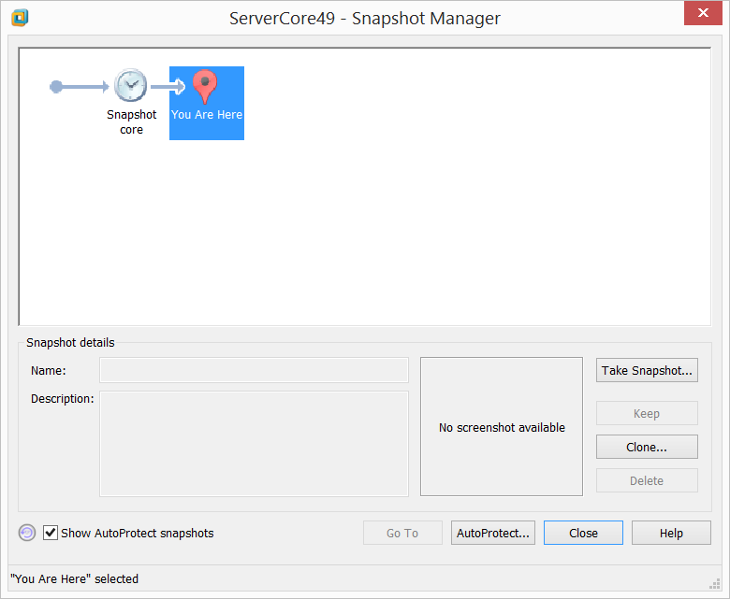
Client49 snapshot
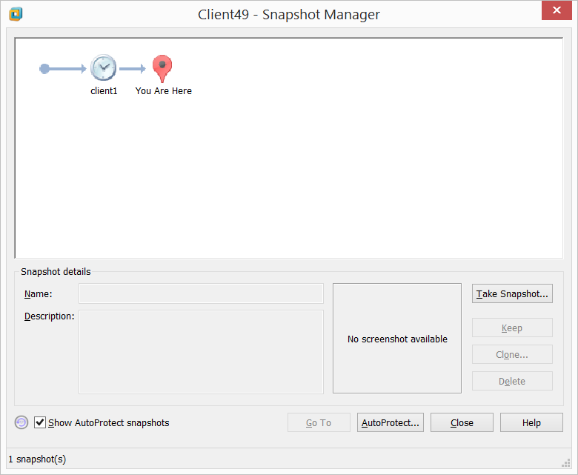

Activity 1.3
%4)
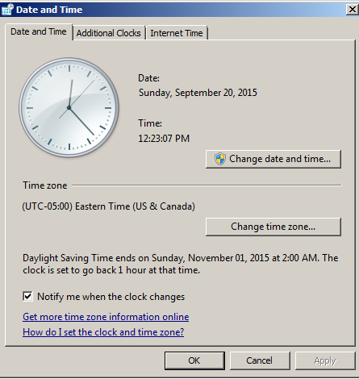

%5)
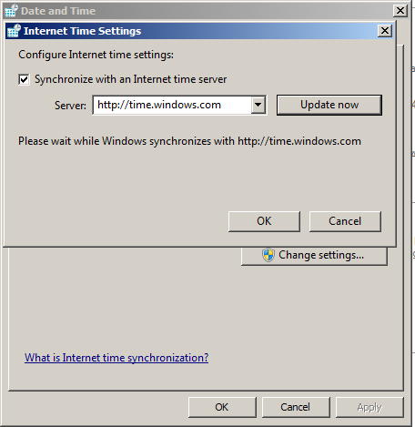
Activity 1.4
%6)
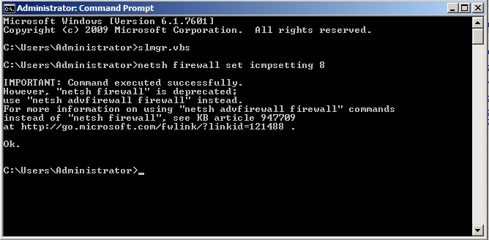

%7)
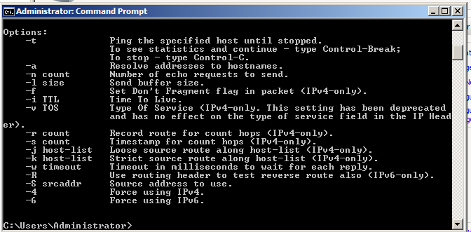
Activity 1.5
%8)
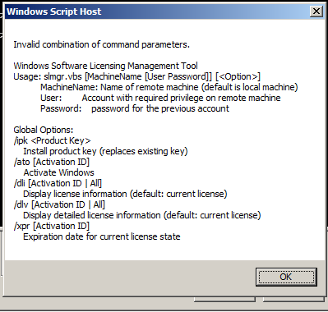

Activity 1.7
%9)


