Acco 240 Chapter.12
April 13, 2015
2:03 PM

Standard costs and balanced scorecard

The need for standards:

- Standards set by government agencies are called Regulations. (Provincial jurisdiction).

- Standards that are established internally by the company can include standards for personnel matters, such as employee absenteeism etc., ethical code of conduct, quality control standards for product and standard costs for goods and services.

- Standard Costs: Predetermined unit cost used as performance measures.

Distinguishing between standards and budgets:

- In theory both are pretty much the same, both are predetermined costs, and both contribute to management planning and control. There is a difference, however in the way the terms are expressed.

- A standard is a per unit amount.

- A budget is a total amount.

Other Differences :

- Except for MOH applied to job and process, budget data are not journalized in cost accounting systems.

- In contrast, as will be illustrated in the appendix to this chapter, standard costs are sometimes used in cost accounting system. Also , a company may report its inventories at standards cost on financial statement , but it would not report inventories at budget costs.

Why standard costs?

Advantages:

- Facilitate management planning
- Promote greater economy by making employees more '' Costs-conscious''
- Help set selling price
- Contribute to management control by providing basis for evaluation of cost control
- Help highlight variances in management by exception
- Simplify costing of inventories and reduce clerical costs.

**All these advantages are only available when standard costs are carefully established and prudently used.

Setting Standard Costs

To be effective in controlling costs, standard costs need to be up- to date at all times. Thus thus standards should be reviewed continuously and changed when they are judged not to be a good performance measurement tool anymore.
Circumstance that could cause the revision standard include: Changed in wage rate, change in product specifications or new manufacturing methods.

Ideal vs. Normal standards

Ideal standards : Represent optimum level of performance under perfect operating conditions.

Normal standards : Represent efficient levels of performance that are attainable under expected operating conditions.

** Normal standard are the most common way used by company. Properly sets the standards are rigorous but attainable. It includes time for; rest periods, machine breakdowns and other '' normal'' contingencies in the production process.

Case study:

Direct materials (Price standard / quantity standard):

DM price standard is the cost per unit of DM that should be incurred.

- This standard should be based on the purchasing department best estimate of cost of raw materials.
- Often based on current price. The standard price should also include an amount for related cost , such as receiving , handling storing….

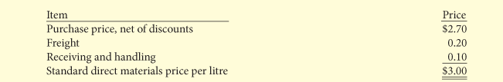

DM materials quantity standard is the quantity of direct materials that should be used per unit of finished goods.

- Expressed as a physical measure
- In setting the standard, management should consider both quality and quantity of materials that are required to manufacture the product.
- The standard should include ; allowance for unavoidable waste and normal spoilage.

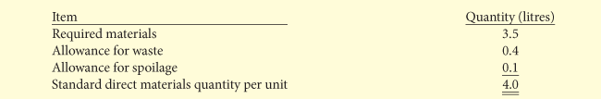

Direct labour (Price / Quantity)

Direct labour price standard is the rate that should be incurred for DL.

- Based on current wage rate and is adjusted for expected changes, such as cost of living adjustments.
- Includes employer payroll taxes and benefits.

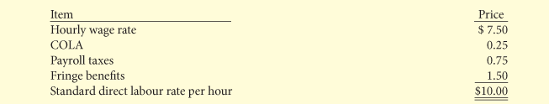

Direct labour quantity standards is the time that should be required to make one unit.

- This is especially critical in labour intensive companies.
- Allowances should be made in this standard for rest periods, cleanup, machine set-up and machine downtime.

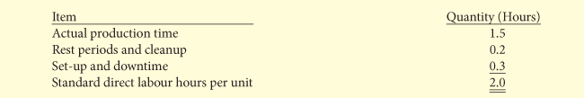

** The standard DL cost per unit is the standard DL rate times the standard DL hours.

Manufacturing Overhead

- Standard predetermined overhead rate is used in setting the standard.
- The overhead rate is determined by dividing budgeted overhead cost by an expected standard activity index. (Standard DL hours and Standard machine hours are 2 examples of standard activity indexes). (Many company use ABC costing in way to affect O/H).

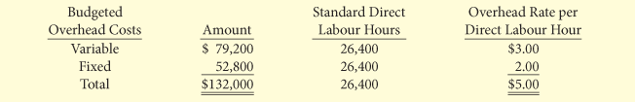

**The standard manufacturing overhead rate per unit Is the predetermined over rate times th eactivity index quality standard.

Total standard Cost per unit.

The total standard cost per unit is the sum of the standard costs of DM , DL and MOH.

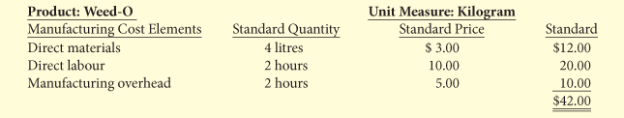

Analyzing and reporting Variances from standards

Variances: Difference between total actual costs and total standard costs.

When Actual costs are higher than standard costs , the variance is unfavourable.

When the Standard costs are higher than actual costs , the variance is favourable.

*Negative and Positive variances has to be investigate, when reach a certain level of variance.

DM Variances

Total DM budget Variance Formula:

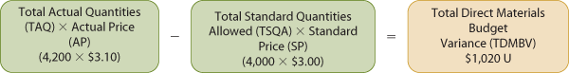

Material Price Variance Formula:

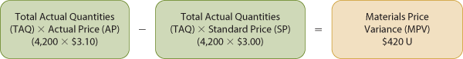

** If the material purchased during the month is different from the material used during the month, the price variance is calculated by multiplying the total actual quantities purchased by the difference between the actual and standard price.

***Material Price Variance = AQ x (AP - SP)

Material quantity variance Formula :

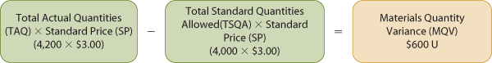

** Material quantity variance can also be calculated by applying standard price to the difference between actual quantity and standard quantity allowed.

*** Material Quantity Variance = SP x (AQ-SQ)

DM Variance Matrix

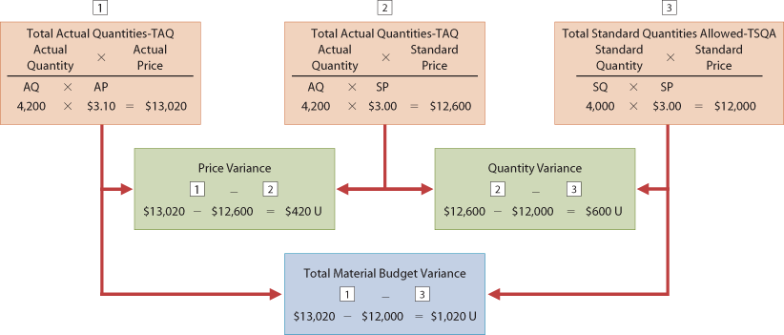

Causes of Materials Variances:

Price
- May be both internal and external factors
- Start by investigating the Purchasing Department

Quantity
- Investigation start at the Production department

DL Variances

Total DL budget Variance Formula:

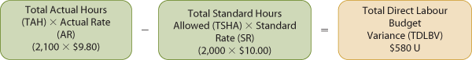

Labour price variance Formula:

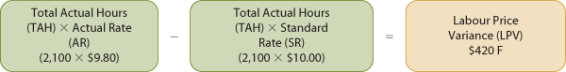

*Alternative: LPV= AH x (AR-SR)

Labour Quantity Variance Formula:

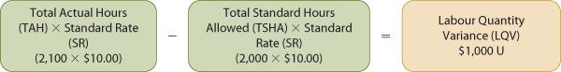

*Alternative: LQV= SR x (AH-SH)

DL Variance Matrix

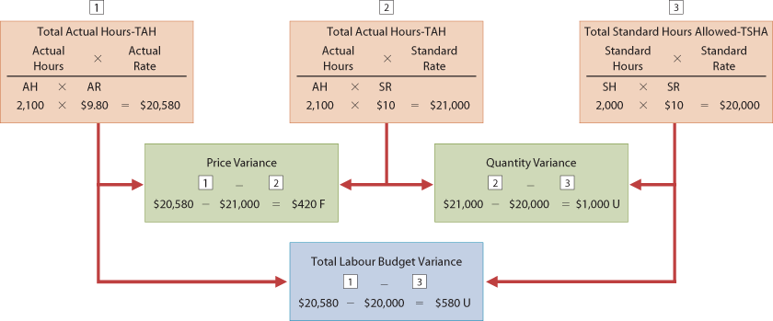

Causes of labour Variance

Price
- Higher wages than expected
- Misallocation of Worker
- Production department

Quantity
- Worker efficiency
- Production department

Manufacturing overhead variances

Total o/h Variance Formula:

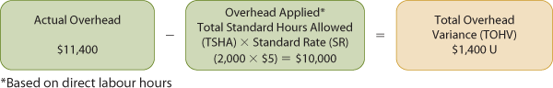

Total Variable O/H Budget Variance (Flexible Budget)

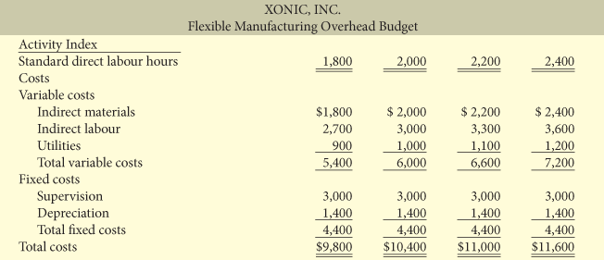

Total Variable O/H Budget Variance Formula:

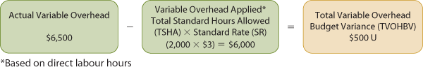

Variable O/H spending variance Formula:

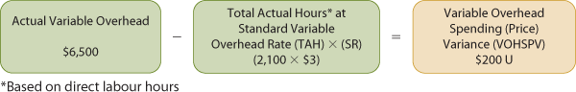

Variable O/H efficiency variance Formula:

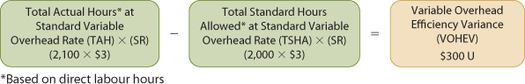

**Alternative : VOH efficiency Variance = SR x (AH-SH)

VOH variance Matrix

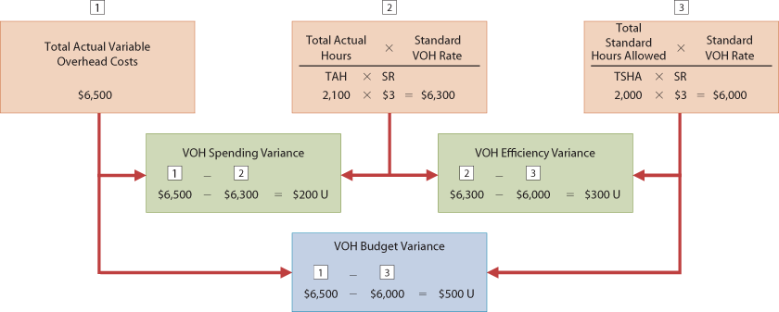

Total Fixed Overhead Variance Formula:

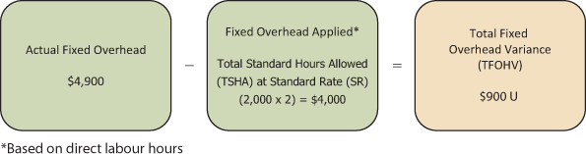

Fixed O/H spending (Budget) variance:

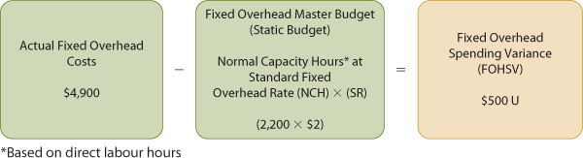

Fixed O/H Volume Variance:

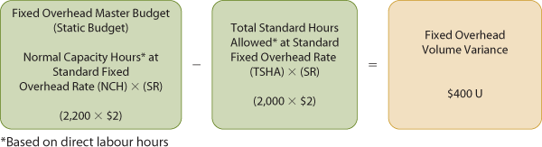

Alternative:

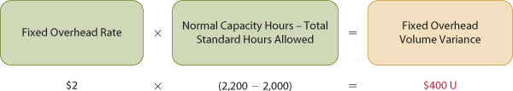

Fixed O/H Variance Matrix

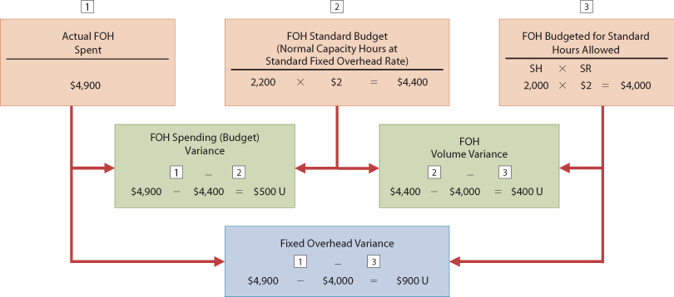

Important to remember:

- The standard hours allowed are used in each of the Variances.

- The total budget O/H variance generally relates to total VOH budget variance and FOH spending variance only.
(VOH Spending + VOH Efficiency + FOH Spending = Total budget overhead variance )

- The volume variance rate relate only to FOH cost and it's also called Production volume variance.

- Overapplied or Underapplied O/H is the difference between the total actual O/H costs (Variable + Fixed) and the budget O/H at the standard base allowed.
(Total Actual O/H costs - Budget O/H at Standard Base Allowed)

Causes Of MOH Variances

- Higher than expected use of indirect material/labour/factory supplies

- Increase in indirect manufacturing costs

- Production department is also responsible for the O/H volume variance if the cause is either inefficient use of direct labour or machine breakdown.

- When the cause is a lack of sales orders, the production department is not responsible.

Reporting Variances

- All variances should be reported to the proper level of management as soon as possible so proper review and corrective action can be taken.

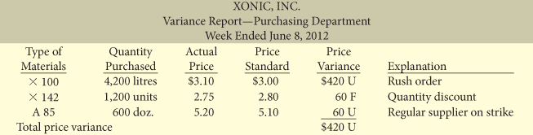

*Explanation column is filled after management has been consulted.

Statement Presentation of Variances

*In income statement prepared for management under Standards cost accounting system, the COGS is stated at standard cost the variances are disclosed separately.

**In financial statement for shareholder and other external users, standard costs may bused. The costing of inventories at standard cost is in accordance with GAAP, when there's no significant difference between actual and standard costs. However, if there's a big differences between the two costs, inventories and the COGS must be reported at actual costs.

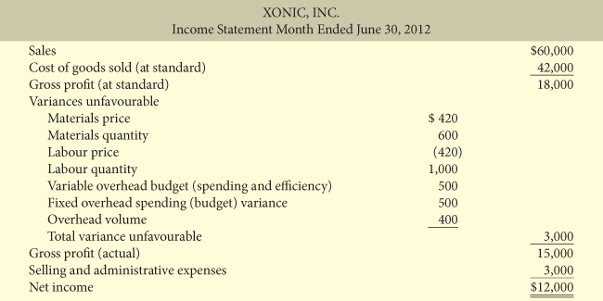

Balanced Scorecard

Is Usage of financial and non-financial measure in an integrated system the link performance measurement and company's strategic goals.

Perspective of evaluation:

- Financial perspective, most traditional view of the company. Use financial performance measure.

- Customer perspective, evaluate how well the company is performing in the eyes of the people who buy and use its product or services. (Compared to competitors: Price, quality, innovation, customer service and other dimensions.)

- Internal process perspective, evaluates the internal operating process that are critical to success. Critical aspects of value chain (…) are evaluated to ensure that the cie. Is operating efficiently and effectively.

- Learning and Growth perspective, evaluates how well the cie. Develops and retains its employees.(Evaluation of employee skills, satisfaction, training etc.)

Flow of influence across Balanced Scorecard perspectives

Objectives linked to company goals

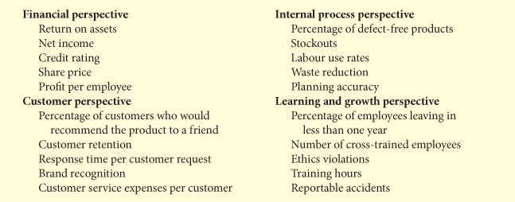

Non-Financial Measures used in various industries

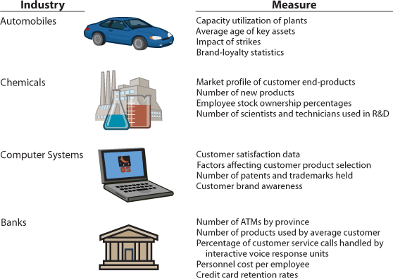

Summary Balanced Scorecard

- Employ both financial and non-financial measures.

- Create links so that high-level corporate goal can be communicated all the way down to the shop floor.

- Provides measurable objectives for such non-financial measure as product quality.

- Integrates all of the company's goals into a single performance measurement system, so that too much weigh will not be place on a single goal.

