Acco 240 Ch.11
6 avril 2015
15:06

Budgetary Control Concept

Budgetary control is the use of of budget to review company performance. To do so we compared the actual result with the planned objectives. Budget report are use because planned objective often lose a lot of their potential value if progress is not monitored along the way.

Budgetary control formalized reporting system:

- Identify name of report
- State frequency
- Specify purpose
- Indicate primary recipient

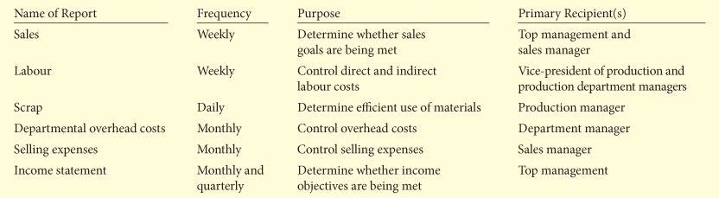

Process of Budgetary Control:

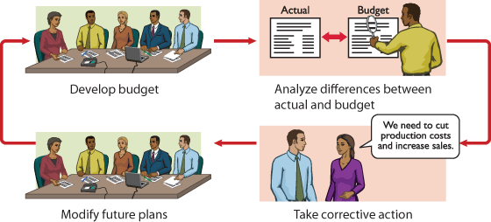

Static Budget report ( 1 level of activity / Fixed cost)

Projection of budget data a 1 level of activity. As a result, companies always compare actual result with budget data at the level of activity that was used in developing the master budget.

Uses / Limitations

- Useful in evaluating performance of sales manager.

- Good to evaluate managers control costs when (1) cost are close form approximates master budget activity level.

- Good to evaluate managers cost control when (2) the behaviour of cost in response to change in activity is fixed.

- Static Budget is therefore appropriate for fixed manufacturing cost and for fixed selling and administrative expenses.

- Not good for evaluation of managers ability to control variable costs.

Examples:

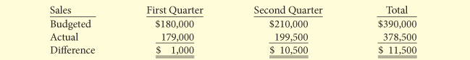



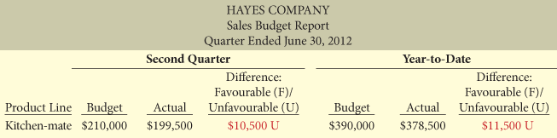

Flexible Budgets (Various Level of activity / Variable Costs)

Flexible budget Project budget data for various level of activity. (Can be prepared for all type of budget including Master Budget)

Developing The flexible Budget:

- Identify index of relevant range of activity
- Identify the variable costs, and determine the budgeted variable cost per unit of activity for each cost.
- Identify the fixed costs, and determine the budgeted amount for each cost.
- Prepare budget for selected increment of activity within relevant range.

- The activity index that management choose should be something that significantly influences the costs that are budgeted.
- For manufacturing overhead the activity index is usually the same as the index used for calculating the predetermined overhead rate ( DL / Labour hours or Machine Hours).
- For selling and administrative expenses, the activity index is usually sales or net sales.

*Choice of increment of activity is largely matter of judgement.

Flexible Budget Reports
Made of 2 Sections:

(1st section)
Production data for selected activity index (DL hours etc.)

(2nd Section)
Cost data for Variable et Fixed costs.

*The report provides a basis for evaluating a manager's performance in two areas: Production control and cost control. Flexible budget reports are widely used in production and service departments.

Example Full Case study: (p.478/p.479)

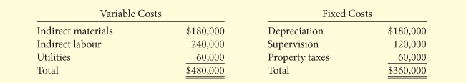

- Identifiy activity index/ relevant range of activity

- Identify Variable cost/ determine the budgeted variable cost per unit
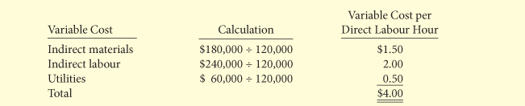

- Identify the fixed cost / determined the budgeted amount for each costs.

- Prepare the budget for the selected increments of activity within the relevant range.

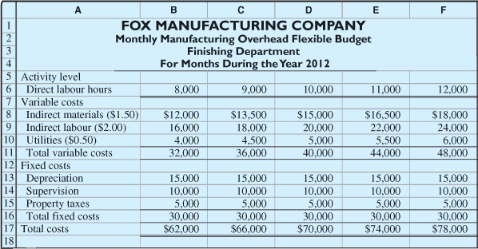

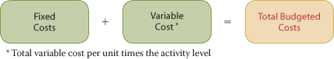

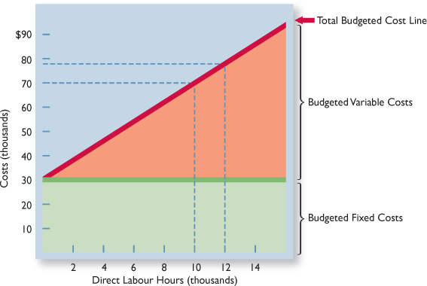

- Flexible Budget Reports

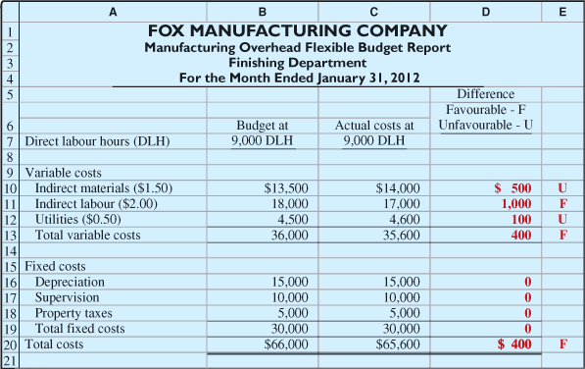

Management By exception

Management by exception: means that top managements review of a budget report is focused either entirely or mostly on differences between actual results and planned objectives.

Materiality : Usually expressed as a % difference from the budget.You can also add a certain $ amount as a check point. The company should investigate all differences that are over or under budget by at least the specified % or $ amount to understand what's going on.

Controllability of the Item: Manager's should not be accountable for things out of their control. Non controlable item might not be flagg and investigate even if the difference between actual and budgeted is greater than the materiality point.

The Concept of responsibility Accounting

Responsibility accounting: involves accumulating and reporting costs(and revenues, where relevant) that involve the manager who has the authority to make the day-to-day decisions about the cost item.

Under responsibility accounting, a manager's performance is evaluated based on the matters that directly under that manager's control.

Conditions of responsibility:

- Cost and revenue can be directly associated with the specific level of management responsibility
- The cost and revenues are controllable at the level of responsibility that are associated with.
- Budget data can be developed for evaluating the manager's effectiveness in controlling the costs and revenues.

Under responsibility accounting, any individual who has control and is accountable for a specified set of activities can be recognized as a responsibility centre. Thus, responsibility accounting may extend from the lowest level of management to the top.

Responsibility accounting is especially valuable to in a decentralized company. Decentralization means that the control of operation is given to many managers throughout the organisation. The term segment is sometime used to identify area of responsibility in decentralized operations.

*The reporting of costs and revenues under responsibility accounting differs from budgeting in 2 ways:

- A distinction is made between controllable and non-controllable items.
- Performance reports either emphasize or include only the items that the individual manager can control.

Responsibility accounting applies to both for profit and non-profit organisation . Whether it's for maximizing net incomes or efficiently provide a services.

Controllable VS Noncontrollable revenues and costs

A cost is considered to be controllable at a particular level of managerial responsibility if manager has the power to incur it in a specific period of time.

Criterions:

- All cost are controllable by top management because of its range of authority.
- Fewer costs are controllable by lower level of managerial responsibility because the manager's authority decreases at each level.

**In genereal, costs that a level of responsibility directly incurs can be controlled at that level. In contrast, cost that are indirectly incurred and allocated to a responsibility level are considered to be NONCONTROLLABLE at that level.

Responsibility Reporting System

In a responsibility reporting system, a report is prepared for each level of responsibility in the company's.

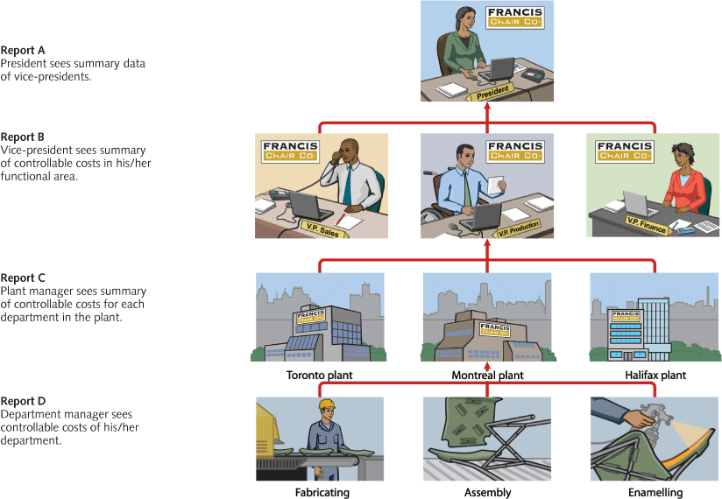

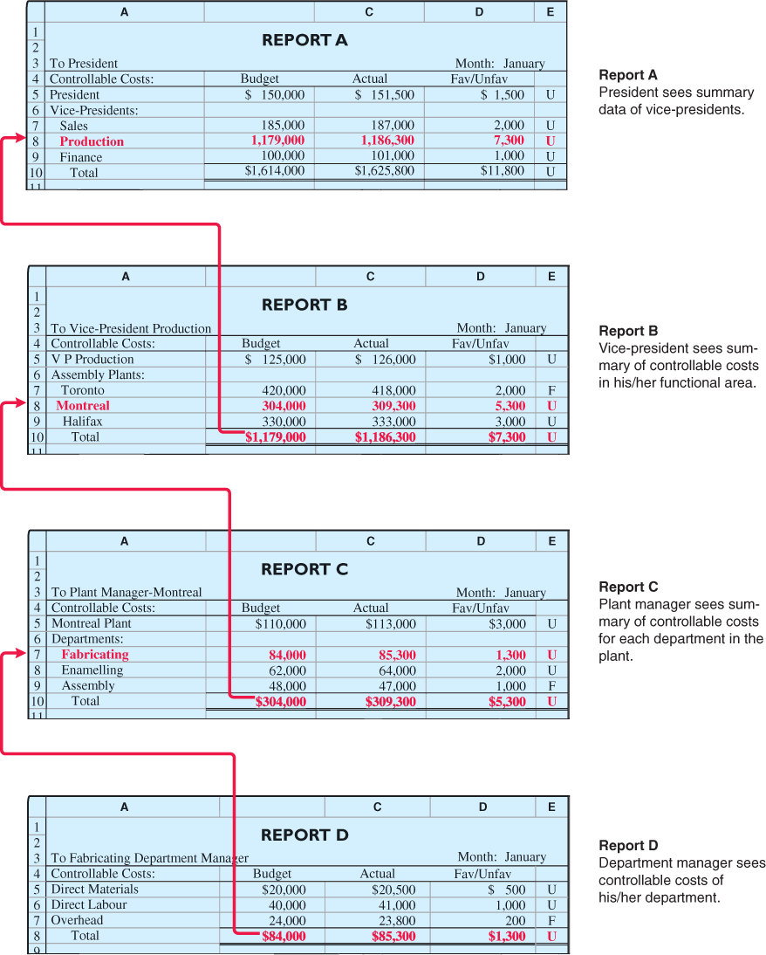

1.
Report D is typical of reports that go to managers at the lowest level of responsibility shown in the organization chart—department managers. Similar reports are prepared for the managers of the fabricating, assembling, and enamelling departments.

2.
Report C is an example of reports that are sent to plant managers. It shows the costs of the Montreal plant that are controllable at the second level of responsibility. In addition, Report C shows summary data for each department that the plant manager controls. Similar reports are prepared for the Toronto and Halifax plant managers.

3.
Report B is a report at the third level of responsibility. It shows the controllable costs of the vice-president of production and summary data on the three assembly plants that this officer is responsible for.

4.
Report A is typical of the reports that go to the top level of responsibility—the president. This report shows the controllable costs and expenses of this position and summary data on the vice-presidents who are accountable to the president.

**A responsibility reporting systems makes it possible to use management by exception at every level of responsibility. In addition, each higher level of responsibility can obtain the detailed report for each lower level of responsibility.

Principles of performance evaluation

Performance evaluation is a management function that compares actual result with budget goals.

Behavioural principles (5)

- Managers of responsibility centres should be directly involved in setting goals for their areas of responsibility.

- The evaluation of performance should be based entirely on matters that can be controlled by the manager being evaluated.

- Top management should support the evaluation process.

- The evaluation process must allow management to responds to their evaluations.

- The evaluation should identify both good and poor performance.

Reporting Principles (5)

- Contain only data that are controllable by the manager of the responsibility centre.

- Provide accurate and reliable budget data to measure performance.

- Highlight significant differences between actual results and budgeted goals.

- Be tailor-made for the intended evaluation.

- Be prepared at reasonable intervals.

Types of responsibility centres (3)

Cost centre (Expense):

- A costs centre incurs cost(and expenses) but does not directly generate revenues. Managers of costs centre have the authority to incurs costs.

- They are evaluated on their ability to control costs.

- Cost centre are usually production departments or service departments.

- Responsibility reports for costs centre compare actual controllable costs with flexible budget data.

- Only controllable costs are includes in the report, no distinction is made between variable and fixes costs.

- Management continues the concept of management by exception.

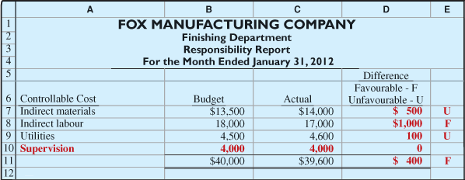

Profit centre (Expenses+ Revenues):

- Incurs cost (expenses) and generates revenues.

- Managers of profits centre are judged on the e profitability of their centre.

- Profit centre include the individual department of retail store ; clothing furniture branch offices of bank etc.

- To evaluate performance we need detailed information about controllable revenues and costs. (The operating revenues that are earned by a profit centre , such as sale, are controllable by the manager. All variable cost (expenses) that are incurred by the centre are also considered as controllable (costs/expenses).

- Important to determine the controllability of fixed costs, it is necessary to distinguish between direct and indirect fixed costs.

Direct Fixed costs:

Cost that are specifically for one centre and are incurred for the benefit of that centre alone. Example; salaries established by the manager for supervisory personnel and the cost of time keeping department. These cost can be trace directly to 1 centre ( traceable costs ). Most Direct fixed costs are controllable by the profit centre manager.

Indirect Fixed costs:

Company's overall operating activities and incurred for the benefit of more than 1 profit centre. Indirect fixed costs are allocated to each store based on some equitable basis. (Property taxes on a building may be allocated by base on the area of floor space used by each centre.). Because these fixed costs are apply to more than 1 centre, they are also called (common costs). Most indirect fixed costs cannot be controlled by the profit centre manager.

Responsibility report

- Controllable fixed cost are deducted from contribution margin.

- The amount by which the contribution margin is greater than the controllable fixed costs is identified as the controllable margin ( Contribution margin - Controllable fixed costs= Controllable margin ).

- Noncontrollable cost are not reported.

**Controllable margin is considered to be the best measure of the manager"s performance in controlling revenues and costs.

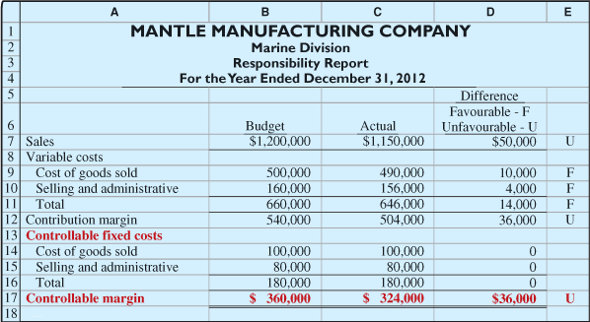

Investment centre (Expenses+ Revenues+ ROI):

- Incurs costs (expenses),generates revenues. In addition, an investment centre has control over the investment funds that are available for use.

- Managers are evaluated on both profitability of the centre and the rate of return earned on the funds invested.

- Investment centre are often associated with product lines and subsidiary companies.

Return on investment:

(controllable margin can be replace by operating income )

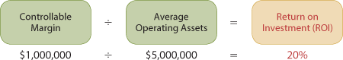

Extended version:

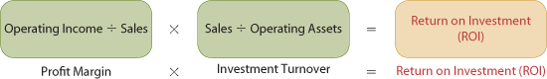

The investment centre manager can control both factors in this formula.

- Operating asset include : Current assets and plant assets that are used in operation by the centre and are controlled by the manager. Non-Operating asset such as idle plant asset and land held for future use , are excluded. (Avg. operating asset are usually based on the asset's cost or book value at beginning and end of the year).

Responsibility report

- All fixed cost are controllable by its manager.

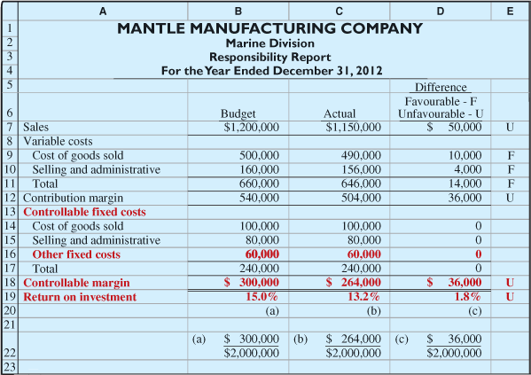

Judgemental Factors in ROI

- Valuation of operating assets. May be valued at their acquisition cost, book value , appraised value or market value. ( first 2 are easy to find in accounting records.)

- Margin(income)measure. This measure may be controllable margin, income from operations or net income.

Improving ROI

- Increasing controllable margin: Controllable margin can be increased by increasing sales or by reducing the variable and controllable fixed costs.

- Reducing the Average Operating assets.

Residual Income campared with ROI

Residual income is the income that remains after subtracting from the controllable margin the minimum rate of return. RI can be use as performance measurement like ROI.

*Problem with ROI is that it ignores an important variable; the minimum rate of return on a company's assets.

Residual Income formula :

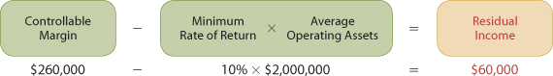

Economic Value added formula :

Residual income Weakness:

- The goal of RI is to focus on maximizing the total amount of residual income
- This goal ignores the fact that one division might use substantially fewer asset to attain the same residual income as another division.

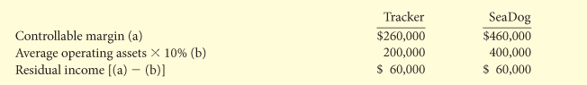

**Using RI both investments would be equal because it ignores the fact that seadog division required twice as much in operating asset to achieve the same level on RI as Tracker division.

