Acco 240 chapter 7
2 mars 2015
14:19

Decision-Making and the incremental analysis approach

-Management's decision-making process

4 steps process

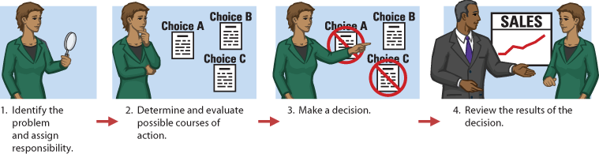

Accounting's contribution to the process occurs mostly in steps 2 and 4.

In step 2 for each possible course of action, accounting provide relevant revenue and cost data. These shows the expected overall effect on net income.

In step 4, accounting prepare internal report that review the actual impact of the decision.

**In making business decision, management usually consider both finnancia ( revenue, costs and cie profitability )l and non-financial information ( employee turnover, environment , cie overall image )

-Incremental analysis approach(Differential analysis)

Decison involve a choice among alternative course of action. Focus on differences.
( ex. buy or lease a car)

Incremental analysis: is the process used to identify the financial expenses that change under alternative course of action. When using this method sometime you will find that both cost and revenue will vary . In other cases, only costs or only revenue will.

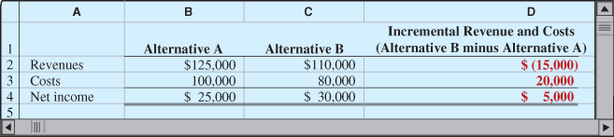
(basic approach in incremental analysis)

*This type of analysis always involves estimates and uncertainty ( data can be gather from market analysis, engineer and accountant).

-3 important cost concept of incremental analysis

- Relevant cost: In I.A. The only factors to be considered are 1) those cost and revenues that are different for each alternative, and 2) those cost and revenue that will occur in the future. (Cost and revenues that do not differ across alternative and will not occur in the future can be ignored when trying to choose between alternative.

- Opportunity cost : In choosing to take one action, the cie. must often give up the opportunity to benefit from some other action. This lost benefit is called an opportunity cost.

- Sunk cost : Cost that have already been incurred and will not be changed or avoided by any future decision. (Sunk cost are not relevant cost)

Types of incremental analysis

- Accept an order at a special price
- Make or buy component parts or finished products
- Sell products or process them further
- Retain or replace equipment
- Eliminate or retain an unprofitable business segment
- Allocate limited resources

-Accept an order at a special price

Sometime capany may have an opportunity to obtain additional business if it is willing to make a major price concession to a specific customer.

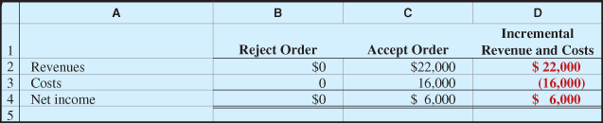
(accepting order at special price)

2 points should be emphasized ( for the ex.): 1st , it assumed that the sales of the product in other markets would not be affected by this special order because if sales lost would 've occurs the company would've take it under consideration in their decision making process. 2nd that if the company was operating operating at full capacity it's likely that it would have rejected the order.

-Make or Buy

When manufacturer assembles component parts in producing a finished product, management must decide whether to make or buy. The decision of make or buy is often called outsourcing.
This decision should be made based on the incremental analysis.

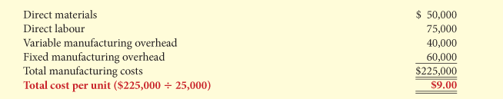
(annual product cost data)

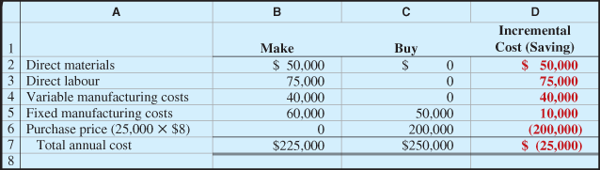
(incremental analysis- Make or Buy)

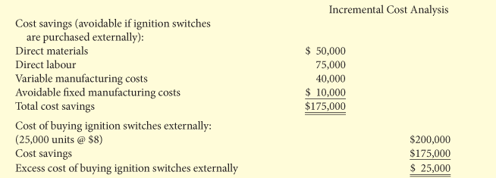
(Incremental cost analysis)

-Opportunity Cost

Opportunity cost is the potential benefit that a company may lose by following an alternative course of action.

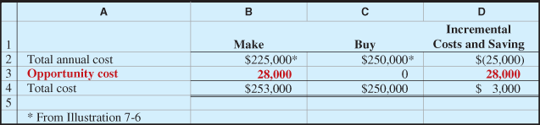
(Increment analysis-make or buy, with opportunity cost)

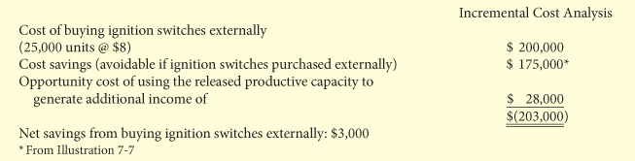
(Single column format for incremental analysis make or buy)

-Sell or process further

Many manufacturers have the option of selling products at a particular point in the production cycle or continuing to process the products in order to sell them later at a higher price. The basic decision rule is as follow: Process further as long as the incremental revenues from the processing is more than the incremental processing costs.

Single- Product case

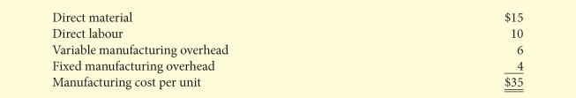
(per-unit cost of unfinished table)

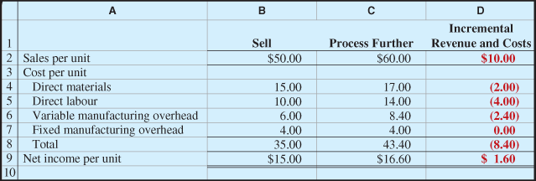
(per-unit incremental analysis - sell or process further)

Multiple- product case

In many industries, several end products are produced from a single raw material and a common production process. These multiple end products are commonly called joint product.

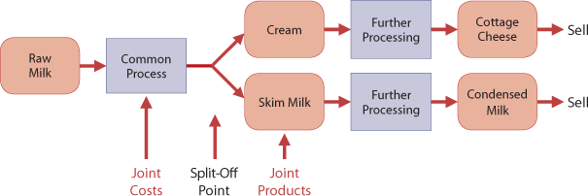

(Joint production process- Sell or process further )

**All cost that are incurred before the point at which the two products are separately identifiable ( split-off point) are called joint cost. To determine the cost of each product, joint product cost must be allocated to individual products. This is frequently done based on ( Relative sales value of the joint products). Although this allocation is important for determining the product cost, it is irrelevant in sell-or-process-further decisions. This is because the joint product costs are sunk cost.

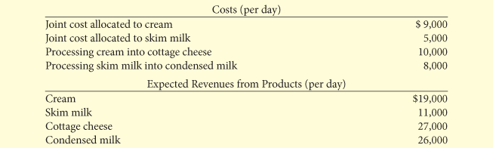

(cost and revenue data per day)

From these information we can determine whether the company should simply sell or process further.

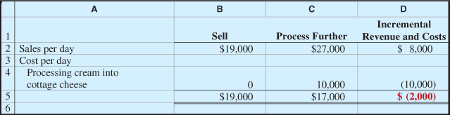
(Incremental analysis of whether to sell or process further)(cream into cottage cheese)

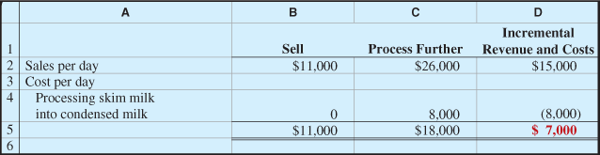
( Incremental analysis of whether to sell or process further )(Skim milk into condensed milk )

**Joint cost allocated to each product ( $9000 to cream and $5000) is irrelevant in deciding whether to sell or process further. Because the joint costs remain the same whether or not they process further.

-Retain or replace equipment

Management often has to decide whether to continue using an asset or replace it.

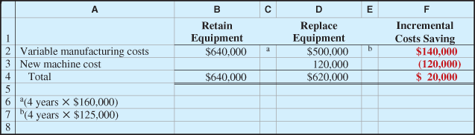
(Incremental analysis- retain or replace equipment)

*The book value of the old machine does not affect the decision. Book value is a sunk Cost . Sunk cost are not relevant to I.A.

**The effect of book value on current and future earnings is the same regardless of the replacement decision. ( see p. 290 for more explanation)

*** Any trade-in allowance or cash disposal value of the existing asset, however, is relevant to the decision, because the company will not realize this value if it continues to use the asset.

-Eliminate an unprofitable segment

Management must sometimes decide whether to eliminate an unprofitable business segment. Again the key is to Focus on the relevant cost- the data that change under the alternative courses of action.

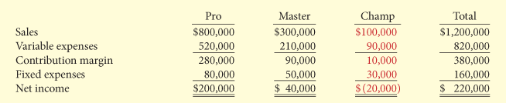
(segment income data)

** Se p.291 for a complete analysis of the situation.

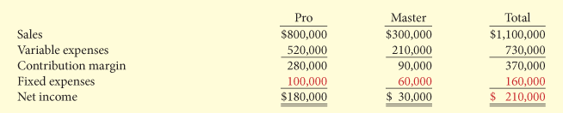

(Income data after eliminating the unprofitable product line)

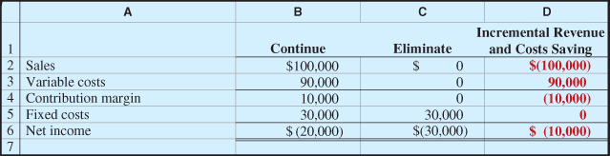
(Incremental analysis- eliminating an unprofitable segment)

**In deciding on the future of status of an unprofitable segment, management should consider the effect of elimination on related product lines. Product lines that continue maybe able to get some or all of the sale lost by the discontinued product line. In addition management should consider the effect of eliminating the product line on employees who may have to be laid off or retrained.

-Allocate limited resources

One factor that affect the sales mix decision is how much of the available resources each product uses.
Everyone's resources are limited.( Floor space, raw materials, direct labour...). When company has limited resources , management must decide which product to make and sell in order to maximize net income.

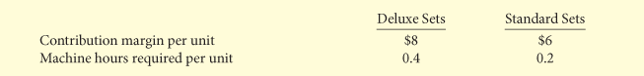
(contribution margin and machine hours)

In this case it's necessary to find the contribution margin per unit of the limited resource: in this case the CM per machine hour.
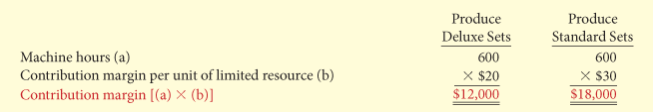
(Contribution margin per unit of limited resource)

The total contribution margin under each alternative is find b multiplying the machine hours by the contribution margin per unit of the limited resource.
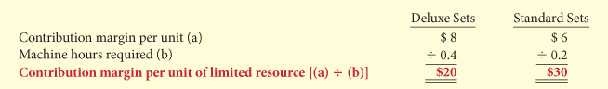
(Incremental analysis- calculation of total contribution margin )

** In addressing this problem we have not questioned the limited number of machine hours, and have simply tried to maximize the contribution margin under this constraint.

Theory of constraints : is a specific approach to constraints in which the company manage them to improve its overall results. According to this theory, a company must continually identify its constraints and find ways to reduce or eliminate them, where appropriate.

Qualitative factors:

Should not ignored the impact of the decision taken on the qualitative level ( impact on employee , impact on community ). The cost saving of that may result from a decision must be weighted against the qualitative factors.

*Qualitative factors matter!

Summary of Study Objectives

1. | Identify the steps in management's decision-making process. Management's decision-making process consists of (a) identifying the problem and assigning responsibility for the decision, (b) determining and evaluating possible courses of action, (c) making the decision, and (d) reviewing the results of the decision.
2. | Describe the concept of incremental analysis. Incremental analysis is the process companies use to identify financial data that change under alternative courses of action. These data are relevant to the decision because they will vary in the future among the possible alternatives.
3. | Identify the relevant costs in accepting an order at a special price. The relevant information in accepting an order at a special price is the difference between the variable manufacturing costs to produce the special order and expected revenues.
4. | Identify the relevant costs in a make-or-buy decision. In a make-or-buy decision, the relevant costs are (a) the variable manufacturing costs that the company will save, (b) the purchase price, and (c) opportunity costs.
5. | Identify the relevant costs in deciding whether to sell or process materials further. The decision rule for whether to sell or process materials further is as follows: process further as long as the incremental revenue from processing is more than the incremental processing costs.
6. | Identify the relevant costs in deciding whether to retain or replace equipment. The relevant costs a company needs to consider in determining whether it should retain or replace equipment are the effects on variable costs and the cost of the new equipment. Also, it must consider any disposal value of the existing asset.
7. | Identify the relevant costs in deciding whether to eliminate an unprofitable segment. In deciding whether to eliminate an unprofitable segment, the relevant information is the contribution margin, if any, produced by the segment and the disposition of the segment's fixed expenses.
8. | Determine the sales mix when a company has limited resources. When a company has limited resources, it is necessary to find the contribution margin per unit of the limited resource. This amount is then multiplied by the units of limited resource to determine which product maximizes net income.

À partir de l’adresse <http://edugen.wileyplus.com/edugen/courses/crs6454/weygandt9781118033890/c07/d2V5Z2FuZHQ5NzgxMTE4MDMzODkwYzA3XzExXzAueGZvcm0.enc?course=crs6454&id=body&mode=main>

