Acco 240 Chapter 4
February 6, 2015
6:39 PM
The nature of Process Costing

- Process cost systems : apply cost to similar product that are mass-produced in a continuous way.
In process cost system we are talking about period of time and units produced over this period instead of each job.
Process costing for service companies : repetitive routine aspect of the business like auto-care vendors, routine legal services, basic tax practice...

Process Cost flow

DM Wip Wip Finished Cost of Goods Sold
DL Department A Department B Goods
MOH Inventory
*Hs

Job-Order cost flow vs Process Costing

Similarities:

- Manufacturing cost element: Both system track the 3 elements.

- Accumulation of Materials cost, labour cost and overhead: In both system
Raw materials are debited to Raw materials inventory
Factory labour are debited to Factory labour
overhead cost are debited to MOH.

- The flow of cost : Its the same for both system so the accumulated manufacturing cost are assigned to the same accounts which are Wip inventory, Finished goods inventory and Cost of goods sold, the only difference is in the method of assigning costs to these accounts.

Differences:

- The number of wip account used: In process costing many wip account are used ( usually 1 per department of production)

- The document used to track costs: Instead of using job cost sheet we use a production cost report where are summarized costs for each department.

- The point at which the cost are totalled: Instead of recording the cost at the end of the job the costs are totalled at the end of a predetermined period of time.
- Unit cost calculation: For Job-Order costing( cost of each job/ unit produced for the job)
For Process Costing ( total manufacturing cost/units produced during the period)
More info Book p. 122

Operations Costing

- Companies often use a combination called operation costing system.
Similar to process costing since companies use standardized methods to manufacture a product. At the same time product may have some customized individual features that require the use of a job-order costing system.
Ex: Ford use the same assembly line to produce different car with different materials.

Assignment of manufacturing Cost

- Materials Cost: All raw materials that are issued for production are materials cost for the production department. Materials requisition slip may be used but less often than in Job-order costing because the requisition are for larger quantities of material under process costing. Usually at the beginning of the process most of the materials needed are add but other materials may be added at various point of production.

Ex: to record raw materials used Debited Credited

Work in process Machining XXXXXX
Work in process Assembly XXXXXX
Raw Materials inventory XXXXXX

Factory Labour Costs: Labour cost are assigned to a process rather than a job, the labour cost that is chargeable to process can be obtained from payroll register or a department's payroll summaries.

Ex: to assign factory labour to production Debited Credited

Work in process Machining XXXXXX
Work in process Assembly XXXXXX
Factory Labour XXXXXX

Manufacturing Overhead Cost: The objective is to assign the overhead cost to the production department on an objective and equitable basis. That basis is the activity that drives or causes the cost.
A major driver of overhead cost in continuous manufacturing operation is MACHINE TIME USED not direct labour. Thus machine hours are widely used to allocate MOH.

Ex: to assign overhead to production Debited Credited

Work in process Machining XXXXXX
Work in process Assembly XXXXXX
Manufacturing Overhead XXXXXX

Transfer out next department: at the end of the month an entry is needed to record the cost of the goods transferred out of the department. ( Debit the account where the units are transferred in and credit where it's transferred out)

Ex: to record transfer of units to assembly department Debited Credited

Work in process Assembly XXXXXXX
Work in process Machining XXXXX

Transfer to finished Goods: units completed are transferred to the finished goods inventory

Ex: record the transfer of units to FG
Debited Credited
Finished goods inventory XXXXXX
Work in process Assembly XXXXXX

Transfer to cost of goods sold: When finished goods are sold , they get transferred to cost of goods sold.

Ex: to record cost of units sold Debited Credited

Cost of goods sold XXXXXX
Finished goods inventory XXXXXX

Equivalent units of production

Measure the work done during the period, expressed in fully completed units. Its use to determine the cost per unit of completed product.

Weighted Average Method (Formula):

Units completed  And transferred out | + | Equivalent unit of Ending  Work in Process | = | Equivalent Units of  Production

Beginning Wip ( for material cost) :100% because all the materials are added at the beginning of the process.

Conversion cost: Refer to the sum of labour cost and overhead cost.

Ending Wip ( for material cost) :100% because all materials are added at the beginning of the period.

** In calculating equivalent units, the beginning Work in process is not a part of the equivalent units of production formula.

Résumé Formulas (Weighted Average):

Materials Cost
Units completed and  transferred out  ( Materials) | + | Equivalent units of Ending  Work in process  (Materials) | = | Equivalent units of  Production  (Materials)

Conversion Cost
Units Completed and  transferred out  (Conversion Cost) | + | Equivalent units of ending  Work in process  (Conversion Cost) | = | Equivalent units of  Production  (Conversion cost)

The Production Cost report

Is a key document management uses to understand the activities in a department; it shows Production quantity and cost data for department.

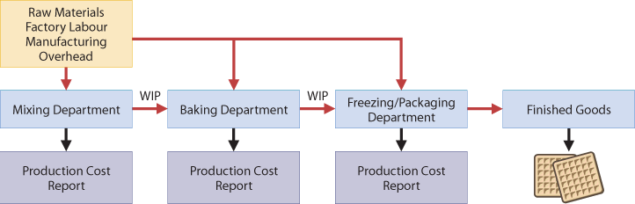

The production Cost report 4 steps of production:

1- Calculate the physical unit flow.
2- Calculate the equivalent units of production.
3- Calculate the unit production costs.
4- Prepare a cost reconciliation schedule.

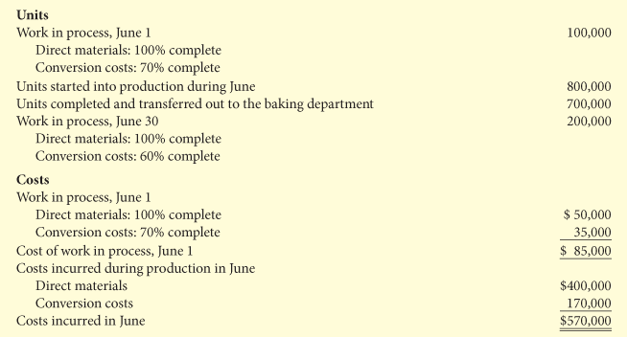

1- Calculate the physical unit flow

The physical units are the actual units to be accounted for during a period, regardless of any work performed.

Total Units to be accounted for
Beginning Work in  Process. (Start of  period) | + | Units started(or transferred)  INTO production during the  period | = | Total units to be  accounted for.

The total units are then accounted for by the output of the period* to give the Total units accounted
for.

Total units accounted for
Units completed and  transferred out during  the period. | + | Ending Work in  Process at the end  of the period. | = | Total units  accounted for.

* out put of the period = units transferred out + Units in process at the end of the period.

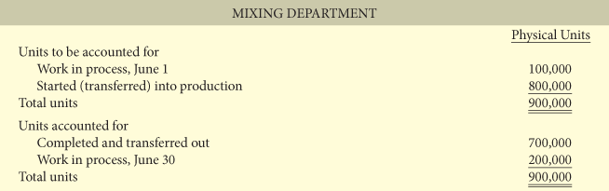

2- Calculate the equivalent unit of production

Measure department productivity in equivalent units. Materials are added at the beginning of the
Process and conversion cost are incurred evenly during the process. Thus 2 calculations of equivalent units are needed (Materials / Conversion)

Materials Cost
Units completed and  transferred out  ( Materials) 100% | + | Equivalent units of Ending  Work in process  (Materials) 100% | = | Equivalent units of  Production  (Materials)

Conversion Cost
Units Completed and  transferred out  (Conversion Cost) 100% | + | Equivalent units of ending  Work in process  (Conversion Cost) Given% | = | Equivalent units of  Production  (Conversion cost)

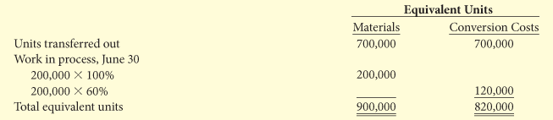

Using the same formulas as previous in the note*

3-Calculate the unit production costs

Unit production costs are cost expressed in terms of equivalent units of production.
When equivalent units of prod. Are different for materials and conversion cost 3 unit costs are calculated: 1) materials cost, 2) conversion cost, 3) Total manufacturing cost.

Formula for 1) Unit Materials Cost/unit

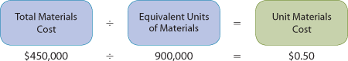

Calculation for Total materials cost.



Formula for 2) Conversion Cost/unit

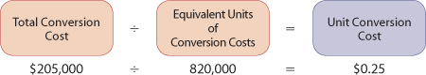

Calculation for Total Conversion cost.



Formula for 3) Total manufacturing Cost/unit

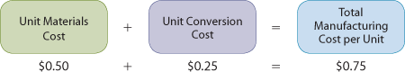

4- Prepare a cost reconciliation schedule

- Now we are ready to determine the cost of goods transferred out to the next department and the cost in Ending work in process.



*Total cost charged to the department during the month.

- The following Illustration shows a COST RECONCILIATION SCHEDULE:
Prepared to assign The units transferred out to the 1st department to the 2nd department and the ending work in process of the 1st department.

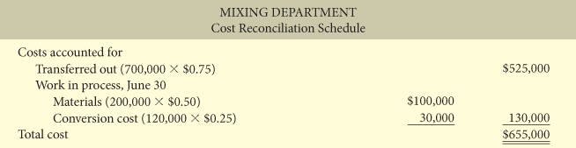

*To calculate the cost of units transferred out we use the total manufacturing cost/unit
Multiplied by # of unit transferred out.

** To calculate the Ending Wip you need to use The Ending Wip for Materials and the
Ending Wip for Conversion cost we calculated in step 2 (equivalent units).

Review Preparation of cost Report

1 Physical units
2 Equivalent units
3 Unit cost (Materials/Conversion)
4 Cost reconciliation schedule

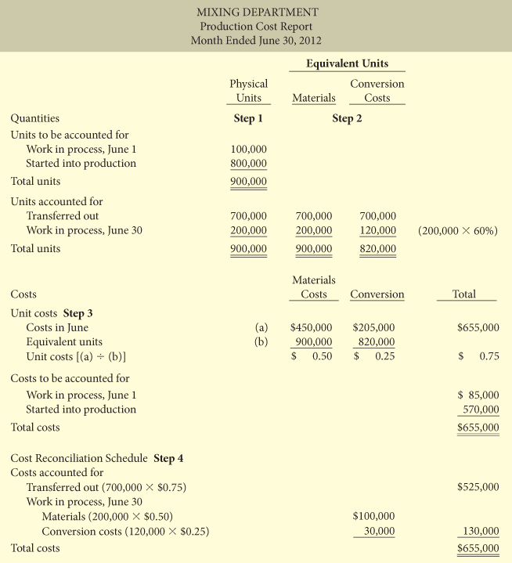

Production cost report gives a basis for evaluating a department productivity. Cost data can be used to judge whether unit cost are reasonable. Also by comparing cost data with goals management can see if current objective are meet.

Calculate Equivalent units and Create Cost Production Cost report for a sequential process setting

In sequential process settings The cost of completed good from a first department are treated as input material cost in the following department. Therefore we need to use an additional cost component called ''TRANSFERRED IN'' percentage of completion is 100%.

Example:
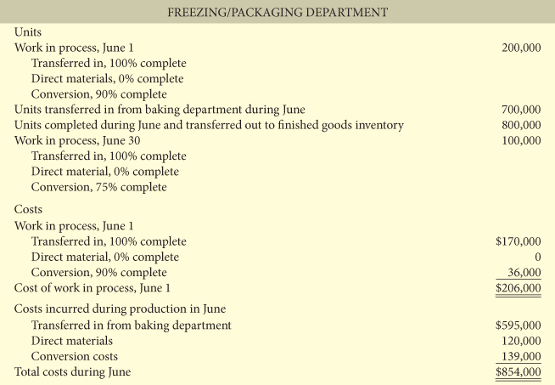

Production cost report for a Sequential setting Example using the information of the previous Illustration.

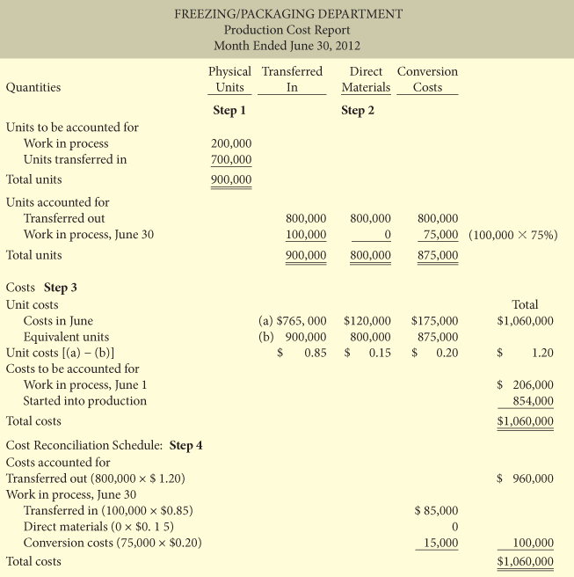

Additional calculations



Under FIFO method

Under FIFO the equivalent units are the sum of the following work:

- Work done to finish the units from the beginning WIP inventory
- Work done to complete the units started in production during the period (referred as units started and completed)
- Work done to start, but only partially complete, the units in ending WIP inventory.

*Normally, in a process costing system, some units will always be in process at both Beginning and at the end of the period.

- Physical unit flow: Under FIFO Physical unit schedule is often extended to explain the transferred-out section. (see Illustration 4A-4/ 4A-5 p.140)

- Calculate Equivalent unit of production ( for Materials): Since materials are entered at the beginning of the process, no additional materials cost are required to complete the beginning work in process. In addition 100% of the Ending work in process have been incurred.

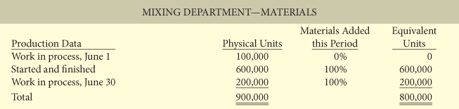

Equivalent units (for conversion cost): SUM of Use the % of remaining work to complete the job of the Beginning Work in process. Add the Units STARTED and COMPLETED during the period (100%) and the % complete for ending work in process inventory.

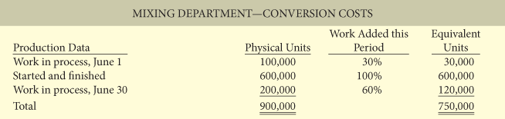

- Calculate the Unit Production Cost : Under FIFO, the unit cost of production are based entirely on the production cost incurred during the month. Thus, the cost of Beginning Work in process are not relevant, because they were incurred on work done the previous month.
(calculations Illutration 4A-8)

- Cost Reconciliation Schedule: Under FIFO, the first goods to be completed during the period are the units in the beginning work in process. Thus, the cost of the beginning work in process is always assigned to good transferred to finish goods(or next department). It also mean that ending WIP will be assigned only production costs that are incurred in the current period.

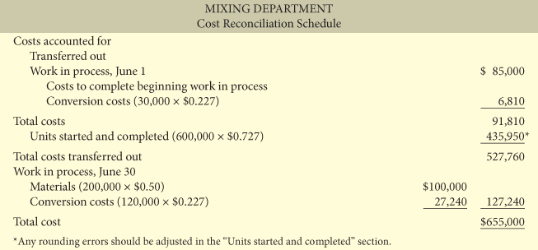

Preparing Production Cost Report

1 Physical units
2 Equivalent units
3 Calculate unit cost
4 Cost reconciliation Schedule



