Acco 240 Chapter 10
26 mars 2015
15:29
Budgetary Planning

Budgeting basics

Budget: Its a formal written statement in financial term of management's plans for a specified future time period.

Budget and accounting

From accounting records, management can obtain historical data on revenues,costs and expense which are very helpful in order to set future budget goals.

Accountant are responsible for:

1- Presenting management'S budgeting goals in financial terms.

2- In this role they translate Management plans and comunicate the budget to employees throughout the company.

3- Prepare and produce periodic budget reports that provide basis for measuring the performance and comparing actual result with planed objectives.

*Budget and the administration of the budget are entirely management's responsibilities.

The benefits of budgeting

- It requires all levels of management to plan ahead and to formalize goals on recurring basis.

- Provides definite objectives for evaluating performance at each level of responsibility.

- Creates early warning system for potential problems so that management can make changes before things get out of control.

- Easier to coordinate activities within the business. Fit each segment goals with overall company objectives. Thus production and sales can be integrated with expected sales.

- Greater management awareness of the entity's overall operations and impact on operations of external factors, such as economic trends.

- Motivates personnel throughout the organization to meet planned objectives.

Essential of effective budgeting

Effective budgeting depends on :

- A sound organizational structure that clearly defines authority and responsibility for all phases of operation.

- Budget based on research and analysis, resulting in realistic goals that will contribute to a company's growth and profitability.

- Effectiveness of a budget program is directly related to how well its accepted by all levels of management.

- Once accepted the budget should be an important tool of evaluation of performance.

Length of the budget of the budget period

Not necessarily 1 year in length. A budget may be prepared for any period of time.

Factor influencing the length includes:

- Type of budget.
- Type of organization.
- Need for periodic appraisal.
- Actual business conditions.

**The budget period should be (1) long enough to provide an attainable goal under normal business conditions. (2) Ideally , the period should be long enough so the seasonal or cyclical fluctuation do not have a big impact on it. The period (3)shouldn't be too long either so it's possible for the company to base his budget on reliable estimates.

The most common budget length is 1 year but it's often supplemented by monthly or quarterly budgets.

Many companies use the continuous 12 month budgets. These budgets drop the month just ended and add a future month. The Advantage of this method, it keep management planning a full year ahead.

The Budgeting Process

- Usually start several months before the end of current year).

- Begins with the collection of data from each organizational unit of the company.

- Past performance is often the starting point for setting future budget goals.

- The budget is developed within the framework of a sale forecast. This shows potential sales for the industry and the company's expected share of these sales. Various factors are considered:

1- General economic conditions.
2- Industry trends.
3- Market research studies.
4- Anticipated advertising and promotion.
5- Previous market share.
6- Changes in prices.
7- Technological developments.

*The input of sales personnel and top management is essential to sales forecast.

Budget Committee: Used by large companies his purpose is to act as a review board where management can defend their budget goals and request. The committee is also responsible for putting the budget in its final form.

Budget Committee composition (Big companies): Predident, Treasurer,Chief Accountant(Controller) and management personnel from each major area within the cie.

Budgeting and Human resources

Budget can have significant effect of management motivation (positive or negative)

Participative Budgeting: Process where every level of management is invited to participate to the budget (Bottom-up).

*Overall goal is to reach agreement on a budget that managers consider fair and achievable, but which also meet corporate goals.

Advantage:

- Lower-level management have more detailed knowledge of their specific area and thus should be able to provide more accurate budgetary estimations.

- Lower-level management being invited to participate in the process they are more likely to see the resulting budget as fair.

Disadvantages:

- More time-consuming /costly than (Top-Down) approach.

- Encourage budgetary gaming through budgetary slack.

Top-Down Approach: The budget is simply dictated to lower-level managers.

Budgetary slack: Happen when manager intentionally underestimate in order to make easier to achieve budgetary goals.

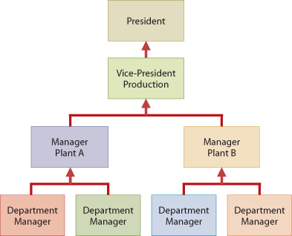

Budgeting and long-range planning

Differences:

- Long range planning: Usually 5 years or more instead of 1 max for normal budget.

- Emphasis on long-term goals, strategies and policies development.

- Anticipated trends in economic and political environment and how to react to them.

The master budget

Budget is a shorthand term to describe several budget documents. All these documents are combined into a master budgets (interrelated document).

The master budget is divided in 2 :

Operating budgets: are the individual budgets that are used to prepare the budgeted income statement. These budgets establish goals for the company's sales and production personnel

Financial budgets: are the capital expenditure budget, the cash budget, and the budgeted balance sheet. These budgets focus mainly on the cash resources that are needed to fund expected operations and planned capital expenditures.

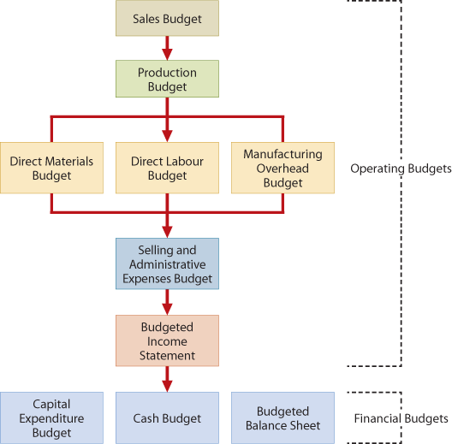

Preparing the operating Budgets

(1) Sales Budget

- The sales budget is the 1st budget that is prepared.

- Each other budget depends on the sales budget.

- The S/B is derieved from sales forecast.

- Represent management best estimate of revenue for the period.

*Inaccurate S/B can affect net income. Too optimistic you'll have to sale at reduced Price. Too conservative will result in shortage in inventory, thus lost of sales revenues.

The sales budget is prepared by Multiplying the expected sales volume in unit for each product by its anticipated selling price per unit. ( Expected Sales volume X Anticipated selling price = Sales Budgeted )

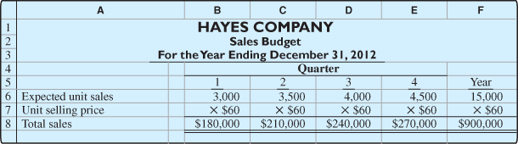

(2)Production Budget

The production budget show the units that must be produced to meet expected sales. Production requirement are determined with the FORMULA:

( in this formula WIP is ignored since for this cie. WIP is assumed to be NON-EXISTANT)

*A realistic estimate of ending inventory is essential to correctly schedule production requirement. Excessive ending inventory in one quarter may lead to cutback and employee layoffs in the next quarter. On the other hand, inadequate inventories may result in either added costs for overtime or lost sales.

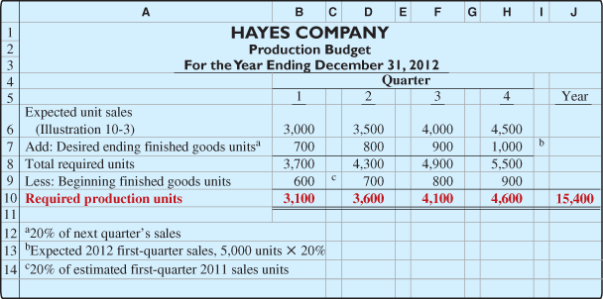

- The Production budget, in turn, becomes the basis for determining the budgeted costs for each manufactuiring cos element.

(3)Direct Meterials budget

DM budget shows both the qty and cost of direct materials that need to be purchassed. The quantities of DM to purchase are determined by this FORMULA:

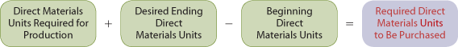

The budgeted cost of DM to be purchased is then calculated by multiplying the required units of DM by the expected cost per unit. (Required units of DM X Expected cost per unit).

*The desired ending inventory is a Key component in the budgeting process. Inadequate inventories could result in a temporary shutdowns of production.

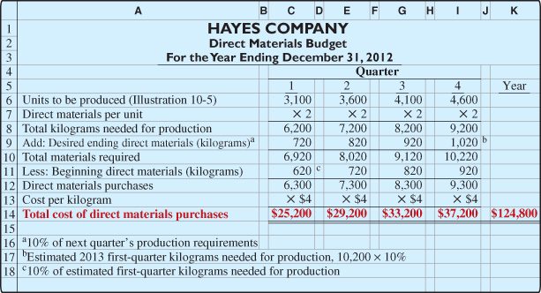

(4) Direct labour Budget

Like DM budget, the DL budget contains quantity (hours) and cost of DL that will be needed to meet production requirements. The total DL cost is calculated using this FORMULA:

*DL labour hours are determined from the production budget.The DL budget is critical in maintaining a labour force that can meet the expected Levels of production.

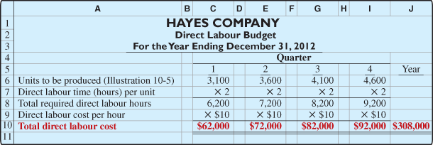

(5) Manufacturing overhead budget

The MOH budget shows the expected MOH for the period. MOH are distinguishses between VOH and FOH.

(Detailed calculation p.435)

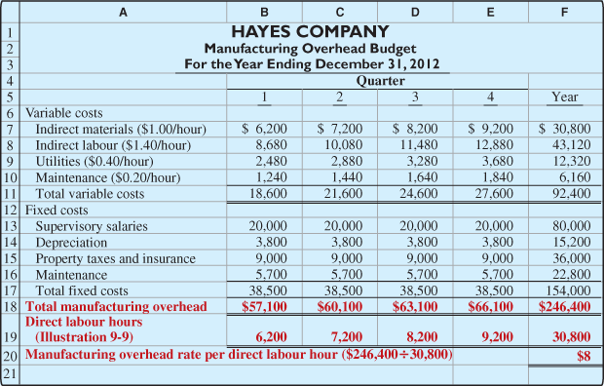

(6) Selling and Administrative expenses Budget

This budget projects selling and administrative expenses for the budget period. Expenses in this budget are also divided it 2 categories (Variable S/A and Fixed S/A).

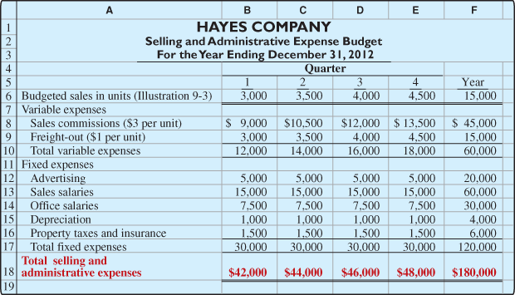

Budgeted Income Statement

The budgeted income statement is an important end product of the operating budget, This budget shows the expected profitability of operations for the period. It provides basis for evaluating company performance. The budgeted income statement is prepared using the various operating budget for the period.

(All calculations p.436)

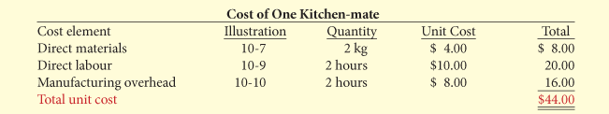

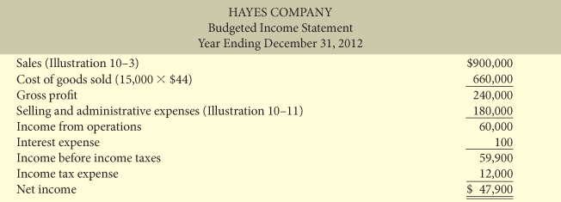

Preparing the Financial Budgets

(1) Cash Budget

The cash budget shows expected cash-flow. Because cash is so vital, this budget Is often considered to be the most important output in preparing financial budgets. Top help treasurer manage the cash well, cash budget is typically prepared at least once a month and sometime even daily.

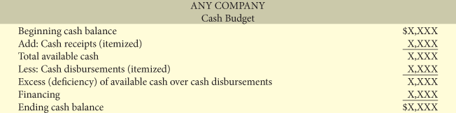

*Cash budget contains (3) sections :

- Beginning Balance

- Cash receipts : Includes ecpected receipts from the company'S main operations. These are usually cash sales and collection form customers on credit sales. Shows also anticipated receipts of interest and dividends and proceeds from planned sales of investment, plant assets and copany capital stock.

- Cash disbursements: Shows expected cash payements including: DM,DL,MOH and S/A expenses. Also displayed in this section : projected payment for income taxes,dividends,investments and plant assets.

- Financing: Showsexpected borrowings and repayment of borrowed funds plus interest. This section is needed when there's cash deficiency or when the cash balance is below management's minimum required balance.

- Ending Balance

( info about cash budget example p.438-439)

*****Depreciation expense, gains and losses on disposals of assets, and accruals are non-cash amounts that will not appear on the cash disbursements budget.

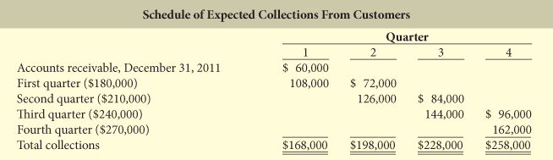

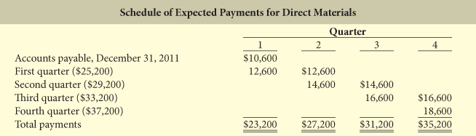

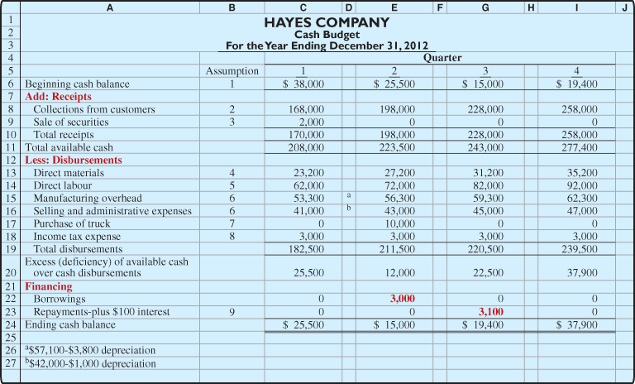

Budgeted Balance Sheet

The Budgeted balance sheet is a prohection of the company's financial position at the end point of the budget period. This budget is developed from the budgeted sheet for the preceding year and the budgets for the current year.

Info:

Buildings and equipment | $182,000 | Common shares | $225,000
Accumulated depreciation | 28,800 | Retained earnings | 46,480

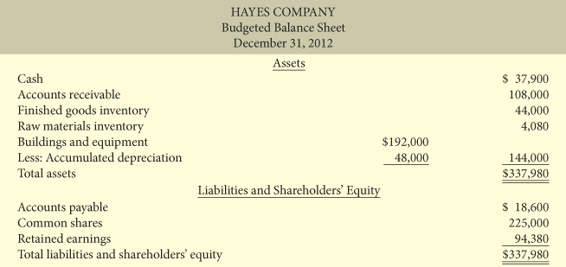

(All calculations p.441)

Budgeting in Non-Manufacturing Companies

Merchandisers

The sales budget is also the starting point and the key factor in the development of the master budget. Same as in Manufacturing operation.

The 2 major differences:

- Merchandiser uses a merchandise purchases budget instead of a production budget.
- Merchandiser does not use the manufacturing budgets (DM/DL/MOH) .

*The merchandise budget shows the estimated cost of goods to be purchase to meet expected sales. FORMULA:

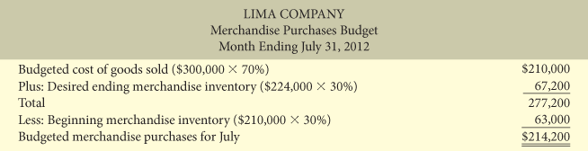

(Calculations / info p.443)

Service Enterprises

Budgeting is about coordonating professional staff needs with expected services. If a firm is overstaffed, several problem may result:

1-Labour cost will be disproportionately high.
2-Profit will be lower because of aditional salaries.
3-Staff turnover may increase because there is not enough challenging work.

If understaff problem may result:

1-Lost of revenue due to the incapacity to meet current and future client needs
2-Professional may look for other jobs because their workload are too heavy.

Buget data for service enterprise may be obtained from expected output or expected input.

- When using output Important to determined expected billings of client for service provides.(output would be the sum of auditing,tax, and cusulting services)

- When using input each individual professional staff is required to project is or her time that will be billed. Billing rate are then applied to his billable time to calculate the expected service revenue.

Not-For-Profit organizations

Budget is usually based on cash-flow (expenditure/receipts), rather than on a revenue and expenses.

- Starter point is usually the Expenditures, not receipts.
- Management task generally is to find the receipts needed to support the planned expenditures.

