Acco 240 Chapter 9
21 mars 2015
14:45

External sales :

Same uniform product: price is set by the market force ( supply/demand law) TARGET COSTING.

Different unique product : price is set by the company TARGET SELLING PRICE.

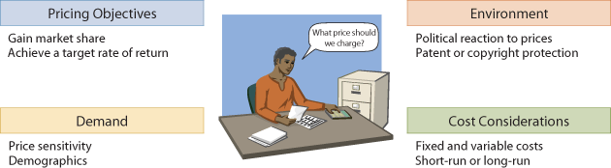

Target costing: (use Market price and desired profit )

(** The target costing is use in competive market, instead of setting is own selling price , the company need to focus on their cost in order to acheive their desired profit since the price is set by the market. Law of supply demand )

- To be use in a competitive, common-product environement where the market price is already set, and instead the company must set a target price.

Formula:

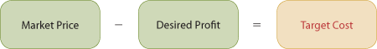

Three cost-plus pricing methods : (Full/Absorption/VC)

(** The cost plus formula is used to set selling price in less competitive or non-competitive market )

Full cost-plus Pricing: ( use Total Cost )

- To be used in less competitive market or non-competitive environement, the company have to set is own price.

- In this approach company determines a cost base and adds a markup to the cost base to determine a target selling price. The size on the markup depends on the desired ROI or operating income for the product line, product or service.

- In determining the proper markup, the company must consider how the cost base is defined.

Formula :

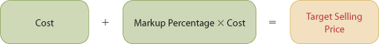

(1) Calculate Varibale Cost / Unit

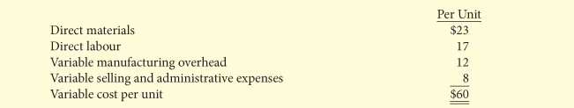

(2) Calculate Fixed Cost/Unit
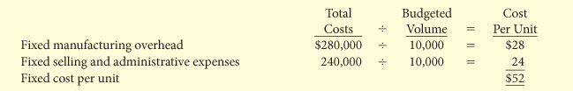

(3) Calculate Selling price using ( Total cost + ROI )

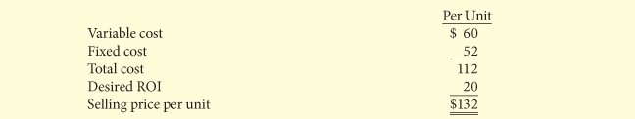

Formulas:

Mark up%:

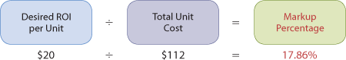

Target selling Price/ unit :

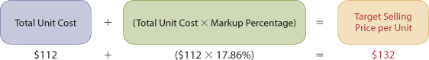

Advantage /Limitation of Full Cost-Plus pricing :

- Major advantage : Simple to calculate

- Limitation : does not consider the demand side. (Set the price ou want but you dont know if there's buyers willing to pay that price ).

- Limitation : Sale volume play a large role in calculating the per-unit cost. (The lower the sale volume, the higher the price to meet the ROI ), because the fixed cost and the ROI are spread over a fewer units, and therefore the fiexed cost / unit and the ROI/ unit increase. The oposite effect would occur ( the higher the sale volume the lower the price to meet ROI ), because fixed cost and ROI would be spread over a larger number of units, and therefore the fixed cost/ unit and ROI / unit would decrease , utilmately decreasing the selling $ per unit.

- Since we are using the budgeted sale to calculate pricing if the Bugeted sale volume is higher then the actual sales the company will lose money unless it raise its selling price. ( Same is also true )

Absorption Cost-Plus Pricing :(use Manufacturing Cost)

- The absorption cost-plus approach is consistent with GAAP beacause it defined the cost base as the manufacturing cost.

- Both Variable and fixed selling/andministrative cost are excluded from this cost base.

- Under this method we use the markup to provide for selling / admin. Costs plus the ROI.

(1st step) Calculate the manufacturing cost/unit.

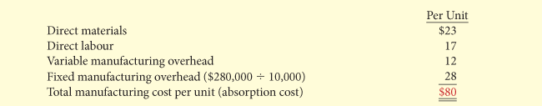

Information on Variable and Fixed S/A per Unit and ROI per unit.
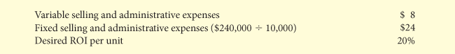

(2nd step) Calculate Markup % (must cover ROI and S/A expensed per unit)

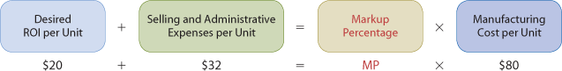

(3rd and final step) Set the target price

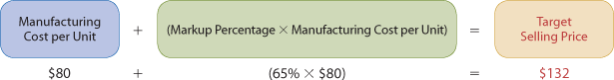

**Absorption- cost Income statement using the information found above:

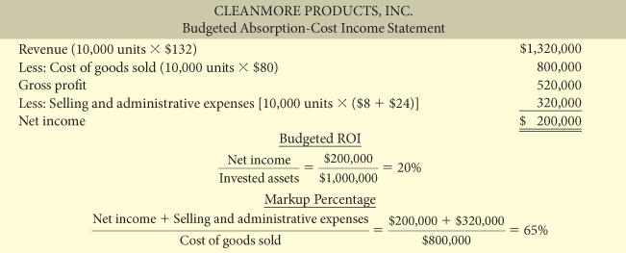

- Bugeted ROI is calculate.

- Because of the fixed cost element, if more than 10 000 units are sold, the ROI will be greater than 20% and if fewer unit are sold the % will be less than 20%.

- Markup percentage is verrified. (By adding net income and the cost Selling/adimin. Expense together and devide by COGS or cost base )

Advangtage of Absorption and Full costing method

***Most companies that use cost-plus pricing, will use Absorption cost or Full cost as the basis, because:

- Company's cost accounting system provide absorbtion costing info. More easily, because they already exist in general leger. ( more cost effective )

- Basing the cost-plus formula on only Variable cost could encourage management to set price too low in order to boost the sale and could create a suicidal price-cutting when using V.C. for full cost.

- Absorption and Full cost are the easiest basis to defend when prices need to be justified to all interesseted parties.

Variable Cost-Plus Pricing (use only the VC)

- This method is more useful for making short-term decision since it consider VC and FC behaviour pattern separately.

- Under this method the cost base consist of all variable cost including variable selling and admin Cost.

- Because fixed cost are not included in the base, the markup must cover all fixed cost (included Fixed s/a) and the target ROI.

(1st step) Calculate variable cost per unit

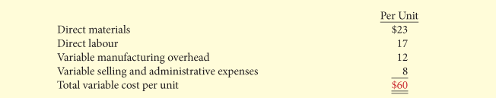

(2nd step) Calculate the markup % using this Formula

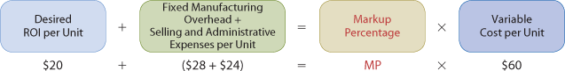

*Unlike for the Absorption method, now we only use F s/a cost and to this amount we add the FOH.

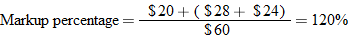

(3rd step ) Set target selling price using this formula

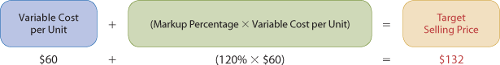

*Always use the proper cost base for the method

**Variable cost income statement using the information found above:

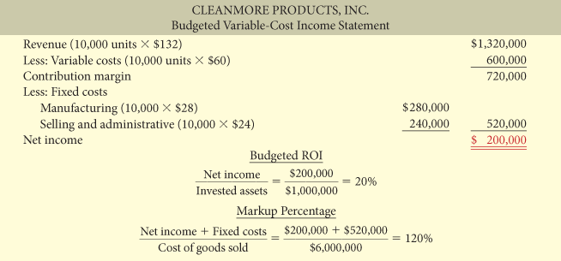

- Bugeted ROI is calculated the same way in both Absorption and Variable costing method

- Markup % is verrified by adding Net income and the fixed cost together and diving by COGS

Disadvantage of using Variable costing :

- Manager may set price too low and consequently fail to cover fixed costs. In the long-run it will lead to losses.
As a result campanie using VC must use a higher markup in order to set a price that will give them a fair return.

- Under any of the 3 methods, the company will reach his desired ROI only if they reach the budgeted sales volume for the period.

- Reaching ROI is the result of many factors and some of these are beyond company control such as : Market conditions/political and legal issues/ customers' tastes/Competitors' actions.

Reason for using Variable costing approach :

- Being based on Variable cost, its more consistent with the CVP analysis that manager use to measure the profit implication of change in price and volume.

- Provides the type of data that managers need for pricing special orders. It shows incremental cost of accepting one more order.

- It avoid arbitrary allocation of common fixed cost such as executive salary to individual product lines.

Time and Material pricing (use labour rate and material rate)

- This method is widely used for service company, especially professional firms such as public public accountant, law firm , engineering, construction company etc.

- Under this approach, the company set 2 pricing rate : 1 for the labour used on a job and 1 for the material used on job.

- The labour rate include : Direct labour time and other employee costs

- The material charges are based on the cost of direct part and materials used and a material loading charge for related overhead cost.

Example : Lake Holiday Marina Boat repair shop.

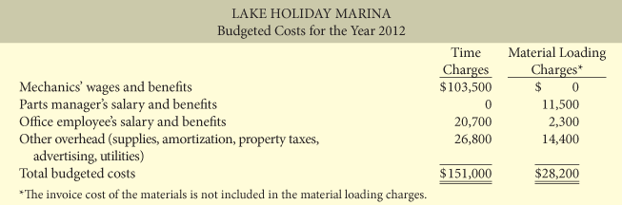

(1st step) Calculate the labour charge per hour

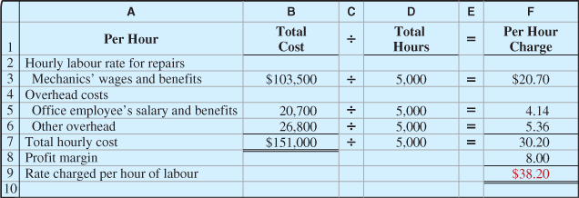

The labour per hour charge include:

1- Direct labour cost of employee including the hourly rate or salary and the fringe benefit.
2- Selling/ admin and similar overhead cost.
3- Allowance for desired profit or ROI of employee time.

(2nd step) Calculate the material loading charge

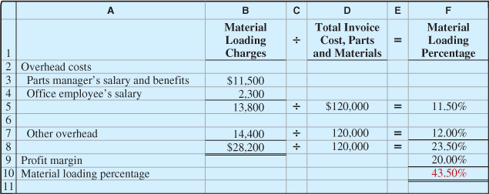

To determine the percentage of material loading, company does the following:

1- Estimate the annual costs for purchasing, receiving, handling and storing the materials.
2- It devides this amount by the total estimated cost of part and materials.
3- It adds a disred profit margin on the materials themselves.

(3rd step ) Calculate charges for a particular job

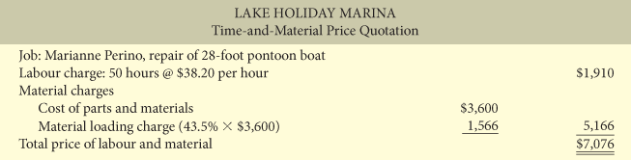

The charge for any particula job are the sum of :

1- Labour charge.
2- The charge for materials.
3- The materials loading charge.

Internal Sales :

Vertical growth; means that the company expands in the direction of either its suppliers or its
customers.

Transfer pricing

*The Transfer price is the price used by a company to record the internal transfer of goods between two divisions.

- The price charged for intermediate goods is the cost of goods sold to the buying division and the revenue to the selling division.

- A high transfert price will result in a high revenue for the selling division and a high cost for the buying division. ( vice-versa)

- Transfert price can be a subject of high desagreement and can be beneficial for a division but hurt the company as a whole.

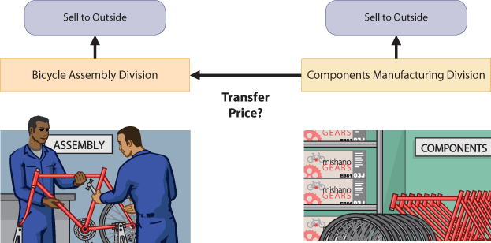

Three Objective for transfert pricing policy :

1- Promote goal congruence: Should motivate division managers to choose actions that maximize company earnings as a whole and it should allow each divison manager to take decison that maximize the divisons earnings.

2-Maintain devisional autonomy : Top management should not interfere with the decision-making process of division managers.

3- Provide accurate performance evaluation: The policy should make it possible to accurately evaluate the division mangers involved in the transfer.

Formula :

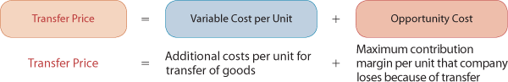

***Key Elements :

- The minimum price that the selling divsion is willing to accept and th maximum price the buying division is willing to pay.

- For the selling division the minimum transfer price is the price that it needs to charge the buying division so that the selling division would not be better of selling to outside buyers .

- For the buying division the maximum price is determined by the outside market. That is the price that the buying division would have to pay to the outside market in order to have teh same product.

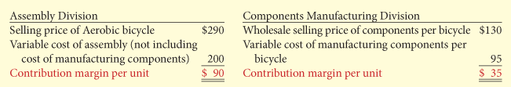

2 different situation for transfer pricing

First situation : No excess capacity (full capacity)

Since there is no excess capacity , its means that all the unit produced are sold , so the minimum transfer price would be the selling price that the division charge to outside buyers or the Max CM that company loses because of the transfer.

P.384(more info)

Formula (No excess capacity)

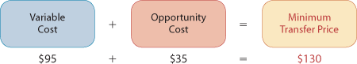

Second situation : Excess capacity (available capacity)

The division production is greater than the sale volume there for the division has excess capacity . In this situation the selling division will accept a minimum selling price much lower than if they were at full capacity. In order to sell his excess capacity the selling division must received a price that will at least cover his variable cost per unit. Otherwise it make no sense to sell its products.

P.385 (more info)

Fromula (Excess capacity )

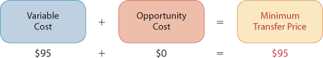

Three approaches for determining transfer price

(1) Negociated transfer price:

- Determined through an agreement by division managers

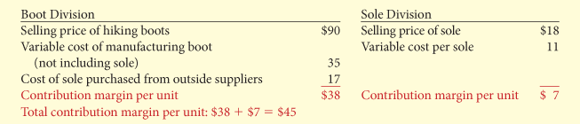

No excess capacity (full capacity)

- The selling division must received a price covering its variable cost plus its lost contribution margin(oportunity cost) in order to sell to the other division . In other words, it means that the selling division must received the market price at which it sales is units to outside buyers in order to accept the transfer.

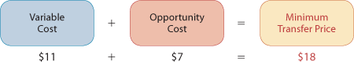

- From the buyer point of view the maximum price he's willing to pay is the price he would pay an outside supplier to have the same product. If the buying division can pay less than the minimum price offered by the selling division by purchassing it's product on the external market, there will be no deal between the two division.

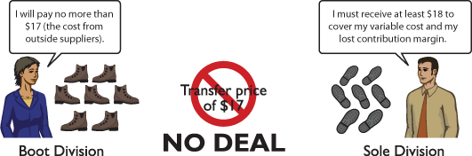

Excess Capacity ( available capacity )

-At excess capacity the selling division would accept a minimum price that at least cover it's variable cost. The opportunity cost would be 0 since not all unit are sold and therefore they would not be giving up anything by acccepting the transfert.

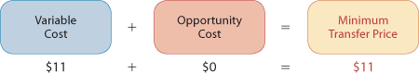

** So under the negocitaed transfer price approache Given excess capacity we use a range from the minimum selling price at excess capacity to the maximum price willing to pay by the buyer to negaciate the transfer price. In this case the range of negociation should be between $11 and $17.

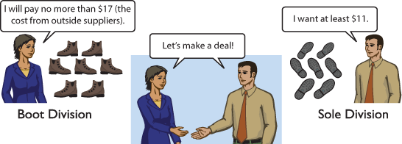

Summary : (need excess capacity or higher market price for a deal to happen )

Under negociated transfer-price, the selling divison set the minimum transfer price ($11) and the buying division set the maximum transfer price ($17). This system provides a sound basis to negociate transfer price since both division are better off if they use proper decision rules.

Limitations of transfer price (not often used)

- Market price information is something not easily obtainable.
- Lack of trust between the two negotiating division may lead to a breakdown of negotiation.
- Negotiation often lead todifferent pricing strategy which is not easy to work with and somtime costly to implement.

(2)Cost-Based tranfer prices (good Excess)

- Base the transfer price on the cost of the division that produce the goods or service.
- Price may be based on variable cost alone or Variable cost + fixed cost.
- The selling division may add a markup

Limitations

- Under this approach, divisions sometimes use improper transfer prices. This leading to a loss of profitability for the company and unfair evaluation of division performance.

- Cost base does not present division's true profitability.

- Does not provide selling division enough incentive to control its costs (whatever what the cost are they're passed on the next division). Company try to control that component by using standard costs instead of actual costs.

**Cost based is easy to understand
**Easy to use because information is already available in accounting system
**Market information is not something available

Therefore the cost-based method is the most used method by companies.

Under this method CM. Is greater for the buyer division and Lower for the selling division after transfer.

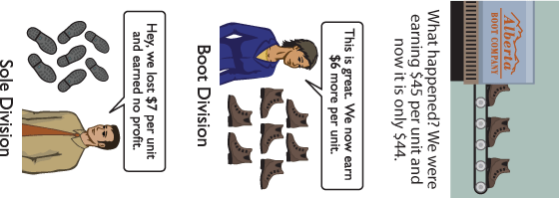

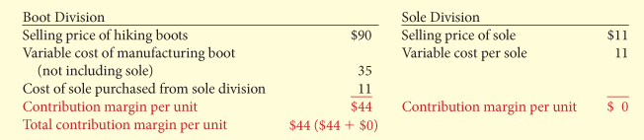

P.389( for explication of what happen when No excess/excess capacity occurs )

(3)Market Based Transfer Prices (good when No excess)

- Based on the actual market price of competing goods or services

- Considered best approach because its objective and generally provides proper economic incentives.

- In many case there"s no well-defined market so a reasonable market value canot be determined, therefore companies may use a cost-based system.

Under this method the selling divison wont care if they sale internally or externally since the price used for both will be the same. The buying division will also be staisfied since they don't pay more that if they were purchasing on the external market.Both division would have the market price. One receiving it and the other one paying it.

When selling division has excess capacity Market based transfer price is not good because it sales to the other division at market price when it shouldnt .Only the variable cost of the product that should be paid since we recall that when we have excess capacity the oportunity cost = 0 .Thus if the manager of the buying division is not inform that the selling division has excess capacity it could lead to losses for the whole company since the manager could add a markup% to the product and as a result overprice it.

Outsourcing on transfer pricing

Outsourcing: Buying from supplier instead of doing it internally.

As companies increasingly relying on outsourcing fewer component are transferred internally between divisions, reducing the need for transfer prices.

Transfers between divisions in different countries

More company globalize, more transfers are happening between division in different countries.

- The difference in tax can make transfer price difficult to to set.

- Company must pay income tax in the country where the profit is generated.

- Inorder to increase income and pay less tax, many company prefer to report more income in countries with low tax rate and less income in countries with high tax rate.

- They do this by adjusting the transfert price, More CM in countries where the income tax is lower and less CM where the income tax is higer.

- Manger of the company with the reduce CM margin might not be happy about the transfer price.

- The companie smust ask themselves whether its leagal and ethical to use the transfer price they are using.

- Companies will seek to reduce their tax amount but the have to obey the law (CRA transfer price regulation in canada) limit are also set .



