Acco 240 chapter 8
16 mars 2015
14:09

Inventory costing Methods

Absorption Costing: ( more for longterm decisions )

Under this method DM, DL and Both VOH and FOH are classified as Product costs. Because all manufacturing cost are charged to or absorbed by, the product (some FOH are expensed right away but some other are differed to future period as a part of ending inventory ). It's the approach use for external reporting under GAAP.

We use a normal income statement using COGS and Gross Profit.

*Net Income is affected by change in production level.

Variable costing: (use more for short-term decision )

Under this method only DM, DL and VOH are considered as product cost. FOH is considered as a period cost and is expensed when incurred (expense in the same period). Used for internal purpose anddecision making process.

We use CVP income statement under VC which mean , we calculate the Variable COGS+ V. sell/Admin. and CONTIBUTION MARGIN .

*Net Income is not affected by change in production level.

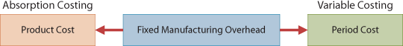

Illustration comparing absorption costing ans variable costing:

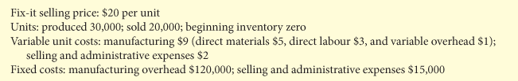

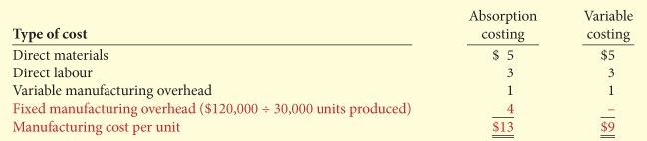

Absorption costing illustration:

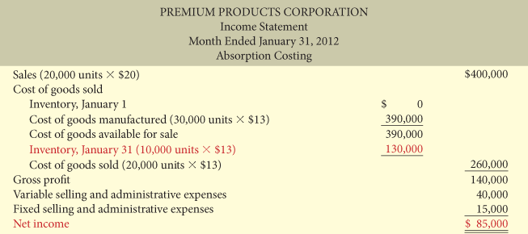

Variable costing Illustration :

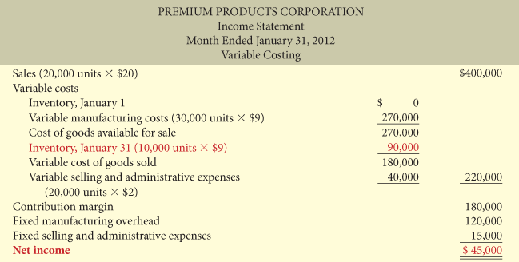

**There is one primary difference between variable and absorption costing: under VC the FOH is charged as an expense in the CURRENT PERIOD.

Illustration of production level vs sell level and their impact on Income under Both method:

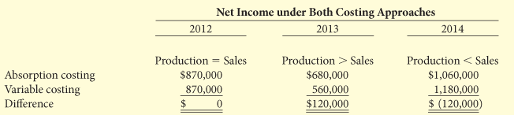

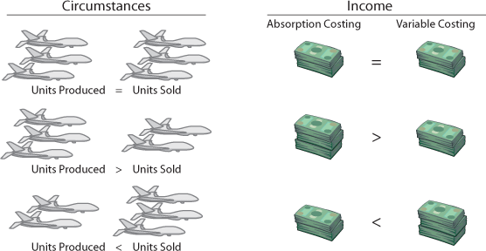

** The difference is the cost of ending inventory. Because under absorption costing we use the FOH as product cost which increase the value of ending inventory . ( all about Fixed cost and ending inventory ).

Decision-Making concerns

Performance evaluation:

Under absorption since not all the FOH are expensed in the period in which they are incurred some management could be tempted to over produce in order to show an Higher net income. Since the FOH not expensed during the period are differed as a part of ending inventory , it reduce cost of good sold and therefore virtually increase net income.

But sometime what is good for the management is not good for the company. As a cie. over-produced the build up of inventory cost more money to the company. Manager may make more money because the net income is increasing but at the end it cost more money to the company.

Under Variable costing the company would avoid this situation because net income under Variable costing is not affected by changed in
production level.

Potential Advantages of Variable Costing
Variable costing has the following potential advantages compared with absorption costing:
1. | The use of variable costing is consistent with the cost-volume-profit material presented in Chapter 6 and the incremental analysis material presented in Chapter 7.
2. | Net income calculated under variable costing is not affected by changes in production levels. As a result, it is much easier to understand the impact of fixed and variable costs on the calculation of net income when variable costing is used.
3. | Net income calculated under variable costing is greatly affected by changes in sales levels (not production levels), and it therefore provides a more realistic assessment of the company's success or failure during a period.
4. | Because the fixed and variable cost components are shown in the variable-costing income statement, it is easier to identify these costs and understand their effect on the business. Under absorption costing, the allocation of fixed costs to inventory makes it difficult to evaluate the impact of fixed costs on the company's results.

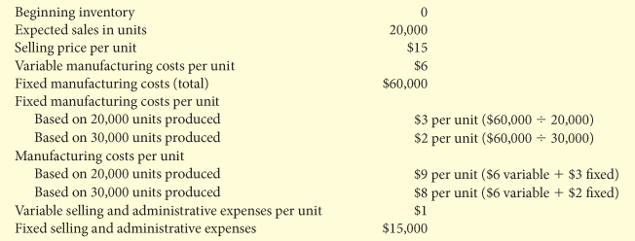

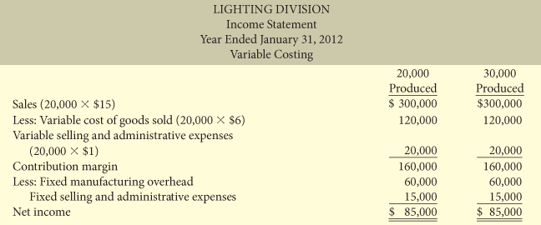

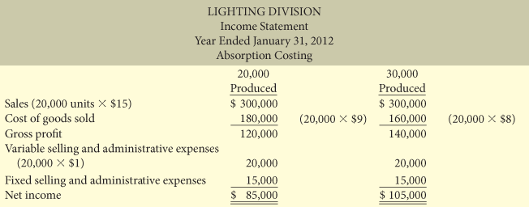

Normal costing: (absorbtion costing family)

Allocate overhead Using actual direct manufacturing cost and actual production units with a predetermined overhead rate. Using predetermined overhead rate is more pratical than assigning FOH cost to production.

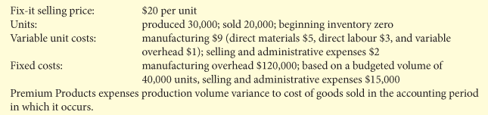

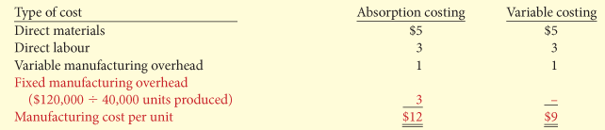
*per unit manufacturing cost.

Absorption and normal costing illustration:

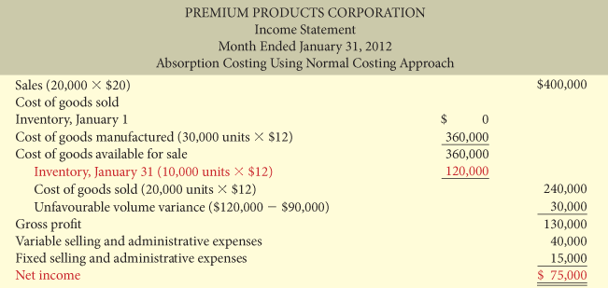

*Volume Variance is the amount of fixed overhead costs that are not allocated to a product because actual production varies from budgeted production. It's also known as fixed overhead volume Variance.

Formula:

( Actual Production - Budgeted production ) X Budgeted overhead rate = Volume Variance

*Fixed component of overhead rate

Reconciliation of absorption costing net income to Variable costing net income:

Absorption costing net income (Illustration 8A-3) | $75,000
Less: Ending inventory fixed manufacturing overhead | $30,000
Variable costing net income (Illustration 8A-5) | $45,000

Throughput costing/ super-variable costing: (Variable costing family)

Under throughput costing all costs are treated as period expenses except for DM.

Its based on lean manufacturing principles. According to this principles , cost can be reducedand profitability increased by improvement in manufacturing workflow. Help manage operation more efficiently and with more controle as it eliminate waste and focuses more accurately on customer's needs.

This method is suitable only for 1st companies that engaged in manufacturing proces in which conversion cost such as direct labour and manufacturing overhead are fixed cost and do not vary proportionaly with the units of production. Assembly line and continous process tat are highely automated are most likely to meet these craterion . 2nd craterion is the management favour cost accouting information that is helpful for short-term incremental analysis.

Through put vs variable:

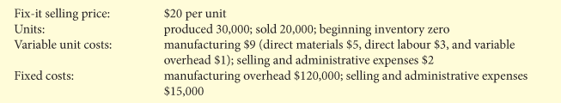

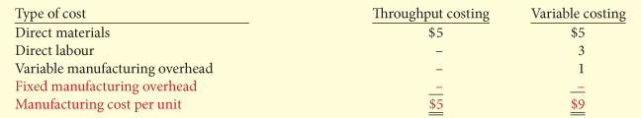

*The manufacturing cost per unit is $4 (9-5). Lower under throughput because we are only taking care on Direct Material cost.

Throughput Costing illustration:

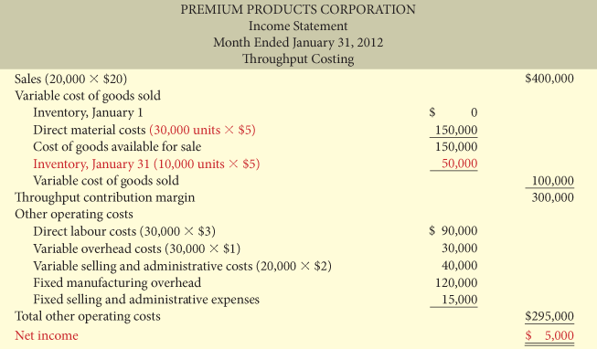

*Throughput Contribution Margin: Difference between Revenues and Material cost for the unit sold.

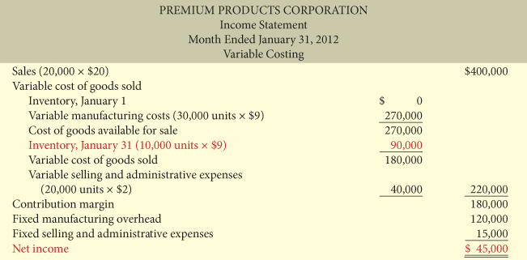

**Conceptually, there is one major difference between throughput and variable costing; under throughput, the direct labour and variable manufacturing overhead are charged as an expensed in the current period. Therefore, they are not differed to future periods through ending inventory. As a result variable cost will show a higher net income then throughput costing where ever there are more unit produced than sold.
Variable Costing Throughput Costing

Advantage of throughput costing:

- Reduce incentive for management to build excess inventories in order to spread fix manufacturing cost over a larger number of units produced.
- Encourage management to reduce operating cost such as DL and VOH which are treated as period cost NOT product costs.

**** When ask to reconcile throughput to variable costing or normal to absorption costing. It's always about the amount differed in ending inventory.

Throughput and VC:

(Ending inventory) X (VOH/unit+ DL/unit ) = Cost differed in ending inventory

Normal and Absorption:

(Ending inventory) X (actual FOH/unit - budgeted FOH/unit) = Cost differed in ending inventory
vox -

