Acco 240 chapter 6
February 16, 2015
1:14 PM

Cost-Volume Profit Analysis and Income Statement

CVP analysis : is the study of the effect that change in costs and change in volume have on a company's profits.

Basic Component:
- Volume or level of activity
- Unit selling price
- Variable cost per unit
- Total fixed cost
- Sales mix

Assumption underlying each CVP analysis:
- Cost and Revenue are linear throughout the relevant range of activity index (40-80%)
- All cost can be classified as Variable or Fixed cost
- Change in activity level are the only factors affecting costs
- Inventory level remain constant- All unit produced are sold
- When 1 or more product is sold, sales mix remain constant. Meaning that the % of total sales that each product represent will stay the same.
p.226

CVP income statement

Important for decision-making, Management often want CVP presented in an Income statement format.


*Relevant Information for income statement

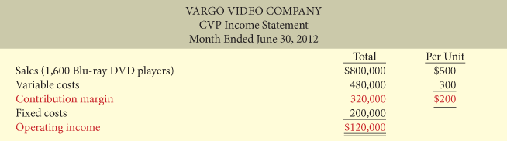

*CVP income Statement( with operating Income)

Company often prepare detailed CVP income statement.

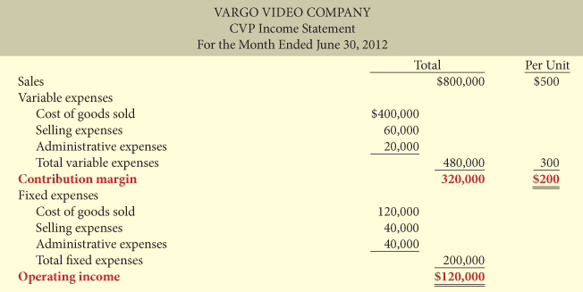

*CVP detailed income statement

Traditional income statement and CVP income statement both report the same bottom-line operating income.
However, a traditional IStatement Does not classify cost as variable or fixed, therefore would not report a contribution margin. In addition CVP often shows the per unit amount.

Contribution Margin

Contribution margin per unit: indicate that for every unit sold, the company will have to pay a certain amount to cover its fixed cost and contribute to operating income.

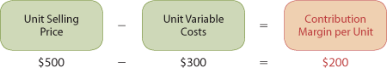

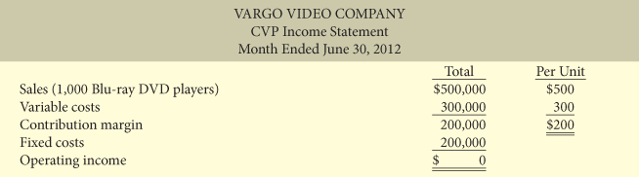

*Income statement assuming 0 operating income.

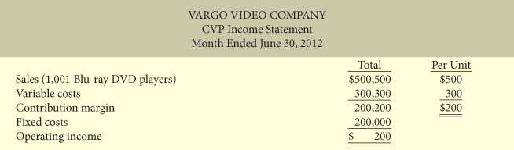

*Income statement, with operating income.

Contribution margin ratio: is the contribution margin per unit divided by the unit selling price.(usually %)

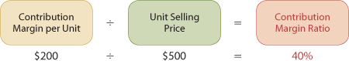

The contribution margin ratio of 40% means that (0.4$) of each sales dollar can be applied to fixed cost and contribute to operating income. Using Contribution margin ratio management can quickly determine what increases in operating income will result from any increases in sales.

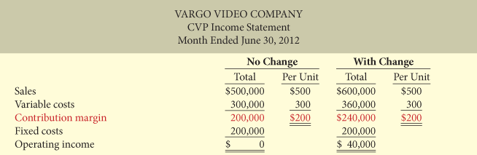

*Comparative Income statement at different level of activity

Applying Basic Cost-Volume-Profit concepts

Break-even analysis: Total revenues = total costs (Variable and fixed). At this level the company will realize no income and suffer no loss. At B-E point the operating income is 0.

Useful to management when decides whether to introduce a new product lines, change pricing on established product or enter a new market.

3 ways to calculate the B-E point:
- Mathematical equation
- Using contribution marging
- Derived from a CVP graph
The B-E point can be expressed in sales unit or sales dollars.

Mathematical equation

The break-even point can be calculated directly from the equation by using unit selling prices and unit variable costs.



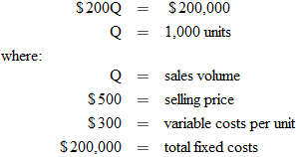

To find the sales dollars required to break even, we multiply the units sold at the break even point by the selling price per unit.

Contribution Margin Technique

We know that Contribution Margin = Total revenues - Variable cost. It follows that at break-even point, the Contribution Margin must = Total fixed cost. On the basis of this relationship we can calculate the B-E point by using either the contribution margin per unit (sales units) or the contribution margin ratio (sales dollars).

B-E point in units

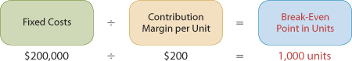

B-E point in Dollars

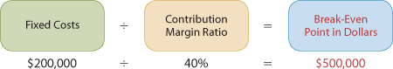

Graphic presentation

Using a graph showing Cost, Volume and Profits. (Cost -Volume-Profit graph).

- Plot total sales line starting at 0 activity level. (revenue line is assumed linear throughout relevant range).
- Plot the total fixed cost using a horizontal line. The fixed cost stay the same at every activity level.
- Plot total cost line. This start at fixed-cost line and 0 activity level. It increase by the variable cost at each level of activity. (on the graph the amount of Variable cost can be derived from the difference between total cost and fixed cost line at each level of activity.)
- Determine Break-Even point from intersection of the total cost line and the revenue line. The Break-Even in dollar is find by drawing a horizontal line from B-E point to vertical axis and the Break-Even in unit is find drawing a Vertical line from B-E point to the horizontal axis. A CVP graph also shows Operating income and net loss area.

Useful for management since they can quickly see the effects of a change in any element in the CVP analysis.

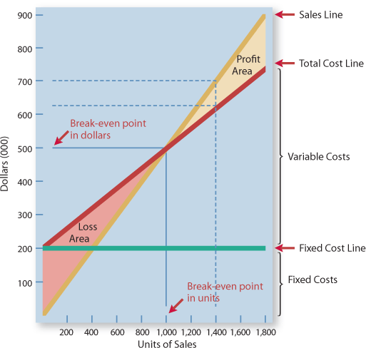

Target operating income before and after tax

Target operating Income: set by management as an income objective for a product line, it indicates the sales the company needs in order to achieve a specified level of income.

3 ways to determined the sales necessary to achieve the target:
- Mathematical equation
- Contribution margin technique
- Graphic Presentation

Mathematical

Required sales may be presented in sales unit or sales dollars.



The sales dollars required to achieve the target are found by multiplying the units sold by the units selling price.

Contribution Margin Technique

Required Sales in Units

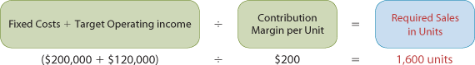

Required Sales in Dollars

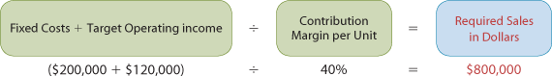

Graphic Presentation

The CVP graph can be use to find the sales required. In the profit area of the graph, the distance between the sales line and the total cost line at any point equal operating income.

Target Operating Income after Tax

Management may want to know the effect of taxes on operating income and to set target for operating income after taxes.

After taxes formula:

Before taxes formula: ( to know the what the amount before taxes need to be in order to achieve a target of operating income after taxes)

*Example to find target operating income before tax.

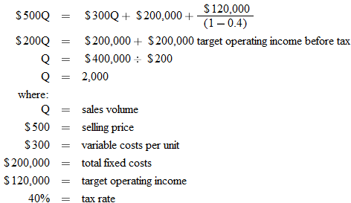

Contribution Margin technique

Required Sales in Units



($200,000+($120,000/(1-0.4))) / $200 = $2,000 units

Required sales in Dollars



$400,000 / 40% = $1,000,000

Margin of safety

Margin of safety is the difference between actual or expected sales and sales at the break-even point.
It measures the '' cushion'' that management has, allowing it to still break-even if expected sales fail to be reached.

Margin safety in Dollars

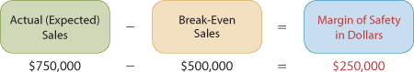

*This means that the company's sales could fall by $250,000 or 500 units before operating at loss.

Margin safety ratio

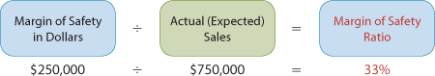

*This means that company's sales could fall by 33% before operating at loss.

The greater the dollar or the % the greater the margin of safety will be.

Sales Mix

Sales mix is the relative proportion in which each product is sold when a company sells more than one product.

Break-Even Sales in units

Cie. can calculate break-even sales for a mix of 2 or+ by determining weighted-average unit contribution margin of all the products.

Sales mix as a function of units sold

Per-unit date-sales mix
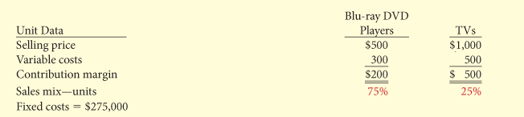
*related information

To find break-even point we then determine the weighted-average Unit contribution Margin for the two products

Weighted-Average unit contribution

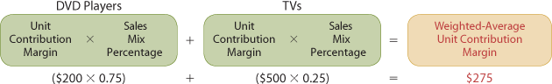

Then we use the Weighted-Average Unit Contribution Margin to calculate the break-even point in unit sales.

Break-Even point in unit sales

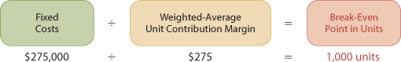

Break-even proof (sales units)

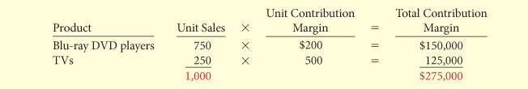

*Management should continually review the company's sales mix. At any level of units sold, operating income will be greater if higher contribution margin unis are sold, rather lower contribution margin units

Break-Even sales in dollars

The previous method work well for company who only has a small number of products.

*Information necessary for performing CVP analysis

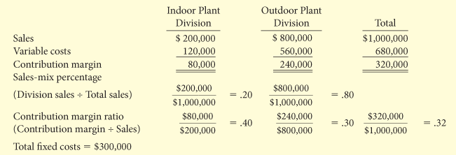

Weighted-Average contribution Margin Ratio

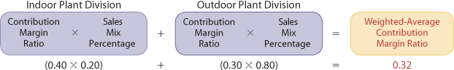

Break-Even Point in Dollars ( we use the W-Avg Contribution ratio)



