COMM 215
Chapter 1

Business Stats can be segmented into 2 categories:
Descriptive statistics (to describe data)
Charts
Graphs (histogram/bar chart/etc)
Numerical measures
Inferential statistics (to be able to draw inferences from the data)
Estimation: Looking closely at a subset of a larger data set.
Hypothesis testing

Procedures for collecting data:
Experiments: collect data (new vs old, test diff temperatures/diff durations/etc)
Produces a single outcome whose result CANNOT be predicted with certainty
“Experimental design”: a plan for performing an experiment in which the variable of interest is defined
Telephone surveys
Closed-ended questions (yes/no)
Demographic questions
Limited scope and length
Written questionnaires and surveys:
similar to telephone
OPEN-ended (more difficult to analyze) and CLOSED-ended questions
SEE TEXTBOOK PAGE 10
Direct observations:
Data being collected is observed and based on what takes place in the process.
Time consuming
Personal interviews: structured
Potentially biased by observer
Costly

Data Collection Issues: SEE PAGES 12-13
Data accuracy
interviewer bias (leads to a specific response. should be neutral)
non responsive bias (can’t draw an accurate conclusion)
selection bias (should make sure people are neutral)
observer bias
measurement error
internal validity (data must be only to do with that specific study)
external validity

1.3 Populations, Samples, and Sampling Techniques

Frame: List of all objects (which are each called “Sampling Units”) in the population
Population: whole set/group of objects from which we want information
Sample: subset of that population (its too expensive and time consuming to study an entire population, and often less room for human error)
Census: Official count or survey of entire population.

Parameters [population]: descriptive numerical measures (average/proportion/etc) computed from an ENTIRE POPULATION. (generally not known because population is too large)
Statistics [sample]: Corresponding measures computed for a SAMPLE.

Sampling Techniques:
(both have the objective of obtaining a sample to closely represent the population)
Statistical (aka Probability Sampling): Sampling method that allows every item in the population to have a known or calculable chance of being included in the sample.
Simple random sampling
Stratified random sampling
Systematic sampling
Cluster sampling.
Non-statistical: Sampling method that uses convenience, judgement, or other non-chance processes. Subjective, gives more chance to some people than others.

Statistical Sampling (aka Probability Sampling) (p. 16-18)
Simple Random Sampling
Every possible sample has an equal chance of being selected
Selection may be WITH or WITHOUT replacement
Sample can be obtained through random number tables or computer generator
Stratified Random (most important and reliable method)
Divides population in subgroups (strata) according to some common characteristics (gender/income level/etc)
Has the potential to provide the desired information with a smaller sample size
Selects a simple random sample from each subgroup
Combines samples from all subgroups into one estimated result
Systematic Random
Decide on sample size: n (example: 500 students out of 20,000)
Divide ordered frame of N individs into groups of k individs: k= N/n (ex:20,000/500=40)
Randomly select 1 individ from 1st group (ex: 25th person out of the first 40; then every 40th person so 25, 65, 105, 145,…)
Cluster Sampling
Divide pop. into several clusters m, each equally representative of the population
Select a simple random sample from each cluster
Here all the items in the cluster can be used

1.4 Data Types and Measurement Levels
Data Types:
Quantitative Data: numerical. (dollars/pounds/inches/percentages)
Qualitative Data: categorical. (marital status/eye color/etc)

Time-Series Data: Same item (ex: sales of bread in a country) throughout years
Cross-Sectional Data: Different items (ex: sales of bread in 5 countries) all in a same year

4 Levels of Data Measurement:
Nominal Data: (Lowest Level) ex: a) Divorced, b) Married, c) Single, d) Other
Ordinal (or Rank) Data: (Mid-Level) ex: levels of income.
Interval Data: (Higher Level)
Ratio Data: (Highest Level) ex: Weight of packages/distance/money/time

Data Mining: electronic storage has permitted the greatest volume of data collection yet. Data Mining involves analyzing data for patterns and conclusions that aren't always immediately evident.

Chapter 2

2.1 Frequency Distributions and Histograms

Frequency Distribution
Discrete variables (data that can take on a countable number of possible values)

Ex: possible values: 1 to 11.
Discrete Data: Minimum possible value is 1, Maximum possible value is 11.
*When there is a small range of possible data, we can construct a Frequency Distribution Table to document the frequency of each possible value in the given data set.

Ex: Found 160 results for Philadelphia and 330 results for Knoxville.
If we want to compare these results on an equal scale, we need to compute relative frequencies.

Grouped Data Frequency Distributions
Continuous variable (Weight, Time, Length)

When constructing a grouped frequency distribution:
First, sort the quantitative data from low to high (this sorted data is called an array).
Then, define the classes for the variable of interest.
Must be mutually exclusive
Must be all-inclusive
Should be of equal width
Avoid empty classes if possible

The 4 steps for grouping data into Classes:
Determine the number of groups/classes to use.
Rule of thumb: Use between 5 and 20 classes
Use rule: 2^{k} ≥ n
In general, use fewer classes for smaller data sets/more classes for larger data sets.
Establish the class width.
The minimum class width is determined by the equation:
W= (Largest value - Smallest value)/ Number of Classes
If you need to round the number, round UP.
Ex: (30-0)/8=3.75, so class width of 4. (0-3, 4-7, 8-11, 12-15, …, 28-31)
Determine the boundaries for each class.
Class boundaries determine the lowest possible value and the highest possible value for each class.
Determine the class frequency for each class.
In the class 0-3, frequency is 8+8+22+22=60, 4-7 is 11+13+12+14=50, etc.

Histograms
Frequency Histogram: Puts classes into a more visual interpretation.
Frequency Polygon: (aka Line of Succession of points) connect all mid-points of each “rectangle” in the histogram, then connect with 0 line. Creates a closed shape.
Frequency Curve:
Ogive Curve: Cumulative Relative Frequency represented by a line of points. This can help to visually approximate a value that wasn’t in the given data, between 2 points that were given.
Joint Frequency Distribution: Data can be characterized by more than just one variable. A table can be constructed with both quantitative and qualitative data. (Parking Garage example)
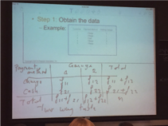

2.2 Bar Charts, Pie Charts, and Stem and Leaf Diagrams

Bar Charts: Don’t deal with numerical data on x-axis, so no need for intervals.
Pie Charts: Portions represent a bar chart on a 360 degree representation.
Stem and Leaf Diagram: Mostly used when we have small to medium sized data.

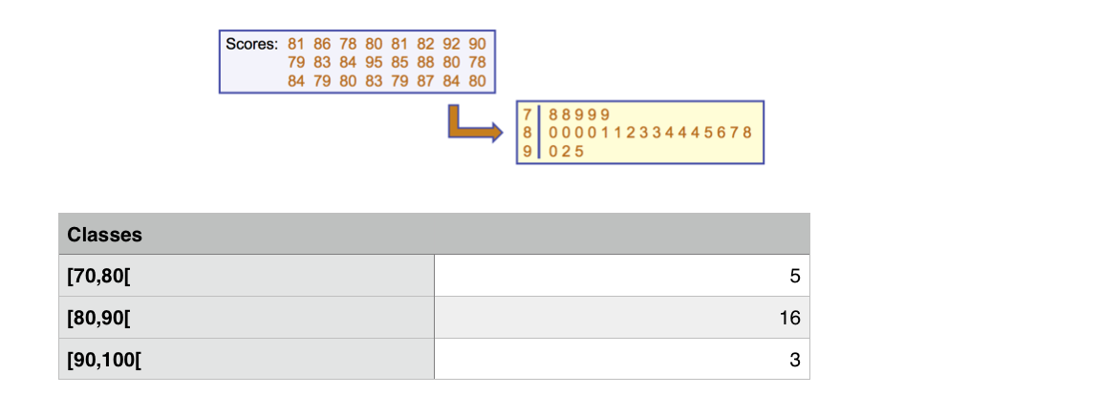

2.3 Line Charts and Scatter Diagrams
Line Chart: Data reported by DATE will be represented by a Line Chart.
Scatter Diagram: 2 variables. Important to determine which is dependent and which is independent.

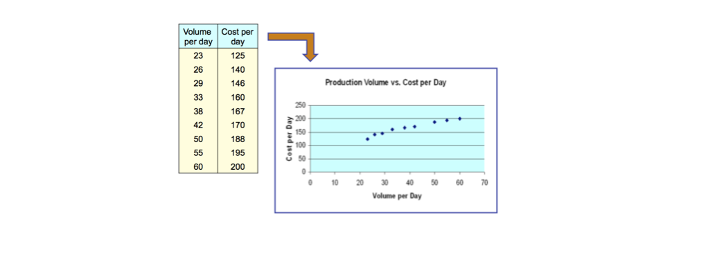

Interpretation: From this scatter plot, we can conclude the relationship is positive, where cost increases when volume increases. “Natural Logarithmic linear curve”

Chapter 3
3.1 Measures of Center and Location

( Parameters: Any quantity that I can compute on a population. )
( Statistics: Any quantity that I can compute on a sample of that population. )

Population Mean: Sum of all data divided by population size. (Formula: mu (μ) is a parameter)

Sample Mean: Sum of all sample values divided by sample size. (Formula: x-bar is a statistic)

Median (Md) : A center value that divides an array (numerical order) of data into two halves.

Skewed Data
Right-skewed: Mean is greater than Median.
Left-Skewed: Median is greater than Mean.
Symmetric: Mean equals Median.

Mode: Gives the most frequent value in the data set. Can be used for quantitative and qualitative data.
3.1.1 Other measures of Location

Weighted Mean: Multiply each weight by the data value, sum it up and find the mean.
(Example: Norwegian ski instructors)

Percentiles: Determine which percentile you’re looking for, use equation: i=(p/100)(n). (p=desired percentile, n=number of values in whole data set)

Quartiles:
1st quartile = 25th percentile (Q1) (25% or below)
2nd quartile = 50th percentile (Q2) = median
3rd quartile = 75th percentile (Q3)

Box and Whisker Plots: Used to graphically display quantitative data, and to identify any outliers (unusually small or large data values not really belonging to a majority).

Example: The sorted sample data showing the miles between fill-ups is as follows:

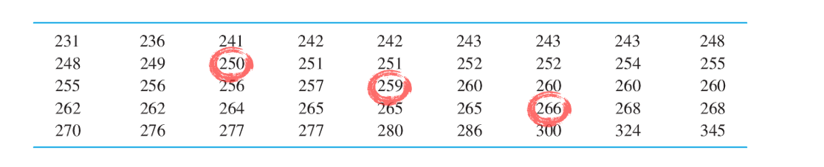
Step 1: Sort from low to high.
Step 2: Calculate Q1, Q2 and Q3.
i=(p/100)(n)=(25/100)(45)=11.25
Q1 will be the 12th value, which is 250 miles.
i=(p/100)(n)=(50/100)(45)=22.5
Q2 will be the 23rd value, which is 259 miles.
i=(p/100)(n)=(75/100)(45)=33.75
Q3 will be the 34th value, which is 266 miles.
Step 3: Draw the box with Q1 Q2 and Q3
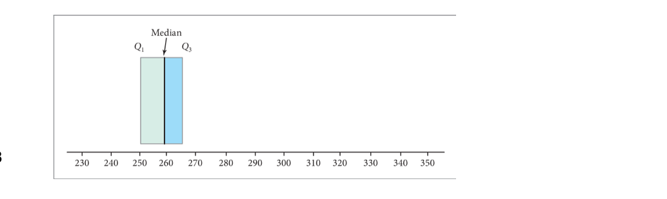

Step 4: Compute the upper and lower limits.
Lower limit = Q1 - 1.5 (Q3-Q1) = 250 - 1.5 (266-250) = 226
Upper limit = Q3 + 1.5 (Q3-Q1) = 266 + 1.5 (266-250) = 290
Any value outside of these limits is an outlier.
Step 5: Draw the whiskers and plot the outliers.
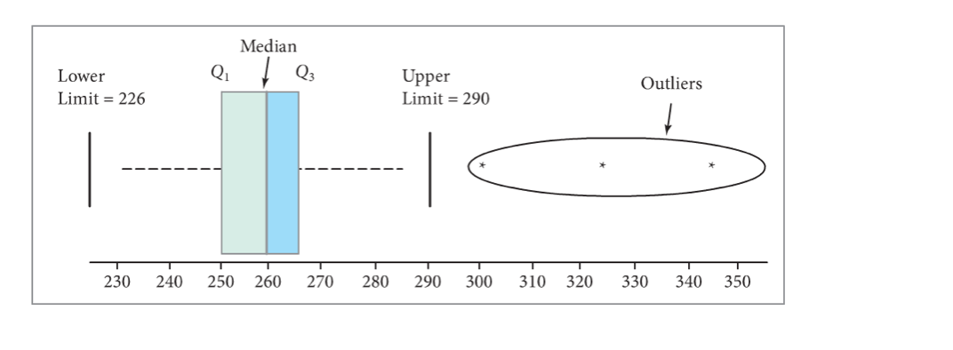
3.2 Measures of Variation
Range: Considered a weak measure of variation.
R = max value - min value
(Plant A: R = 30 - 15 = 15. Plant B: R = 27 - 23 = 4)
Interquartile Range: Eliminates outlier problems.
Interquartile R = Q3 - Q1

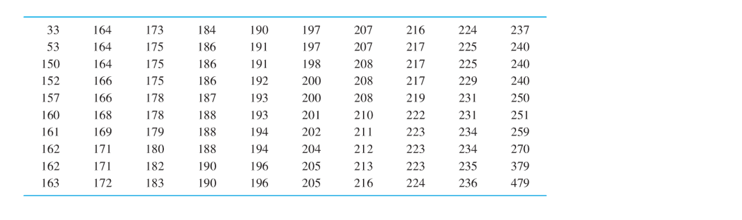
Step 1: Sort data into an array from lowest to highest.
Step 2: Compute the range using R equation.
R = 479 - 33 = 446.
Step 3: Compute Q1 and Q3.
Q3: i = (75/100)(100) = 75, thus Q3 is between the 75th and 76th data values.
Q3 = (219 + 222) / 2 = 220.50
Q1: i = 25
Q1 = (178 + 178) / 2 = 178
Step 4: Compute the interquartile range.
Q3-Q1 = 220.50 - 178 = 42.50

Population Variance
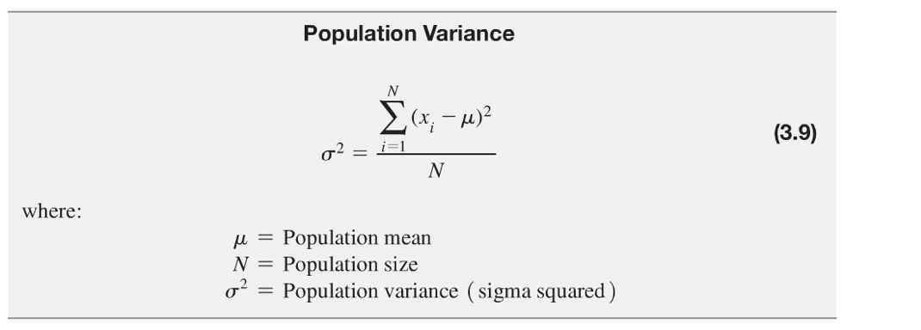
Step 1: Find mean.
mu = (sum of all x)/N = 125/5 = 25
Step 2: Subtract the mean from each value. Since some results will be negative, we will square the result.
Step 3: Square the (mean-value) results.
Step 4: Find sum of squared values and divide by sample size N.
250 / 5 = 50. “The population variance is 50 mobile homes squared”.

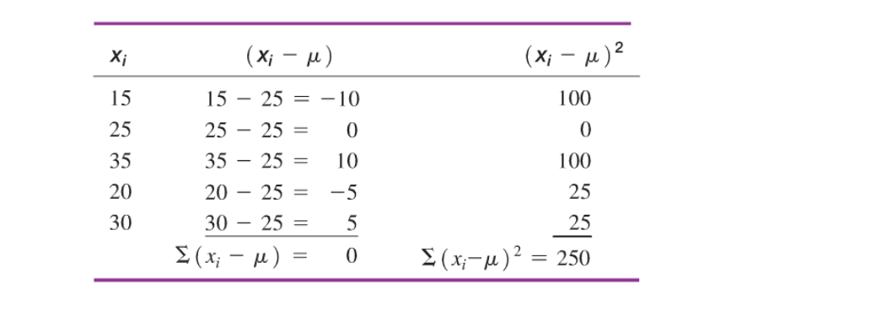Standard Deviation: For decision makers, the standard deviation indicates how spread out a distribution is. It is the positive square root of the Population Variance.
Since we cannot say “50 mobile homes squared”, we find the square root to get back to the original units of measure.
Therefore, “the population standard deviation of Plant A’s production output is 7.07 homes”.
(See example 3-11 p.106) 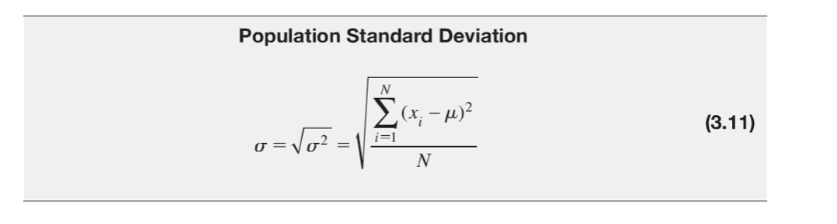
3.2.1 Sample Variance and Standard Deviation
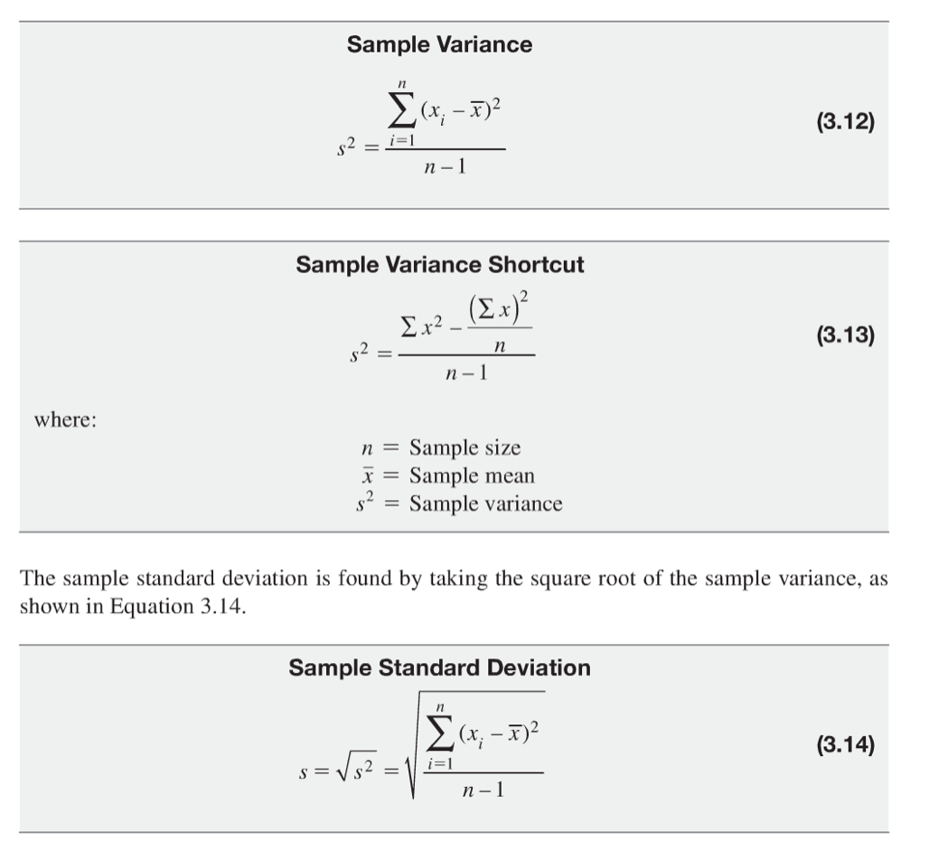
3.3 Using Mean and Standard Deviation together

For distributions having the same mean, the distribution with the largest standard deviation has the greatest relative spread. But when two or more distributions have different means, the relative spread cannot be determined by merely comparing standard deviations…

Coefficient of Variation (CV) : is used to measure the relative variation for distributions with different means.

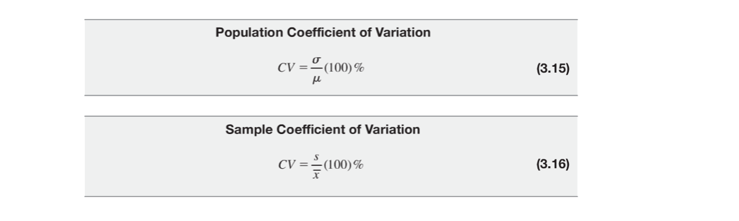

The distribution with the largest CV is said to have the greatest relative spread.

The Empirical Rule: For this rule to be used, the frequency distribution must be bell-shaped.
Example: mean = 15.1 s = 3.1
If we move 1 standard deviation in each direction from the mean, approximately 68% of the data should lie within the range: [12 — 18.2].
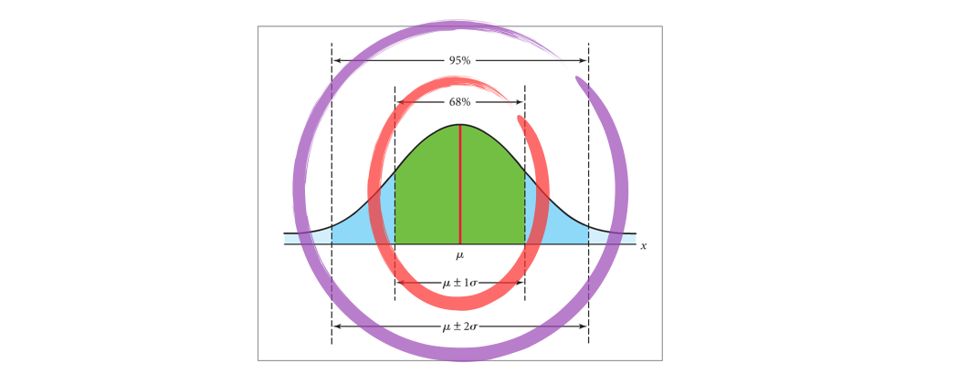
Approximately 95% of the data should lie with the range: [8.9 — 21.3].
Tchebysheff’s Theorem: Used in cases where a distribution is not bell-shaped. This theorem can be applied to any distribution. o+2s=75%, 0+3s=89%.

Standardized Data Values: Used when dealing with quantitative data. Especially useful when the data scales of two distributions are substantially different.

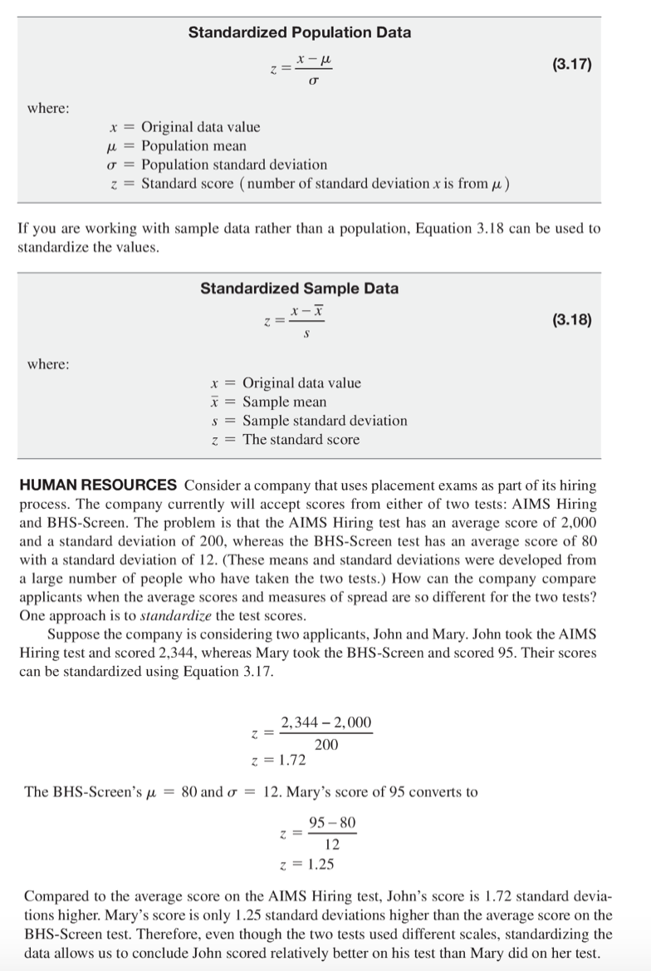

Chapter 4
4.1 Probability

Experiment: A process that produces a single outcome whose result cannot be predicted with certainty.

Types of events:
Mutually Exclusive events: Events do not occur at the same time.
Independent events: The occurrence of the first event in no way influences the probability of the occurrence of the other event.
Example: Toss a coin.
SS:{(HH), (HT), (TH), (TT)}
Event A: First toss is Head. A = {(HH), (HT)}
Event B: Second toss is Tail. B = {(HT), (TT)}
Dependent events: The occurence of one event impacts the probability of the other event occuring.

4.1.1 Methods of assigning probability

Classical Probability Assessment: Method is based on the ratio of the number of ways an outcome or event of interest can occur to the umber of ays any outcome or event can occur when the individual outcomes are equally likely.
P(E) = (# of ways E can occur) / (total # of possible outcomes)
Example: A: “even outcome” = {2,4,6}
P(A) = 3/6 = 1/2 = 0.5
Relative Frequency Probability Assessment: Method defines proability as the number of times and event occurs divided by the total number of times and experiment is performed in a large number of trials.
P(E) = (# of times E occurs) / N
Subjective Probability Assessment: Method defines probability of an event as reflecting a decision maker’s state of mind regarding the chances that the particular event will occur.
4.2 Rules of Probability

Probability of event occurring is ALWAYS between 0 and 1.
The sum of the probabilities of all possible outcomes is 1.
The probability of an event E is equal to the sum of the probabilities of the individual outcomes forming E.
The complement (Ē) of an event E is the collection of all possible outcomes not contained in event E.
P(Ē) = 1 - P(E)
Example: Population of 4 items: A, B, C, D. Select 2 items without replacement.
Sample Space: {(AA), (AB), …} (since this is too long to write, use tree diagram:
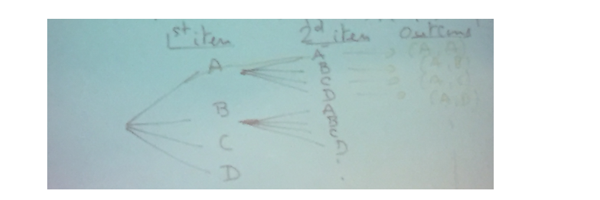
Event E: “item A is in the sample selected”
SS={AB, AC, AD, BC, BD, CD}
E={AB,AC,AD} (“Without Replacement” = The order is not important)
E occurs if the outcome of the experiment belongs to the subset E.
Event F: “Item B is selected”
F={BA,BC,BD}
“Either E or F will occur”: E U F = {AB, AC, AD, BC, BD}

“Both E and F will occur”: E∩F = {AB}
Rule of Addition: 80 male, 120 female. 25 male and accounting.
Select one student at random.
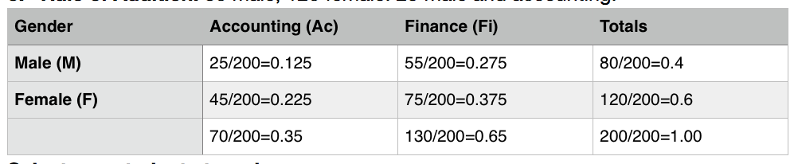

P[“Either male or Finance”]= P[“M or Fi”] = P(M)+P(Fi)-P(M and Fi) = (80/200) + (130/200) - (55/200) = 0.4+0.65-0.275= 77.5%

Mutual exclusivity:
Example: If you know that the student selected is a female. What then is the probability of her being in Accounting?
P [Ac⎟F] (“Probability of 1 event given that we know an event for certain”) = 0.225/0.6 = P (F and Ac)/ P(F)

*** P[F and Ac] is a joint probability of the events F and Ac (of all events).

*** P[Ac⎟F] is a conditional probability, where Ac(uncertain event) happens given F(certain event).

Multiplication Rule.
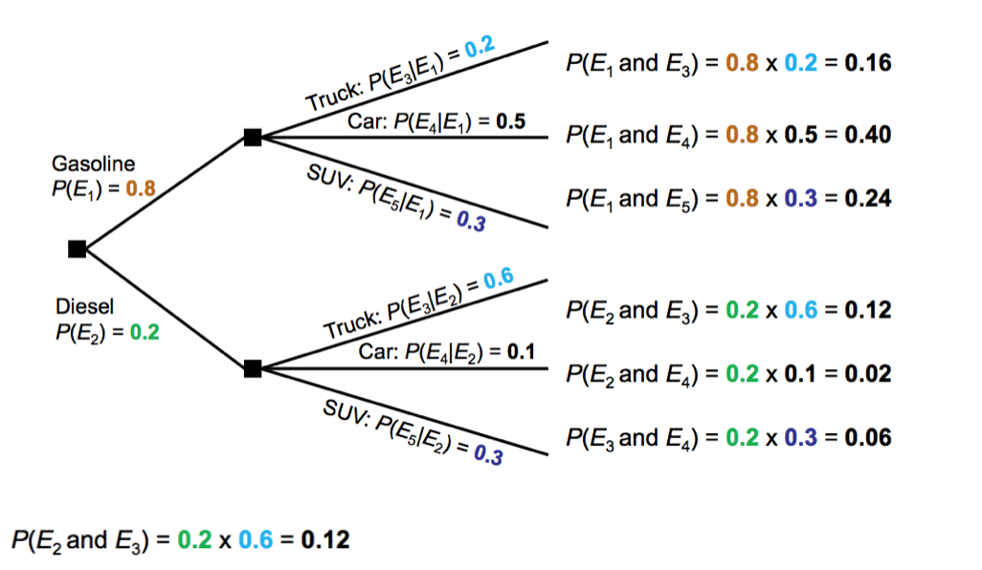
“12% of vehicles are Diesel Trucks”

P(E3⎟E2)= 60% of Diesel vehicles are Trucks.
P(E3) = P [“Truck”]
“Truck”=“Truck and Gasoline” OR “Truck and Diesel”

P [“Truck”] = P [“Truck and Gasoline”] + P [“Truck and Diesel”]
= P ( [Gas] + P[Truck⎟Gas] ) + P ( [Diesel] + P[Truck⎟Diesel] )
= 0.16 + 0.12
= 0.28
In other words: “Truck” = (T ∩ G) U (T ∩ D)

Example: Exercise 4-35

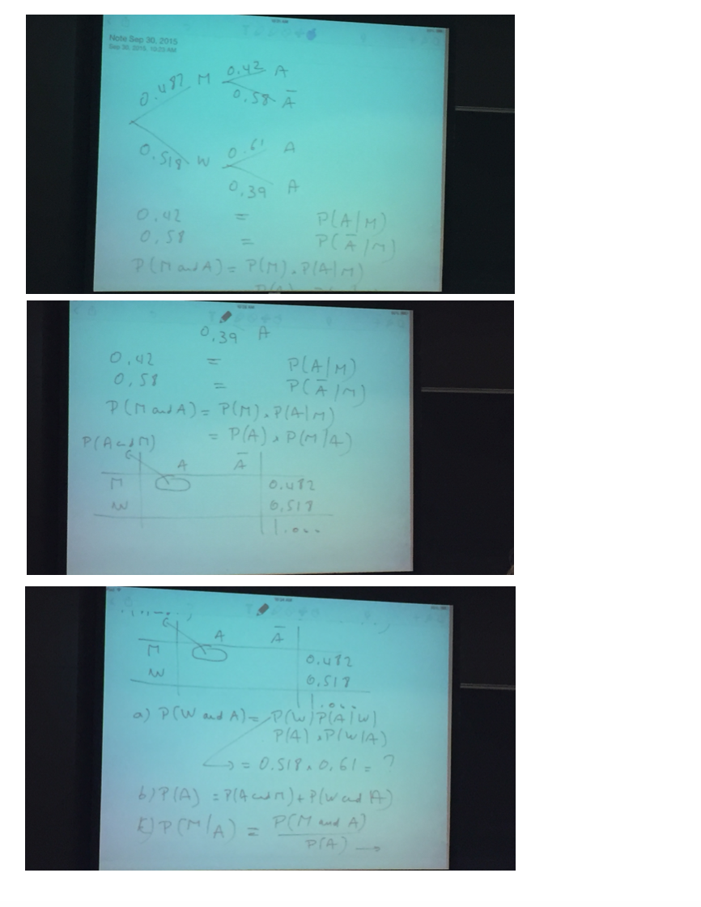
Chapter 5

Example: Toss a die twice.
SS={(1,1),(1,2),…,(1,6),(2,1),…,(6,6)}
6^2=36 outcomes.
Let x=“sum of two tosses”
Possible values of x: 2,3,…,12.

Discrete Random Sampling:
Many possible outcomes: # of complaints per day, # of TVs in a household, # of rings before the phone is answered, etc
Only two possible outcomes: Gender (Male, Female), Defective item (Yes, No), Game result (Win, Lose), etc

Expected Value E(x) : sum of x time P(x). Is used to interpret an average value (kind of like the center of distribution) of x.

Standard Deviation:
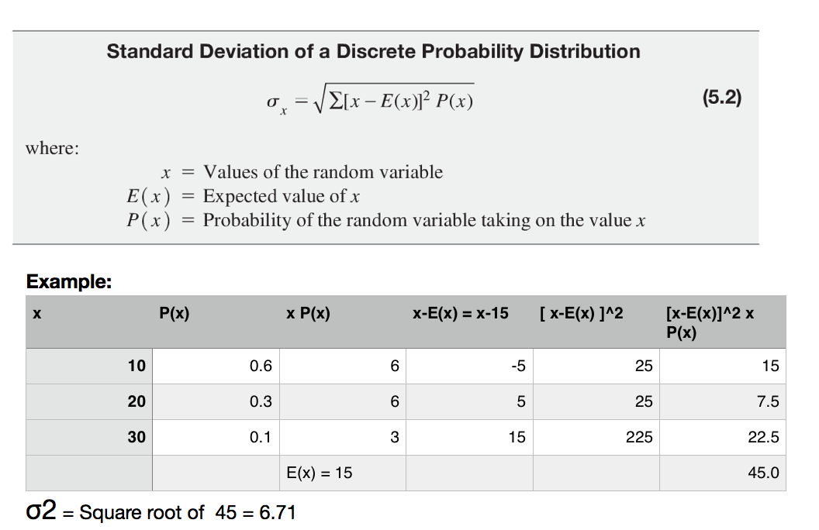

Example: Toss 2 coins. x = number of Heads
SS={HH,HT,TH,TT}

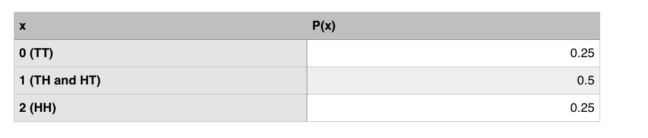

E(x) = (0 x 0.25) + (1 x 0.5) + (2 x 0.25)
^{σ2 = 0.707}
5.2 The Binomial Probability Distribution

A distribution that gives the probability of x successes in n trials in a process that meets the following conditions:
A trial has only 2 possible outcomes: Success or Failure
There is a fixed number, n, of identical trials
The trials of the experiment are independent of each other
The process must be consistent in generating successes and failures (can be overlooked when the sample size is equal to or less than 5% of the population)
If p represents the probability of a success, then 1-p = q …

Example: Population size N=10. It has 4 successes and 6 failures.
P [“Success” in first trial]= 4/10
P [“Success” in second trial]
With replacement = 4/10
Without replacement = 3/9

Example: N=1000, 50 successes.
P[“Success” first trial]= 50/1000
P[“Success” 2nd trial without replacement]= 49/999

Example: n=4 trials. P(S)=p=0.2, P(F)=1-p = 0.8. x = number of successes among 4.
What are the values that x can take?
x={0,1,2,3,4}
SS={FFFF,SFFF,FSFF,FFSF,FFFS,…,SSFF,…SSSF,…}
Chapter 6

Standard Normal Distribution: Has a mean of 0 and a standard deviation of 1.0
Example: if x is distributed normally with mean of 100, standard deviation of 50, and z-value for x=250.
z=(250-100)/50=3.0

Table
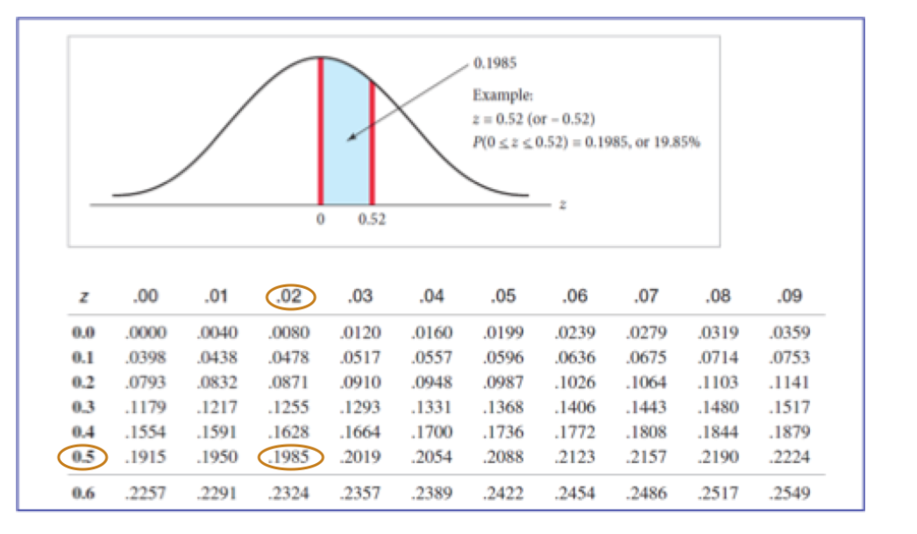
Example:
P[-infinity < z < + infinity]=1
P[0< z < + infinity] = 0.5 = P[-infinity < z < 0]
P[z<0.52]=0.50+0.1985=0.6985
0.52 is the 69.85th percentile of the standard normal distribution
Find Q3: P [z < ?] = 0.75
0.75-0.5=0.25
Zo=0.67 is the third quartile (75th percentile).

