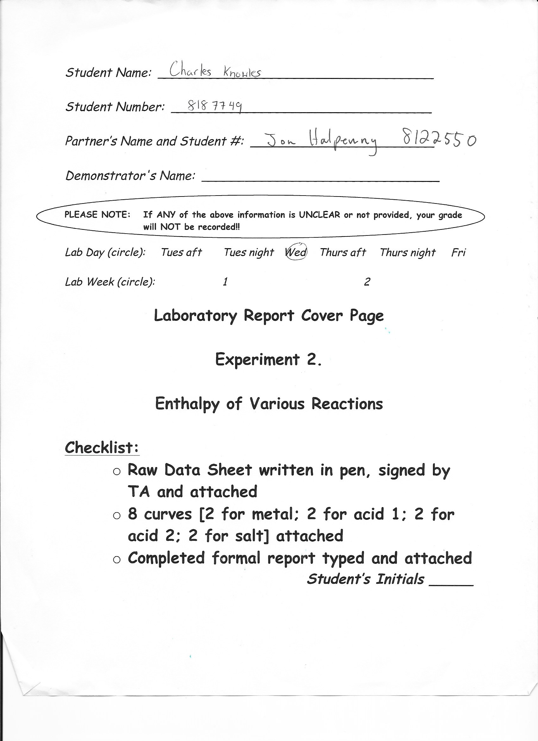

Introduction:

Throughout the lab we will be preforming four different sets of trials to experimentally determine the specific heat capacity of a metal, to determine the enthalpy of neutralization of two different acids, and finally to determine the enthalpy of a solution.

We use Hess’s law to determine the enthalpy of complex reactions. Hess’s law states that: “the enthalpy or heat change accompanying a chemical reaction is independent of the pathway between the initial and final states. If a chemical change takes place by several different routes, the overall enthalpy change is the same, regardless of the route by which the chemical change occurs.”

To find the energy gained by a substance we use the formula q=mc∆T with energy gained (q) in Joules. We have measured the mass on an analytic balance, we are able to read the ∆T off the graph and look up the specific heat capacity of the substance. In the case of the lab we are determining the energy gained by water and by an unknown salt. Therefore we can use the C value for water (4.184) and for the unknown salt (3.815).

“The specific heat capacity represents the heat necessary to raise the temperature of 1 kg of a material by 1 ºC.”

A key equation in the approximation of the molar mass of the metal is C_{metal} X Molar Mass= 25 J/mol•. This is a very interesting equation because of the fact that it is universal and is relatively accurate in the approximation of the molar mass during our lab. If we were using an exact value for the specific heat capacity (c) the molar mass approximation would be a lot more accurate but seeing as we are using rounded, experimental data to make anther approximation it has a greater +/- value.

Procedure:
The procedure can be found on pages 27-38 of the lab manual.

Data Tables:
Specific heat capacity of a metal:
 | Trial 1 | Trial 2
Metal | Copper | Copper
Mass of metal (g) | 9.9777 | 9.7626
Temperature of boiling water (ºC) | 100 | 100
Mass of foam cup (g) | 1.9009 | 1.9009
Volume of distilled water (mL) | 20 | 20.9
Change in temperature (∆_{Water}T) (ºC) | 2.78 | 2.69
Energy gained by water (J) | 232.41 | 235.00
Change in temperature of the metal (∆_{Metal}T)(ºC) | -73.62 | -73.10
Specific heat capacity of metal (J/g•C) | 0.316 | 0.329
Approximate molar mass of metal (g/mol) | 79.11 | 75.98
% Error | 24.5 % | 19.5 %

Observations:
- The initial temperature of the water is very steady
- As soon as the hot metal was added there was a huge spike in the temperature
- Soon after the spike the temperature plateaued
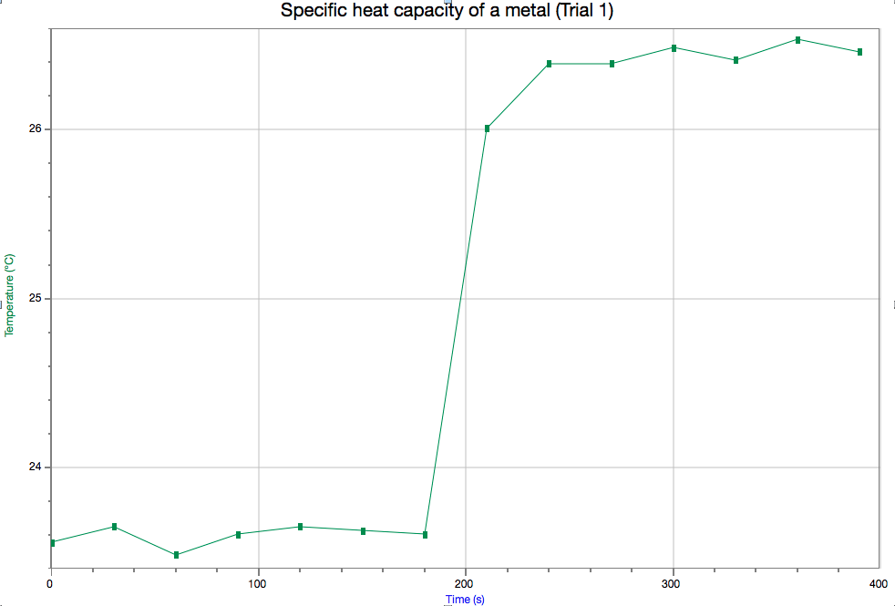

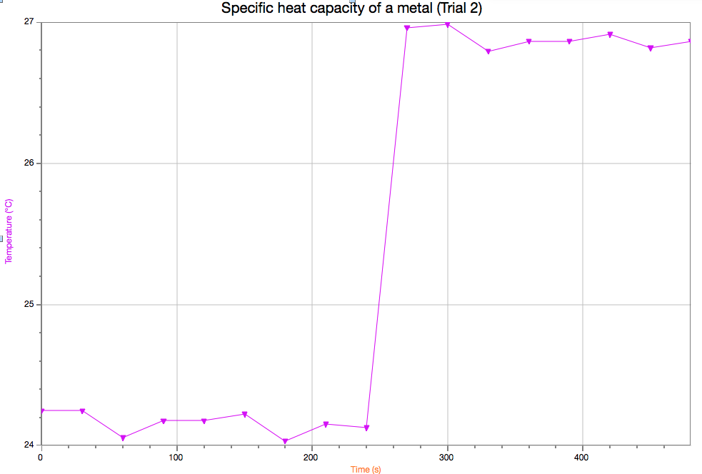

Enthalpy of Neutralization (acid 1):
 | Trial 1 | Trial 2
Base | NaOH | NaOH
Volume of base (mL) | 41.2 | 47.0
Acid | HCL (1.1 M) | HCL (1.1 M)
Volume of Acid (mL) | 41 | 46.7
Mass of calorimeter + neutralized solution (g) | 85.056 | 95.556
Change in temperature (∆_{Water}T) (ºC) | 5.75 | 6.58
Volume of final solution (mL) | 82.2 | 93.7
Mass of final solution (g) | 83.15 | 93.65
Energy released (J) | 2.00 | 2.57
Amount (mol) of limiting reagent (OH-) | 0.0245 | 0.212
Amount (mol) of water formed in the neutralization | 0.0245 | 0.0212
Heat of neutralization (ºC) | 81.6 | 121.26

Observations:
- Very quick reaction
- Swirling the contents seemed to increase the reaction time
- Final temperature plateaued very quickly after the reaction was complete

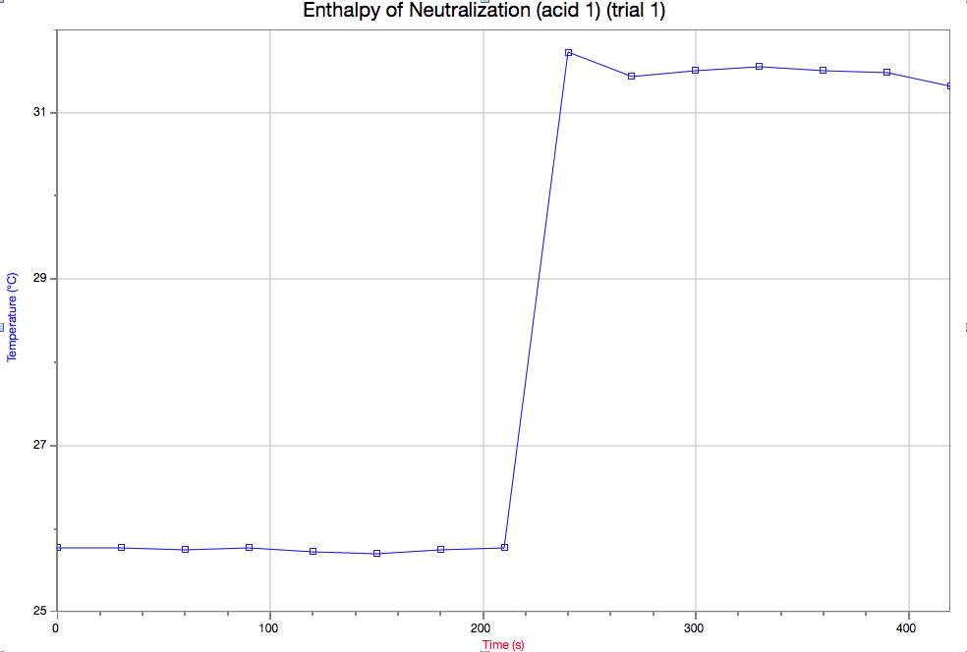

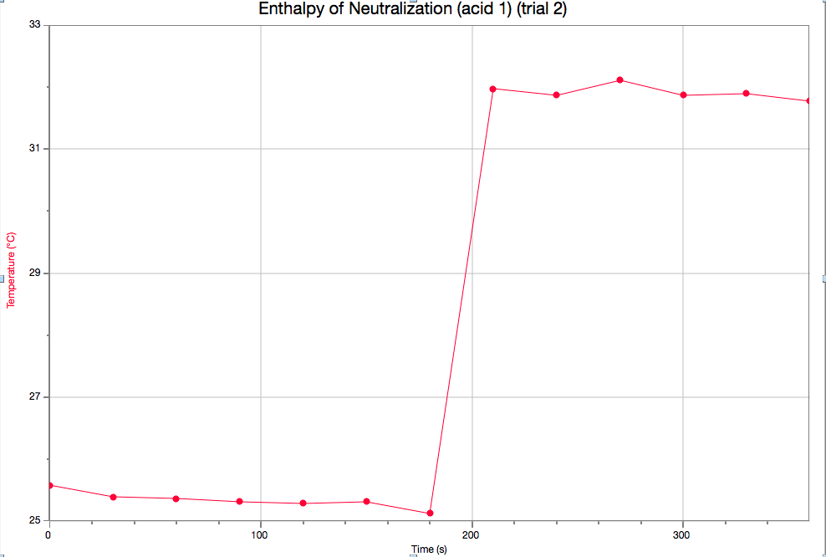

Enthalpy of Neutralization (acid 2):
 | Trial 1 | Trial 2
Base | NaOH | NaOH
Volume of base (mL) | 40.0 | 42.5
Acid | HNO₃ (1.1 M) | HNO₃ (1.1 M)
Volume of Acid (mL) | 39.8 | 42.0
Mass of calorimeter + neutralized solution (g) | 82.656 | 87.356
Change in temperature (∆_{Water}T) (ºC) | 5.59 | 6.13
Volume of final solution (mL) | 79.8 | 84.5
Mass of final solution (g) | 80.75 | 85.45
Energy released (J) | 1.88 | 2.19
Amount (mol) of limiting reagent (OH-) | 0.02525 | 0.02376
Amount (mol) of water formed in the neutralization | 0.02525 | 0.02376
Heat of neutralization (ºC) | 75.2 | 92.4

Observations:
- Extremely similar to reaction with the other metal
- Very quick reaction time
- Final temperature plateaued very quickly after the reaction was complete
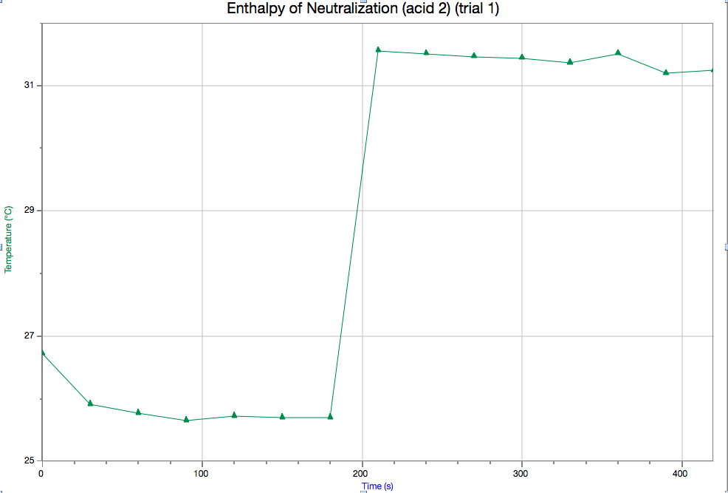
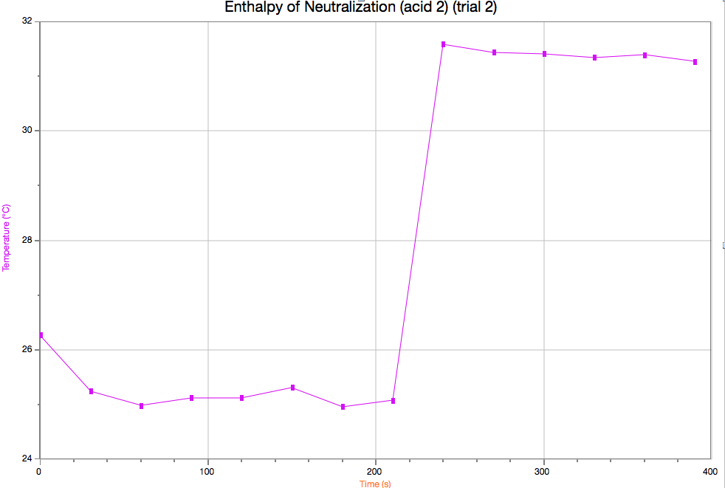

Enthalpy of Solution (Used salt A):
 | Trial 1 | Trial 2
Mass of salt (g) | 1.8278 | 1.7129
Volume of water (mL) | 20.4 | 18.9
Mass of water + cup (g) | 22.7706 | 19.3309
Mass of calorimeter + neutral solution | 24.5984 | 21.0438
Change in temperature (∆_{solution}T) (ºC) | -3.84 | -3.48
Energy released by the solution (J) | -0.332 | -0.245
Enthalpy of dissolution (J/mol) | 13566.53 | 11093.00

Observations:
- Endothermic reaction
- Very rapid reaction
- Final temperature plateaued very quickly after reaction was complete

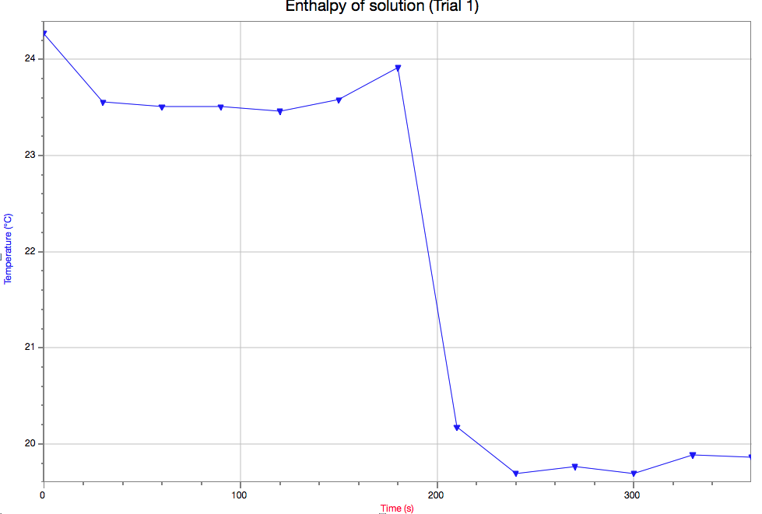
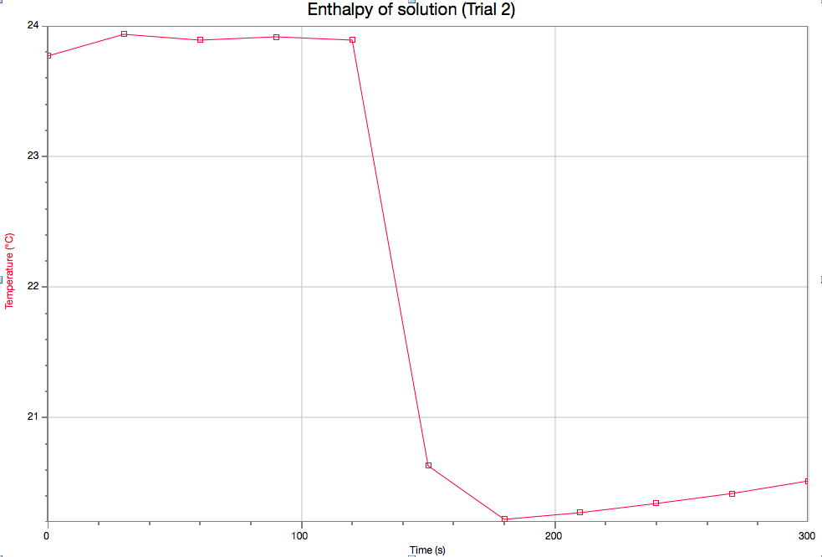

Sample calculations:
(using data from Specific heat capacity of a metal trial 1 unless otherwise stated)

Change in Temperature of water:

Average Temperature₂- Average Temperature₁= ∆_{water}Temp
∆_{water}Temp= (26.90) – (24.21)
= 2.69ºC

Energy gained by water:

q=mc∆T
q=(20 g) (4.18 J/g•C) (2.69)
q= 232.41 J

Change in temperature of metal:

∆_{metal}Temp= Average Temperature₂ – Temperature₁
= (26.38) – (100)
= -73.62

Specific heat capacity of metal:

q=mc∆T
c=q/(m∆T)
= (-232.41)/(9.977)(-73.62)
= 0.316 J/g•C

Molar mass of metal:

C_{metal} X M_{metal}= 25 J/mol•C
(0.316) M_{metal}= 25
M_{metal}= 25/(0.316)
= 79.11 g/mol

% Error:

%= (Exp-theo/theo) X100
= (79.11- 63.54)/(63.54) X100
= 24.5%

**Using data from enthalpy of neutralization (metal 1) trial 1 for the upcoming sample calculations**

Volume of final solution:

V₁+V₂=V_{f}
V_{f}= (41.2) + (41)
=82.2 mL

Mass of final solution:

m_{f}= m_{cup+solution} - m_{cup}
= (85.0560) – (1.9009)
= 83.151 g

Amount of LR:

n=C/V
= (1.01) / (41.2)
= 0.0245 mol

Amount of water:

Since it’s a 1:1 ratio n=0.0245 mol

Heat of neutralization:

∆_{N}H= q_{N}/ n_{x}
= (2.00)/ (0.0245)
= 81.6 ºC

** Using data from enthalpy of a solution trial 1 for the upcoming sample calculations**

Enthalpy of dissolution:

∆_{S}H= -[(m_{solution}) (c_{solution}) (∆_{solution}T)]/n_{salt}
= -(22.681) (3.815) (-3.84)/(0.0245)
= 13566.93

Discussion:

After completing the lab and comparing the graphs from all of the trials we can see many similarities between some and many differences between others. First of all, each reaction that was completed was very quick. None of them took longer than 30 seconds to react completely. That is why on every graph we can see a very large steep spike in the temperatures. The steepness (slope) is equivalent to reaction time and how quickly the solution is heating or cooling the surroundings. The magnitude of the spike whether positive or negative is equivalent to the amount of energy it expelled or consumed respectively.

Looking at the graph of “Specific heat capacity of a metal (trial 1)” and “Enthalpy of neutralization (acid 1) (trial 1)” we can see that the graphs are extremely similar. They are both exothermic meaning heat is produced during the reaction and therefor the temperature of the solution is increased. Although they are similar they are also very different; the final temperature of the specific heat capacity graph was 26.5 while the final temperature of the enthalpy graph was 31.5. The ∆T for each graph was very different, for the specific heat graph it was around 2.5 ºC while the enthalpy graph was around 6.1 ºC. This means the reaction completed during the enthalpy produced more heat than the specific heat capacity reaction.

Now looking at the graph of “Enthalpy of neutralization (acid 1) (trial 1)” and “Enthalpy of solution (Trial 1)” we can see that the graphs are not similar at all. This is due to the fact that the Enthalpy of solution reaction is endothermic meaning energy is needed for the reaction to be completed rather than producing energy. The reaction gets the energy from the heat of the water, thus decreasing the temperature. We can see this happening on the graph with a ∆T value of approximately 4.1 ºC. This is opposite to the Enthalpy of neutralization reaction, during this reaction energy is produced and therefore heats the temperature of the water by approximately 6.1 ºC.

Conclusion:

During the lab we found that the specific heat capacity of metal and the approximate molar mass were 0.316 J/g•C and 79.11 respectively. The heat of neutralization for HCL was 81.6 ºC and for HNO₃ was 75.2 ºC. Finally the enthalpy of dissolution for the unknown salt A was 13566.53.

Raw Data:

Enthalpy of a Metal:
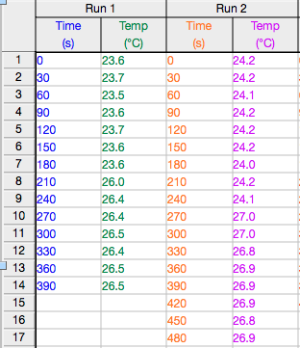

Enthalpy of Neutralization (HCl)
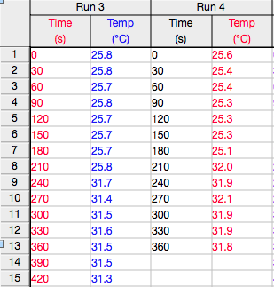

Enthalpy of Neutralization (HNO₃)
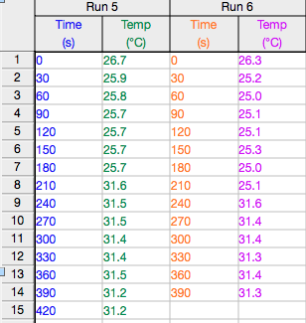

Enthalpy of Dissolution of a salt
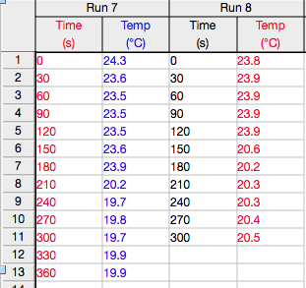

Data collected in the lab: 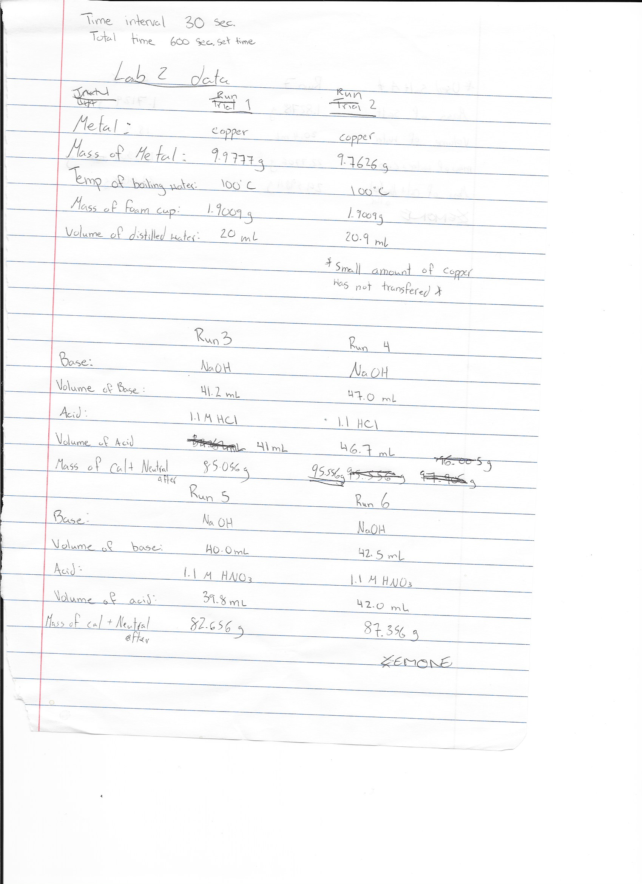
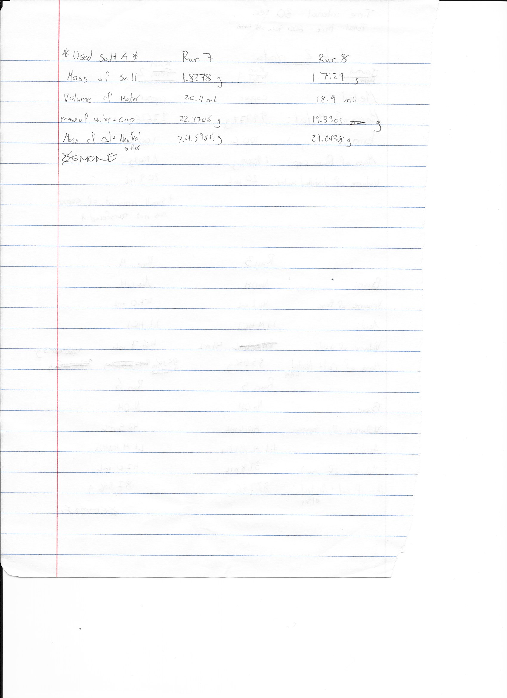

http://www.worldlibrary.org/articles/hess's_law, Author unnamed, World library
Qiujuan Liu, Xiaodong Huo, Xiaofeng Yan, Lucian A. Lucia, Physical and Chemical properties and Effluent from the Pre-Conditioning Refiner Chemical Alkaline Peroxide Mechanical pulp process, page 6324 (2013)

