Shipping Terms
FOB Shipping Point: buyer pays freight-in; owns goods on delivery
FOB Destination: Seller pays freight-in; owns goods on arrival

Disposal of PPE
Gain – contra expense account; loss – expense
Retirement:
DR: AD, Loss; CR: Asset

1. Gain/Loss = Proceeds (Cash, allowance) – Carrying Amt
2.. Removal old asset (AD and asset account)
3. Cash: DR if sale, CR if trade-in allowance
Cash = List price –Trade-in allowance
4. Add new asset
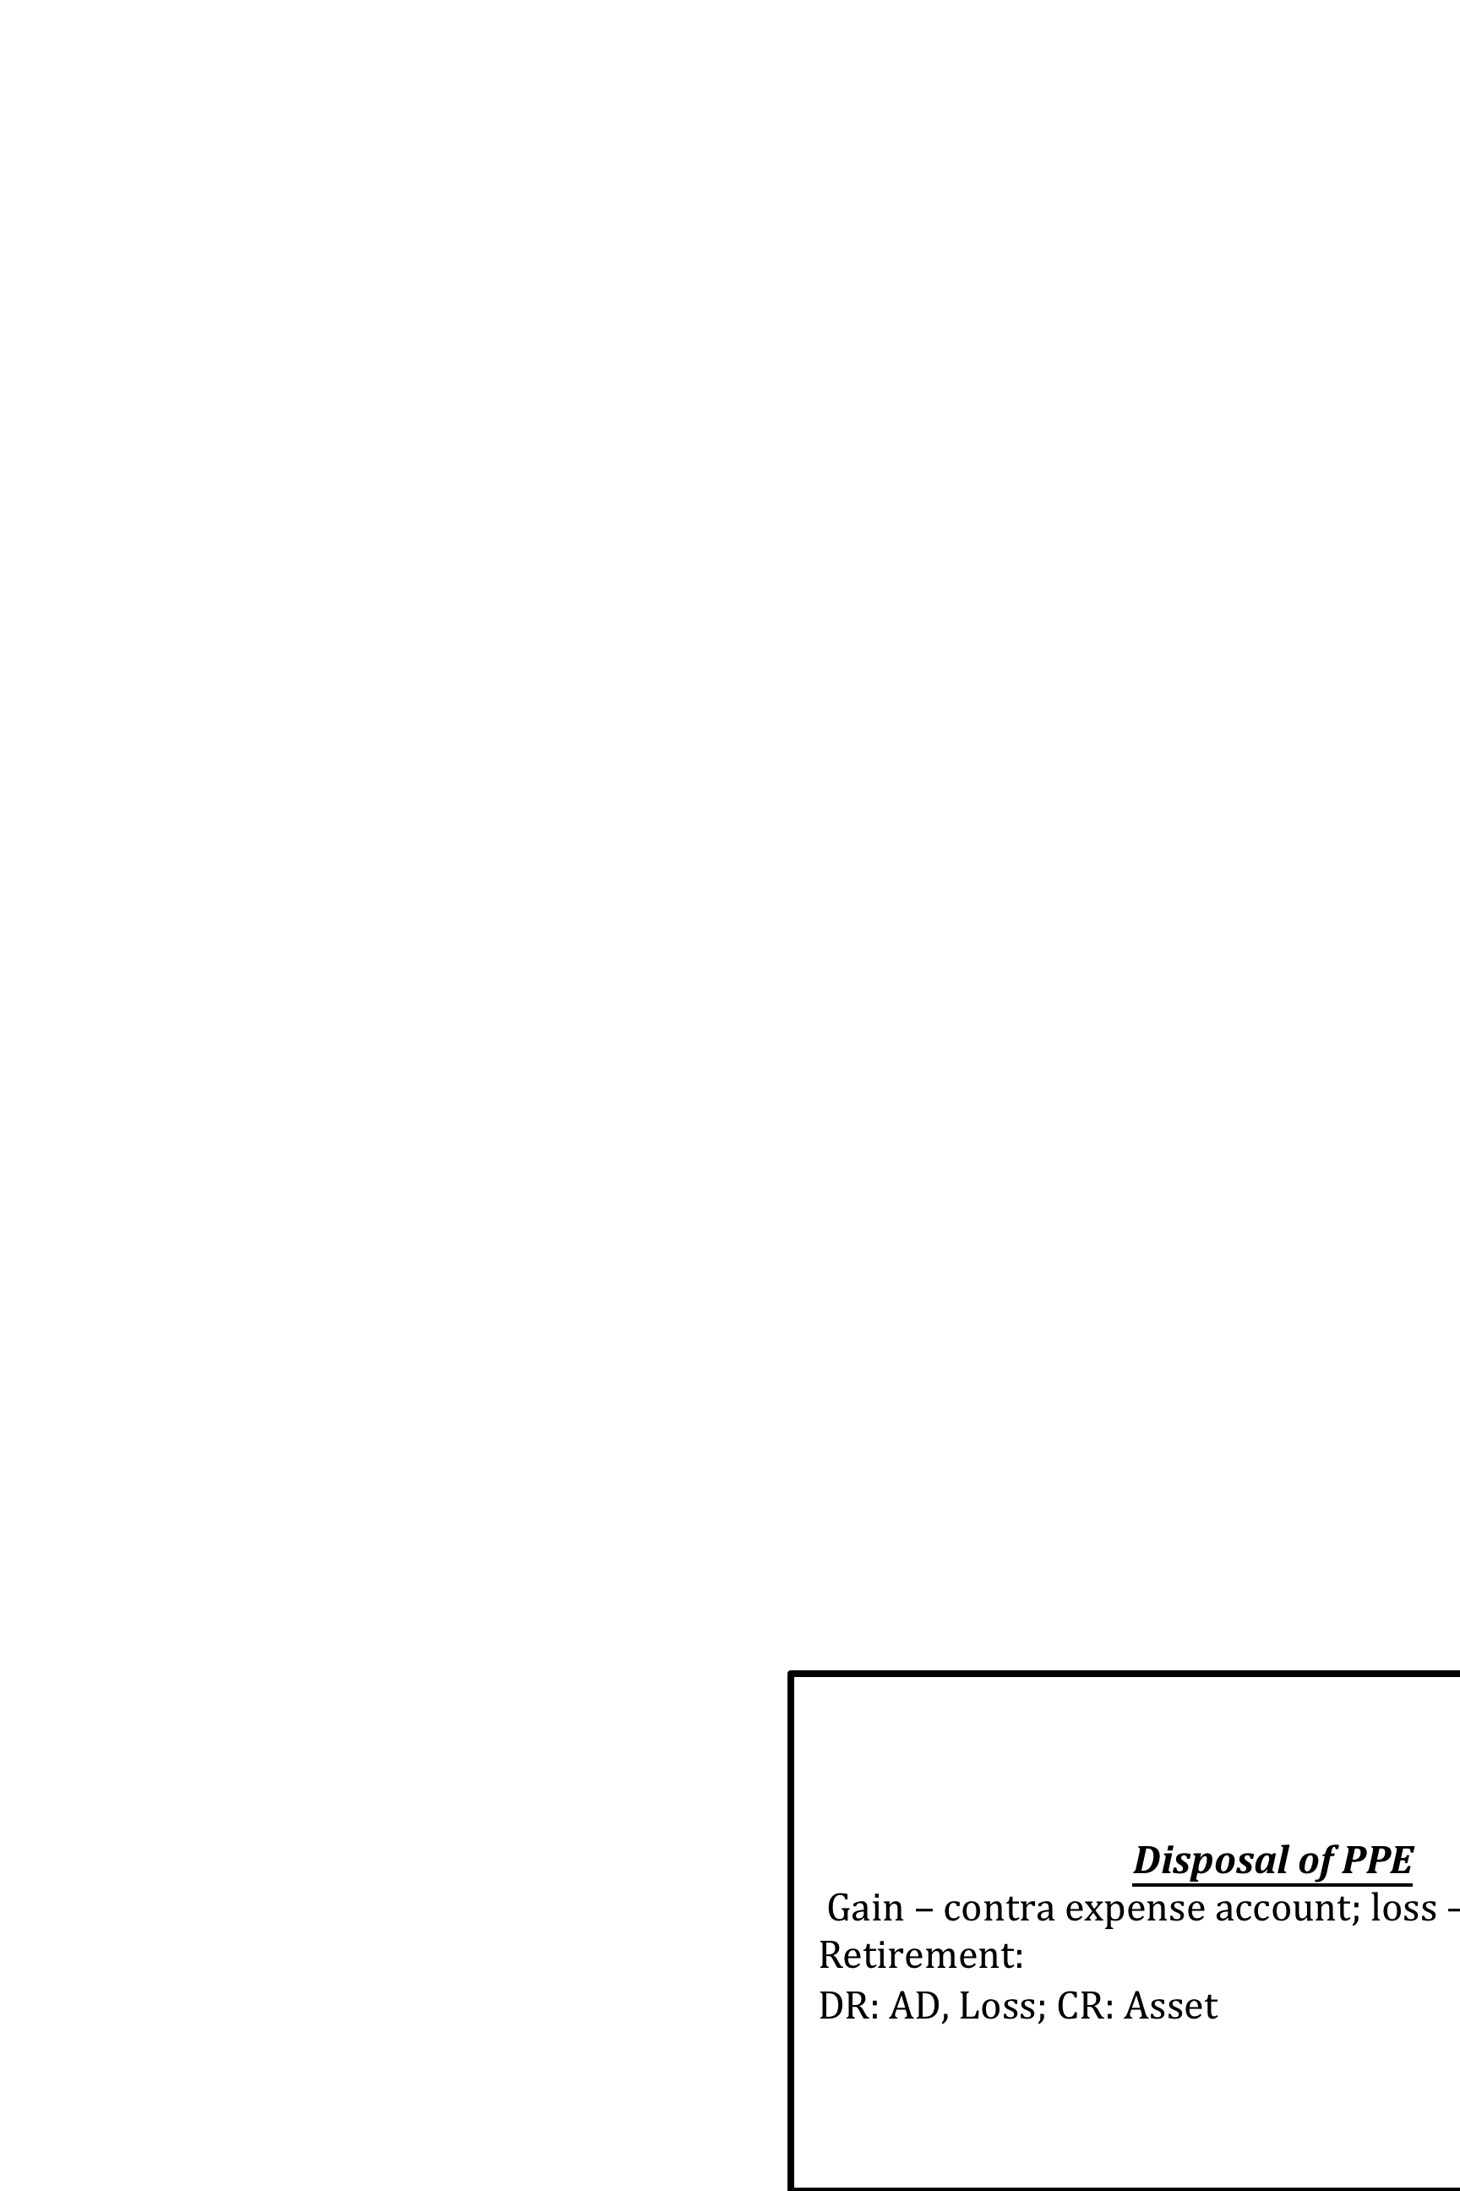
Trademarks
Not asset if developed internally (normal OE)
Asset if purchased externally

Royalties: payment to franchisor
Intangible Assets (Amortized)
-Shorter of legal life or useful life
-No RV; use straight-line method
-Finite lives: patents, copyright, R&D
-Research Expense operating expense
-Development Costs non-current asset
-Post-development commercialization; amortize development costs
-Infinite lifespan: trademark, franchise, public licenses

Other Notes
-If part of price is returned when receiving cash, keep in mind to account for the return!
-Duty only paid by buyer!
-Land improvements: structural additions to land (e.g: sidewalks)
-License fee: operating expense -Goodwill – impairment not reversed
-Asset fully depreciated still report it

Capital cost – benefit future; purchase + costs to get asset ready for use (e.g: upgrades, replacement of major part)
Asset retirement costs – DR to asset account

Impairments
Impairment loss = Carrying amount – recoverable amount

If recoverable amt < carrying amount:
DR: Impairment loss
CR: Accumulated depreciation
Note: Impairment loss is operating expense.
Reversing impairment: only to carrying amount where if impairment never occurred

Depreciation Formulas
Carrying Amt = Cost – Accumulated Depreciation
Depreciable Amt = HC – RV
Straight Line = (HC-RV)/UL * n/12
Diminishing balance = Carrying Amt/UL * n/12
Units of production = Depreciable Amt/UL*Units Produced in Period
Note: USE TIMELINES
Note: Stop depreciation once carrying amt = RV or useful life used up (adj. entry needed)
LCNRV
Inv. (E/B) recorded at lower of cost or net realizable value
If cost > NRV:
DR: COGS
CR: inventory

Inventory Table
1. Order 6. Return -
2. Purchase + 7. Return Duty -
3. Duty + 8. Return Freight +/-
4. Freight in+ 9. Return discount +
5. Discount - Note: buyer pays duty
Sales Inventory Chart
Order #
1. Sale
2. Returns & Allowances
3. Repayment
4. Discount?

Inventory Case Approach
1. Handle purchases individually/ in sequence of acquisition
2. Use table
3. Record NET units and purchase
4. Calculate unit cost
5. Calculate UFAS, COGAFS, COGS
Note: Make separate T acc. called units; check duty, freight-in first!!
Ending Inventory

Merchandise Inventory Formulas
Unit Cost = Net purchase cost/net total units (3 d.p)

Average Cost = COGAFS/UAFS

Terms
-Consigned goods – owed by consignor (until sold)
-Goods taken home on “approval” – owed by seller
-Goods sold, but stored for alteration – owed by buyer
-Damaged/lost – removed from inv.
GOODS OWNED IN TRANSIT AT FYE: Belong in Ending Inventory
Sale/Purchase Discounts: LESS ANY RETURNS AND ALLOWANCES ON INVOICE PRICE
Returns & Discounts:
DR: A/P
CR: Inventory
Discounts:
-Not recorded for separately! Accounted for in entry to inventory and A/P
-Ending inventory appears on balance sheet!
-COGS determined at end of accounting period

Purchase Discounts

Allowances and Returns

COGS

O/B

Purchases

Freight-in

COGAFS
Merchandise Inventory

Sales = Cash + A/R
For discounts CR A/R

Returned items waiting to be fixed: DR: Returns & Allow.
Notes Receivable
Note dishonored at maturity convert to A/R (including value of note and interest earned)
-Continue fails to pay write off A/R
-If pays collection of cash entry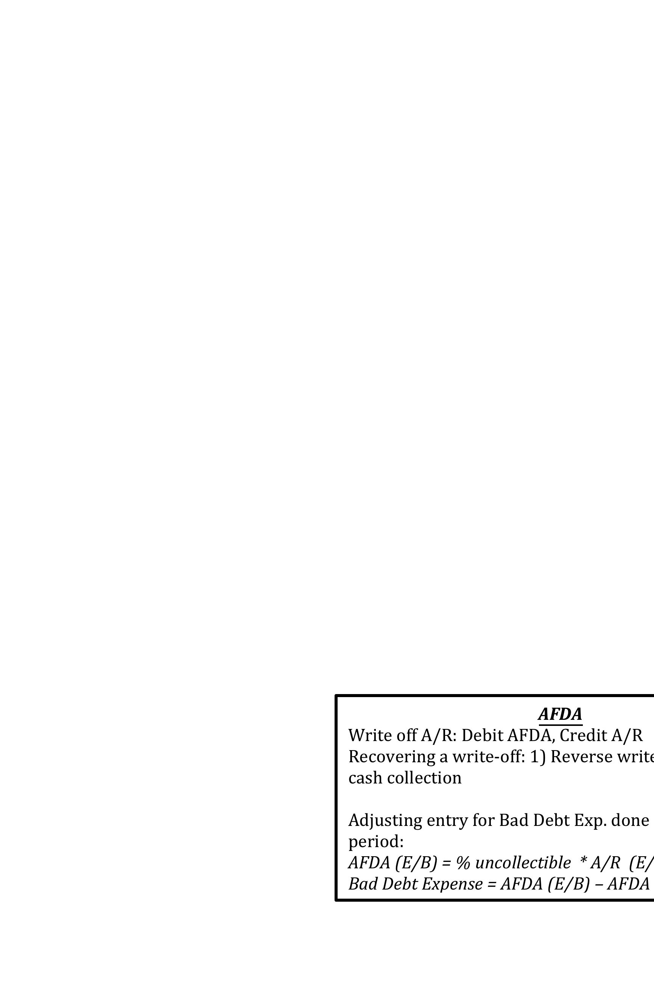 record as cash collection
AFDA
Write off A/R: Debit AFDA, Credit A/R
Recovering a write-off: 1) Reverse write off; 2) Record cash collection

Adjusting entry for Bad Debt Exp. done at end of period:
AFDA (E/B) = % uncollectible * A/R (E/B)
Bad Debt Expense = AFDA (E/B) – AFDA (T/B)
Bank Reconciliation: Terms
Cleared – accepted by bank
Returned – refused by bank b/c payer does not have enough funds in bank account
Stale dated – older than 6 months, cannot be cashed
Post dated – cashed in at later date (nothing if no revenue; AR if revenue)
Petty cash – account never changed in transaction; instead CR cash; only change if establishing
Outstanding cheque – cleared by comp, but not bank
NSF – establish A/R for company (cheque + charge)
Bank Reconciliation: Steps
Per Bank (O/B = E/B on bank statement)
1. Deposits in Transit (+)
2. Outstanding cheques (-)
Note: Including ones from last month
-O/B = E/B on bank statement

Per Books (O/B = E/B from last month’s statements)
Add: Cash receipts; less: cash disbursements
1. Unknown deposits (+) (interest)
2. Unknown payments (e.g: Bank service charge, NSF) (-)
3. Errors

Check last month BR, cash receipts/disbursements, bank statement circle anything not matching

Closing Entries (CE in T-accounts)
1. Close revenues to income summary
2. Close expenses to income summary
3. T/B income summary and calculate income tax
DR: Tax expense
CR: Tax payable
4. Close tax expense to income summary (after-tax profit)
5. Close dividends

Note: RE in adjusted trial balance represents the amount before closing
On balance sheet, RE should be the adjusted amount
-No income tax for losses
A/R – interest if not paid within 30 days
N/R – interest throughout
Net Realization Value = A/R – AFDA

Prepaid Expenses
Supplies Exp. = Supply (balance) – Supply on hand

DR: Supplies Exp.
Cr: Supplies
DR: Insurance Expense
CR: Prepaid Insurance
DR: Rent Expense
CR: Prepaid Rent

-a
Accrued Expenses
-Expenses incurred but not billed (e.g: interest, rent, salaries)

DR: Expense
CR: Payable
-Salaries payable counting starts after most recent payday (based on no. of unpaid working days)! Only record if next pay day is next accounting period

When accrued expense is paid:
DR: Payable and Expense (but not full amt)
CR: Cash
Accrued Revenue
-Revenue not billed but earned (e.g: interest revenue)
DR: Receivable
CR: Revenue
Unearned Revenue
-If paid back:
DR: Unearned Revenue
CR: Revenue
Retained earnings no change until closing

Transactions recorded when they occur

Revenue recognized g/s transferred

Balance Sheet
Current Assets Non-Current Assets Equity
-Cash -Long-term investment -Retained Earnings
-Short term investments -PPE -Share Capital
-A/R -Land
-Notes receivable -Building Liability
-Inventory -Equipment -Unearned Revenue
-Supplies -Leasehold improvements
-Prepaid Expenses -Intangible assets (Copyright) & Goodwill

Income Statement:
Gross Sales
Less: Returns & Allowances..
Net Sales
COGS
Gross Profit
Operating Expenses
Income Tax Expense
Net Profit After Tax

Income Statement:
Gross Sales
Less: Returns & Allowances..
Net Sales
COGS
Gross Profit
Operating Expenses
Income Tax Expense
Net Profit After Tax

