COMM 210: Contemporary Business Thinking, Section P
WEEK 1
Critical thinking = Analyzing the validity of arguments presented in a text
  - Identify the author’s major conclusions
  - Describe & evaluate supporting evidence
  - Uncover assumptions & values
  - Determine soundness of causal logic
  - Deconstruct use of persuasive language

Fundamental business theories
- Chandler on business success
- Greiner on evolution/growth of organizations
- Tannenbaum & Schmidt on leadership
- Collins & Porras on company’s Vision
- Mintzberg on the manager’s job
- French and Raven on social power
- Barney on internal resources and capabilities
- Kaplan & Norton on performance measurement and evaluation
- Handy on managing change
- Herzberg on motivation

Contemporary Business Thinking Content & Outcomes
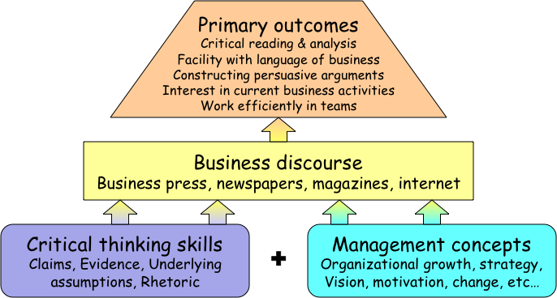
Recommended learning approach
  - Read the fundamental business theory article. Identify the objective(s) of the article, and make notes of the main concepts.
  - Read the ‘’Dyer’’ chapter and make notes of the main points. Practice with the textbook exercises.
  - Read the business article(s) and highlight what applies to the theory/concepts of the theory and to the Dyer’s readings

WEEK 2
Building Successful Organizations
- Differentiate between contestable and unproblematic claims
- Identify Chandler’s claims & discuss their validity
- Identify Chandler’s numerous concepts of his article on industrial success
- Understand and practice the uses of concept maps

Claims
- A claim is the major conclusion of a piece of writing that the author is trying to persuade you to accept
- Explicitly or implicitly stated
- Likely locations
- Cue words: therefore, thus, in summary, I believe that, clearly, in short (…)

Unproblematic claims
- Consistent with our own experiences and observations
- Facts independent of interpretation
- Agreement among experts or strongly supported general claims that are common sense
- Technical or mathematical claims

Contestable claims
- Not commonly accepted knowledge
- Often introduce new ideas that awaken curiosity
- Sometimes presented as if it were a fact
- Cannot stand on their own

Presenting claims
- Intelligible and fair summary
- Concept lists & concept maps
“Concept maps are a compact way of summarizing complex material.” (Dyer, 2011)
- “A picture, the say goes, is worth a thousand words.” (Dyer, 2011)
- Concept maps may be simple boxes-and-arrows figures that highlight the main issues and show relationships. They may look like tree diagrams, geographical maps, or other creative images that summarize the author’s main point.” (Dyer, 2011)

Writing effectively
- Present main ideas with clarity and emphasis
- Claim near the beginning or end
- Cue words
- Make your titles work for you
- Make claim memorable for your readers

Business terms and popular expression
- Board of directors: a group of people who have legal responsibility to guide the affairs of a corporation or firm. (Corporate governance refers to the rights and responsibilities of the board of directors, managers, and owners of a company.)
- Bottom Line a summary number that expresses how successful a company has been from a financial point of view, profit, net income (triple bottom line: financial, social and environmental performance)
- Chief Executive Officer must have a clear vision. Works with top management team with Chief Financial Officer (CFO), Chief Operating Officer (COO) and sometimes with Chief Information Officer (CIO)
- Emotional intelligence is the ability to understand and manage your own emotions, accurately perceive and understand the emotions of others and use emotions competently to sustain good relationships.
- Globalization, steady increase in the extent to which markets, labour, knowledge and technology, as well as commercial, social, and political activities in countries around the world are integrated (multinational corporation)
- Knowledge workers are employees who work primarily with their intellect and knowledge, and who create value for a firm by processing and creating information (intellectual capital is a set on intangible assets that a company owns or controls)
- Outsourcing is delegating some of the organization’s activities to an outside manufacturer or service supplier to focus on core competence (central activity and specialized expertise). Also called contracting out or offshoring if in another country
- R&D (Resource and Development) is the activities in a firm that combine scientific research and technological development to produce innovations in products or services.
- Shareholders are part-owners of the corporation (stakeholders are a broader group of people who have interest in the firm because they are influenced by its actions) CSR.
- Vision: an image of the future held by the leader of the organization (related term with mission statement which is a broad statement of the purpose of the business, the firm’s reason for being and the underlying values that animate the organization.

Alfred Chandler (1918-2007)
Credited with creating the field of business history
‘’The enduring logic of industrial success’, the dynamic growth of competition that drives modern industrial capitalism

Two key concepts
- Economies of scale: Large plants can produce products at a much lower cost than small ones because the cost per unit drops as the volume of output rises (geographic expansion)
- Economies of scope: Large plants can use many of the same raw and semi-finished materials and intermediate production processes to make a variety of different products (related product market)

Chandler’s major claims
But for firms to benefit from these economies (exploit cost advantages of economies of scope and economies of scale):
- Flow of materials through the plant must be kept constant to assure capacity utilization
- Two related set of investments: national (and international) marketing and distribution functions must be created
- Teams of lower and middle managers need to be recruited
- Logic of managerial enterprise for first movers and challengers

Chandler’s secondary claims
- Once a firm loses the opportunity to be a first mover, it is difficult to regain competitive advantage
- Entrepreneurial companies that do not make long-term investments to create organizational capabilities and then continue to reinvest remain small and sold-out and cannot achieve long-term success (logic of industrial growth)
However, size is not all!
- Growth through unrelated diversification is a poor corporate strategy, few if any organization capabilities to give competitive edge, top managers have little specific, technical knowledge or experience and acquisitions created overload of decision making at the corporate office: ignores logic of managerial enterprise, bigger=worse
- Business ownership patterns have diminished the likelihood of many firms’ long-term success

Chandler: Concept list
- Economies of scale & economies of scope
- Functional divisions, management hierarchy & geographical expansion
- First movers & challengers
- Research & development (innovation)
- Related (growth through new market in related industries) & unrelated diversification (acquisitions, mergers and divestitures)
- Separation of top (corporate office) and middle managers(running operating divisions, profit and market share) in the case of unrelated diversification
- Entrepreneurial enterprise (staying small)
- Stock market pressure (due to ownership pattern)
- Short-term thinking (due to market pressure)

WEEK 3
Structure and Growth of Firms
- Describe and explain how and why organizations grow
- Describe and apply the concepts of organizational structure and management style
- Develop critical thinking skill: Analyzing and evaluating the evidence for a claim

Larry Greiner
“Evolution & Revolution”
A theory of organizational life cycles, with a focus on growth
Based on past experiences and knowledge rather than future
Evolution or evolutionary period: steady growth and stability
Revolution or periods of revolution: substantial organization turmoil and change

Greiner’s major claims
- Organizations grow through a series of evolution and revolution phases that are function of the age and the size of the organization
- Management practices that work well in one phase bring on a crisis in the next
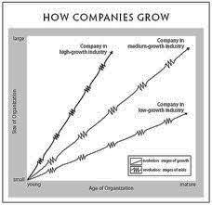
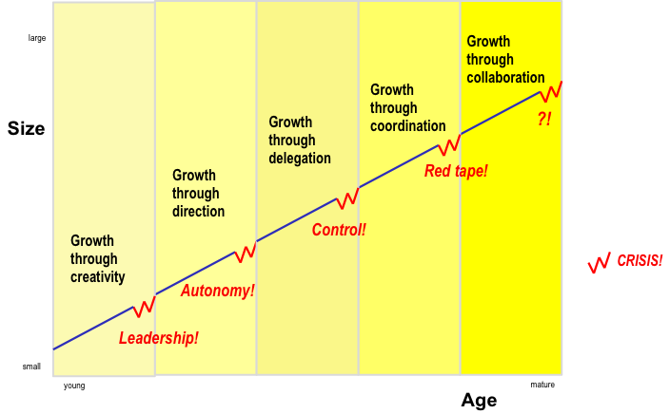
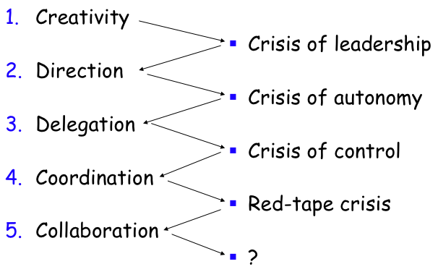
Greiner’s primary concepts (5 dimensions)
Greiner’s concept map
The 5 (developmental) phases of growth
- Age of the organization
- Size of the organization
- Stages of evolution
- Stages of revolution
- Growth rate of industry, market, environment
- Management style
- Organizational structure

To know:
  - The exact name of the evolution phase
  - The characteristics of the evolution phase (what is happening)
  - The issues that lead to a crisis
  - The exact name of the crisis
  - The required solution for the crisis

Additional information:
- Each phase is at once a result of the previous phase and a cause for the next phase
- Few make it through all stages
- Transitions are not natural or smooth
- Miniphases in big phases
- Know where you are in developmental sequence
- Recognize the limited range of solution
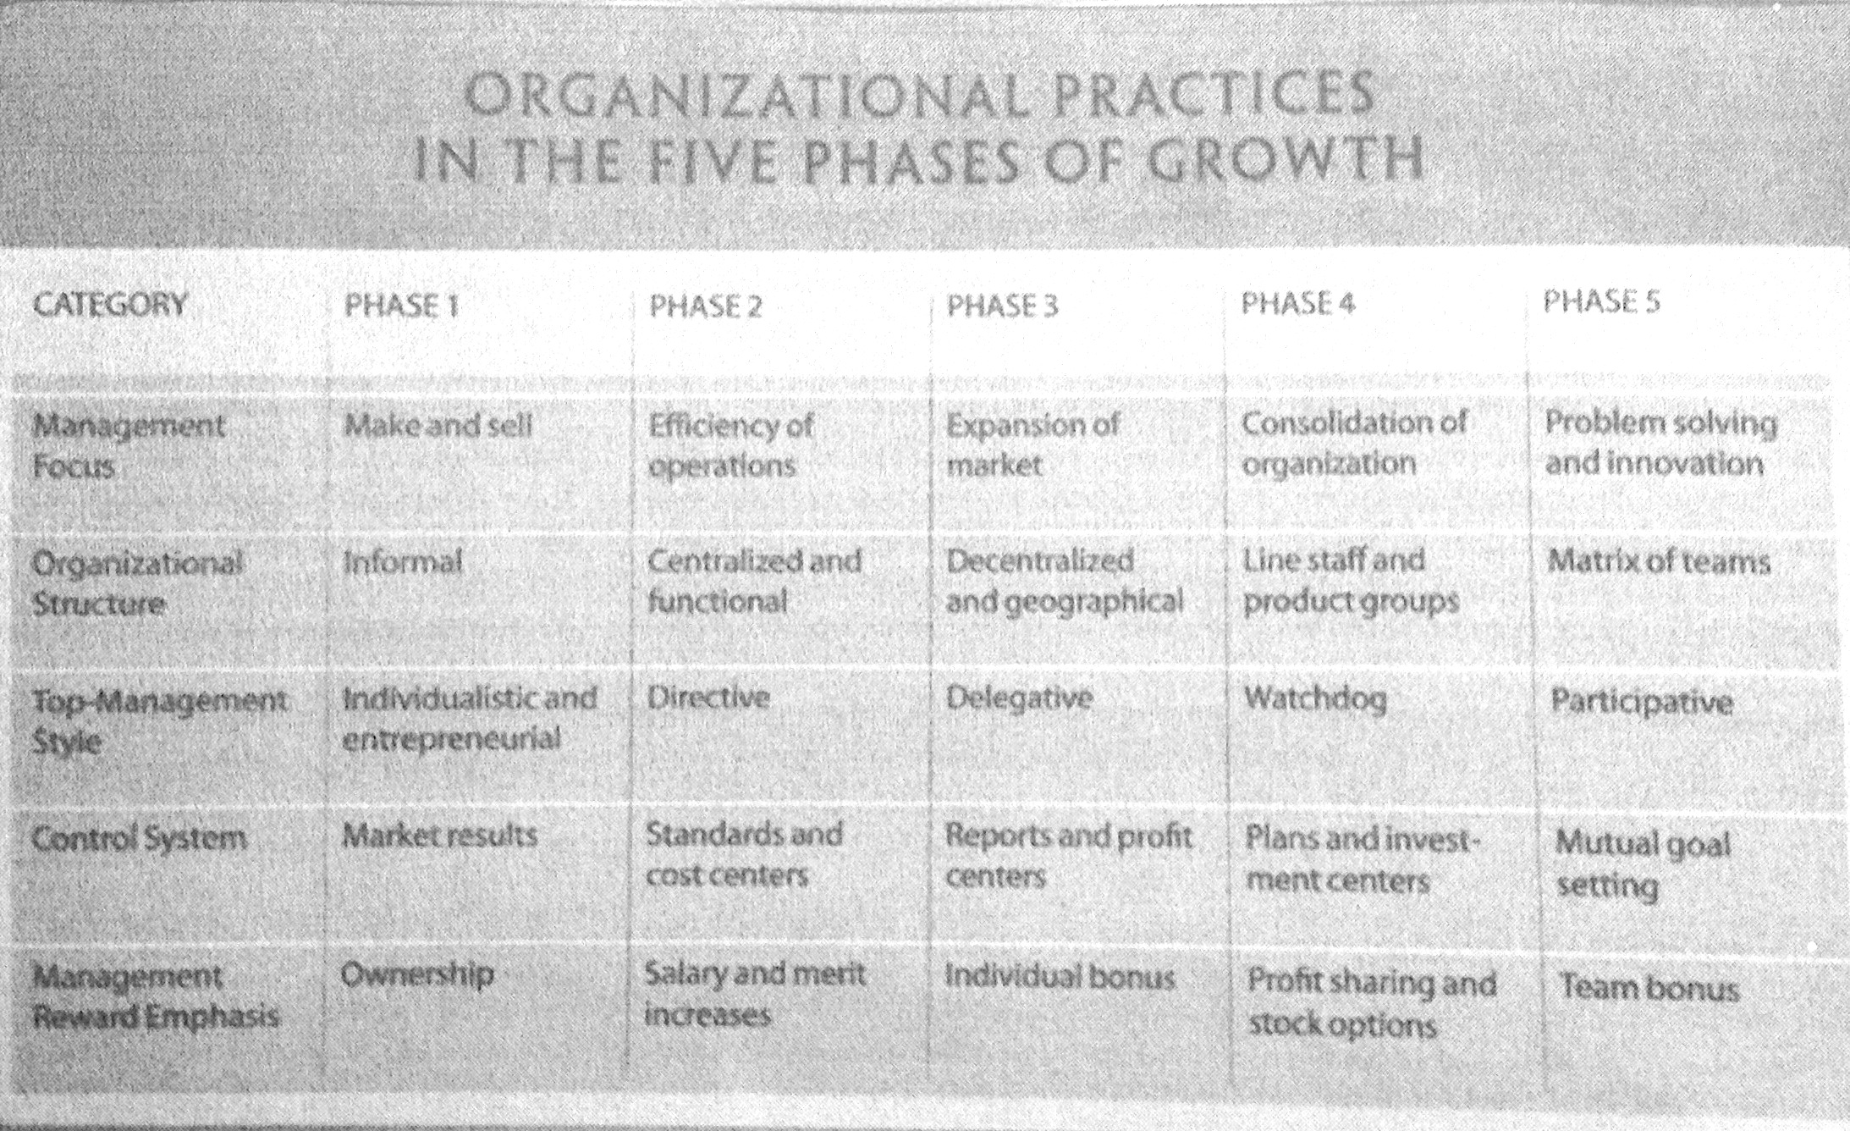
- Realize that solutions breed new problems

Category | Phase 1 | Phase 2 | Phase 3 | Phase 4 | Phase 5
Issues | Knowledge of management  Unwanted management responsibilities loss of motivation | Inappropriate management style for controlling a more diverse and complete organization lower-level feel restricted and controlled | Losing control over highly diversified field of operation, freedom breeds a parochial attitude, | Lack of confidence build between line and staff, and headquarters and the field, bureaucratic system procedures takes precedence over problem solving and innovation | ? psychological saturation who grow emotionally and physically exhausted from the intensity of teamwork and the heavy pressure for innovative solutions
Solutions | Strong capable business manager with knowledge and skills to introduce new business techniques | More delegation and decentralization of power, decentralized organization structure | Top managers seeks to regain control over the company as a whole using special coordination techniques | Strong interpersonal collaboration social control and self-discipline replace formal control, formation of teams | New structures and programs that allow employees to periodically rest, reflect and revitalize themselves. Dual organizational structure of habit structure (getting the daily work done) and reflective structure (stimulating new perspective and personal enrichment)
Greiner’s secondary claims
- Organizations should not try to skip phases
- Top managers whose style is no longer appropriate should remove themselves
- Growth is not inevitable

Advantages of large, bureaucratic organizations
- Hierarchical authority promises control and responsibility
- Specialization of sub-units promises accountability, control and expertise
- Management by rules promises control and consistency
- Being impersonal promises objectivity, consistency and equality

Employees’ examples of red tape
- Each department has its own agenda, and departments don’t cooperate to help other departments get the job done
- Top managers are dangerously ill-informed and insulated from what is happening on the front lines or in "the field”
- Quantitative measurements are favoured over qualitative measurements, so the concentration is on quantities of output, with less and less concern for quality of output
- Both employees and customers are treated more as numbers than people

Evidence
- Claim: central idea that the author is trying to persuade you to accept
- Evidence: any statement that is a response to the question ‘Why this is true?’
- Claim+ evidence = argument
  - Several arguments in longer piece of writing

Finding the supporting evidence can consist of:
- Statistics, Details of past events,
- Anecdotes, Quotes, etc.…
Cue words:
- Because, As a result, In the first place, in the second place, for example, In addition, given that, studies show, for the following reasons, etc.
Each piece of evidence must be explained

Criteria to test the quality of the evidence (6):
Evaluate the supporting evidence
- Accuracy
- Difficult to judge without an independent source of information
- 2 ways to proceed:
    - Do our own research to verify accuracy
    - Use proxies to evaluate accuracy: trivial errors, grammar, spelling mistakes, inaccurate quotes, or precision.
- Precision
- Comes from numbers and quotes
- 18.4% is better than “quite well” or “almost 20%”
- Ambiguous words should not be overused
- Numbers and direct quote should be provided
- Precision creates the impression of accuracy
- Beware of over-precision
- Sufficiency
- How much evidence?
    - Importance of claim
    - Potential damage
- Fallacy of hasty generalization (jumping to the conclusion too quickly without enough evidence)
- Representativeness
- Variety in the sources of evidence should match the variety in the population
- Fallacy of hasty generalization
- Authority
- Training, credentials, experience of others
- Classics or current writing
- Context-dependent
- Fallacy of false appeal to authority
- Fallacy of argumentation ad populum (bandwagon); of false appeal to authority
- Evaluate the supporting evidence
- Clarity of expression
- Quantitative data should be interpreted
- Direct quotation should also be interpreted
- Other objections: issues of relevance related to underlying assumptions
- Greiner’s evidence

WEEK 4
Leadership
- Discuss the evolution of the leadership theories through time
- Understand Tannenbaum & Schmidt leadership continuum
- Apply the fundamental theories to a business article
- Practice in essay-writing: Finding and presenting your own evidence for a claim

Background: Classic ideas about leadership
- Trait leadership theories
  - Are there “born leaders?” What traits are important?
- Behaviour leadership theories
  - Do successful leaders behave in certain ways? Can these behaviours be learned?
- Contingency/Situational leadership theories
  - What does successful leadership depend on?

Answering the Need
- Old Problem: How to lead followers?
- New Problem: When should a decision be made by the leader? When should employees be consulted? And to which extent?

“... The purpose of this article is to suggest a framework which managers may find useful in grappling with this dilemma....” R. Tannenbaum and W.H. Schmidt; HBR: May-June 1973; page 163

Tannenbaum & Schmidt: How to choose a leadership pattern--concept map
Power influence

Key Questions
- If the subordinates make the decision, is the manager responsible? YES
- What role should managers play?
- Member or authority figure
- Should subordinates be able to tell what style manager is using? YES
- How do you measure a manager’s “democracy”? By the significance of decision entrusted to subordinates.

The notion of Contingency
- Is there a universal type of leadership?
- No.
- What types of leadership are practical and desirable?
- It depends on the manager, the subordinate and the situation ( can have 1,2 or 3)
- Authority and freedom are never without their limitations (depends of the organization and societal environment
- A group can functioned without a manager

How to Lead: 3 Forces impact
- Forces in the Manager (trait, behaviour leadership theories)
- Value system (convictions)
- Confidence in subordinates (knowledge, competence, qualifications)
- Own Leadership inclinations (comfort)
- Feelings of security in uncertain situation “tolerance of ambiguity”
- Good managers are aware of the three forces levels and makes decision accordingly regarding his leadership

- Forces in the Subordinate (more democratic) the “expected behaviour”
- High need for independence
- Readiness to assume responsibility for decision-making
- High tolerance for ambiguity
- Interest in problem and its importance
- Identify with the organization’s problems and goals
- Have knowledge and experience
- Learned to be part of decision making

- Forces in the Situation (contingency, situational leadership theories)
- Type of organization (values, traditions, influencing behaviour, size, location and structure)
- Group effectiveness (experience in working together, degree of confidence)
- Nature of the problem (background, information, knowledge)
- Time pressures
- Long-run strategy (think ahead of the advantages, what he can learn, not only the problem)
- Objectives to be attained (to raise the level of employee motivation (1), to increase the readiness of subordinates to accept change (2), to improve the quality of all managerial decisions (3), to develop teamwork and morale (4), to further the individual development of employees (5).

Essay writing: Analysis approach
- Using Chandler’s theory on industrial success and Tannenbaum & Schmidt theory on leadership, write an essay titled “Would W.L. Gore continue to be successful in the future?”

Approach:
- Define Chandler concepts that make companies successful
- Assess how well Gore is applying these concepts
- Assess the future (leaders, subordinates, situations) of Gore according to Tannenbaum & Schmidt
- Draw a conclusion answering the question

Plan your essay
- Structure (claim, intro, paragraphs – number and content- , conclusion)
- Claim (clear, short, place in essay)
- Evidence (should meet 6 qualities of good evidence)
- Mention the theorists names
- Decide which aspects of your evidence are strongest. Write a 2 page essay to present your argument

Answering the question
- Start with an introduction that include a clear claim about company success in the future
- Write the body of the response (3-5 paragraphs) that include:
- Chandler’s concepts and Gore’s application of the concepts
- Present leadership style and potential style in the future (leader, subordinates, situation)
- Write a conclusion that summarizes your response and potentially restating your claim

How should you have answered this essay question?
- Make sure your claim includes the theory you are required to refer to.
- Your evidences should be used to prove the aspects that you are focusing on your claim.
- Assume you are an economist and your opinion has been asked about the future of W.L. Gore.

WEEK 5
Vision: Ideology and Envisioned Future
- Uncover & critique underlying assumptions
- Understand what is a well-conceived vision
- Be able to reconcile the need for stability with the need for change
- Explore a point of view about the difference between a leader and a manager

Examples of clear claims
- Based on Chandler’s theory of industrial success and Tannenbaum and Schmidt’s theory of leadership Gore will be successful in the future.
- Although Tannenbaum and Schmidt would agree that Gore’s leadership will optimize creativity and cooperation, Gore will not be successful based on Chandler’s theory of industrial success

Example of showing evidence:
Chandler states that successful companies use R&D as an important tool as it leads to innovation. Gore is a unique company due to its innovativeness in operating principles and revolutionary approach in fostering ongoing consistent breakthrough creativity. Gore encourages its employees to spend 10% of their time on speculative new ideas which helped the invention of Elixir, the top selling guitar string.

Planning future essays:
- According to theory, NOT article
- Order of evidence: theory, application to article, %, quote, article
- Read what is required twice! Annotate article & choose relevant management theory(ies)
- Select evidence (recall six qualities of good evidence)
- Prepare the structure of your answer (make notes at back of question sheets)
- Introductory sentence (clear claims; can be bullet point)
- Content of each paragraph
- Conclusion (summary of key message in one sentence)
- Write the essay
- Re-read

Underlying assumptions:
Underlying assumptions = logical link that fills the gap between the evidence and the claim
- Implicit or explicit principles that form the bases of our beliefs & reasoning
- Tell us whether evidence provided for a claim is relevant
- Once a person’s assumptions about a certain topic are formed, they are the foundation of everything she thinks, does and says

Explore underlying assumptions:
- What must be true if the claim is to follow from this evidence?
- What general principal might link this particular claim to this particular evidence?
- What beliefs might I expect from this type of person?
- Could someone believe this evidence and still disagree with the claim? Why?

Reality assumptions: our beliefs about reality; about the way things are, what exists, what happened.
Value assumptions: our ideals, our standards of right and wrong, the way things ought, acceptable, desirable, should to be.
Challenging reality and value assumptions.

- What key claims are made in the article?
- What underlying assumptions explain these claims?
- For whom are they an assumption? And why?

Collins & Porras:
Vision ‘’Building your company’s vision’’
« VISION provides guidance about what CORE to preserve, and what FUTURE to stimulate progress toward »

Core ideology: Enduring character of an organization – a consistent identity that transcends product or market life cycles, technological breakthroughs, management fads, and individual leaders
- Core ideology = core values + core purpose
- Most lasting, sign of contribution of founders
- Glue that holds the organization together.

Core values: Essential and enduring tenets; small set of timeless guiding principles; beliefs about what is important
- Intrinsic values must stand the test of time
- The “Code of Ethics” or “How we do business”

Core purpose: The organization’s reason of existence; people’s idealistic motivations for doing the company’s work; capture the soul of the organization
- Can never be fulfilled
- Why do we exist? Raisin d’être

“Discovering” core ideology
- You do not create or set core ideology,
- Role of core ideology is to guide and inspire, not differentiate
- Authenticity, discipline and inspirational
- Description of what actually exists, not just what we wish existed
- Needs to be meaningful and inspirational only to people inside the organization
- Find people who are predisposed to share the organization’s core values and purpose
- More than creating a perfect statement!
- Not core competence: strategic concept that defines the organization’s capabilities (what you are particularly good at) whereas ideology captures what you stand for and why you exist.

Envisioned future “Creative Process”
- BHAGs: Big, Hairy, Audacious Goals
- 10-30 years
- Powerful way to stimulate progress
- Target BHAGs can be quantitative or qualitative, common-enemy BHAGs involve David-versus-Goliath thinking, Role-model BHAGs suit up-and-coming organizations, Internal-transformation BHAGs suit large, established organizations
- Clear & compelling; serves as unifying focal point of effort; acts as a catalyst for team spirit
- Takes little or no explanation
- Not a sure bet….! 50 to 70% probability of success
- Vision-level BHAG
- Vivid description of BHAGs that is vibrant, engaging and specific description of what it will be like to achieve the BHAG (passion, emotion and conviction)
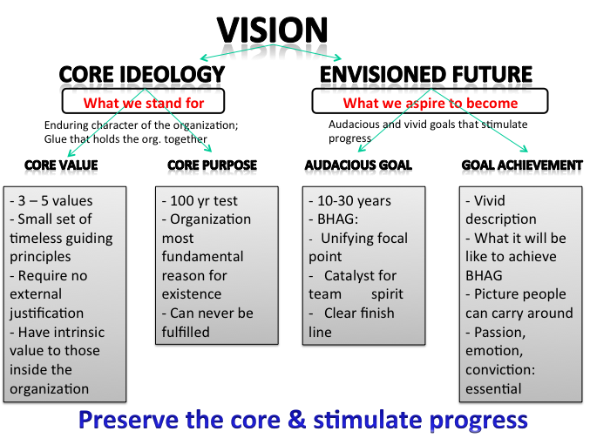
- Beware of the We’ve Arrived Syndrome Fundamental dynamic of visionary companies: preserve the core and stimulate progress
Abraham Zaleznik
Managers and leaders: Are they different?
Zaleznik main claim
- “Managers embrace process, seek stability and control, and instinctively try to resolve problems quickly….. Leaders in, contrast, tolerate chaos and lack of structure and are willing to delay closure in order to understand the issue more fully” (p.74)
- Vision (leader) versus Execution and results (manager)

Zaleznik sub-claims
- “Business leaders have much more in common with artists, scientists, and other creative thinkers than they do with managers” (p.74) Humanities and social skills
- “Organizations need both managers and leaders to succeed” (p.74)
- “Leaders work in the opposite directions. Where managers act to limit choices, leaders develop fresh approaches to long-standing problems and open issued to new options” (p.77)
- “Leaders work from high risk positions” (p.77)
- “For those who become managers, a survival instinct dominates the need for risk, and with that instinct comes an ability to tolerate mundane, practical work” (p.77)
- “Managerial personalities form moderate and widely distributed attachments. Leaders, on the other hand, establish, and also break off, intensive one-to-one relationships

Managers vs. Leaders personality:
- Attitude toward goals – active vs. reactive; shaping ideas rather than responding to them
- Conceptions of work - Managers limit choices, leaders develop fresh approaches
- Relations with others – Managers prefer to work with people and relate to them according to the role they play. Leaders relate in more intuitive and empathetic way
- Senses of Self – once born vs. twice born

- Article to prepare for the (Oct 9)mid-term exam
- Get the articles from CLUES, Course Reserves
- How l Did It... Chobani’s Founder on Growing a Start-Up Without Outside Investors, HBR, Oct. 2013, pp. 45-48
- Even a Giant Can Learn to Run, New York Times, Dec 31, 2011
- Read carefully, ponder, discuss, think about questions that could be asked

- Midterm is closed-book/notes
- Clean copy of the articles
- 4 short answer questions (1/2 page)
- 1 essay question (1 page)
- Paper (not electronic) language dictionaries allowed
  - Mid-term counting for 20% of your term grade

WEEK 6 (exam) WEEK 7
The Manager’s Job and Social Power
- Describe the various roles a manager plays as he does his job
- Describe various ways influence and power operate in organizations
- New critical thinking skill: Causal claims
- Conducting Interviews

Henry Mintzberg 1939-“Business Guru” of Canadian origin
The practices of managers, The Manager’s Job

What do Managers do?
Myths
- The manager is a reflective systematic planner
- The effective manager has no regular duties to perform
- The senior manager needs aggregated information which a formal MIS provides
- Management is becoming a science or a profession
- Mintzberg’s manager’s roles
- Myth:
  - Managers plan, organize, coordinate & control
- Realities:
  - Interpersonal roles
- Figurehead, Leader, Liaison
  - Informational roles
- Monitor, Disseminator, Spokesperson
  - Decisional roles
- Entrepreneur, Disturbance-handler,
- Resource-allocator, Negotiator
Managerial roles

- Figurehead
- Leader
- Liaison
- Monitor
- Disseminator
- Spokesperson
- Entrepreneur
- Disturbance-handler
- Resource-allocator
- Negotiator

- Think back to a job you have had. Which roles did your own boss enact most frequently?
- Which role best describes Dale Moser’s job when he adds a new service (like he did between Chicago and Memphis)? When he rides the buses himself once a month?

Mintzberg Interview
- An interview with Henry Mintzberg discussing how his ideas of over 35 years ago still hold up in the internet
- http://www.theglobeandmail.com/video/pure-managing/article1288545/

Types of Power: French & Raven
Social Power “who holds it over whom”
Power is a relationship, not an attribute
Power
- Do you like power? Why?
- Why do we need to consider it in a management course?
- How can we say that somebody has power?
- How do someone gain power?
- Is there a unique type of power?
- Forms of managerial influence

- Reward Power, based on one’s perception that other has the ability to mediate rewards for him
- Coercive Power, based on one’s perception that the other has the ability to mediate punishments on him
- Legitimate Power, based on one’s perception that the other has a legitimate right to prescribe behaviour for him
- Referent Power, based on one’s identification with the other
- Expert Power, based on one’s perception that the other has some special knowledge or expertise

Examples:
REWARD: Give them a good peer evaluation
Provide them with special benefits
Influence their getting a pay increase

LEGITIMATE: Tell them that they have commitments to meet
Make them recognize they have tasks to accomplish
Make them feel they have commitments to meet

REFERENT: Make them feel like I approve of them
Make them feel important
Make them feel personally accepted

COERCIVE: Give them tough, undesirable jobs to do
Make things unpleasant for them
Make the work difficult for them

EXPERT: Share my experience & special skills
Provide good technical suggestions
Provide them with good task-related advice

Forms of managerial influence
Role

- Figurehead
- Leader
- Liaison
- Monitor
- Disseminator
- Spokesperson
- Entrepreneur
- Disturbance-handler
- Resource-allocator
- Negotiator
Social Power
- Reward power
- Coercive power
- Expert power
- Legitimate power
- Referent power

Use of power at Megabus
- What is the relationship between these different people? Do they hold any power on each other?
  - Dale Moser
  - Moser’s Scottish boss
  - Federal transportation officials
  - Joseph Schwieterman, director of the Chaddick Institute for Metropolitain Development
  - Brian Izzo, one of Schwieterman’s students

Causal Claims
- Sharpen your analytical skills
- Three first parts of the critical thinking model that you should now understand:
  - Identify the author’s major conclusions
  - Describe & evaluate supporting evidence (6 criteria of evidence)
  - Uncover assumptions & values

“Reality is a marble cake”
- This is Henry Mintzberg’s way to say that cause and effect relationships are multiple, and therefore difficult to identify.

Causal explanation = Author’s interpretation of cause & effect relationships
Reverse causation:
Rival causes: The same evidence can be consistent with different interpretations
- 3 types of Rival causes related to:
1. Differences between groups
2. Association of characteristics
a. Reverse causation?
b. Effect of 3rd variable?
3. The post hoc, ergo propter hoc fallacy
<After this> <Therefore> <Because of this>
Interview
- Interviewers:
- Was it difficult or easy?
- Was there any response you wanted to follow up on?
- What would you do differently?
- Interviewee:
- How did you feel during the interview?
- What suggestions would you make to the interviewer?
- Audience:
- What are your observations?
- What suggestions would you make to both sides?

Tips for conducting interviews
- Present introductory letter
- Dress neatly! Do not chew gum!
- Address participants politely
- Ask questions as on interview guide; follow-up if needed
- Complete interview in 10-15 minutes as promised
- Tell interested participants that they may be given a copy of your report

Handling data
- Take notes during the interviews
- Type up your notes and add details as soon as possible after the interview
- Keep notes confidential
- Your instructor may ask you to bring these notes to class later in the term

WEEK 8:
Strategy, Resources and Capabilities
- Understand how companies develop and maintain competitive advantage
- Be able to find examples of resources and capabilities that are valuable, rare, hard to imitate and organized to be exploited
- Critical thinking skills: Techniques of persuasion

Jay Barney on Internal Resources and Capabilities
- Jay Barney is one of the most influential contributor within the field of strategy today, and is a professor at Fisher College of Business at Ohio State University.

The SWOT framework
- SWOT Analysis is the traditional tool for strategic analysis. It is not Barney’s theory
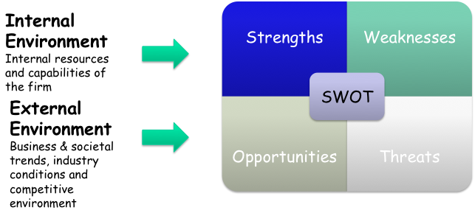
- SWOT framework has two components: Internal and External Environment analysis

Barney’s article (Looking inside for competitive advantage) provides a tool to assess the organization internal resources and capabilities
Barney’s major claims
- A firm will have a sustained competitive advantages if its resources and capabilities are valuable, rare, inimitable and organized in a way that allows to exploit potential opportunities.
- A firm will be successful if it has resources with the right attributes and characteristics
- The most careful and complete analysis of firms’ competitive environments cannot, by itself, explain their success
- Strategists also need to analyze the competitive implications of firms’ internal strengths and weaknesses

The Firm’s Resources and Capabilities
- Financial, physical, human, organizational assets used by the firm to develop, manufacture and deliver products and services to its customers.
- Financial: debt, equity, retained earnings, etc…
- Physical: machines, manufacturing facilities, buildings.
- Human: experience, knowledge, judgment, wisdom, etc…
- Organizational: history, relationships, trust, culture, formal reporting structure, patents, etc….

Four important questions about resources and capabilities
- The Question of Value: Does a firm’s resources and capabilities enable it to exploit an opportunity, and/or neutralize a threat?
- The Question of Rareness: How many competing firms already possess these valuables resources and capabilities?
- The Question of Imitability: Do firms without a resource or capability face a cost disadvantage in obtaining it compared to firms that already possess it?
- The Question of Organization: Is a firm organized to exploit the full competitive potential of its resources and capabilities?

The question of Imitability
- The importance of history: Valuable and rare resources acquired or developed through unique historical circumstances can be a source of sustained competitive advantage
- The importance of numerous small decisions: A firm’s competitive advantage seems to depend on numerous “small decisions” (rather than big ones) through which a firm’s resources and capabilities are developed and exploited in developing, nurturing and exploiting resources
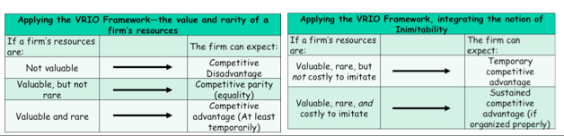
  - The importance of socially complex resources: Reputation, trust, friendship teamwork and culture, while not patentable are much more difficult to imitate
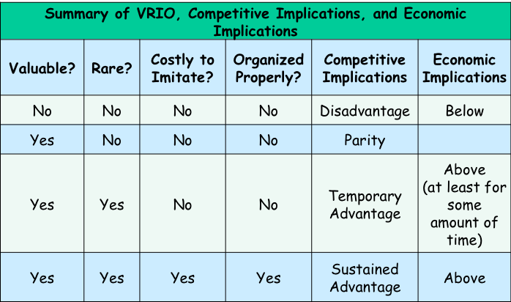
Applying the VRIO Framework: Value, Rarity, Inimitable, And Organized Properly

Techniques of persuasion
  - Anticipate objections based on
    - negative evidence
    - alternative causes
    - conflicting assumptions
  - Counter-argue objections
- Limit claims you cannot rebut
  - Acknowledging limitations makes your writing MORE persuasive
    - Limits to generalizations
    - Level of probability less than 100%
    - Re-defining terms
- Rhetoric – use of language to convince
  - Detail (evidence and assumptions)
  - Tone (scholarly vs. narrative)
  - Vividness (being concrete draws attention)

- Which foundational business article did you find most convincing so far? Why or why not? Analyze why it is (or is not) persuasive for you
- Work individually for 15 minutes. Write down your findings. I will collect them as part of the participation grade.
- Techniques of Persuasion
- In groups of 4-5 discuss your findings for 25 minutes. Try to persuade the group with regards to your findings
- We will follow with a class discussion
- How will you maximize the persuasiveness of your team project report?

WEEK 9:
Performance, measurements and evaluation
Objectives for today
- Consider how firms keep track of their own performance
- Describe why measurement is important for companies to achieve their goals
- Practice the creation of good measurements
- Explore how to write a persuasive essay.

Kaplan & Norton’s Balanced Scorecard
Kaplain (Harvard Business School professor)
Norton (Consultant)
- The Balanced Score Card is a Performance measurement system/tool
- Kaplan & Norton’s balanced scorecard
- What you measure is what you get!
- The traditional financial performance measures worked well for the industrial era
- The “bottom line” is not enough

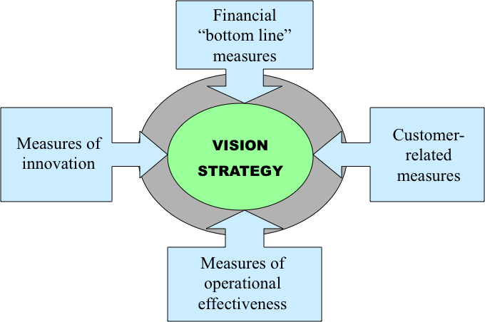
Four perspectives for a balanced scorecard
- Customer perspective
    - What matters most to customers?
- Internal business perspective
    - How can we produce to meet customer expectations?
- Innovation & learning perspective
    - How can we make continual improvements?
- Financial perspective
    - How can we ensure profitability for shareholders?

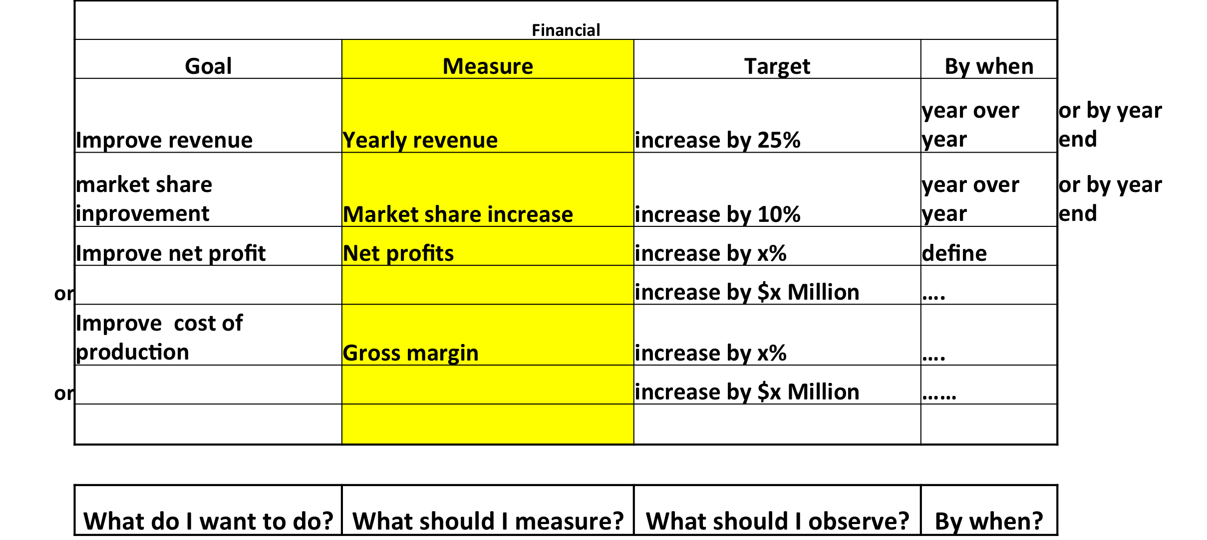
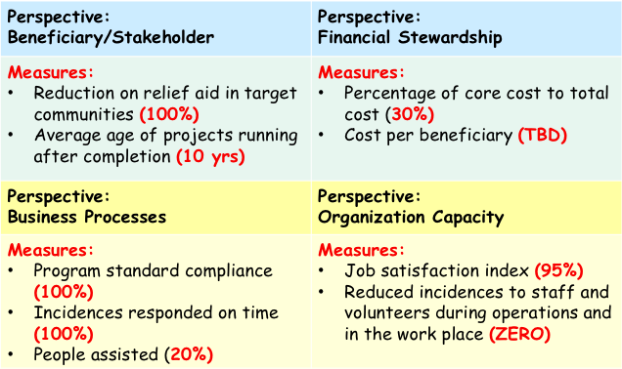
Balanced Scorecard: Kenya Red Cross (2010) Balanced Scorecard: Financial perspective

http://www.balancedscorecard.org/LinkClick.aspx?fileticket=b2j-xzGAsbk%3d&tabid=57
http://www.balancedscorecard.org/BSCResources/ExamplesSuccessStories/tabid/57/Default.aspx

- When doing a balanced scorecard, make sure measures are specific and applicable to Cirque du Soleil case and its industry.
- Try to come up with at least 2 measures for each perspective.

Writing a persuasive essay
- Outline your (contestable) claim and sub-claims
  - Ask yourself: “Why do I think this claim is true?” List reasons
  - Logic of your argument must be crystal clear
- Arrange your evidence
  - 2-3 pieces of evidence for each sub-claim (sufficient; accurate)
    - Views of experts; Quotes from interviews (authoritative; precise)
    - Statistics (precise)
    - Examples from your own experience, diverse variety of others (representative)
    - Detailed descriptions / background information (precise)
  - Give each section of your essay a meaningful subtitle (clear)
  - Any negative evidence? Do you anticipate readers’ objections? Do you need more evidence?
- Write your first draft
  - Don’t try for perfection the first time
    - The DOWN draft and the UP draft
  - Be careful not to plagiarize!!!
- Revise your work
  - Team contributions have to be integrated – similar style
  - Write your introductory sentences – engage the reader’s interest and attention
  - Write your concluding sentences – a strong ending tells people what they have learned
  - Add visual aids (charts, photos, clipart, concept maps)
- Full list of references

Cirque du Soleil essay
- Using the theories we studied this semester, write a one-page essay on the Cirque du Soleil should do to address its “tarnished brand”.
- Make sure you state a clear claim
- Make sure you provide good quality evidence for your claim
- You may also use the Techniques of persuasion we studied in classes 8 and 9.
- Work on claim
- Work on clarity
- Add more info (sufficiency): for every argument, provide evidence. This because that (eg)
- Representative (customers, boss, etc) provide all parties opinion

Making an argument using Structured Debates
  - Make sure you understand underlying facts, ask questions, develop refutations
  - Agree on a joint claim & summarize best evidence – positive and negative. Counter-argue negative evidence or limit argument appropriately

Debatable claims
- It is better to be an employee in a large multinational than a small locally-focused company
- To reduce poverty, it is more effective to “boost local economies in post-conflict countries” than to donate goods
- Organizations should always promote managers from within the firm
- It is a mistake to hire relatives of employees
- It would be desirable to be an employee in a firm like Gore with a “flat” hierarchy
- It is desirable to be an employee in a firm with a strong culture and vision

WEEK 10:
Organizational Change
- Describe ways that managers and employees can deal with change
- Be able to reconcile the need for stability with the need for change in organizations

Feedback: Balanced scorecard
- What you put in the goal you have to be able to measure it.
- All goals should be consistent

Essays
- A company cannot follow a theory
- You should give evidence from the article of what they are doing wrong and then your suggestion based on a theory
- You write about a theory but do not give the name of the author-Is this your idea?
- You cannot refer to the case ( As Cassivi states- You are analyzing the Cirque)
- Barney –The company cannot be valuable, rare or imitable
        - The product cannot be valuable, rare or imitable
        - RESOURCES
        - Two opposites

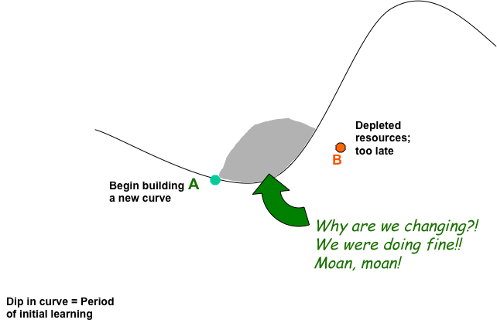
Handy’s Sigmoid curve: Key to effective growth

Questions
- It is easy for a company to know where it is on the curve?
- What is the discipline of the second curve?
- If you realize that you are not that far on the first curve, will this be a waste of time?
- What is the curvilinear logic?

The Paradox of Time:
  - By the time you know where you ought to go, it’s too late to go there
  - If you keep on going the way you are, you will miss the road to the future
  - Because it is easy to explain things looking backward, we think that we can predict them forward.

The S-shaped curve:
  - Empires, Corporations, Product life cycle, Love and relationships, Personal career, etc..
  - The 2nd curves: When to start the 2nd curve
  - Who should lead the 2nd curve?
  - Time of great confusion

The discipline of the 2nd curve:
  - How do we know where we are on the 1st curve?
  - Keeping the 2 curves going will be a habit
    - Benefits of the discipline of devising the 2nd curve.
    - The traditional four-stage of discovery: Questions; Ideas; Test; Review
  - Essential: Let go of your past

Curvilinear logic:
  - The paradox of success: « What got you where you are won’t keep you where you are»
  - It means starting life again, and it is harder as you become older
  - Entrusting the culvilinear thinking to the next generation
  - « Kaizen »
  - Must be wary not to abandon the 1st curve too early

Fertilizing the 2nd curve:
  - Seniors: Permission + Encouragement
  - New ideas can co-exist with old

An unusual business model
Describe the culture at Tom Shoes, as described by Chu & Weiss in The Cobbler’s Conundrum
- Is Toms’ business model consistent or inconsistent with Handy’s ideas? Discuss each element of the sigmoid curve as applied to Tom Shoes, using examples from article to aid the clarity of your argument
  - Point A & B
  - Initial dip in curve
  - The second curve
  - Shaded area between the curves

Capitalism
- “Capitalism, newly triumphant, probably has to re-invent itself” (Handy, p. 55)
- Does the Cobbler’s Conundrum article provide evidence that capitalism is re-inventing itself? Explain.

Viewpoints on change
- What have other authors had to say about managing change?
  - Collins & Porras
  - Greiner
  - Chandler
- Are their ideas consistent with the sigmoid curve? In what ways do they differ?

The Cobbler’s Conundrum Exercise
- Develop a “Cobbler’s conondrum” exam question based on the ideas of the author assigned to your team
- Your questions should be designed to test your fellow class members on their knowledge of the classic management theory (or critical thinking) and their ability to apply it to the concrete situation of Tom’s.

WEEK 11:
Motivation
- Review major concepts related to work motivation in organizations

Herzberg on Motivation
- http://www.youtube.com/watch?v=o87s-2YtG4Y – part 1
- http://www.youtube.com/watch?v=gtYi4102OvU&feature=related – part 2

Herzberg’s concepts: How do you motivate employees?
- Hygiene factors
- Motivators
- Dissatisfiers
- Satisfiers
- Job enrichment/Vertical job loading
- Jobenlargement/Horizontal job loading
- Negative KITA
- Positive KITA
- Herzberg’s concepts: How do you motivate employees?
- Explain what the concept means
- Try to find an example of each concept

Principles of vertical job loading
- Remove some controls while retaining accountability
- Increase accountability of individuals for own work
- Give person a complete natural unit of work
- Grant additional authority; job freedom
- Make periodic reports directly available to workers themselves rather than supervisors
- Introduce new, more difficult tasks
- Assign workers to specialized tasks, enabling them to become experts

Some steps for job enrichment
- Select jobs, approaching them with the conviction that they can be changed
- Brainstorm possible changes
- Screen to remove hygiene suggestions & horizontal loading
- Avoid direct participation by the employees whose jobs are to be enriched
- Be prepared for an initial drop in performance
- Expect first-line supervisors to experience some anxiety
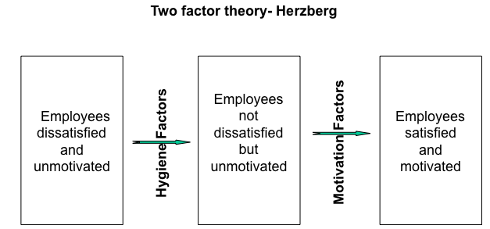

Motivation at GoodLife
1. In your view, is GoodLife a truly motivating place to work in Herzberg terms?
Include discussion of both hygiene factors and motivators
Justify your responses with specific evidence from the article
2. Would you like to work at Goodlife? Why?
3. Will GoodLife’s constant expansion make it a more or a less motivating place to work?

Put examples of questions at the end.
Ask for exam theories

