ACCO 310 MEMORIZATION SHEET

Chapter 1
Amortized: Gradually write off initial cost of asset
Information Symmetry: All Stakeholders equal access to relevant information
Information Assymetry: All Stakeholders have unequal access to relevant information: manager have more knowledge of what’s going on in the company.
- Adverse Selection: Information asymmetry may attract wrong kinds of companies in capital market
- Moral Hazard: With information asymmetry, people may act in their own favor at the expense of others
AcSB: Canadian Accounting Standards Board
- For ASPE
IASB: International Accounting Standards Board
-For IFRS

Chapter 2
Conceptual Framework:
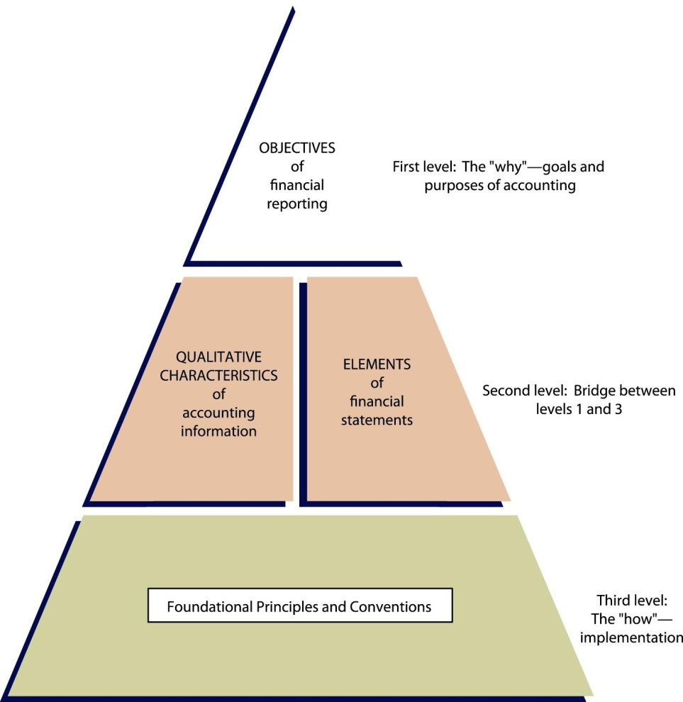
Fundamental Qualitative Characteristics:
- Relevance
- Representational faithfulness

Enhancing Qualitative Characteristics
- Comparability
- Verifiability
- Timeliness
- Understandability
Other comprehensive Income: Only exists under IFRS
Foundational Principals:
- Recognition/Derecognition
1. Economic Entity Assumption
2. Control
3. Revenue Recognition and realization principle
4. Expense Recognition/Matching principle
- Measurement
1. Periodicity Assumption
2. Monetary Assumption
3. Going Concern Assumption
-Must look out 12 months ahead
-If liquidation is likely, use liquidation accounting at NRV
-Must use full disclosure for any material uncertainty of going concern
4. Historical Cost Principal
5. Fair Value Principle

- Presentation and Disclosure
1. Full Disclosure Principal
-Anything relevant to financial decisions
-Can be made on main body of statement, in notes or in supplementary information
Financial engineering: legally structuring transaction to meet company’s financial reporting objective
Chapter 3
Debit Credit
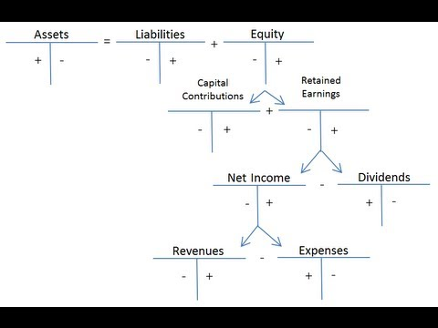

Adjusting Entries:
- Prepayments:
- Prepaid Expense
- Unearned Revenue
- Accruals
- Accrued Revenues
- Accrued Expenses
- Estimated Items
- Bad Debt
- Unrealized Holding Gain or Loss
- Unrealized Holding Gain or Loss – OCI
Closing Entries
Revenues, Expenses closed to Income Summary
Income Summary closed to Retained Earnings
Dividends closed to Retained Earnings
Other Comprehensive Income closed to Accumulated OCI
Chapter 4 Statement of Comprehensive Income
Quality of Earnings: How well reported income reflects underlying business
-Integrity
-Sustainability
-Presentation
Earnings management: Decreases quality of earning
Comprehensive Income vs Net Income
-Comprehensive Income = Net Income + OCI
-Under ASPE OCI doesn’t exist
Presentation Under IFRS
- Can be presented in a single combined statement: Statement of Comprehensive Income
- Can be presented as two statements: Income statement & statement of comprehensive income
- Can be presented as single step or multi step income statement
Single Step Income Statement
- Presents two groupings before discontinued operations: Revenues, Expenses
- Income tax expense usually as last items before Net income
Multi-step Income Statement
- Operating and non-operating activities are separated
- Continuing Operations
  - Operating Section
    - Net Sales
    - Cogs
    - Selling Expense
    - Gen & Admin Expenses
      - Expenses must be based on nature & function
  - Non-operating section
    - Other Revenues or Gains
    - Other Expenses & Losses
  - Income Tax
- Discontinued Operations:
  - Income/Loss from operations
  - Gain/Loss from disposition
    - BOTH Must be reported Net of Tax
    - Asset is remeasured at lower of carrying value and fair value net cost to sell
    - Under ASPE these assets (That are held for sale) are not reclassified ( Current asset stays current, long term assets stays long term)
    - Under IFRS these assets (That are held for sale) are reclassified to current assets
- Other Comprehensive Income
  - Includes gain/losses not reported on Net Income

Chapter 5 Statement of Financial Position: Balance Sheet
Balance Sheet Classification
- Assets
  - Current Assets
    - Disclose Any Restrictions to Cash
    - Receivables measured at NRV
    - Inventories measured at lower of cost and NRV, If manufacturing company separate inventories into raw material, work in progress and finished goods
  - Long Term Investments
    - Measured At Cost/Amortized Cost or Fair Value
  - Property Plan & Equipment
    - Measured at cost or fair value (FV or cost only under IFRS, cost as ASPE)
    - Disclose useful life, salvage value, depreciation method
  - Intangible Assets
    - Grouped under finite or infinite life
    - Finite life: Amortized over useful life
    - Infinite life: not amortized
  - Other Assets
- Liabilities
  - Current Liabilities
  - Long Term Debt
- Shareholders Equity
  - Capital Shares
    - Exchange value of issue shares
    - Disclose, issued, authorized and outstanding amounts
  - Contributed Surplus
    - Premium from issuing or reissuing shares
  - Retained earnings
  - Accumulated OCI / Surplus
Chapter 22 – Cash Flow Statement
Cash Flow Classifications
- Operating Activities
  - Collections from customers
  - Payments to supplier
  - Payments to employees
  - Payments to CRA for text
- Investing Activities
  - Purchase or disposal of capital asset
  - Acquiring interest in another corporation
- Financing Activities
  - Issuing debt, Repayment of debt
  - Issuing new shares or repurchase of currently outstanding shares

IFRS vs. ASPE – Cash Flow Statement
ASPE | IFRS
Interest Expense/Revenue, Dividend Revenue, classified as operating. Dividends declared classified as financing | Interest or dividends paid can be operating or financing
 | Interest and dividends received can be operating or financing

Two Methods For Preparing Operating Cash Flow Section
- Direct
- Determines operating cash flows directly for each operating source or use of cash
- Indirect
- Reconciles Net income to cash flows from operations
  - Operating Activities: Look at current liabilities & current assets
  - Investing Activities: Look at non-current assets
  - Financing Activities: Look at non-current liabilities & equity
Disclosures
ASPE & IFRS
- Significant non cash investing and financing transactions
- Policy on cash and cash equivalents
- Reconciliation of cash and cash equivalents to balance sheet accounts
IFRS
- Cash paid for taxes
- Cash paid for interest
- Restriction on cash and cash equivalent

Case Analysis
Steps to take
- Find your role in the case:
- Identify your role, are you an auditor, analyst or manager?
- Identify the stakeholders
- Consider business requirements
- Understand the company
- Are you under GAAP or IFRS?
- What is your objective?
- Analyse the issues
- Identify financial reporting issues
- Look for alternatives
- Look for relevant alternatives
- Consider Qualitative & Quantitative analysis
- Incorporate GAAP or IFRS.
- Analyse the issues
- State recommendations for resolving issue
- Summarise conclusion

