OB Notes

Chapter 1

- Resource value
  - Rare- in short supply
  - Inimitable- incapable of being copied
    - History
    - Numerous small decisions
    - Socially complex resources

- Rule of one eighth
the belief that 1/8 of the organization will do what is required to build profits by putting people first

- Scientific method
  - theory
  - hypothesis
  - data
  - verification

Chapter 2 Job Performance

Job performance- employees behavior that contributes either positively or negatively to the accomplishment of organizations goals

- Task performance- employee behaviors that are directly involved in the transformation of organizational resources into good or services that the organization produces

  - Routine task performance- well known responses by employees to predictable task demands
  - Adaptive task performance- thoughtful responses by employee to unique or unusual task demand
  - Creative task performance- physical outcomes that are both novel and useful

- Citizenship behavior

  - Interpersonal- going beyond normal job expectations to assist, support and develop co-workers
    - Helping- assisting co-workers with heavy work loads, aiding with personal manners and showing new employees the ropes
    - Courtesy- sharing important information with co-workers
    - Sportsmanship- Maintaining positive attitude with co-workers through good and bad times
  - Organizational- going beyond normal expectations to improve operations of the organization aswell as defending organizations and being loyal to it
    - Voice- speaking up to offer constructive suggestions for change (often reaction to negative work event)
    - Civil virtue- participation in company operations at a deeper then normal level through voluntary meetings, readings and keeping up with news that affects the company
    - Boosterism- positively representing the organization when in public
- Counterproductive behaviors
  - Property deviance- behaviors that harm an organizations assests and possessions
    - Sabotage – purposeful destruction of equipment, process or product
    - Theft- stealing company product or equipment

  - Production deviance- intentionally reducing organizational efficiency of work output
    - Wasting resources- using to many materials or too much time to do little work
    - Substance abuse- to use of drugs or alcohol before or during work

  - Political deviance- behaviors that intentionally disadvantage other individuals
    - Gossiping- conversation about other people in which facts are not confirmed
    - Incivility- communication thinat is rude, impolite, discourteous, lacking manners

  - Personal aggression- hostile verbal and physical actions directed towards other employees
    - Harassment – unwanted physical contact or remarks from colleague
    - Abuse- employee assault or endangerment from which physical or psychological injuries may occur.

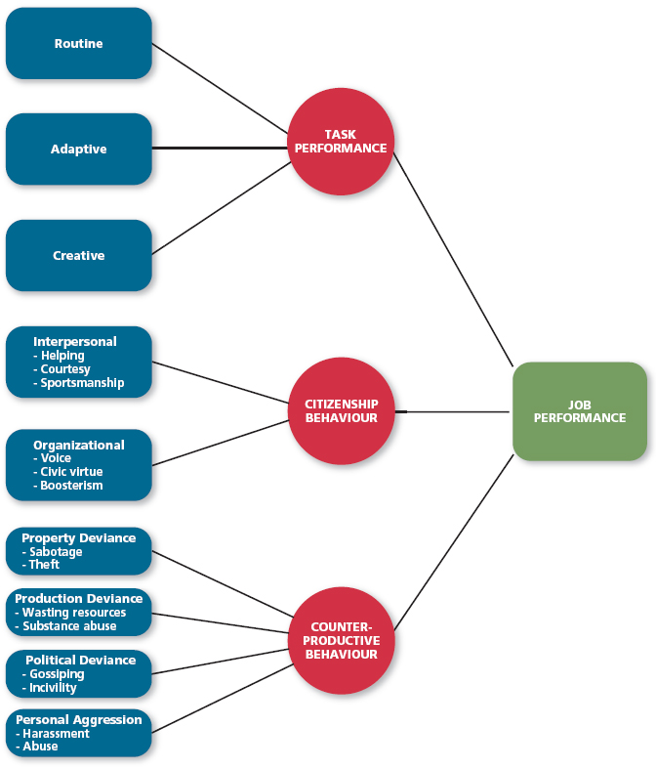

Chapter 3 organizational commitment

Forms of commitment:

- Affective commitment- employees desire to remain a member of an organization due to a feeling of emotional attachment
- Continuance commitment- employees desire to remain a member of an organization due to an awareness of the costs of living
- Normative commitment- employees desire to remain a member of an organization due to a feeling of obligation

Withdrawal Behaviors
- Psychological withdrawal (neglect)- mentally escaping the work environment
  - Daydreaming- a form of psychological withdrawal in which ones work is interrupted by random thoughts or concerns

  - Socializing- a form of psychological withdrawal in which one verbally chats with co-workers about non-work topics

  - Looking busy- a form of psychological withdrawal in which one attempts to appear consumed with work when not performing actual work tasks

  - Moonlighting- a form of psychological withdrawal in which employees use work time and resources to do non-work related activates

  - Cyberloafing- a form of psychological withdrawal in which employees surf the internet and email to avoid doing work related activities

- Physical withdrawal (exit)- physical escape from work environment
  - Tardiness- a form of psychological withdrawal in which employees arrive late to work or leave early

  - Long breaks- a form of psychological withdrawal in which employees take longer then normal lunches or breaks to spend less time at work

  - Missing meetings- a form of psychological withdrawal in which employees neglect important work functions while away from office

  - Absenteeism- a form of psychological withdrawal in which employees do not show up for an entire day of work

  - Quitting- a form of psychological withdrawal in which employees voluntarily leave the organization

Independent form model- method predicts various withdrawal behaviors are uncorrelated

Compensatory form model- method predicts various withdrawal behaviors are negatively correlated

Progression model- method predicts various withdrawal behaviors are positively correlated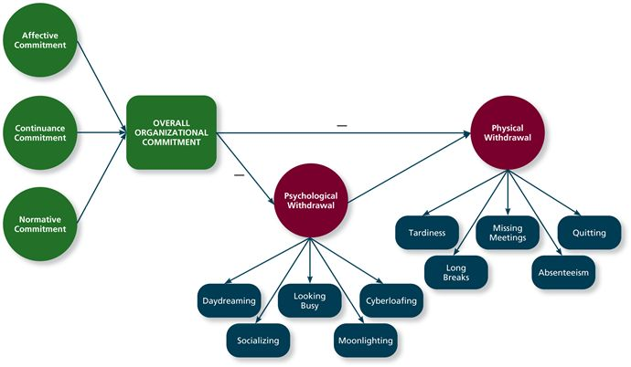
Chapter 4 Job Satisfaction

Values- things people consciously or unconsciously want to seek or attain

Value-percept theory- theory that argue job satisfaction depends on whether the employee perceives that his/her job supplies the things that he/she values

- Pay satisfaction- employees feeling about compensation for their job
- Promotion satisfaction- employees feeling about how the company handles promotions
- Supervision satisfaction- employees feelings about their boss including competency, communication and personality
- Co-worker satisfaction- employees feeling about their co-worker including abilities and personalities
- Satisfaction with work itself- employees feelings about their work tasks
  - Meaningfulness of work- a psychological state indicating the degree to which work tasks are reviewed as something that counts to employees system of philosophies and beliefs
    - Variety- the degree to which a job requires different activates and skills
    - Identity- the degree to which a job offers completion of a whole, identifiable piece of work
    - Significance- the degree to which a job really matters and impacts society as a whole
  - Responsibility for outcomes- a psychological state indicating the degree to which employees feel they are key drivers of the quality of work output
    - Autonomy- the degree to which a job allows individual freedom and discretion regarding how the work is to be done
  - Knowledge of results- a psychological state indicating the extent to which employees are aware of how well or how poorly they are doing
    - Feedback- the degree to which the job itself provides information about how well the job holder is doing

Job characteristics theory- theory that argues 5 core characteristics (Variety, Identity, Significance, Autonomy, Feedback) combined to result in high levels of satisfaction in work itself

Affective events theory- a theory that describes how workplace events can generate emotional reaction that impacts work behavior
- Positive emotions- employees feeling of joy, pride, relief, hope and love
- Negative emotions- employees feeling of fear, guilt, shame sadness
- Emotional labour- the management of their emotions that employees must do to complete their job duties successfully

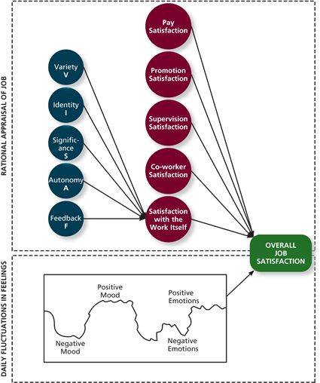
Chapter 5 Stress

Transactional theory of stress- a theory that explains how stressful demands are perceived and appraised, also how people respond to the perceptions of appraisals

Types of stressors:
- Hindrance stressors- stressors that tend to be appraised as thwarting progress towards growth and achievement
  - Work hindrance stressors
    - Role conflict- others having different expectations of what an individual needs to do in a role
    - Role ambiguity- a lack of direction and information about what needs to be done in a role
    - Role overload- an excess of demands on an employee preventing him from working effectively
    - Daily hassles- minor day to day demands that interfere with work accomplishments

  - Non-work hindrance stressors
    - Work-family conflict- conflict in which demands of a work role hinder the fulfillment of the demands in a family role
    - Negative life events- events such as divorce or death of a family member that tends to be appraised as a hindrance
    - Financial uncertainty- uncertainty with regard to the potential for loss of livelihood, savings, or ability to pay expenses
- Challenge stressors- stressors that tend to be appraised as opportunities for growth and achievement
  - Work challenge stressors
    - Time pressure- the sense that the amount of time allotted to do a job is not quite enough
    - Work complexity- the degree to which job requirements tax or just exceed employees capability
    - Work responsibility- the number and importance of the obligations that an employee has to other

  - Non-work challenge stressors
    - Family time demands- amount of time committed to fulfilling family requirements
    - Personal development- participating in activities outside of work that foster growth and learning
    - Positive life events- events such as marriage or birth of a child that tends to be appraised as a challenge
Primary appraisal- evaluating whether a demand is stressful and if it is, the implications of the stressor in terms of personal goals and wellbeing
Secondary appraisal- when people determine how to cope with stressors

Types of strain
- Physiological strain- reactions from stressors that harm human body
- Psychological strain- negative psychological reactions from stressors such as depression, anxiety, anger
- Behavior strain- patterns of negative behavior that are associated with other strains

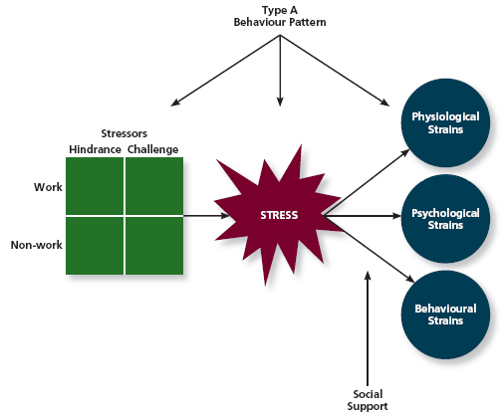

chapter 6-10 notes on other doc
Chapter 10 Teams, diversity and communication

- Types of teams:
  - Work team- relatively permanent team in which members work together to produce goods or services
- Management team- a relatively permanent team that participates in managerial-level task that effect the whole organization
- Parallel team- a team composed of members from various jobs within the organization that meets to provide recommendations about important issues
- Program team- a team formed to take on one time tasks, most of which tends to be complex and require input from members from different functional areas
- Action team- a team of limited duration that performs complex tasks in contexts that tend to be highly visible and challenging

- Team interdependence
  - Task Interdependence- the degree to which team members interact with and rely on other team members for information, materials, resources needed to accomplish work for the team
  - Goal interdependence- the degree to which team members have a shared goal and align their individual goals with that vision
  - Outcome interdependence- the degree to which team members share equality in feedback and reward that results from achieving the goal

- Team Composition- the mix of various characteristics that describes the individuals who work in the team
  - Role- the behavior that a person is generally expected to display In a given context
  - Ability- team member posses a wide variety of abilities
  - Personality- team members posses wide variety of personality traits which affect the role the team member takes on
  - Diversity- the degree to which team members are different from one another
  - Size- having a greater number of members is beneficial

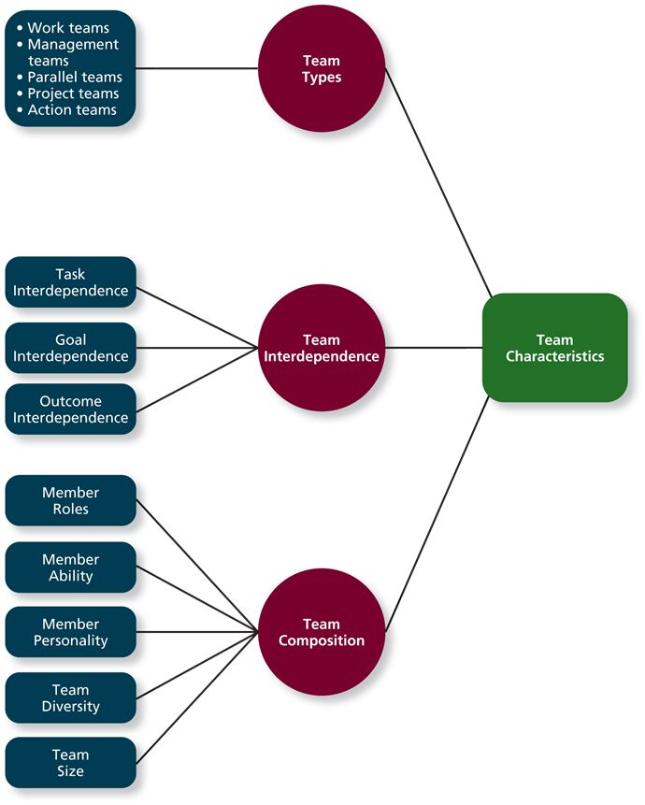

Chapter 11 Power, Influence, Negotiation

Types of power:
- Organizational power
  - Legitimate power- a form of organizational power based on authority or position
  - Reward power- a form of organizational power based on the control of resources or benefits
  - Coercive power- a form of organizational power based on the ability to hand out punishment
- Personal power
  - Expert power- a form of organizational power based on expertise or knowledge
  - Referent power- a form of organizational power based on the attractiveness and charisma of the leader

Influence tactics and their effectiveness:
- Most effective
  - Rational persuasion- the use of logical arguments and hard facts to show someone that a request is worth while
  - Inspirational appeals- an influence tactic designed to appeal to ones values and ideals, thereby creating an emotional reaction
  - Consultation- an influence tactic whereby the target is allowed to participate in deciding how to carry out or implement a request
  - Collaboration- An influence tactic whereby the leader makes it easier for the target to complete a request by offering to work with and help the target

- Moderately effective
  - Ingratiation- The use of favors, compliments, or friendly behavior to make the target feel better about the influencer
  - Personal appeals- An influence tactic in which the requestor asks for something based on personal friendship or loyalty
  - Exchange- An influence tactic in which the requestor offers a reward in return for performing a request
  - Apprising- An influence tactic in which the requestor clearly explains why performing the request will benefit the target personally

- Least effective
  - Pressure- An influence tactic in which the requestor attempts to use coercive power through threats and demands
  - Coalitions- An influence tactic in which the influencer enlists other people to help influence the target

Responses to influence attempts
- Internalization- A response to influence tactics where the target agrees with and becomes committed to the request
- Compliance- When targets of influence are willing to do what the leader asks but do it with a degree of ambivalence
- Resistance- When a target refuses to perform a request and puts forth an effort to avoid having to do it

Negotiation- A process in which two or more interdependent individuals discuss and attempt to reach agreement about their differences

- Distributive bargaining- A negotiation strategy in which one person gains and the other person loses
- Integrative bargaining- A negotiation strategy that achieves an outcome that is satisfying for both parties

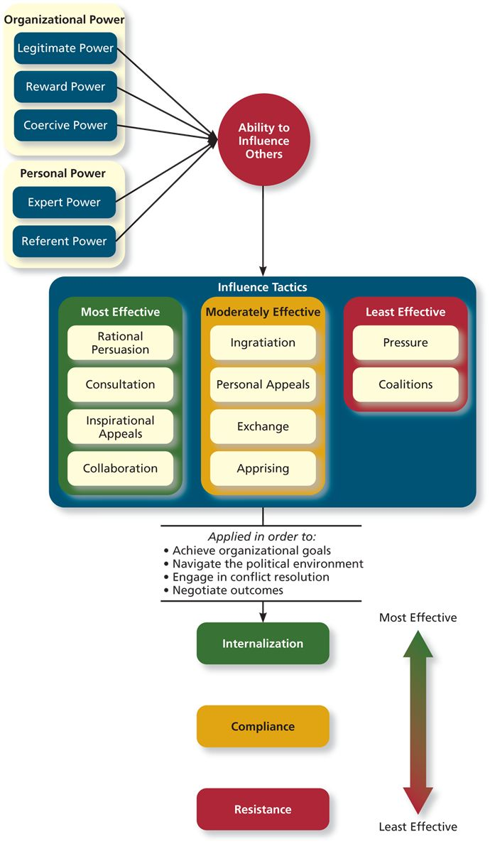
Chapter 12 Leadership style and Behavior

Leader effectiveness- The degree to which the leader's actions result in the achievement of the unit's goals, the continued commitment of the unit's employees, and the development of mutual trust, respect, and obligation in leader–member dyads

Leader decision-making styles
- Delegative style- A leadership style where the leader gives the employee the responsibility for making decisions within some set of specified boundary conditions
- Facilitative style- A leadership style in which the leader presents the problem to a group of employees and seeks consensus on a solution, making sure his or her own opinion receives no more weight than anyone else's
- Consultative style- A leadership style in which the leader presents the problem to employees asking for their opinions and suggestions before ultimately making the decision him- or herself
- Autocratic style- A leadership style where the leader makes the decision alone without asking for opinions or suggestions of the employees in the work unit

Time-driven model of leadership A model that suggests that seven factors, including the importance of the decision, the expertise of the leader, and the competence of the followers, combine to make some decision-making styles more effective than others in a given situation

Day to day behavior performed by leader

- Initiating structure- A pattern of behavior where the leader defines and structures the roles of employees in pursuit of goal attainment
- Consideration- A pattern of behavior where the leader creates job relationships characterized by mutual trust, respect for employee ideas, and consideration of employee feelings

Life cycle theory of leadership- A theory stating that the optimal combination of initiating structure and consideration depends on the readiness of the employees in the work unit

Readiness- The degree to which employees have the ability and the willingness to accomplish their specific tasks

- telling When the leader provides specific instructions and closely supervises performance
- Selling When the leader explains key issues and provides opportunities for clarification
- Participating- Leader behavior in which the leader shares ideas and tries to help the group conduct its affairs
- Delegating- Leader behavior in which the leader turns responsibility for key behaviors over to employees

Transactional and transformational behaviors

- Laissez-faire- When the leader avoids leadership duties altogether
- Transactional- A pattern of behaviour in which the leader rewards or disciplines the follower on the basis of performance
  - Passive management-by-exception- A type of transactional leadership in which the leader waits around for mistakes and errors, then takes corrective action as necessary
  - Active management-by-exception- A type of transactional leadership in which the leader arranges to monitor mistakes and errors actively, and takes corrective action when required
  - Contingent reward- A more active and effective type of transactional leadership, in which the leader attains follower agreement on what needs to be done using rewards in exchange for adequate performance
- Transformational- A pattern of behavior in which the leader inspires followers to commit to a shared vision that provides meaning to their work while also serving as a role model who helps followers develop their own potential and view problems from new perspectives

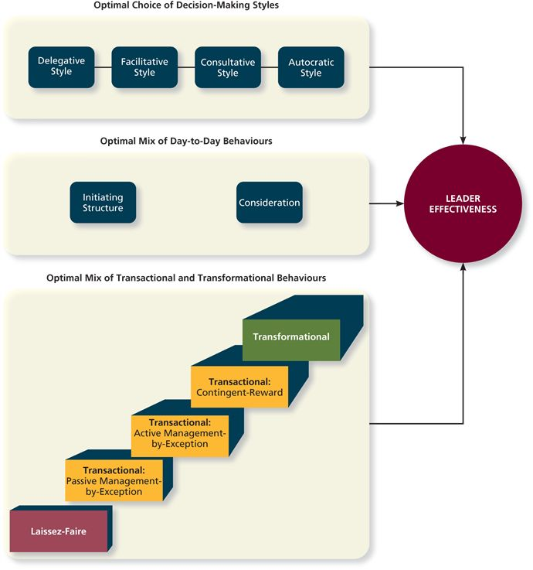
Chapter 13 organizational structure

Organizational chart A drawing that represents every job in the organization and the formal reporting relationships between those jobs

Elements of organizational structure:
- Work specialization The degree to which tasks in an organization are divided into separate jobs
- Chain of command Answer to the question of who reports to whom, and signifies formal authority relationships
- Span of control Represents how many employees each manager in the organization has responsibility for
- Centralization Aspect of structure that dictates where decisions are formally made in organizations
- Formalization The degree to which rules and procedures are used to standardize behaviors and decisions in an organization

Mechanistic organizations Efficient, rigid, predictable, and standardized organizations that thrive in stable environments
Organic organizations Flexible, adaptive, outward-focused organizations that thrive in dynamic environments

Organizational design- The process of creating, selecting, or changing the structure of an organization
- Business environment- The outside environment, including customers, competitors, suppliers, and distributors, which all have an impact on organizational design
- Company strategy- An organization's objectives and goals and how it tries to capitalize on its assets to make money
- Technology- The method by which an organization transforms inputs to outputs
- Company size- The number of employees in a company

Common organizational forms:
- Simple structure- An organizational form that features one person as the central decision-making figure
- Bureaucratic structure- An organizational form that exhibits many of the facets of a mechanistic organization
  - Functional structure An organizational form in which employees are grouped by the functions they perform for the organization
  - Multidivisional structure An organizational form in which employees are grouped by product, geography, or client
    - Product structure An organizational form in which employees are grouped around different products that the company produces
    - Geographic structure An organizational form in which employees are grouped around the different locations where the company does business
    - Client-based structure An organizational form in which employees are organized around serving customers
  - Matrix structure A complex form of organizational structure that combines a functional and multidivisional grouping
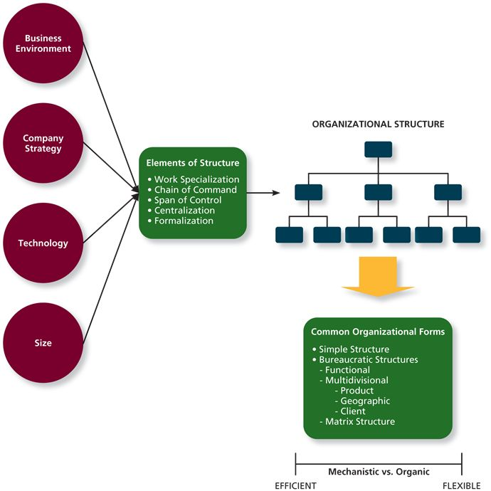

Chapter 14 Organizational culture and change

Three components of organizational culture:
- Observable artifacts- Aspects of an organization's culture that employees and outsiders can easily see or talk about
- Espoused values- The beliefs, philosophies, and norms that a company explicitly states
- Basic underlying assumptions- The ingrained beliefs and philosophies of employees
General culture types:

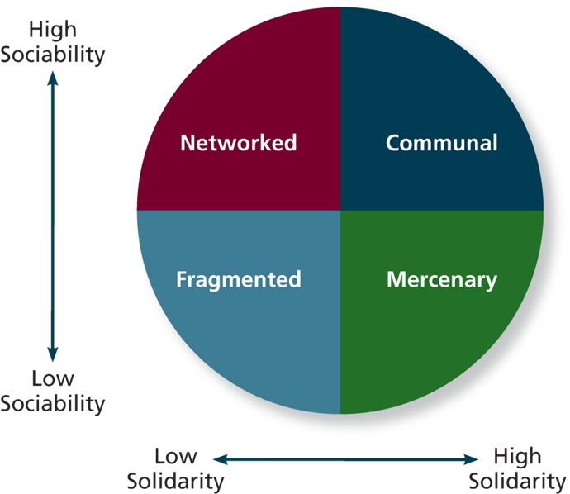

- Fragmented culture- An organizational culture type in which employees are distant and disconnected from one another
- Mercenary culture- An organizational culture type in which employees think alike but are not friendly to one another
- Networked culture- An organizational culture type in which employees are friendly to one another, but everyone thinks differently and does his or her own thing
- Communal culture- An organizational culture type in which employees are friendly to one another and all think alike

Specific Culture types:
- Customer service culture- A specific culture type focused on service quality
- Safety culture- A specific culture type focused on the safety of employees
- Diversity culture- A specific culture type focused on fostering or taking advantage of a diverse group of employees
- Creativity culture- A specific culture type focused on fostering a creative atmosphere

Culture strength- The degree to which employees agree about how things should happen within the organization and behave accordingly
Maintaining an organizational culture:
- Attraction/selection/attrition- A theory that states that employees will be drawn to organizations with cultures that match their personality, organizations will select employees that match, and employees will leave or be forced out when they are not a good fit
- Socialization- The primary process by which employees learn the social knowledge that enables them to understand and adapt to the organization's culture
- Changes in leadership-
- Mergers and acquisitions-



