In experiment (A), a cell is placed in a solution of molecules and observed over a period of time for the movement of these molecules in or out of the cell. The figures below represent a part of the cell and the solution.
The double lines that separate the box represent the cell membrane. The left side of the box is the inside of the cell (i.e. cytoplasm) and the right side, the outside (i.e. environment). Refer to the legend beside the figure for membrane bound proteins (transporters), ATP and the molecules glucose and fructose.

Figure 1: Start of the experiment A.

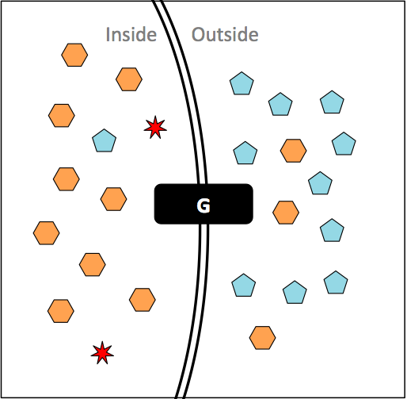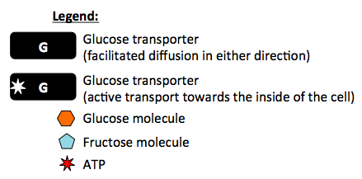

Question 1
- At the start of an experiment (figure 1), you examine the cell and determine that the ratio of Glucose inside the cell vs. Glucose outside the cell is: (circle the best answer)
Glucose inside = ? greater than one (>1)
Glucose outside equal to one (=1)
less than one (<1)

- The cell is allowed to sit in the solution for a long period of time. At the end of the experiment, you would expect the ratio of Glucose inside the cell vs. Glucose outside the cell to be: (circle the best answer)
Glucose inside = ? >1
Glucose outside =1
<1

- Explain your answers above using your knowledge of membrane permeability, transporters and concentration gradients i.e. how is Glucose able to move through the cell membrane if at all?
Glucose cannot simply diffuse through the cell membrane, it needs a transporter to get across the membrane. The glucose transporter in this cell is a carrier protein that facilitates diffusion of glucose in both directions. Once an equilibrium between glucose inside and glucose outside is reached, there is no net movement of glucose across the membrane.

In a second experiment (B), another cell (as shown below) is place in a solution of molecules and observed over a period of time. Refer to figure 2 below.

Figure 2: Start of experiment B.

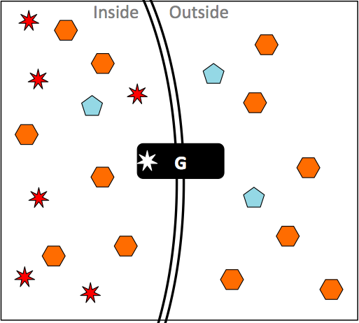

Question 2
a) At the start of an experiment (figure 2), you examine the cell and determine that the ratio of Glucose inside the cell vs. Glucose outside the cell is: (circle the best answer)
Glucose inside = ? >1
Glucose outside =1✔
<1

b) The cell is allowed to sit in the solution for a long period of time. At the end of the experiment, you would expect the ratio of Glucose inside the cell vs. Glucose outside the cell to be:
(circle the best answer)
Glucose inside = ? >1✔
Glucose outside =1
<1

- Explain your answers above using your knowledge of membrane permeability, transporters and concentration gradients i.e. how is Glucose able to move through the cell membrane if at all?

In the case of the above shown glucose transporter, ATP is used for active transport of glucose in one directions, into the cell – over a period of time, the ratio of glucose inside/glucose outside, will therefore be greater than 1.
Question 3
In a new experiment (C), two types of cells are examined for the ability to transport Glucose. Each cell type is added to a Glucose solution and you monitor the ratio between the Glucose concentration inside and outside the cells over a period of 30 minutes.
Cell type 1 = flask 1 with Glucose
Cell type 2 = flask 2 with Glucose

Figure 3: The data is represented on a graph

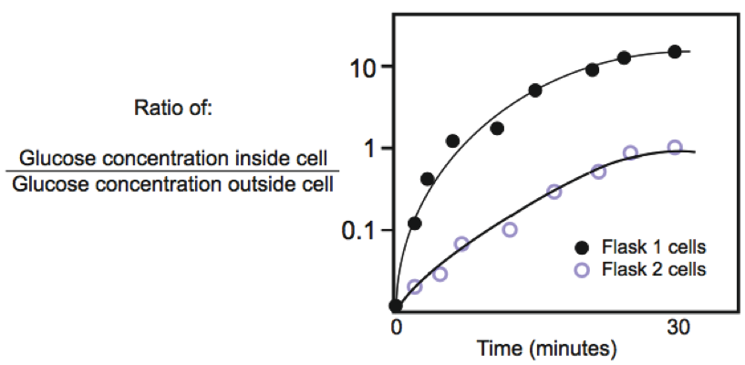

- Interpret the graph in Figure 3 by showing the relative amounts of Glucose inside and outside the membrane at the three time points given below. Draw a “G” to symbolize each Glucose molecule. If applicable, draw and label the appropriate transporter as shown in Figures 1 & 2.

Time zero  Flask 1 or Flask 2 | Time 30 minutes  Flask 1 cells | Time 30 minutes  Flask 2 cells

- Now explain the type of Glucose transport for each of the flasks.
To answer this question we specifically look at how the glucose ratio changes over time.
- We look at whether the ratio is greater than, less than, equal to 1.
- The ratio informs us whether the cells are working AlONG or AGAINST the concentration gradient.
- Flask 1: The cells have active transporters to transport glucose, because the ratio of glucose inside to glucose outside is high - a ratio far from equilibrium.
- Flask 2: The cells use facilitated diffusion to transport glucose across the membrane, because the ratio of glucose inside to glucose outside at T30 is 1 - an equilibrium ratio.

- Match the statements that best describes the cells in experiment C:
Write 1 for cell type 1 (flask 1).
Write 2 for cell type 2 (flask 2).
Write N for Neither.
RECORD ALL THAT APPLY.

Statement | Cell Type
Cells transport glucose using a transporter via active transport. | 1
Cells transport glucose using a transporter via facilitated diffusion. | 2
Glucose is moving in one direction. | 1
Glucose is moving with the concentration gradient. | 2
Glucose is moving against the concentration gradient. | 1
Glucose transport requires a transporter. | 1,2
Glucose moves across the membrane by simple diffusion. | N
The cell must expend energy for glucose to be transported. | 1
Glucose movement across the membrane requires a membrane  protein. | 1,2
The Glucose transporter does not undergo a conformational change. | N
The Glucose transporter undergoes a conformational change. | 1, 2
Glucose cannot (does not) move across the cell membrane. | N
Question 4
In this last experiment (D), the two cell types in question 3 are added to separate flasks with Glucose solution containing an ATP inhibitor.
Cell type 1 = flask 1 with Glucose + ATP inhibitor
Cell type 2 = flask 2 with Glucose + ATP inhibitor

Predict the effects of the ATP inhibitor on Glucose transport by drawing a transport curve for each flask on the graph below.
Note: ATP inhibitors can act instantly.

Figure 4: Flasks 1 and 2 with an ATP inhibitor added at time zero.

