Evaluations

Independent Reading Assignments (4% throughout semester)
In Class Assignments (6% throughout the semester – submitted in hard copy form, done in small groups in class)
Exam 1 (35% October 14th – non cumulative)
Exam 2 (35% November 25th – non cumulative)
True or false, multiple choice, fill in the blank, short answers, one long answer/development
Sensory-Perceptual skills presentation (5% November 9th and 11th)
Done in pair
Development of motor skills presentation (3%) and report (12%) Dec 2, 3, 9
Done in group of 3

UNIT 1

1 – What is this course about?

Motor skill development throughout the lifespan
(infancy, childhood, adolescence, adulthood, elderly)

Theoretical perspectives on motor development
(historical and current theories of motor development

Understanding motor development in the context of a constraints model

3 – Roles in this course

Professor; instructor
Provides students with a variety of ways to engage in processing the material to be learned (lectures, assignments, virtual campus)

Student; learner
Practices recalling and processing the material to be learned (attend lectures, complete assignments, use virtual campus resources)

4 – Motor Control, Learning and Development

Motor control;
Understanding how the nervous system controls muscles to permit skilled and coordinated movements
(coordinated actions, understanding what areas are responsible for creating the movement)

Motor learning;
Changes in skilled and coordinated movements that are related to experience and practice

5 – Bernstein’s Degrees of Freedom Problem

Coordination involves bringing body parts into a functional relationship in order to achieve a task goal

Redundant biomechanical degrees of freedom create an infinite number of possible movements >>> the problem of understanding coordination (can make it difficult)

6 – Degrees of Freedom

10^12 neurons
10^2 joints
10^3 muscles
10^9 receptors

Can we understand coordination by looking at how specific movements are selected?

When someone says touch your nose… why does everyone seem to adopt the same movement pattern? (All use index, touching the nose the same way)

Many degrees of freedom but we all seem to be narrowing down to the same movement pattern

Motor control;
What has the movement pattern included? (muscles, nervous system, etc.)

7 – Motor Development

Development is a continuous process of change in functional capacity
(Functional capacity is the ability to successfully interact with the world)
Represents a cumulative process – development is always occurring, but the amount of change may be more or less noticeable at various points in the live span.

Development is related to, but not dependent on age

Development involves sequential change

Development occurs through maturation and growth of all body systems AND its interactions with the environment and task.

8 – Changes in Motor Performance

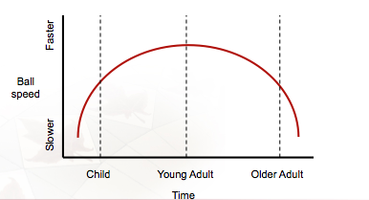

Performance level of throwing a ball

Child will throw almost the same way as an older adult.
Is the “why” the same? Do they throw the ball at that specific speed for the same reason? NO, it’s not for the same reason.

The goal is not to just try and understand the performance. Understanding WHY the performance is the same is important

Development is an ongoing process that occurs throughout lifespan

Motor development affects motor control
9 – Growth, Maturation and Aging

Physical growth;
Quantitative increase in size or body mass (Timiras, 1972)
(Age, height, etc.)

Physical maturation;
Qualitative advance in biological makeup (Teeple, 1978)
(Sexual maturation; pubic hair, appearance of breasts, menstruation)

Aging;
Process occurring with passage of time, leading to: loss of adaptability, loss of full function, and eventually death (Spirduso, 1995)
(Up to mid 20s, we are not considered aging. Only after that we start seeing declines)

10 – Common themes in course

Universality vs Variability

Universality;

Individuals show a great deal of similarity in the course of development
- Common developmental stages based on shared characteristics
“Did you crawl before you walked?”
- Typical or average behaviors can be useful for tracking developmental change
Normative Universality – helps us see if there are any problems with the development of a child (if late or not)
- BUT any individual is more likely to be below or above the average
- Individuals can also skip “milestones”
“Oh but I never crawled.” – Took a different path in the developmental process

UNIVERSAL FASHION
Shared stages of development by everyone, within different cultures, countries, etc. – UNIVERSAL

There is individuality (variability) in universality…
Someone can start crawling at 8 months, vs. 6 months and 11 months.

11 – Common themes in course

Nature vs Nurture

Debate centers on relative contribution of genetic inheritance and environmental factors

Nature;
Genetics
(What you start out with – usually physiological attributes)

Nurture;
Environment
(What he environment provides you – growing up in good socioeconomics, with siblings, with access to different facilities, etc.)

Some say that it’s not about genetics, and that it’s all about what you get from teachers, parents, and more. Anyone can be an expert in whatever domain that they choose.
Books:
Talent is Overrated by Geoffrey Colvin, 2010
The Talent Code by Daniel Coyle, 2010

Others say that you don’t have to be nurtured to be good ad something
http://www.youtube.com/watch?v=DT94FGBj2FU
^ This kid was never nurtured to be a music composer – So… Nature?

12 – Common themes in course

Ericsson (1997, 2005);
Athletes need 10 000 hours of deliberate practice to become an expert

Height;
If you’re tall (nature), it doesn’t mean that you will be good as basketball. And if you’re short, it doesn’t mean that you will be good at gymnastics… so nature does come in, but only to a certain extent.

Psychological aspects – both nature and nurture

Also, Nature vs Nurture varies based on the sport we are talking about!

Talent identification:
http://www.ausport.gov.au/sportscoachmag/development_and_maturation2/talent_identification_and_development_a_priority
http://www.csipacific.ca/content/SportDevelopment/TalentIdentification/TalentIDindex.asp
http://www.uksport.gov.uk/pages/talent-id/
13 – Research Developmental Change

Longitudinal research;
Same individuals are observed over a long period of time
Ex.: at 5, 10, 15, 20 years old
Gold Star Standard!
The research method you would use if you’re looking at developmental change.

Cross-sectional research;
Different individuals of various ages are observed at he same point in time
Ex.: in 2010, groups of children born in 1990, 1995, 2000 and 2005 are observed.
Same question as longitudinal research, but you would take a group of people born in different years and collect the data the same year.

14 – Researching Developmental Change

 | Advantages | Disadvantages
Longitudinal | - Eliminates possibility of the cohort effect  - Direct observation  - Account for individual variation | - Slower  - Attrition  (People may drop out… move away, get injured, pass away, etc. – so if you need 60 people, you start with 120)  - Most costly  (Because we’re tracking the participants)  - Repeating the same test  (May distort data/affect the results)
Cross-sectional | - Faster  - Sample  (Easier to get more people)  - Less costly | - Cohort effect  - Lose examining individual variation  (People develop at different rates so you don’t see the individual variation)  - Inference based

15 – Researching Developmental Change

Cohort;
A group whose members share a common characteristic, such as age or experience.

Cohort Effect;
Motor differences that can be explained by a common characteristic other than developmental change.
Ex.: 5 year old now growing up with smartphones vs 30 year old that didn’t.
^ Has a cohort effect
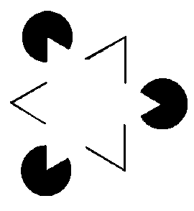
Ex.:
Kids in the 1980 stopped seeing the illusion triangle because the black circles were seen as Packman (which is a game that came out in the 1980s)
^ So experiences created a different finding.

When doing a cross-sectional design research, these cohort effects can be happening!

16 – Researching Developmental Change

Sequential or mixed longitudinal research design; 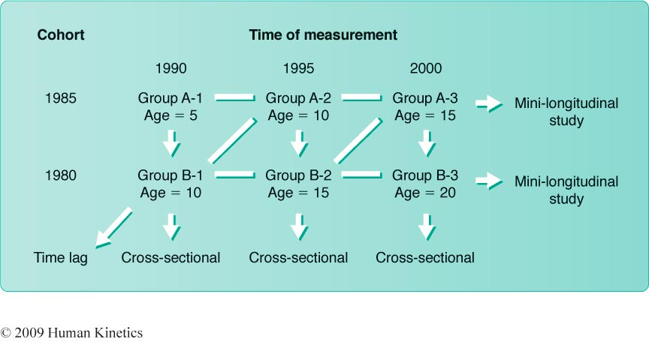
You don’t necessarily have a cohort effect as soon as you have a cross-sectional design research.

Time lag;
Comparing group A2 and B1
If these B1 10 year olds are showing the same results as these A2 10 year olds, then there is no cohort effect.

17 – History of Motor Development

READINGS

How have researchers attempted to classify and explain patterns of developmental change?

- Maturation of the CNS
- Normative Descriptive
- Biomechanical Descriptive
- Information Processing
- Dynamic Systems
- Perception/Action
^ Perspectives that are used in the literature.

18 – Maturational Perspective

^ Strongly influenced by the works of Gesell and McGraw.
Focused primarily on the individual – biological and genetic factors.
Gesell says, “Individual variation has more to do with genetic heritage than environment”.

GESELL AND MCGRAW ARE NATURISTS
Looking at the genetic, not the environment that they’re within.

For research, they usually use identical twins because they have the same genetics and start with the same template.

19 – Maturational Perspective

Motor development is primarily attributed to growth and maturation of the central nervous system (CNS). Other body systems are relatively unimportant.
Growth and maturation of the nervous system triggers the emergence of new skills. (It’s really the CNS that is dictating the changes that we see in movement)

20 – Myrtle McGraw

Co-twin experiment [Johnny (with super cool toys) vs Jimmy (with boring block toys)];
Results – Dependent on type of motor skills
Researchers have challenged results.

Naturists will say that the toys will have no impact on the child’s development
Nurturists will say that these different toys will have an impact.
21 – Ecological Perspective

Development driven by interrelationship of individual, environment, and task

Two major branches;
- Dynamic systems
(Body, dynamics)
- Perception-action
(How you take the acquired information and use it to move in the environment)

22 – Dynamic Systems

Theory was advocated in early 1980s by Kugler, Kelso, and Turvey (among others)

Body systems spontaneously self-organize (not driven by thought process of CNS)
- Organization is driven by constraints
- Constraints are channels by which movement can occur; they both encourage and discourage certain movement patterns

Body systems develop at different rates
- Movement only emerges when all systems are at necessary point of development
- Slowest system is called the rate limiting system
(System that is holding you back from executing a movement)

All body systems can develop at different rates – Movement only emerges at the level that we need them to execute proficiently

Constraints;
Example of the motor locomotion
Human (bipedal) vs Kangaroo (hopper) vs Dog (all four)
All can all move in all ways, but our skeleton drives us humans to walk on both feet, kangaroos to hop, and dog to walk on all fours → it is what’s most efficient to each.
So since our skeletal system discourages hopping and quadruped movement, and encourages bipedal movement, it is a constraint!

REVIEW

Growth, Maturation and Aging
Quantitative, qualitative, and quantitative

Universality vs Variability
We see consistent patterns in people’s development, but we see variations within those

Nature vs Nurture
Contribution of genetics vs contribution of the environment, and anything outside of the physiological make up

Research Designs
Longitudinal (gold standard)
Cross-sectional (inference based)
Sequential/Time-lag (inference based)
^ Doesn’t eliminate the cohort effect, but allows you to see if there’s one

History of Motor Development
Maturation
(NATURE APPROACH)
Ecological perspective – Dynamic and Perception-Action
(NATURE AND NURTURE, AND THEIR INTERACTIONS)

23 – Dynamic Systems: Graphing Change
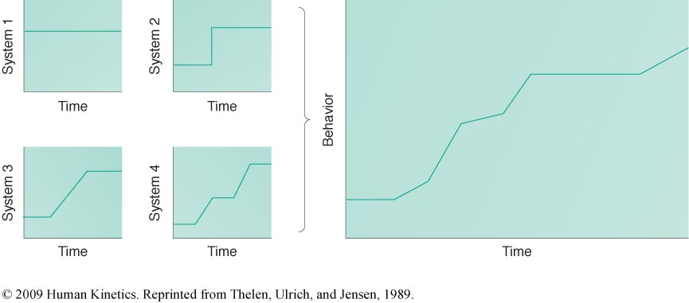
Systems that we use for walking;
- Balance system
- Muscular system
- Skeletal system
- Central nervous system

The rate limiting system to walking between 0-24 months is the balance system. Why?
Balance comes when all the other systems are developed. To use balance, you have to be standing, which requires a good skeletal, muscular, and central nervous system. Balance uses all three other systems.

24 – Perception-Action

Based on the work of J.J. Gibson (1960s and 1970s)
An affordance is the function an environmental object provides to an individual.
“Potential complementary relationship between the organism and the environment” (VanLeeuwen et al., 1994)

Different things afford different kind of movement…
Ex.: walking on ice afford walking slower, taking smaller steps, etc.

25 – Perception-Action

The characteristics of an object define its meaning to an individual
Graspability, catchability, etc.
(The characteristics can give us affordance…
Ex.: a table; smooth, hard – so we can afford to write on it, sit on it, etc.
Ex.2: catching a Frisbee vs catching a medicine ball – can afford to catch one hand or both with different motions)

Object functions are perceived based on the individuals’ dimensions (i.e., are body scaled) rather than the object’s actual properties
Ex.: a kid going up the stairs vs a grown up going up the stairs… they have the same goal, but different strategy because of the body scaling → different affordances, so they generate different pattern/strategy

So remember that when you’re working with populations, you have to consider their body scaling and more.

26 – Karl Newell’s Model of Constraints

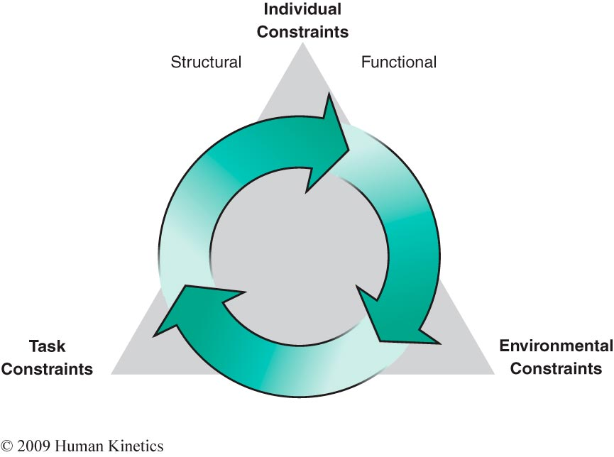
27 – Individual Constraints

Structural constraints;
- Related to the body’s physical structure
Ex.: hinge structure of the elbow constraints movement to one plane
Ex.: cardiorespiratory system development
- Structural constraints may change with growth and aging
Can be any system; skeletal, muscular, cardiorespiratory, etc.
Anything that is a physical part of the body.

28 – Individual Constraints

Functional constraints;
- Related to behavioural function
Motivation, attention, previous experience, knowledge
Motivation will change the pattern executed…
Ex.: “Get from point A to point B” – usually will just walk. “Whoever gets from point A to point B the fastest will get an extra 5% on their final grade” – Motivation changed! So pattern changed into running.
- Functional constraints may vary widely between individuals
Still characteristics of the individual

29 – Environmental Constraints

- External to the individual
- Properties of the world around us
Gravity, floor surface/terrain, weather conditions.
Affects how an individual is able to perform;
(interact with structural and functional constraints of the individual)
Ex.: Gravity on the moon (bounding) vs gravity on the Earth (walking)
Ex.2: Running from land to water
- Sociocultural environment
Cultural and societal values/conditions
Affects opportunities and experiences
Ex.: Sydney Crosby. Born in a county where hockey is a dominant sport.

30 – Task Constraints

- External to the individual and specific to the task
Goals of the task
Rules of the task
Tools/equipment to be used in the game/task

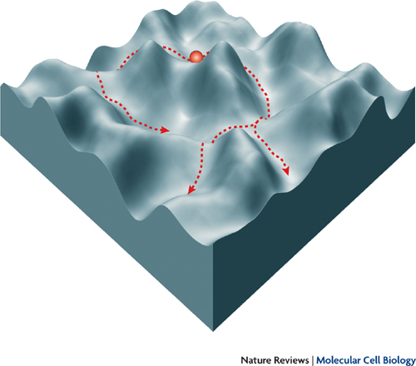
31 – Interaction of Constraints

- Interaction of individual, environmental and task-related constraints
- Creates an “attractor landscape” in which certain behavior is more or less likely to occur

Valleys – encouraging a movement
Mountains – discouraging a movement
With this, you start being attracted to certain movements more than others
UNIT 2

2 – Prenatal Development

Conception to birth – 38 weeks
Three stages
- Germinal
- Embryonic
- Fetal

Germinal

0-2 weeks – begins at sperm penetration into ovum (zygote)
Zygote travels and implants as a blastocyst onto uterine wall

3 – Implantation

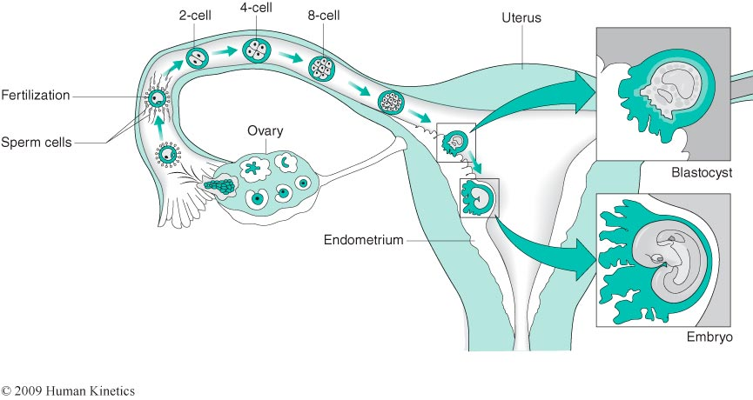

4 – Embryonic Development

2-8 weeks – starts when blastocyst attaches to uterine wall

Blastocyst has three layers that differentiate to form specific tissues and organs;
- Ectoderm
Skin, nails, hair, sensory organs, CNS
- Endoderm
Respiratory and digestive systems, internal organs
- Mesoderm
Inner layer of skin, muscles, skeletal and circulatory systems
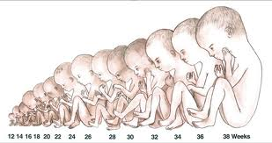
MOST CRITICAL PERIOD
5 – Fetal Development

9 weeks to birth – appearance of bone cells marks the beginning of fetal stage

At this point, fetus resembles a human

Continued growth by hyperplasia (cell number) and hypertrophy (cell size)

6 – Characteristics of Development

Month / Characteristic;
1 | Vertebral column forms, heart forms, small buds for arms and legs form, other body systems begin
2 | Eyes and nose form, limbs become longer, fingers and toes begin to form, ossification begins at the end of this month (fetal development)
3 | Eyes and nose further develop, ears begin to form, ossification continues
4 | Hair begins to appear on head, continued development of body systems, joints begin to form
5 | Head becomes less disproportionate, lanugo develops, rapid development of body systems continues
6 | Eyelids separate, eyelashes form, nails grow, vernix covers skin
7 | Most body systems fully developed, premature birth possible (age of viability)
8 & 9 | Subcutaneous fat is deposited, lanugo is shed

9 months is typically prenatal time
6th month is mostly fine tuning of the body… eyelashes fingernails, etc.

Vernix on newborn is the waxy covering that protects the baby

Lanugo is almost like a fur that will coat the infant. Will see it on the infant if born premature. They need lanugo to keep warm when in womb. Once the subcutaneous fat is deposited, lanugo is shed.

Proximodistal principle of growth:
Proximal aspect is the core
Distal aspect is going out to the further ends of the body, like fingers and toes.
Center out, Proximal to distal
Ex.: Limbs on months 1 and 2 (small buds then grow into full limbs)
Ex.2: Heart forms first (internal organ) then you start working outward

- Cephalocaudal principle of growth:
Cephalo aspect is head
Caudal aspect is tail but we don’t have a tail so bottom
Top to bottom, head to toes
Ex.: month 3 and down… Eyes and nose further develop, later on joints begin to form…
Ex.2: Vertebral column formed, and then later skeletal components come into play.

Typically, prenatal development will go on for 40 weeks long, but 37 weeks is fine. If too long before that, it is considered a premature birth.
Premature birth – mother not getting nutrients that they need, etc.
50% of cases are a whole mishmash of reasons.
After 25-26 weeks, a premature birth is usually viable.

In Ottawa, a baby boy was born at 21 weeks, but the neonatal department was able to save him.

Once born, what is the rate limiting system – respiratory system! (not cardiorespiratory)
They need to breathe with their own lungs
If the baby is born early, they will need assistance to breathing. Once developed enough, they can start breathing on their own.

Why do we put the baby in an incubator system if they breathe on their own and their heart is beating on its own? To maintain the body temperature, and maybe even for immunity (months 8 & 9)

REVIEW

There have been several major theoretical approaches to understanding motor skill development.

Ecological approaches, Dynamic systems and Perception-Action theories, are current theories that reflect our current understanding of the motor system.

Newell’s model of constraints comes from the ecological approach.

Developmental change in motor behaviour is dependent on changing constraints (Newell’s model);
- Individual structural
- Individual functional
Ex.: A child not having enough of an attention span
- Environmental
Ex.: Heat
- Task
Ex.: kick ball with feet only, rule
Socioeconomic influences – if don’t have enough money, can’t participate in whatever sport.

Prenatal development has 3 stages;
- Germinal
- Embryonic (most critical/important period)
- Fetal (longest period) (bone cells start being linked down)

7 – Abnormal Prenatal Development

Source of abnormal development can be genetic or extrinsic.

Genetic disorders can result from;
- Dominant gene inheritance
- Recessive gene inheritance
- Sex-linked recessive gene inheritance
- Gene mutation (e.g., Down Syndrome)

Women above the age or 35 can now get tested to see if they would get a child susceptible of getting the Down syndrome

8 – Dominant disorders

Mutation on one of the 22 autosomal chromosomes inherited is sufficient to cause disorder. (It takes only one mutated gene to express a genetic disorder.)

Movement disorder;
- Huntington’s chorea
Movements that are not goal oriented… involuntary. Begins to show as you are aging in the late 30s. So you may have the gene without knowing about it, and may not express itself until later in life
http://www.youtube.com/watch?v=SpNsspu16Pg

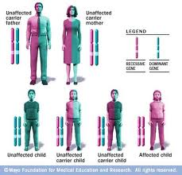
9 – Recessive disorders

Inheritance of mutation on two autosomal chromosomes needed to express gene
Example of a disorder;
- Cystic Fibrosis
Only occurs under a situation where you inherit the mutant gene from both parents to express the disorder

Blue eyes are also recessive – two parents with brown eyes can have a child with blue eyes
BUT you can’t have two blue eyed parents have a brown eyed child (not recessive)

“Looks just like the father!” – Because mother KNOWS that it’s her child, but as for the father… it could be anyone.
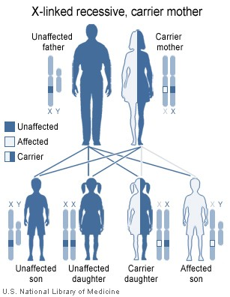

10 – X-linked recessive disorder

X-linked = Sex-linked
X chromosome carries the defect
Men tend to be affected whereas women are carriers
Examples;
- Color blindness
- Hemophilia
- Duchenne muscular dystrophy
http://www.abc.net.au/7.30/content/2012/s3407966.htm
X affected, Y cannot counter it, so son is affected. So typically males more so than females that show the x-linked recessive disorder.

11 – Extrinsic Causes of Abnormal Development; Physical Environment

Physical environment;
- Internal/external pressures
Ex.: Women who are having twins, one twin pushing on other twin, affecting the internal pressure.
Ex.2: Falls that can cause contusions, or car accident, etc. Anything that could hit the infant and affect developmental process.
- Temperature
Ex.: Avoiding things that make you really hot (hot tubs or saunas) or really cold (falling in a really cold lake when canoeing)
- Exposure to X-rays or gamma rays
Ex.: Incident in Japan with the nuclear reactors… Infants that were born shortly after were impacted.
- Atmospheric pressure
Ex.: Don’t plan on going to Mount Everest to prevent hypoxia.

12 – Extrinsic Causes of Abnormal Development; Nourishment

Oxygen and nutrients diffuse between fetal and maternal blood in placenta to contribute to growth and maturation of the fetus.
- Importance of maternal health status
- Competition for resources (between the mother and the baby, so mother has to make sure that she is getting enough good nutrients for both)
(Baby is being nourished by whatever is being ingested by the mother through the umbilical cord – it’s the lifeline!)

Teratogens are delivered through nourishment system and act as malformation-producing agents.

Some teratogenic effects result from;
- Too much of a substance (excess)
- Too little of a substance (deficiency)
- Something that should not be in the system (mere presence)

13 – Table 1: Example of Teratogens

Category | Examples
Deficiency | Not getting enough of something that should be in the system;  ex.: general lack of nutrients
Excess | Too much of something that should be in the system;  ex.: too much vitamin D can cause CNS defects
Mere Presence | Something in the system that should not be there at all;  ex.: drugs, alcohol, tobacco, viruses
http://www.youtube.com/watch?v=VNCLZJa4gkA
Case study – 1995 pregnant woman in Winnipeg

Child agency knew that the woman was pregnant but abusing substances. They went to court and wanted the judge to have her go into a detox rehabilitation institute against her will. The woman obviously fought it, not wanting to go in. What was the court’s decision and why?
They couldn’t do anything about it. They can’t put her there against her will, but when the baby would be born, they would take him away. At fetal stage, they’re not their own person anymore. When do you identify an individual as a person? Since then, there have been some changes. Different states have their own different ruling.

YOU ARE A PERSON ONCE YOU RESEMBLE A HUMAN BEING – 8 WEEKS

14 - System Undergoing Growth at Time of Teratogen

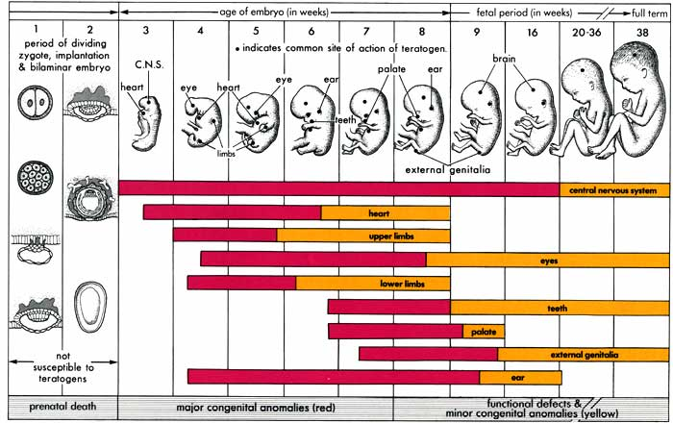

Thalidomide prescription drug – used to prevent nausea and more during early stages of pregnancy. It caused a lot of different deformities that affected the CNS.
At 3 weeks of age, when the nausea and all started, the mother would start taking the drug if she had morning sickness. Would continue taking it up until 3 months into pregnancy. But that’s when most of the child’s development is happening – that’s why using this drug affected the baby.
^^^^ TERATOGENS IN THE SYSTEM AT A TIME WHERE A LOT OF DEVELOPMENT IS HAPPENING.

15 – Can Babies Learn Inside the Womb?

Decasper and Spence (1986)

16 women read one of three stories out loud during the last 6.5 weeks of pregnancy.
Babies provided two non-nutritive soothers to suck on
- One would trigger the previously read story
- One would trigger another random story
Story of choice was the previously heard story – the cat in the hat
Decasper and Spence argued that learning could happen prenatally
Think about the different senses; which one could be considered truly “nature driven at birth”.

REVIEW

Cephalocaudal vs proximodistal
Respiratory system is the limiting system at birth
Adipose tissue is the last thing to develop during fetal development
If premature birth, room temperature needs to be controlled for the baby.

X-linked disorder is expressed in men usually. Not women because they have that dominant X chromosome that cancels the expression of the other mutant X chromosome.

Pregnant women;
Don’t want the body core temperature to overheat
No x-rays or gamma rays exposure
Avoid changes in atmosphere
Be careful with what is ingested during pregnancy (there is a link between what’s developing and the teratogen presence in a woman’s body)

Practice questions;
It takes only 8 weeks after conception for the developing fetus to resemble a human
TRUE
Premature births are typically due to poor prenatal care
FALSE
The respiratory system is the last to develop
FALSE
Boys are more affected than girls with the x-linked recessive disorder
TRUE
The mother’s placenta serves to protect the fetus from harmful viruses/drugs while in the womb
FALSE

16 – The Birth Process

The birth process is a traumatic event, and many things can go not as expected.
Complications
- Breech birth
Baby’s butt is facing down instead of the head. This used to be a really big complication, bad for both mother and baby.
Baby without oxygen for too long = CNS is greatly affected
Now, if we know it’s a breech birth, C-section is done
- Forceps delivery
Baby pointing the right way but not going through as fast for some reason. Forceps are then used. Can hit the brain since skull isn’t solid therefor can cause problems in development of the child

Alternative birthing styles
- Leboyer technique
Dim room, no noises, warm bath for baby, placement of baby with mother ASAP, massage to incite first breath
(Less traumatic)
- Traditional hospital
Bright lights, loud, cold air, test baby first, smack on the butt to induce first breath
(Traumatic)

17 – Testing the Gentle Birth Hypothesis

Nelson et al. (1980)

28 women traditional hospital
28 women Leboyer technique
Measures:
- Amount of crying at birth
- Assessment tests at
  - 24 hours
  - 72 hours
  - 8 months
(Muscle tone, reflexes, motor skill performance, motor milestones, etc.)
Results; NO DIFFERENCES

Longitudinal design because they followed the same individuals across multiple time change!

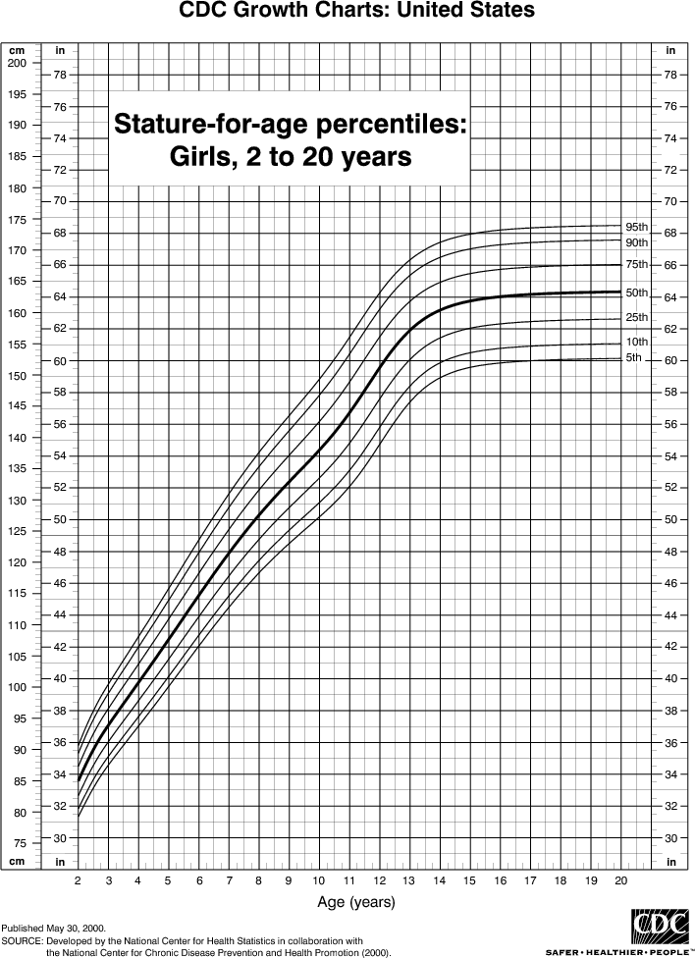
18 – Postnatal development

Overall growth follows sigmoid pattern (S-shaped)
Timing of spurts and steady periods can vary between individuals
Timing differs between sexes

Percentiles shown in the side
Shows if lower or higher in the 5th percentile, etc.

Provides a development tracking

19 – Velocity Curves for Height
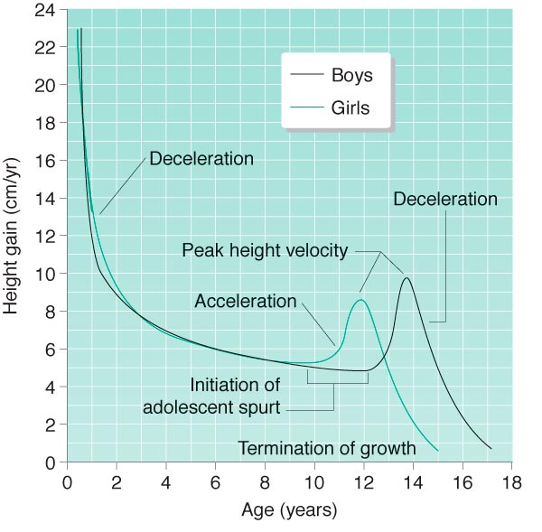
Velocity curve
Rate of change that’s occurring

Peak height velocity
The most growth is happening

Girls
Peak height velocity occurs at 11.5-12 years of age.
Growth in height tapers off around 14, ends around 16.

Boys
Peak height velocity occurs at 13.5-14 years of age.
Growth in height tapers off around 17, ends around 18.

Longer growth period of males contributes to greater height (then hits the age of take off – when acceleration starts)

Big change, then less and less, then another fast growth, then slows down again (S-shaped)

20 – Weight

Follows sigmoid pattern (S-shaped).

Is susceptible to extrinsic factors, especially diet and exercise.

Individuals grow up, then fill out: Peak weight velocity follows peak height velocity;
3.5-10.5 months in girls
2.5-5 months in boys

21 – Relative Growth

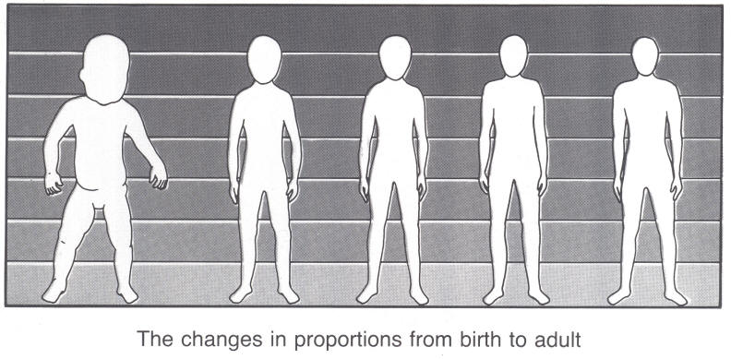
Body as a whole follows sigmoid pattern; specific parts, tissues, and organs have different growth rates.

Body proportions change from head-heavy, short-legged form at birth to adult proportions.

Head is 1/6th of the body as a baby!
Postnatal development; cephalocaudal

22 – Body Proportions

Changes in the body proportions can affect movement performance
Example of recommendations by Salmela and Durand-Bush for gymnastics;
Kids shouldn’t be doing any kind of back rolling until they are 5 years of age in order to protect their head, since their arms are still to short to push it off the ground.

Differences in body proportions for males and females:
- Males broader shoulders relative to hips compared to females
- Males legs contribute to standing height more than females
(So males have longer legs although women seem to have theirs longer – high waist pants, high heels, show more legs, etc.)

23 – Physiological Maturation

Height, weight, body proportions are all growth measures that contribute to change in size as children and youth become older (also maturational changes).
Individual variation occurs for all these measurements.

It is difficult to infer maturity from age alone, size alone, or age and size together.
(Can’t go just by height and growth alone to determine maturation level.)

24 – Maturational Indices

Secondary sex characteristics
- Menarche for girls
- No clear marker for boys
Dental eruption
- Appearance of teeth
- Loss of teeth
More maturationally advanced if teeth come out earlier or fall off faster
Ossification process
- Taller or not

Variations in maturation timing:
- Early maturers vs late maturers
If had peak height velocity at 10, you would be considered an early maturer (woman)
A late maturer usually ends up being taller on average
An early maturer will grow faster in a shorter period of time
The later maturer will have more time to grow before that short fast growth happens, therefore will grow slower, longer, then boom

Relative age effect in sports
When you’re selected in sports teams, it is done at a very young age.
Bigger taller and better-coordinated people are selected first because they are considered more maturationally advanced. Because of that, they get even better at their sport since they get more ice time, or more attention from their coach.
CUT OFFS – made based just on maturational growth advantages.
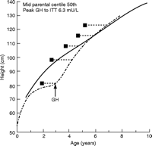

25 – Extrinsic Influences on Postnatal Growth

Individuals are especially sensitive during periods of rapid growth.

Catch-up growth demonstrates extrinsic influences. (Basically, you can catch up if something goes wrong… if you get sick or injured, then growth slows down, but once better you catch up)
(Nutrition affects our growth and so on…)

26 – Skeletal system

The embryo has a cartilage model of the skeleton.

Ossification begins at the primary centers in the mid-portions of long bones prenatally. (When you start seeing skeletal cells, it is no longer an embryo but a fetus.)

Skeletal growth starts at the spinal column, then upper limbs, and eventually in the humeral areas.

Skull bones do not fully ossify to enable passage through birth canal.
(Cartilage – cone head.)

27 – Postnatal Growth: Skeletal system

Growth in bone length (linear growth) occurs at secondary centers at the end of bones.
These centers are called epiphyseal plates, growth plates, or pressure epiphyses.

Growth in bone girth (appositional growth) occurs along the diaphyses (bone shaft).

Question;
Does exercise contribute to bone growth?
Exercise contributes to appositional growth, not linear growth.

Exercise doesn’t change your growth really one way or the other!

Random;
If you want to do a research project on appositional growth, what kind of exercise would you get the participants doing, and for how long?
Could use identical twins since they have the same genetic base (while checking for same nutrition, sleep, etc.) OR use athletes that use one side of their body more than the other, like Tennis players!

28 – Postnatal Growth: Skeletal system

Round bones ossify from center outwards.

Ossification is a maturational index:
- Talent identification
Dance – a selection process where they don’t want dancers to get really tall.

Ossification is typically complete for girls by age 16 and age 18-19 for boys.

29 – Injury to the Skeletal System

Damage to the diaphysis (bone shaft):
- Bone heals through remodeling process
- No long term consequences

Damage to epiphysis (secondary centers):
- Bone cannot heal to the same extent
(because this is where the bone grows…)
- Bone length differences can occur
(once damaged, doesn’t have the same potential to grow)

Traction epiphysis damage
- Little leaguer’s elbow (baseball)
To prevent LLE, in baseball they have a pitch count.
Ex.: cannot make more than 3 innings, max 60 pitches, etc.
We set rules to protect the athletes^.

REVIEW

The birth process

Postnatal growth
Height, weight, body proportions (timing different between males and females),

Postnatal maturation
Can’t use growth measures, but we use growth measures to get an idea of the maturation measures

Indices:
- Secondary sex characteristics
- Dental eruption
- Ossification process

Relative age effect (late birthday athletes usually end up elite because they are older when they make the cutoffs – a November/December 1995 will compete with 1996s)

30 – Skeletal System in Adults

Bone undergoes remodeling throughout the lifespan:
Old bone is absorbed by a low bone mineral density and microarchitect, new bone formed by osteoblasts.

In adulthood, bone growth slows, fails to keep pace with reabsorption and bone becomes more brittle.
http://www.youtube.com/watch?v=BrI7Ra5FTus&feature=related

Skeletal structure itself changes little unless one has osteoporosis.

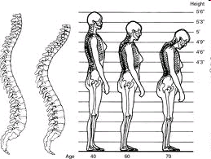
31 – Osteoporosis

Osteoporosis is a systemic skeletal disorder characterized by a low bone mineral density and microarchitectural deterioration of bone tissue.

According to Osteoporosis Canada, ¼ women and at least 1/8 men over the age of 50 suffer from osteoporosis.

Osteoporosis leads to ribcage collapse, stooped posture, and reduced height. Fractures occur more easily when a person falls.

32 – Four Mechanisms of Bone Mass Regulation

Mechanism 1  Stimulation of deposition  More/more active osteoblasts  Results from:  - Weight-bearing activity  - Fluoride intake | Mechanism 2  Inhibition of deposition  Fewer/less active osteoblasts  Results from:  - Lack of weight-bearing activity  - Chronic malnutrition  - Alcoholism  - Chronic disease  - Normal aging
Mechanism 3  Inhibition of withdrawal  Fewer/less active osteoclasts  Results from:  - Weight bearing activity  - Estrogen  - Testosterone  - Adequate vitamin D and calcium intake | Mechanism 4  Stimulation of withdrawal  More/more active osteoclasts  Results from:  - Lack of weight-bearing activity  - Estrogen deficiency  - Testosterone deficiency  - Inadequate vitamin D and calcium intake  - Normal aging

Less cells taking away, or more cells putting in
vs
More cells taking away, less cells putting in

Physical activity is an example of what targets all these different mechanisms:
When doing a weight-bearing activity, bone cells become more active and they start sending signals out to the osteoblasts to be more active, and to the osteoclasts to be less active.

Targeting mechanisms 1 and 3 when doing weight-bearing activity.
Targeting mechanisms 2 and 4 when not doing weight-bearing activity.

Weight-bearing activities have to stress the skeletal system* not swimming

Estrogen declines with age in women!

Nutrition requirements are very important too!

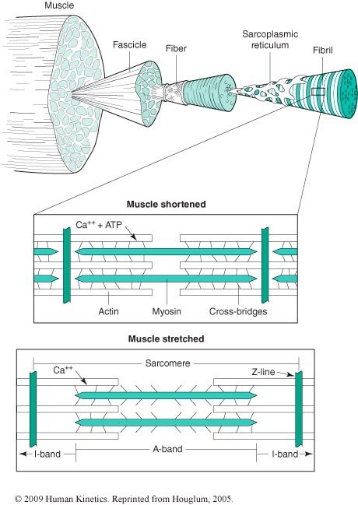
33 – Muscular System

Prenatal growth involves hyperplasia and hypertrophy.

Postnatal growth mainly involves hypertrophy.

Muscles increase in diameter (intensity) and length by addition of sarcomeres.

34 – Muscle Fiber Type

Adult muscle is composed of type I, type IIa, type IIx and type IIb fibers.

Exact proportions vary between individuals.

At birth, 15-20% of fibers are undifferentiated AND 15% of the fast twitch cannot be clearly categorized.

By age 1, distribution of muscle fiber type is similar to adult distribution.

35 – Muscular System in Adolescence

Differences between sexes become marked in adolescence:
- Boys add until age 17, and girls until age 13
- Upper body musculature vs lower body musculature
Upper body differences more remarkable than in lower body between males and females. Males will have a stronger, more developed upper body.

Interactions between skeletal system and muscular system:
- Osgoode Schlatter’s disease
  - Growth spurt makes children vulnerable because their bones, muscles, and tendons re growing quickly and not always at the same time
  - Muscles are short because bones grow faster, therefore muscles pull on bones, typically on the knees

36 – Muscular System in Adulthood

Loss of muscle mass is minimal until the age of 50.

Loss occurs mainly in number of fibers up to age 70.

Then the size of muscle fibers decreases and by age 80, 30% of muscle mass can be lost.

Whether type II fibers undergo greater loss is unclear.

Difficult to differentiate between contributions of aging vs diet and lifestyle.
http://www.youtube.com/watch?v=-5om6gbDwA8

Association to lifestyle - might see changes in muscle mass, but there is variability due to lifestyle and all.

37 – Strength

Strength is the ability to exert force.

In part, the force a muscle can exert depends on its cross-sectional area.

Strength does not always change in parallel with muscle size.

Neurological factors are also involved:
- Motor unit activation
- Timing of muscle firing
- Hormonal factors
- Protein structure and enzyme systems of the muscle fiber

https://www.youtube.com/watch?v=cOoP5yX1bZ4
^ Can’t explain the strength, the guy is tiny! Answer – muscle fibers that are recruited!

38 – Developmental Changes in Strength

Boys and girls are similar in strength levels until age 18 years.
Among same-size children of different ages, more mature children are stronger.

39 – Hall and Lee (1984) Sex Differences in Motor Performance: Fact or Fiction?

Between the ages of 7-12, the performance of boys exceeds that of girls in tests of running speed, jumping ability, and throwing.

The absence of physiologically based explanations for sex differences in physical performance and the presence of an accelerated rate of female maturation suggest a performance advantage for females prior to the onset of puberty…

What would happen if they were provided with the same co-educational physical education experiences? Longitudinal design study of children in grade 3-4-5.

Basically;
No physiological differences between males and females at that age, so why is it that females aren’t performing to the level of males?
Protocol where boys and girls were doing and expected to do the same.

40 – Hall and Lee (1984): Results

Why did we see the differences between males and females in elementary school?

Anticipation or expectations that teachers had of the females were lower than those for males. (Pygmalion effect.)

Expectations influenced people’s performance.

Social stigma on being outperformed by a girl wasn’t good – so more of a social aspect.

Sociocultural influences > physiological influences at that age!

41 – Strength Throughout Lifespan

After growth ceases, increases in muscle mass are associated with resistance training.

Strength generally declines gradually after 30s.
- 18-20% loss in strength in the 50s
- 45% loss after the age of 65

Loss of strength may be greater than loss of muscle mass
- Due to changes in fiber types, CNS and vascular system (blood supplied)

Some older adults do not lose strength.

Loss of strength is greatly affected by exercise and activity levels, nutrition, and disease.
42 – Strength Training

Prepubescents (before hormones start kicking in) can increase strength with training:
- Improved neuromuscular coordination plays a role
- Youths should be monitored to avoid injuries

Adolescents and adults can increase strength and muscle mass with appropriate resistance training:
- Muscle mass can be increased with training over time
- Those with cardiovascular disease should be monitored

REVIEW

Osteoblasts and Osteoclasts
More muscular differences in upper body than lower body between males and females

Questions:
Prenatal growth of the muscular system occurs through increases in cell number and cell size
TRUE
Keyword – Prenatal! Postnatal is cell size mostly
(hyperplasia + hypertrophy vs hypertrophy only)

Muscle length increases occur through the addition of sarcomeres
TRUE
If muscle length growth doesn’t stay in line with bone length growth:
Osgood Schlatter

Differences in muscularity between males and females begin to occur at age 9
FALSE
When females are age 13 and males are age etc.

Shouldn’t be doing strength training with prepubescent because it has no effect
FALSE
Can improve neurologically (CNS power, fiber recruitment, etc.)
Obviously no heavy weight low reps, but more light weights high reps.

At birth, 15-20% of the fibers are still not defined in terms of fiber type. Changes in strength occur through increases in the cross sectional size of a muscle + neurological and hormonal factors.
Hall and Lee (1984) concluded that observed differences in motor performance in children less than 12 years of age is due to sociocultural factors rather than physiological factors.

43 – Flexibility

Flexibility is the ability to move joints through a full range of motion
http://www.youtube.com/watch?v=NAIchzKinkQ&feature=related
Movement patterns that we can engage in vary from one person to another. Constraints are different from one person to another (ex.: between the girl in the video and us)

Flexibility is specific to each particular joint.
- A goniometer is often used
- Common test is sit and reach
Very limiting test, only tapping into one particular aspect.

Limited flexibility can be a factor in injury
Being flexible is an important component for health and well being, as it decreases risk of injuries.

Domain that is often ignored when we look at the big picture but shouldn’t be.
Cardio, Strength and Flexibility go hand in hand!

44 – Developmental Changes in Flexibility

Infants and toddlers are very flexible.
Studies show that declines in flexibility start in childhood.
Flexible individuals can maintain or improve levels.
Girls as a group are more flexible than boys.
(Because of the sports girls practice – dance, figure skating, gymnastics, etc.)
Adults gradually lose flexibility, especially in little-used joints and after age 50.
Adults who maintain training for flexibility maintain their levels.

Situation;
If you are 70 years of age and you’ve lost your flexibility, you can get back some of it, but not to the level of flexibility you had when you were 5 years of age.

You can also be too flexible… Gymnastics and Dance. Generates complications as a function of you continually working in ROMs beyond what you should be doing.

Ones potential for flexibility can be different from one person to another.
45 – Central Nervous System

Maturation perspective:
Genes direct the development of the CNS
Newell’s perspective:
Extrinsic factors can exert influence, not only genes
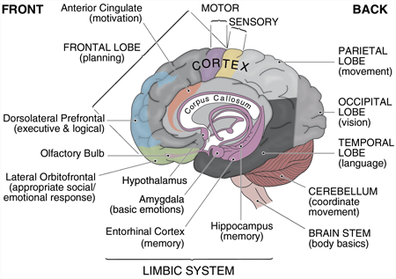
46 – The Brain

Cortical structures (Lobes)
- Frontal lobe
- Temporal lobe
- Occipital lobe
- Parietal lobe
Subcortical structures
- Cerebellum
- Brainstem
- Hypothalamus
- Amygdala

47 – The Spinal Cord: An Extension of the Brain

Afferent information comes through the sensory nerves from the back.
Efferent information goes down and out through the motor nerves from the front.
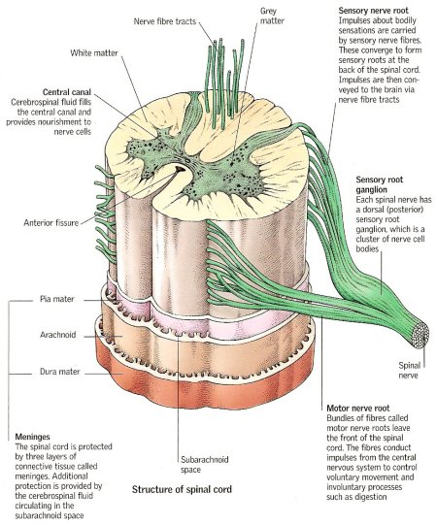
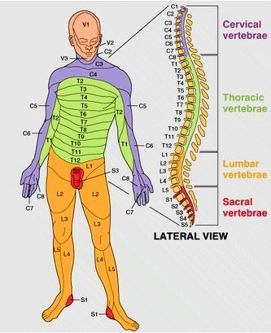
DERMATOMES
48 – Descending Pathways: Pyramidal and Extrapyramidal Pathways

Descending pathways – Efferent – From the brain then down and out
Pyramidal pathway:
Direct pathway, starting from the cortical structures, going straight down. Very fast pathway responsible for fine motor movements.
There is crossover. Some of the fibers will remain going straight down, that’s why some function will remain after a stroke.
5% ipsilateral
95% contralateral

Extrapyramidal pathway:
Start from subcortical region, going either straight down OR up to cortex then straight down. Used for things unconsciously done.
Starts below cortex, then can either go straight down, or go up to the cortex then back down.
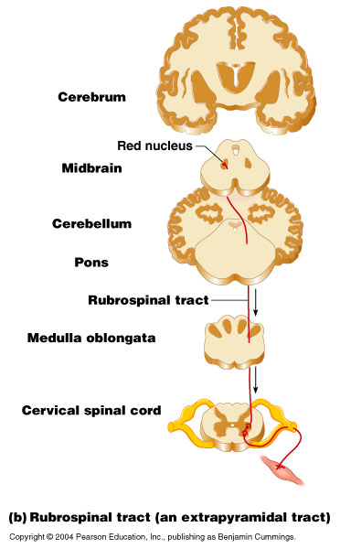
Reflexes, things you don’t have to think about constantly, such as maintaining posture.
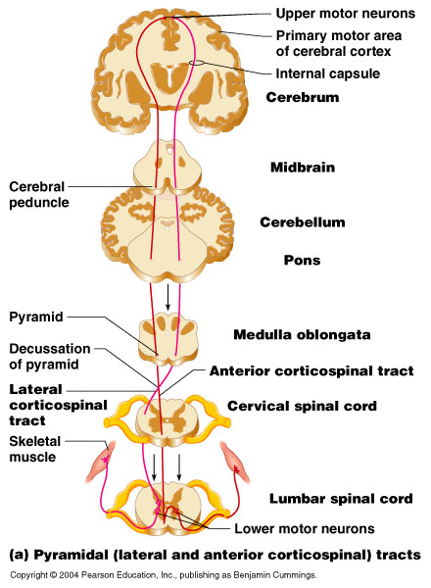

49 – Ascending Pathways: Dorsal Column and Anterolateral Pathways

Dorsal Column Anterolateral Column
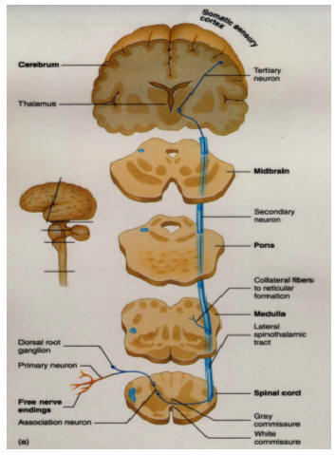
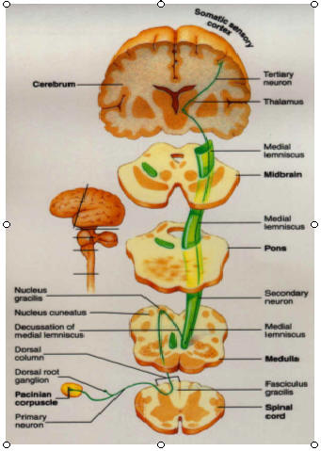

50 – Ascending Pathways: Dorsal Column and Anterolateral Systems

Dorsal Column System | Anterolateral System
Touch sensations:  - High degree of localization of stimulus  - Fine graduations in intensity of stimulus  Phasic sensations (vibrations).  Sensations of movement against the skin.  Fine positional and pressure sensations. | Thermal sensations:  - Cold  - Warm  Pain sensations.  Crude pressure and touch sensations  Tickle and itch sensations  Sexual sensations

Can accurately smack the mosquito because we feel where it is on our skin thanks to those systems.

Crude pressure and touch sensation overlaps with dorsal column (sensations of movement against the skin). REDUNDANCE – pressure and touch and vibrations.

Damage to the dorsal system: I know that you are touching me but I don’t know where.

51 – Prenatal Neural Development

Process generally includes neuron formation, differentiation into general type (for different roles), and migration (to their different sites).

By the end of the 4th month, almost all neurons of the brain will have formed; as many as 200 billion! (PRENATAL!!!!)

By the end of the 6th month, neurons are in their place and differentiated.
Ex.: brainstem vs cerebellum vs frontal cortex (thinking, high process, planning)

Once in place, neurons develop an axon to carry signals to neurons, glands, organs, and/or muscles (communication of signals).
Teratogens could disturb normal migration and branching

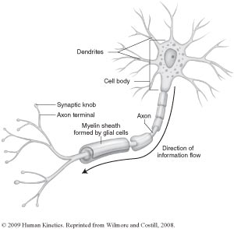
52 – Prenatal Neural Development

At birth, child has 100 billion neurons (falls down to 100 because those who aren’t used start fading away).

Neural connections begin to form after neurons are in place, then axons grow.

Neural pruning takes place; axons compete for connections with other neurons.

53 – Postnatal Neurological Growth

Brain growth increases rapidly after birth:
- At birth, brain weights about 25% of adult brain
- By age 4, brain weights already about 80% of adult brain

Growth involves these factors:
- Increases in size of neurons
- Prolific branching to form synapses
- Increases in glial cells for support and nourishment of neurons
- Increases in myelin to insulate axons

Brain demonstrates enormous plasticity:
- The brain restructures itself through experience
- Young brain is especially plastic
- Neural pathways that are stimulated are strengthened

Video watched in class:

A child’s brain recovers faster than the adult’s because it is much more elastic, plastic.
Requires quickly, playing a keen role in rehabilitation.
Can live with half a brain if the removal surgery is done at a very young age.
At first, can’t talk and all, but with time, the brain’s plastic capacities allow migration of the things/abilities, that were taken with the brain’s half, to the other half that remains, making function both sides of the body with only half of a brain.

Macrophages consume the damaged tissue. Then they signal astrocytes, which help clean up by releasing a substance. The substance encourages new good functional neurons to branch out and take over the damaged tissue/neuron that was cleaned up.

Neurons need to be used to set up new communication lines. Need to have a particular movement happening. A variety of neurons are working together in order to create that movement.

PLASTICITY! Influences of experiences!
Children born with damaged brains. They made them experience massage, touché, water, etc. These experiences changed the neurowiring of their brains, and they were functional!

54 – Postnatal Development of the CNS

Spinal cord and lower brain centers are relatively advanced at birth.

Cerebral cortex gradually becomes more functional after birth:
- Dendrites developing
- Synaptic connections
- Myelination
- Inhibition of subcortex

Myelination of axons allows faster conduction of neural impulses.

Direction of myelination tends to follow direction of conduction:
- For sensory pathways; towards the brain
- For motor pathways; away from the brain

55 – Nervous System in Older Adults

Aging involves:
- Loss of neurons
- Loss of dendrites
- Loss of synaptic connections
- Reduced level of neurotransmitters
- Damage to myelin sheath

Neural Network model; breaks in neural network links cause detours and therefore slowing in motor responses.

Exercise counters cognitive decline!
http://www.youtube.com/watch?v=d8ZPnUfGNmI (1:51)

As we are aging, we may not be able to create new neural networks, so we see how to detour with what we already have instead (take another path instead of creating one).

Question;
Give an educated explanation of why you left the elderly woman in the dust (using at least one of the changes in the nervous system associated with aging):
Because of the loss of neurons, dendrites and synaptic connection, signal takes longer to create an action since it has taken a detour. Also, damage to myelin sheath makes the transfer of signaling slower, therefore slows down the reaction process.
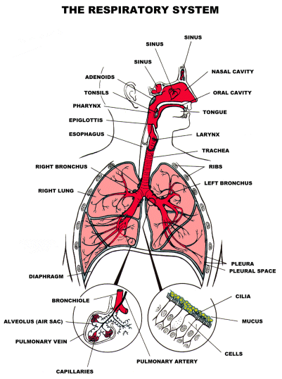

56 – Cardiorespiratory System

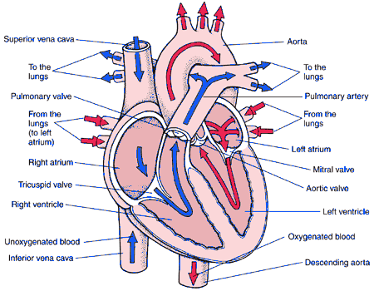
Cardiorespiratory systems include the heart and lungs

57 – Cardiorespiratory (CR) Function and Children

The many myths include the following:
- System development restricts vigorous activity
- Children automatically get enough exercise
  - Current participaction commercial
https://www.youtube.com/watch?v=vX_Hyqp-3ac

Worldwide trend is towards reduced fitness – sitting, technology, etc.
http://www.youtube.com/watch?v=Rpyw_VGrC3o&feature=endscreen

High percentage of children in Western societies have risk factors in heart diseases.

58 – Factors Related to Anaerobic Performance

- Body size; muscle mass
- Ability to metabolize fuel sources in the muscles
- Quick mobilization of oxygen delivery systems

Is children’s anaerobic capacity similar to an adult’s?
NO. Their muscles are not able to generate as much force for the anaerobic source of activity.

59 – Changes in Anaerobic Response with Growth and Maturation

Energy reserves increase as muscle mass increase.
- Sex differences?

Tolerance of by-products of metabolic process is improved.
- Lactic acid tolerance development

More mature children have better anaerobic performance.

Improved neuromuscular coordination contributes to improved performance.

Training can improve prepubescent anaerobic power;
Continued improvement through adolescence.

Don’t think of all body systems always in isolation.

60 – Anaerobic Responses in Adulthood

Once adult body size is attained, anaerobic performance is stable.

Improvement reflects training alone.

In older adulthood:
- A loss of muscle mass can result in lower anaerobic performance
- Accumulation of byproducts from energy metabolism occurs sooner
BUT masters athletes do not show same level of declines!
(Not as dramatic… aging bodies can still deal with anaerobic performances)

61 – Aerobic Responses in Childhood

Children have a smaller stroke volume, thus smaller cardiac output.
Hypokinetic circulation.

Children compensate in part with higher heart rate.

Children have lower concentrations of hemoglobin.
The blood protein that carries oxygen^
Oxygen availability within the blood cells isn’t to the same extent.

Children have an efficient system;
- Can extract more of the oxygen circulating than adults
- Also mobilize their aerobic systems faster
Efficiency makes up for lower hemoglobin!

Children cannot exercise for as long as adults can.

62 – Changes in Aerobic Response with Growth and Maturation

Heart size increases.

Hemoglobin concentration increases.

Oxygen-extraction ability decreases to adult levels.

Ability to sustain exercise is related to body size and maturity level.
- Maturation process gives us changes in muscle mass and CNS (firing of movements) resulting in more efficient recruitment of muscle fibers

By late adolescence and into adulthood, trained men have an advantage over trained women.

Myth: Originally thought women could not engage in long bout of aerobic exercise
- Not until the 1960’s that women could run 400-600 meters in the Olympics
- Thought that insides would fall out with physical activity
- Katherine Switzer is the first woman to run a marathon
  - Strong advocate for women to run marathon events in the 1984 Olympics

63 – Maximal Oxygen Uptake

Defined as the largest amount of oxygen the body can consume during aerobic work.

It is strongly related to lean body mass.

Maximal oxygen uptake increases linearly:
- Boys; 14-late adolescence
- Girls; 12-13
At 12, girls plateau, and boys have and increase in aerobic capacity

Maximal oxygen uptake per kg of body weight is then stable in boys and declines slightly in girls.

64 – Training Effects in Children

Growth status and maturation level must be considered.
Once the changes occur in hormone levels thanks to puberty, that’s when you see the changes.

“Trigger hypothesis” (Katch, 1983) holds that the hormonal levels of puberty are necessary for substantial training effects.

Aerobic training yields small improvements at best in preadolescents.

Aerobic training yields significant improvements at puberty and through to adulthood.

65 – Endurance Training Effects in Adults

Maximal oxygen uptake increases.

Stroke volume increases.

Maximum cardiac output increases.
Amount of blood pumped into circulatory system

Oxygen is better extracted from blood at muscle sites.

Ventilation improves.

66 – Structural and Functional Changes in the Heart with Aging

Structural:
- Loss of cardiac muscle
- Loss of elasticity in cardiac muscle
- Thickening of left ventricle
- Fibrotic changes in the valves
- Loss of elasticity in major blood vessels

Functional:
- Maximum achievable heart rate with exercise decline
- Stroke volume in some older adults decline
- Cardiac output declines during heavy activity not at rest or with submaximal work

67 – Respiratory Changes with Aging

Elasticity of lung tissue declines.

Vital capacity decreases, especially in smokers.
Ability to exhale

Oxygen-Carbon dioxide exchange loses efficiency.

Pulmonary factors play a lesser role in older adults decreased aerobics performance.

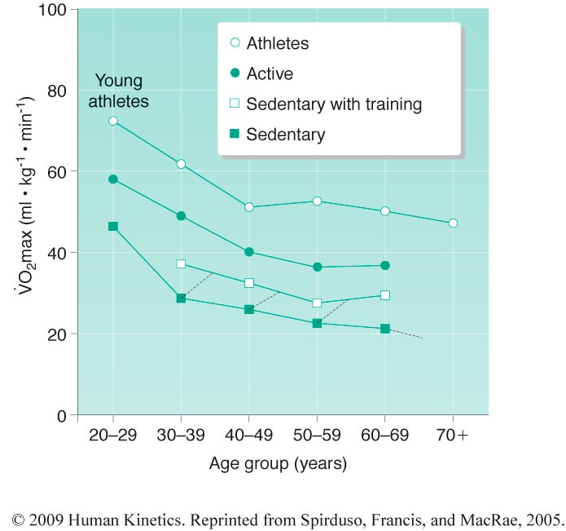
68 – Training Effects in Older Adults

Adults who are sedentary will show declines in aerobic endurance.

Those who remain active decline in aerobic endurance only gradually.

Sedentary adults who begin training can increase maximal oxygen uptake and improve blood lipid levels.

69 – The Motor Development Continuum

Phase | Approximate Age | Stage | Notes
Reflexes/spontaneous movements | Prenatal - variable | Prenatal and infancy | Might end at variable times
Rudimentary Motor Skills | Birth – 2 yrs | Infancy | No need for training or special environment. Universal Fashion.
Fundamental Motor Skills | 2 – 6 yrs | Early childhood | More involved in doing the task (catch, throw, swimming, etc.)
Sport/specialized skills + gowth and refinement | 6 – 12 yrs  13 – 18 yrs | Late childhood  Adolescence | Dive off diving board, figure skating, movement skills usually related to sports.
Peak performance | 18 – late 30s | Adulthood | Not all – gymnastics is on of many exceptions, rather than aerobic (marathon is towards 30s)
Regression | 40s – 100s | Older Adulthood

Skating could be both Rudimentary motor skill and Fundamental motor skill. Depends at what age it was learned. Before 2 vs after 2.

70 – Example of Rudimentary Motor Skills
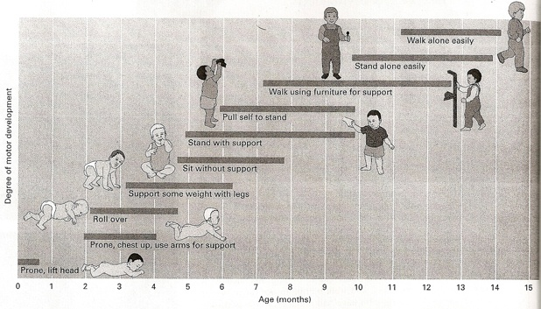

71 – Examples of Fundamental Motor Skills
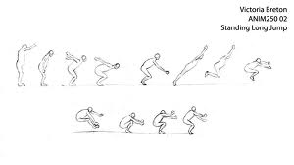


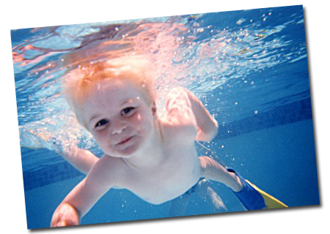
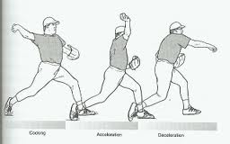
REVIEW

Aerobic performance;
- Children have smaller hearts, lower stroke volume, less cardiac output, less hemoglobin, less muscle mass
  - What affects endurance of physical activity more? Muscle Mass!
- Training in age group?
- Training benefits for neurological system more than cardio system at a young age
- Adolescents and adults have increased heart size, greater stroke volume, greater hemoglobin, greater muscle mass – better aerobic performance!

Prenatal Growth;
- Cell # increases
- Differentiation and migration of neurons
- Axon growth
- Gruning

Postnatal Growth;
- Increase in size of neurons
- Dendrites
- Synaptic branching
- Myelination
- Glial cells

Aging;
- Loss of neurons, dendrites, synaptic branching, myelin
- Decrease in NTS

Cardiorespiratory system
- Anaerobic power:
Rate at which the person can meet the demand to do a short-term intense activity
Availability within the muscle
- Anaerobic capacity:
Maximum oxygen deficit a person can tolerate

Why lower performance in children, older adults, and adult females?
- Muscle mass is not in place, loss of muscle mass, or males have more muscle mass than females (Fat Free Muscle Mass). In older adults, the lactic acid is not removed as quickly

Does training enhance performance in:
- Children?
Yes, but related to neurological benefits, not change in muscle mass
- Adolescents?
Yes, this time related to muscular system

72 – Developmental Sequences for Fundamental Motor Skills (FMS)

Biomechanical descriptive period (1960s – 1970s)
- Lolas Halverson
  - Longitudinal observations of children doing varied FMS
    - How do they emerge in children and what are the different kinds of phases they go through to be able to catch or throw or more.
  - Stages of development for many of the FMS
  - Your Motor Skills Project

73 – Early Motor Behavior

Reflexive or Spontaneous (Clark, 1995):
Two main categories of infant movement: spontaneous movements and infantile reflexes.
- Reflexive: Stereotypical responses elicited by specific external stimuli
- Spontaneous: Movements not caused by known external stimuli
Random moving and kicking in babies

74 – Spontaneous Movements

Original theory:
Extraneous, no purpose

Current theory:
Building blocks, similar to some voluntary movements
Helps maturation

Ex.:
- Spontaneous arm movements resemble reaching
- Spontaneous kicking resembles adult walking

75 – Supine Kicking

A rhythmical movement.
Coordinated pattern.
Cooperative movements of the ankle, knee and hip joints.
Resembles the pattern of a walking step but not identical.
More variability in timing.
Co-activation of muscles.

Not identical – more variability in timing of the movement. In walking, there is agonists and antagonists where antagonists will usually relax to allow the movement of walking. But in babies, both activate at the same time so it changes the pattern compared to adults’
76 – Infantile Reflexes

Reflexive movements are involuntary movements in response to a specific stimulus.

They involve single muscle or specific group of muscles (not the whole body).

There are three types:
- Primitive reflexes
- Postural reactions
- Locomotor reflexes

79 – Purposes of Reflexes

Structural explanations:
- Reflexes are a byproduct of the human neurological system
- Central nervous system development:
  - Subcortical structures are mature
(mostly myelinated except for the thinking ones)
(these structures control involuntary movements)
  - Control of movement is automatic and non-conscious

Functional explanations:
- Needed to help infant survive
Ex.: put a suce in the mouth of a child and it will immediately begin to suck to get nutrition. Without this reflex, cannot get nutrition and will die.

Applied explanation:
- Reflex movements lead to goal directed coordinated movement

