Anatomy – study of the structure-what are the names of the parts
Macroscopic and Microscopic

Physiology – study of how body parts function

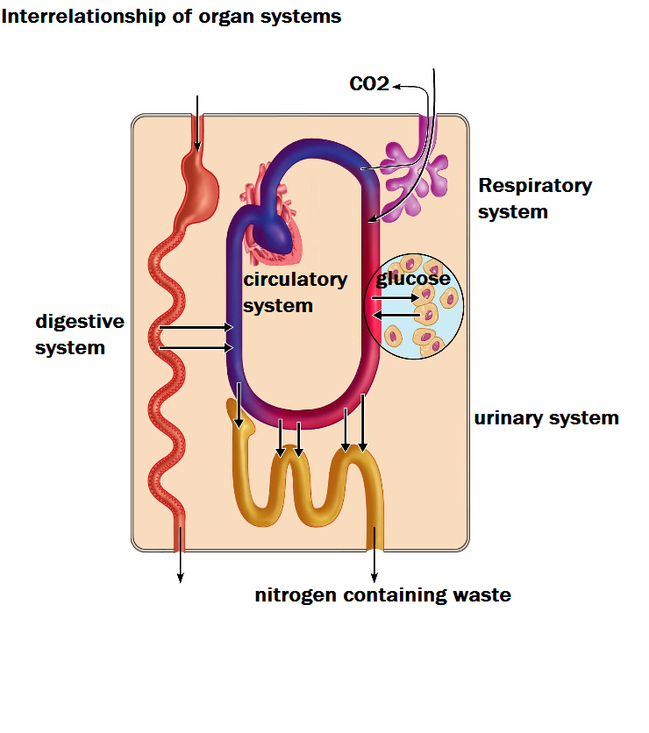
8 necessary Life Functions

- Movement – heart pumping
- Respond to environment – external and internal
- Digestion – break down foods
- Metabolism – all chemical reactions in body
- Excretion – get rid of waste products – undigested material
- Reproduction – making offspring – meiosis

- Human survival needs:
1. Nutrients – chemical for
-energy
-cell building
2. Oxygen
-needed to cellular respiration
3. Water
- solvent for metabolic reactions
4. Stable body temperature
- for enzymes to work
5. Atmospheric pressure appropriate
- for gas exchange with environment

Homeostasis
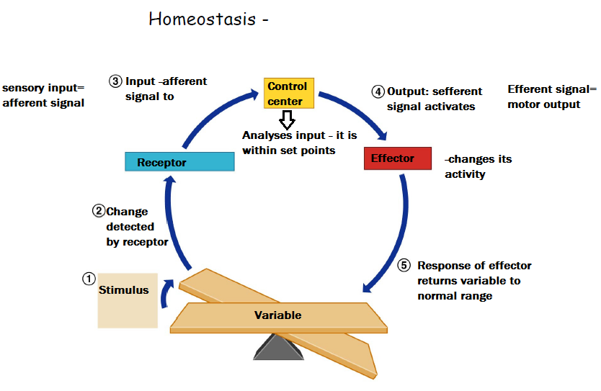
Feedback Mechanism
You breathe faster when exercising
What is the: stimulus? Receptor? Control center (integrator)? Effector?

What is the effect of this feedback mechanism?

The Language of Anatomy
Special terminology is used to prevent misunderstanding
Exact terms are used for:
- position **palms forward**
- direction
- regions
- structures
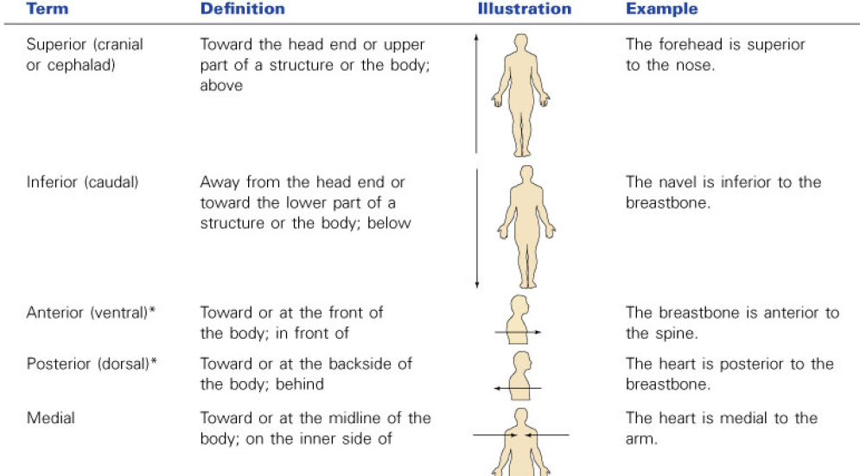
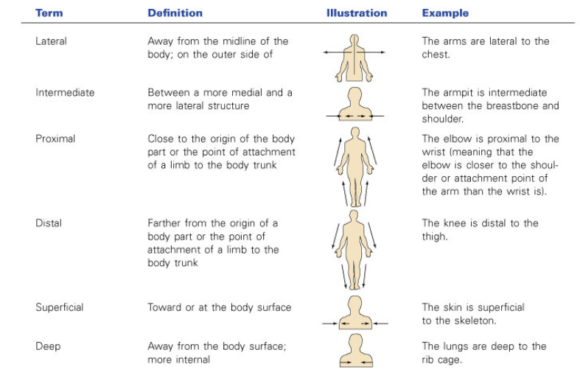
Anterior – front
Posterior –back
Medial – close to the midline of the body
Lateral – away from the midline of the body
Proximal – close to the origin or body part
Distal – away from the origin or body part

Questions: Fill in the blanks:
(superior/inferior)
Head is superior to hips.
Hips are to the inferiorshoulders.
Heart is superiorto the stomach.
(anterior/posterior)
Eyes are anterior to the brain.
Nails are posterior on side of hand.
Spine is to the stomach.
Shin is on the side of the leg.
(medial/lateral)
Ears are lateral to the nose.
Hips are to the arms.
Heart is medial to the lungs.
(distal/proximal)
Knee is proximal to the ankle.
Elbow is proximal to the wrist.
Fingers are on distal the end of the arm.
Thigh is proximal to the knee.
Feet are on the distal end of the leg.

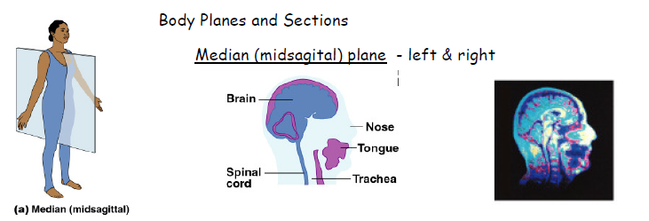
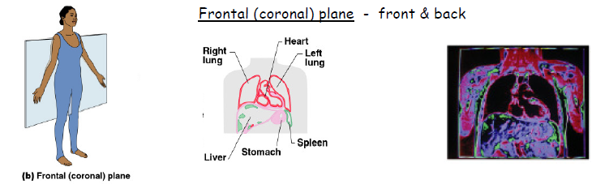
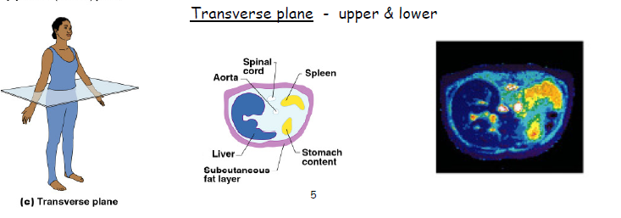
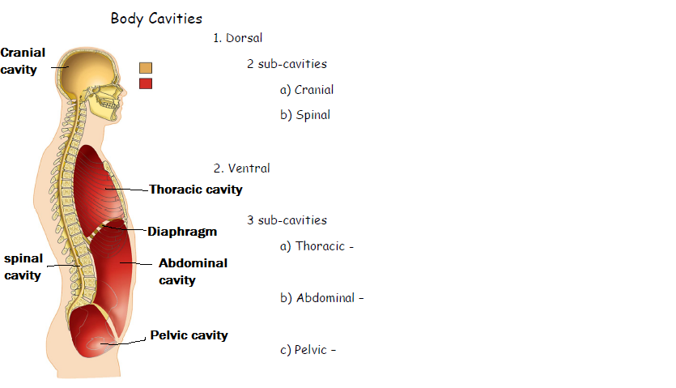
j.j.

