Chapter 1
active listening listening that demands close attention to the literal and emotional meaning of a message and a level of responsiveness that shows the speaker the message was both heard and understood. (p. 17)
body language (kinesics) non-verbal communication conveyed by gestures, eye contact, posture, and facial expressions. (p. 15)
business ethics the socially accepted moral principles and rules of business conduct. (p. 19)
bypassing misunderstanding that results from the receiver inferring a different meaning from a message based on the different meanings of the words that are used (p.10)
channel a communication pathway or medium over which a message travels. (p. 9)
channel barriers inappropriate choices of channel that impede communication (p.10–11)
channel overload the inability of a channel to carry all transmitted messages. (p. 10)
chronemics the study of time in non-verbal communication. (p. 14)
cognitive dissonance the tendency to reject messages based on personal value systems. (p. 17)
communication a transactional and relational process involving the meaningful exchange of information. (p. 6)
communication barriers problems that can affect the communication transaction, leading to confusion or misunderstanding. (p. 10)
communication theory a system of ideas for explaining communication. (p. 6)
culture the shared customs and patterns of behaviour of a particular group or society, including its language, rules, beliefs, and structures. (p. 23)
cybernetics the study of how information is processed and how communication systems function. (p. 7)
decoding the act of extracting meaning from spoken, written, and non-verbal communication. (p. 9)
downward communication flow channels information from superiors to subordinates. (p. 19)
dyadic a group of two (p. 11)
emotional interference a psychological factor that creates problems with the communication transaction. (p.10)
encoding the act of converting ideas into code in order to convey a written, oral, or non-verbal message. (p. 9)
environmental interference interference that results from preconceptions and differing frames of reference. (p. 11)
ethnocentrism the tendency to make false assumptions, based on limited experience, that one’s own cultural or ethnic group is superior to other cultural or ethnic groups. (p. 23)
external communication communication with audiences who are part of an external environment. (p. 17)
feedback the receiver’s response to a message that confirms whether the original message was received and understood. (p. 9)
formal communication channels facilitate the flow of information through an organization’s hierarchy. (p. 18)
formal communications network a system of communication sanctioned by organizational management. (p. 18)
hard skill a technical skill a person requires for a specific job. (p. 2)
high-context cultures cultures in which communication depends not only on the explicit wording of a message but on its surrounding context. (p. 24)
horizontal communication flow enables individuals at the same organizational level to share ideas and exchange information. (p. 19)
informal oral network unofficial internal communication pathways that carry gossip and rumours, sometimes accurate, sometimes not (also known as a grapevine) (p. 18)
information overload a condition whereby a receiver cannot process all messages due to their increasing number. (p.10)
internal communication communication through the channels of an organization. (p. 16)
libel a false published statement that is damaging or injurious to a person’s reputation. (p. 21)
low-context cultures cultures that favour direct communication and depend on explicit verbal and written messages exclusive of context. (p. 24)
message any type of oral, written, or non-verbal communication that is transmitted by a sender to an audience. (p. 9)
mixed messages conflicting perceptions of a signal or message that may result in miscommunication. (p.10–11)
noise any form of physical or psychological interference that distorts the meaning of a message. (p. 10)
non-verbal behaviours communication that takes place through gestures, facial expressions, eye contact, and posture. (p. 25)
non-verbal communication communication that does not use words but takes place through gestures, eye contact, and facial expressions. (p.12)
paralanguage (vocalics) non-verbal vocal qualities of communication. (p.15)
physical and technical interference interference external to the sender and receiver. (p.10)
proxemics the study of the use of and perception of space. (p. 14)
receiver the person for whom a message is intended, who decodes the message by extracting meaning from it. (p. 9)
rhetoric the use of language to persuade an audience. (p. 7)
semantics the study of the words and symbols we choose. (p. 7)
semantic interference interference caused by ambiguity, jargon, language, or dialect differences, and different ways of assigning meaning. (p. 10)
semiotics the study of how meaning is assigned and understood (p. 7)
sender the participant in the transaction who has an idea and communicates it by encoding it in a message. (p. 9)
soft skill a social, interpersonal, or language skill that complements a person’s technical skills. (p. 2)
upward communication flow channels information from subordinates to superiors. (p. 18)
Chapter 2
audience analysis the process of assessing the needs and knowledge of readers and listeners and adapting messages accordingly. (p. 40)
brainstorming a method of generating content by listing ideas as they come to mind. (p. 42)
cause-and-effect development a method of organization that links events with the reasons for them. (p. 45)
chronological development a method of organization that describes events in the order in which they occurred. (p. 45)
collaborative writing the process of writers working together to create finished reports, proposals, and other important documents. (p. 52)
drafting the preliminary writing of a document. (p. 46)
editing the process of checking a writing draft to ensure it conforms to standards of good English, style, and accepted business-writing practice. (p. 48)
freewriting a method of generating content based on unstructured writing and the recording of ideas as they come to mind. (p. 47)
journalistic questions the essential questions (who, what, why, when, where, and how) that frame journalists’ inquiries as they focus and prepare their stories. (p. 44)
mapping or clustering a method of generating content by visualizing the main topic and its subcategories. (p. 44)
medium or channel the physical means by which an oral or written message is transmitted. (p. 41)
organizing and outlining the process of arranging information for clarity and impact. (p. 45)
outline a framework for a document, showing its divisions and elements. (p. 45)
prewriting the process of gathering ideas and establishing the purpose, audience, and channel for a message. (p. 38)
primary audience the intended receiver of a message—the person or persons who will use or act on a message’s information. (p. 41)
reader benefits the advantages the reader gains by complying with what the author proposes in buying products, following policies, or endorsing ideas. (p. 41)
revising or revision the process of reviewing and making changes in a draft document—adding, deleting, reorganizing, or substituting—to transform it into a finished document. (p. 48)
richness a quality of the types of cues by which meaning can be derived from a message. (p. 42)
scope the breadth or limitations of a document’s coverage. (p. 39)
secondary audience anyone, other than the primary audience, who will read a document and be affected by the action or decision it calls for. (p. 41)
sequential development a method of organization describing the arrangements of steps in a process. (p. 45)
writer’s block a psychological state of being unable to begin the process ofcomposition out of fear or anxiety over the communication task. (p. 47)
Chapter 3
abstract nouns things not knowable through the senses. (p. 64)
acronym a pronounceable word formed from the initial letters of other words (NATO). (p. 63)
active voice a writing style in which the grammatical subject of a sentence performs the action. (p. 71)
ambiguity a term that describes an obscure or inexact meaning. (p. 59)
analogy an explanation of the unfamiliar in terms of the familiar. (p. 65)
buzzwords fashionable, technical, or computer jargon. (p. 61)
clichés overused, tired expressions that have lost their ability to communicate effectively. (p. 62)
concrete nouns things knowable through the senses. (p. 64)
connotation a word’s implied or associative meaning, often coloured by emotion. (p. 73)
denotation a word’s literal or dictionary definition. (p. 73)
emoticon a symbol consisting of a sequence of keystrokes that produce a sideways image of a face conveying any one of a range of emotions. (p. 63)
expletive construction a phrase such as there is/are or it is/was at the beginning of a clause, delaying the introduction of the subject. (p. 71)
formality the level of writing; whether the writer is using the appropriate register based on an observance of the rules and conventions of writing. (p. 73)
idiom a word or phrase that has a meaning different from its literal meaning. (p. 65)
impersonal style a style of writing that seems objective and detached based on its use of third-person pronouns. (p. 74)
jargon a term that describes (1) the specialized terminology of a technical field or (2) outdated, unnecessary words used in a business context. (p. 61)
nouns words that name people, places, things and abstract concepts. (p. 68)
noun conversions or nominalizations verbs that have been converted into nouns with the addition –ment or –tion endings. (p. 68)
passive voice a writing style in which the grammatical subject of a sentence is acted upon. (p. 71)
personal style a style of writing that seems warm and friendly based on its use of first- and second-person pronouns. (p. 74)
phrasal verb a verb that combines with one or more prepositions to deliver its meaning. (p. 59)
plain style or plain language a style of writing that places value on simplicity, directness, and clarity. (p. 58)
prepositional phrase a phrase beginning with a preposition and functioning as a modifier. (p. 71)
pronouns words that replace or refer to nouns. (p. 59)
reader benefits the benefits or advantages a reader can gain by complying with the action the writer endorses. (p. 76)
redundancies unplanned repetitions. (p. 69)
salutation a greeting at the beginning of a letter: “Dear Ms. Gill.” (p. 78)
slang coined words or existing words that are informal and havemeanings specific to particular groups or localities. (p. 63)
tone the implied attitude of the author to the reader, as reflected by word choice. (p. 73)
verbs words that describe actions, occurrences, or states of being. (p. 68)
voice a term that describes a verb’s ability to show whether the subject of a sentence acts or is acted upon. (p. 59)
we-attitude a writing style that focuses on the shared goals and values of the writer and the reader(s). (p. 77)
you-attitude a writing style that focuses on the reader rather than the writer. (p. 76)
Chapter 4
appositive a word or group of words that renames a preceding noun. (p. 92)
clause a group of related words containing a subject and a complete verb; when it delivers full meaning it is called an independent clause; when it doesn’t deliver its full meaning by itself, it is called a dependent clause. (p. 88)
closed question a question with a limited number of possible responses. (p. 92)
coherence the logical and semantic links between sentences. (p. 107)
comma splice the error that occurs when two independent clauses are connected with nothing more than a comma. (p. 102)
complex sentence a sentence containing one independent clause and one or more dependent clauses. (p. 90)
compound sentence a sentence containing two or more independent clauses joined by one or more coordinating conjunctions. (p. 89)
dangling modifier a phrase that describes something that is implied rather than actually stated in a sentence. (p. 102)
declarative sentence a sentence that makes a statement. (p. 92)
dependent clause (or subordinate clause) a clause that cannot function on its own as an independent grammatical unit. (p. 88)
elliptical construction a sentence structure that deliberately omits words that can be inferred from the context. (p. 103)
emphasis in writing, the practice of making facts and ideas stand out from surrounding text. (p. 95)
faulty predication an error involving the illogical combination of subject and verb. (p. 103)
format a term for the parts of the document and the way they are arranged on a page. (p. 109)
fused sentence two or more independent clauses erroneously run together without the use of required punctuation or coordinating conjunctions. (p. 101)
hypothetical question a question that poses a supposition. (p. 92)
independent clause a clause, containing a subject and complete verb, that functions on its own as an independent grammatical unit. (p. 88)
misplaced modifier an incorrectly placed descriptive word or phrase that attaches its meaning illogically to another word in a sentence. (p. 102)
mixed construction the error of substituting an incompatible grammatical structure for one that is correct, resulting in unclear or illogical meaning. (p. 104)
modifier a word or group of words that describes or gives information about another word in a sentence. (p. 102)
number a term that refers to whether a word is singular (one) or plural (more than one). (p. 94)
open question a question with an unlimited number of possible responses. (p. 92)
paragraph a group of sentences that develops one main idea. (p. 105)
parallelism the use of the same grammatical forms or matching sentence structures to express equivalent ideas. (p. 94)
person a term that describes who or what is performing or experiencing an action in terms of the noun or pronoun that is used: first person (I, we), second person (you), and third person (he, she, it, they). (p. 94)
phrase a group of words containing a subject or verb, which cannot stand on its own as a complete sentence. (p. 88)
prepositional phrase a phrase beginning with a preposition that sets out a relationship in time or space. (p. 91)
pronoun reference the relationship between a pronoun and the antecedent to which it refers. (p. 93)
proofreading a process of checking the final copy of a document for errors and inconsistencies. (p. 109)
sentence fragment a portion of a sentence that is punctuated like a complete sentence but does not deliver full meaning. (p. 101)
shouting the largely unacceptable practice of typing a message in block letters. (p. 95)
simple sentence a sentence containing one main or independent clause. (p. 89)
subject the word or group of words in a sentence that acts or is acted upon. (p. 89)
transitional expressions words and phrases that show logical, temporal, and spatial relationships and connect ideas to create coherence. (p. 108)
topic sentence a sentence that summarizes the main idea in a paragraph. (p. 106)
verb the word or group of words in a sentence that describes an action, occurrence, or state of being. (p. 89)
verb tense the form of a verb that shows time (past, present, or future). (p. 94)
Chapter 5
attachment an independent computer file sent with a regular e-mail message. (p. 128)
boldface a thick, black typeface used for emphasis. (p. 117)
bullets visual cues, usually large round dots or squares, that set off items in a list or emphasize lines. (p. 117)
chunking the grouping of items of information together to be remembered as a unit. (p. 121)
complimentary close a formulaic closing, usually a word found after the body of a letter and before the signature. (p. 128)
distribution list a group of e-mail recipients addressed as a single recipient, allowing a sender to e-mail many users without entering their individual addresses. (p. 126)
e-mail (electronic mail) messages distributed by a computerized mail service. (p. 117)
flaming the act of sending out an angry e-mail message in haste without considering the implications of airing such emotions. (p. 125)
follow-up message provides a record of a meeting—its time, place, purpose, and any agreements that may have been made. (p. 135)
goodwill message a message that enhances the value of a business beyond its tangible assets by creating a bond of friendship and establishing trust and mutual understanding between the writer and the recipient. (p. 134)
header a block of text appearing at the top of a document. (p. 117)
headings visual markers consisting of words or short phrases that indicate the parts of a document and signpost its organization. (p. 117)
instant messaging (IM) the exchange of messages over the Internet between two or more users who are online simultaneously. (p. 136)
informative memo a message to which the reader will react neutrally. (p. 130)
italics sloping letters used for emphasis or to distinguish foreign words. (p. 119)
list a group of three or more logically related items presented consecutively to form a record or aid to memory. (p. 120)
memo a specially formatted document that is sent to readers within an organization. (p. 117)
netiquette the informal code of conduct governing polite, efficient, and effective use of the Internet. (p. 124)
request memo a message that asks the reader to perform a routine action. (p. 132)
salutation the greeting in a letter, used to address the person being written to. (p. 127)
response a message that answers a request or query. (p. 133)
shouting the practice—often considered rude—of typing e-mail messages in uppercase letters. (p. 127)
spam an advertising message—electronic junk mail—sent widely and indiscriminately. (p. 125)
subject line indicates the title, topic, or purpose of a document, used to file and retrieve the document; it tells the readers what is important about the document. (p. 118)
Chapter 6
adjustment a written response to a complaint that tells the customer what will be done about the complaint in terms of solving the problem, correcting an error, granting a refund, or adjusting the amount due. (p. 149)
announcement a message that makes something known about a company policy, event, or personnel change. (p. 166)
attention line an optional letter element identifying the individual, officer, or department to whom or which the letter should be directed. (p. 173)
claim a demand or request for something—often a replacement or a refund—that is considered one’s due. (p. 149)
claim adjustment a response to a claim letter telling the customer what your company intends to do to correct the problem. (p. 159)
complimentary close the word of formal closing (often “Sincerely”) after the body of the letter and before the signature. (p. 174)
continuation page heading identifies the second and succeeding pages of a letter with a heading that includes the name of the addressee, the date, and the page number. (p. 175)
copy notation indicates that copies of a letter have been sent to individuals other than the addressee. (p. 175)
cover or transmittal letter an informative letter that accompanies materials sent from one person to another explaining why those materials are being sent. (p. 167)
dateline identifies the date on which a message is written. (p. 172)
delivery/confidential notation an optional letter element identifying how a message is transmitted and who is authorized to open and read it. (p. 172)
direct-approach message a message that presents the main point in the first paragraph. (p. 144)
enclosure notation indicates the enclosed or attached material that accompanies a document. (p. 175)
full-block letter style a letter format in which all elements are aligned at the left margin. (p. 171)
goodwill message a message that enhances the value of a business beyond its tangible assets by creating a bond of friendship and establishing trust and mutual understanding between the writer and the recipient. (p. 161)
identification initials indicate the writer (capital letters) and typist (lowercase letters) of a message. (p. 175)
informative letters messages that provide important/relevant information and to which the reader will react neutrally. (p. 166)
inquiry a message that asks for or seeks information. (An inquiry or information response is a message that supplies information). (p. 153)
inside address a standard letter element supplying the name and full address of the recipient. (p. 172)
letterhead a printed heading on company stationery, containing the address of an organization or individual but not the individual’s name. (p. 172)
letter of congratulations a message conveying pleasure at someone’s happiness or good wishes on someone’s accomplishment. (p. 164)
letter of sympathy (or letter of condolence) a message expressing sadness at someone’s bereavement and offering words of comfort. (p. 165)
modified-block letter style a letter format in which the return address, dateline, complimentary close, and signature block are aligned just to the right of centre page and all other elements are aligned at the left margin. (p. 171)
order acknowledgement an informative letter that confirms the details of a merchandise purchase and shipment. (p. 155)
order request a request for merchandise that includes a purchase authorization and shipping instructions. (p. 146)
personalized form letter a letter in which the identical message is sent to more than one person; it is adapted to the individual reader with the inclusion of the reader’s name, address, and perhaps other information, all of which may be stored in a database and merged with the form letter. (p. 155)
ragged right margins unjustified margins that end unevenly on the right side of the page. (p. 170)
reference line an optional letter element identifying a file or policy number. (p. 173)
request memo a message that asks the reader to perform a routine action. (p. 145)
response a message that answers a request or a query. (p. 152)
salutation a letter greeting identifying the individual for whom the letter is intended, including the recipient’s personal title and surname (e.g., “Dear Ms. Gill”). (p. 173)
simplified letter style a letter format in which the salutation is replaced by a subject line and the complimentary close—except for the writer’s name and signature—is omitted. (p. 171)
signature block includes the writer’s name, title, and organization in a neatly formatted arrangement. (p. 175)
subject line a line that identifies the content or focus of a message. (p. 174)
thank-you letter (or letter of appreciation) a message thanking someone for helping you, extending hospitality to you, or doing business with your company. (p. 162)
Chapter 7
buffer a meaningful, neutral statement that cushions the shock of bad news. (p. 192)
goodwill closing draws attention away from the message to a positive and continuing relationship with the reader. (p. 195)
indirect writing plan a method of organizing a document so that the main message is delayed and presented toward the end. (p. 192)
negative message a message that communicates negative information that may upset or disappoint the reader. (p. 187)
Chapter 8
appeal an attempt to persuade. (p. 220)
collection letters a series of increasingly persuasive appeals to a customer asking for payment for goods and services already received. (p. 230)
demand letter makes a firm and unequivocal request for immediate payment that attempts to persuade the debtor to pay the bill within a stated time by raising the possibility of legal action. (p. 232)
inquiry letter a letter that attempts to determine the circumstances that are preventing payment and asks for payment. (p. 230)
logical fallacy an error in logic that weakens a persuasive argument—for example, a personal attack, a mistaken assumption that one event causes another, or a reliance on testimony of someone who isn’t an expert. (p. 220)
Maslow’s hierarchy of needs a specific order of needs identified by Abraham Maslow—physical needs, the need for safety, social needs, the need of self-esteem, and the need for self-actualization—all of which motivate humans. (p. 218)
persuasion the process of gradually influencing attitudes and behaviours and motivating the audience to act. (p. 218)
reminder letter informs a customer in a friendly way that a payment has not been received and emphasizing the customer’s good credit until now. (p. 230)
sales letter a letter that promotes a product, service, or business and seeks prospective customers or additional sales. (p. 234)
Chapter 9
logical fallacy an error in logic that weakens a persuasive argument—for example, a personal attack, a mistaken assumption that one event causes another, or a reliance on testimony of someone who isn’t an expert. (p. 220)
Maslow’s hierarchy of needs a specific order of needs identified by Abraham Maslow—physical needs, the need for safety, social needs, the need of self-esteem, and the need for self-actualization—all of which motivate humans. (p. 218)
persuasion the process of gradually influencing attitudes and behaviours and motivating the audience to act. (p. 218)
reminder letter informs a customer in a friendly way that a payment has not been received and emphasizing the customer’s good credit until now. (p. 230)
sales letter a letter that promotes a product, service, or business and seeks prospective customers or additional sales. (p. 234)
resumé a persuasive written document in which a job applicant summarizes her qualifications and relates her education, work experience, and personal accomplishments to the needs of a prospective employer. (p. 251)
scannable resumé a paper or electronic resumé that is prepared for scanning through uncluttered formatting and inclusion of a keywords section. (p. 262)
unsolicited application letter (or job-prospecting letter) an employment letter written when the applicant does not know that a company is hiring. (p. 270)
Chapter 10
alphanumeric outline an outlining system that combines numbers and letters to differentiate levels of headings. (p. 297)
analytical report (or recommendation report) a report that interprets and analyzes information and offers recommendations based on findings. (p. 291)
bar chart a visual consisting of parallel horizontal or vertical bars of varying lengths, each representing a specific item for comparison. (p. 302)
business report a document in which factual information is compiled and organized for a specific purpose and audience. (p. 288)
conclusions and recommendations the closing section of an analytical or recommendation report in which specific actions are proposed to solve a problem or aid decision-making. (p. 299)
decimal outline (or numeric outline) an outlining system that uses a combination of numbers and decimal points to differentiate levels of headings. (p. 297)
descriptive head (or talking head) a heading that describes the actual content of a report and provides more information about it. (p. 294)
deviation bar chart a specific type of bar chart that shows positive and negative values. (p. 304)
feasibility report an analytical report that evaluates whether a project or alternative is advisable and practical. (p. 313)
findings the most substantial part of a report, in which qualitative and numeric data is presented and organized by time, convention, order of importance, or component. (p. 298)
flow chart a diagram that maps out procedures, processes, or sequences of movement. (p. 309)
formal report a business document of ten or more pages based on extensive research and following a prescribed format or pattern that includes elements such as a title page, transmittal or covering letter, table of contents, and abstract. (p. 289)
functional heading each of a series of generic headings that, when taken together, show a report in outline. (p. 294)
Gantt chart a bar chart that is used to show a schedule. (p. 308)
grouped line graph a line graph that makes comparisons between two or more items. (p. 307)
heading a title or subtitle, usually a word or short phrase, within the body of a document that identifies its parts and gives clues to its organization. (p. 293)
incident report a short report that documents problems and unexpected occurrences that affect a company’s day-to-day operations. (p. 312)
informal report a report using a letter or memo format, usually running from a few paragraphs to ten pages in length. (p. 289)
informational report a short report that collects data related to a routine activity without offering analysis or recommending action; it is organized in three parts: introduction, findings, and summary/conclusion. (p. 291)
introduction the first section in the body of a report, which provides readers with the information they need in order to understand and evaluate the report itself; it must include either the report’s purpose or a statement of the problem the report addresses. (p. 298)
investigative report a report written in response to a request for information about a specific problem or situation. (p. 312)
justification report an analytical report that justifies the need for a purchase, investment, policy change, or hiring. (p. 313)
letter report a short, external report presented in letter format. (p. 292)
line graph a visual that uses lines on a grid to show trends according to the relationship between two variables or sets of numbers. (p. 307)
matrix a word table containing qualitative information rather than numerical data. (p. 301)
memorandum report a short, internal report presented in memo format. (p. 291)
one-time report a report that presents the results of a special or long-term project. (p. 291)
organizational chart a diagram that shows how various levels or sectors of an organization are related to one another. (p. 309)
periodic report an informational report that is filed at regular intervals. (p. 291)
picture graph a visual that uses pictorial symbols to represent particular items. (p. 306)
pie chart a circular diagram presenting data as wedge-shaped segments showing proportions or percentages of the whole. (p. 302)
progress and activity report a short report that provides information on the status of a project, including current work, work done during the time since the previous report, and work to be completed in the next period. (p. 320)
proposal a document presenting plans and ideas for consideration and acceptance by the reader. (p. 314)
recommendation report an analytical report that recommends action, often in response to a specific problem. (p. 313)
segmented bar chart (or divided bar chart) a visual consisting of a single bar divided according to the different portions that make up an item as a whole. (p. 303)
summary the closing or second-last section of a report that briefly restates its main points. (p. 299)
table a chart that presents data, usually numerical, in a compact and systematic arrangement of rows and columns. (p. 300)
trip report (or conference report) a short report that summarizes the events of a business trip or conference. (p. 314)
visual aids (including charts, graphs, tables, and illustrations) materials that present information in visually appealing ways to show trends and relationships, represent numbers and quantities, and make abstract concepts concrete. (p. 299)
Chapter 11
American Psychological Association (APA) style a documentation system used by writers in the social and physical sciences. (p. 381)
appendix a section of the back matter of a proposal or formal report where specialized supplemental materials are archived. (p. 362)
back matter the parts containing supplemental information that may follow the main body of a proposal or report. (p. 361)
conclusions the section of a report that restates the main points. (p. 380)
executive summary (or abstract) a synopsis of the body of a proposal or report specifying its highlights and recommendations. (p. 361)
external proposal a proposal issued to governmental or private industry clients outside an organization as a means of generating income. (p. 359)
formal report an account of a major project written according to a prescribed structure defined by formal elements such as a title page, letter of transmittal, table of contents, and executive summary or abstract. (p. 370)
front matter the parts of a proposal or report that are included before the main body. (p. 361)
internal proposal a persuasive document that attempts to convince management to spend money or implement plans to change or improve the organization. (p. 359)
list of tables/figures/ illustrations a front-matter list of the titles and page numbers for tables and figures included in a document. (p. 362)
Modern Language Association (MLA) style a documentation system used by writers in the humanities. (p. 381)
parenthetical in-text citations notations set within parentheses that identify sources of quotations or ideas that are cited in the body of the report. (p. 381)
proposal a business document that suggests a method for solving a problem or seeks approval for a plan. (p. 359)
recommendations a section of a report that outlines specific actions to be taken. (p. 380)
references a section of the back matter of a proposal or formal report that lists the source material that has been cited in the text. (p. 362)
references or works cited an alphabetically arranged list that identifies sources referred to in a report. (p. 381)
request for proposals (RFP) a detailed document requesting proposals and bids on specific projects. (p. 359)
table of contents (TOC) a front-matter list of the first- and second-level headings that appear in a proposal or formal report, all of which constitute an overview of the material to follow. (p. 362)
team writing the practice of multiple writers working together to produce a single document. (p. 374)
title page a front-matter page of a proposal or formal report that includes the title of the document, the names of the intended recipient and the author, and the date of submission. (p. 362)
work plan a document that defines the approach, personnel responsibilities, resource needs, and scheduling for a major project. (p. 373)
Chapter 12
active listening listening that demands close attention to the literal and emotional meaning of a message and a level of responsiveness that shows the speaker of the message was both heard and understood. (p. 430)
agenda a document that establishes the purpose and goals of a meeting and outlines what the meeting will address, thereby helping to focus the group. (p. 428)
extemporaneous speaking a method of delivery in which the speaker relies on notes rather than manuscript memorization. (p. 419)
external meeting a formal meeting that involves outsiders in addition to company personnel. (p. 426)
flip chart a large stand-mounted writing pad with bound pages that can be turned over the top. (p. 413)
formal meeting a scheduled meeting that operates according to a pre-set agenda under guided leadership for the purposes of achieving specific goals. (p. 426)
groupthink the practice of thinking or making decisions as a group, whereby conformity is rewarded and dissent punished; the result of groupthink is often poor decision-making. (p. 430)
groupware software designed to facilitate group work by a number of different users. (p. 431)
impromptu speaking a delivery method in which the speaker makes remarks without the aid of prepared notes. (p. 418)
informal meeting a small, sometimes unscheduled meeting that may operate without strict rules. (p. 426)
internal meeting a formal meeting that involves only personnel from within an organization. (p. 426)
meeting minutes a written record of what occurred at a meeting, who attended it, and when and where it was convened. (p. 431)
non-verbal communication a form of communication that does not use words, only media such as gestures, eye contact, and tone of voice. (p. 407)
oral presentation an informative or persuasive speech delivered using only notes and visual aids to guide the speaker’s performance. (p. 407)
overhead projector a device that projects the enlarged image of a transparency onto a screen. (p. 413)
PowerPoint presentation software offering standard templates and other features that aid in the design of integrated text and effective visuals. (p. 416)
sound bite a short, quotable extract from a recorded interview that is edited into a news broadcast. (p. 435)
special-occasion presentation a speech made in appreciation, in acceptance of an award, in commemoration of an event, or by way of introduction. (p. 424)
template a stored pattern for a document from which new documents can be made. (p. 416)
visual aids typically charts, graphs, and tables used to present data in clearly understandable and appealing ways. (p. 412)
web-conferencing synchronous web-supported communication allowing for real-time transmission of sound and images to other locations. (p. 431)

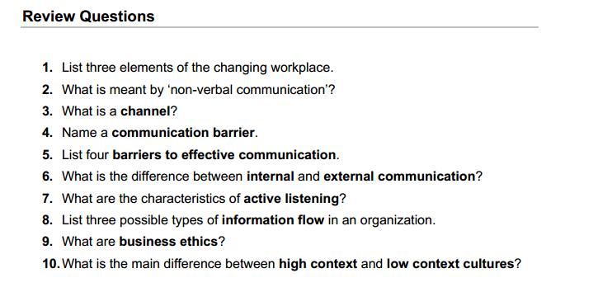
Chapter 1
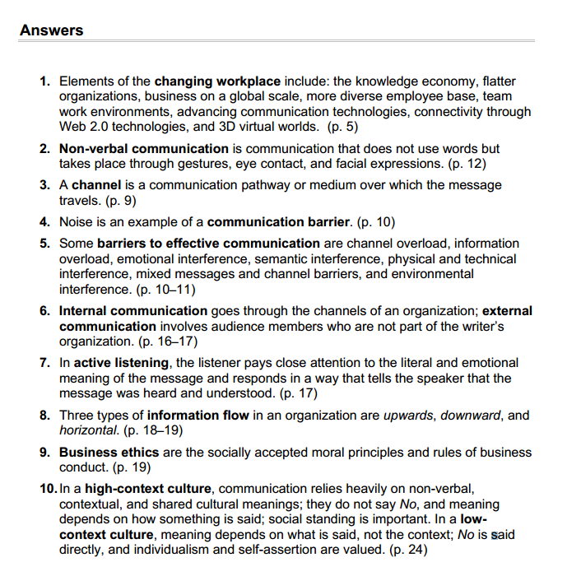
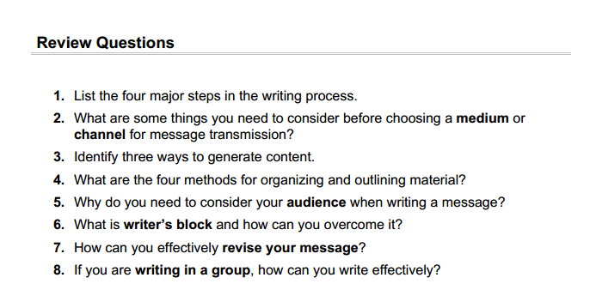
Chapter 2
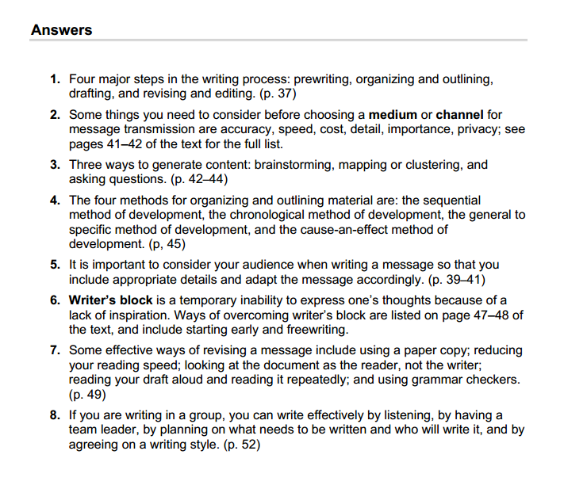

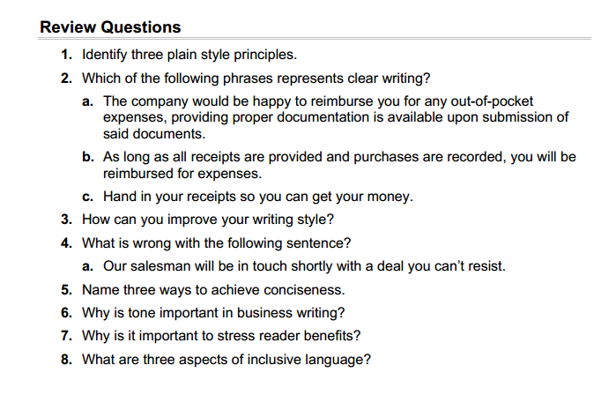
Chapter 3
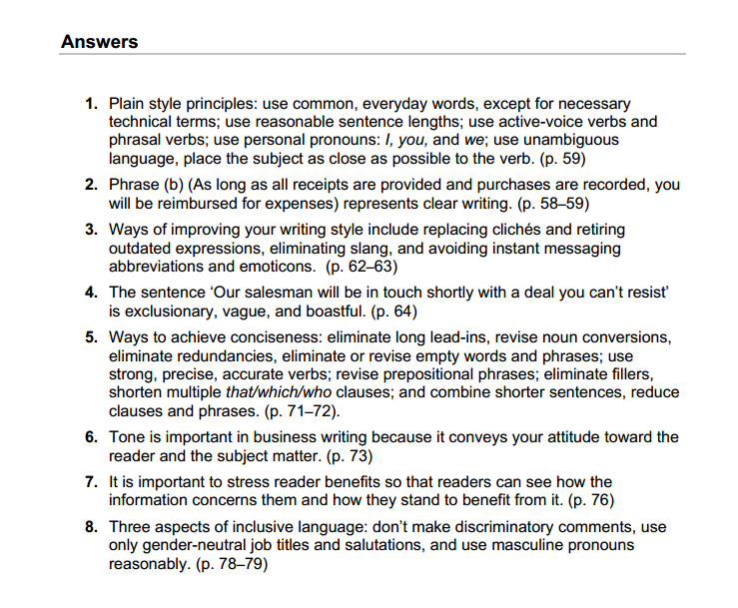
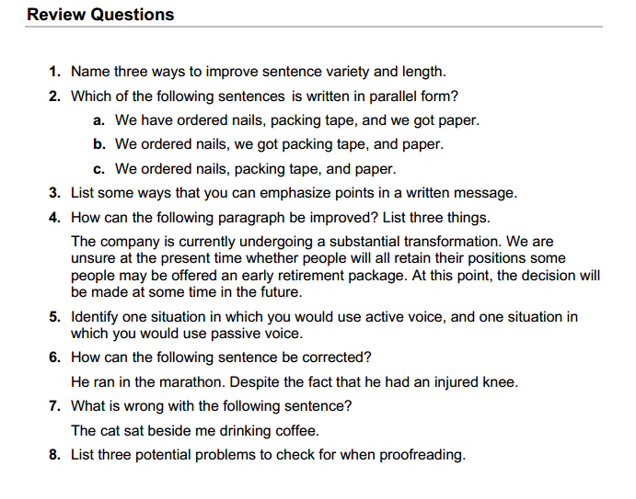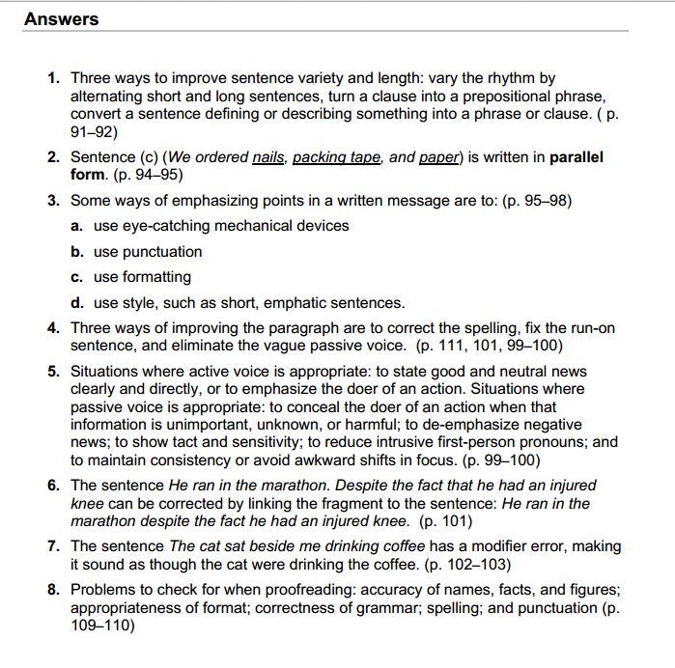
Chapter 4
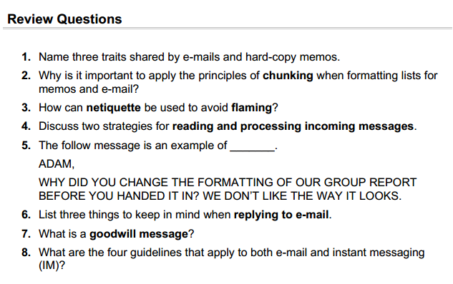
Chapter 5
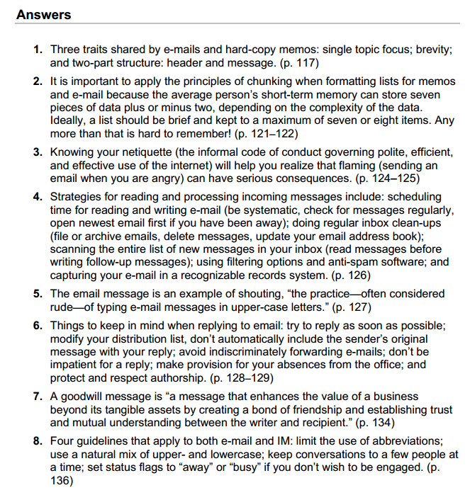
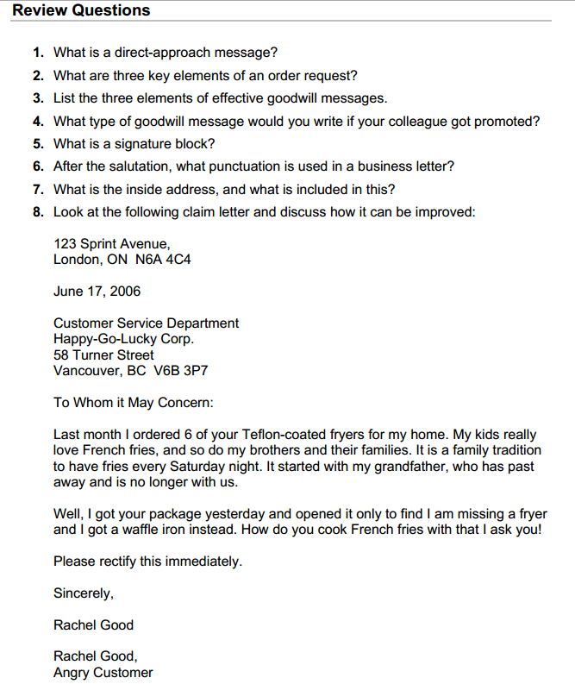
Chapter 6

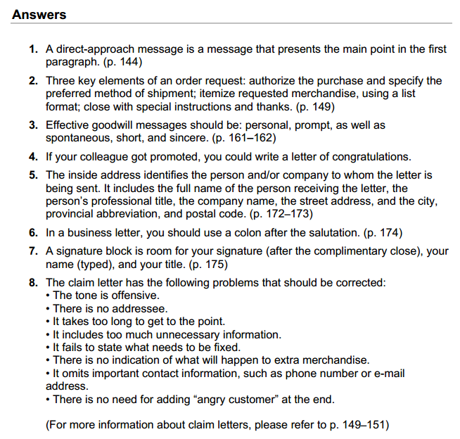
Chapter 7
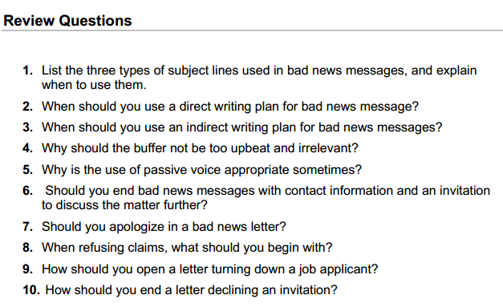

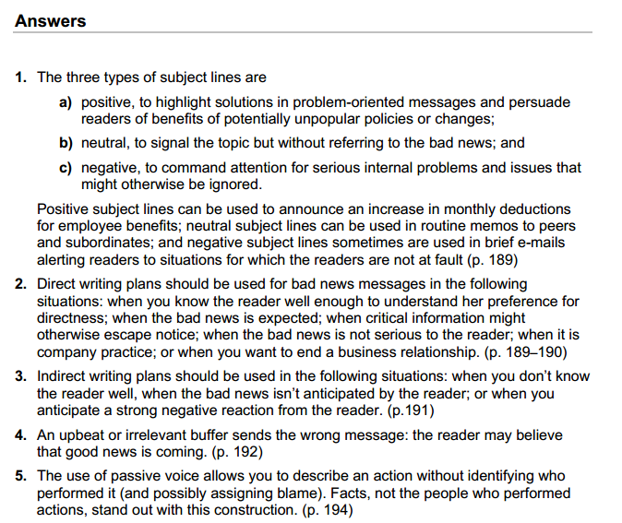
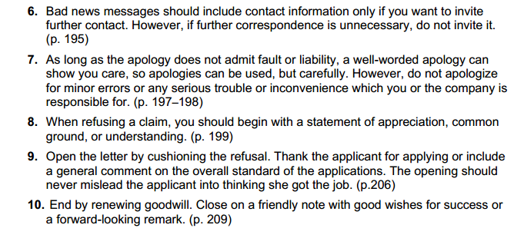

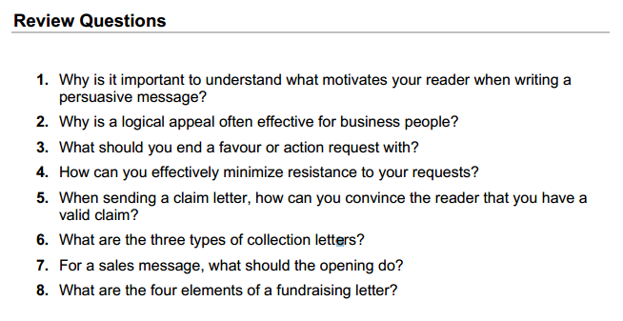
Chapter 8
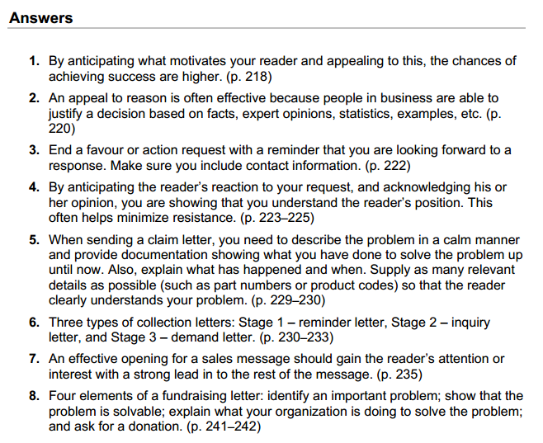

Chapter 9
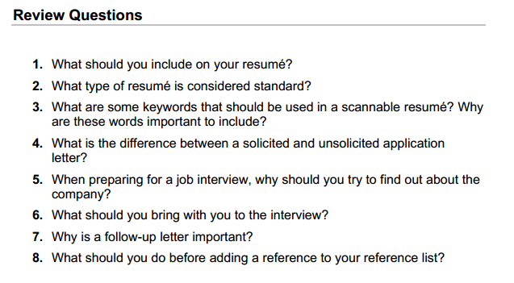
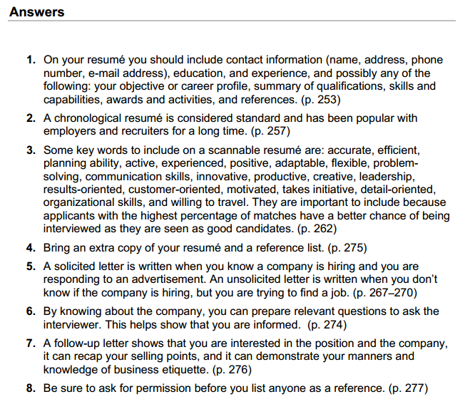
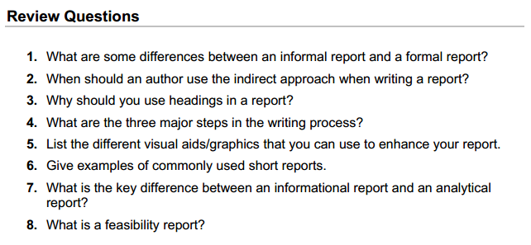
Chapter 10

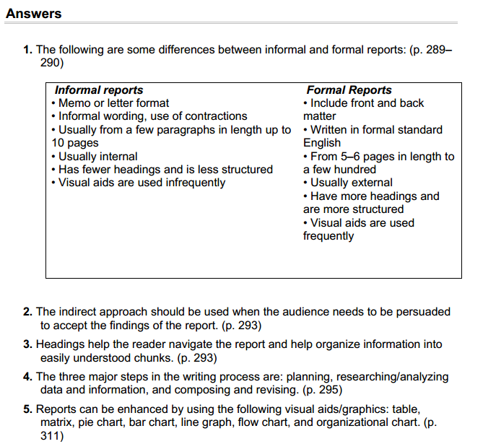

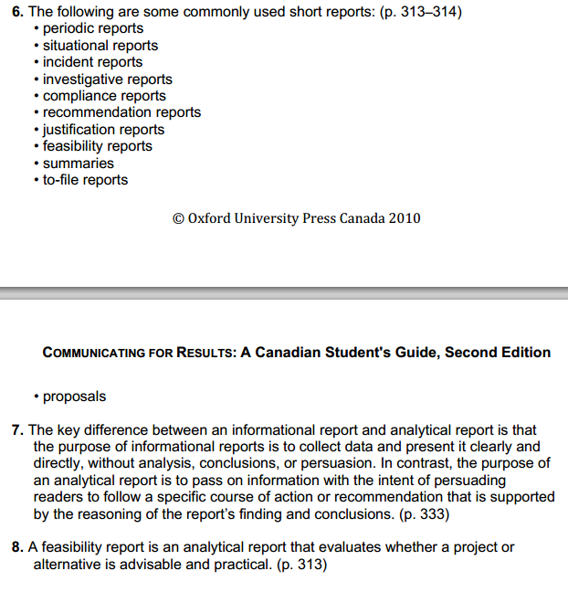
Chapter 11
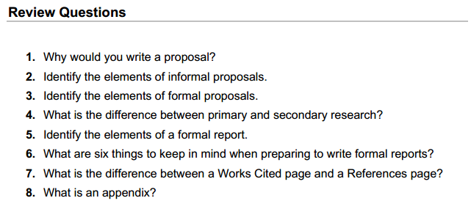
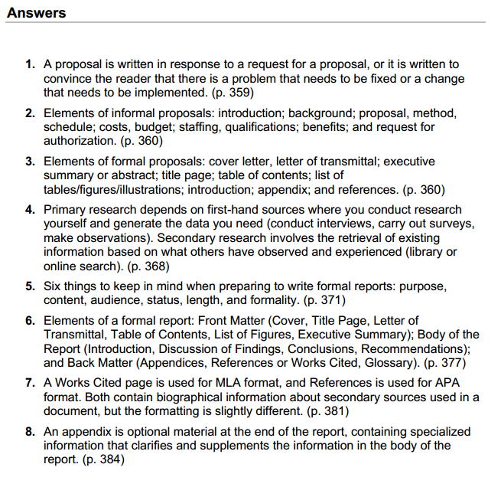.
Chapter 12


