Obesity March 6, 2015
Causes of Obesity
- social pressure
- lack of exercise
- parental techniques
- lack of time to make healthy lunches
The obesity problem:
- WHO projects that by 2015, approximately 2.3 billion will be overweight and more than 700 million will be obese
- Once considered a problem in high-income countries, overweight and obesity are now dramatically on the rise in low to middle income countries, particularly in urban settings
- Obesity is a problem in wealthy societies
- poor in a poor society = no luxuries to sit and do nothing, and scarce food no obesity
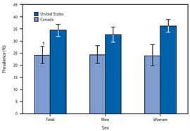

Health Consequences
- Cardiovascular disease (heart and stroke)
- Cancer
- Diabetes (type II) very common in obese people
- Sleep apnea
- Hepatic steatosis (fatty liver)
- High blood pressure
- Osteoarthritis
- Gastroesphageal reflux disease
- Social discrimination*
Obesity Cycle
- there are many aspects to the obesity
- makes it difficult to understand and then solve
Food-obesity (a mathematical explanation)
- Chow (2012) mathematical model points the finger at “the overproduction of food in the US”
- predictive models
- Beginning in the 1970s there was a change in agricultural policy
- Instead of paying farmers not to engage in full production, they were encouraged to grow as
much food as they could
- Technological changes made farms much more productive
- Price of food plummeted while the number of calories available to the average American
grew by about 1,000 a day
The influence of education-environment
- Lower education rates translate into higher obesity rates
- Education allows one to have better resources for healthier food choices, to neighborhoods that have parks and recreation facilities, access to health care and insurance
- people who are better educated have better resources to better food choices
- better neighbourhoods have better food outlets
What about energy imbalance?
- Energy imbalance between calories consumed and calories expended
- calories in vs. calories out (energy expenditure)
Energy intake
- Global shift in diet towards increased intake of energy-dense foods that are high in fat and sugars but low in vitamins, minerals and other micronutrients
- sugary foods get a lot of research attention
Sugar
- 25% of total calories consumed come from sugar – should be around 5%
- once you hit 18% compared to 5% of total calories there is a significant metabolism harm that promotes diabetes
Foods you should eat everyday
- tomatoes
- hemp seeds
- cucumbers
- kale
- grapefruit
- garlic
Why we eat more than we are supposed to (Lustig, 2012)
- Humans rely on the hormone leptin to send signals to the brain to regulate what we ate; leptin also tells the brain when you’ve had enough to eat
- The way your body stores fat is a carefully regulated process that is controlled by leptin
- People have become leptin resistant-because of excess sugar the brain is unable to accurately hear the leptin signals to stop creating and storing more fat and start burning the excess
- Chronic elevation in leptin levels lead to leptin resistance
Energy expenditure
- A trend towards decreased physical activity due to the increasingly sedentary nature of many forms of work, changing modes of transportation, and increasing urbanization
- we usually sit more than we sleep
- even if you go to the gym for an hour, if you sit for the whole day, you will not get health benefits
Screen and consumption
Energy expenditure profiles for inactive vs. active individuals
- our basal metabolic rate (BMR) contributes the most to our energy expenditure profile in inactive
- we want to change an inactive person’s energy expenditure from more BMR to more PA (physical activity)
Built Environment
- Within home—screen use
- Within school—little emphasis on PE
- Within community—access to PA is limited
- Parent behavior—diet, PA, other (medication)
Obesity and incidental activity
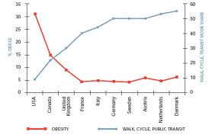
- when we reduce the amount of sitting, it does to incidental movement
- we need a good incidental movement profile
- US has the worst profile highest obesity rate and lowest number of walking, cycling, and public transit)
- those that have the environment that encourages more incidental movement, there will be fewer obese people
- the two lines are a reflection of us
Cars and obesity
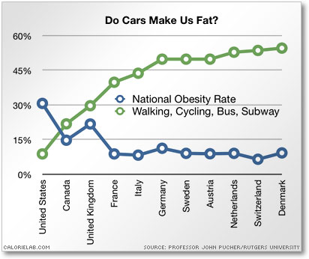
- the less reliable we are on cars, the better obesity profile there is
- in our society, driving is positive
- in other countries, driving is not thought of as good – better to walk
- less driving means more incidental activity because we are on our feet and moving around
What about sleep?
- sleep is important for the regulation of obese
- Lack of sleep causes weight gain in children and adults
- Those who sleep less tend to eat more and be more inactive compared to those who sleep more
- sleep is an important modulator of neuroendocrine function and glucose metabolism
- wake longer = more time having access to food
Pregnancy and obese children
- Health Canada statistics show:
- That the mothers of obese pre-schoolers have a higher pre-pregnancy BMI
- Children of obese mothers are twice as likely to be large for gestational age at birth
- That large for gestational age babies are more likely to be obese pre-schoolers
- we need to deal with the problem before the child is even born
- need to prevent excessive weight gain of mothers so that the babies don’t have excessive weight gain in the first couple of years
Stressed moms may raise fat children
- Millions of poor children in the US may be getting fat before the age of 10 because their mothers are stressed out and the youngsters seek escape in unhealthy comfort food (Gundersen et al., 2008)
- Stress is rooted in poverty and can be brought on by money woes, excessive work loads, insufficient health insurance, and lack of spousal support (limited strength model)
- in order to get people out of obesity, we need to make them not poor
Medication
- Many more people today are on medications for health problems—side effects such as weight gain, increased appetite, or fatigue resulting in lack of energy to exercise
- some medications have side effects of weight gain, and when many people are taking more than one medication
Genetics
- Research indicates that certain genetic characteristics may increase an individual’s susceptibility to excess body weight
- Genes can directly cause obesity disorders such as Prader-Willi syndrome
- Genetic susceptibility may exist in conjunction with contributing environmental and behavioral factors
- A common quoted genetic explanation for the rapid rise in obesity is the mismatch between today’s environment and “energy-thrifty genes” that multiplied in the past under different environmental conditions when food sources were rather unpredictable
- Maasai Tribes of Africa vs. People of the Western Developed World
- these people don’t know when/where their next meal will be
- these people run an animal to its death (so much energy to eat)
Other ways genes might influence obesity?
- Inability to control BMR (e.g., hypothyroidism)
- Drive to overeat
- Tendency to be sedentary
- Diminished ability to use dietary fats as fuel
- Enlarged easily stimulated capacity to store fat (e.g., FTP gene which is linked to fat buildup)
- Calories burned during exercise and while resting
Measurement of obesity
- Trade off between accuracy and feasibility
- BMI used for body size can misclassify people as obese because it doesn’t take into account muscle vs. fat

March 9, 2015
Obesity measurement
- Body Mass Index (BMI) weight in kg (2.2 pounds per kg) divided by the height squared in meters (39.37 inches per meter)
- BMI > than 25 is considered overweight
- BMI > 30 is considered obese
- BMI > 40 is considered morbid obese
- BMI has to be adjusted for different ethnicities
Measurement
- Body mass index (BMI) is the commonly used index of relative weight
- An individual with a BMI of 30 or more is considered OBESE (applies to both men and women)
- This would relate to a direct measure of approximately 25% body fat in men and 30% body fat in women
How accurate is BMI in predicting fat, and what are its limitations?
- it is a general measure of body size without indicating body fat vs body mass
- This is important because body composition rather than body mass is the more significant predictor of health risk
- Studies have found that BMI is not always accurate in predicting levels of body fat (Frankenfield et al., 2001)
- Significant numbers of people with a BMI below 30 are also obese and thus misclassified by BMI
- Measurement of body fat is a more appropriate way to assess obesity in people with a BMI below 30
What about BMI and lean mass?
- Significant numbers of people who are fit and short in stature will be misclassified by BMI as obese (greater than 30)
BMI and children
- The situation is more complex in children, where BMI threshold of obesity varies with age and sex

Measuring Obesity
- Is BMI the best measure?
- Weight circumference or waist to hip ratio may be a better indicator of obesity
- Ratio of fat mass to height squared (FMI—Kelly et al., 2009)
- What about visceral fat vs. subcutaneous fat? (Ross et al., 2000)
- fat around our organs is the most dangerous
- What about organ fat (i.e., hepatic fat)? (Stewart et al., 2008)
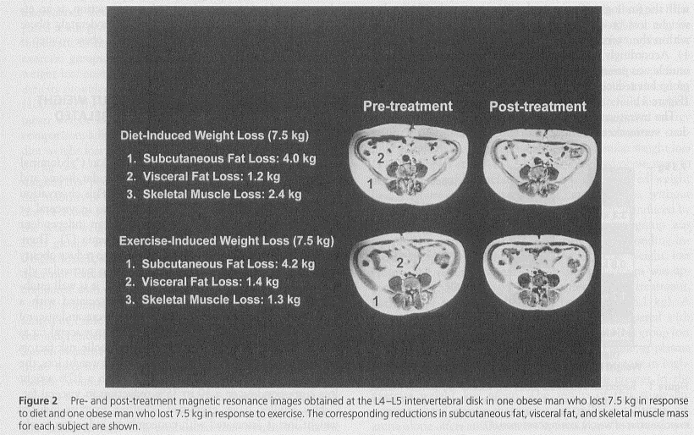
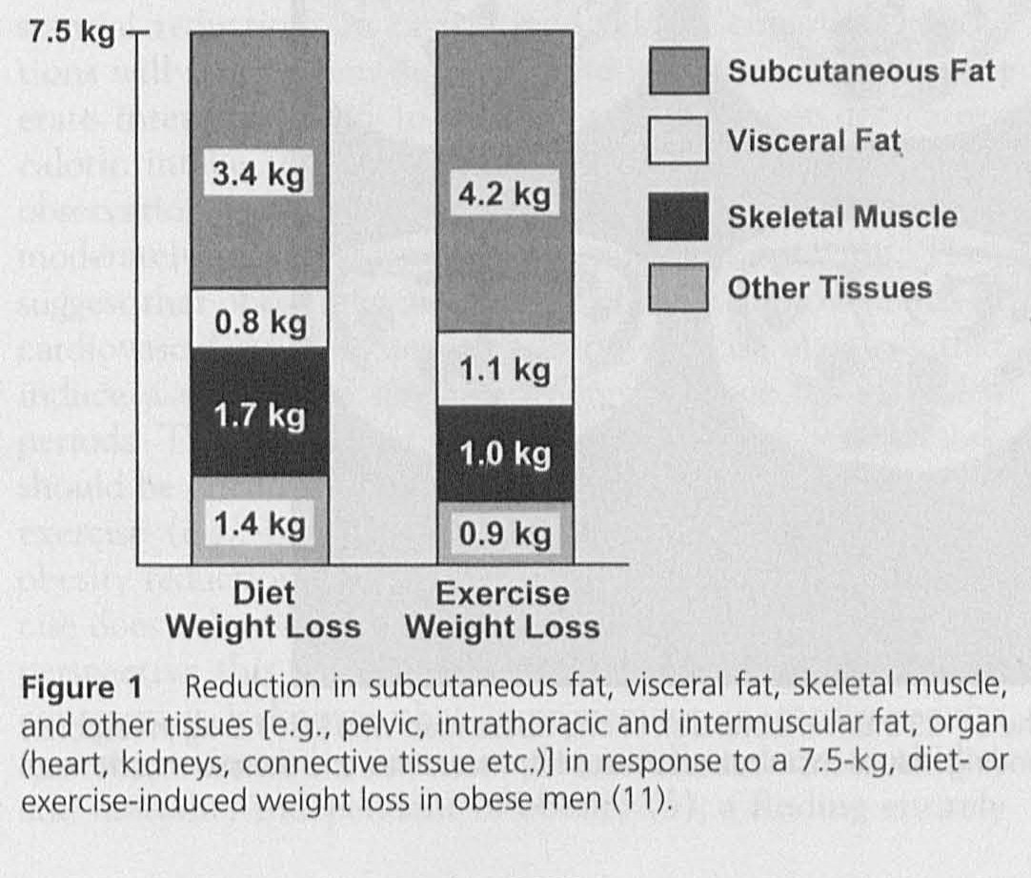
- when we lose weight through diet vs lose weight
through exercise - CT scan of 1 individual
- more subcutanrous fat is lost when exercise than - same pattern as chart on the left
from diet - both loss 7.5 kg
- visceral fat profile also favours exercise group - these provide a better image of how bad
- less weight due to skeletal muscle loss in exercise obesity is
- exercise weight loss is superior to diet weight loss
Conceptual framework of youth obesity (adapted from Bronfenbrenner’s Ecological Systems Theory)
Individual factors
- Lower levels of physical activity, increased sedentary behaviours, lower quality dietary intake and dieting.
- A common theory appeals to the concept of “lipostatic regulation” whereby an individual’s set points may influence their energy intake and activity choices in addition to their metabolism
- we all have a natural set point for body weight
- when you start messing up these systems, it can cause challenges
- there is no evidence that proves that weight loss can be maintained long term, yet people still
promote weight loss products
- To some degree, this set point is heritable with ample studies pointing to genetic determinants and gene-environment interactions
Family environment
- It has been shown that parental educational attainment and parental care reduces obesity risk in adolescents (girls, in particular).
- For both boys and girls, parental obesity is a risk factor for obesity in adolescence and early adulthood.
- There is evidence for an association between and child obesity. Maternal depression studies have shown that children of mothers with depressive symptoms are more likely to be obese or overweight in infancy, childhood, and adolescence.
- Possible mechanisms include restrictive feeding practices, poor mother-infant interaction, and poor parenting.
- Interestingly, some research has suggested that maternal depression and other family stressors lead to arousal of the child’s hypothalamic–pituitary–adrenal axis (HPA); the resulting increase in cortisol levels disrupts the metabolic system and leads to central adiposity in the child.
- cortisol levels peak in the morning and then they gradually decrease
- depression = cortisol levels are higher and they don’t decrease as much as normal
- this causes an inflammatory response in the body
Community environment
- It is recognized that a variety of temporal changes have taken place which result in a more obesogenic “built” environment, including increased availability of convenience foods, increased use of automobiles and increased use of electronic and televised forms of entertainment.
- The community food environment (e.g. proximity to fast food outlets, supermarkets, farmers markets) and other aspects of the local food economy, has been shown to influence food choices, not surprisingly since food choices are often influenced by convenience.
- Community recreational facilities, transit availability, neighborhood walkability/bikeability, and other components of the built environment, have been shown to influence physical activity levels.
Early life influences-prenatal and postnatal
- Prenatal risk factors for obesity include maternal smoking, maternal obesity and maternal diabetes.
- Extremes of infant birthweight, both high and low, have been shown to be markers predicting later obesity; the literature generally reports J-shaped and U-shaped relationships between birthweight and subsequent obesity.
Multilevel examination of prenatal, childhood, and adolescent determinants of youth obesity (CIHR)
- Campbell et al Longitudinal data set
- cohort description and prior data set
- combining factors in a systematic ways to see the profile from birth to adolescents
- have to look at multiple factors as to why some people become obese and some don’t
Lifestyle
- can screen use can be used as part of the solution instead of part of the problem?
- can we get kids to be active through activity programs?
Medication
- can children take drugs to control body weight
Surgery
- can surgery be beneficial
what happens when youth get surgery to restrict the amount of food that goes into their stomach
Youth Obesity Research EHPL

How inactive are kids today?
Screen Invasion
- technology today is a big problem

90% of Canadian children do not meet the guidelines
How do children in other countries participate in activities?

- We fall way behind in domestic duties and transportation compared to other countries yet all of our interventions target school and leisure activities
Pedometer Measured Step Counts
- Amish people’s step counts exceed Canadian step counts because domestically and transportation point of view, they walk more
Fitness of Canadian children and youth: Results from 2007-2008 Canadian Health Measure Survey (Tremblay, 2010)
Physical Activity Levels
- Canada has a failing grade of physical activity
BMI
- Males and females are getting bigger according to BMI
Waist Circumference
- larger waist circumference in both males and females
- larger, less strong, less flexible
- children are taller, heavier, fatter, rounder, weaker, and less flexible than in 1981
- these results forecast accelerated non-communicable disease development, increased health care costs, and loss of future productivity
Obesity decreased self-esteem, increased asthma, and increased musculosketal issues

