ADM 1300
Lecture 2: Management Learning-Past to Present

- Management is getting the right things done through other people
- Management thought started over 100 years ago
Classical Management Approaches
- Scientific Management
- Administrative Principles
- Bureaucratic Organization

***NOTE: Assumption-People are rational

Scientific Management- Frederick Taylor
- The systematic study of the relationship between people and tasks to resign the work for high efficiency
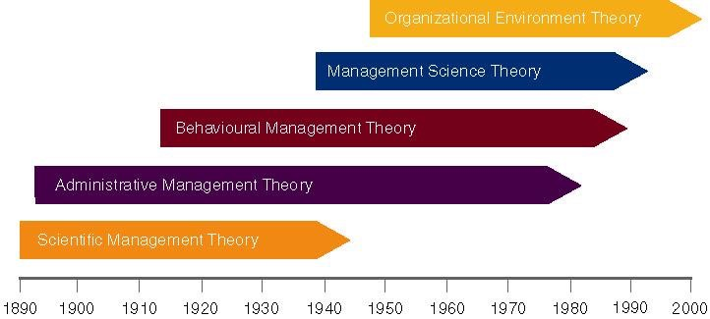
- Taylor sought to reduce the time a worker spent on each task by optimizing the way the task was done

Principles to Increase Efficiency
- Develop a job science that includes: rules of motion, standardized work implements, proper working conditions
- Carefully select workers with the right abilities to perform the job
- Train workers to do the job and give them proper incentives to cooperate with the job science
- Support workers by carefully planning their work
- Study&Codify then Select&train then reward

Problems
- Managers implemented only the increased output side of the plan
- Did not allow workers to shore in benefits
- Jobs became very boring and dull
- Workers ended up distrusting scientific management
- Workers intentionally under performed
- management responded with increased use of machines

- Frank and Lillian Gilbreth refined Taylor’s methods by making improvements to time and motion studies
- Time and motion studies
- Break down each action into components
- Find better ways to do it
- Reorganize each action to be more efficient

- They studied fatigue problems, lighting, heating and other work issues

Gilbreths VS.. Taylor
- Gilbreths’ studies were more focused on how a task was done and how to best eliminate unneeded, fatiguing steps in any process
- Gilbreths’ form of scientific management has a more developed view of the worker and his/her interests vs. Taylor’s predominant view of the worker as driven solely by pay
- Gilbreths used photography as a means to study human motion in completing tasks

Lessons From Scientific Management
- Make results-based compensation a performance incentive
- design jobs with efficient methods
- Carefully select workers for jobs
- Train workers to to the job the best they can
- Train supervisors to support workers

Administrative Management- Henri Fayol
- Postulated that all admin. activities could be divided into six groups
- Technical (production/manufacturing)
- Commercial (purchases, sales)
- Financial (finding and controlling capital)
- Security (protecting property and persons)
- Accounting (stock-taking, costing)
- Administrative or managerial activities

“Foresight, organizing, commanding, coordinating, controlling”

14 principles
- Division of labour- leads to job specialization, is such thing as too much specialization
- authority and responsibility-both formal and informal authority
- Unity of Command-employees should have one boss
- line of authority-Clear chain from top to bottom
- centralization-the degree to which authority rests at the very top
- Unity of Direction-One plan of action
- Equity-treat all employees fairly
- Order-each employee is put where they are most valuable
- initiative- encourage innovation
- discipline-Obedient, applied, respectful employees needed
- remuneration of personnel-the payment system contributes to success
- stability of tenure- importance of long term employment
- General Interest>Individual Interest- organization takes precedence
- Esprit de corps- share enthusiasm or devotion to organization

Bureaucratic Organization- Max Weber
Bureaucracy
- An ideal, intentionally rational, and very efficient form of organization
- based on principles logic, order, and legitimate authority
- A formal system of organization and administration to ensure effectiveness and efficiency

Five principles of bureaucracy
- A manager’s formal authority derives from his/her position
- People should occupy position because of performance not social connections
- authority and responsibility of each position relative to every other position should be clear
- Positions should be arranged hierarchically
- Managers must create a well defined system of rules, standard operating procedures, and norms

Key Points of Bureaucracy
- Authority-the power to hold people accountable for their actions
- Positions in firms should be based on performance
- Position duties are clearly identified
- Lines of authority should be clear. Workers know who to report to
- Rules, Standard Operating Procedures and Norms are used to determine how the firm operates

Behavioural Management Approaches
Human Resource Approaches Include
- Follett’s notion of communities
- Hawthorne Studies
- Maslow’s Theory of Needs
- McGregor Theory X&Y
- Argyris’ theory of adult personality

**** NOTE: Assumption-People are social and self-actualizing

Mary Parker Follett:
- Suggested workers help in analyzing their jobs for improvements
- The WORKER knows the best was to improve jobs
- If workers have the knowledge of the task, then they should control the task

The Hawthorne Studies-Elton Mayo
- Hawthorne Plant of the Western Electric Company in Cicero, Illinois
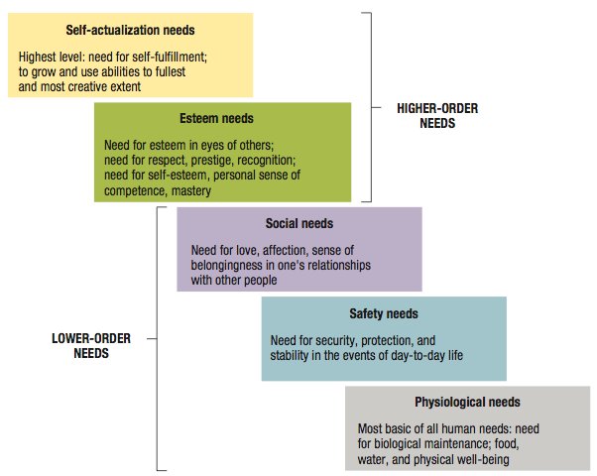
- Examined the physical and environmental influences of the workplace (lighting, humidity) and later examined the psychological aspects (breaks, group pressure, hours, managerial leadership)
- Four general conclusions:
1. The aptitudes of individuals are imperfect predictors of job performance
2. The informal organization affects productivity
3. Work-group norms affect productivity
4. Workplace is a social system

Maslow’s Theory of Human Needs
- A need is a physiological or psychological deficiency a person feels compelled to satisfy
- Need levels: physiological, safety, social, esteem, self-actualization

- Deficit Principle: A satisfied need is not a motivator of behaviour
- Progression Principle: A need becomes a motivator once the preceding lower-level need is satisfied
- Both principles cease to operate at the self-actualization level

Theory X Theory Y- Douglas McGregor
- Proposed two different set of worker assumptions
Theory X
- Assumes the average worker is lazy, dislikes work and will do as little as possible
- Managers must closely supervise and control through reward and punishment
Theory Y
- Assumes workers are not lazy, want to do a good job and the job itself will determine if the worker likes the work
- Managers should allow the worker great latitude, and create an organization the stimulate the worker

Modern Management Foundations
Foundations for continuing developments in management
- Quantitative analysis and tools
- Systems View of Organizations
- Contingency Thinking
- Commitment to Quality
- Learning Organizations
- Evidence-Based Management

