ADM 1300
Lecture 1

Organizations:
- A collective of people working together to achieve a common purpose
- Organizations provide useful goods and or services that return value to society and satisfy customer needs

Organizations as open systems

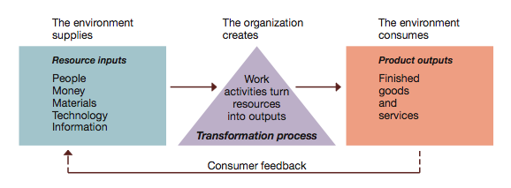
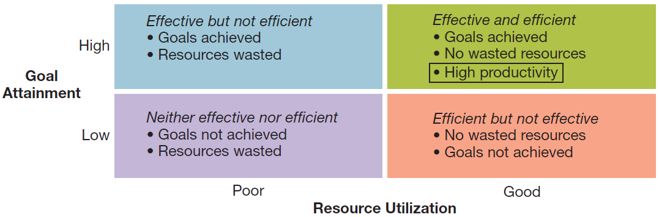
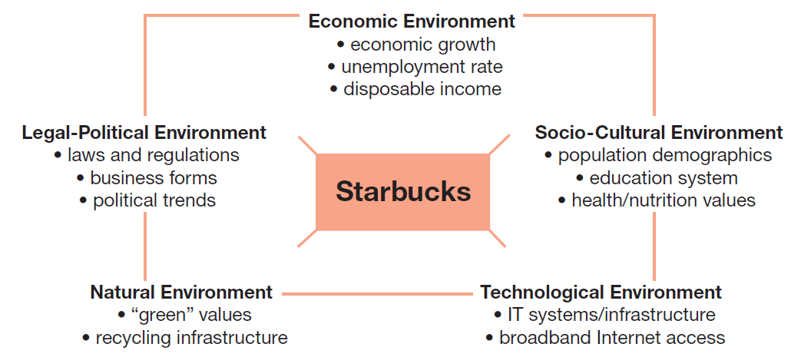
Productivity and the dimensions of organizational performance

Organizational Environment
- Economic-Health of Economy
- Logal-Political-Norms, customs, social values
- Socio-Cultural-Philosophy/Objectives of political party running government
- Technological-Development and availability of technology
- Natural Environment-Nature and conditions of environment

- Specific/Task Emvironment: organizations, groups and persons a organization interacts and conducts business with. This includes important stakeholders (customers, suppliers, competitors etc.)

- Value creation is creating value and satisfying needs of constituencies

Multiple Stakeholders in the specific environment of a typical business—>

- Environmental Uncertainty is a lack of knowledge regarding what exists and what developments may occur in the external environment
- Two dimensions of uncertainty are degree of complexity and rate of change

Managers in the New Workplace
Levels of management:
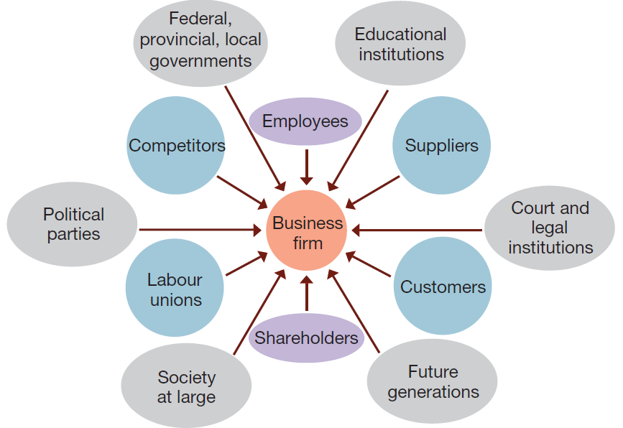
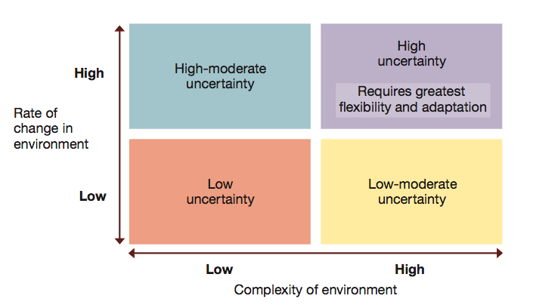
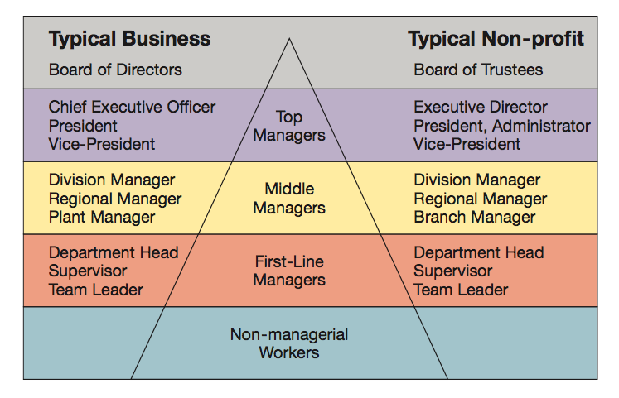
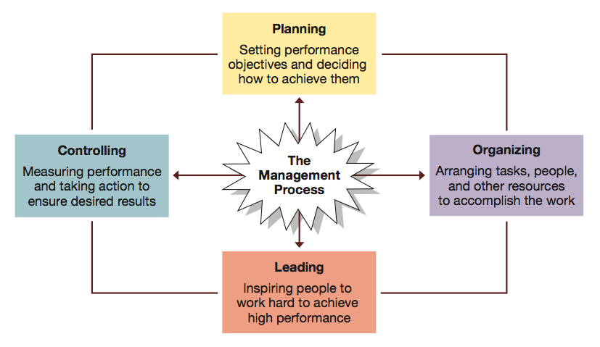
Top Managers- responsible for success of organization as a whole or of its larger parts
Middle-In charge of large departments or divisions
Team Leaders-In charge of small group of non-managerial workers

The Management Process
- Managers achieve high performance for their organizations by best utilizing its human and material resources
- Management is planning, organizing, leading and controlling to use resources to accomplish performance goals
- all managers do the above 4 functions
- functions are done continually

Planning-The process of setting objectives and determining what actions should be taken to accomplish them

Organizing-The process of assigning tasks, allocating resources, and arranging the coordinated activities of individuals and groups to implement plans

Leading-The process of arousing people’s enthusiasm to work hard and direct their efforts to fulfill plans and accomplish objectives

Controlling-The process of measuring work performance comparing results to objectives, and taking corrective action as needed

Managerial Roles
Informational Roles
- Involve giving, receiving, and analyzing of information
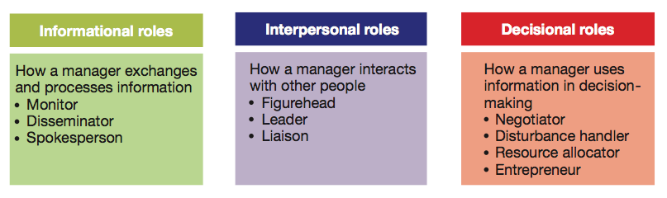
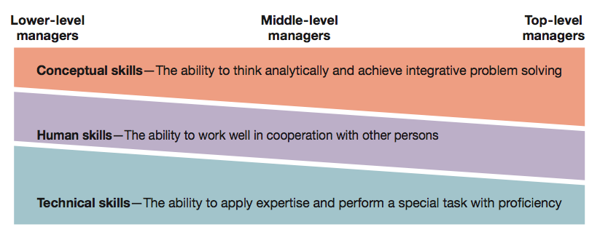
Interpersonal Roles
- Involve interactions with persons inside and outside the work unit
Decisional Roles
- using info to make decisions in order to solve problems or address opportunities
Essential Skills
Skill-ability to translate knowledge into action that results in desired performance
Technical Skill-Ability to apply special proficiency or expertise to a task
Human/Interpersonal Skill-Ability to work well with others
Conceptual Skill-Ability to think critically and analytically to solve complex proble

