Theo 206 – Lesson 1

Reading Notes

- The first centuries of the Christian tradition is called the Patristic Period.
- It is the period where the fathers (petres) did pioneering work in turning the Christian movement into a self-assured religious, social and intellectual force.
- The Patristic Period behinds roughly around 100 of the common era (C.E.) and follows the life and work of Jesus’s immediate followers.
- The Patristic Period ends with Constantine (306-337).
- The year 800 makes room for all the different views on when the Patristic Period ends.
- The formative Christian period was traditionally called “the age of the fathers” and designates a certain segment in time and also a kind of literacy production.
- Writers were interested in the emergence of a mainstream institution, the church and studied the period of time called “church history”
- As early as the 2nd century the term khristianismos , which was then translated to the term Christianity, refers to the way of life of the Christians vs that of the Jews and the Greeks.
- Previous centuries were satisfied with written testimonies but today we have several other tools to learn more about Christianity, example archaeology and the interpretation of iconography.
- For Jews and Christians the early 4th century marked a separation between the two religious traditions. Before investigation of the Patristic Period relied on the study of both Christian and Jewish origins.

Study Notes

The Christian Bible
Christianity is the faith based on Jesus Christ’s:
- life
- teachings
- death
- resurrection and ascension into heaven

Jesus lived some 2000 years ago.

The Christian Bible contains:
- Old Testament (OT) + apocrypha/deutero-canonical books
- New Testament (NT): 27 books, including 4 Gospels (“good news”)
- Gospels were written some 40-50 years after Jesus’s death

Methods of Bible Interpretation

These methods include:
- Historical critical method
- Literal method
- Allegorical method
- Mystical method
- Moral method

The most widespread with scholars today is the historical critical method which looks at:
- historical context
- intended audience of the author (Jewish audience? Greek?)
- desired effect of the author (convert people? Convey a message of salvation? Teach a moral?)

The Gospels

The first 3 gospels are the synoptic gospel (taken from the word seen together.) These are the gospels of Mathew (Mt) Mark (Mk) and Luke (Lk) .

These gospels look similar in context. The gospel of Mathew and Luke are based on an earlier gospel the gospel of Mark. A source they refer to as Q (German word quelle = source) Mathew and Luke have used the earlier version of the gospel of Mark, that no one has seen yet but scholars hope to find, as a source of their writing.

The gospel of Mathew targets Jewish Christian audience . He is presented as second Moses and messiah. The fact that the author was familiar with who Moses was and familiar with notion of messiah, proves that its targeting a particular audience.

The gospel of Luke targets as a non-jewish audience. Speaks in more universal terms. He had to explain who Moses was because the audience was not familiar with it.

The Gospel of John (Jn) (4th gospel):

Jesus is the eternal Son and Logos (or Word) of God, the incarnate God on Earth.
There are also apocryphal (or secret) gospels attributed to Thomas, Peter, Mary Magdalene, Philip, and even Judas – most of them come from Gnostic circles and are later.

The evangelists, along with their symbols in iconography from the Book of Kells (image), are:

Matthew the Evangelist, symbolized by a man, to represent the human nature of Christ.
Mark the Evangelist, symbolized by a lion, to represent Christ as king.
Luke the Evangelist, symbolized by a bull or a calf, to represent Christ as sacrifice and as priest.
John the Evangelist, symbolized by an eagle, to represent the Christ as God.

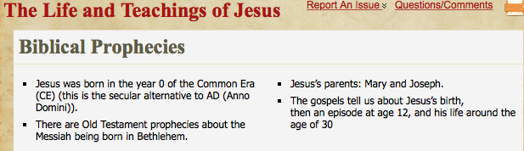

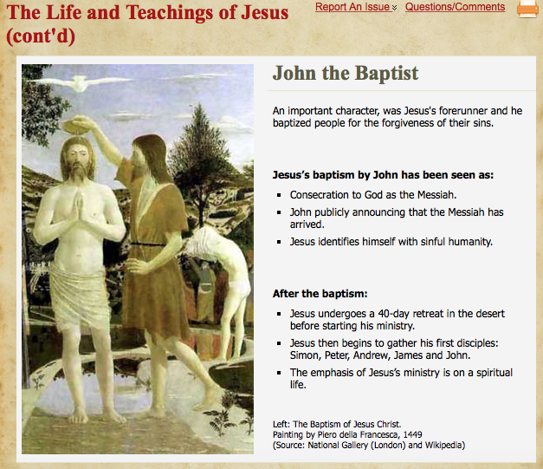

Jesus’s Ministry

Miracles of Jesus.

- Miracles today are seen as a suspension of natural laws.
- How does the bible understand miracles? During his ministry Jesus performed miracles, miracles are seen as the sign of the presence of god. Jesus talks about it as the kingdom of good, a glimpse into the better world.

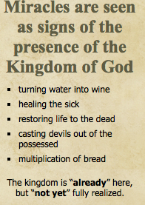
Jesus talks about these miracles by referring to the Kingdom of God. The Kingdom of god is a NEW reality where there is equality, no suffering, no pain. Scholars looking at what Jesus said as a tension as already here and not yet realized. The kingdom of god is already here it is present in what jesus is doing (in his healing of the blind and the sick). However, there are miracles where the justice of jesus is being shown but we still see a lot of injustice around (in today’s world). This tension is that we have a taste of this new reality but we don’t have a full taste of it. This full realization of the kingdom of god is not gonna come right now, we still have some time to go.
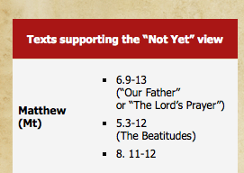

Prayer our father Mt- chapter 6 version 9 NOT YET VIEW.

Prayer says “thy kingdom come” which means that the kingdom is not yet here.

Jesus’s incounter with John’s desciples NOW VIEW.
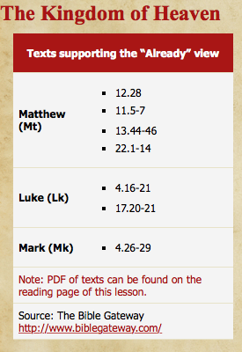
Are you really the messiah? Jesus replies look at my miracles. Look at what happens when I perform such miracles. Regular reality is somewhat suspended and a new reality is present.



