CHAPTER 3: Employment Income

Identifying Employment Income
- Employment Income results from the taxpayer working for another person (individual or corporation)
- Alternatively, a taxpayer may be self-employed, which results in business income

Employee vs Self-Employed
Employee | Self-Employed
Permitted a limited number of deductions | Can deduct all reasonable expenses incurred to earn income
Employees must withhold income tax, CPP and EI contributions from employees’ paycheques (source deductions) | Taxpayer is required to remit tax installments and double the CPP premiums (both employer’s & employee’s share)
- The self-employed are taxed on ‘net income’
- Employees are taxed on gross income
- Taxpayers have a preference how they are classified for tax purposes, resulting in conflict between individual taxpayers and the tax authorities

Tests to Determine Whether the Taxpayer is an Employee or an Independent Contractor
- Control Test:
- Who controls HOW and WHEN the work is performed
- Is the worker free to hire assistants or sub-contract some of the work?
- Integration Test:
- Services provided for a specified work OR on an ongoing basis?
- Old test based on services performed: integral to the business or an accessory?
- CRA: “a person is engaged to achieve a defined objective and is given all the freedom to obtain the desired result” = self-employed
- Ownership of Tools
- Economic Reality:
- Individual invests capital and manages the business
- Chance of profit or loss

Defining Employment Income
According to the Income Tax Act, Income or Loss from an Office or Employment is determined by the following provisions:
- Section 5 – Basic Rules
- Section 6 – Other income inclusions arising from employment
- Section 7 – Stock Option Benefits
- Section 8 – Deductions allowed against employment income

Salary, Wages and Other Remuneration
The Income Tax Act states:
S.5(1) “a taxpayer’s income for taxation year from an office or employment is the salary, wages and other remuneration, including gratuities, received by the taxpayer in the year”
Thus employment income includes:
- Salary and wages, and
- Other remuneration, which includes commissions, bonuses, honorariums, tips/gratuities, director’s fees and gifts received from employer’s customers
Income is reported on a calendar year basis, January 1 to December 31, on amounts received, ie. on a cash basis

Taxation of Benefits
- What if your employer reimbursed you by:
  - Paying you small taxable salary, but
  - Provided many benefits to give you a generous lifestyle, but those benefits were non-taxable?
- You’d live richly but pay very little taxes! (UNFAIR)

Restoring Equity
- To ensure that all taxpayers are taxed fairly:
S.6(1)(a) specifies that “benefits of any kind” must be included in income from employment

Benefits Which are Taxable (w/ HST)
- Board & lodging furnished as an employment perk (excluding free or low-rent board & lodging in a remote location or special work site)
- Personal travel benefits for employee or family members
- Personal use of employer’s vehicle
- Gifts in excess of $500/yr
- Awards in excess of $500/yr
- Long service or anniversary awards in excess of $500/yr
- Tuition fees/education costs on courses not of benefit to employer
- Reimbursement of the cost of tools used for employment
- Financial counseling and income tax preparation, except for re-employment or retirement purposes
- employee premiums paid by employer to a public provincial hospitalization plan or a public medical insurance plan

Non-Taxable Benefits
- Employer’s contributions to retirement plans, private health plans or group sickness, accident or life insurance plans
- Discounts on employee merchandise (unless the price becomes less than employer’s cost)
- Subsidized meals (provided at reasonable price)
- Uniforms and special clothing provided by employer to be worn while working
- Transportation to the job in remote locations
- Subsidized school services in remote areas
- Reimbursement of reasonable relocation expenses
- Amounts paid to public office holders to reimburse them for incurring costs related to employment activities
- Reasonable business trip expenses

Bonuses
- Some companies offer their employees bonuses:
  - Employees report income (for tax purposes on a cash basis, ie. when the cash is received)
  - Corporations report for tax purposes on an accrual basis
  - This difference can provide a tax planning opportunity
- For example, a business with a Dec 31 fiscal year end can:
  - Declare a bonus at year end and deduct the amount using the accrual basis for reporting
  - Pay the bonus early in the next fiscal year
  - As a result, the tax owing on the bonus by the employee is deferred by one taxation year

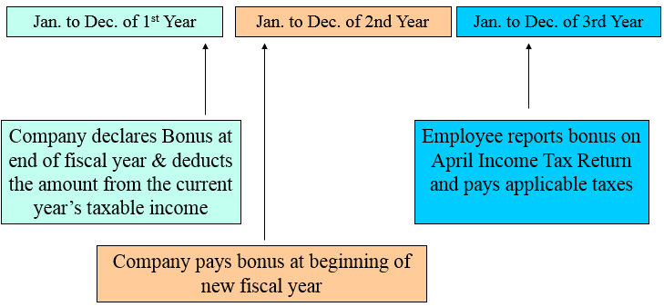
Example of Tax Planning for Tax Deferral on Bonus Payments

Constraints on Bonus Arrangements
Payment of Bonus | Tax Consequences
Within 180 days of business year end | Employer deducts when bonus declared  Employee includes when bonus received
More than 180 days but within 3 years | Employer deducts when paid  Employee includes when received
More than 3 years after bonus was declared | Employer deducts when paid  Employee includes when earned

A Taxable Benefit: Compensation for Loss on Home When Employee Asked to Relocate
- Employers may ask employees to relocate
- The move must be an “eligible relocation” which means the new work location of the employee is at least 40km from the current location
- The employer may offer to compensate the employee for losses on the sale of their old home
- When the employer compensates the employee on a housing loss:
  - The first $15000 is tax-free
  - Half of the amount over $15000 is taxable

PART 2
Employee Loans
- Employers occasionally offer interest-free or low interest loans to valuable employees
- To ensure equity amongst taxpayers, CRA prescribes minimum rates of interest, adjusted quarterly, based on the prime lending rate
- See Regulations 4300 and 4301
- If the interest rate given to the employee is less than the government’s prescribed rate, it results in a deemed interest benefit

Deemed Interest Benefit
Calculated as:
- Amount of Loan X Rate prescribed in Reg 4301 X 3 of days/365 loan outstanding
- LESS Interest actually paid by the employee before Jan 30 of following year

Loans for Investment Purposes
- Investing for business purposes
- Invest in income-generating assets, even shares of the company
  - Deemed interest benefit must be added to income
  - Deemed interest benefit can also be deducted as an expense against investment income
  - Thus the net result is zero

Home Loans
Employers may offer employees low or no-interest loans to assist them with the cost of their housing:
- If the employee [or their spouse] is relocating, the loan is considered a “home relocation loan” and the move must locate the taxpayer at least 40km closer to work – The first $25,000 of a relocation loan is exempt from tax for the first 5 years and is a Division C deduction for the taxpayer
- Loans can also be made to employees to purchase a new home or refinance an existing home mortgage

Imputed Interest on a Home Loan
- The interest rate benefit on a home loan is calculated on a quarter-by-quarter basis, and is the lesser of:
- The prescribed rate for the quarter while the loan was outstanding, or
- The prescribed rate in effect at the time the loan was made
- Option a) is a rate that changes every quarter whereas option b) locks in the prescribed rate in effect on the date the loan is granted
- The option b) rate can be used for a five year period (and a new option b rate can be locked in again at every 5 year anniversary)
- If the rate decreased within a 5 year period, the taxpayer uses the lower rate

EXAMPLE: Tax Calculation on Employee Loan
On May 1, Ms. Goodman borrowed $35,000 from her employer and signed a promissory note to pay 3% interest in monthly installments and repay the principle in five equal installments on each anniversary date. She used the $35,000 in the following manner:
- $20,000 for a down payment on a new home she moved into immediately
- $10,000 on a good used vehicle for work
- $5,000 on dividend-paying shares
Identify the impact on her Income Tax Return.
Tax Consequences of Ms. Goodman’s Loan
Ms. Goodman must include an imputed interest benefit from May 1 to December 31 in her employment income.
Regulation 4300 prescribed the following rates for the year as follows:
- 1st Quarter = 5%
- 2nd Quarter = 4%
- 3rd Quarter = 5%
- 4th Quarter = 5%
Imputed Interest (Vehicle and Shares) is:
Imputed Interest is:
 | Vehicle | Shares
2nd Quarter: May 1 to June 30 inclusive:
61/365 X 4% X $10,000 = | $66.85
61/365 X 4% X $5,000 = |  | $33.45
3rd Quarter: July 1 to Sept 30 inclusive:
92/365 X 5% X $10,000 = | $126.03
92/365 X 5% X $5,000 = |  | $63.01
4th Quarter: Oct 1 to Dec 31 inclusive:
92/365 X 5% X $10,000 = | $126.03
92/365 X 5% X $5,000 = |  | $63.01
Imputed Interest on Vehicle | $318.91
Imputed Interest on Shares |  | $159.47
Imputed Interest (Home) is:
- Prescribed Rate
2nd Quarter: May 1 to June 30 inclusive:
61/365 X 4% X $20,000 = $133.70
3rd Quarter: July 1 to Sept 30 inclusive:
92/365 X 5% X $20,000 = $252.05
4th Quarter: Oct 1 to Dec 31 inclusive:
92/365 X 5% X $20,000 = $252.05
Imputes Interest under Option A $637.78
- Locked-In Rate (4% on May 1)
From May 1 to Dec 31 inclusive:
245/365 X 4% X $20,000 = $536.99
THEREFORE:
Imputed Interest on Vehicle $318.91
Interest Paid: ($10,000 X 3% X 245/365) (201.00) $117.91

Imputed Interest on Shares $159.47
Interest Paid: ($5,000 X 3% X 245/365) (100.50) 58.97*

Imputed Interest on Home Loan $536.99
Interest Paid: ($20,000 X 3% X 245/365) (402.00) 134.99**
Amount to Include on Tax Return $310.58

(*The imputed interest cost on the shares is deductible as carrying charges)
(**The imputed interest costs on the home loan is NOT deductible in Division C because she did not relocate)

Forgiveness of Employee Loans
Ssec.6(15) requires that any unpaid principle of a loan that is forgiven must be included in income
Allowances and Reimbursements
Allowance  (More $$ to Employee) | Reimbursement  (Return of Employee’s $$)
- Allowance is a fixed sum in excess of salary paid to the employee, without a receipt, by the employer  - S.6(1)(b) requires that allowances be included in income (with some exceptions) and taxed | - The employee paid an expense of the employer (ex. stamps for office mail)  - When the employee provides receipt and the stamps, the employee is reimbursed the cost  - This is not taxable

Exceptions to the Inclusion of Allowance in Income
- Allowances for expenses of individuals involved in sales or negotiating contracts need not be included in income [subpar 6(1)(b)(v)]
- For an allowance to be exempt from inclusion in income, the following conditions must apply:
- The allowance must be reasonable
- The allowance must be only for travelling expenses
- The recipient must be involved in selling of property or the negotiation of contracts for the employer
- ‘Ordinary Employees’ can exclude allowances from income under the following conditions:
- Employee does not sell property or negotiate contracts
- The allowance is reasonable
- The allowance is for traveling (but not with a motor vehicle)
- The employee must travel away from the municipality and metropolitan area of the employer’s establishment where the employee normally works

What is the Difference between the Two Exceptions?
- Use of Motor Vehicle:
- Included for employee selling property or negotiation contracts
- Excluded for ordinary employee
- Geographic Area
- Unlimited for employee selling property or negotiation contracts
- Restricted for ordinary employee to travel outside normal municipality or metropolitan area where employee works

Employee Drives Own Vehicle

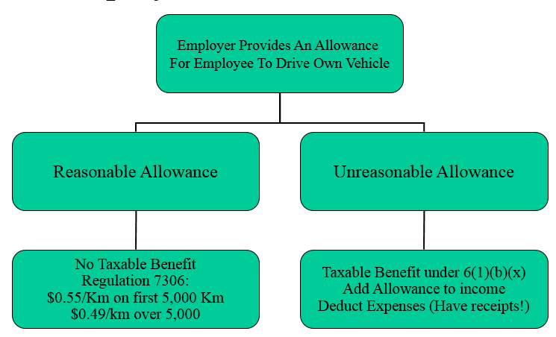

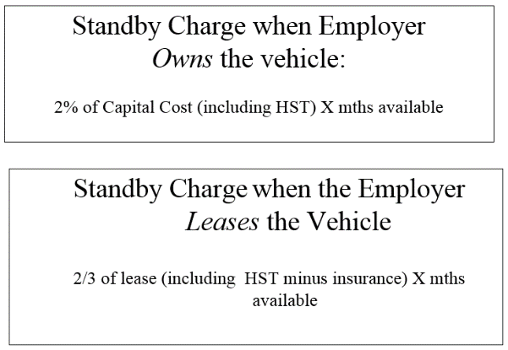
Benefit from an Automobile Provided by an Employer
STANDBY CHARGE
- Benefit is conferred on an employee upon the availability of an employer-provided vehicle
- To reduce availability, employees should return the keys to the employer for periods when the vehicle is not going to be used
- The standby charge can be reduced if the vehicle is used primarily (more than 50%) for employment
- Reduction is determined by multiplying the standby formula by the fraction, A/B where:
A is the total personal km driven, to a max of 20,004km per year
B is 1,667km per month that the vehicle was available to a max of 20,004km per year
0 ≤ A/B ≤ 1
- A is based on personal usage and the greater (lesser) this amount, the higher (lower) the standby charge
OPERATING COST BENEFIT
- Operating expenses include gas, insurance & maintenance, but not parking
- These costs are typically paid by the employer but rarely reimbursed by the employee, thus there is a taxable benefit to the employee from operating the car
- Benefit: $0.27 X # km driven for personal use, minus any amounts reimbursed by the employee within 45 days of year end
- OR, if vehicle is used primarily (more than 50%) for business, the employee can elect to take 50% of the standby charge

EXAMPLE 1: Employer Owned Vehicle
Cost of Vehicle: $25,000
Months Available: 9
Total Kms: 16,000
Personal Kms: 1,600
- Step 1: Calculate Personal Use Ratio A/B:
$\frac{1,600}{16,000}=10\%$ (Qualifies for both standby reduction and choice of operating benefit alt since >50%)
- Step 2: Calculate Standby Charge:
$\frac{1,600}{1,667 X 9} (2\% X Capital Cost X Mths available)$
$\frac{1,600}{1,667 X 9} (2\% X \$25,000 X 9)$ = $482
- Step 3: Calculate Operating Cost Benefit:
$0.27 X 1,600 Personal Km = $432
OR ½ of standby charge = $241
- Total Taxable Benefit
Standby Charge $482
Operating Cost Benefit $241
Total Taxable Benefit $723

EXAMPLE 2: Employer Leased Vehicle
Lease Cost of Vehicle: $4,800 ($400/mth)
Months Available: 12
Total Kms: 32,000
Personal Kms: 16,500
- Step 1: Calculate Personal Use Ratio:
$\frac{16,500}{32,000}=51.6\%$ (NOT qualify for either standby reduction or choice of operating benefit)
- Step 2: Calculate Standby Charge
(2/3 X Lease Cost X Months available)
(2/3 X $400 X 12) = $3,216
- Step 3: Calculate Operating Cost Benefit:
$0.27 X 16,500 Personal Km = $4,450
- Total Taxable Benefit
Standby Charge $3,216
Operating Cost Benefit $4,450
Total Taxable Benefit $7,671

Reducing the Taxable Benefit Further
- Taxable benefit can be further reduced by reimbursing the employer for the personal use of the vehicle
- Using Example 1, if the employee had reimbursed the employer $50/mth through payroll deductions for the personal use of the vehicle, the taxable benefit would be:
Standby Charge $482
Operating Cost Benefit $241
Less: Reimbursement ($50 X 9 mths) (450)
Total Taxable Benefit $273

Tax Planning
An employee should evaluate 2 options:
- Using the company vehicle for personal use and incurring a taxable benefit, or
- Using their own vehicle for company purposes and receiving a non-taxable allowance
USING EXAMPLE 1:
- Using the company vehicle for personal use would result in a taxable income of $723 (or $273 with reimbursement to employer)
- Using the employee’s own vehicle for 14,400 km of business use would result in a non-taxable benefit of:
5,000km @ $0.55 = $2,750
9,400km @ $0.49 = 4,606
Total non-taxable benefit $7,356

PART 3
Summary of Employee Benefits
Taxable | Non Taxable
Room & Board | Housing in Remote Locations
Provincial Health Care | Private Health Care
Wage Loss Plans | Group Accident, Sickness and Life Insurance Plans
Use of Employer’s Vehicle | Moving Expense Reimbursement
Low or No Interest Loans | Schools in Remote Locations
Travel Benefits | Uniforms
Tuition | Subsidized Meals
Cost of Tools | Merchandise Discounts
Gifts from Employer | Job Transportation
Prizes or Awards | Transportation Passes (airline, bus, or rail employees)
Counselling Fees
- Benefits that create inequity between taxpayers are generally taxable (tax re-establishes equity)
- Benefits related to personal pleasure or enjoyment are taxable (trips, vehicle availability, expenses for spousal accompaniment on trips, etc)
- A benefit deductible by the employer is generally taxable to the employee (with few exceptions)

Stock Options
- Stock option: an agreement which grants the employee the right to invest in company’s shares at a given price before a specified date
- Stock options are intended to provide management with incentives to maximize firm value (aligns management’s and shareholder’s interest by making management a shareholder)
- Employers like the scheme because it does not involve before or after-tax cash outflows – many small companies just don’t have the cash

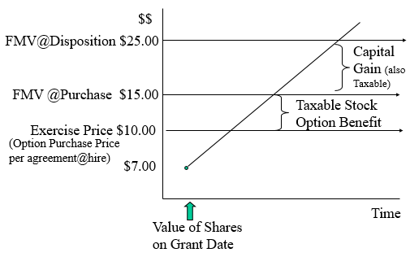
How Options Work

Example of A Stock Option Calculation
On January 1, 2010, Ms. Smith was given an option to purchase 10,000 shares of XYZ Corporation for $8.00 per share. This option extends for three years. The value of the shares at particular dates are as follows:
- January 1, 2010 $8.00
- January 1, 2012 $9.50
- January 1, 2015 $11.00
Determine the impact when Ms. Smith exercises her option on Jan 1/12 and sells on Jan 1/15.
EXERCISE OPTION:
Taxable Benefit:
FMV of shares on exercise date:
$9.50 X 10,000 shares $95,000
Cost of shares:
$8.00 X 10,000 shares $80,000
Taxable Benefit [ssec.7(1)] $15,000
Because Ms. Smith paid $80,000 cash and is taxed on the $15,000 benefit, the tax authorities consider the adjusted cost of those 10,000 shares to be $95,000 or $9.50 per share.
SELLS OPTION:
Proceeds of disposition:
$11.00 X 10,000 shares $110,000
Adjusted Cost Base:
$9.50 X 10,000 shares $95,000
Capital Gain $15,000
Taxable Capital Gain
$15,000 X ½ $7,500

Rules Regarding Stock Options
- The option must be received as a result of employment
- When stocks are purchased under the option, the difference between the option price (the purchase price agreed to in the employment contract) and the FMV is a taxable employment benefit
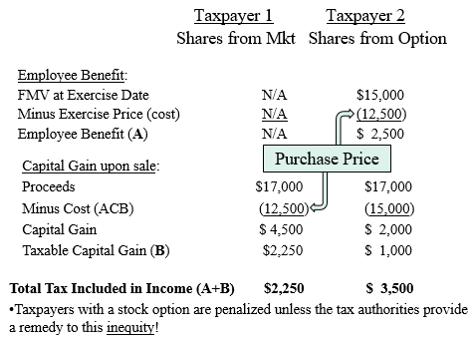
- Inclusion of this stock option benefit in income has the potential to create inequity between employees who purchase the shares through their employment contract versus individuals who purchase shares from a broker

How Does This Inequity Arise?
Consider 2 individuals. Both:
- Purchase their stock for $12,500
- Sell their stock for $17,000
Taxpayer 1 purchased the stock on her own from a broker.
Taxpayer 2 purchased the stock through a stock option negotiated when she was hired.

The Remedy
- There is a “stock option deduction” under Division C, equal to ½ of the stock option benefit, provided:
  - The shares are common shares (Reg. 6204)
  - The employee and employer are dealing at arm’s length
  - The option (exercise price) ≥ FMV of shares on grant date [par.110(1)(d)], specifically
    - At the time of hire, the FMV of the company shares are $8
    - The option (exercise) price must be greater than or equal to $8 for the Division C deduction to be available

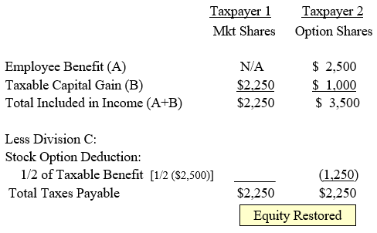
Effect of the Division C Deduction

Where is Division C?
3(a) Income from all Sources
3(b) Net Taxable Capital Gains
3(c) Subdivision e Deductions
3(d) Current Year Losses
Net Income for Tax Purposes (NIFTP)
Division C Deductions:
- Home Relocation Loan Deduction
- Stock Option Deduction

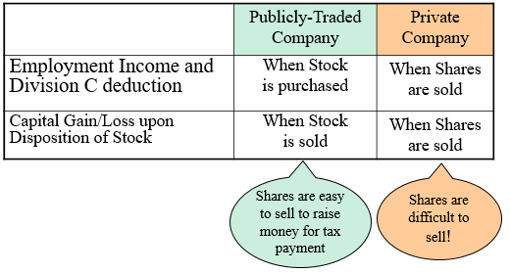
Timing of Inclusion of the Taxable Benefits from Stock Options

Deductions from Employment Income
According to ITA 8(1) of the Income Tax act:
- ITA 8(1)(a) Volunteer’s deduction: If an allowance is provided, only amounts in excess of $1000 is taxable (volunteers: volunteer firefighter, volunteer ambulance technician, search & rescue volunteer)
- ITA 8(1)(b) Legal expenses incurred to collect unpaid wages, salaries, or benefits
- ITA 8(1)(c) Clergy residence: the cost of living accommodation (rent/owned) must be included in income and then deductible to a maximum of remuneration received (employer completes form T1223)
- ITA 8(1)(d) A teacher’s contribution to the Canadian Education Association up to a max of $250
- ITA 8(1)(e) Meals (at 50%) and lodging for a railway employee traveling away from the ordinary place of residence
- ITA 8(1)(g) Meals (at 80%) and lodging for an employee employed by a transport company (passenger and/or goods transportation) while traveling away from the ordinary place of residence
- ITA 8(1)(f) Sales Expenses, if the employee was employed in the selling of property or negotiating of contracts, and:
- The salesperson was required to pay own expenses (Employer provide Form T2200)
- The salesperson was ordinarily required to work away from employer’s place of business
- The salesperson must not be in receipt of an allowance which was excluded from income
- The salesperson is paid, at least in part, by commission
NOTE: 8(1)(f) restricted to Salespersons
Under 8(1)(f), the following expenses can be deducted by a salesperson, to the maximum of commission:
- Advertising & promotion
- Meals and entertainment (at 50%)
- Lodging while traveling
- Motor vehicle costs (prorated for business use)
  - Fuel & Oil, Maintenance, Repairs, Insurance, Licence & Registration Fees
  - No CCA or Interest Expenses
- Parking
- Work space in home (maintenance, property taxes & insurance, but not mortgage interest or depreciation)
- Supplies (long distance telephone calls & cellular phone airtime; but NOT the basic monthly or connection charges)
- Licences, bonding & liability insurance, training
- Salary to an assistant or substitute
- Lease costs on office equipment & computers
- ITA 8(1)(h) Travel Expenses, provided
- The employee is required to pay own travel expenses (Form T2200)
- The employee is required to work away from the employer’s place of business
- Any allowance has not been excluded from income, AND
- NO claim has been made under par.8(f)
Travel expenses include:
- Accommodation
- Airline, bus, or railway tickets and taxi fares
- Meals (at 50% and if away for ≥ 12 hours)
ITA 8(1)(h.1) Motor Vehicles Expenses, provided
- The employee is required to pay own travel expenses (Form T2200)
- The employee is required to work away from the employer’s place of business
- Any allowance has not been excluded from income, AND
- NO claim has been made under par.8(f)
Motor vehicle costs include:
- Fuel & Oil
- Maintenance & Repairs
- Insurance, Licence & Registration Fees
- Prorate costs for business use

The Interaction of ITA 8(1)(f) and 8(1)(h)(h.1)
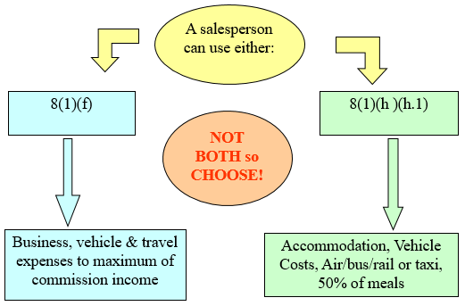

- ITA 8(1)(i) Dues and other expenses of performing duties, including:
  - Professional Dues, Union Dues, Licenses
  - Salaries to an assistant, including CPP and EI
  - Supplies the employee is required to provide
  - Office Rent or workspace in the home
Under 8(i), if the employee is required to provide work space in the home (Form T2200)
Expenses are deductible if:
- This is the space where the individual principally performs their employment duties, or
- The space is used exclusively and on a regular and continuous basis for employment purposes
Deductible Expenses:
- Maintenance (fuel, electricity, minor repairs, cleaning)
- Based on % of floor space to a maximum of employment income after all other deductions
- ITA 8(1)(j) Motor Vehicle and Aircraft Costs
If the employee is eligible for deductions under 8(f), (h), or (h.1), then they may also deduct under this section, for a motor vehicle:
- Interest on borrowed money (limited to $300/mth)
- Capital Cost Allowance (limited t $30,000 plus GST/PST)
- ITA 8(1)(m) Registered Pension Plan (RPP_ Contributions
- Employees can deduct their contributions to an employer-sponsored plan from their income
- ITA 8(1)(s) Tradesperson’s Tool Expenses
- A deduction on purchases of tools in excess of $1000, to a maximum deduction of $500

Limitations on Employee Deductions
- Expenses can’t exceed commission income
- Home office expenses cannot create a loss; the excess can be carried forward
- Motor vehicle expenses cannot create a loss; the excess can be carried forward

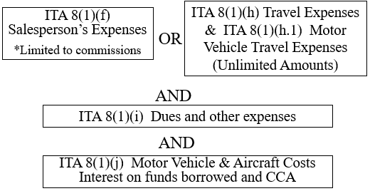
Diagram Illustrating the Deduction Provisions

Example: Calculating a Salesman’s Expenses
Terry began his sales career in November, and throughout November and December, he made only $300 in commissions. It takes time to build a clientele. However, he incurred the following expenses:


