CARDIOVASCULAR

TOPICS
- Blood (hemolymph)
- Hemodynamics – basic principles
- Pumps (hearts)
- Types of circulatory systems – open vs. closed
- Anatomy – comparative aspects
- Cardiovascular physiology

1. BLOOD
- Many vertebrates are similar to humans in the breakdown of blood
- There are two categories of extracellular fluid
  - Interstitial fluid
  - Blood plasma

COMPOSITION OF BLOOD (HUMAN)
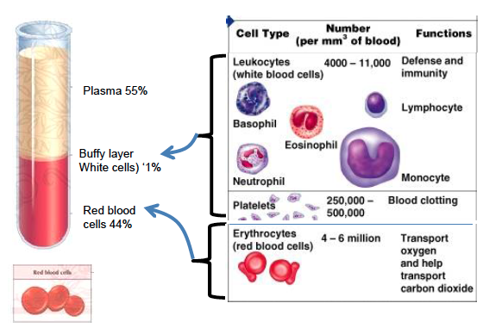

- Proteins play an important role in circulation and excretion due to their oncotic pressure
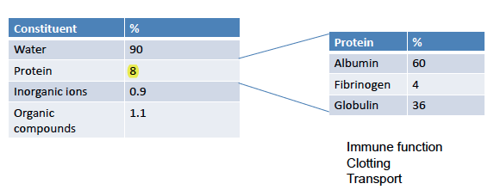
- Blood plasma is composed of the things in the table below:
  - If protein falls too low, circulatory problems will result
  - Organic compounds are circulated in the blood to bring energy containing things into the blood or take organic breakdown products of these compounds into the kidney or somewhere where it will convert it to something else
2. HEMODYNAMICS: BASIC PRINCIPLES
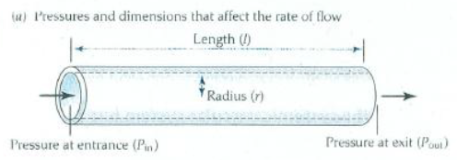

- Pressure difference on either side is important if the tube needs to be different in order for fluid to flow
- Size of tube is important because the radius will determine how fast fluid will flow through it
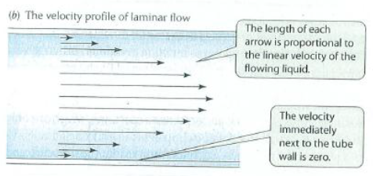
- Length represents the resistance: longer the tube, the more energy that will be needed in order for the fluid to flow
  - Fluid flows fastest in the middle and slowest against the walls because friction is greatest against the walls
  - Any irregularities in the surface will cause problems in the flow, so we will assume that the flow is laminar
  - Laminar flow occurs when a fluid flows in parallel layers, with no disruption between the layers
- What factors affect blood flow through a tube?
  - Pressure difference (P_{in} – P_{out})
  - Dimensions (length, radius)
  - Viscosity – molasses harder to pump than water
  - How are these related?
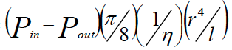
- Poiseuille equation
  - Flowrate =
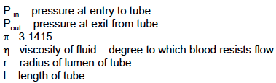

  - Ƞ = viscosity – the degree to which blood resists flow under an applied force
    - The bigger the viscosity, the smaller the flow rate will be
    - Blood is 3-4 times more viscous than water at 37 degrees Celsius
  - What affects viscosity?
    - Temperature as temp falls, viscosity increases, which means its harder to pump blood when it is cold
    - Proteins
    - Blood cells

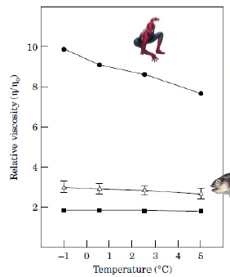
BLOOD VISCOSITY AND TEMPERATURE
- As temperature falls, viscosity increases
- Fish blood viscosity is much lower at any temperature compared to the human, and are far less sensitive to temperature change

ANTARCTIC ICEFISH
- Predict that because cold water holds so much oxygen, they don’t need as much hemoglobin
- It is possible that they are able to reduce the amount of red blood cells – however, this is not really well understood
- In other words, high oxygen = lack hemoglobin?
- Channichthyid icefishes lack red blood cells and hemoglobin
  - Not ALL Antarctic fish do this, its one big family that have lost their erythrocytes and hemoglobin
  - The cellularity of the Antarctic blood (white-blooded) is lower, which reduces the viscosity
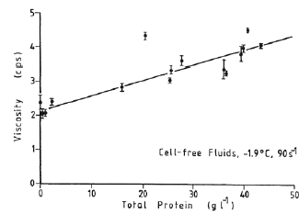
  - Some Channichthyid icefishes lack myoglobin
    - Therefore, heart of the ice fish is brownish simply because of the mitochondria content
    - Other fishes have red hearts largely because of the myglobin
- White blooded notothenioids have a higher density of hyaloid (retinal) arteries

EFFECT OF PROTEIN CONTENT ON VISCOSITY
- The more protein you put into your blood, the greater its viscosity
- This could be a limit on the capacity to pack proteins in
  - If you wanted to put more albumin in, it could be a problem
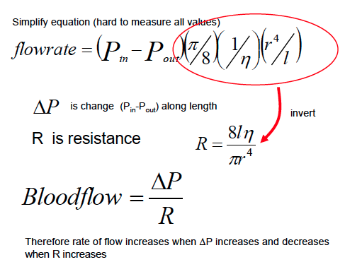

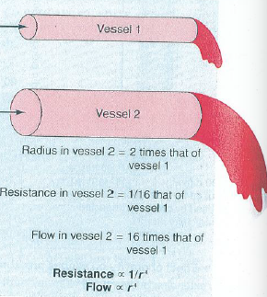
- Vessel 1 has high resistance due to small radius
- Vessel 2 has low resistance due to large radius
  - Because of 4th power small changes in radius, it can have a big impact on flow
  - To note: this becomes important during vasodilation and constriction
- Doubling the radius decreases the resistance to 1/16
  - This increases the flow 16 times because the resistance is inversely proportional to the fourth power of the radius
- The pump creates constant pressure, however depending on the resistance and pressure difference in vs. out, the flow changes
  - High resistance = no flow
  - Moderate resistance = moderate flow
  - Low resistance = large flow
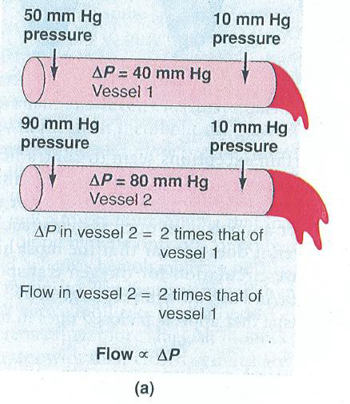
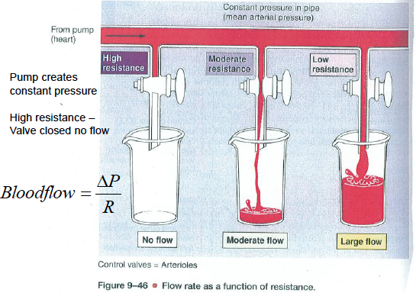
  - Large pressure difference creates a greater flow

3. PUMPS: HEART MUSCLE
- 1. Has to work continuously – lots of mitochondria for aerobic catabolism
- 2. Needs lots of oxygen – myoglobin usually present
- 3. Needs energy source (lipids, carbohydrates, amino acids) – good blood supply

METABOLIC FUELS FOR TISSUES (e.g. heart)
Animal | Carbohydrate | Amino acids | Lipids
Bivalve mollusc | *** | ***** | No
Cephalopod mollusc | *** | ***** | No
Elasmobranch fish | *** | ***** | No
Teleost fish | *** | *** | *****
Mammals | *** | * | *****
- You can see that mammals (i.e. humans) mainly rely on lipids for metabolic fuel
TYPES OF PUMPS (HEARTS)
- 1. Myogenic
  - Pace is determined by heart muscles themselves (all vertebrates have these)
  - The heart beat is initiated and regulated by specialized groups of muscle cells
  - Is capable of generating a cardiac contraction independent of nervous input – therefore, if the heart is removed from the body, it continues to beat for some time
- 2. Neurogenic
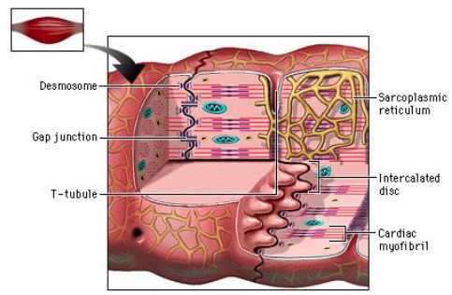
  - For most insects, heart contraction is initiated and regulated predominantly by external nerves
  - If heart is removed from the body, it stops beating completely

MYOGENIC HEARTS
- All vertebrates
- Are innervated but beat is without input from nerves
- Muscle cells are electrically coupled via gap junctions in intercalated discs
- Pace set by pacemaker
- Intercalated discs: connecting heart cells electrically (gap junction) and mechanically (desmosome)
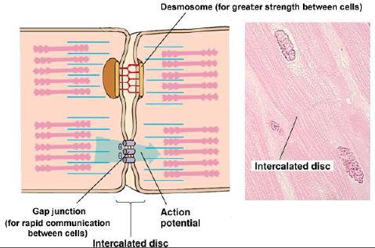
  - Gap junctions are a specialized intercellular connection between a multitude of animal cell-types
    - They directly connect the cytoplasm of two cells, which allows various molecules, ions and electrical impulses to directly pass through a regulated gate between cells
    - For rapid communication between cells
  - Desmosomes help to resist shearing forces and are found in simple and stratified squamous epithelium
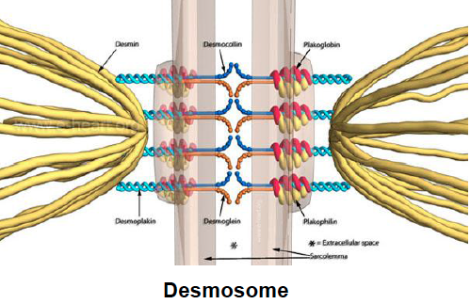
    - Forms the site of attachment between certain epithelial cells, which consist of local differentiations of the apposing cell membranes
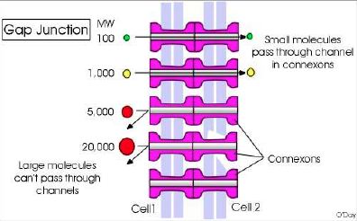
    - For greater strength between cells
NEUROGENIC HEARTS
- Arthropods: crustaceans, insects, spiders, molluscs
- Each cell is innervated and only contracts when stimulated
- The neurogenic heart of a lobster
  - Has a cardiac ganglion that initiates and controls its contractions
  - The cardiac ganglion is composed of nine neurons
  - The posterior four neurons are small, whereas the anterior five are large
    - Neuronal processes exit the ganglion to innervate the cells of the heart muscle
    - Regulatory neurons from the CNS enter the ganglion in the dorsal nerve

4. TYPES OF CIRCULATORY SYSTEMS – OPEN VS. CLOSED

OPEN CIRCULATORY SYSTEM
- Usually present in many invertebrates
- If you’ve got an open system, generating high pressures will be a problem – this can be found in often sluggish animals, such as lobsters
- Pump blood into a hemocoel with the blood diffusing back to the circulatory system between cells
  - Blood is pumped by a heart into the body cavities where tissues are surrounded by the blood
  - A hemocoel is the primary body cavity of most invertebrates, containing circulatory fluid

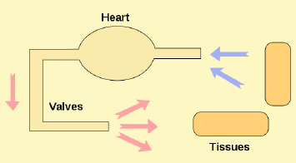

- CRAYFISH AND LOBSTER
  - Have a cor frontale which is an accessory heart (powered by skeletal muscles) positioned upstream from the extensive vascular networks of the brain
    - It is believed to help ensure that adequate perfusion pressures are maintained in the brain
  - The circulatory plan
    - Because the respiratory pigment of decapod crustaceans is hemocyanin, the blood turns bluish when oxygenated, but is clear when fully deoxygenated
    - Oxygenated blood pumped to tissues under high pressure
- INSECTS
  - Blood flow through the tissues of an insect is principally through lacunae and sinuses
  - Blood flows principally from posterior to anterior in the dorsal part of the body, and from anterior to posterior in the ventral part of the body

CLOSED SYSTEM
- Vertebrates, and a few invertebrates, have a closed circulatory system
- Have the blood closed at all times within vessels of different size and wall thickness
- In this type of system, blood is pumped by a heart through vessels, and does not normally fill body cavities
CLOSED SYSTEM: INVERTEBRATES
- CEPHALOPOD MOLLUSCS
  - Physiologically, the circulatory system of squids and octopuses resembles that of vertebrates far more than it does that of the other molluscan groups (which have low-pressure, open circulatory systems)
  - A squid or octopus has a principle heart, called its systemic heart, and two weaker, auxiliary branchial hearts
    - Hemocyanin, the respiratory pigment of squids and octopuses, turns blue when well oxygenated but is clear or nearly clear when deoxygenated

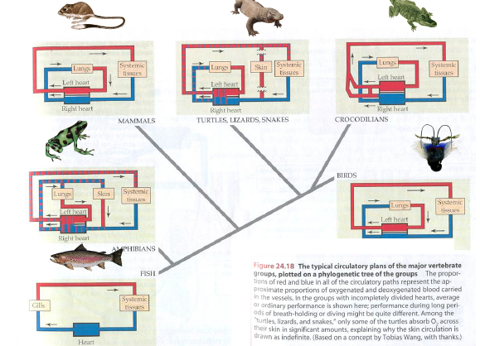
CLOSED SYSTEM: VERTEBRATES
- FISH CIRCULATION
  - The heart pumps blood anteriorly into the ventral aorta, which gives off afferent branchial vessels to the gill arches
  - Blood perfuses the gills
  - Blood is collected into efferent branchial vessels, which empty into the dorsal aorta
  - Blood is distributed to the systemic tissues by the dorsal aorta
  - The great veins return deoxygenated blood from the systemic tissues to the heart
  - BASICALLY, oxygenated blood moves to tissues after passing through gills
- AMPHIBIANS
  - The skin of amphibians is an important site of O₂ uptake – some of the major arteries to the skin arise from the pulmonary arteries
    - Thus, is deoxygenated blood is preferentially pumped to the lungs, it is also preferentially pumped to the skin
  - Oxygenated blood from skin adds oxygen to blood entering right heart
  - Oxygenated and unoxygenated blood mixes before passing to tissues
- TURTLES, LIZARDS, SNAKES
  - Oxygenated and unoxygenated blood mix before moving to tissues
  - In reptiles like turtles, the circulation isn’t much different from that of amphibians – there’s a completely separated heart so the capacity to deliver oxygen at a high rate is not optimal
  - Very few of them can use skin as a respiratory surface, however soft turtles can use the skin on their shell and some can use skin on rectum
  - Since only some of the turtles absorb O₂ across their skin in significant amounts, this explains why the skin circulation is drawn as indefinite
- CROCODILIANS
  - Oxygenated and unoxygenated blood do not mix before moving to tissues
  - Ventricle is completely divided into two chambers by a septum
  - They have two systemic aortas, which arise from the left and right ventricles
    - The two aortas are connected shortly after their exit from the ventricles by an aperture called the foramen of Panizza
    - The foramen has a tooth like valve that can prevent circulation from the right ventricle to the lungs by closing and changing the O₂ content of the blood to the rest of the body
      - More blood tends to go to other parts of the circulation if its closed
- BIRDS
  - Oxygenated and unoxygenated blood do not mix before moving to tissues
- MAMMALS
  - Similar to crocodiles but there is no foramen in mammals
  - Oxygenated and unoxygenated blood do not mix before moving to tissues

5. ANATOMY – COMPARATIVE ASPECTS

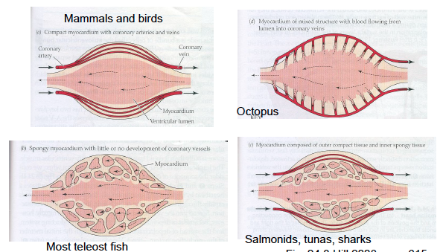
CARDIAC CIRCULATION
- Heart muscle need blood supply
- MAMMALS AND BIRDS
  - Compact myocardium with coronary arteries and veins
- OCTOPUS
  - Blood flowing through the myocardium opens into vessels and drains into or out of the fluid flowing into the heart
- MOST TELEOST FISH
  - Spongy myocardium with little or no development of coronary vessels
- SALMONIDS, TUNAS, SHARKS
  - Myocardium composed of outer compact tissue and inner spongy tissue

ANATOMY: MAMMALIAN HEART
- 4 valves
- 2 A-V valves
- 1 aortic valve
- 1 pulmonary valve
- Systole = period of contraction
- Diastole = period of relaxation
- Oxygenated blood lungs pulmonary veins left atrium left atrioventricular valve left ventricle aortic valve systemic aorta systemic circuit right atrium right A-V valve right ventricle (deoxygenated blood at this point) pulmonary valve pulmonary trunk pulmonary circuit
- SEQUIENCE OF CONTRACTION IS CRITICAL!
  - Important that different parts of the heart contract at the right time – if they don’t, then the heart(?) would rupture
    - Should be conducted in an organized way
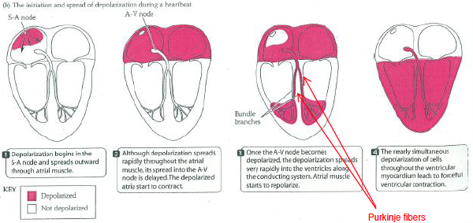
- Depolarization of heart cells originates in SA (sinoatrial) node
  - 1. SA, AV nodes generate action potential and set pace
  - Purkinje fibers, non-contractile, large fast conducting
    - These fibers come from the atrioventricular node and allows for electrical impulse conduction

ELECTROCARDIOGRAM
- Contraction = systole
- Relaxtion = diastole
- Ventricular contraction (systole) results in increased blood pressure
- Isovolumetric contraction – ventricle contracts but there is no change in volume (blood flow)
  - Valves closed, pressure increases in ventricle

INTERACTION OF OXIDATIVE PHOSPHORYLATION AND WORK IN THE HEART, IN VIVO
- At the level of the heart cells themselves, important to think what controls them
- Six things that are important for the smooth operation of cardiac cells
  - 1. Oxygen
  - 2. ATP
  - 3. Creatine P
  - 4. Calcium
  - 5. Adenosine
  - 6. Redox
- If oxygen is not delivered, can’t make ATP at the rate that you need, Many hearts have myoglobin, which is an oxygen store and can smooth out the oxygen flow
- If the amount of ATP available is not sufficient, heart can’t contract properly (must be maintained in steady state)
  - To buffer this, there is a phosphagen (Creatine P) that is a unique isoform that helps to buffer ATP is it drops significantly
- Calcium is used for the muscle contraction cycle, here it is involved in myosin contraction process and regulating some of the mitochondrial enzymes that are used to generate ATP
- Adenosine is a signal that other mechanisms are not working properly
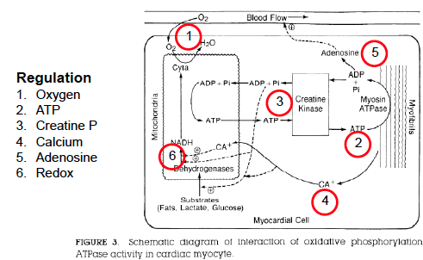
- Redox has to be satisfied continuously, it will be balanced in a steady state

6. COMPARATIVE CARDIAC PHYSIOLOGY
- Cardiac output = heart rate x stroke volume
- ml/min = beats/minute x ml/beat
- BLUE WHALE
  - Mass = 685 kg
  - Heart rate = 12 beats/min
  - Stroke volume = 24 L
  - Cardiac output = 288 L/min
- Because animal size is very variable, the heart has to be able to deal with the issues it may face
  - If you have a high metabolic rate (small animal) the heart has to be able to deal with this and deliver blood to the tissues

BLOOD FLOW
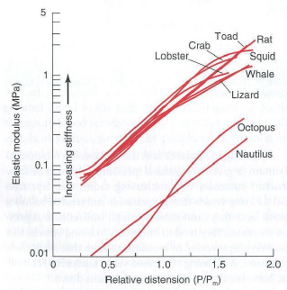
ANATOMY
- Two main groups of the blood vessel
  - The thickness of the arteries depends on where they are – ones closest to the heart tend to be thicker however as we get farther and farther away from the heart, blood pressure is less thus arteries are thinner
  - The venous circulation experiences lower pressures, and therefore doesn’t need to have as thick layers
- Arteries are designed to be elastic to allow for a lot of amino acids in their structure
  - Elastin is important for the arteries for the elasticity
- The graph on the right shows that for a lot of different animals, the elastic properties regarding the artery is very similar (lobster, crab, toad, lizard, etc.)
  - However, octopus to nautilus are not on the line
  - Virtually all aorta is distensible due to the elastin

HEMODYNAMICS
- Resistance the force opposing the flow of blood
- Compliance a measure of the ability of a hollow structure to stretch with an applied pressure
- Arteries usually have a thicker smooth muscle layer than veins of similar diameter
- Large elastic arteries are a “pressure reservoir” that dampens (smooths out) fluctuations in blood pressure
  - Elastic recoil during diastole continues driving blood forward when heart is not pumping
  - REALLY IMPORTANT that arteries are elastic to smooth out the blood flow
- Small muscular arteries increase resistance and decrease compliance
- Arterioles control flow to capillaries by selective vasoconstriction:vasodilation (smooth muscle)
- Venous system is a “volume reservoir”
  - Increased compliance and decreased resistance
- By the time you reach the arterioles and capillaries, the blood pressure reaches mid 30s and continues to drop
  - It is important that the blood pressure be low at the capillaries because they’re only a small number of cells thick
  - It is also really important that the flow slows down when it reaches the capillary bed because that is where all the exchange happens
- As the blood flows from the aorta to the veins, most of the drop in blood pressure occurs in the terminal arteries, arterioles, and capillaries
  - Pulse diminishes when blood flows in the arterioles, so there is no pulse in the capillaries or later vessels
- Relationship between velocity and cross sectional area is inversely proportional
  - The blood slows dramatically as the cross-sectional area of the vasculature increases

HOW IS FLOW CONTROLLED?
- 1. Arteriole radius (vasoconstriction dilation)
- 2. Precapillary sphincters
- 3. A-V anastomoses
- In the capillary bed, there are times where the tissue does not need as much blood
  - You don’t need to perfuse all the blood of the capillary all the time
- Then there are some anastomoses that are short cuts – if they are open or closed, allows for blood flow
  - Convenient if you need full flow or no flow
- Precapillary sphincters act as valves within the capillary when you see that the skin is getting red, that probably means that the sphincters are opening up and letting a lot of the blood flow

CAPILLARY STRUCTURE
- Not all capillaries are the same
- There are 3 main types:
  - 1. Continuous
    - Layer of endothelial cells, and material around it that keeps the capillary in its proper shape
    - The cells tend to be quite tightly close to each other
    - Allows for efficient delivery through the capillary bed
    - Used in muscles, lungs, gonads, brain
  - 2. Fenestrated
    - Have a lot of small holes that allows for fluid to move out of the capillary lumen into the interstitial fluid
    - It may be important to bring hormonal signals to the tissue so that the cells that are on the other side of the interstitial fluid can be signaled
  - 3. Sinusoidal
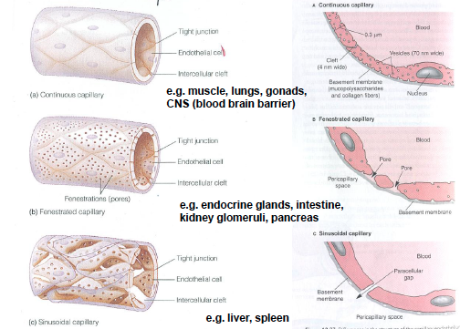
    - Quite large holes in the vessels that allows for anything in the blood, except the cells themselves to move out into the interstitial fluid

EXCHANGES ACROSS CAPILLARY WALLS
- Capillary walls have pores in order to exchange small water-soluble substances and lipid-soluble substances are passed through the endothelial cells
- The size of the pores is such that most of the plasma proteins cannot move through them
  - You don’t want the protein to leave the capillaries

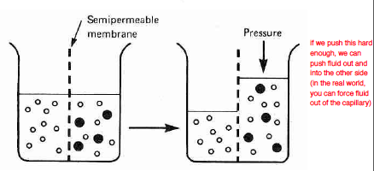
ALBUMIN AND ONCOTIC PRESSURE
- Oncotic pressure = colloid osmotic pressure
- DIAGRAM
  - Generates pressure differential between two sides of the beaker
  - Albumin is the less diffusible component, so they tend to stay on the side where there is less water

THE STARLING-LANDIS HYPOTHESIS
- Blood osmotic pressure is greater than interstitial osmotic pressure because of proteins
- The walls of blood capillaries are fenestrated in most tissues, meaning that they are densely perforated by minute open pores such as gaps between adjacent cells
- Fluid movement occurs readily through these pores
- On the graph, the osmotic pressure difference can be represented as a horizontal line because the losses and gains of fluid are not great enough to change the relative osmotic pressure substantially
- As blood flows along prior to reaching the dashed line, fluid is forced out and it loses volume
  - But thereafter fluid is reabsorbed and it regains volume
- The vertical line shows the extent to which the osmotic pressure of the blood plasma exceeds the osmotic pressure of the extracellular tissue fluid surrounding the capillaries
- The hydrostatic pressure difference shows the extent to which the blood pressure in the capillaries exceeds the hydrostatic pressure in the extracellular tissue fluid surrounding the capillaries
- Capillary has fluid on both sides
  - The mean blood pressure in the capillary is greater than that of the interstitial fluid (green line)
- The capillary is facing the interstitial fluid (which is basically like blood, but lacks protein)
  - Fluid flows out into that, concentrating protein into the capillary, the hydrostatic pressure difference drops which changes the direction of fluid flow
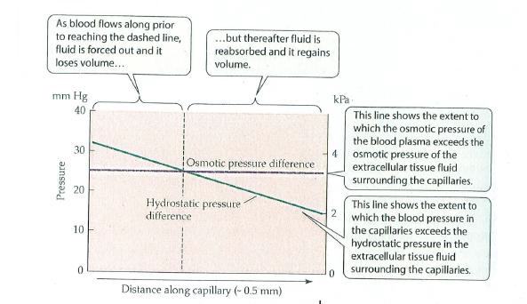

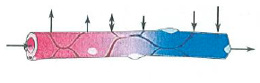
STARLING-LANDIS MODEL
- At the arterial end, the hydrostatic pressure (about 30 mmHg) is greater than the colloid osmotic pressure so fluid leaves
- Hydrostatic pressure falls towards venous side (about 15 mmHg), drops below osmotic pressure difference so net influx of fluid

KWASHIORKOR
- Sufficient calorie intake, but with insufficient protein consumption results in hypoalbuminemia
- Usually the protein that is decreased is albumin
  - If the kidney fails in certain ways, can deplete protein into the urine
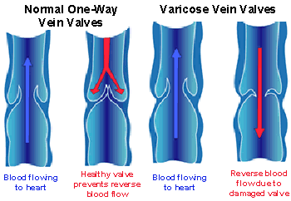
ANATOMY: VEINS
- Veins are more compliant than arteries – they stretch more easily in response to pressure
- How does blood get back to heart?
  - 1. One way valves
  - 2. Skeletal muscle contractions
  - 3. Respiratory movements create pressure gradients in thoracic cavity
- The radii of veins increases as they get closer to the heart, so velocity of blood increases
- VALVES
  - In varicose veins, the valves are damaged
- SKELETAL MUSCLE PUMP
  - When a skeletal muscle contracts it puts pressure on the vein, pushing blood in both directions
    - The resulting pressure opens the proximal one-way valve and closes the distal one-way valve, squeezing blood toward the heart and preventing backflow
  - When the skeletal muscle relaxes, the one way valves are in the opposite configuration
    - The relaxation reduces pressure on the distal valve, which opens and allows blood to flow in
    - Back pressure from the blood in the proximal segment of the vein closes proximal valve, preventing back flow

HEMODYNAMICS: HYDROSTATIC PRESSURE
- What affects pressure?
  - Elevation!
- Above the heart, arterial pressure decreases with height
- Below the heart, fluid-column effects increase the arterial pressure
- FLUID COLUMN EFFECTS
  - For every 13 cm in height, the blood pressure increases every 10 mmHg

EFFECTS OF WEIGHTLESSNESS ON CIRCULATION

WEIGHTLESSNESS
- If you go to space, blood is no longer flowing with gravity, with more pressure flowing into our head
  - Over time, that can be fixed a bit by changing blood volume – however when you come back to earth you have to readapt to the gravity impact on circulatory system
  - Not necessarily lethal, but impacts people in the initial stages going into space
- On earth, fluid accumulated in the lower half of the body
  - Within a few minutes of arriving in a weightless environment, about 2 litres of body fluids migrate to the chest and head
HIGH BLOOD PRESSURE
- Really high blood pressure for giraffes
- Have trouble pumping blood down to head, edema when head down
- Because their head is so high, the pressure could be really low, but the brain is there so it needs a good flow of blood
  - This means that the heart has to have a higher pressure than what we would have in order to maintain a blood pressure to their head
- Because their legs are so long there is a risk of blood pooling when they put their head down in order to drink water
  - There has to be a way in order to keep their head from exploding
  - When they bend down to drink, they separate their legs really widely
- Important animal model revealed that arterial pressure near the giraffe heart is about twice that in humans, to provide more normal blood pressure and perfusion to the brain
  - Skin on legs is thick enough to keep the blood from pooling in the lower extremities
- They have a variety of circulatory adaptations to keep the head from exploding
  - Blood flows into an alternate circulatory bed (rete mirable)
    - Results in a raise in blood vessels to allow blood to flow in a certain pathway, conserve heat, etc.
  - More valves in the veins to prevent the backup of the venous system into the brain
- Giraffes have aout 250 mmHg arterial pressure in the heart, while humans have 100 mmHg
  - This is in order to pump blood to the head

CALCULATE BLOOD PRESSURE OF GIRAFFE
- If head is 2500 mm (2.5 m) above heart
- 250 cm/13 = 19.23
- 19.23 x 10 mmHg = 190 mmHg at heart

GIRAFFE ADAPTATIONS FOR MOVING BLOOD UPHILL
- Larger heart, especially left ventricle
- Tight skin
- Heart beats faster (2x human rate)
- Thicker blood vessels with more CT
- Less permeable capillaries
- Brain retes

