Coulombic Attraction Defects:
 | CO. # | A.P.F. | ATOM/UNIT
S.C. | 6 | 0.52 | 1
B.C.C. | 8 | 0.68 | 2
F.C.C. | 12 | 0.74 | 4
H.C.P. | 12 | 0.74 | 6
$r=\sqrt[1-n]{\frac{A}{nB}}$ $E_{A}=Energy of Attraction$ $\frac{N_{v}}{N}=exp\left[-\frac{Q_{v}}{kT}\right]$
${∆H}_{substitution}={∆H}_{formation}+{∆H}_{migration}$
$E_{A}=-\frac{A}{r}$ $E_{R}=Energy of Repulsion$ $N=ρ×\frac{N_{A}}{A}$ ${∆H}_{interstitial}={∆H}_{migration}$
$E_{R}=\frac{B}{r^{n}}$ $r=interatomic distance$ $N_{v}=\# of defects$ $N=\# of potential sites$
$A,B,n=const.$
Van Der Waal’s $Q_{v}=activation energy \left[J/atom\right]$ Hardness-Tensile Strength
$\%IC=\left\{1-exp⁡\left[-1.25{\left(X_{A}-X_{B}\right)}^{2}\right]\right\}×100\%$ $T=temperature \left[K\right]$ $T_{s}=3.45×BHN [MPa]$
$\%IC=ionic character$ $k=boltzmann^{'}s const.$ $T_{s}=500×BHN [psi]$
$X_{i}=electronegativity of element i$ $→1.38×{10}^{-23}\left[J/{atom∙K}\right]$ Pressure Unit Conversion
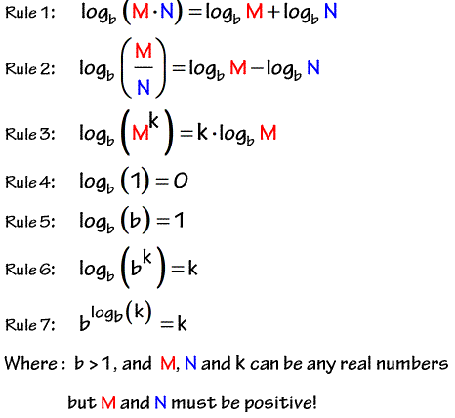
Diffusivity $→8.62×{10}^{-5}\left[eV/atom∙K\right]$ $1 \left[psi\right]=6894 \left[Pa\right]$
$J_{x}=-D\frac{dC}{dx}=-D\frac{C_{2}-C_{1}}{X_{2}-X_{1}} ←Fick^{'}s 1^{st}$ $ρ=density\left[kg/m^{3}\right]$
$\frac{dC}{dt}=D\frac{d^{2}C}{dx^{2}} ←Fick^{'}s2^{nd}$ $N_{A}=avagadro, 6.02×{10}^{23}$
$D=D_{0}exp\left[-\frac{Q_{d}}{RT}\right]$ $A=atomic mass \left[g/mol\right]$
$CONST.=\frac{C\left(x,t\right)-C_{0}}{C_{s}-C_{0}}=1-erf\left[\frac{x}{2\sqrt{Dt}}\right]$ Phase Transformation Homogeneous Nucleation
$erf\left[x\right]=\frac{2}{\sqrt{π}}\int_{0}^{x}{e^{-t^{2}}dt}$ -phases tend toward lower energy level $∆G=\left(Volume\right)\left(∆G_{v}\right)+\left(Surface\right)(γ)$
$C_{x}=\left(\frac{C_{1}+C_{2}}{2}\right)-\left(\frac{C_{1}-C_{2}}{2}\right)×erf\left[\frac{x}{2\sqrt{Dt}}\right]$ -draw line down vertically for % composition $∆G=\left(\frac{4}{3}πr^{3}\right)\left(∆G_{v}\right)+\left(4πr^{2}\right)(γ)$
$C_{x}=concentration @ x$ -inverse lever law for mass fraction of phase $\frac{d∆G}{dr}=0→r^{*}=-\frac{2γ}{∆G_{v}}$ & $∆G^{*}=\frac{16}{3}π\frac{γ^{3}}{{∆G_{v}}^{2}}$ & $∆G_{v}=-\frac{∆H_{f}\left(T_{m}-T\right)}{T_{m}}$
$C_{1}=conc.of higher value$ -$Austenite, γ=0.76 \%C$, FCC $∆G=0→r_{0}=-\frac{3γ}{∆G_{v}}$
$C_{2}=conc.of lower value$ -$Ferrite, α=0.022 \%C$, BCC $I=\frac{dN}{dT}$
$t=time \left[s\right]$ -${Cementite, Fe}_{3}C=6.7 \%C$ $N^{*}=N_{t}×exp\left[-\frac{∆G^{*}}{kT}\right]$
$C_{s}=surface concentration \left[kg/m^{3}\right]$ -$Pearlite=88.9\%α, 11.1\%{Fe}_{3}C$ $v^{'}=s^{*}v×exp\left[\frac{∆H_{d}}{kT}\right]$
$C_{0}=initial concentration \left[kg/m^{3}\right]$ $E_{C}=\%C+\frac{\%Mn+\%Si}{6}+\frac{\%Cr+\%Mo+\%V}{5}+\frac{\%Cu+\%Ni}{15}$ $I=N_{t}s^{*}v×exp\left[-\frac{∆G^{*}+∆H_{d}}{kT}\right]$
$J_{x}=flux in x Dir. \left[kg/m^{2}∙s\right]$ $G=U+pV-Ts$ $I=rate of nuleation \left[atom/s\right]$
$D=diffusion coefficient \left[m^{2}/s\right]$ $G=H-TS$ $N^{*}=\# of critical sized particles$
$C_{i}=concentration \left[kg/m^{3}\right]$ $G=Gibbs free energy$ $∆G=total free energy$
$x_{i}=depth \left[m\right]$ $U=internal energy \left[J\right]$ $∆G_{v}=bulk free energy$
$D_{0}=pre-exponential \left[m^{2}/s\right]$ $P=pressure \left[Pa\right]$ $γ=surface free energy$
$T=temperature \left[K\right]$ $V=volume \left[m^{3}\right]$ $r^{*}=critical radius$
$Q_{d}=activation energy \left[J or eV/mol\right]$ $T=temperature \left[K\right]$ $N_{t}=\# particles per volume \left[\#/Litre\right]$
$R=gas constant$ $S=entropy \left[J/K\right]$ $v^{'}=frequency$
$→8.31 \left[j/mol∙K\right]$ $H=enthalpy \left[J\right]$ $s^{*}=\# liquidous atoms facing nucleus$
$→5.189×{10}^{19} \left[eV/mol∙K\right]$ Pro-Eutectoid % Heterogeneous Nucleation
Avrami Equation ${wt\%}_{i,tot}={wt\%}_{i,pro}+{wt\%}_{i,eut}×{wt\%}_{eut}$ $γ_{αβ}×cosθ+γ_{βδ}=γ_{αδ}←surface tension force balance$
$y=1-e^{-kt^{n}}$ $r=1/{t_{0.5}}$ Phase Transformations (hot↔cold) $∆G=\left(V_{lens}\right)∆G_{v}+\left(A_{lens}\right)γ_{αβ}+\left(A_{circle}\right)γ_{βδ}-\left(A_{circle}\right)γ_{αδ}$
$n=\frac{\ln\left(-\frac{\ln\left(1-y\right)}{k}\right)}{\ln{t}}$ Eutectic: L↔S₁+S₂ $V_{lens}=\frac{πh^{2}\left(3r-h\right)}{3}$ $A_{lens}=2πrh$
$k, n=const.$ $r=transformation rate$ Eutectoid: S₁↔S₂+S₃ $r_{circle}=r×sinθ$ $h=\left(1-cosθ\right)r$
$t_{0.5}=time for 1/2 of rxn$ Peritectic: L+S₁↔S₂ $\frac{d∆G}{dr}=0→r_{hetero}^{*}=-\frac{2γ_{αβ}}{∆G_{v}}$
Converting from Mass to Volume Fraction Peritectoid: S₁+S₂↔S₃ $∆G_{hetero}^{*}=\frac{4}{3}π\frac{γ_{αβ}^{3}}{∆G_{v}^{2}}\left(2-3×cosθ+\cos^{3}θ\right)$
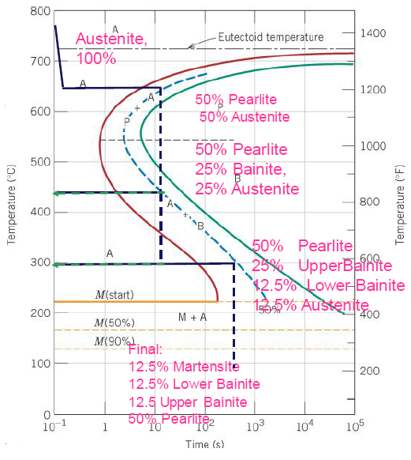
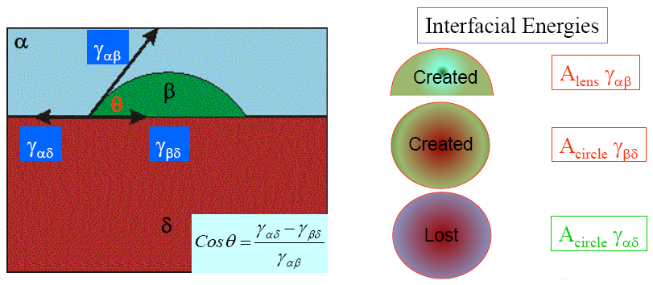
$V_{α}=\frac{{W_{α}}/{ρ_{α}}}{{W_{α}}/{ρ_{α}}+{W_{β}}/{ρ_{β}}} \& W_{α}=\frac{V_{α}×ρ_{α}}{V_{α}×ρ_{α}+V_{β}×ρ_{β}}$ Strength & Ductility $∆G_{hetero}^{*}=\frac{1}{4}∆G_{homo}^{*}\left(2-3×cosθ+\cos^{3}θ\right)$
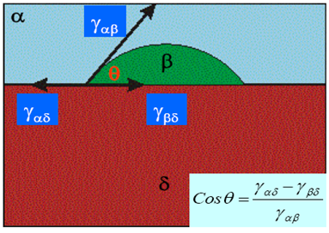
$V_{i}=Volume of element i$ Martensite
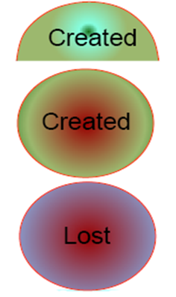
$W_{i}=Weight of element i$ Tempered Martensite
$ρ_{i}=Density of element i$ Bainite
$n_{mi}=\# moles in element i$ Fine Pearlite
$C^{'}=atom\%$ Coarse Pearlite
$C_{i}=Concentration \% of element i$ Spheroidite pearlite
$A=Atomic Weight$ Classification of Steels:
$m_{i}=m_{i}^{'}=mass of element i$ Low-carbon→ <0.25 wt%C
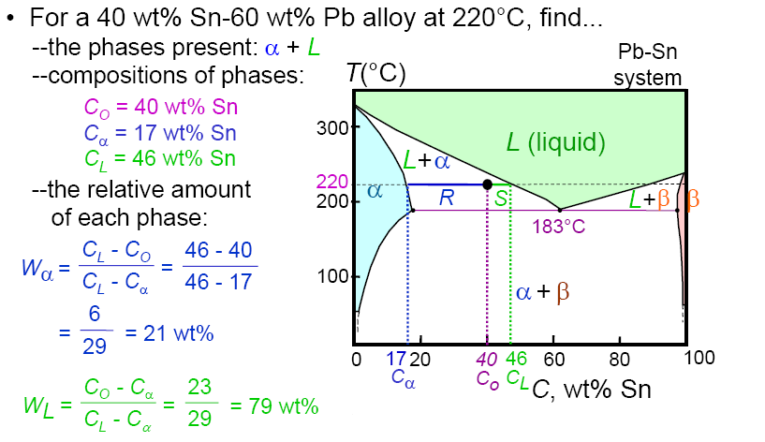
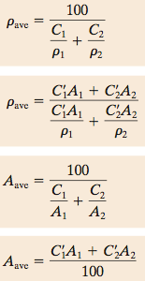
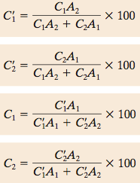
$C_{i}^{''}={mass}/{unit}volume element i$ Med-carbon→ 0.25 ~ 0.60 wt%C
High-carbon→ 0.60 ~ 2.14 wt%C
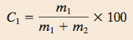

A₁→T_{γ,eut}
A₃→T_{γ,hypo}
A_{cm}→T_{γ,hyper}
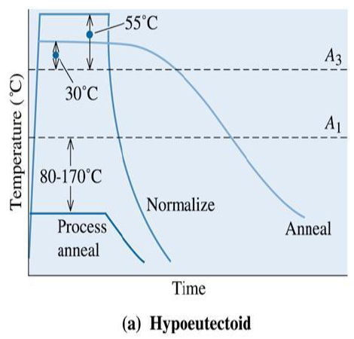
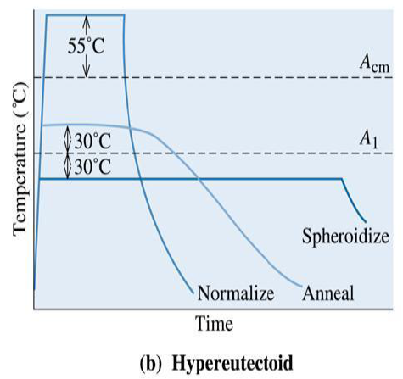

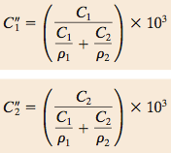

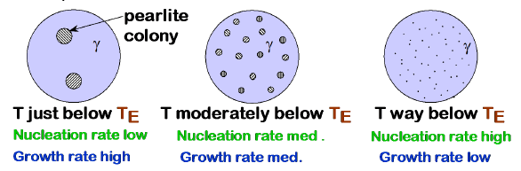

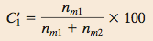

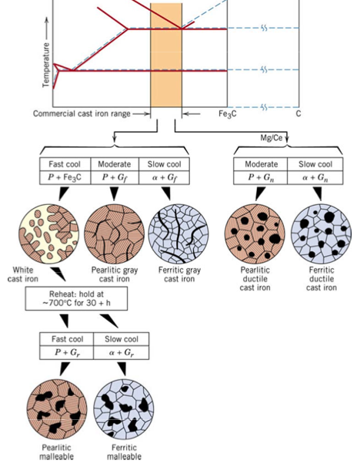

2-3% Si
0.05% Mg

Annealing Furnace Cooling RC15
Normalizing Air Cooling RC30
Quenching Water Cooling RC65
Tempering Heating after quench RC55
Austempering Quench to inter- RC45
mediate temp and hold

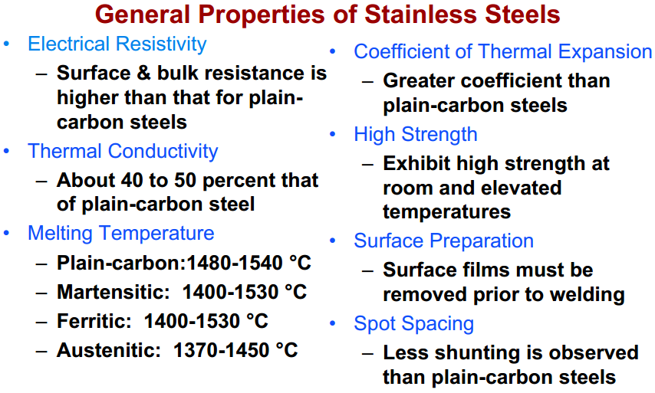
Tips for Design Problems. Notes to self:
Max D = Min HRC @ Center
Max HRC = Min D
Jominy Test just tells cooling rates. Use equivalent length on bottom y axis – it’s easier to match up.
HRC stated: Check Jom. If material does not support HRC, find next best HRC giving material. Are we doing Carburization? You’ll need Cs, SO Then, Austenize Temp (in K)? Find Graph. D_{o,}Qd, (R=8.31) of austenite? Find Chart. Diffusion Eqn to get D. D goes into Fick 2nd Law. Use Erf chart. Result is Cs. Use Carburization Eqn.
A note on word choice in design
problems. “[@x Distance on Bar] IS
#HRC” If [is], use that parameter as
guiding parameter. Look up materials
that match that HRC value.
Oil or water? Oil: Smaller D. Slower Cooling.
Water: Larger D, Faster Cooling.
If water isn’t working out to getting
a min to max HRC: Consider quenching in oil
after about 10mm in equivalent distance when
matching to a min HRC @ center.

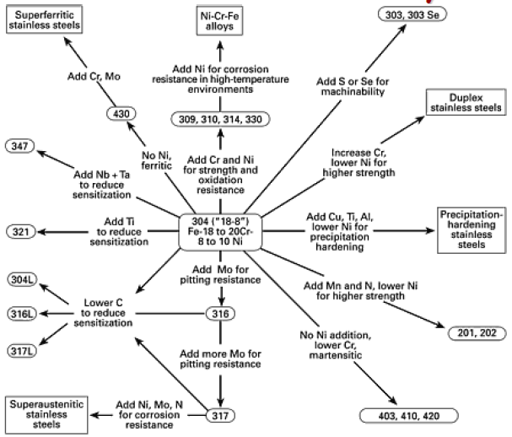

Homogeneous: nuclei of the new phase form uniformly throughout the parent phase
Heterogeneous: nuclei form preferentially at structural inhomogeneities, such as container surfaces, insoluble impurities, grain boundaries and dislocations
Pearlite: Alternating layers of α and Fe₃C.
Bainite: Fine, elongated particles of Fe₃C in a α matrix
Spheroidite: Small spherical Fe₃C particles in a α matrix
Martensite: Martensite is a nonequilibrium single-phase structure that results from a diffusionless transformation of austenite
Tempered Martensite: The microstructural product resulting from a tempering heat treatment of a martensitic steel. The microstructure consists of extremely small and uniformly dispersed cementite particles embedded within a continuous α-ferrite matrix. Toughness and ductility are enhanced significantly by tempering.
Annealing: heat treatment whereby a previously cold-worked metal is softened by allowing it to recrystallize. Full(type): austenitizing, followed by cooling slowly to room temperature. Process(type): Annealing of previously cold-worked products below the eutectoid temperature.
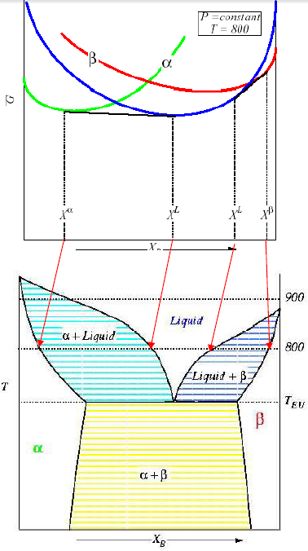
Aging: Precipitate hardening. Artifical: above room temperature. Natural: at room temperature. Overaging: aging beyond the point at which strength and hardness are at their maxima.
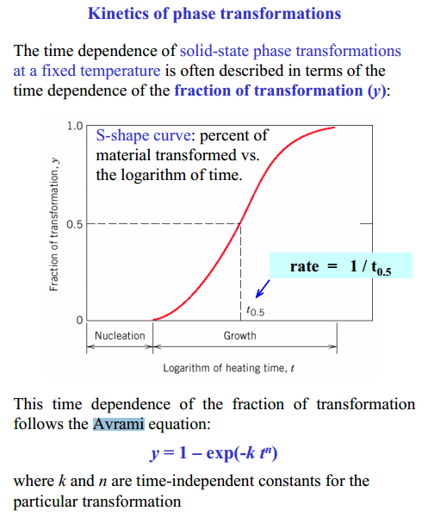
Hardenability: For precipitation hardening, aging above room temperature.
Normalizing: For ferrous alloys, austenitizing above the upper critical temperature, then cooling in air. The objective of this heat treatment is to enhance toughness by refining the grain size.
Free Energy: A thermodynamic quantity that is a function of both the internal energy and entropy of a system. At equilibrium, the free energy is at a minimum.
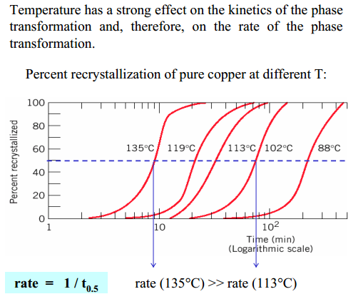
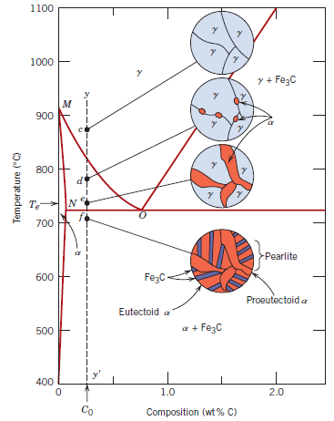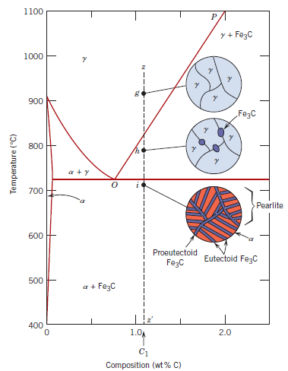

Exam: 190 marks:
First part a lot of definitions. most definitions were found from the formula sheet.
-Define hardenability.
-List 5 major groups of steels.
-Define spheroidization
-Martempering.
-Austempering.
-Plot the normalization, annealing, spheroidization graph for Hypo and HyperEutectic.
-Know the phase transition definitions: Eutectic, eutectic, peritectic refer to the 1st page of the formula sheet.
-Rank ductility of given materials, some may not actually be listed in the given graphs during the exam. Will have to know from knowledge of carbon content in a material and
how it affects the material’s properties.
Long answer questions:
-Plot and compare the hardness profile of two materials (Think it was 4140 and 1040). Basically draw the plot with 0mm in the center of the bottom axis, and the radius distance on each side.
-Find mass concentration of an unknown material given the ductility, and or yield strength, and or elongation.
-Case study on material selection with Jominy HRCs at certain locations (ex: 0.2mm below surface, need 65 HRC)
Tips:
-There didn’t seem to be any emphasis on nucleation.
-Definitely understand Jominy graph and material hardness graphs.
-Work quickly as there is JUST enough time to get through it all (assuming you know it all).
-The case study took up the most amount of marks in the exam. (40 marks), so definitely understand ALL the practice examples in the Diffusion section of this course.
-Know all the scenerios of moving in the graph of the ‘nose’ thing. The thing with the Temperature VS time. How if you get into the NOSE, it’s like A+P which is 50% austenite, 50% pearlite, then if you move within the nose again at a different temperature it’s like 50% pearlite, then becomes 25% austenite and 25% Bainite or w/e.

Note, this provided Formula sheet is provided AS IS. It’s up to you to verify what’s on it young grasshopper…
Good luck. This course is basically how well you know the practice examples. THE ASSIGNMENTS WON’T ACTUALLY HELP YOU AS MUCH AS YOU THINK THEY WOULD FOR THE MIDTERM. DO THE PRACTICE EXAMPLES FROM THE CLASS AND KNOW THEM LIKE YOU KNOW WHERE YOUR BELLY BUTTON IS. (Unless you are a clone).

