UNIT ONE: Reasoning and Critical Thinking
Part One
Readings: CT, Chpt. 1 & Additional Concepts
YouTube: Darth Vader Cell Phone Ad
START READING THE REPUBLIC!!
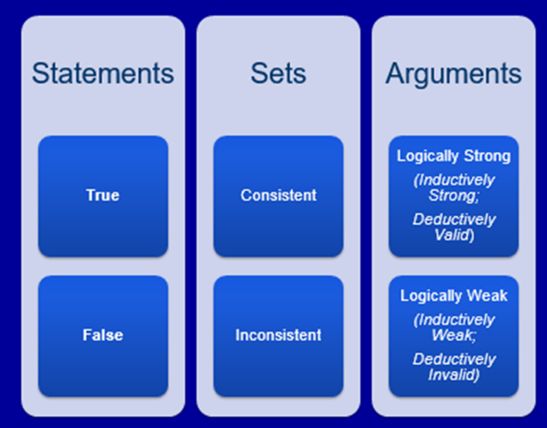
Note: The last topic on the Additional Concepts sheet, “Counterexamples to Deductive Arguments” is something we will get to later in the term.
The Basic Concepts of Critical Thinking “The Philosopher’s Toolbox”
Logical Concepts and their Respective Properties
“What is in the philosopher’s toolbox?”

Statements
- The most basic concept of critical thinking is that of the statement. * Know definitions well
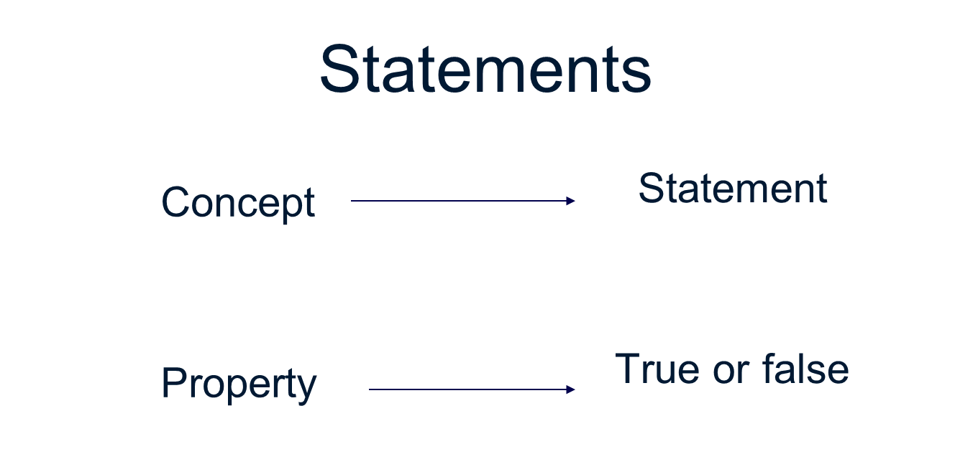
- Definition: A statement is a sentence used to make a claim. Statements are capable of being either true or false.
- Logic also calls them assertions or propositions. (Statement could be called assertions)
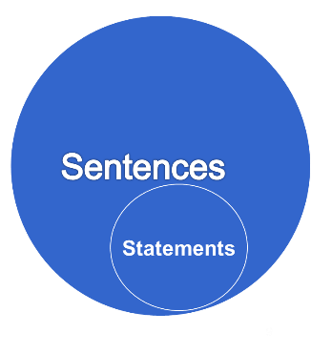
- Logicians only study statements
- This property of being either true or false distinguishes statements from sentences which are not capable of being either true or false: commands, questions and expressions of volition (wishes).

Examples

Proposition: Socrates is a man.*
Command: Be a man, Socrates.

Question: Is Socrates a man?
Expression of Volition: Oh, that Socrates were a man.

Two Laws of Logic
- This property of being either true or false brings us to two fundamental laws of logic.
- The Law of Non-Contradiction
- The Law of the Excluded Middle or the Law of Bivalence
- Let’s use two simple propositions as an example.
- Socrates is a man Proposition
- Socrates is not a man Negation of that Proposition
- First, a Little Shorthand …
- For the sake of clarity and brevity, logicians and philosophers sometimes like to represent statements with symbols.
- They find it convenient to represent statements with letters such as a, b, c or p, q, r.

Socrates is a man. p
Socrates is not a man not-p (can also be written ~p or -p)
Tilde p
Example
Symbolize the following:
Lassie is a dog. p
Lassie is not a dog.not-p

The Law of Non-Contradiction

What would you Say?
Student: Professor, did I pass the test?
Professor: Yes, you did pass the test.
Student: I passed the test?
Professor: No, you did not pass the test.
Student:????
Professor: You did pass the test, and you did not pass the test.

- In other words, at one and the same time, one cannot truthfully both assert and deny that something is the case.
- One cannot assert both p and not-p at the same time.
- Contradictions (p and not-p) cannot be true.
- The sentences we are dealing with obey what is known as the Law of Non-Contradiction.
- This law states that it is impossible for both a proposition and its negation to be true at the same time.
- In other words, at one and the same time, one cannot truthfully both assert and deny that something is the case.
- One cannot assert both p and not-p at the same time.
- Contradictions (p and not-p) cannot be true.

The Law of the Excluded Middle or the Law of Bivalence
- This logical law states that every proposition must be either true or false. In other words, any middle position between truth and falsity is excluded. (There is no in between )(Head of Tails)
- It follows from this law that for any given proposition and its negation, one must be true and the other one false. If a proposition is true, its negation must be false. If a proposition is false, its negation must be true.
- If “Socrates is a man” is true, then its negation, “Socrates is not a man,” must be false
- If p is true, not-p must be false.
- If “Lassie is a dog” is true, then “Lassie is not a dog” must be false.

Consistency
Sets
Propositions can be combined in groups or sets.

- Socrates is mortal.
- Socrates is a philosopher.
- Lassie is a dog.
- Lassie is brave.

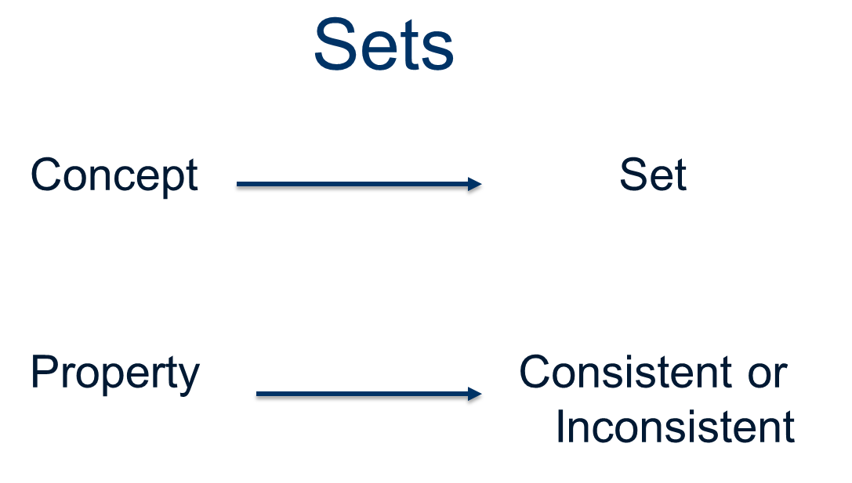
- While propositions are either true or false, sets of propositions are consistent or inconsistent.

- It is very important to understand that consistency does not imply that all or any of the sentence in a consistent are in fact true
- Definition: A set of propositions is consistent if and only if it is possible for all of the propositions in that set to be true at the same time. In another words, a set of propositions is consistent if these propositions do not contradict one another.

Examples

Socrates is mortal.
Socrates is a philosopher.
Lassie is a dog.
Lassie barks.

These sets of propositions are consistent because it is possible for their members to be true at the same time.

Example
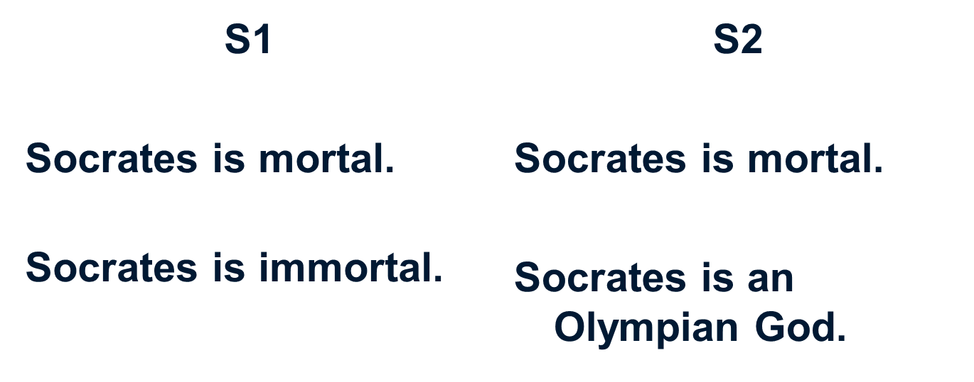
The following sets of propositions are inconsistent because they contain a contradiction. In other words, it is not possible for their members to be true at the same time.

- Two false statements can be consistent, as in the following example.
- Examples
- Socrates is immortal.
- Socrates is an Olympian God
- To logically evaluate a set of propositions as consistent is only to see that it is possible for them to be true at the same time, not that they are actually true.

Inference
- Sometimes our thoughts merely come to us one after another.
- They are not really linked to one another.

Example #1
- Socrates is a man.
- Socrates went for a walk.
This is just a set of propositions.

Example # 2
Ollie is a cat.
Ollie is asleep.
This is just a set of propositions.

Inference
- Suppose that I notice a particular relation, a logical relation, between my thoughts.
- I see that one thought provides support for another thought or makes it reasonable to believe that another thought is true.
- In this case, the second thought follows from the first thought. My thoughts no longer simply come together, I actively link them.

Example # 1
- Socrates is a man. Socrates is mortal.
We can see a logical relation between these propositions.
- Socrates is a man. Therefore, Socrates is mortal.

Example # 2
- Ollie was out all night. Ollie is tired.
- Since Ollie was out all night, Ollie is tired.

Inference
- The penny drops, so to speak, the light goes on.
- We see a logical relation between thoughts.
- We draw an inference.
- Inference: A logical relationship between thoughts.
- How can we define this relationship?
Definition: Inference is a relationship between two thoughts that occurs when one thought supports or justifies or makes it reasonable to believe another thought.

Inference indicators:
Since, thus, implies, consequently, because, it follows that, given that

