LECTURE #2

Current Assets are expected to be turned into cash within one year or one operating cycle

Listed in order of liquidity: reverse order is also possible

Non-current assets: not expected to be turned into cash within one operating cycle
Ex. Long-term investments, property, plant, and equipment, intangible assets and goodwill

Long Term Investments:
Ex. debt securities, loans, notes, bonds, mortgages. These assets are normally not intended to be sold within the next year

Tangible assets are used for the business in the long run such as land, buildings and equipment

Depreciation: allocation of the purchase price of property, plant, and equipment over their estimated useful lives

  - Companies systematically assign a portion of the cost of an asset to expense each year
  - Under IFRS, this allocation is referred to as depreciation for property, plant, and equipment, and amortization for intangible assets
  - Under ASPE, amortization is often used instead of depreciation

Some assets do not depreciate, ex land

Accumulated depreciation account shows the total amount of depreciation taken to date

The difference between the cost of the asset and its accumulated depreciation is referred to as the carrying amount of the asset

Intangible Assets – non current assets that do not have a physical substance and represent a privilege or a right held by the company

Examples: Patents, copyrights, trademarks, licenses

Goodwill: excess price paid on the acquisition of another company (hidden assets)

Generate a future value to the company

Current Liabilities: obligations that are to be paid within the coming year or operating cycle
Examples: bank indebtedness, accounts payable, accrued liabilities, bank loan/notes payable. Current maturities of long-term debt
Non-Current Liabilities: debts expected to be paid or settled after one year
Examples: bank loan/notes payable, lease obligations, pension and benefit obligations, deferred income tax liabilities

Usually accompanied by extensive notes to financial statements

Shareholder’s Equity

Share Capital: investment of cash (or other assets) in the company by shareholders in exchange for preferred or common shares

Retained Earnings: Cumulative profits kept for use in the company

-Specific tools can be used to analyze the financial statements
-Ratio analysis expresses the relationships between selected financial statement data
-Use comparisons to aid in analyses:
  - Intracompany comparisons cover two or more years for the same company
  - Intercompany comparisons between the company and a competitor
  - Industry average comparison based on averages for the particular industry

Liquidity Ratios: measure a company’s short-term ability to pay its obligations that will come due within the next year (higher values are generally better)

Working Capital = Current Assets – Current Liabilities

Current Ratio = Current Assets
Current Liabilities

Solvency Ratios: measure a company’s ability to survive over a long period of time
- the higher the percentage of debt to total assets, the greater the risk that debts cannot be repaid when they are due (lower values are generally better)

Debt to Total Assets = Total Liabilities
Total Assets

Profitability Ratios: measure a company’s operating success for a given period of time (higher values are generally better)

Earnings per share = Profit available to common shareholders
Weighted average number of common shares

Price-earnings ratio = Market price per share
Earnings per share
Objective of Financial Reporting: to provide financial information that is useful to existing and potential investors, lenders and other creditors

Who are making decisions about providing resources to a company:
-buying, selling, holding equity and debt
-providing or settling loans or other credit

Qualitative Characteristics of Accounting Information:

- Relevance:
  - Information has relevance if it makes a difference in users’ decisions
  - May have predictive value and/or confirmatory value
  - Materiality is important: will information influence the decisions of users?
- Faithful representation:
  - Information should reflect economic reality
  - It must be complete, verifiable and free from material error
a
Enhancing Qualities of Useful Information

- Comparability:
  - Users can identify and understand similarities and differences in items
- Verifiability:
  - Independent consensus that information is faithfully represented
- Timeliness:
  - Available before it loses its usefulness in decision-making
- Understandability:
  - Classified, characterized and presented clearly and concisely

Cost Constraint: ensures that the value of the information provided by financial reporting is greater than the cost of providing it
- The benefits of financial reporting should justify the costs of providing and using it

Going Concern Assumption

- The business will continue operating in the foreseeable future
- The key assumption – provides a foundation for accounting
- Provides justification for using cost as the value of certain assets

Measurements of the Elements of a Financial Statement

- Accountants have developed principles that describe when and how the elements of financial statements should be:
  - Recognized, Measured, and Reported
- Known as generally accepted accounting principles
Generally Accepted Accounting Principles

- Historical cost:
  - Assets and liabilities should be recorded at their cost when acquired
  - Not only at time of purchase, but throughout the life of each asset and liability
- Fair value:
  - Certain assets and liabilities should be recorded and reported at fair value
- In choosing between these two, apply the concepts of relevance and representational faithfulness

LECTURE #3

Accounting Transactions

- Accounting information system:
  - The system of collecting and processing transaction data and communicating financial information
- Can vary widely based on factors such as:
  - Type of business and its transactions
  - Size of company
  - Amount of data
  - Information requirements

- An individual accounting record of increases and decreases in a specific asset, liability, or shareholders’ equity item
- Three parts:
  - The title of the account
  - A left or debit side
3) A right or credit side

Debits and Credits
- Describe where entries are made in the accounts:
  - Debiting: entering an amount on the left side of the account
  - Crediting: entering an amount on the right side of the account
- If debit amounts exceed credit amounts, account has a debit balance
- If credit amounts exceed debit amounts, account has a credit balance

Assets = Liabilities + Shareholders’ equity

- Assets (left side of the equation) increase with debits (left hand entries) and decrease with credits
- Liabilities and Shareholder’s equity (right side of the equation) increase with credits (right hand entries) and decrease with debits
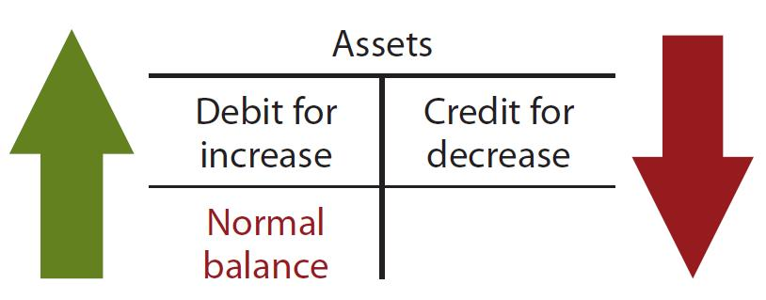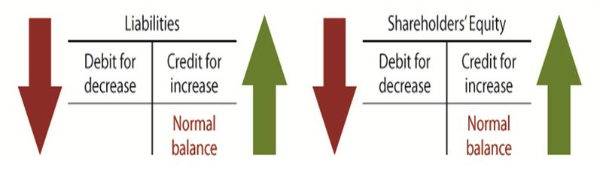

Step 3 of Accounting Cycle: General Ledger

- Entire group of accounts maintained by a company
  - List of accounts is called a chart of accounts
- Contains all the asset, liability, and shareholders’ equity accounts
- Posting is the process of transferring information from the general journal to the general ledger accounts

Step 4 of Accounting Cycle: Trial Balance

- List of all the accounts and their balances at a specific time
- Serves to prove the mathematical equality of debits and credits after posting
Sum of debits = sum of credits
- Aids in the preparation of financial statements

LECTURE #4

- Companies need immediate feedback on how well they are doing
- Accounting divides the economic life of a business into artificial time periods
Month, quarter, year
Many transactions affect more than one time period

Accrual Basis of Accounting

- Transactions affecting a company’s financial statements are recorded in the period the events occur, rather than when cash is received or paid
Revenue is recorded when earned, rather than when cash is received
Expenses are recorded when goods or services are consumed, rather than when cash is paid

Cash Basis of Accounting

- Revenue is recorded only when cash is received
- Expenses are recorded only when cash is paid
- Can lead to misleading financial statements:
Revenue and expenses can be manipulated by timing the receipt and payment of cash
Can increase or decrease profit

Revenue Recognition

- Revenue is recognized when:
Sales or performance effort is substantially complete
Amount is determinable (measureable)
Collection is reasonably assured
- In a merchandising company:
When merchandise is sold (point of sale)
- In a service company:
When the service is performed

Revenue is recorded when earned:
Phone company (per second)
Cash/Accounts Receivable $500
Revenue $500
Small convenience store (per transaction)
Cash/Accounts Receivable $500
Revenue $500

Expense Recognition

- Expenses are recognized when:
Due to ordinary activity, a decrease in future economic benefits occurs
Related to a decrease in an asset or an increase in a liability
It can be measured reliably
- Tied to changes in assets and liabilities
- Often (but not always) coincides with revenue recognition

Illustration – Expense Recognition

- Rent payment ($200)
- Employee salaries payment ($600)
- Legal fees ($300)
All these items represent consumption of goods or services due to ordinary activity of the company. They will be related to a increase in a liability (e.g.: payable) or decrease in an asset (e.g. : cash)

Expenses are recorded when goods or services are consumed:
Rent expense $200
Cash/Liability $200
Salary expense $600
Cash/Liability $600
Legal expenses $300
Cash/Liability $300

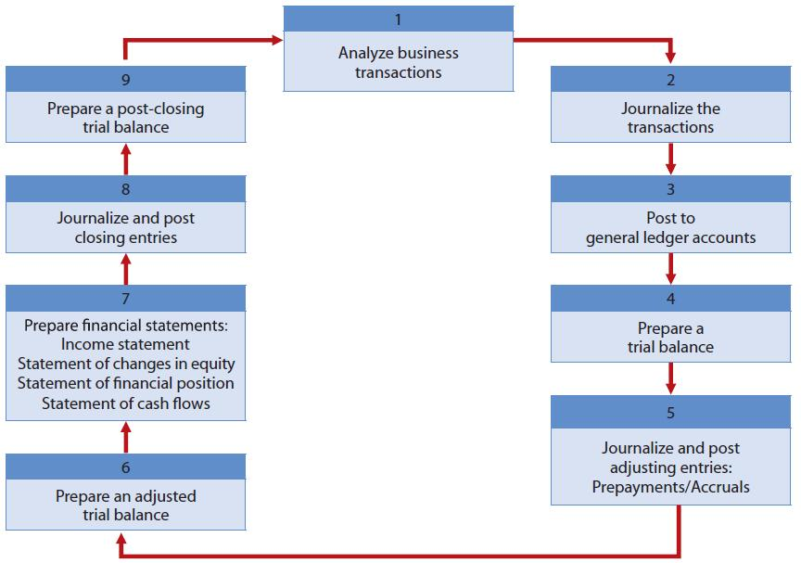
Adjusting Entries

- Adjusting entries are made to adjust or update accounts at the end of the accounting period
- Required because the trial balance may not contain complete and up-to-date data
Some items are not recorded daily
Some costs are not recorded during the accounting period, as they expire due to the passage of time
Some items may be unrecorded

Types of Adjusting Entries

- Prepayments
Prepaid expenses
Unearned revenues
- Accruals
Accrued revenues
Accrued expenses

Prepaid Expenses

- Costs that are paid for in cash before they are used
When the cost is incurred, an asset (prepaid) is increased (to show the future service or benefit) and cash is decreased
- Expire with the passage of time (e.g.: prepaid rent) or through use (e.g.: PP&E)
Not practical to record this expiration on a daily basis, so done when statements are prepared
- Adjusting entry increases an expense account and decreases the asset (prepaid) account

Prepaid Expense Illustration

A company prepares its Financial Statements on May 31, 2014.
- On May 1st 2014 the Company renewed it’s insurance coverage by paying $12,000 premium on a one-year insurance policy.
Required: Prepare the Adjusting entries at May 31, 2014

Journal entries at May 31, 2014:
1) Insurance expense $1,000
Prepaid insurance $1,000
(To record insurance expense for May 2014)

Unearned Revenue

- Cash that has been received before revenue is earned
When the cash is received, a liability account (unearned revenue) is increased and cash is increased
- The opposite of prepaid expenses
- Adjusting entry decreases the liability (unearned revenue) account and increases a revenue account
Reflects the amount of revenue earned in the period and the remaining liability at the end of the period

Accruals

- Accruals have not been recognized at all until an adjustment is made
- Revenues that have been earned, but not received in cash or recorded (accrued revenues)
Adjusting entry results in an increase to both an asset and a revenue account
- Expenses that have been incurred, but not yet paid or recorded (accrued expenses)
Adjusting entry results in an increase to both an expense and a liability account

Accrued Revenue Illustration

A company prepares its Financial Statements on May 31, 2014.
- Revenues of $500 were earned during the period but not yet billed to the client (revenue usually booked with supporting documents but invoice is not yet sent).
Required: Prepare the Adjusting entries at May 31, 2014

Journal entries at May 31, 2014:
1) Accounts receivable $500
Revenue $500
(To record revenue earned at May 31, 2014)
A company prepares its Financial Statements on May 31, 2014.
- Employees were last paid May 23, 2014 and have worked 5 days since then. Salaries for 5 days represents $1,000 for all employees.
Required: Prepare the Adjusting entries at May 31, 2014
Journal entries at May 31, 2014:
1) Salary expense $1,000
Salary Payable $1,000
(To record salary earned at May 31, 2014)-
Picture below is a summary of basic relationships

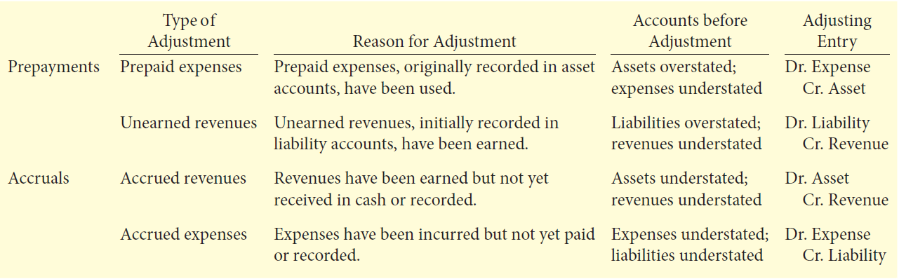
Adjusted Trial Balance
Figure 1 Summary of Accounting Cycle
- Prepared after all adjusting entries have been jounalized and posted
- Shows the balances of all accounts at the end of the accounting period
Including those accounts that have been adjusted
- Proves the equality of total debit balances and total credit balances after the adjusting entries have been made
- The main source for preparation of financial statements

Closing the Books

- Revenue and expense accounts are subdivisions of retained earnings
Considered to be temporary accounts
- Statement of financial position accounts carry forward into the future
Considered to be permanent accounts
- Closing entries
Temporary account balances are transferred to Retained Earnings
Produce a zero balance in the temporary accounts to prepare them for the next period’s activity

Temporary and Permanent Accounts
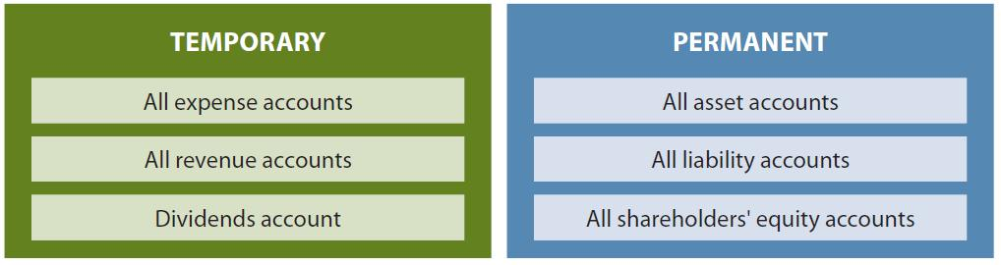

The Closing Process (4 Steps)

- Close revenue accounts:
Debit each revenue account for its balance and credit Income Summary
- Close expense accounts:
Debit Income Summary and credit each expense account for its balance
- Close Income Summary:
Debit (or credit) Income Summary for the balance in the account and credit (debit) Retained Earnings
- Close Dividends account:
Debit Retained Earnings and credit Dividends account for the balance

The Closing Process Illustrated
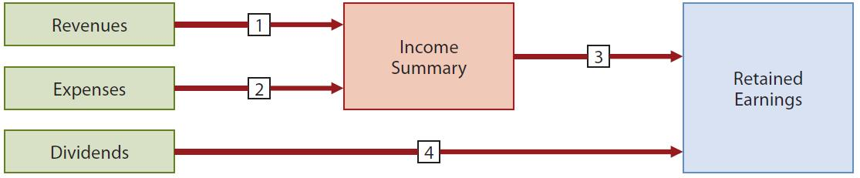

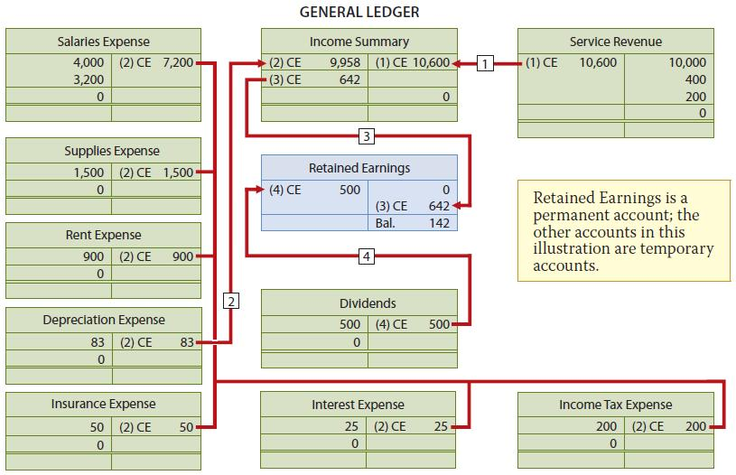
Post-Closing Trial Balance

- Lists all permanent accounts and their balances
After all closing entries are journalized and posted
- Proves the equality of total debit balances and total credit balances after the closing entries have been made

Other Comprehensive Income (OCI) and Accumulated Other Comprehensive Income

- For companies reporting under IFRS only
Companies reporting under ASPE do not recognize OCI
- May have complex items that determine OCI rather than profit
Similar to revenues and expenses
- Items in OCI plus profit = comprehensive income



