ASSIGNMENT # 1
FORECASTING and AGREGATE PLANNING

A group of minimum of two (2) and maximum of three (3) students must submit their assignment. Students must work in groups. No individual assignment is allowed unless approved by the professor.

Students are reminded that submitted assignments must be neat, readable, and well-organized. Assignment marks will be adjusted for sloppiness, poor grammar and spelling, as well as for technical errors. Plagiarism on assignments will not be accepted, each student must sign the statement of integrity.

E-mail questions related to the assignment should be sent to the Teaching Assistant or posted on the Blackboard Learn course website “Discussion Area” (viewed by all).

Section A: Hardik Chheda (hchhe073@uottawa.ca )
Section B: Matthew Masaro (masa068@uottawa.ca )
Section C: Nicolas Legendre (nlege038@uottawa.ca )
Section D: Hassan Kiyani (hkiya045@uottawa.ca )

Problem # 1
National Mixer, Inc. sells can openers. Monthly sales can openers for seven-month periods were as follows:
Sales
Month (000 units)
February 19
March 18
April 15
May 20
June 18
July 22
August 20

- Plot the monthly data.

- Forecast September sales volume using each of the following:
    - A linear trend equation. (use regression analysis)
    - A Four-month moving average.
    - Exponential smoothing with a smoothing constant equal to 0.1, assuming a February forecast of 19(000).
    - The naïve approach
    - A weighted average using 0.2 for August, 0.6 for July, and 0.20 for June.

- Which method seems least appropriate? Why?
Problem # 2
Bus and Subway ridership for the summer months in London, England, is believed to be tied heavily to the number of tourists visiting the city. During the past 12 years, the following data have been obtained:
Year  (summer months) | Number of Tourists  (in millions) | Ridership  (in millions)
1 | 7 | 1.5
2 | 2 | 1.0
3 | 6 | 1.3
4 | 4 | 1.5
5 | 14 | 2.5
6 | 15 | 2.7
7 | 16 | 2.4
8 | 12 | 2.0
9 | 14 | 2.7
10 | 20 | 4.4
11 | 15 | 3.4
12 | 7 | 1.7

- Plot these data and decide on an appropriate model to predict the ridership for the summer months (Justify briefly your answer).
- What is the expected ridership if 10 million tourists visit London in a year? (Show your work).
- Explain the predicted ridership if there is no tourists at all. Would you place much confidence in such a forecast? (justify your answer)
- What are the model’s standard error, correlation coefficient and coefficient of determination?

Problem # 3

Period (DAY) | Number Served | Period (DAY) | Number Served
1 | 80 | 15 | 94
2 | 75 | 16 | 87
3 | 78 | 17 | 93
4 | 95 | 18 | 106
5 | 130 | 19 | 145
6 | 136 | 20 | 150
7 | 40 | 21 | 49
8 | 87 | 22 | 102
9 | 82 | 23 | 97
10 | 85 | 24 | 113
11 | 99 | 25 | 103
12 | 130 | 26 | 159
13 | 140 | 27 | 159
14 | 47 | 28 | 58
Given the date above use Excel to answer the following questions:
- Plot the daily data of the number of customers served for the evening meal, which forecasting method would you recommend and why?

- Use the multiplicative decomposition model discussed in class and NOT in the book, to calculate the seven seasonal indices (Hint: Use a seven-day centered moving average), and the intercept and slope of the trend component (Hint: deseasonalize the data, fit an appropriate model to the deseasonalized data). Fill in the table below (Include three decimal points).

Seasonal Indices (Day)
1
2
3
4
5
6
7
Intercept
Slope

- Using the multiplicative decomposition model, is the forecast of period 1 to 28 performing adequately? Justify your answer.

- Using the multiplicative model, forecast the “Number Served” for the next two weeks (e.g. forecast the “Number Served” for period 29 to period 42). Show calculation.

Problem # 4

The classified department of a monthly magazine has used a combination of quantitative and qualitative methods to forecast sales of advertising space. The forecast errors over a 20-month period are as follows:

Month |  | Error |  | Month |  | Error
1 |  | -8 |  | 11 |  | 1
2 |  | -2 |  | 12 |  | 6
3 |  | 4 |  | 13 |  | 8
4 |  | 7 |  | 14 |  | 4
5 |  | 9 |  | 15 |  | 1
6 |  | 5 |  | 16 |  | -2
7 |  | 0 |  | 17 |  | -4
8 |  | -3 |  | 18 |  | -8
9 |  | -9 |  | 19 |  | -5
10 |  | -4 |  | 20 |  | -1
- Using the first half of the data (period 1 to period 10), calculate the upper and lower control limits for the control chart with 2 σ limits.

- Construct the control chart with 2 σ limits and plot ONLY the last 10 errors on it. Are the errors random? What is the implication of this?

Problem # 5

K. Cunningham Health and Beauty Products, has developed a new shampoo and you need to develop it aggregate schedule. The cost accounting department has supplied you the costs relevant to the aggregate plan and the marketing department has provided a four quarter forecast. All are shown below.

Associated information is:

Previous quarter’s output 1,500 units
Beginning inventory 200 units
Costs for backorders $50 per unit
Inventory holding cost $10 per unit for every unit held at the end of the quarter
Hiring workers $40 per unit
Firing workers $80 per unit
Unit Cost $30 per unit
Overtime $15 extra per unit
Subcontracting Not available

Your job is to develop an aggregate plant for the next four quarters.

- First, you try a chase plan by hiring and firing as necessary to meet the forecast.

- Then you try a plan that holds employment steady (e.g. level strategy)

- Which is the more economical plan for K. Cunningham Health and Beauty Products?

Problem # 6

A company produces a variety of recreation and leisure products. The production manager has developed an aggregate forecast:

Month | Mar | Apr | May | Jun | Jul | Aug | Sept | Total
Forecast | 50 | 44 | 55 | 60 | 50 | 40 | 51 | 350

Use the following information to develop aggregate plans:

Regular production cost $80 per unit
Overtime production cost $120 per unit
Regular capacity 36 units per month
Overtime capacity 12 units per month
Subcontracting cost $140 per unit
Subcontracting capacity 12 units per month
Holding cost $10 per unit per month
Back order cost $20 per unit per month
Beginning inventory 0 unit
Desired ending inventory in September: 0 unit (and not backlog)

Develop an aggregate plan using the transportation method, states the production schedule and its corresponding cost.

Source:
Problem 1, Problem 4, Problem 5, and Problem 6: Stevenson, W.J. and Hojati, C. 2011. Operations Management (4th Canadian edition). McGraw-Hill/Ryerson. Mass. 741p.

Problem 2: J. Heizer and B. Render; Operations Management, 10th edition, Prentice Hall, 2010

Problem 3: Hillier, Frederick S., Mark S. Hillier 2007. Introduction to Management Science: A Modeling and Case Studies Approach with Spreadsheets. (3rd ed.). McGraw-Hill/Irwin. New York. 602p.

Solution:

Problem # 1

- Plot the monthly data.

- Forecast September sales volume using each of the following:
- A linear trend equation. (use regression analysis)
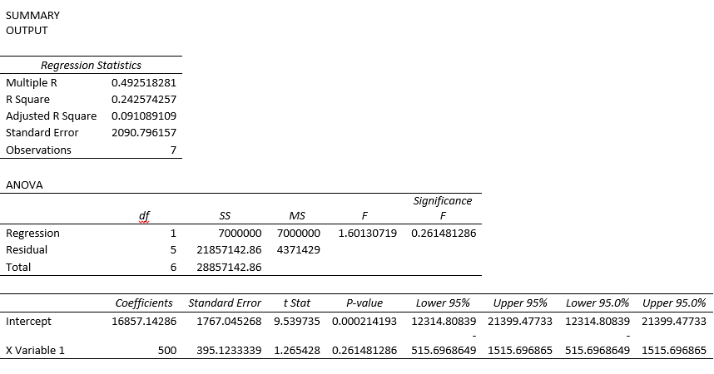

The forecast for September using linear trend equation from excel is 20,857.14286 units.

- A Four-month moving average.
The forecasted September sales volume using four-month moving average = (20k+18k+22k+20k)/4 = 20,000

- Exponential smoothing with a smoothing constant equal to 0.1, assuming a February forecast of 19(000).
1 | February | 19000 | 19000 |  | 0
2 | March | 18000 | 19000 |  | -1000
3 | April | 15000 | 18900 |  | -3900
4 | May | 20000 | 18510 |  | 1490
5 | June | 18000 | 18659 |  | -659
6 | July | 22000 | 18593.1 |  | 3406.9
7 | August | 20000 | 18933.79 |  | 1066.21
 |  |  | 19040.41
The forecast for September using exponential smoothing is 19,040.41.

- The naïve approach

The forecast for September using naïve approach is 20,000.

- A weighted average using 0.2 for August, 0.6 for July, and 0.20 for June.

The forecast for September using weighted average
= 0.2(20k)+0.6(22k)+0.2(18k) = 20,800

- Which method seems least appropriate? Why?

A weighted average seems least appropriate method because it requires much historical data and it does not forecast trend well. Moreover, the weights are not appropriately used. The most recent periods usually have heavier weights, where in this case, July is not the most recent period in the question and has the most of the weights.

Problem # 2

- Plot these data and decide on an appropriate model to predict the ridership for the summer months (Justify briefly your answer).

Series 2: Number of Tourists (in millions)
Series 3: Ridership (in millions)

A linear regression model would be appropriate because the technique fits a straight line to a set of points to describe the relationship between two variables.

- What is the expected ridership if 10 million tourists visit London in a year? (Show your work).
1 | 7 | 1.5 | 1.6211 | -0.1211 | 0.1211 | 0.0147
2 | 2 | 1 | 0.8246 | 0.1754 | 0.1754 | 0.0308
3 | 6 | 1.3 | 1.4618 | -0.1618 | 0.1618 | 0.0262
4 | 4 | 1.5 | 1.1432 | 0.3568 | 0.3568 | 0.1273
5 | 14 | 2.5 | 2.7362 | -0.2362 | 0.2362 | 0.0558
6 | 15 | 2.7 | 2.8955 | -0.1955 | 0.1955 | 0.0382
7 | 16 | 2.4 | 3.0548 | -0.6548 | 0.6548 | 0.4288
8 | 12 | 2 | 2.4176 | -0.4176 | 0.4176 | 0.1744
9 | 14 | 2.7 | 2.7362 | -0.0362 | 0.0362 | 0.0013
10 | 20 | 4.4 | 3.6921 | 0.7079 | 0.7079 | 0.5012
11 | 15 | 3.4 | 2.8955 | 0.5045 | 0.5045 | 0.2545
12 | 7 | 1.7 | 1.6211 | 0.0789 | 0.0789 | 0.0062
 | 10 |  | 2.0990
 | 0 |  | 0.5060

SUMMARY OUTPUT
Regression Statistics
Multiple R | 0.916665699
R Square | 0.840276003
Adjusted R Square | 0.824303603
Standard Error | 0.407357242
Observations | 12
ANOVA
 | df | SS | MS | F | Significance F
Regression | 1 | 8.729767442 | 8.729767442 | 52.608 | 2.74837E-05
Residual | 10 | 1.659399225 | 0.165939922
Total | 11 | 10.38916667
 | Coefficients | Standard Error | t Stat | P-value | Lower 95% | Upper 95% | Lower 95.0% | Upper 95.0%
Intercept | 0.506007752 | 0.268694492 | 1.883208505 | 0.089052275 | -0.092680884 | 1.104696388 | -0.092680884 | 1.104696388
X Variable 1 | 0.159302326 | 0.021963231 | 7.253137252 | 2.74837E-05 | 0.110365198 | 0.208239453 | 0.110365198 | 0.208239453

The expected ridership if 10 million tourists visit London in a year is 2.0990 million.

- Explain the predicted ridership if there is no tourists at all. Would you place much confidence in such a forecast? (justify your answer)

If there is no tourists at all, the predicted ridership is 0.506007752 million. I would not place much confidence in such a forecast because it is out of the range of the confidence interval.

- What are the model’s standard error, correlation coefficient and coefficient of determination?

SE= 0.407357242
R= 0.916665699
R-square= 0.840276003
Problem # 3

- Plot the daily data of the number of customers served for the evening meal, which forecasting method would you recommend and why?

The forecasting method that is recommended is a multiplicative model with a seasonal index. This is because multiplicative models are appropriate if there are seasonal and irregular fluctuations which in this case is demonstrated by the seasonality in the graph.

- Use the multiplicative decomposition model discussed in class and NOT in the book, to calculate the seven seasonal indices (Hint: Use a seven-day centered moving average), and the intercept and slope of the trend component (Hint: deseasonalize the data, fit an appropriate model to the deseasonalized data). Fill in the table below (Include three decimal points).
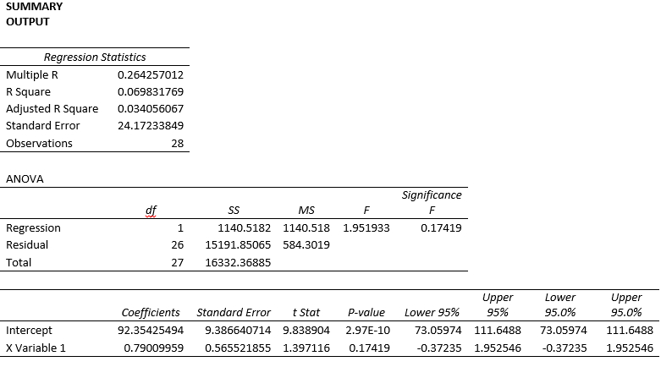

- Using the multiplicative decomposition model, is the forecast of period 1 to 28 performing adequately? Justify your answer.

Weeks 1 – 28 look good in general outside of weeks 7, 14, 21, 24, 26, and 28 due to the high error values.

- Using the multiplicative model, forecast the “Number Served” for the next two weeks (e.g. forecast the “Number Served” for period 29 to period 42). Show calculation.

Calculations are done by multiplying Adj S * Trend.

Problem # 4

- Using the first half of the data (period 1 to period 10), calculate the upper and lower control limits for the control chart with 2 σ limits.

Month | Error | Absolute Error | Error Squared | Upper Limit | Lower Limit
1 | -8 | 8 | 64 | 11.64734012 | -11.84734012
2 | -2 | 2 | 4 | 11.64734012 | -11.84734012
3 | 4 | 4 | 16 | 11.64734012 | -11.84734012
4 | 7 | 7 | 49 | 11.64734012 | -11.84734012
5 | 9 | 9 | 81 | 11.64734012 | -11.84734012
6 | 5 | 5 | 25 | 11.64734012 | -11.84734012
7 | 0 | 0 | 0 | 11.64734012 | -11.84734012
8 | -3 | 3 | 9 | 11.64734012 | -11.84734012
9 | -9 | 9 | 81 | 11.64734012 | -11.84734012
10 | -4 | 4 | 16 | 11.64734012 | -11.84734012
11 | 1 | 1 | 1 | 11.64734012 | -11.84734012
12 | 6 | 6 | 36 | 11.64734012 | -11.84734012
13 | 8 | 8 | 64 | 11.64734012 | -11.84734012
14 | 4 | 4 | 16 | 11.64734012 | -11.84734012
15 | 1 | 1 | 1 | 11.64734012 | -11.84734012
16 | -2 | 2 | 4 | 11.64734012 | -11.84734012
17 | -4 | 4 | 16 | 11.64734012 | -11.84734012
18 | -8 | 8 | 64 | 11.64734012 | -11.84734012
19 | -5 | 5 | 25 | 11.64734012 | -11.84734012
20 | -1 | 1 | 1 | 11.64734012 | -11.84734012

First 10 Months | ME | MAD | MSE | SD | Upper Limit | Lower Limit
 | -0.1 | 5.1 | 34.5 | 5.873670062 | 11.64734012 | -11.84734012

- Construct the control chart with 2 σ limits and plot ONLY the last 10 errors on it. Are the errors random? What is the implication of this?

Judging by the chart the data is not random and seems to follow a seasonal trend. The charts show month 13 as the highest error of the points while month 18 is the lowest error. This increase and decrease with endings and starting around zero further supports that there is a seasonal trend.

Problem # 5

- First, you try a chase plan by hiring and firing as necessary to meet the forecast.

Period | Demand | production | Ending Inventory | Hiring | Firing
Previous |  | 1500 | 200
Quarter 1 | 1600 | 1600-200=1400 | 0 | 0 | 100
Quarter 2 | 1200 | 1200 | 0 | 0 | 200
Quarter 3 | 1500 | 1500 | 0 | 300 | 0
Quarter 4 | 1300 | 1300 | 0 | 0 | 200
Total unit | 5600 | 5400 | 0 | 300 | 500
unit cost |  | $ 30 |  | $ 40 | $ 80
Total cost |  | $ 162,000 |  | $ 12,000 | $ 40,000
The total cost for chase plan will be $214,000 ($162,000+$12,000+$40,000)

- Then you try a plan that holds employment steady (e.g. level strategy)

Period | Demand | Production | Ending Inventory | Inventory | Backorder
Previous |  | 1500 | 200
Quarter 1 | 1600 | 1350 | 0 | 0 | 50
Quarter 2 | 1200 | 1350 | 1350-1200-50=100 | 100 | 0
Quarter 3 | 1500 | 1350 | 0 | 0 | 1500-1350-100=50
Quarter 4 | 1300 | 1350 | 1350-1300-50=0 | 0 | 0
Total unit | 5600 | 5400 |  | 100 | 100
Unit cost |  | $ 30 |  | $ 10 | $ 50
Total cost |  | $ 162,000 |  | $ 1,000 | $ 5,000
The total cost for employment steady plan is $168,000($162,000+$1,000+$5,000).

- Which is the more economical plan for K. Cunningham Health and Beauty Products?

The employment steady plan is more economical plan for K. Cunnigham Health and Beauty Products. It is because employment steady plan ($168,000) has a lower cost than chase plan ($214,000).

Problem # 6

Develop an aggregate plan using the transportation method, states the production schedule and its corresponding cost.

The aggregate plan for the company is:
Regular time production:
36 units in March, 36 units in April, 36 units in May, 36 units in June, 36 units in July, 36 units in August and 36 units in September.
Overtime Production:
12 units in March, 12 units in April, 12 units in May, 12 units in June, 12 units in July, 7 units in August and 12 units in September.
Subcontracting:
2 units in March, 0 units in April, 3 units in May, 12 units in June, 2 units in July, 0 units in August and 0 units in September.

The corresponding cost well be:
36*$80+12*$120+2*$140=$4,600
36*$80+8*$120=$3,840
4*$130=$520
36*$80+12*$120+3*$140=$4,740
36*$80+12*$120+12*$140=$6,000
36*$80+12*$120+2*$140=$4,600
36*$80+4*$120=$3,360
36*$80+12*$120=$4,320
3*$130=$390
$4,600+$3,840+$520+$4,740+$6,000+$4,600+$3,360+$4,320+$390=$32,370

The corresponding cost for this aggregate plan is $32,370.

