FINAL EXAM ECO 2117 C (PART 1 OF 3)

PART 1: MULTIPLE CHOICE AND OPEN ANSWER QUESTIONS

Duration: 3 hours starting at 14.00 on Monday 20 April 2015
Location: Faculty of Social Sciences Building (FSS), room 2005

VERSION | A  (mention this on the optical answer sheet under 'course code' as ECO2117CA)
STUDENT NAME
STUDENT ID

Grading and instructions:

This exam determines 50% of the final grade. In total 120 credits can be obtained over multiple choice questions (40 credits, 2 points per question), open answer questions (40 credits, varying per question) and the assignment essay (40 credits).

Absence from an examination
Absence from any examination or test due to illness must be justified. The Faculty reserves the right to accept or reject the reason offered. Reasons such as travel, employment, and misreading the examination schedule are not accepted. For the procedures you need to follow when you are too sick to write your exam: http://aix1.uottawa.ca/~pmakdiss/Differee(EN).pdf

Examination policy

During the exam:
- You are NOT allowed to make use of the textbook, lecture slides, personal notes, a pocket calculator or any other sources of information.
- Language dictionaries are allowed but should be free of personal notes. Your dictionary may be subject to inspection and the right to use it can be withdrawn if the above condition is not met.
- If you finish writing the exam early, hand in your exam and the corresponding answer forms to the teaching assistant in front of the class room. If you are not finished at the end time, stay seated until one of the teaching assistants collects your exam and answers.
- You are asked to identify yourself by means of your student ID or another official ID document (driver's licence, passport, health insurance card).

After the exam:
- An answer key is posted on the website latest 24 hours after the final exam.
- Complaints about exam questions should be communicated to the professor in writing latest 5 workdays after the final exam (emails are accepted).
- Preliminary grades are posted on the website latest 10 workdays after the final exam.
- Exam review office hour: You can review your exam and discuss the amount of points and/or grade awarded for the exam on Tuesday 12 May from 13:00 to 14:00 at Prof. Notten's office (FSS 6051). It is expected that you first consult the answer key before making any enquiries about the amount of points awarded.

Multiple choice (20 questions, 2 credits per question, 40 credits in total)

1. Development economics is:

- microeconomics but then applied to developing economies
- macroeconomics but then applied to developing economies
- the application of both microeconomics and macroeconomics to developing economies
- neither of the above
Answer: d

Question 2 is related to Table 2.4:

Table 2.4 Human Development Index for selected countries (Todaro & Smith, p53)
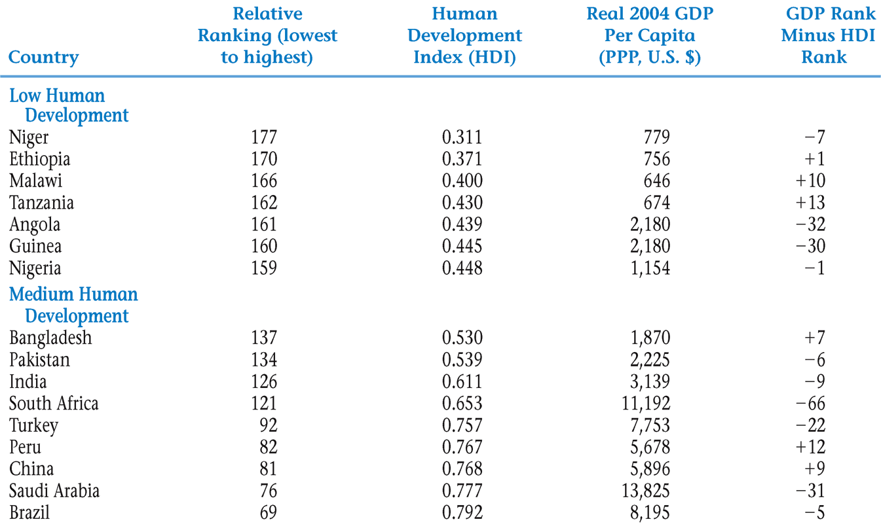

2. If Malawi's HDI rank is 166 and Malawi's 'GDP minus HDI rank' is 10 then:

- Malawi's per capita GDP rank is 176. This means that the per capita GDP ranking overestimates socio-economic development in Malawi.
- Malawi's per capita GDP rank is 156. This means that the per capita GDP ranking overestimates socio-economic development in Malawi.
- Malawi's per capita GDP rank is 176. This means that the per capita GDP ranking underestimates socio-economic development in Malawi.
- Malawi's per capita GDP rank is 156. This means that the per capita GDP ranking underestimates socio-economic development in Malawi.
Answer: c

3. Which of the following statements on Gross National Income (GNI) and Gross Domestic Product (GDP) is correct?

- GDP and GNI are different measures; GDP measures production while GNI measures income
- GNI is calculated as the total domestic and foreign value added claimed by a country's residents without making deductions for depreciation of the domestic capital stock
- GNI comprises GDP plus the difference between the income residents receive from abroad less payments made to nonresidents who contribute to the domestic economy
- Neither of the above statements is correct
Answer: c

4. The false paradigm model attributes lack of development to

a. Inadequate attention to price incentives.

b. Inappropriate advice from rich country economists.

c. Low levels of savings and investment.

d. A lack of government regulation.

Answer: b

5. Which of the following is a criticism of the neoclassical counter-revolution school’s approach?

a. Markets are not competitive in developing countries.

b. Externalities are common in developing countries.

c. Inequality may worsen when interventions are removed in developing countries.

d. All of the above.

Answer: d

6. The market-friendly approach to development emphasizes

a. self-interested behavior of public officials in LDCs.

b. the dependence of LDCs on former colonial powers.

c. the inherent efficiency of markets in developing countries.

d. that markets in LDCs fail sometimes and selective interventions can promote economic development.
Answer: d

7. Kuznets’ inverted-U hypothesis

a. implies that things must get worse before they get better.

b. suggests that inequality will worsen and then improve as a country grows.

c. suggests that inequality will improve and then worsen as a country grows.

d. points out six characteristics of modern economic growth.

Answer: b

8. Assuming that the Gini coefficient for Egypt is 0.403 and the Gini coefficient for Australia is 0.404, it is possible to conclude that both Egypt and Australia have:

a. virtually the same number of households in absolute poverty.

b. virtually the same percentage of households in absolute poverty.

c. virtually the same level of the Human Development Index.

d. None of the above.

Answer: d.

9. A subsistence economy is:

a. a very low income economy.

b. an economy in which people make what they consume.

c. an economy in which people receive food for pay.

d. all of the above.
Answer: b

10. A typical IMF stabilization package involves
- erecting barriers against foreign investment.
- overvaluing the exchange rate.
- liberalization of exchange controls.
- a reduction in interest rates.

Answer: c

11. Special Drawing Rights are financial assets created by

a. the World Bank.

b. the United National Development Program.

c. multinational corporations.

d. the International Monetary Fund.

Answer: d

12. As the number of years of schooling completed increases, the expected private return and private cost of education

a. increase at roughly the same rate.

b. increase at different rates, with expected private return increasing at a slower rate than private cost.

c. increase at different rates, with expected private return increasing at a faster rate than private cost.

d. do not increase.

Answer: c

13. An example of the adverse selection is:
- the client can manipulate the probability of an event (i.e. default, accident)
- overconsumption by client
- the purchaser of a service can conceal that he/she is a bad risk
- providers are less willing to supply desired products
Answer: c
14. Microfinance institutions typically have higher transaction costs than traditional banks, in part due to:
- big transaction sizes
- small transaction sizes
- too many borrowers
- none of them
Answer: b
15. The vent for surplus theory states that by opening up closed agrarian economies:
- Excess land and labour resources will be used
- Specialisation in the production of one good will occur
- Their production possibility frontier will shift to the right
- Rich countries get richer the poor countries get poorer
Answer: a
16. When a country adopts an industrialization strategy to improve exports empirical literature shows that such policies usually
- Come after countries have protected their infant industries for a period of time
- Lead to an increase in agricultural exports
- Encourage the depreciation of its currency
- None of the above
Answer: a

17. Which of the following statements about import substitution strategies is false?
- It encourages firms to be inefficient
- It has reduced the quantity of primary goods exported
- It has benefited foreign firms
- It encourages the imports of manufactured goods
Answer: d

18. Which of the following is an objective of macroeconomic stabilization?
- eliminating current account deficits.
- controlling inflation.
- restoring fiscal balance.
- all of the above.
Answer: d

19. When it comes to the composition of tax revenues from different sources,
- developing countries derive the largest portion of their revenue from income taxes and developed countries from consumption taxes.
- developing countries derive a larger portion of their revenue from trade taxes than developed countries.
- both developing countries and developed countries derive the largest portion of their revenue from income taxes.
- both developing countries and developed countries derive the largest portion of their revenue from consumption taxes.

Answer: b

20. A development bank
- accepts deposits from the poor.
- makes loans for industry expansion.
- is an agency such as the World Bank.
- all of the above.

Answer: b

Open questions (Max. 40 credits)

Question 1: Human capital

Question 1A: There are moral (equity) and economic (efficiency) reasons justifying that governments spend public resources on health and education. Mention one economic reason explaining why it is efficient for governments of developing countries to invest in education. Briefly explain, or illustrate your answer with an example.
(5 credits)
______________________________________________________________________________
Answer: see also p. 362-365, 368, 383-385 in textbook and lecture slides (especially slide 21)

1. Positive externalities / spill-over effects to education

Examples of spill-over effects of education from individuals to their environment:
- The better the education of the mother the better the health of her children
- A person with literacy skills can read documents for illiterate people or come up with innovations that will benefit others

2. Costs of private education for low income / poor families

Due to low income and difficult access to credit poor families may underinvest in the education of their children. With lower costs of education (for instance through free primary education), children of poor families are more likely to go to school.
______________________________________________________________________________

Question 1B: The figure below graphically illustrates the costs and benefits that a family takes into account when considering whether it should send their child to secondary school or not (according to the human capital approach). Explain what a Conditional Cash Transfer (CCT) program does and how such a program affects the trade-off between costs and benefits.
(5 credits)

Figure: Financial trade-offs in the decision to continue in school
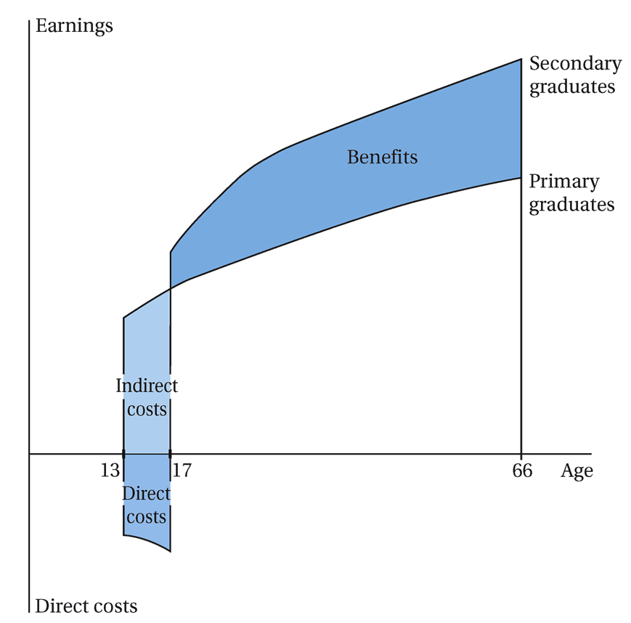

______________________________________________________________________________

See also answer guidelines assignment 3 and all accompanying reading materials.

Conditional Cash Transfer (CCT) programs provide cash transfers to low income families on the condition that the family meets one or several conditions related to the health and education of its household members especially children (i.e. vaccinations, vitamin supplements, school enrolment, regular health check-ups).

CCT programs the costs and benefits of human capital investments poor households
1. by reducing the direct costs through subsidized or free services & vouchers for food
2. by increasing the benefits through cash transfers (you could also argue that the transfer reduces the indirect costs as children are effectively now paid to stay in school).

(Please note that families still have a choice to not send their children to school. It is just that with a CCT program this now choice also entails that they will additionally give up the cash transfers and other benefits.)
______________________________________________________________________________

Question 2: Balance of payments & borrowing from abroad

Question 2A: A country can finance a current account deficit by borrowing capital from abroad. Explain why such a strategy, while justifiable over a short period, may lead to more severe balance of payment problems in the long term. Please distinguish between capital, current, and cash accounts in your explanation.
(5 credits)
______________________________________________________________________________
Answer: see also pp. 638-650 in textbook and lecture slides.

By obtaining a loan from abroad, a country can compensate for the current account deficit with a capital inflow (from foreign loans) on the capital account. However, once the loan is obtained, it needs to be “serviced” by means of interest payments (current account) and repaid by means of amortization payments (capital account) => capital outflows. The danger is that this short-term strategy turns into a long-term strategy, leading to an increase in the total value of foreign debt, requiring more and more capital outflows and thereby claiming a larger share of the foreign exchange gained by capital inflows (exports, borrowing, remittances, FDI, etc.). If this continues, the country will run out of currency & gold reserves (cash account) and a debt crisis might be triggered (the country defaults on its debt, interest rates on new foreign debts skyrocket, or lenders not willing to give any new loans), leading to a deep economic crisis.

______________________________________________________________________________

Question 2B: Explain two long-term strategies that could prevent balance of payments problems in the long run.
(5 credits)
_____________________________________________________________________________

Answer: see also Ch 13 pp. 638-650 in textbook and lecture slides, or, Ch 12 pp. 593-620

There are several long-term strategies that could be used:
(a) Devalue official exchange rate: stimulates exports and discourages imports.
(b) Encourage foreign investment and foreign aid: improves the capital account (but very often comes in the form of loans, not grants).
(c) Restrictive fiscal and monetary policies: often a condition imposed on loans provided by the IMF and the World Bank, these policies are designed to reduce domestic demand in order to lower imports and reduce the inflationary pressures that may have contributed to the “overvalued” exchange rate.
(d) A mix of (credible) trade policies that will stimulate / expand exports in products / services in which the country has a (potential) comparative advantage and for which the commodity terms of trade do not decline.

______________________________________________________________________________

Question 3: Financial system & microfinance

Question 3A: A country’s financial system performs six functions, each of which supports economic activity. Mention two functions and explain what it means for an economy if the financial system performs reasonably well in this function.
(5 credits)
______________________________________________________________________________

See also pp. 730-731.

- Providing payment services
  - This means that it is easy to exchange goods and services (i.e. through cash, bank accounts & credit cards). (leads to more exchange, hence economic growth)
- Matching savers and investors
  - This means that is becomes more attractive to save and that more capital is available for investment projects
- Generating/distributing information
  - Stock prices reflect the average judgment of many investors regarding the profitability of a firm and this information is public; in providing loans, banks collect information about a firm’s business plan and its financial situation
- Allocating credit efficiently
  - Credit goes to those projects that have the highest expected rate of return; thus available savings are redirected to the most promising investments.
- Pricing, pooling, and trading risks
  - A well-developed financial system provides a wide range of savings & investment products. This allows investors (including consumers who save for instance for their retirement) to put their savings / investments into a diversified portfolio.
- Increasing asset liquidity
  - While some projects may take a long time to pay off (i.e. hydrodam), if such project can be financed through stocks/bonds than investors don’t have to wait until the project becomes profitable but they can simply sell their stock /bond to other parties if they need the cash
_____________________________________________________________________________

Question 3B: Microfinance entails the supply of basic financial services including lending, savings and insurance products to poor and low income people. Over the past decades Microfinance Institutions (MFI's) have proven that it is possible to provide financial services to population groups that were previously thought to be 'unbankable'. Explain two problems that prevented the provision of banking services to the poor and indicate in what way MFI's were able to solve each of them.
(5 credits)
_____________________________________________________________________________

For more detailed information: microfinance lecture slides, pp. 739-745 and Grameen Bank case study in textbook

Problems: asymmetric information, collateral, costs of provision ó products demanded, financial literacy & beyond

Solutions: innovations in service types & service provision, social collateral & reputation, charge higher costs, bundle financial service with other services
_____________________________________________________________________________

Question 4: Trade

Question 4A: The factor endowment trade theory is a classic trade theory that is still relevant to understanding trade between countries. The theory predicts that trade is beneficial for all the countries involved. Explain (in words) why trade occurs according to this theory? (5 credits)
(5 credits)
_____________________________________________________________________________
For more details see slides 18-21 on international trade and chapter 12 (especially p. 576-581)

This theory explains why countries produce the same good at a different price and thus why trade would occur between these countries. The theory depends on two propositions:
- different products require different combo’s of production factors
- countries have different endowments in production factors

As a result, countries with a relatively high endowment in labour and land can produce labour and land intensive products more cheaply. Trading will mean that these countries will produce (relatively more) labour intensive products and that they will export those products. In return, these countries will import capital intensive products from countries that have a high endowment in capital.

You could have also mentioned that trade thus leads to a restructuring of the economy (toward the good for which a country has a comparative cost advantage) and that, as a consequence, consumers in both countries are able to achieve higher levels of consumption
___________________________________________________________________________

Question 4B: North-South models contest the claim that both countries will gain from trade: these models predict that dynamic inefficiencies will lead to increased dualism between developing and developed countries. Briefly give one example of such a dynamic inefficiency.
(5 credits)
___________________________________________________________________________

Answer: You could have illustrated either of the following points (p. 607-608):

• Different initial capital levels: Rich countries have higher initial capital levels > thus there are economies of scale for further capital accumulation in manufacturing output > combined with rise in monopoly power > cumulative competitive advantage compared to LDCs

• Different income elasticities of exports: low income elasticity of LDC exports > declining terms of trade (Prebisch-Singer hypothesis, p. 598-599)

___________________________________________________________________________

