1. A) Market for apartments (table):

Q | P (demanded) | P (supplied)
0 | 1200 | 300
5 | 1175 | 325
10 | 1150 | 350
15 | 1125 | 375
20 | 1100 | 400
25 | 1075 | 425
30 | 1050 | 450
35 | 1025 | 475
40 | 1000 | 500
45 | 975 | 525
50 | 950 | 550
55 | 925 | 575
60 | 900 | 600
65 | 875 | 625
70 | 850 | 650
75 | 825 | 675
80 | 800 | 700
85 | 775 | 725
90 | 750 | 750
95 | 725 | 775
100 | 700 | 800
105 | 675 | 825
110 | 650 | 850
115 | 625 | 875
120 | 600 | 900
125 | 575 | 925
130 | 550 | 950
135 | 525 | 975
140 | 500 | 1000
145 | 475 | 1025
150 | 450 | 1050
155 | 425 | 1075
160 | 400 | 1100
165 | 375 | 1125
170 | 350 | 1150
175 | 325 | 1175
180 | 300 | 1200
185 | 275 | 1225
190 | 250 | 1250
195 | 225 | 1275
200 | 200 | 1300
205 | 175 | 1325
210 | 150 | 1350
215 | 125 | 1375
220 | 100 | 1400
225 | 75 | 1425
230 | 50 | 1450
235 | 25 | 1475
240 | 0 | 1500

B)

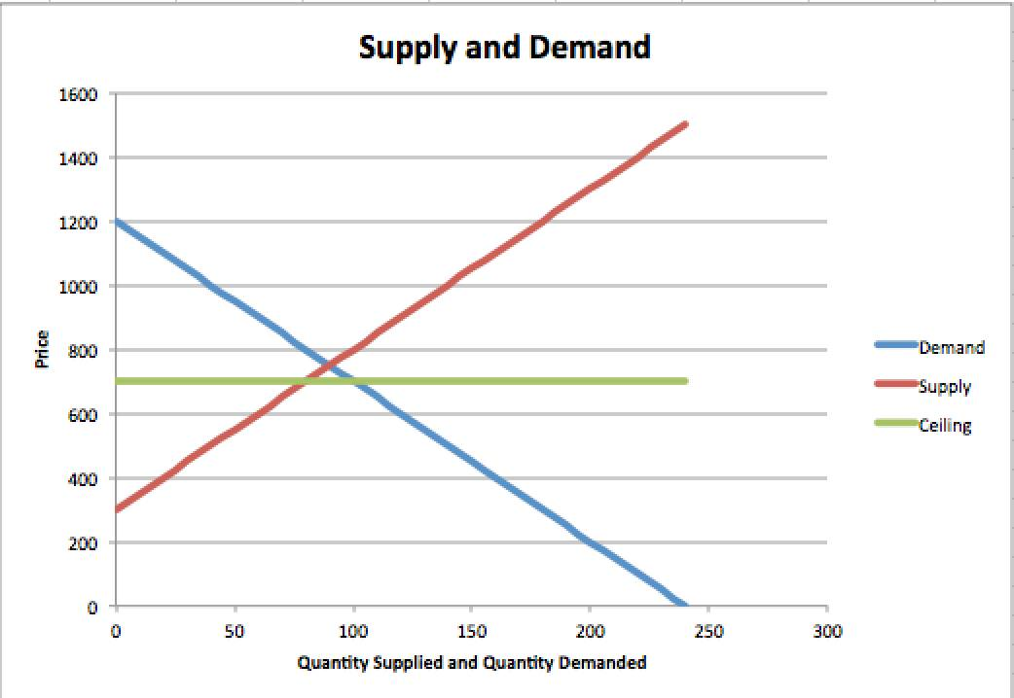

C) Finding the equilibrium rent:

1200 - 5Q = 300 + 5Q

-10Q = -900

Therefore, Q= 90

Qd(90) = 1200 – 5(90)

= 750

Qs (90) = 300 + 5(90)

= 750
The equilibrium quantity is 90, the equilibrium quantity demanded is 750 and the equilibrium quantity supplied is 750. Therefore, the equilibrium price and quantity supplied and the quantity demanded matches the one on the table.

D) With the price ceiling, 80 units are being rented. Since the price ceiling is below the rent equilibrium, quantity demanded is in excess, causing a shortage. There will be a shortage of 20 that will occur because quantity demanded is 100 and quantity supplied is 80, there, there’s a shortage of 20 apartments (100-80=2).

E) The total consumer and producer surplus has decreased bye $500 which can be expressed through the algebraic expressions below:

Before the market price ceiling:

TS= (b*h)/2
TS=((1200-300)*90)/2
TS=(900*90)/2
TS=81,000/2
TS

2) A) I) The approximate total program expenditures for 2014-2015 is $250.2 billion.

Ii) GDP makes up 13.0% of the 250.2 billion dollar expenditure:

Major Transfers to Parsons: 3.9%
Major Transfer to Other Levels of Government: 3.2%
Direct Program Expenses: 5.8%
Total: 13.0%

III) check

IV) The current annual revenue level is 276.3.

V) The deficit for 2014-2015 is projected to fall to 2.9 billion; however, it will be balanced in 2015.

VI) Elderly benefits, being 43.8 billion dollars of the total 250.2 as well as operating expenses, which is 71.3 billion dollars (greatest expenses).

VII) A huge aspect of revenue is personal income tax, which in general are important sources o revenue, bringing in 137.8 billion dollars for 2014-2015.

B) I) The projected level of expenditures for budget year 204-2015 is $130,376 million.

II) The top 6 expenses are the following:
- Health and Long-Term Care ($50,054 billion)
- Education ($2.4 billion)
- Children’s and Social Services ($24.8 billion)
- Justice Sector ($4.3 billion)
- Trainings, Colleges and Universities ($7.83 billion)
- “Other Programs” ($17.3 billion)

III) Total revenue projected for 2014-2015 is $118.871 million.

IV) The major sources of revenue for the provincial government are personal income tax ($29, 172 million), sales tax ($21.937 million), corporations tax ($10,254 million), and Canada Health Transfer ($12, 350 million).

V) The accumulated deficit for 2013-2014 was $11.3 billion.

VI) The projected level of the deficit for budget year 2014-2015 is $12.5 billion.

3. A)
Price L=100 | 100 |  | TFC= | 200
 | Workers | Output | Marginal Product | Total Cost ($) | Average Total Cost ($) | Marginal Cost ($)
 | 0 | 0.00 | XXX | 200 | XXX | XXX
 | 1 | 20.00 | 20 | 300 | 15.00 | 5.00
 | 2 | 50.00 | 30 | 400 | 8.00 | 3.33
 | 3 | 90.00 | 40 | 500 | 5.56 | 2.50
 | 4 | 120.00 | 30 | 600 | 5.00 | 3.33
 | 5 | 140.00 | 20 | 700 | 5.00 | 5.00
 | 6 | 150.00 | 10 | 800 | 5.33 | 10.00
 | 7 | 155.00 | 5 | 900 | 5.81 | 20.00

B)
Price L=150 | 150 |  | TFC= | 200
 | Workers | Output | Marginal Product | Total Cost ($) | Average Total Cost ($) | Marginal Cost ($)
 | 0.00 | 0.00 | XXX | 200 | XXX | XXX
 | 1.00 | 20.00 | 20 | 350 | 17.50 | 7.50
 | 2.00 | 50.00 | 30 | 500 | 10.00 | 5.00
 | 3.00 | 90.00 | 40 | 650 | 7.22 | 3.75
 | 4.00 | 120.00 | 30 | 800 | 6.67 | 5.00
 | 5.00 | 140.00 | 20 | 950 | 6.79 | 7.50
 | 6.00 | 150.00 | 10 | 1100 | 7.33 | 15.00
 | 7.00 | 155.00 | 5 | 1250 | 8.06 | 30.00

C)
Price L=100 | 100 |  | TFC= | 300
 | Workers | Output | Marginal Product | Total Cost ($) | Average Total Cost ($) | Marginal Cost ($)
 | 0.00 | 0.00 | XXX | 300 | XXX | XXX
 | 1.00 | 20.00 | 20 | 400 | 20.00 | 5.00
 | 2.00 | 50.00 | 30 | 500 | 10.00 | 3.33
 | 3.00 | 90.00 | 40 | 600 | 6.67 | 2.50
 | 4.00 | 120.00 | 30 | 700 | 5.83 | 3.33
 | 5.00 | 140.00 | 20 | 800 | 5.71 | 5.00
 | 6.00 | 150.00 | 10 | 900 | 6.00 | 10.00
 | 7.00 | 155.00 | 5 | 1000 | 6.45 | 20.00

D) In Tables A, B and C, the marginal product ends up staying the same and increases as well like that, until it gets to 3 workers, which causes the marginal product to start to decrease. This occurs because once the number of workers exceeds the amount necessary the level of productivity decreases, which makes the production less efficient and there are not enough resources to work as efficiently as they should be. This shows the law of diminishing marginal product.

E) If you look at the start of the table, the average cost is very high as the fixed cost is spread only at a few units. However, once output starts increasing, the fixed costs effect far more greatly and average fixed costs decrease, in turn decreasing the average total cost in the long run. This effect is carried out in all three tables.

F) In all three tables, the marginal cost decreases and then increases after.

G) The marginal cost curve and marginal product curve has a negative correlation between one another. When the marginal cost increases, the marginal product decreases and vice versa. When the marginal product increases the firm’s productivity is more efficient, it becomes more cost effective. When the marginal product decreases the firm has a negative effect. The relationship overall is in relation to the economics law of diminishing marginal product.

H) The average cost and marginal cost are the effected cost variables. This has occurred due to the changes in wages.

I) Both table A and table C have the same variable costs but it changes when it comes to the fixed costs. All of the cost variables associated with Tables A and C are affected except for the marginal cost. To understand this, we can look at Table C where both tables have the same variable cost but different fixed costs, making the Total Cost curve shift up by $100 from the Total Cost curve located in Table A. As mentioned earlier, marginal cost is unaffected as it is related to the Variable Cost and since both tables have the same variable cost, this gives the same Marginal Cost.

J) Graph 1:
Output | Average total cost | Marginal cost
20 | 15 | $5
50 | 8 | $3.33
90 | 5.56 | $2.50
120 | 5 | $3.33
140 | 5 | $5
150 | 5.33 | $10
155 | 5.81 | $20

Graph 2:
 | Production/Output | Marginal Product
0 | 0 | ---
1 | 20 | 20
2 | 50 | 30
3 | 90 | 40
4 | 120 | 30
5 | 140 | 20
6 | 150 | 10
7 | 155 | 5

