EXCI 233 Midterm Notes

Health Trends in Canada
Life Expectancy: (generally has been increasing in Canada)
- The Canadian life expectancy at birth is 81.1 years in 2009
- 78.8 for men
- 83.3 for women
- Registered Indians: (70.4 men) (75.5 women)
- Men have increased 10% since 1980
- Women have increased 7% since 1980
- Best Canadian provinces ON, BC, QC
Infant Mortality: (has decreased by more than half since 1979)
- Higher mortality rate for males than females
- Mortality rates have decreased more for men than women in general (women’s curve is not as steep)
- The Canadian national avg is 4.9/1000
- Lowest rates in PE, NS, QC, BC
- IN the G7 countries Canada was second highest for infant mortality
Mortality: (all circulatory and cancers rates have decreased in Canada from 2000 to 2009)
- In 2009, Heart attack and lung cancer were the leading in Canada.
- The probability of dying from a heart attack, stroke, or leading cancers was higher for men in 2009
- Highest in Nunavut compared to all other provinces and territories
- Heart attacks were the leading cause of death from circulatory diseases
- Lung cancer is the leading cause of death from cancer
Low-Income: (has decreased from 1976, although have a few spikes certain periods)
- Women more often than men had low income risk
- Much higher in large urban areas
- Canada was the third highest in low income rates in the G7
- The measure of low income is by Market Basket Measure (MBM)

Chapter 1: Invitation to health
Health: the process of discovering, using, and protecting all of the resources within our bodies, minds, spirits, families, communities, environment.
- A positive optimistic outlook
- Sense of control over stress and worries; time to relax
- Energy and vitality: freedom from pain or serious illness
- Supportive friends and family, and a nurturing intimate relationship
- A personally satisfying job
- A clean environment
Wellness: purposeful, enjoyable living or more specifically, a deliberate lifestyle choice characterized by personal responsibility and optimal enhancement of physical, mental, and spiritual health.
- It means more than not being sick, but taking the steps to prevent illness and lead to a richer, more balanced, more satisfying life.
- John Travis Iceberg Model 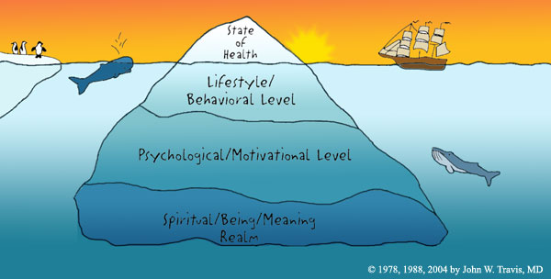
- Lifestyle/behavioral level – what you eat, how active you are, how to protect yourself from hazards
- Psychological/motivational – influences the lead us to choose a certain lifestyle
- Spiritual/being/ meaning – determine if your state of health is disease or wellness
Physical Health: the realm between death and performing at your very best.
- Feed bodies nutritiously
- Exercise regularly
- Avoid harmful substances
Psychological Health: refers to both emotional and mental state (feelings and thoughts)
- Ability to express emotions, to function independently and to cope with challenges of daily stressors
Spiritual Health: identify own basic purpose in life
- Sense of greater meaning in your life
- Prayer can change your stress level and actually make you healthier because you believe in a divine power.
Social Health: ability to interact effectively with other people and the social environment.
- Developing satisfying interpersonal relationships, and to fulfill social roles.
Intellectual Health: ability to think and learn from new life experiences, your openness to new ideas, and your capacity to question and evaluate information.
Environmental Health: the impact that your world has on your well being.
- Protecting yourself from dangers in the air, water and soil or products that you use.

Life Expectancy:
- Life expectancy in Canada is 80.7 years for those born in 2007
- The figure is 83.0 years for women, 78.3 for men
- Canada had the second highest life expectancy of G7 countries
Canada’s Health:
- Infant mortality rate (death of a live-born infant before the age of one per 1000 live births) has declined dramatically in the last century
- In Canada in 2007, the infant mortality rate (IMR) is 5.1/1000 live births; (in 1901, the rate was 130/1000 live births)
- Canada’s IMR ranks second highest in rank order/second lowest of G7 countries
- Heart disease and cancer become important causes of death in mid-age and up
- Males have higher mortality from heart disease, stroke, colorectal and lung cancers
- Single parents, recent immigrants, disabled persons and Aboriginal people were at greater risk of low income compared to Canadians in general
- Someone at a low income has greater challenges in providing food, shelter and basic necessities
Health of College Students:
- Incidence of life-threatening illness is lowest in this age group
- Gender differences are apparent
  - College-aged men are more likely to engage in risk-taking behaviours, are more likely to be hospitalized
- Women more than men report significantly elevated stress levels
- Higher levels of education are related to lower levels of certain diseases
Prevention:
- Prevention can take many forms
  - Primary prevention seeks to stop problems before they start
  - Prevention can also target individuals with risk factors to help them avoid potential problems
- Protection goes hand-in-hand with prevention
- Protection is a way to decrease the risks of our actions
Assessing Risks:
- Are there possible benefits of taking this risk?
  - Is risk voluntary? Is it fair? Are there alternatives?
  - How the risk is presented-positive or negative light
Health Promotion:
- Health promotion combines prevention and protection
- WHO defines health promotion as “the process of enabling people to improve and increase control over their health”
- Health promotion programs combine different aspects:
  - Educational
  - Peer counseling
  - Environmental
  - Encouraging volunteerism, to look beyond oneself to the wider community

Chapter 2 Personal Fitness:

Physical Fitness:
- Physical fitness-the ability of the body to respond to routine physical demands
- Body should also have reserve capacity to react to unexpected physical demand
  - Think of a situation that would call on reserve capacity to meet unexpected physical demand?
Cardiorespiratory Fitness:
- Cardio-respiratory fitness
  - The ability to sustain prolonged rhythmic activity
  - Achieved by aerobic exercise, related to oxygen used by body to support the activity
    - Name some activities that contribute to cardio-respiratory fitness.
    - What other terms are used to describe this type of activity?
- The heart, lungs and blood vessels need to carry more oxygen to all of the body’s cells
- This type of activity is also called aerobic activity because the body uses as much or slightly more oxygen than it usually takes in

Muscular Fitness:
  - Muscular strength refers to force within muscles
    - Strength is shown by the maximum weight that we can lift, push, or press in one effort
  - Muscular endurance is ability of muscles to perform repeated effort
    - Endurance is measured by the number of times you can lift, push, or press a given weight
What are the different components that contribute to the weight that registers when you step on the scale?
- Water weight: e.g.-blood, plasma, intercellular fluid, cerebrospinal fluid, fluid in the eyeball, urine, the juice you just had….
- Weight of the bones and teeth
- Muscle weight
- Fat weight
- Which one changes the most on a daily basis?
- Which one do we worry most about?
Body Composition:
  - Relative amounts of fat versus lean tissue in body
  - A high body fat % is related to increased incidence of heart disease, high blood pressure, diabetes, stroke, some forms of cancer, among other conditions
- Flexibility
  - Refers to range of motion around each joint
- Physical conditioning
  - Conditioning is enhanced with improved cardiorespiratory, muscular strength and endurance, and flexibility
Couch Potato Crisis
- Being sedentary increases the risk for heart disease, high blood pressure, obesity, osteoporosis
- Increasing one’s physical activity level (by 150 Calories burned per day) can lower heart attack risk
Benefits of Exercise:
- Exercise is related to:
  - Lowered risk of heart disease, stroke and high blood pressure, better circulation overall
  - Lowered risk of overweight and obesity, Type 2 diabetes, some cancers (colon/rectal/breast/prostrate)
  - Having stronger bones and a lowered risk of osteoporosis
  - Increased flexibility, better functioning of the digestive system, less risk of constipation
  - Stronger immune system to fight off infections
  - Positive effects on mood and ability to handle stress
  - More strength and stamina in old age that increases the ability to live independently for longer
Target Heart Rate:
- Target Heart Rate (THR) is used to assess whether the exercise is strenuous enough to challenge the heart and lungs
- Take carotid pulse which should be taken during or immediately after exercise to determine level at which you have been exercising
- Target heart rate is based on exercising at a percentage of average maximum heart rate for each sex and for various age groups
- Exercising at 60% of the target heart rate is considered low-moderate activity
- Exercising at 85% of the target heart rate is considered vigorous activity
Muscular Strength and Endurance:
- Strength is related to the muscles being able to work efficiently and reliably
- Strength conditioning leads to firmer muscles that will be able to contract more vigorously, with less effort and lower risk of injury
- Strength training increases the size of the muscle fibres and also strengthens the connective tissue around the muscle
- Strength training leading to increase in muscle tissue is the best way to increase the use of body fat during exercise
- Inactivity leads to gradual loss of muscle size and weakening strength
- Increasing use of a muscle leads to the muscle growing stronger
- The muscle is trained by overloading-increasing the work demand of the muscle over the usual

Flexibility:
- Flexibility refers to the range of motion that is achievable without injury at a joint or group of joints
- Flexibility increases until adolescence after which flexibility tends to decrease over the rest of the lifespan
- Types of stretching:
- Static Stretching: involves a gradual stretch held for a short period of time (10 – 30 seconds)
- Passive Stretching: your own body, a partner, gravity, or a weight serves as an external force or resistance to help your joints movie through their full range of motion.
- Active Stretching: stretching a muscle by contracting the opposing muscle
- Ballistic Stretching: characterized by rapid bouncing movements.
Benefits of Flexibility:
- Prevention of injury
- Relief of muscle strain
- Relaxation
- Relief or soreness after exercise
- Improved posture
- Better athletic performance

Chapter 3 Personal Nutrition:
- Nutrients are needed by the body for various functions
  - Energy
  - Building/repair of tissues
  - Regulating body functions
- Some nutrients are classified as essential since they must be supplied from foods
  - There are 6 classes of nutrients? Can you name them?
    - Water, protein, carbohydrates, fats, vitamins, minerals
- Macronutrients are needed in large quantities every day (> a few grams per day)
  - Which are macronutrients? (Hint: most but not all macronutrients provide energy)
    - Protein, fats, carbohydrates are macronutrients and provide energy
    - Water is a macronutrient that does not provide energy
- Micronutrients are needed in smaller quantities (< 1 gram per day)
  - Which of the nutrient functions do micronutrients fulfill?
    - Micronutrients work in regulating the body
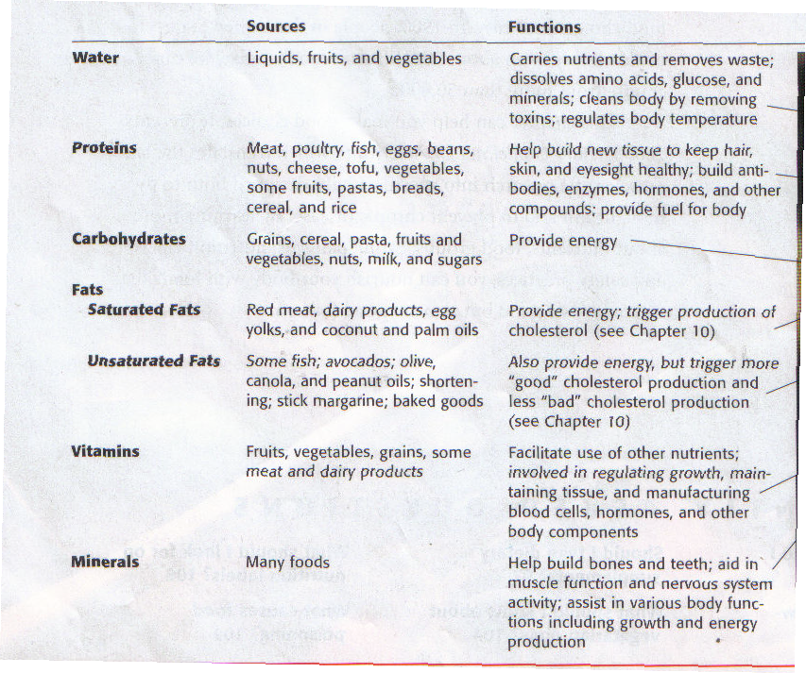

- Carbohydrates, fats, proteins are macronutrients that provide energy for body’s activities, measured in Calories
- Recommended intake:
  - 45-65% Calories from carbohydrate
  - 20-35% Calories from fat
  - 10-35% Calories from protein
Caloric Needs:
- Caloric requirements depend on gender, life stage, weight, health
- BMR (basal metabolic rate) also determines caloric need
- Activity level is a greatly variable factor that also determines Caloric need
- Water:
- Is essential for many functions such as maintaining temperature, carrying nutrients and wastes via the blood, aiding digestion
  - How much water should you drink in a day?
    - The suggestion is for an intake of 2 litres (8 cups of fluid-not necessarily all as water) per day
Protein:
- Provides 4 Calories per gram
- For growth and repair of body, manufacturing antibodies, skin
- The 20 amino acids contained in the protein are really the required nutrients
- Of the 20 amino acids, 9 are essential since the body cannot manufacture them in adequate amounts
- Animal proteins provide all the amino acids needed (complete proteins)
- Plant proteins may have low levels of some of the essential amino acids

Carbohydrates:
- Carbohydrates provide body with energy
- All carbohydrates are broken down into primarily glucose
- All carbohydrates provide 4 Calories per gram
- Carbohydrates are necessary for brain function
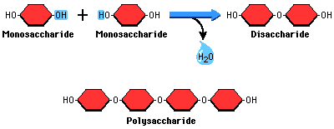
- Simple carbohydrates
  - Sugars and sugar containing foods, including honey, brown sugar, also found in fruits and vegetables
- Complex carbohydrates
  - Found in whole grains, beans, lentils
- Dietary Fibre
  - Non-digestible form of carbohydrate naturally found in foods
- Functional Fibre
  - Also non-digestible, may be added to foods
- Fibre is necessary to promote elimination and may decrease risk of developing heart disease and cancer

Fats:
- Responsible for providing Calories, 9 Calories per gram
- Aid in the absorption of fat-soluble vitamins
- Functions as cushioning for the abdominal organs, also for temperature regulation
- Lipids are also part of the cell membrane, lining of nerve cells
- Unsaturated fats
  - Unsaturated fats are those that are liquid at room temperature
  - Can be monounsaturated or polyunsaturated
  - Unsaturated fats are recommended as a way to decrease incidence of heart disease
  - Omega-3 found in fish are also highly recommended
- Saturated fats
  - Saturated fats are solid at room temperature
  - Vegetable oils are processed to produce partially hydrogenated fats
- Trans fats (which are unsaturated fats), are thought to increase cholesterol levels in humans, are produced during the hydrogenation process

Vitamins and Minerals:
- Most vitamins and minerals regulate the body’s growth and metabolism, do not provide Calories, some work as anti-oxidants
- Most vitamins need to be provided in the diet
- Some vitamins are fat-soluble (A, D, E, K)
- Vitamin D can be produced in sufficient quantities by the body, depending on exposure to the sun
- Water-soluble vitamins, if taken in greater quantities than needed, will be lost in the urine
- All B vitamins, including folic acid, as well as vitamin C, are water soluble
- Folic Acid (folate)
  - Insufficient levels of folic acid in pregnant women increases risk of development of neural tube defects in baby
Vitamins:
- Anti-oxidant functions
  - Vitamins C, E, Vitamin A precursors, act as anti-oxidants that reduce damage from oxidative processes of body's metabolism
- Consume these vitamins from natural sources in foods rather than in supplement form
Minerals:
- Building of bones and teeth, enzyme functions, nerve and muscle function, are where some minerals are required
- Iron and calcium are the most likely minerals to be deficient in the diet
Minerals – Calcium:
- Most of calcium in body is in bones and teeth
- Body must build up peak bone mass by young adulthood to prevent osteoporosis in later life
- Osteoporosis leads to increased risk of wrist and hip fracture in later life
Minerals – Sodium
- High sodium is a factor in the development of high blood pressure
- Sodium intake should be kept to 2.4 grams/day (approx.1 tsp of table salt)
- Most sodium comes from processed and restaurant food
Review Questions:
- Why is folic acid (also known as folate) particularly important as a nutrient, and for whom?
- Explain the concept of peak bone mass, and what nutrient is important in this process
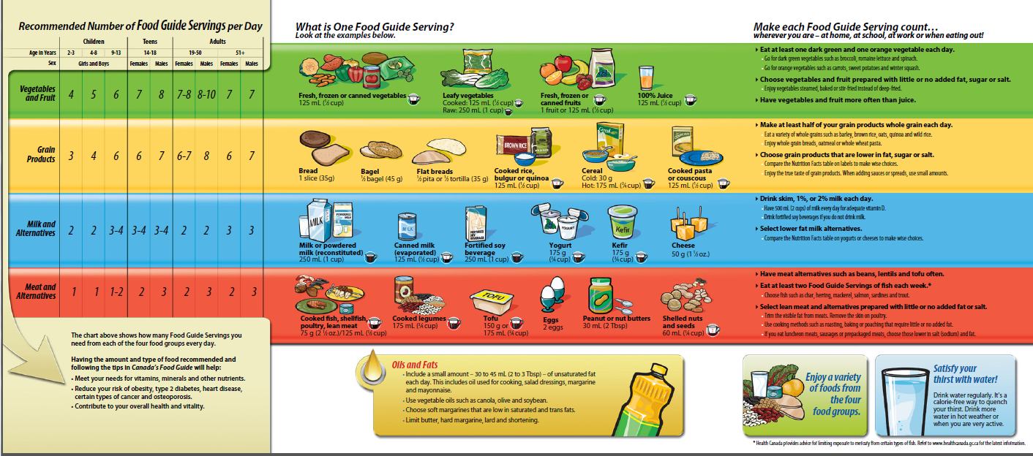
Review Questions:
- What are the major contributions of each food group—vegetables & fruits, grain products, milk & alternatives, meat and alternatives?
- What other type of food is recommended although it is not within one of the food groups? Why?
- Which types of foods should be limited? Why?
- In following the food guide, how would someone be working towards health now and in the future?

Obesity and Weight Management:
- Obesity rates have soared around the world
- 2 out of 3 Canadians is overweight or obese
- Incidence of obesity is related to adoption of Western lifestyle
How did we get like this:
  - 1 pound excess fat = approx. 3500 Calories
  - 2 chocolate chip cookies = 140 calories
  - How long would it take to gain 1 pound of fat by eating 2 extra cookies per day?
    - 25 days
  - How many pounds could you gain in 1 year?
    - Approx. 15 pounds
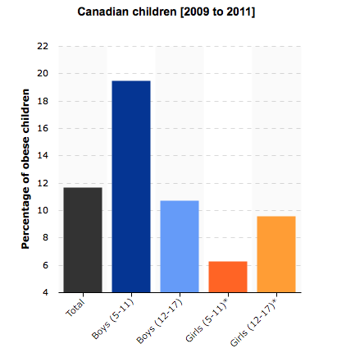
- Genetic and environmental factors determine one’s Basal Metabolic Rate (BMR)
- The BMR is the lowest rate of energy expenditure in the body other than sleeping
How did we get so fat:
- Genetic predisposition, lack of physical activity, larger food portions, and unhealthy eating habits, have contributed to the increase in overweight and obesity.
Calculate BMR:
- Males
  - 1 calorie*weight in kg*24
- Females
  - 0.9 calorie*weight in kg*24
  - Weight in pounds/2.2=weight in kg
- Take your basal metabolism figures and add the amount for activity:
  - If sedentary-add 30%
    - Typical student
  - Light activity-add 50%
    - Bike or walk to school, exercise 3-4 times weekly
  - Moderate-add 70%
    - Very active days, exercise 4-5 times weekly, active job that includes being on feet
  - Strenuous-add 100%
    - Little sitting, exercise most days of the week, physically demanding job
- Add 5% allowance for digestion of food
- This gives approximately the total calories needed for the day
*Scientists have found genes that contribute to metabolism and appetite but have not found a genetic cause for obesity.

- The tool used to assess overweight or obesity is called the BMI (chart)
- BMI=weight (kg)/height (m²)
- Body Fat%-ideal is less than 20-22% for a man, and less than 30% for a woman
- Waist circumference > 35inches for a woman and > 40 inches for a man incur greater health risks
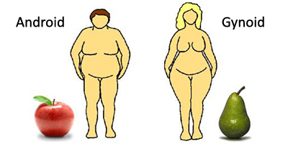
- Apple shaped obesity (android) obesity
  - More of the fat is stored around the abdomen, with the increased risk of heart disease, high blood pressure
- Pear-shaped obesity
  - More fat is stored around the hips and thighs
- Pear-shaped obesity is more common in women, and is related to storing fat for pregnancy and nursing
Waist-to-hip Ratio:
- Waist measurement/hip measurement is also used
  - Ratio of 0.80 for women and 0.90 for men is considered safe
  - Ratio 1.0 or above is considered at risk
- When weight is lost, men lose more fat from abdominal area than women do

- Incidence of diabetes, heart disease and stroke, certain cancers, premature death increase with increasing weight levels
- List the different methods of evaluating healthy weight or body composition, as well as their strengths and/or limitations?

Weight Loss Approaches
- Those in diet or exercise groups showed the greatest improvement
- Low Calorie diets of varying levels had similar results compared to each other
- Physical activity was very effective in decreasing abdominal fat
- Person-to-person contact was very effective
- Basic requirement is to decrease Caloric intake and/or increase activity level
Difference between Hunger and Appetite:
Hunger - the physiological drive to consume food
Appetite – the psychological desire to eat, influence and control our desire for food.
Satiety – the feeling of fullness and relief from hunger (the neurotransmitter serotonin has been known to produce feelings of satiety)
Why do we over eat:
- Desire to eat is function of both physical and psychological factors
- Hunger is physiological need to eat
- Appetite is psychological desire to eat
- Satiety is feeling of being satisfied that prompts feeling of fullness
Low Carb Diets:
- These diets tend to be high in protein, high in fat
- Comparable amounts of weight are lost on the low-carbohydrate diets compared to low-fat diets
Low fat diets:
- This type of diet restricts fat intake to less than 30% of Calories
- Very low-fat diets can reverse some build-up of plaque related to heart disease
Low calorie diets:
- A diet that provides fewer than 800 calories is likely to be nutritionally unbalanced, potentially dangerous
- 1000-1200 Calories per day is the lowest recommended for females, and 1200-1600 Calories for males
- Very rapid weight loss is due to water loss rather than loss of body fat, and may induce the loss of muscle tissue including heart muscle tissue
Yo-Yo Syndrome:
- Some dieters lose weight and then regain the lost weight, and even increase their overall weight
- Exercise is the way to control this up-and-down cycling of weight

- Amphetamine-like products
  - These products are compounds that stimulate the central nervous system, leading to increased heart rate, heart damage
  - Ephedra is a stimulant that has been tied to heart attack and strokes
Diet Foods:
- “Light” foods may not be lower in Calories or fat compared to the foods they are supposed to replace
- Artificial sweeteners and fake fats should not be substituted for nutritious foods
Exercise:
- Exercise has the effect of decreasing the appetite
- The combination of exercise (increased Caloric use) and decreased Caloric intake will contribute to weight loss
- Exercise can increase muscle mass, contributing to more tissue able to burn Calories, increase energy expenditure
Body Image:
- Media images influence how people react to their body image
- Women tend to see themselves as overweight even if they are not
- Men tend to see themselves as underweight even if they are not
Overcoming a Weight Problem:
- Gastric Surgery
  - Surgery, called gastric bypass surgery, is done to reduce the volume of the stomach
  - Other techniques used are gastric bubble-put in the stomach to cause the patient to feel full when following a low Calorie diet
- Surgery is a drastic approach
- Other approaches include behaviour modification, cognitive therapy and social support
- A person has to learn new ways of coping to overcome the problem
Review:
- What are hunger, appetite and satiety, and how do they differ?
- What are some of the weight loss approaches that are used by dieters?
- Weight cycling comes into play with those who follow weight loss diets. What is this, and what is the negative consequence?
- Discuss the effectiveness of exercise as a method to decrease body weight.
- Discuss positive and negative consequences of gastric surgery as a weight-loss method.
- What is the most reliable intervention for obesity?
  - Prevention, prevention, prevention
- Which gender suffers more often from “apple-shaped” or android obesity, and which suffers more often from “pear-shaped” or gynoid obesity? What are the relative risks of each on a person’s long-term health?

Exercise, Learning and Aging

Brain Cells
- Could be anywhere from 10 billion to 100 billion
- Some areas of the brain produce new cells throughout life, despite earlier thinking this did not occur
- Neurogenesis:
- Process by which neurons are produced
- The hippocampus and the olfactory bulb are the 2 areas where neurogenesis continues throughout life.
Exercise and the Brain
- Studies show that regular physical activity is beneficial for the brain
- Benefits include improvement of attention, memory and learning, as well as lessening of stress and the problems of attention deficit disorder
- If one exercises, the brain cells demonstrate change which leads to them working together more efficiently
- Exercise encourages and enhances this process
- Aerobic exercise increases blood flow to the brain
- The increased blood flow increases the oxygen available to brain tissue
- Exercise also increases the production of a growth factor called BDNF, a protein that encourages brain cells to grow, connect and communicate in new ways
- New cells are produced in an area of the brain called dentate gyrus which is involved in the learning process
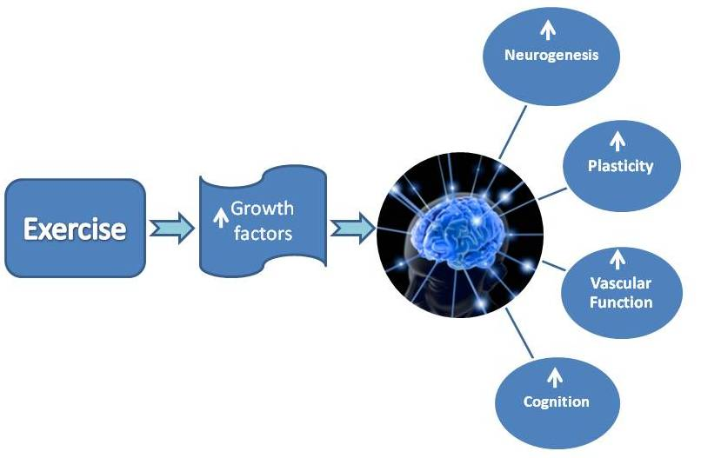
The hippocampus is responsible for retaining memories. The olfactory bulb is responsible for the sense of smell.
- Studies show that aerobic activity in children leads to improvements in math and reading skills
- These findings counteract the notion that physical exercise energizes children too much to have them concentrate and learn
- The exercise that most benefits the brain is cardiovascular exercise
- Other types of exercise which require concentration also seem to facilitate learning somewhat
- Brain cells of those who exercise show molecular differences from those who do not exercise
- Studying twins, genetic differences were found within the cells related to the amount of exercise
New research is showing that exercise can slow, and possibly reverse, the aging process
- Telomeres, at the end of the chromosomes, shorten with each division of the cell, until the telomere is too short and the cell cannot continue to divide
- Telomere length in white blood cells was used as an indicator of aging
- In the twin study, telomere length was related to activity levels
- 100 minutes of exercise per week resulted in telomeres that resembled those of people 5-6 years younger than persons who exercised only 16 minutes per week
- Those who exercised 3 hours/week (180 minutes) seemed to have telomere length that showed them about nine years younger
- The relationship of aging and telomere length held even when obesity, smoking, marital status and other factors were taken into account

Time Management
- The relationship of aging and telomere length held even when obesity, smoking, marital status and other factors were taken into account
Skills to develop for good time management:
- Set clear goals
- Break goals into smaller, clear and attainable steps
- Review your progress
- Prioritize tasks according to importance and/or urgency in relation to your goals, leave less important tasks that are not related to your goals aside
- Organize your study/work schedule
- Making a list is important
Use lists effectively:
- Write down what you need to do, rather than depending on your memory for what needs to be done
- Use of an organizer is helpful
- Prioritize items on your list by importance and then by urgency
Set Goals:
- Goals need to be clearly defined and specific
- Goals should also be realistic & achievable
- It is useful to have an alternate plan to achieve your goals in case your first plan is not possible in the way you expected
Prioritize:
- Focus on tasks that are important and/or urgent
- Urgent tasks are not always important, so less time should be spent on unimportant tasks, even if they are urgent
Avoid Procrastination:
- It is important to overcome the fear of doing something and make decisions or take action without delaying the process
Break down tasks:
- Break down tasks into smaller sections
- Try to complete one section before going on to the next
- Rewarding yourself after completion of part of the larger task will maintain enthusiasm to continue
Preserve:
- Use frustration and failure to your advantage
- Learn from mistakes by accepting them as stepping stones to success
- Exercise, relaxation, yoga, meditation can help deal with pressure
Organize you time:
- Organize your study/work schedule
- Making a list is important to remind oneself of tasks to be completed
- Identify time wasting tasks and reduce or eliminate them, for example, emails, Facebook, Twitter
- Keep a log of what you do during a week to better be able to identify where you may be misusing your time
- Develop a routine
- Keep your workspace in order
- Do not leave tasks to the last minute
Revise:
- Establish a regular area for doing revisions of course work
- Plan a schedule for when you will do your revisions
- Use graphics, diagrams, highlighters to emphasize important information

Time Management & Avoiding Procrastination

- List at least 3 of the techniques mentioned by the guest speaker and/or mentioned in the text and notes that will help a person better manage his/her time.
- Place the following in the correct quadrant, according to Covey’s classifications:
reading/sending text messages during a conference, working on an outline for a term paper due in 1 month, watching Olympic coverage on TV, exercise/going to the gym, taking a sick family member to the doctor.
- List both components that define procrastination as mentioned by our guest speaker.
- List and give example of at least 4 of the reasons or ways one procrastinates, and provide a solution for each example you have chosen.

Eating Disorders:
- Disordered eating can be not eating enough or eating too much or too quickly
- Several factors like including genetics, stress, gender, culture may be involved
- Incidence of eating disorders has increased greatly over last 20 years
- Most important factor seems to be previous dissatisfaction with body
Extreme Dieting:
- Dieting is very prevalent in teen years, especially in girls
- Parents and media have greatest influence on development of concerns about weight
- Extreme dieting can take form of cutting back on caloric intake or of increasing physical activity
Compulsive Overeating:
- Compulsive eaters eat for reasons not related to hunger
- Food is a source of comfort against low self-esteem, inner emptiness
- Compulsive overeaters need to learn new eating habits and ways of dealing with problems
Binge Eating:
  - Rapid consumption of an abnormally large amount of food in a relatively short period of time
  - The result of binge eating is increase in weight that leads to depression
  - Professional treatment is needed through education, cognitive therapy, psychotherapy and behavioural therapy
- During these episodes they experience
- Eating much more rapidly than usual
- eating until they feel uncomfortably full
- eating large amounts of food when not feeling physically hungry
- eating large amounts of food throughout the day with no planed mealtime
- eating alone because they are embarrassed by how much they eat and their eating habits
Who develops these and why?
- Estimates are that between 0.5 and 1% of young women in late teens and early twenties develop anorexia
- Incidence has been growing in the last three decades in developed countries
- Incidence is increasing among males, minorities, women of all ages and there are some cases in preteens
Factors related to development of Anorexia Nervosa:
- Biological factors
  - The condition is more common among close relatives, as is depression
  - Anorexia is associated with changes in brain neurotransmitters such as dopamine, serotonin and norepinephrinne
- Psychological factors
  - Anorexia can develop as a result of personal loss
  - An anorexic is often a driven perfectionist trying to gain control over his/her life and assert independence
- Family and sociocultural factors
  - Some individuals with anorexia initially lost weight to make themselves more attractive
  - Some sports, such as ballet and gymnastics, increase pressure for weight loss
  - In some individuals, there is a desire to slow their maturation

Signs of Anorexia:
- The individual refuses to maintain normal weight, has an intense fear of getting fat or gaining weight
- The individual feels fat even when clearly very thin
- Absence of at least three menstrual cycles
- Treatment is multifactorial
- It includes:
  - Medical therapy (hospitalization and refeeding)
  - Behavioural therapy
  - Cognitive therapy
  - Family therapy
Consequences of Eating Disorders:
- Anorexia
  - Loss of subcutaneous fat, loss of muscle mass, including heart muscle mass
  - Increased sensitivity to the cold
  - Irregular heartbeat, possible death due to changes in heart and irregular blood electrolyte levels
Bulimia Nervosa and its Causes:
- Bulimia involves repeated binges and purging, either through vomiting or use of laxatives
- Some bulimics use fasting or excessive exercise to compensate for binges
- Obesity in adolescence is often a risk factor
- Family conflicts and stress may also play a role
- Bulimia can be seen as a symptom of depression
Signs:

- Repeated binge eating
- Feeling of lack of control over eating behaviour
- Regular reliance on self-induced vomiting, laxatives or diuretics
- Strict dieting, fasting, vigorous exercise to prevent weight gain
- A minimum of two binging episodes per week for at least three months
- A preoccupation with body shape and weight
- Teeth become eroded due to action of stomach acids after vomiting episodes
Treatment:
- Treatment involves nutritional counseling, cognitive-behavioural therapy, medication, individual or group psychotherapy
- Anti-depressant medications such as Prozac are used
- Dental problems caused by repeated vomiting need to be corrected
Review Questions-Eating Disorders

- What are the different ways in which disordered eating manifests itself?
- What are some of the factors that increase the risk of someone developing an eating disorder?
- What are the behaviours associated with extreme dieting?
- What are the behaviours associated with compulsive overeating?
- Describe an eating binge, and the physical and psychological results of long-term binge eating behaviour.
- What is the typical profile of a person who develops an eating disorder?

Sleep Needs

****Watch Videos on Sleep Needs******
- Sleep can be disturbed by irregular bed times, stress, diet, activities before bedtime, drugs
- Lack of sleep interferes with efficient daily functioning
- Sleep is necessary for survival and good health
- Why we need sleep is still not fully known
- Individuals vary in their need for sleep, but range is 6-10 hours every day
- Level of excitement, emotions, age, diet, drugs influence how rested one feels after a period of sleep
- Older adults may not sleep as well as younger persons
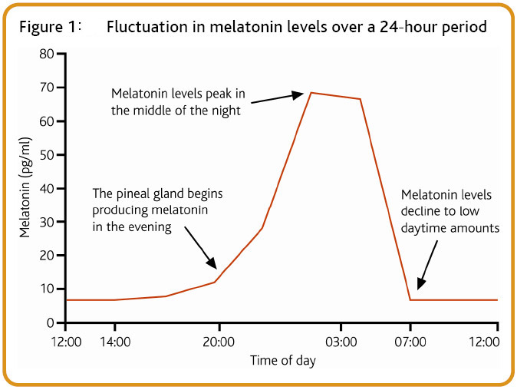
Aging and Sleep:
- With less physical activity in older persons, falling asleep may be more difficult
- With aging, the body produces less growth hormone and less melatonin, 2 hormones that are related to sleep
- Less exposure to sunlight may also become a problem
- Older persons fall asleep earlier, wake up earlier and tend to wake up more often
- Older persons may have sleep difficulties induced by medical problems or the medications used to treat those problems
The Basics of Sleep:
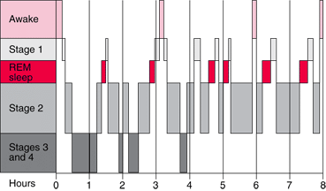
Types of Sleep:
- Two stages of sleep
  - Non-REM
    - This type of sleep has 4 stages
  - REM (Rapid Eye Movement)
- Non-REM
  - Accounts for the majority of time spent in sleep
  - Stage 1 is the first and lightest stage of sleep, stage 4 is the deepest level, from which it is difficult to arouse the sleeper
  - Blood pressure, heart rate and breathing are at their slowest in stage 4 of non-REM sleep
- REM sleep
  - Electrical activity in the brain is very high
  - The eyes move rapidly behind the eyelids
  - Respiration rate is increased, although the muscles are paralysed
  - Most vivid dreaming occurs during REM sleep
Sleep Deficit or Sleep Deprivation:
- Evidence is pointing to the idea that sleep is a predictor of how long one will live
- Chronic sleep deprivation increases the risk for developing diseases such as those of the heart
- The relation may come from the diminished time that the body has to repair itself
- The amount of sleep people get has been decreasing over the last 100 years since the development of the light bulb
- The recommended amount of sleep for adults is 8 hours per night
- The theory is that sleep time is necessary for the body to repair damage of daily living
  - From the videos: http://www.cbsnews.com/video/watch/?id=4181992n
Part 1:
  - Listen for the relationship between sleep and memory
  - What are the emotional responses in the college subjects who were deprived of sleep?
  - Carefully observe the response time of the young lady in the experiment
  - What was the term used to describe the “tuning out” of a person who is chronically sleep deprived? How much time elapses before coming out of lane while driving? How much time would it take for a driver to end up in the ditch?
  - What are some incidences in the news that are thought to have been related to sleep deprivation?
  - Explain the response of sleep-deprived subjects to disturbing images, and the suggested explanation for the atypical reaction.

  - If you or your classmates are deprived of sleep, what is the likely response to this situation?
  - What was the term used to describe the “tuning out” of a person who is chronically sleep deprived? What is a possible result if this occurs?
Part 2:
  - http://www.cbsnews.com/video/watch/?id=4181994n
  - List the different effects of sleep deprivation
  - Which chronic diseases may be related to sleep deprivation?
  - What were the physical effects on the young man in the study who was profiled in this segment?
  - Which type of sleep was he being deprived of—deep sleep or REM sleep?
- What is the solution for society of widespread sleep deprivation in the population?
Effects on Cardiovascular System:
- The Nurses Health study has shown that women who slept less than 6 hours per night had an 18% higher risk of heart attack
- Those who slept 5 hours per night had a 39% increased risk
- During REM sleep, blood pressure and heart rate increase
- Stress hormones adrenaline and cortisol are released just before waking
- If sleep is reduced, stress on the heart may be increased
- Sleep apnea is a condition in which the airway is obstructed during sleep
- Breathing can stop many times through the night
- To counteract the effect of the stoppage in breathing, the body’s reaction is to hyperventilate
- During the hyperventilation, BP and heart rate increase markedly
Sleep Deficit-Diabetes:
- Post-breakfast blood sugar levels showed dramatic rise in one study
- Secretion of insulin was lowered
- In another study, women who were sleep-deprived were more likely to develop diabetes than those who slept 8 hours per night
Sleep Deficit-Hormonal Imbalance:
- Levels of thyroid hormones are abnormal in persons who are sleep deprived
Sleep-Immunity:
- Immune defence will decrease if one accumulates a sleep deficit, even after only one night of sleep deprivation
- One night of recovery sleep allowed some return of immune system to normal
Sleep-Weight Gain:
- Recent research is showing that being deprived of sleep increases the appetite
- The mediator may be leptin, a hormone that signals satiety after eating, which may be reduced in those who are sleep-deprived
- The result is that there is an increase in appetite
- Growth hormone release is diminished with lack of sleep
- This hormone is needed to encourage healing and repair, even in adults, and controlling percentages of fat and muscle in the body
- Growth hormone is secreted during sleep, and the amount secreted declines with age
- Caloric intake for those who stay awake longer than usual tends to increase over and above the amount required to cover the extra activity needs of the body
Review:
- What function does sleeps fulfill, and what is the suggested range of hours of sleep most adults should attain?
- What are the 2 hormones that are related to feeling sleepy and the amount of sleep we get?
- What do these terms mean—REM, non-REM? Compare the differences between them.
- Sleep deprivation can have various negative effects on the body. Which chronic diseases have been linked through studies to sleep deprivation?

Protecting Yourself from Heart Disease:
Heart Disease Defined:
- Heart disease describes diseases that affect the heart itself, the blood vessels of the heart, as well as other conditions that affect the heart
- Heart disease generally describes conditions that result in narrowing or blockage of the vessels that can lead to heart attack, chest pain on exertion (angina) or stroke (blockage of blood vessels to brain)
- The terms heart disease and cardiovascular disease are used interchangeably
Symptoms:
- In cardiovascular disease, the blood vessels become blocked, narrowed of stiffened
- The stiffness prevents the blood vessels from carrying sufficient oxygen and nutrients to the heart, brain and other tissues
- A person with heart disease may experience shortness of breath and chest pain on the slightest exertion
- Other symptoms include numbness, weakness in the arms or legs if the narrowed blood vessel is in the extremities
- More serious symptoms may include a heart attack, angina (chest pain), stroke or heart failure
How the Heart Works:
- The heart is simply a muscular pump that distributes necessary blood throughout the body
- The blood is the carrier for oxygen and nutrients to the tissues, and for carbon dioxide and wastes taken away from the tissues for disposal
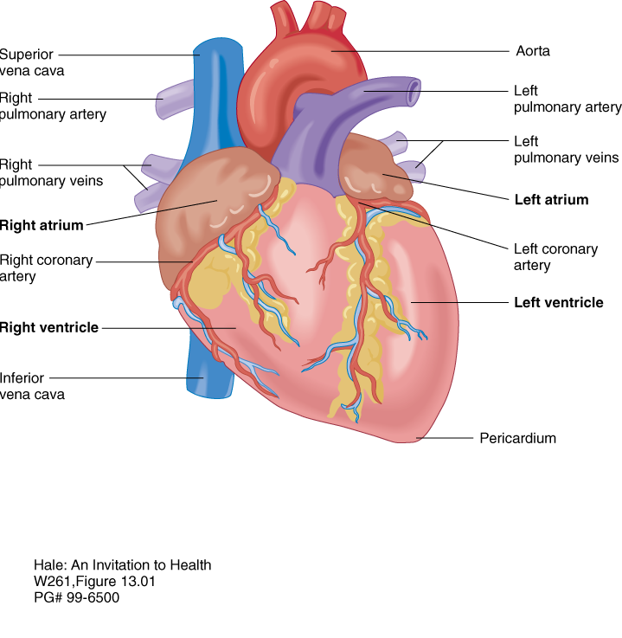
©2003 Wadsworth, a division of Thomson Learning, Inc. Thomson Learning™ is a trademark used herein under license.
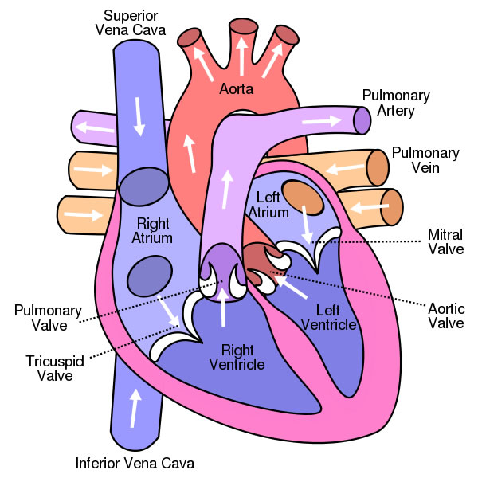
- The right side of the heart (right atrium) collects deoxygenated blood from the tissues then pumps it to the lungs from the right ventricle
- The collecting vessels are the venules that then empty into the larger veins which carry the deoxygenated blood to the right atrium
- In the lungs, the carbon dioxide is removed from the blood and oxygen is picked up
- After leaving the lungs, the newly oxygenated blood is brought back to the left side of the heart (left atrium)
- From there, the blood is pumped from the left ventricle and out to the body
- Blood vessels that carry oxygenated blood to the tissues are the aorta (the largest artery), the arteries and then the smaller arterioles
- The smallest blood vessels in the body are the capillaries
- The walls of the capillaries are the areas where exchange of oxygen, carbon dioxide, nutrients and wastes occurs
- Valves within the heart ensure that blood keeps moving in the correct direction with no backflow of blood
- When the heart is contracted, this is the moment of maximum pressure on the blood
- This moment is called the systole, when the ventricles are contracted
- When the heart is relaxed between beats, this moment is called the diastole
- It represents the time when the blood pressure is lowest between heartbeat cycles-the ventricles are filled with blood and not contracted
- There is an electrical system in the heart that distributes the signal for heart contractions
- The signal originates in the brain, then is sent to the SA node (the heart’s pacemaker, also called the sinoatrial node)
- The electrical signal is distributed throughout the heart muscle
- A second node (the AV or atrioventricular node) checks the signal then distributes it throughout the heart to maintain coordination in the pumping action of the heart
Causes of Heart Disease:
- Atherosclerosis is the medical term for what is generally called heart disease
- This refers to a buildup of fatty plaque in the heart’s blood vessels (coronary arteries) that occurs over time
- The walls become narrowed, which decreases blood flow and oxygen passage to the heart muscle
Risk Factors:
- Age
  - Increasing age increases one’s risk of heart disease, through changes in arteries or weak or thickened heart muscle
- Gender
  - Males have a higher risk of heart disease before the age of approx. 55-60
  - After menopause in women, females’ risk of heart disease rises to approximate the rate of men
Risk Factors of Cardiovascular Disease:
- Family History
  - Onset of heart disease in a close male relative (before age 55) or close female relative (before age 65) increases risk
- Smoking
  - Nicotine intake from cigarettes leads to constriction or narrowing of blood vessels
  - Carbon monoxide, damages the lining of blood vessels, esp. those of the heart
- Poor Diet
  - A diet that is high in fat, cholesterol and salt increases the risk for heart disease
- High blood pressure
  - Elevated blood pressure that is not dealt with can lead to narrowing and thickening of artery walls
- High blood cholesterol
  - Elevated levels of cholesterol in the blood increase risk of formation of fatty plaques in the artery walls
  - “Bad cholesterol” or LDL cholesterol describes the lipoprotein that carries cholesterol to the body’s tissues
  - A high level of LDL increases risk
  - HDL, also known as “good cholesterol” is a lipoprotein that removes cholesterol from the body’s tissues and takes it back to the liver
  - A low level of HDL increases risk
- Diabetes
  - Increases risk, especially if diabetes is poorly controlled
- Obesity
- Physical Inactivity
  - Lack of activity or sedentary living increases risk
- High stress is a risk factor, esp. if stress is constant, not dealt with
- Poor Hygiene
  - Certain infections can increase risk, as can poor dental hygiene through entry of infectious agents into the blood stream
- Heart failure
  - The heart is too weak to pump blood through the body adequately
  - The ventricles (the pumping sections of the heart) become bigger but weaker
- Heart attack
  - When the flow of blood through a coronary artery is blocked due to a clot or complete narrowing, a section of the heart will be deprived of oxygen and will be damaged or destroyed
Stroke:
- Stroke
  - Arteries of the brain are narrowed or blocked
  - This leads to lack of oxygen to the corresponding part of the brain
  - The brain’s cells will start to die within minutes without immediate attention to decrease the blockage
Complications:
- Aneurysm
  - A bulge occurs in the wall of the artery
  - The aneurysm can burst, leading to lack of oxygen or serious internal bleeding
- Peripheral artery disease
  - The arms, and especially the legs, do not receive enough blood, therefore are deficient in oxygen
  - The result is pain on exertion
- Sudden cardiac arrest
  - Due to serious disturbance in electrical signals to heart
  - The heart stops beating, so that no blood flows to the rest of the body
  - This condition is life-threatening, and can result in sudden death
Treatment and Drugs:
- Lifestyle changes are necessary
- Dietary changes-eat a low-fat, low sodium diet
- Physical activity-at least 30 minutes of moderate exercise on most days of the week
- Quit smoking
- Limit alcohol intake
- If hypertension (high blood pressure) is present, medications will be used to control this condition
- Blood thinning medications (e.g. baby aspirin) and/or cholesterol lowering medications can be prescribed
Review:
- What risk factors can’t be changed?
- What risk factors can be changed to lower one’s risk of heart disease?
- How many unchangeable risk factors do you have?
- How many changeable risk factors do you have
- You can check your BP at a pharmacy for free
Lifestyle/Home Remedies:
- If you smoke, stop smoking, as smoking is a very potent risk factor for heart disease
- Control blood pressure
- Keep cholesterol at a healthy level (LDL below 130 mg/dl or 3.4 mmol/L)
- Control diabetes through proper diet, use of medication, healthy weight
- Become physically active-at least 30 minutes of moderate activity most days of the week
- Follow a healthy eating regime, more fruits, vegetables, whole grains, less fat and sodium
- Maintain a healthy weight
- Ensure waist measurement does not exceed 40 inches if male, 35 inches if female
- Practice good hygiene to decrease risk of infections
- Maintain good dental hygiene to decrease risk of oral infections affecting the heart
- If already affected by heart disease, get a flu shot every year, as being infected by the flu increases heart attack risk
Questions?
- What is the basic function of the heart?
- Which of the four sections of the heart is the most important for ensuring adequate blood (and therefore oxygen) transport to the body’s tissues?
- The aorta is the largest artery in the body. What are the next smaller branches called, and which are the smallest? What is the name of the smallest blood vessels of the body and what is their important task?
- What is the name of the compound that becomes deposited in the body’s blood vessels that sets in motion the development of atherosclerosis?
- List the risk factors for cardiovascular disease. Which of these risk factors are unchangeable, and which are changeable and more related to lifestyle habits? Are there any of the risk factors that could be unchangeable for some persons but changeable for other persons?
- Some videos related to this subject:

- http://www.youtube.com/watch?v=H04d3rJCLCE
- The anatomy of the heart and cardiovascular system, explains atherosclerosis
- http://www.nlm.nih.gov/medlineplus/ency/anatomyvideos/000021.htm
- Short explanation of the electrical system of the heart

