Cell Biology

Lecture 1 September 11th 2015
Office: Gendron (GNN) 260
Office Hours: Tuesdays 1:00-2:15 pm
Email: mjonz@uottawa.ca

Introduction to Cell Biology

Cell biology: In General
- Structure and function of cells
- From groups of cells (tissues, organs) to molecules (e.g proteins)
- Forms basis of many other disciplines, e.g. physiology, medicine, developmental biology, biochemistry, neuroscience
- Evolution: diversity of life and conserved characteristics
3 Divisions of the Living World
- Archaea: Life came out of some archaea bacteria.
- Eubacteria: is the more modern bacteria
  - Prokaryotes
- Eukaryotes: the main focus of this course
- The difference here is one change per 10 nucleotides and it tends to matter a little less where these cells are coming from. If you are looking at different types of animals, there are differences but from the perspective of a cell biologist its not at all that different.
- 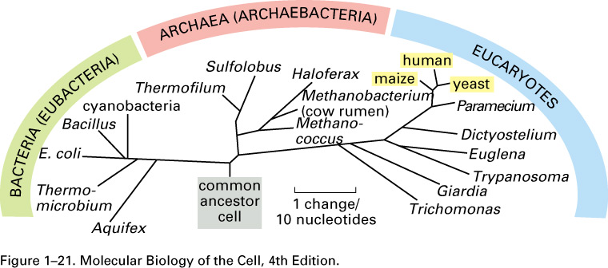

Characteristics of Eukaryotes
- They have compartments, Nucleus, 1000x larger by volume, “cytoskeleton”, internal membranes.
- Some form of cytoskeleton structure made of different proteins.
- Compartmentalization is important in the genesis of these cells because of separation from other environments.
- ATP currency of energy found in all cells, can even be used for neurotransmission.
- Biochemical aspects
Other Features
- Size: 10-100 micrometers
- Separated from outside by a memebrane
- Cells communicate with other cells
- High degree of organization and compartmentalization
- 70% H2O
- ATP required for many reactions
- Chemical composition: sugars, fatty acids, amino acids, nucleotides
The Importance of Water
- Covalent bonds with the H2O molecule, hydrogen bonds allowing easy interactions between the water. 70% of cells are made up of water, is the mediate resource of chemical reactions in a cell.
- A large amount of proteins that take part in more than one chemical reaction in the end there’s such high specificity.
- The hydrophobic effect and the cell membrane. Water is important because it allows the formation of membranes. Phospholipid membranes are always going to be hydrophobic.
- Transient interactions between waters allow for liquid state
- Medium permits a vast amount of chemical reactions
The Plasma Membrane
- Very important in the formation of membranes and the evolution of cells. If we fill a test tube with water and oil, the oil goes at the top, they all arrange themselves so that the polar heads face the water and the nonpolar don’t. The membranes are formed from amphipathic molecules
- Formation of a vesicle (micelle) of a 3D sphere where we have 2 layers
- 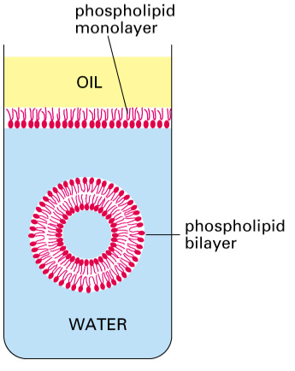
- The cell membrane must be permeable
- Insertion of membrane proteins (ion channels, transporters) allows passage or exchange of important ions or molecules.
- Highly conserved among cellular organisms

Lecture 2 September 15th 2015

Research Techniques I: Microscopy and Cell Imaging
“Seeing” at the cellular and subcellular level

Several Types of Microscopy
- Light microscope: something we’ve been using for a very long time
  - Fluorescence microscope: at specific wave lengths we can manufacture bulbs that can stimulate wide spectrum light. Filters to separate high intensity light
  - Confocal microscope: same fluorescent principals, more complicated technique to reduce background.
  - Two- photon microscope
- Electron microscope: something not generated with light. some allow to see large structures or we can look at vesicles, bilayers etc.
- 1A= 0.1 nm
- In the light microscope you can’t see the thickness of something.
- What are the differences and when would you apply these techniques?
- The limitations of light microscopy come from the diffraction of light in air, water and oil. It limits our ability to use it in smaller scales.
- 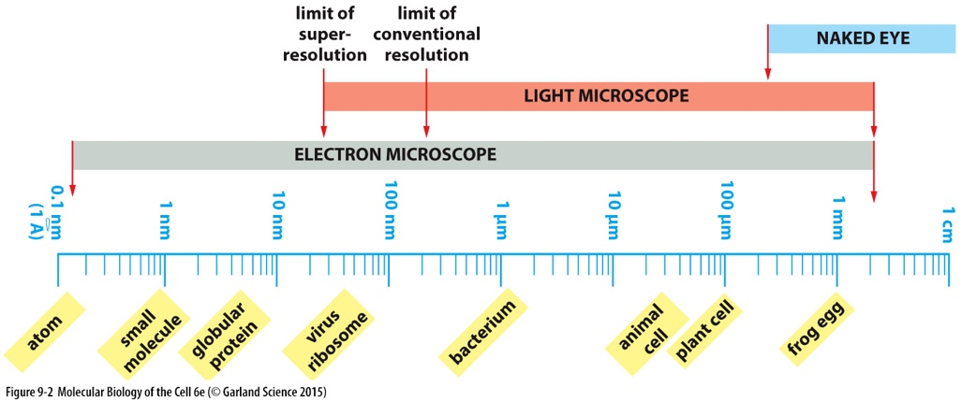

The light microscope (LM)
- Utilizes basic light path
- Used for live or fixed cells and tissue
- Tissues: upright microscope
- Isolated cells: inverted microscope
- Work away from the path of light, it originates from some light source. Focuses the light on the specimen by a condenser which then focuses on the back of the eye.
- 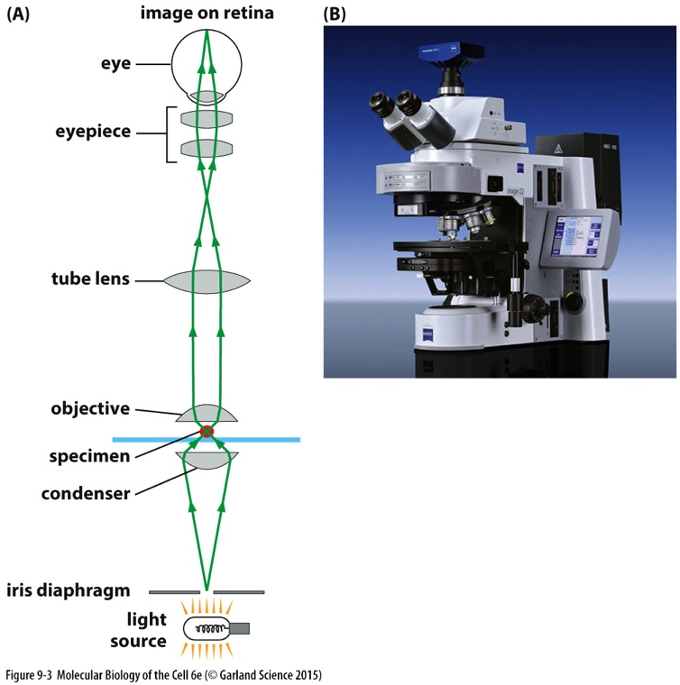

Four types of LM
- Bright field
- Transmitted light
- You can put dyes in them to label things
- Phase contrast
- Converts phase differences into changes in brightness
- Pushed microscopy forward and allowed us to see more definition
- As light travels through a specimen, the waves are more effective and slightly modified so that for a moment it will be out of sync.
- Phase shift where the waves are no longer aligned
- Phase contrast microscope takes this phase shift and puts it back in line where it increases the brightness
- Use little rings to re-align
- Wave properties of light can be exploited.
- In unstained cells, a phase shift will occur as light travels through the cell
- Phase alignment is related to increased brightness
- Observable with phase contrast
- 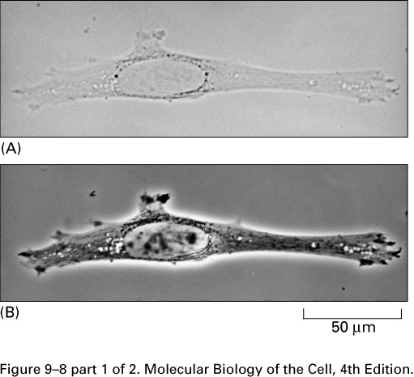
- 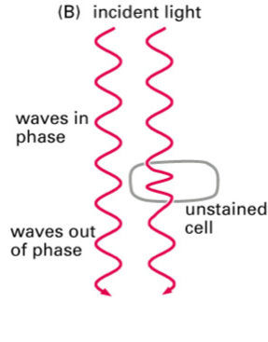

- Differential interference contrast (DIC)
- Takes these phase properties of life and produces phase contrast.
- The way the light is separated, uses prisms.
- Dark field
- The light is oblique
- When you illuminate anything the light is always scattered
- 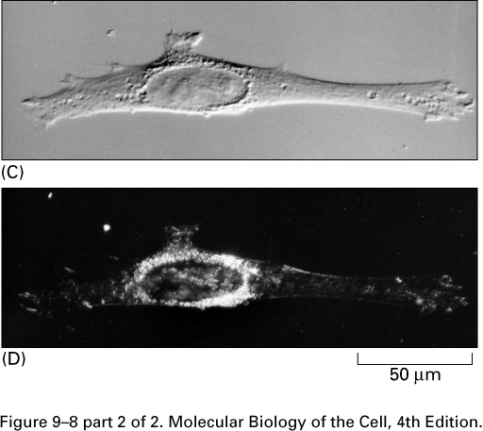
Fluorescence Microscopy
- We use this type in cases where we want to detect specific molecules or even ions.
- Based on the principal that some molecules absorb and emit light at specific wavelengths
- Light is elevated to an excited state, short period of time later it drops down to the ground state, when it does so it emits a photon of light. Substances that emit and absorb can be used, this emission is always occurring at longer wavelengths.
- Whatever force of molecule we are working with; these principles are always going to be the same.
- Configure our microscopes so that we can excite that molecule at that wavelength.
- Two different colours because you have to excite the molecule in the blue spectrum of light
- Atomic absorption of a photon is follower by emission at a longer wavelength, and a light signal is detected.
- A variety of fluorescent molecules are used in fluorescence microscopy
- Note spectral characteristics of each dye/molecules
- 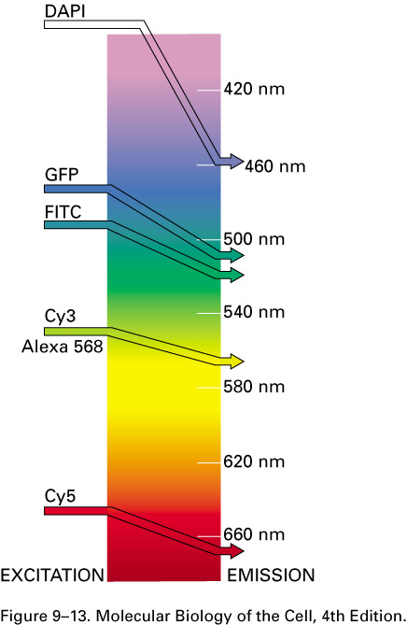
- Fluorescence microscope is optically similar to LM.
- High energy lamps (Hg) provide bright source.
- Filters reduce light of unwanted wavelengths
- Chromophores excited at specific wavelengths.

- 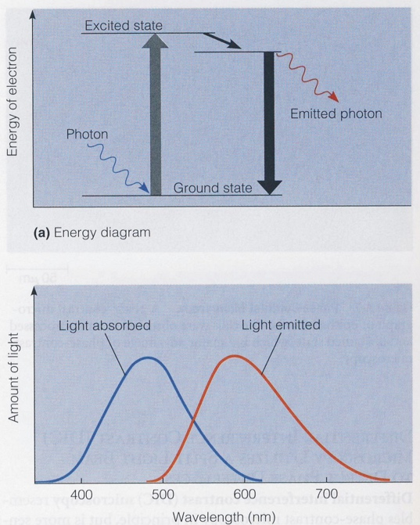

Phase and DIC compared
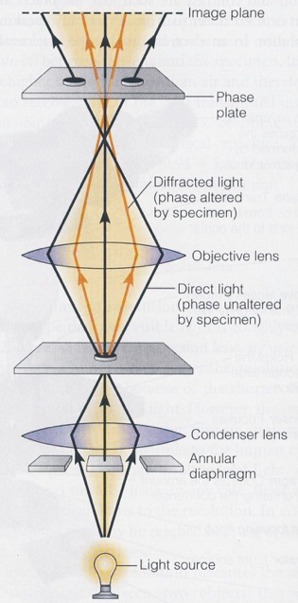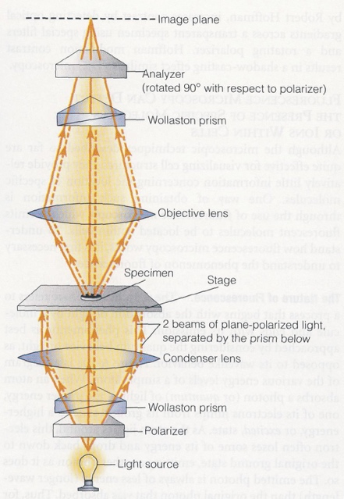

GFP in Research
- Transgenic mice generated to express GFP and other “FPs”
- Permits selective labelling and imaging of cells in live specimens
Tissue Preparation
- Look at how cells are organized in tissues. We have to first prepare them for microscopy.
- Microtome: Cut tissues away so we can place them on microscope slides
- Fixation: preserve and stabilize proteins, if you take tissue that is not fixed you get a pile of mush. Cells and tissues begin dying off because it needs to be preserved. Needs to be close to the environment where it came from, and then you can put fixatives to preserve the tissue. Makes it stronger, cross links proteins…
- Embedding: in many cases we embed it into plastic or some kind of sugar compound that we can freeze (polyethylene glycol compound).
- Sectioning: cut small sections about 1-10 micrometers on a microtome
- Staining: haematoxylin and eosin are both very common.
- 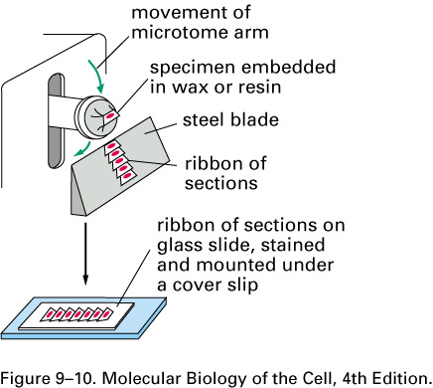

Immunofluorescence
- Antibodies, using technology from our understanding of the immune system.
- Antibodies are produced in a host animal such as mice, chicken etc., (all sorts of different mammals)
- They produce antigens, produce antibodies against this antigen
- Fixed tissue is permeabilized and treated with primary antibody directed against a specific antigen.
- If we take our fixed tissue, we apply the antibodies and we apply a primary antibody. We use a secondary antibody which carries a fluorescent probe (anything that is excited by light) binds to the primary antibody. These are also produced in an animal; they bind to immunoglobulins.
- Antibody binds to antigen on or within cell.
- Indirect immunohistochemistry where we are using two different methods, labels cell structures.
- Why do we use primary and secondary? Why don’t we just put the fluorescent marker onto the serotonin antibody? Because it amplifies the antibody, far better signal then if there was just one probe on a single antibody.
- 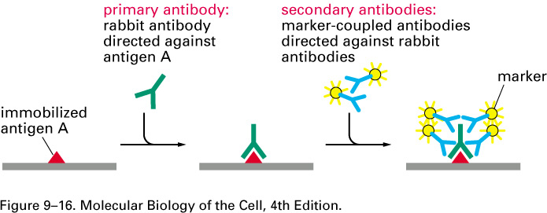

Confocal Microscope
- Much more clear image with a reduced noise or background signal.
- Particularly useful for applications involving thick sections or whole-mount preparations
- When you do fluorescent, prevents you from finding the out of focus. Useful in situations which we are using thick tissue sections, maybe 10 or more micrometers thick
- We can use the same markers, just a different way of getting these images
- Confocal: refers to the similarity between the light source and the object.
- The pinholes are very small holes used to make these, they can be adjusted in size, they help focus light onto the specimen. Helps polarize light in a specific direction. Produces an optical section with low background “noise”.
- Illuminating a small part of what we want to see. Once we excite this part of the tissue, light moves towards the detector
- We want to filter a lot of the stuff and get deep down to the tissue. The light that is in focus is in focus because of the objective lens, it is perfectly focused past the pinhole. If we wanted to see a big part of the tissue it wouldn’t work because it is not focused enough and it wont be detected * therefore reducing the unwanted signal.
- We use this when we use thick pieces of tissues! We can produce 3D rudiments of tissues and begin to manipulate virtual tissue.
- This way you can produce optical sections. You can image this entire piece of tissue while always taking out the information.
- 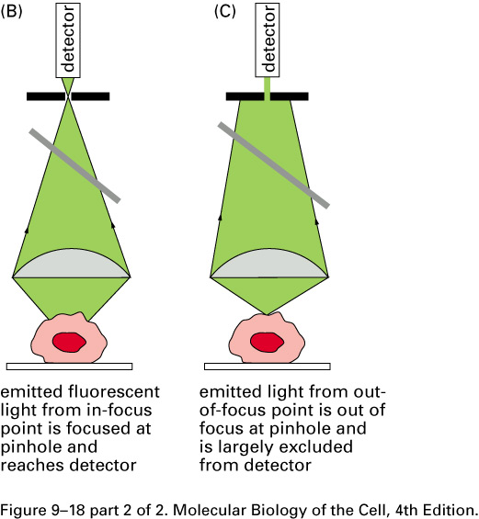
Two-photon microscopy
- Advantages:
  - Non-linear technique that uses higher-order light-matter interactions from multiple photons to generate contrast
  - Allows deep tissue imaging (up to 1 mm depth possible)
  - In this process, absorption occurs in the near IR region, and NIR light penetrates deep into tissue.
- Disadvantage:
  - Very costly
- Two-photon absorption involves “simultaneous” (-0.5 fs) arrival at excitable molecule.
- Excitation and emission occurs, as in fluorescence
- However, signal is dependent upon photon density, so absorption is spatially confined
- In confocal, single photon absorption occurs throughout exc. Light cone.
- Utilized in a similar sort of situation but we can get high resolution and we can go deeper into tissue.
- IR light can be used to penetrate deeper into tissues and illuminate markers that can be expressed. Used mostly in deep tissues.
- They arrive at the same time and excite these markers.
- Technique is very costly
- 2 Photons that are elevated to an excited state, because of this if we focus light on a very discrete portion of tissue.
- Rapid intensity stimulation of light, in such a precise way that you are only going to excite the molecules associated with a small group of cells.
- It is dependent on photon density
- 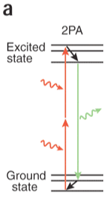
- 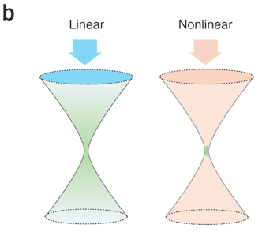
- Differs from confocal by excitation laser and detection pathway
- Rapid high-energy laser pulses (100 fs; 100 MHz) are emitted.
- Beam expansion tube and scan lens focus light onto sample
- Signal collected by detector depending on sample thickness.
- No pinholes needed, as in confocal.
- Example of in vivo deep-tissue imaging.
- 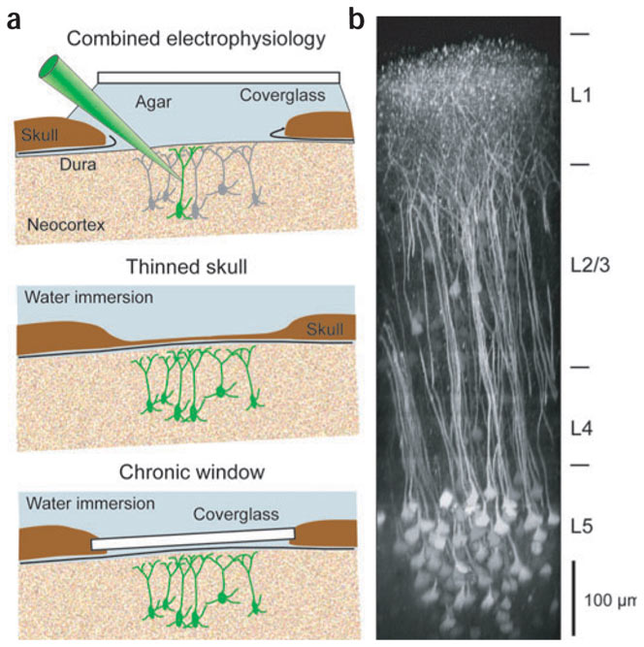
Things to Consider…
- What are the primary differences between the different types of microscopy discussed so far?
- Think about appropriate applications in which you would use regular fluorescence, confocal and two-photon microscopy.
Research Techniques II: Microscopy and Cell Imaging
“Seeing” at the cellular and subcellular level (cont’d)
Electron Microscopy
- We can resolve structures down to a 10th of a nanometer, or an angstrom. Disadvantages of it is time consuming.
- Something that has been used for many years, we have so many advances in light microscopy. Some cases where this is the only way to go.
- Technique with a long history
- We will discuss two major types:
  - Transmission electron microscope (TEM)
  - Scanning electron microscope (SEM)
- Uses bombardment of electrons rather than light
- Advantage:
  - Resolution 2,000x that of LM. 0.1 nm=1.0 Angstroms. Lower resolution in some biological preparations (2nm)
- Disadvantages:
  - Very time-consuming preparation. But for some experiments, this is the only appropriate technique.
Transmission EM (TEM)
- General configuration analogous to LM. Flipped upside down compared to a regular one
- Condenser lens: helps condense the electrons like a magnet, little grid with a copper screen on it that holds the specimen, after we have another magnet. These focus the image that is produced onto a film or a detector. Electrons emitted at filament or cathode.
- Light that passes through the specimen you will see. With the EM, the electrons might be prevented from getting to the detector. Accelerated by high voltage in a vacuum.
- EM is all about black and white, what gets bounced off and what gets through. Its all about the electron density in the cell. Magnetic coils focus electron beams like a lens
- When we see black spots, we say these are electron dense. Sample may be stained, we can produce contrast by staining
- 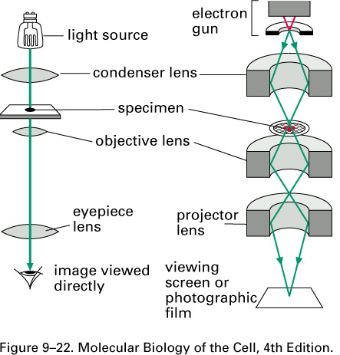

Lecture 3 September 18th 2015

Preparation for TEM
- Lengthy procedure that takes days to weeks.
- The tissue must be fixed in glutaraldehyde and the addition of OsO4 (osmium tetroxide) increases electron density.
- Series of ultrathin sections (50-100nm) on a piece of copper, must be cut with a diamond knife so that it can be suspended over the screens of the copper.
- Typically, in glutaraldehyde, osmium tetroxide is used to stain tissues that produces contrast in the tissue.
- 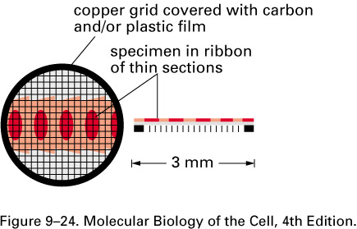
- The slices of tissue are much smaller because we can’t get electrons through them and everything will be reflected. (ultra thin sections)
- Black and white photograph, when electron hits the tissues and bounces away it produces black film. If electrons get through the loosened tissue, it produces a light grey.
TEM Micrograph
A mitochondrion A Mitochondrion in serial sections
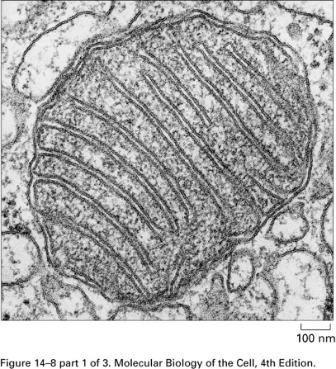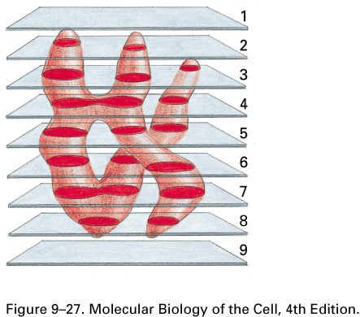

- You can see the cristae of the mitochondria, cannot see this in a light microscope. We are looking at high electron density places, the very thin sections have less electron density and can travel through.
- Mitochondria as we know are very complex organelles, serial section electron microscopy can be time consuming. Eventually generate an image with parts that have different shapes. Serial section microscopy, we then discover what the structure really looks like. (3D)
- You have to think about what it really looks like in 3D, we are only looking at 2D. How do you cut the ultra thin sections? Ultra microtome especially designed for cutting sections (automated, can set it by rotating the tissue and catch on a little puddle of water)
Immunogold EM
- At the stage where after the sections are cut, we then react them with antibodies. These bind to specific antigens on the specimens.
- Generate antibodies for a protein and then put them on the specimen. Instead of a fluorescent marker we use a little particle of gold to the second antibody. It attracts electron density on to the sample. (Specially in the places where the proteins are found)
- The gold increases the electron density in the sample so that you can see more.
Scanning Electron Microscope (SEM)
- Produces 3D images of surface structures.
- Used to study whole cells and tissues, rather than intracellular structures.
- Principles of preparations and operation similar to TEM.
- Cells/tissues coated with heavy metal.
- Scattered electrons from the specimen surface are collected
- Transmission is the transmission of electrons in tissue slices
- This is when you have a whole piece of tissue and you are bombarding that structure with electrons (can use specimens, medal, etc.) this is a technique used in material sciences ex. Nanotubes
- It will give you topological information. If you are applying this to a cell you will see no more than the surface of the cell.
- Produces 3D look to it, produces almost texture to the picture. Would be better to use on tissues rather than organelles.
- Preparation is similar, coat the entire specimen in gold. Put the tissue into a chamber, coated in gold particles (thin layer) and this produces a uniform property, the only variable is the contour
- The head of an insect that has different softness, the gold makes it uniform all over. This information is then turned into topological information after we hit the specimen with electrons.
- The scattering of electrons is what is collected by the detector
- The difference in the set up is where the specimen. You don’t want to record the number of electrons passing through the tissue, want to record the amount bouncing off the tissue.
- 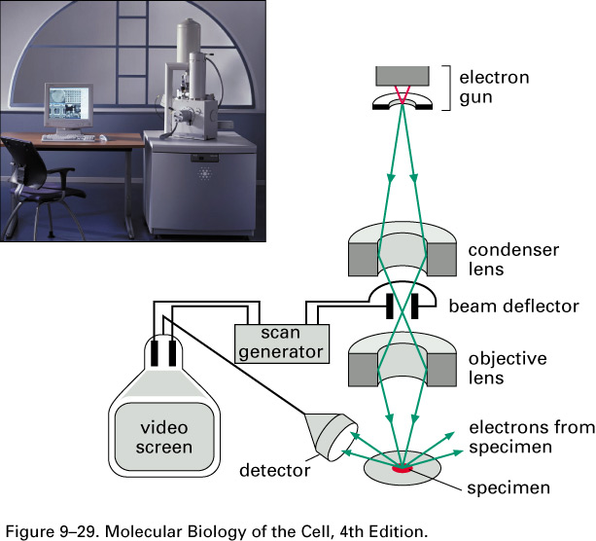

SEM Micrographs
- Bacteriophage and head of an insect. Virus that infects bacteria, example of how we might use SEM.
EM and LM Compared
SEM DIC TEM
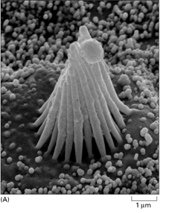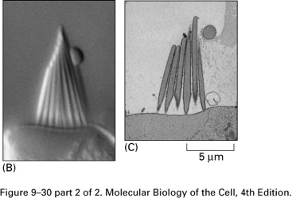

- These are cells involved in detection of sound (stereocilia)
- SEM we are looking at the outer surface of the cell and the orientation of the cell.
- TEM the section of material probably didn’t have the serum.
Ion imaging
- Falls into the category of light microscopy. This is an example of something in which we can derive physiological information from a cell by changes in the intracellular ion concentrations (e.g. Ca and H) which are physiologically important.
- In the case of Ca and protons in terms of pH and concentration. In the case of the concentration of Ca, these are kept in the nanomolar range.
- Ion-selective indicators emit light depending on local ion concentrations which can reveal rapid intracellular dynamics.
- Calcium is very important in tissues… physiologically important because we can use imaging to record changes. We can emit light based on the concentration of these ions
Calcium Imaging
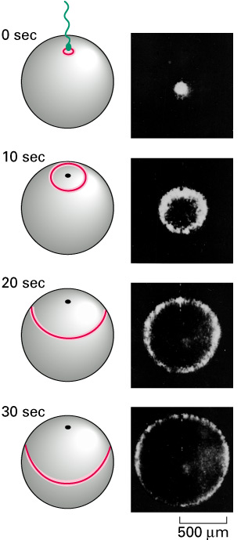

- During fertilization there’s an increased in calcium concentration that travels throughout the egg.
- Intracellular Ca is low.
- Bioluminescent Aequorin injected into a fish egg, reveals Ca wave propagated during fertilization.
- Other synthesized indicator molecules produce signal (E.g. Fura-2, Fluo-4)
- Aequorin, inject these into the cell or expose in. When calcium interacts with one of these dyes it changes the conformation of the indicator dye and changes its light emitting properties (change the emission or the wave length)
- Basically at the site (0 sec) and you can see a white pattern of calcium emerging, this contributes the prevention of other sperm cells to come in
- There are detectors that detect changes in intensity (sometimes in colour) we take this info and transform it into words.
- Ratiometric imaging exploits differential wavelengths associated with ionic bonding. We can compare the emission at the same wavelength. Allows us to produce a ratio based upon the concentration of calcium.
- Dyes can be injected, or “AM” analogues can be used to cross cell membranes. = acetoxymethyl ester

X-ray Crystallography
“Seeing” at the molecular level
- Allows us to understand the structure of proteins, and understand their function. “seeing” at the molecular level.
- Structure and function are inseparable, allows us to achieve atomic resolution. This can be single proteins like hemoglobin or even more.
- The scattering of light; if we take a piece of a cardboard and cast light on it and have a screen on the other side, we will see a pattern of interference. Any wave, you have constructive and destructive patterns. Its this principal of using the wave properties of light and going through more than one hole in a barrier that produces an interference pattern.
- Think of a protein as a structure with a lot of holes in it. Bombarding it with light and what you detect is the interference pattern that you have on the film in the end.
- The crystallography part of it, you have to have a couple milligrams where you can actually see it, you have to produce a crystal of this protein. X-rays can penetrate deep inside structures.
- Depends on the quality of the crystal and the amount of protein that you have in the crystal.
- MacKinnon, structure of K+ ion channel. One of the challenges is to stabilize the proteins so that they can be crystallized (hydrophobic) so how do you do this? They used monoclonal antibodies used to hold protein. Allowed to stabilize.
Lecture 4 September 22nd 2015
Cytoskeleton Filaments

Lecture 5 September 25th 2015
Intermediate Filaments
- When they assemble they make a rope like appearance
IF Types
- Epithelial (keratins) material for example in the finger nail is rich in these types of filaments.
  - Structures exposed to shearing stress or bending.
  - Very diverse family
  - Type I and II keratin chains
  - Add strength in hair, nails
  - Intermediate filaments are labeled in fluorescent green. The blue is the possible location of the plasma membrane.
- Axonal (neurofilaments)
  - Play a role in the growth of axons and the stability
  - Found in central and peripheral axons of vertebrate neurons. Single cell can go the entire length of essentially your leg. Protected by a protective sheet. Inside we have single cells projected in long filaments.
  - Growth, increase axon diameter.
  - Type L, M or H.
Cytoskeleton II: Regulation
- We started off with the three main proteins, we are going to look at the fourth (the accessory proteins). These are important to the cell in terms of regulating the cytoskeleton.
Accessory Proteins
- Filaments (AFs, MTs, IFs) are dynamic and under control of the cell. There are a number of different accessory proteins that take cues from the cell. It is from outside of the cell and is transformed across the membrane and create a cascade of events.
- We see the formation of higher order structures (mitotic spindle- small reactions that contribute to the building of the structure of a cell).
- They modify cytoskeletal dynamics
Nucleation by tubulin protein complex
- They allow for a large extent of placisity and assembly and disassembly
- If we start from scratch, they first must be nucleated.
- There are some accessory proteins that take place in nucleation (alpha and beta tubulin). They both bind GTP, only one has is hydrolized. Gamma tubulin is very important as an accessory protein because it facilitates nucleation.
- Centrosome in animal cells (MTOC)
- Spindle pole body in yeast is the microtubule organizing centre in yeast
- Gamma-tubulin is highly conserved in all different cell types
- Gamma-tubulin ring complex, accelerates MT formation. Faciliates nucleation during the formation of microtubules.
- The way these microtubules are formed are formed as a ring and then folded over. Occurs at the (-) end. We have ring complex that acitively recruits the heterosdimers and eventually forms this structure.
- + end is the actively growing end, we see dynamic changes at the + end
- MT initiation also occurs in cytosol, gamma tubulin is also in plant cells and it can initiate nucleation.
The centrioles and centrosome
- The centrosome contains two centrioles and a cylindrical structure. Before a cell divides the centrioles duplicate as well. Paired at right angles, main task is to organize the pericentriolar material: also called the PCM, contains gamma tubulin.
- The PCM is part of the centrosome, this is what helps organize the microtubules that are so important in the assembly of the cell
- The reason we have duplication, the centrosome has to divide and go to opposite parts of the cell. The PCM starts organizing the gamma-tubulin and these go in all directions.
- Because of dynamic instability we will have merging of the MT and they will overlap.
- Structure of the centrosome is organized in a wheel-like pattern
- Centrosome found near the nucleus
- (-) ends are somewhat anchored into the centrosome, the (+) ends are emanating in all directions.
Nucleation of AFs
- Actin filaments exist in the cortex of the cell and is most dense.
- Changes of cell shape and movement. Some of these include actin related proteins (ARPs) that are facilitated by ABPs (actin binding proteins)
- Rate limiting step in the growth of the cytoskeleton
Initiation of AFs (unbranched)
- Formin, (muscle spindles contraction ) dimer that is a large protein compared to single monomer of actin. Their role is to orientate actin for the correct polymerization.
- As the microtubule is growing, its forming in a spiral way of a microtubule that is going to form a cylinder.
- Organize so that they can properly form a microfilament in more of a complex manner. (spiral like filaments). It kind of stitches everything together. Subunits fall behind it, former dimer is ensuring that there is a correct alignment for this polymerization. In order to be thermodynamically favourable there has to be a correct orientation.
- Think in terms of energy, they have to be properly lined.
Initiation of AF Branches
- Cell periphery, just like gamma tubulin, not only does it produce nucleation, it produces it in branched structures. This is a different utilization of the same protein
- Arp2/3 complex produces branching in the periphery of the cell
- Bind at the (-) end and promote branching … produces this network of actin filaments at 70 degree angles. The nature of the structure of the Arp 2/3 complex, the branching angle is necessary.
- 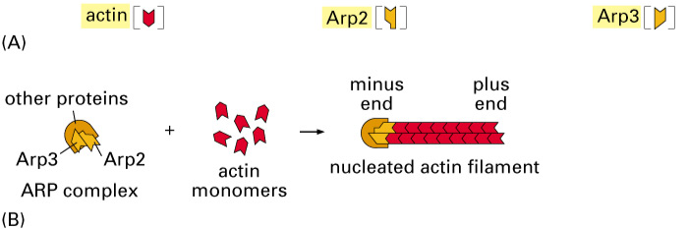
- 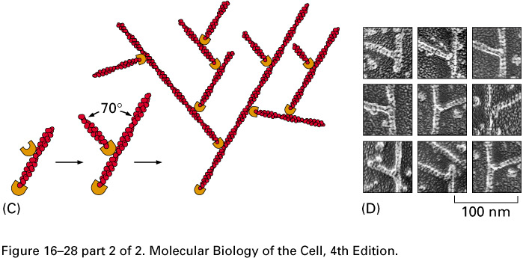
Control of Subunit Pools
- Both actin and tubulin are maintained in the cytosol in high concentrations
- Sequestering of proteins: its not going to be hydrolyzed. It may not be polymerized either. By controlling the subunit pools, they can control or contribute to the formation of the cytoskeleton
Thymosin Sequesters Actin
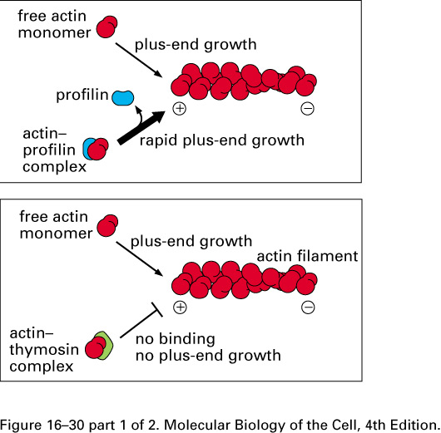
- If actin forms a complex with thymosin, thymosin sequesters actin. It will not bind.
- Free actin monomer continues at its normal paste, proflin forms a complex with actin and speeds up this process. Makes it more possible for actin to bind.
- We have a completion between thymosin and profilin: thymosin is negative and profiling is positive
- 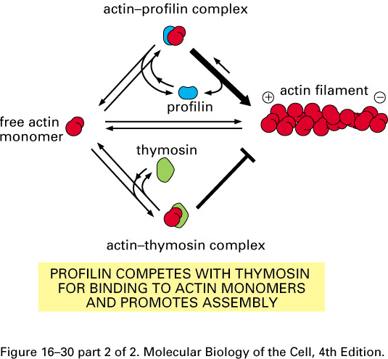
- In a positive and negative force: there is control of filament cell growth * they act at the + end
Stathmin Sequester Tubulin
- Stathmin might have an effect on thermodynamic instability.
- Because it ties up more dimers of tubulin, it makes it more likely that a catastrophe will occur because the concentration of tubulin increases.
- We lose the GTP cap, change shape and bend, the weak molecular bonds between these dimers is not strong enough to keep the microtubule together and it falls apart.
MT- associated proteins (MAPs)
- Might have several binding domains
- The length of a projecting domain determines how closely packed the adjacent MTs are. Lets say we have a cell with MT and MAP2 is bound to the MT and has a little arm that moves out to the side that interacts with another MT adjacent.
- These MAPs can recognize spacing
- Tau that has a different shape, cells that have a higher expression of this protein (in neurons with a denser packing of MTs) this can determine the spacing and packing of the MTs.
- Tau is important in diseases, not able to bind as well to MTs, the spacing of MTs is not regulated as it should be… this can create a neurodegenerative process. Really what’s happening is there is a hyperphosphorylated form: important in cell bio because it changes the structure of proteins which changes function. Tau changes its solubility and changes its ability to interact with MTs.
AF Binding Proteins
- These both bind to the side and not the end
- Cofilin destabilizes AFs
  - Binds to the side and causes a release of actin monomers. Does this by forcing some mechanical stress on the filament. When it interacts with the actin filament it causes a stress, releasing monomers in the subunit pool.
  - Binding induces mechanical stress
  - Treadmilling, turnover
  - Cell locomotion
- Tropomyosin stabilizes AFs
  - Binds to the side of proteins
  - Muscle contraction stability
Moddifications at AF ends
- “capping” accessory proteins that bind to the ends of the proteins.
- CapZ: elongation of microfilaments is slower at the (-) end and faster at the (+) end. This has to deal with the structure of these proteins.
- The difference whether it is hydrolized or not has an affect in the overall structure.
- At the minus end we have monomers that have been hydrolized, less likely to associated with subunits that have not been hydrolized.
- Thermodynamic favourability.
- Does happen but less likely at a slower rate.
- CapZ binds at the + end, if a growing microfilament is better at growing at the plus end, and the capp comes and prevents it, then it starts to grow at the – end.
- We have a strong linear relationship showing the trend of the monomer concentration. If we capp, we have a growth rate that is more NEGATIVE. The dynamics are limited to the minus end of the growing microfilament. This acts to slow down or to regulate the rapid growth.
- They are important for stabilizing the microfilament. (controlling vs. slowing down)
- Trupomodulin (-) capping protein that binds at the (-) end.
Modifications at the MT ends
- In addition to controlling how densely packed microtubules are, they can also stabilize them.
- They bind to the side of the microtubules. If the MT is still growing, it may be the case where this is where the GTP cap is present to prevent it from destabilizing. This leads to longer less dynamic tubules.
- Example: formation of microtoubules in axons, also stabilize so that they don’t fall apart.
- MT important in microtubule formation, dynamic stability is important so that it can form. The other cells that aren’t undergoing mitosis (Ex neuron) may be stabilized by these types of accessory proteins.
- We will see cases where MAPs and other proteins like catastrophin (kinesins) that act to destabilize * opposite affect of MAP proteins. You will see these at the end where they disassemble the mitotic spindle.
Cross-linking proteins and AFs
- High order structures
- Taking actin filaments to build higher order structures. There are many other types of accessory proteins that are important (cross linking proteins)
- They have binding domains, domains specific for binding with actin monomers. The way these cross linking proteins are designed is that they have actin binding domains, placement of these regions that determine the structure being produced!
- Bundling proteins: form compact structures
- Gel-forming: network building proteins
- The red bits in each one of the diagrams represent actin-binding domains. If you have fibrin with two closely packed binding domains, bundling protein that takes actin and puts them very close to each other. Alpha-actinin that’s a dimer.
- Gel-forming that have actin binding domains in very different regions that spread out actin and form networks of actin
Actin Bundling Proteins
- Two bundling proteins here produce two very different structures (high order)
- Alpha-actin, inserted in between these long filaments of actin and they space out the actin filaments. In the case of muscle contraction and how actin and myosin work together. Have to get molecules of myosin INBETWEEN so there has to be enough room! Very important in the production of muscle spindles, allows for molecular motors to come in and cause shortening to the muscle spindle.
- Fimbrin, these produce a different kind of bundle that isn’t as spaced out.
Gel-forming proteins
- Spectrin is important because it has spaced out actin binding domains, when it interacts with actin, ex red blood cells and a very flexible cell… The pliability from the actin around the cell membrane.
- Filamin, produces a network and when filamin controls the way actin comes together, orchestrates how these actin filaments associate with each other.
Changes in Cell shape during embryonic development
- During embryonic development, the neural tube develops, it has to fold in order to properly form. Improper formation lead to nervous disorders
- The height of the cells and the MTs and the rolling of the tube is the AFs. Ectoderm of the developing embryo, the neural plate begins to thicken… if we look closer at the cells, the cells begin to elongate that changes the cell height (mediated by microtubules).
- The rolling is controlled by actin filaments that give a pie shape formation.
- Example of how accessory proteins can orchestrate these changes in cells.
Induction by Extracellular Signals
- Changes in behaviour dynamics of parts of the cytoskeleton can be controlled by extracellular signals
- WASP protein is important because the transmembrane receptor being activated leads to multiple steps. Step 1 receive the signal, activation of WASP, nucleation of branching by Arp2/3, Promotion of assembly by profilin, Elongation reduced by capping proteins, destabilized by cofilin and return of subunits to pool.
- Thick blue line is the plasma membrane pushing forward as it is crawling towards the chemical signal. Capping comes in and regulates it, cofilin returns all the subunits…

