Lecture 1 Introduction to Pharmacology
CHAP 1
General Principles: To administer a drug safely, one must know its usual dose frequency, route of administration, indications, contraindications, significant adverse reactions, and major drug interactions.

Pharmacology
- Pharmacology: the study of drugs and their actions and effects in body systems
- Drugs do not make effects in the body but they do modify physical processes by mimicking or blocking effects of substances found within the body.
- All drugs- legal, illegal, prescription, and OTC
- Pharmacodynamics: the study of biochemical and physiologic drug effects,
- and the mechanisms of drug action
- Pharmacokinetics: the study of drug absorption, distribution, metabolism (the sum of chemical and physical changes in the tissues consisting of anabolism and catabolism), and excretion of drugs
- Pharmacognosy: the study of drugs derived from herbal or natural sources. By studying the composition of natural substances and how the body reacts to them, one gains better knowledge for developing purified versions.
- Pharmacotherapeutics: the study of how drugs are best used and which drug is appropriate for a specific disease
- Toxicology: the study of poisons and poisonings- almost all drugs are capable of being toxic. Toxic effects of substances on the living organisms.
- Pharmacodynamics, pharmacokinetics, and toxicology, are the principle studies of pharmacology that will be studied in depths.
Other Pharmacologic Principles
- Toxicity: refers to drug’s ability to poison the body. It is the state of being noxious and refers to the drugs ability to poison the body. (There may be an antidode for the poison- a drug that reverses the effect)
- Overdose: dose of drug that causes harm. Any drug can be a poison if taken in too large of a dose
- Adverse drug reaction (ADR): any response to drug that is noxious, unintended, and occurs at doses normally used for prophylaxis, diagnosis, or therapy.
- Clinical responses to an ADR include discontinuing the drug, modifying the dose, hospitalizing the patient, or providing supportive measures. An example of ADR is sever vomiting, nausea, vomiting, or diarrhea.
- Occur in people of all ages, and are a major cause of mortality and morbidity, especially among the elderly.
- Side effect: an unintended drug effect; this can be beneficial
Risk vs. Benefit
- Risk-benefit decisions has 3 components:
- Risk assessment – the analysis of scientific data
- Risk perception – how positively or negatively the risk data is viewed
- Risk acceptance – how adverse to, or accepting of risk is the individual
The risk vs. benefits when taking pharmaceuticals
- Taking prescription pharmaceuticals is not risk free
- Many pharmaceuticals can have adverse effects
- Some treat one condition but increase the risk of developing a different condition
- The more serious the condition being treated, the more serious adverse effects are tolerated (cancer-vs bone density or obesity)
Risk vs. Benefits
When treating a patient there are several factors to take into consideration:
- The disease and its severity
- The age and health of the patient
- The risks they are willing to take
- What the patients wants
- What is possible (cure, control symptoms, live longer if terminal)
Drug names:
- Chemical name: chemical makeup of a drug; often very complicated-ex) N-acetyl aminophenol
- Generic name: also official, approved, or nonproprietary name; not protected by copyright- ex) acetaminophen
- Proprietary name: also brand or trade name; assigned by manufacturers and protected by copyright- ex) Tylenol

Drug Reactions
- Idiosyncratic reaction: a unique, strange or unpredicted reaction to a drug
- May be caused by underlying enzyme deficiencies resulting from genetic or hormonal variation. For example: carisoprodal(soma)- may cause idiosyncratic reactions such as transient quadriplegia , dizziness, or loss of vision.
- Allergic reaction: hypersensitivity to a drug that occurs after previous exposure to a similar or same drug, and develops rapidly after re-exposure
- Occurrence in small number of individuals, previous exposure to either the same or chemically related drug, rapid development of an allergic reaction after re-exposure, production of clinical manifestations of an allergic reaction.
- The diagnosis of a drug allergy is often difficult to establish because there are no reliable laboratory tests that can identify the relevant drug, and in some cases the symptoms can imitate infectious diseases.
- Anaphylactic shock: Idiosyncratic, sudden and life threatening allergic reaction. It can cause a sharp loss of blood pressure, uticaria, paralysis of the diaphragm, and swelling of the oropharynx- the end result may be cardiac collapse.
- Epinephrine is frequently injected to combat anaphylactic shock, but must be administered soon after shock.
Anaphylaxis
- Anaphylaxis is a severe allergic reaction that occurs rapidly and causes a life threatening response involving the whole body. The reaction an lead to difficulty breathing and shock ultimately leading to death.
Epipen
- Registered trademark for the most commonly used auto injector of epinephrine (a.k.a adrenaline), used in medicine to treat anaphylactic shock.
Signs and Symptoms
- An allergic reaction usually happens within minutes after being exposed to an allergen, but sometimes it can take place several hours after exposure. A reaction can involve any of these symptoms, and a person could have one or more of these symptoms regardless of the allergen:
- Skin system: hives, swelling, itching, warmth, redness, rash
- Respiratory system (breathing): coughing, wheezing, shortness of breath, chest pain/tightness, throat tightness, hoarse voice, nasal congestion or hay fever-like symptoms (runny itchy nose and watery eyes, sneezing), trouble swallowing
- Gastrointestinal system (stomach): nausea, pain/cramps, vomiting, diarrhea
- Cardiovascular system (heart): pale/blue colour, weak pulse, passing out, dizzy/lightheaded, shock
- Other: anxiety, feeling of "impending doom", headache, uterine cramps, metallic taste
Allergy Symptoms
- Patients should be asked if they have a history of allergies, such as hay fever, rashes or asthma, or have had unusual reactions to any drugs taken orally or by injection.
Tolerance
- Development of resistance to drug’s effects, such that dose must be continually raised to elicit desired response.
- Tolerance is often experiences in relation to drugs of abuse.
- Cross-tolerance occurs when a person produces tolerance to chemically similar drugs.
- Dependence: a frequently confused term, refers to drugs ability to stimulate pleasure centers in the brain, causing the patient to desire more or continued use of the drug
Drugs that commonly produce tolerance are:
- Opiates
- Barbiturates
- Tobacco
- Nitrates
- Alcohol
Cumulative effect:
- Occurs when body cannot completely metabolize and excrete one drug dose before next dose is given.
- With repeated doses, the drug starts to collect in the body and blood tissues, resulting in cumulative toxicity.
- Cumulative toxicity may occur rapidly, such as within ethyl alcohol, or slowly over time, such as with lead poisoning.
Synergism:
- Occurs when combined action of two or more agents produce a greater effect than expected from agents acting separately. If two drugs are taken together that are similar in action, such as barbiturates and alcohol, which are both depressants.
- May be beneficial or harmful.
Potentiation
- A greater effect then expected caused from properties of two or more drugs. Potentiation occurs when two drugs are taken together and one of them intensifies the action of the other.
- to make effective or active or more effective or more active, also: to augment the activity of(as a drug) synergistically.
CHAP 2

Federal Agencies USA
- Food and Drug Administration (FDA): part of U.S. Department of Health and Human Services; controls all drugs for legal use. All drug administration laws are initiated, implemented, and enforced by the FDA.
- Drug Enforcement Administration (DEA): part of the Federal Bureau of Investigation (FBI); enforces controlled substance laws and regulations and prosecutes individuals distribute illegal substance abuse.
- Centers for Disease Control and Prevention (CDC): ensures infection control regulations and provides statistics and information to health professionals about disease treatment
Federal Agencies CANADA
- Therapeutic Products Directorate (TPD): applies the Food and Drug Regulations and the Medical Devices Regulations under the authority of the Food and Drugs Act to ensure that the pharmaceutical drugs and medical devices offered for sale in Canada are safe, effective and of high quality.
- Food and Drugs Act describes regulation of the production, import, export, transport across provinces and sale of food, drugs, contraceptive devices and cosmetics (including personal cleaning products such as soap and toothpaste).
- During the nineteenth century in the United States, OTC opium could be purchased at pharmacies and grocery stores. As a result, addiction became a problem, leading to programs such as the one advertised in this poster.(drink and drugs addiction). However, in 1906, the Pure Food and Drug Act put an end to the sale of unsafe or untested drugs such as opium.
- Amphetamines, Schedule II drugs, have a high abuse potential and are sold illegally under many street names.
Controlled Substances Act (1970) USA
- Gave sol drug control to the DEA.
- Classified according to abuse potential
- Provided research into drug abuse and dependence and drug treatment and rehabilitation
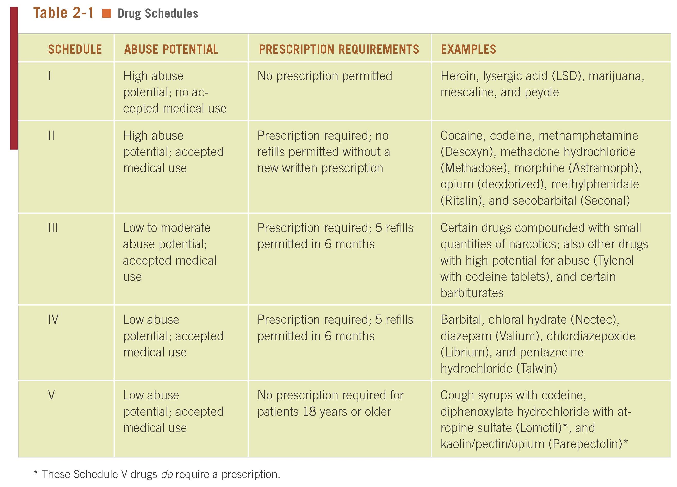
Know example of each drug in each category
Schedule 1: These drugs have a high potential for abuse and they are not accepted for medical use in the USA. Only research purposes
-Doesn’t have to be a big change to make a difference.
Schedule 3: Less abuse potential that those in 1 and 11 and can cause low to moderate physical dependence if abused. They have accepted medical uses in the USA. Schedule 111 drugs contain limited quantities of certain narcotic and nonnarcotic drugs.
Schedule 4: Slight abuse or potential and accepted, accepted medical use. Still most potent then schedule 5 drugs
Schedule 5: lowest potential. Antidiarrheal and antitussive purposes.

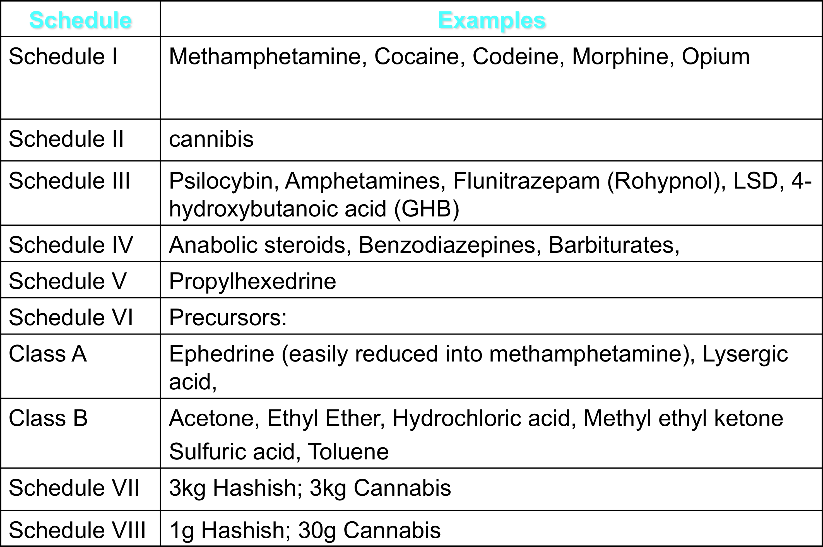

Keeping Medications Safe in the Hospital
- All restricted substances must be stored in locked storage facilities
- This prevents access by unauthorized persons
Ensuring Specificity of Orders
- An order or prescription must clearly state the specific circumstances and conditions under which the drug must be given.
- nonspecific orders, such as “if needed,” “if indicated,” or “as warranted” not typical. Need to indicate hours needed
Safe Medication Administration
- Medications have the potential to cause serious harm to the patient.
- All medication orders must come from the physician or other authorized health-care professional
- Vigilance is needed to prevent errors and ensure quality patient care.
Principles of Drug Administration
- Assess patient health and obtain medication history and use of vitamins, herbs, or food supplements prior to giving medications.
- Determine if route of administration is suitable.
- Assess socioeconomic factors and ability to self-administer (if applicable). As you get older you need more medications but you are also retired and cant afford medication that costs a lot. Two common problem for elderly are lack of transportation to obtain meds, and inadequate finances.
- Any problem the patient have in self administrating the medication must also be identified.
- Someone with a liver or kidney disease taking medications will be too hard on them. There are different routes- ex) orally, through the stomach, dermally- but orally is most convenient. People with Alzheimer’s or elderly people might forget.
7 rights
- Right patient
- Right drug
- Right dose- having too much may be too toxic. For antibiotics, taking too little wont work. For antidepressants, even a little works.
- Right route
- Right time- With food, or without food. Too much water may effect it.
- Right technique:
- Right documentation: Not wise to take more then needed. Documenting the right date and time administration: the drugs name, strength, dose, and route of administration, patients reaction to drug, etc. The record is the document including both the order of medication and the administration.
Dispensing Drugs
- Over-the-counter (OTC) drugs: available for self-medication; do not require prescription
- Legend or prescription drugs: require prescription from licensed practitioner (physicians, dentists, veterinarians, etc.)
Medication Errors
- Inappropriate or incorrect administration of a drug
- Medication errors should be preventable through effective system controls involving all levels of health-care workers as well as the patient.
- Some errors are caused by manufacturing mistakes.
Errors occur in three stages
- Prescribing or ordering medication. Physicians or other persons prescribing the medication may be distracted or interrupted, and as a result, provide incomplete orders. Medication is most prevalent when choosing a medication, its dosage and the schedule.
- Dispensing medication: errors occur as a result of insufficient or inexperienced staffing and lack of adequate time for patient counseling, and can lead to confusion on how to take the medication. Need to double check!
- Administrating medication and monitoring side effects. Most commonly attributed to nurses or others who are legally allowed to handle administration from misread perscriptions, etc.
- THE MOST COMMON ERROR IS DOSAGE.
Why medication Errors Occur
- Miscommunication- poor handwritings, abbreviations.
- Missing information
- Lack of appropriate labeling by manufacturer or pharmacist
- Environmental factors – distractions at hospital
- Poor management
Medication Errors may occur in inpatient settings such as hospitals and nursing homes or in outpatient settings such as physician’s offices or clinics. Can happen through manufacturing. Biggest cause of medical errors.
Causes of Medication Errors
- Wrong patient
- Incorrect route
- Incorrect drug
- Incorrect dose
- Incorrect time
- Incorrect technique
- Incorrect information on patient chart
Manufacturing Errors
- The sulfanilamide disaster of 1937 is an example of formulation or manufacturing errors.
- Elixir Sulfanilamide. During September and October 1937 this drug was responsible for the deaths of more than 100 people in 15 states; company reformulated drug by dissolving sulfanilamide in diethylene glycol- the chemical commonly used in antifreeze
- Mislabeling, contamination, wrong drug, wrong concentration, wrong doses of drugs, counterfeit drugs, and undiscovered toxicity are other causes.
Administering Medications Safely
- Follow all physician orders exactly as written.
- If unsure about an order, ask for clarification.
- Administer a medication only after the order is written in the patient’s chart.
- Use the 7 rights and perform 3 order and label checks when dispensing and administering the drug.

Reducing Medication Errors:
- Provide adequate, trained staff
- Use standardized metric measurement systems
- Develop consistent error-tracking systems
- Establish clear system for review of drug orders, ordering, dispensing, and administration
- Maintain medication profiles with regularly updated allergy and reaction histories. Sometimes can even produce allergy to a drug AFTER you take it. Those with a higher food allergy have a higher drug susceptibility.
- Provide suitable, safe work environments
Ensuring Safe Drug Administration
- Be sure you understand physician’s order and clarify questions about medication, dose, route of administration, and strength with physician.
- Review adverse effects, precautions, purpose, and recommended dose in pharmacology reference book such as PDR.
Orphan Drug Act 1983
- Orphan drugs: used to treat diseases that affect fewer than 200,000 people. Diseases that are really rare and so they do not make much prophet from it.
- Orphan Drug Act: offers financial incentives to nonprofit and commercial organizations to develop and market new orphan drugs in the United States
- Provides a 7-year monopoly on orphan drug sales and tax breaks to new drug developers
- Usually the ones they don’t want you to see will be more in the bottom. The insurance wont pay for the cheap stuff because the big companies need the money.
Ethics and Pharmacology
- Ethics: standards of behavior that encompass the concepts of right and wrong beyond a given situation’s legal considerations.
- Confidentiality: health professionals must maintain strict confidentiality
- Health-care workers must know laws of state/province in which they work, including rules that apply to phoning prescriptions to pharmacists.

