Lab BCH2333

Section: A13 (Thursday afternoon, 1st week)

Lab 4: Lipids and Membranes

TA: Tara Linseman

March 19th, 2015
Bench 9

Alex Jewell 5991135
Partner: Alanna Lumsden 7226469
Purpose:
The first part of the lab focused on preparing two membrane fractions from rat liver tissue using cell disruption, homeogenization, and differential centrifugation to separate the lipids from one another. The first fraction, an endoplasmic reticulum enriched fraction or the microsomal fraction will be used for the purpose of lipid extraction. Using TLC these lipids will be separated and analyzed through comparison to lipid standards extracted from the entire tissue. The second part of the experiment uses the second fraction, a mitochondrial enriched fraction and analyzes its lipid/protein ratio through colorimetric assays, serial dilution and spectrophotometry.
Two-dimensional TLC of microsomal lipids

R1)
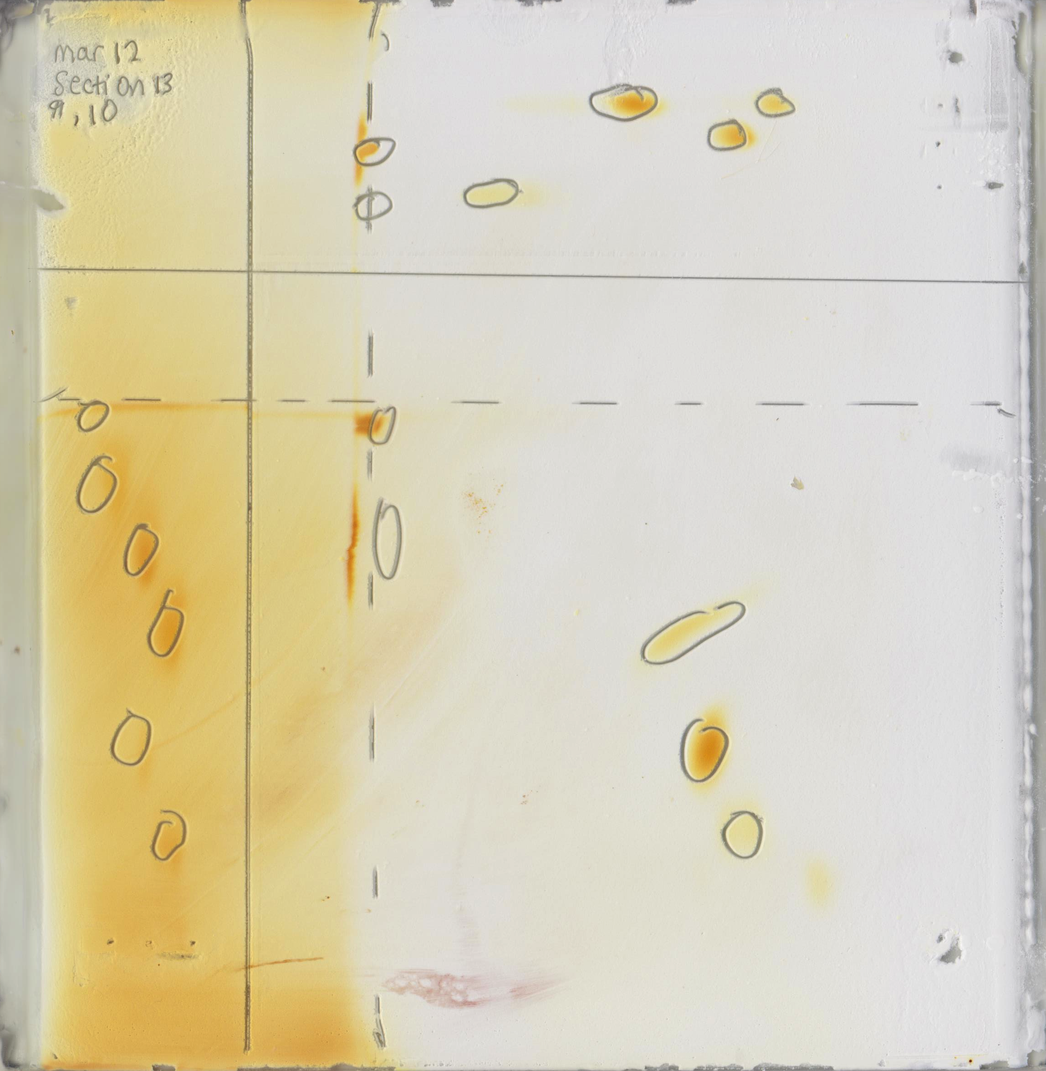
PE
PI
FA
PC
CH
CH
CL

CL
FA
PE

PC
PI

Figure 1. 2D Thin Layer Chromatography (TLC) Plate with lipid standards and sample. The first lipid standard was composed of cardiolipin (CL) and cholesterol (CH). The second lipid standard was composed of fatty acid (FA) and phosphatidylcholine (PC). The third standard was composed of phosphatidylinositol (PI) and phosphatidylethanolamine (PE) .The standards increase from one to three going left to right for both the first and the second dimension. 5 μL of each of the three lipid standards and 10 μL of the sample were pipetted onto both the acid and the base sections of the 20x20 cm Silica G plate that was activated by being heated at 100 °C for 1-2 hours. The plate was then placed in a tank containing the basic solvent system of CHCl₃-MeOH-ammonia (65:35:5 v/v). The first dimension was developed until the solvent reached 1 cm from the horizontal line, then removed and dried with a heat gun for 10 minutes. The plate was turned 90 degrees and placed in a second tank with an acidic solvent system: CHCl₃-acetone-MeOH-acetic acid-H₂O (10:4:2:2:1; v:v)until the solvent reached 1 cm from the horizontal line, and was then removed and dried with a heat gun for 10 minutes. The plates were then placed in an iodine saturated tank for 5 minutes and then removed and placed in a fume-hood. The positions of each spot were then marked with a pencil.
Table 1: R_{f} Values for Lipids in First Dimensions Basic Solvent. This table shows the different R_{f} values for the first dimension. The first dimension was placed in a basic solvent, and 5 microliters of each standard was pipetted onto the basic section as shown in Figure 1. Standard one was composed of cardiolipin and cholesterol. Standard two was composed of fatty acid and phosphatidylcholine. The third standard was composed of phosphatidylinositol and phosphatidylethanolamine. The R_{f} values were taken by measuring the distance the standard traveled and dividing it by the distance traveled by the solvent.
Compound | R_{f} Values
Cardolipin (CL) | 0.725
Cholesterol (CH) | 1
Fatty acid (FA) | 0.60
Phosphatidylcholine (PC) | 0.4375
Phosphatidylinisitol (PI) | 0.3125
Phosphatidylethanolamine (PE) | 0.5625

Table 2: R_{f} Values for Lipids in Second Dimension Acidic Solvent. . This table shows the different R_{f} values for the second dimension. The second dimension was placed in a acidic solvent, and 5 microliters of each standard was pipetted onto the acidic section as shown in Figure 1. Standard one was composed of cardiolipin and cholesterol. Standard two was composed of fatty acid and phosphatidylcholine. The third standard was composed of phosphatidylinositol and phosphatidylethanolamine. The R_{f} values were taken by measuring the distance the standard traveled and dividing it by the distance traveled by the solvent.

Compound | R_{f} Values
Cardolipin (CL) | 0.831
Cholesterol (CH) | 1
Fatty acid (FA) | 1
Phosphatidylcholine (PC) | 0.538
Phosphatidylinisitol (PI) | 0.462
Phosphatidylethanolamine (PE) | 0.692

Sample Calculation:
R_{f} = distance travelled by the compound/distance travelled by the solvent

R_{f} value for CL in basic solvent:
Distance travelled by the solvent: 8 cm
Distance travelled by the compound: 2.5 cm
R_{f} = 5.8 cm/8 cm = 0.725

The R_{f} values of the lipid standards for each of the two solvent systems are not identical. The simplest explanation for this is that lipids react differently in an acidic solution versus a basic solution. How lipids react in different solvents is all dependent on the charge of lipids. In an acidic solution, a proton is gained, whereas in a basic solution a proton is lost.
Phosphatidylinisitol (PI) it has a charge of -1. In an acidic solution, it will act as a base, gaining a proton and becoming neutral. This increases its polarity, meaning it reacts more with the solvent, and won’t travel as far up the plate, resulting in a lower R_{f}. In a basic solution, PI will stay negative decreasing its polarity and it will interact less strongly with the solvent meaning it will have a high R_{f} value. This is also true for cardiolipins and fatty acids.
Cholesterol (CL) and phosphatidylethanolamine (PE) both have neutral charges. They have a higher polarity in the acidic solution then they do in the basic solution. Since they are less polar in the acidic solvent, they won’t interact as well with the solvent, therefore giving it a higher R_{f} value. Whereas in the basic solvent, the polarity for both is higher and interacts more strongly with the solvent, giving it a lower R_{f} value.
Phosphatidylcholine (PC) has a charge of +1. The R_{f} value in PC is higher in the basic solution that it is in the acidic solvent, meaning that it has a higher polarity in the acidic than the basic solvent. This is because PC interacted more strongly in the acidic solvent.

R2)
Table 3: Polarity ranking of Lipids in First Dimension Basic Solution. Ranking of the six lipids found within the 3 lipid standards by polarity and a description of polar groups found on each.
Least Polar

Compound | Structure of Compound | Polar Group
Cholesterol (CH) | 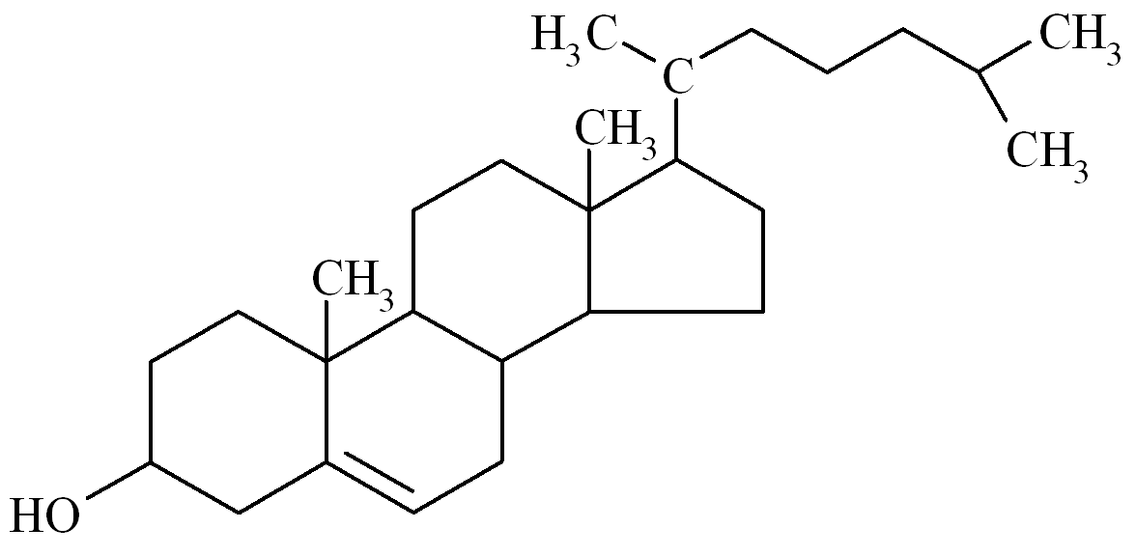 | The only polar group is the alcohol attached to the benzene ring. The remainder of the molecule is fairly non-polar.
Cardiolipin (CL) | 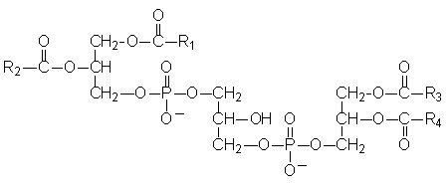 | The phosphate ions are very dense and are polar, along with the carboxylic acid molecules. Each of the phosphates can catch one proton, however each are ionized at different levels of acidity.
Fatty Acid (FA) | 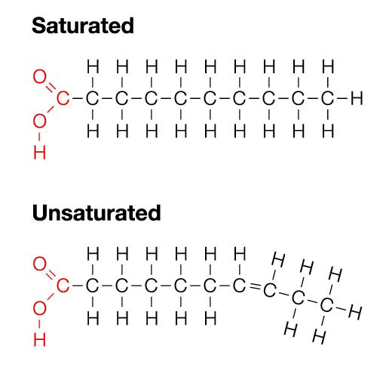 | The polar groups are the carboxyl groups at the end in both saturated and unsaturated fatty acids. The rest of the molecule is non-polar carbon chains.
Phosphatidylethenolamine  (PE) | 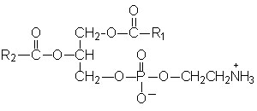 | There is a polar amine group at the head of the molecule and the phosphate group is also polar. The rest of the hydrocarbon chains are nonpolar.
Phosphatidylcholine (PC) | 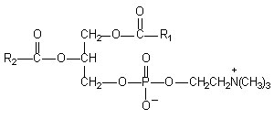 | Phosphatidylcholine contains a polar region composed of glycerol, carbonyl oxygen atoms, photphate groups and on the end is a polar head group containing nitrogen. The hydrocarbon tails of the fatty acids are the non-polar regions.
Phosphatidylinositol  (PI) | 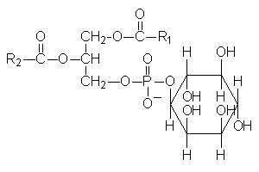 | Phosphatidylinsoitol contains a polar inositol head group attached to another polar phosphate group. The glycerol backbone is relatively neutral and the two fatty acid chains are non-polar.
Most Polar

Table 4: Polarity ranking of Lipids in Second Dimension Acidic Solution. Each of the lipids found in the lipid standards are ranked by polarity and there structures are displayed.
Least Polar
Compound | Structure of Compound
Cholesterol (CH)
Fatty Acid (FA)
Cardiolipin (CL)

Phosphatidylethanolamine (PE)

Phosphatidylcholine (PC)
Phosphatidylinositol
(PI)
Most Polar

For the first standard, cholesterol and cardiolipin, cholesterol will always be less polar than cardiolipin, making it always less affected by the polar silica gel TLC plate. While cardiolipin becomes more polar in an acidic solvent (this decreases its elution distance) cholesterol won’t be affected and will have the same R_{f} value, so this accounts for cardiolipin traveling different distances in the acidic vs basic dimensions.
Cardiolipin is less polar then phosphatidylcholine, as phosphatidylcholine contains a polar positively charged choline molecule and a polar phosphate molecule at the head. Cardiolipin is very symmetric and this even distribution of charge means that it has little polarity across the molecule.
In the second standard, the fatty acid molecule is less polar then phosphatidylcholine , likely because it has so much non-polar region composed of hydrocarbon chains, and phosphatidylcholine has a much greater polarity as its polar region, composed of glycerol, carbonyl oxygen atoms, photphate groups and on the end is a polar head group containing nitrogen. In contrast the fatty acids only have the carboxyl group on the end to make them polar, which is much less then the phosphatidylcholine.
In the third standard, composed of phosphatidylinositol and phosphatidylethanolamine, phosphatidylinositol will be the most polar as it has a very polar insoitiol head group, particularly as the phosphate group gives the molecule a negative charge at physiological pH. In different solvents, they should have opposite effects: in basic elutant they should travel approximately the same distance, however in an acidic eluent PE will become less polar and travel further whereas PI will become very polar and will interact more strongly with the gel.

R3)
a)
Table 5. Lipids assay. Table showing the absorbance along with the dilution factors for each lipid assay trial. 5 assay tubes were used that each contained increasing amounts of mitochondrial membrane suspension in 2 mL of 0.1 M phosphate buffer, pH 11. In order of increasing dilutions the five assays were the control, 1/250 dilution, 1/125 dilution, 1/40 dilution, and 1/25 dilution. The mitochondrial membrane used was created by mincing 2 g of rat liver and then adding it to a homogenization buffer composed of 10 mM Tris, 0.25M sucrose, 1mM EDTA, 1 mM DTT pH 7.5 The solution was then centrifuged at 1,000 xg for 10 minutes. The supernatant was separated and centrifuged against at 25,000xg for 10 minutes. The pellet from this centrifuge was then resuspended and diluted into the five tubes and 50 microliters of brilliant blue R was added. The absorbance for each was then read at 559 nm.
Sample | Dilution fraction | Phosphate pH 11, 0.2 M (mL) | Water (mL) | Membrane suspension (μL) | Brilliant blue R  1.5 g/L (μL) | A₅₅₉
1) Control | 0 | 1 | 0.95 | 0 | 50 | 0.958
2) 1/200 | 0.005 | 1 | 0.94 | 10 | 50 | 0.925
3) 1/100 | 0.01 | 1 | 0.93 | 20 | 50 | 0.745
4) 1/50 | 0.02 | 1 | 0.91 | 40 | 50 | 0.503
5) 1/20 | 0.05 | 1 | 0.85 | 100 | 50 | 0.171

Table 6: Protein Assay. Table showing the absorbance along with the dilution factors for each protein assay trial. 4 assay tubes were used that each contained increasing amounts of mitochondrial membrane suspension in 2 mL of 0.1 M phosphate buffer, pH 11. In order of increasing dilutions the five assays were the blank, 1/200 dilution, 1/50 dilution, and1/20 dilution. The mitochondrial membrane used was created by mincing 2 g of rat liver and then adding it to a homogenization buffer composed of 10 mM Tris, 0.25M sucrose, 1mM EDTA, 1 mM DTT pH 7.5 The solution was then centrifuged at 1,000 xg for 10 minutes. The supernatant was separated and centrifuged against at 25,000xg for 10 minutes. The pellet from this centrifuge was then resuspended and diluted into the four tubes and the absorbance for each was read at 280 nm.

Sample | Dilution fraction | Phosphate pH 11, 0.2 M (mL) | Water (mL) | Membrane suspension (mL) | A₂₈₀
1) Blank | 0 | 1 | 1 | 0 | 0.014
2) 1/100 | 0.01 | 1 | 0.98 | 0.02 | 0.035
3) 1/25 | 0.04 | 1 | 0.92 | 0.08 | 0.147
4) 1/5 | 0.2 | 1 | 0.60 | 0.40 | 0.643

b)

Figure 2. Absorbance vs dilution factors for the lipid assay. 5 assay tubes were used that each contained increasing amounts of mitochondrial membrane suspension in 2 mL of 0.1 M phosphate buffer, pH 11. In order of increasing dilutions the dilution fractions were 0, 0.005, 0.01, 0.02, and 0.05. The mitochondrial membrane used was created by mincing 2 g of rat liver and then adding it to a homogenization buffer composed of 10 mM Tris, 0.25M sucrose, 1mM EDTA, 1 mM DTT pH 7.5. The solution was then centrifuged at 1,000 xg for 10 minutes. The supernatant was separated and centrifuged against at 25,000xg for 10 minutes. The pellet from this centrifuge was then resuspended and diluted into the five tubes and 50 microliters of brilliant blue R was added. The absorbance of each was then read at 559 nm. A linear line was fitted without the control point with the equation y=-15.692 + 0.9195.

Figure 3. Absorbance vs dilution factors for the protein assay. 4 assay tubes were used that each contained increasing amounts of mitochondrial membrane suspension in 2 mL of 0.1 M phosphate buffer, pH 11. In order of increasing dilutions the dilution fractions were 0, 0.01, 0.04, and 0.2. The mitochondrial membrane used was created by mincing 2 g of rat liver and then adding it to a homogenization buffer composed of 10 mM Tris, 0.25M sucrose, 1mM EDTA, 1 mM DTT pH 7.5. The solution was then centrifuged at 1,000 xg for 10 minutes. The supernatant was separated and centrifuged against at 25,000xg for 10 minutes. The pellet from this centrifuge was then resuspended and diluted into the four tubes and absorbance of each was then read at 280 nm. A linear line was fitted to the data with the equation y=3.1598x + 0.0123.

R4)
$$A=εcl$$
A=3.1598
$$ε=2.0 Lg-1cm-1$$
l=1 cm
$$c=\frac{A}{εl}$$
$$c=\frac{3.1598}{2.0\left(1\right)}$$
$$c=1.5799 g/L$$
The protein concentration of the membrane preparation is 1.5799 g/L.

R5) Linear regression was used to find the absorbance:
y=-15.692 + 0.9195
=-15.692(1) + 0.9195
=-14.7725

Subtract from control
0.958-(-14.7725)= 15.7305

Since absorbance decreases 0.011 per 1 μg/ml increase in lipid concentration:

(Absorbance of solution with unknown concentration)/(Unknown concentration)=(Absorbance of solution of 1 μg/ml)/(concentration of 1 μg/ml)
15.7305 x 1 μL/mL=0.011 x unknown concentration
Unknown concentration=1430.045 μL/mL x 1000 mL/L x 1g/1000000 μg=1.43045 g/L

Therefore the concentration of lipids in the mitochondrial enriched fraction is 1.4305 g/L.

R6)

$$m=cV$$
c=1.5799 g/L
V=10 mL
$$m=(1.5799\frac{g}{L})\left(10mL\right)$$
$$m=15.799 mg$$

$$\%yield=\frac{mass of protein(mg)}{mass of tissue (g)}$$
$$\%yield=\frac{15.799 mg}{2 g}$$
$$\%yield=7.8995 mg/g$$

Therefore the yield was 7.8995 mg/g of liver tissue.

References
1. D. Voet and J.G. Voet. Biochemistry. 4th edition. John Wiley & Sons, Inc.
2. F. Autuori, U. Brunk, E. Peterson and G. Dallner. Fractionation of isolated liver cells after disruption with a nitrogen bomb and sonication. Cell Sri. 57, 1-13 (1982).

