Lab BCH2333

Section: A13 (Thursday afternoon, 1st week)

Lab 2: Amino Acids and Proteins

TA: Samantha Cornfeld
February 12th, 2015

Team #9

Alex Jewell 5991135

Partners: Alanna Lumsden (7226469)
Hannah Ackerman (7244984)

Purpose:
The purpose of the first part of this experiment was to separate the three components of a mixture of glycine, aspartic acid and lysine by performing an ion-exchange chromatography procedure on DOWEX-50W-X. It acts like a very strong acid, and by using a gradient of increasing pH it was possible to separate glycine, aspartic acid and lysine based on their isoelectric points. The purpose of the second part of this experiment was to apply electrophoresis on a polyacrylamide gel in the presence of SDS to determine the molecular weight of an unknown polypeptide using ColorBurst molecular weight markers. This was a solution made up of different sizes of prestained proteins, and the proteins were separated during the electrophoresis procedure.
R1.
An amino acid has a carboxyl group (COOH), an amino group (NH₂) and an R group, each with its own pKa. When an amino acid is put into a mixture at pH=3.9, groups on the amino acids whose pKa is less then the pH, it will get deprotonated, and if it is greater then the pH it will get protonated.

Structure of Glycine at pH=3.9
Glycine contains a caroboxyl group with a pKa of 2.35 and an amino group with a pKa of 9.78, and its R group does not have a pKa. The pKa of the carboxyl group is less then the pH so it will get deprotonated. The pKa for the amino acid is greater then the pH, it will get protonated, and so its structure will look like this:

Structure of Aspartic Acid at pH=3.9
The pKa of the carboxyl group in aspartic acid is 1.99 and the amino group is 9.90, the R group has a pKa of 3.90. The carboxylic acid group is less then the pH so it will be deprotonated, and the amino group will be protonated because it has a higher pKa then the pH. The pKa is equal to the pH in this case for the R group, so two forms of the species will exist at a pH of 3.9; one where the R group is protonated and one where it is deprotonated.

Structure of Lysine at pH=3.9
Lysine has a pKa of 2.16 for its carboxyl group and 9.06 for its amino group, as well as an R group with a pKa of 10.54. The carboxylic acid group is less then the pH, so it will get deprotonated while the amino and R group will be protonated because their pKa’s are higher then the pH.

Table 1: Amino acids and their corresponding pKas and isoelectric points (pI). Note that glycine does not have an ionisable side chain. For information on where the pKas for each amino acid in the mixture came from, please see reference entry 1.
Amino Acid | pKa α-COOH  (pK_{a1}) | pKa α-NH₃⁺  (pK_{a2}) | pKa side chain  (pK_{a3}) | pI
Glycine | 2.35 | 9.78 | N/A* | 6.065
Aspartic acid | 1.99 | 9.90 | 3.90 | 2.945
Lysine | 2.16 | 9.06 | 10.54 | 9.80

Each calculation for pI is slightly different, as the formula for pI is different depending on whether it has a basic, acidic or neutral side chain.
pI calculation for Glycine: =½ (pK_{a1}+pK_{a2})
= (2.35+9.78)/2
= 6.065

pI calculation for Aspartic Acid: =½ (pK_{a1}+pK_{a3})
= (1.99+3.90)/2
= 2.945

pI calculation for Lysine: =½ (pK_{a2}+pK_{a3})
= (10.54+ 9.06)/2
= 9.80

R2.

Table 2. Results of ion exchange chromatography performed on DOWEX-50W-X of a mixture of glycine, lysine and aspartic acid. An amino acid mixture (2.5 mM lysine, 2.5 mM glycine, 2.5 mM aspartic acid in water) of 4 mL was applied to the column and eluted into 16 fractions. 100 µl was taken from the eluted fractions and 100 µl of ninhydrin reagent was added and absorbance readings taken of each at a wavelength of 570 nm. The average volume was taken as the average of fractions 3, 6 and 8 and was found to be approximately 4.47 mL. The pH readings were taken from the remaining volume in the fractions. Sample calculations for each amino acid are shown below the table.
Fraction # | Elution Vol. (mL) | pH | A₅₇₀ | A₅₇₀  corrected | Conc. mM | mole
1 | 4.47 | 4.15 | 0.052 | -0.002 | 0 | 0
2 | 8.94 | 3.95 | 0.009 | -0.045 | 0 | 0
3 | 13.41 | 3.94 | 0.061 | 0.007 | 0.00814 | 3.6 x 10⁻⁸
4 | 17.88 | 4.32 | 0.829 | 0.775 | 0.901 | 4.04 x 10⁻⁶
5 | 22.35 | 4.10 | 0.464 | 0.41 | 0.477 | 2.13 x 10⁻⁶
6 | 26.82 | 4.01 | 0.187 | 0.133 | 0.155 | 6.91 x 10⁻⁷
7 | 31.29 | 4.04 | 0.133 | 0.079 | 0.092 | 4.11 x 10⁻⁷
8 | 35.76 | 4.05 | 0.164 | 0.11 | 0.122 | 5.44 x 10⁻⁷
9 | 40.23 | 5.70 | 0.304 | 0.25 | 0.277 | 1.24 x 10⁻⁶
10 | 44.70 | 7.04 | 0.455 | 0.401 | 0.444 | 1.98 x 10⁻⁶
11 | 49.17 | 7.58 | 0.337 | 0.283 | 0.313 | 1.40 x 10⁻⁶
12 | 53.64 | 8.29 | 0.302 | 0.248 | 0.34 | 1.5 x 10⁻⁶
13 | 58.11 | 10.72 | 0.726 | 0.672 | 0.909 | 4.07 x 10⁻⁶
14 | 62.58 | 11.26 | 0.678 | 0.624 | 0.844 | 3.77 x 10⁻⁶
15 | 67.05 | 11.51 | 0.438 | 0.384 | 0.520 | 2.32 x 10⁻⁶
16 | 71.52 | 11.71 | 0.280 | 0.226 | 0.306 | 1.37 x 10⁻⁶

Calculations:

For Aspartic Acid Fraction:

V_{avg=} (fraction 3+ fraction 6+ fraction 8)/3
V_{avg} = (4.4 mL + 4.4 mL+ 4.6 mL)/3 = 4.47 mL

Fraction 5 Elution volume:
V_{E5} = Fraction # x V_{avg} = 5 x 4.47 = 22.35 mL

Corrected absorbance for Fraction 5:

A=Absorbance reading for fraction 5-absorbance reading for blank
A=0.464-0.054
A=0.41

Concentration for Fraction 5:

The pI of aspartic acid is 2.945, which is lower then glycine and lysine’s pI’s and so it will likely be eluted first. Since the pH of fraction 5 is 4.10 and the absorbance of fraction 5 is 0.41 which is a part of the first elution peak, we can assume that aspartic acid is eluted in fraction 5. We would therefore use the absorbance and concentration of aspartic acid to for the concentration calculation as we are calculating the concentration of aspartic acid in fraction 5.

Conc. of aspartic acid=1 mM

Corrected absorption of aspartic acid=Absorbance reading for aspartic acid
standard- Absorbance reading for blank
=0.914-0.054
=0.86
Corrected absorption of Fraction 5= 0.41

A_{Aspartic Acid}/C_{Aspartic Acid}=A_{Fraction 5}/C_{Fraction 5}
0.86 mM/1 = 0.41/C_{Fraction 5}
C_{Fraction 5}=0.477 mM

Mols for fraction 5:
Average elution volume=4.47 mL=0.00447 L
C_{Fraction 5}= 4.77 x 10⁻⁴ M
mols=0.00447 L X 4.77 x 10⁻⁴ M
mols=2.13 x 10⁻⁶

For Glycine Fraction:
Fraction 9 Elution volume:
V_{E5} = Fraction # x V_{avg} = 9 x 4.47 = 40.23 mL

Corrected absorbance for Fraction 9:

A=Absorbance reading for fraction 9-absorbance reading for blank
A=0.304 -0.054
A=0.25

Concentration for Fraction 9:

The pI of glycine is 6.065, which is in between glycine and lysine’s pI’s and so it will likely be eluted second. Since the pH of fraction 9 is 5.70 and the absorbance of fraction 9 is 0.25, which is near the top of the second elution peak, we can assume that glycine is eluted in fraction 9. We would therefore use the absorbance and concentration of glycine for the concentration calculation as we are calculating the concentration of glycine in fraction 9.

Conc. of glycine=1 mM

Corrected absorption of glycine=Absorbance reading for glycine standard-
Absorbance reading for blank
=0.958-0.054
=0.904
Corrected absorption of Fraction 9= 0.25

A_{Glycine} /C_{Glycine} =A_{Fraction 9}/C_{Fraction 9}
0.904 mM/1 = 0.25/C_{Fraction 9}
C_{Fraction 9}=0.277 mM

Mols for fraction 9:

Average elution volume=4.47 mL=0.00447 L
C_{Fraction 9}= 2.77 x 10⁻⁴ M
mols=0.00447 L X 2.77 x 10⁻⁴ M
mols=1.24 x 10⁻⁶

For Lysine Fraction:
Fraction 14 Elution volume:
V_{E5} = Fraction # x V_{avg} = 14 x 4.47 = 62.58 mL

Corrected absorbance for Fraction 14:

A=Absorbance reading for fraction 14-absorbance reading for blank
A=0.678 -0.054
A=0.624

Concentration for Fraction 14:

The pI of lysine is 9.80, which is higher then aspartic acid and glycine’s pI’s and so it will likely be eluted last. Since the pH of fraction 14 is 11.26 and the absorbance of fraction 14 is 0.624, which is near the top of the third elution peak, we can assume that lysine is eluted in fraction 14. We would therefore use the absorbance and concentration of lysine for the concentration calculation as we are calculating the concentration of lysine in fraction 14.

Conc. of lysine=1 mM

Corrected absorption of lysine=Absorbance reading for lysine standard-
Absorbance reading for blank
=0.793-0.054
=0.739
Corrected absorption of Fraction 14= 0.624

A_{Lysine} /C_{Lysine} =A_{Fraction 14}/C_{Fraction 14}
0.739 mM/1 = 0.624/C_{Fraction 14}
C_{Fraction 14}=0.844 mM

Mols for fraction 14:

Average elution volume=4.47 mL=0.00447 L
C_{Fraction 14}= 8.44 x 10⁻⁴ M
mols=0.00447 L X 8.44 x 10⁻⁴ M
mols=3.77 x 10⁻⁶

R3.

Figure 1. pH and concentrations found in different elution volumes. The red line represents the pH and the blue line represents the concentration. The pH of the fractions was measured during the lab, and the concentration was calculated using the standard absorption and concentration and the formula A1/C1=A2/C2. It should be noted that each fractions were assigned to a specific amino acid based on their pI and the absorbance readings at different pH’s, for example glycine has a pI of 6.065 and so based on the pH of the solution it should have been eluted in fraction 9 or 10 and so its standard concentration and absorption values were used to calculate the concentration of fractions 8-11. The standard absorption and concentration of lysine was used for fractions 12-16, while the standard absorption and concentration of aspartic acid was used for fractions 1-7.

This graph shows three peaks, which should represent the pH and volume at which each amino acid was eluted. The first peak spikes very quickly at approximately 17.88 mL, and based on the pI for aspartic acid and the pH at 17.88 mL, it should correspond to aspartic acid. The second peak occurs around 44.70 mL and based on the pI of glycine and the pH at 44.70 mL it should correspond to glycine. The third peak occurs around 58.11 mL, and based on the pI for lysine and the pH for 58.11 mL it should correspond to lysine. Since the second peak is so small, I think some of the glycine was probably mixed in with the first aspartic acid peak, as most of the aspartic acid should have been eluted out in the first or second fraction as its pI is only 2.945 and the aspartic acid peak does not appear till the fourth fraction. To improve resolution, the amino acids would have to be better separated, which could be accomplished by increasing the amount of drops per column and increasing the number of fractions. This would allow the amino acids to be better separated.

R4.

Recovery yield = (actual mass/theoretical mass) x 100%

Aspartic acid

Used fractions 1-7
Molar Mass of aspartic acid = 133.1g/mol
Mass=mol x mol mass

Experimental Yield= (mols of fraction 1 x molar mass of aspartic acid) +(mols of fraction 2 x molar mass of aspartic acid)+ (mols of fraction 3 x molar mass of aspartic acid)+ (mols of fraction 4 x molar mass of aspartic acid) + (mols of fraction 5 x molar mass of aspartic acid) +(mols of fraction 6 x molar mass of aspartic acid)

Experimental mass of aspartic acid=(0 mols x 133.1g/mol) +(0 mols x 133.1g/mol)+ (3.6 x 10⁻⁸mols x 133.1g/mol)+ (4.04 x 10⁻⁶mols x 133.1g/mol) + (2.13 x 10⁻⁶ mols x 133.1g/mol) + (6.91 x 10⁻⁷ mols x 133.1g/mol) = 0.00092 g
Theoretical mass of aspartic acid = 4mL x (2.5mg/mL) x (1g/1000mg) = 0.01g
Recovery yield = (0.0092 g/0.01 g) x 100 = 92%

Glycine
Used fraction 8-11
Molar Mass of glycine = 75.07 g/mol
Mass=mol x mol mass

Experimental mass of glycine= (mols of fraction 8 x molar mass of glycine) +(mols of fraction 9 x molar mass of glycine)+ (mols of fraction 10 x molar mass of glycine)+ (mols of fraction 11 x molar mass of glycine)

Experimental mass of glycine=(5.44 x 10⁻⁷ mols x 75.07 g/mol) +(1.24 x 10⁻⁶x 75.07 g/mol)+ (1.98 x 10⁻⁶ mols x 75.07 g/mol)+ (1.40 x 10⁻⁶ mols x 75.07 g/mol)= 0.00039 g

Theoretical mass of glycine = 4mL x (2.5mg/mL) x (1g/1000mg) = 0.01g
Recovery yield = (0.00039 g/0.01 g) x 100 = 3.88%

Lysine
Used fraction 12-16
Molar Mass of lysine = 146.19 g/mol
Mass=mol x mol mass

Experimental mass of lysine= (mols of fraction 12 x molar mass of lysine) +(mols of fraction 13 x molar mass of lysine)+ (mols of fraction 14 x molar mass of lysine)+ (mols of fraction 15 x molar mass of lysine) + (mols of fraction 16 x molar mass of lysine)

Experimental mass of lysine=(1.5 x 10⁻⁶ mols x 146.19 g/mol) +(4.07 x 10⁻⁶ x 146.19 g/mol)+ (3.77 x 10⁻⁶ mols x 146.19 g/mol)+ (2.32 x 10⁻⁶ mols x 146.19 g/mol) + (1.37 x 10⁻⁶ mols x 146.19 g/mol)= 0.00190 g

Theoretical mass of lysine = 4mL x (2.5mg/mL) x (1g/1000mg) = 0.01g
Recovery yield = (0.00190 g/0.01 g) x 100 = 19.05%

For the recovery yields, aspartic acid was the best as it had approximately a 92% yield. Most likely the aspartic acid is being eluted over the first seven, or even eight, fractions as the pI is 2.945 and so the aspartic acid would elute in the first 7 fractions as their pH fluctuated between 3-4. Realistically, the aspartic acid would have all come out within the first fraction, and so it is possible that glycine is in some of the first few fractions. However, the pI of glycine was found to be approximately 6.025, so it should not have been eluted till around the 9-10 fraction where the pH’s were 5.70 and 7.04 respectively. This correlates with the high absorbance of fraction 10. The pH of the fractions increased much more dramatically after the 9th fraction, and so it is likely that glycine and lysine ended up eluting together, resulting in their poor yields of 3.88% and 19.05% The gradient may not have been slow enough to result in a clear separation in peaks for glycine and lysine, as the top of the peaks for both is only separated by two fractions. To account for why more lysine and glycine were not eluted, errors could have been made when creating the buffer and when setting up the column, an air bubble could have been caught in the column or the column may have needed to have been flushed out more. The gradient might not have been strong enough, and as pointed out before most likely some amino acid was eluted out in other fractions which would change the results of the yields.

R5.
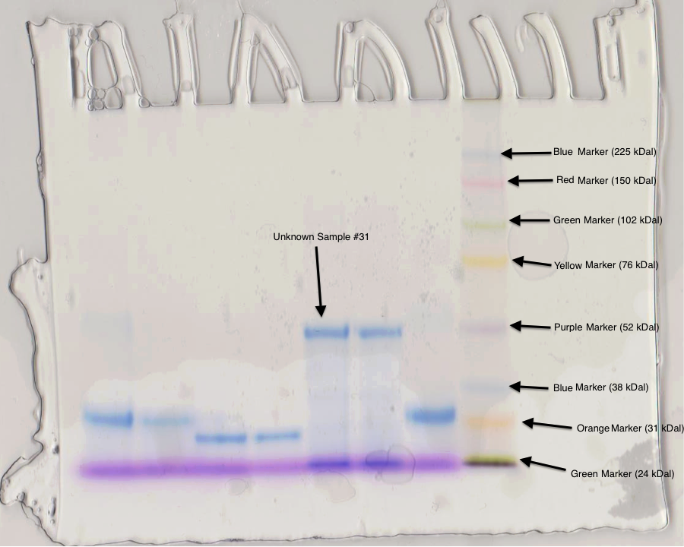
Figure 2. Gel Electrophoresis with unknown sample. Our sample was # 31 for this well and was applied in well 5, in well 8 the rainbow colored protein molecular weight marker was applied for comparison purposes.

Table 3: Gel electrophoresis protein results. The migration distance was measured in cm from the beginning of the plate to the middle of the marker line. The molecular weight (MW) was taken from the laboratory manual and the log was calculated using these values.
 | Migration Distance (cm) | Molecular Weight (kDal) | Log Molecular Weight
Green | 0.1 cm | 24 | 1.38
Orange | 1.4 cm | 31 | 1.49
Blue | 2.5 cm | 38 | 1.58
Purple | 4.3 cm | 52 | 1.72
Yellow | 6.2 cm | 76 | 1.88
Green | 7.5 cm | 102 | 2.01
Red | 8.7 cm | 150 | 2.18
Blue | 9.6 cm | 225 | 2.35

Sample Calculations:
Log MW of Purple Marker:

Purple band MW=52 kDal
Purple band log MW= log(52)=1.72

Figure 3: The log of the molecular weight of the standards plotted against the distance they migrated acros the gel. The migration distance was measured in cm as the distance the molecular marker travels from the top of the gel. The formula of the linear regression was y = 0.1392x + 1.1975 and with this formula the molecular weight of an unknown polypeptide can be calculated if we have its migration distance.
Molecular Weight of Unknown Sample #31
The linear regression is y = 0.1392x + 1.1975
x= migration distance of unknown aliquot= 4 cm
y = 0.1392(4 cm) + 1.1975
y=1.7543
y=log MW
So MW= 10^(y)

MW=10^(1.7543)

MW= 56.8 kDal
The molecular weight of the unknown polypeptide #31 is 56.8 kDal, which seems right as it seems to have traveled the same distance as the purple marker which has a molecular weight of 52 kDal.
References:
1. D. Voet and J.G. Voet. Biochemistry. 4th edition. John Wiley & Sons, Inc. Pp. 359-365; 68-69.

2. Levene, P.A. and Simms, H.S. J. Biol.Chem. Calculation of Isolelectric Points. 1923 55:801-813.

