Population Genetics-Problem Set #6

- a. Plot of p vs t.:
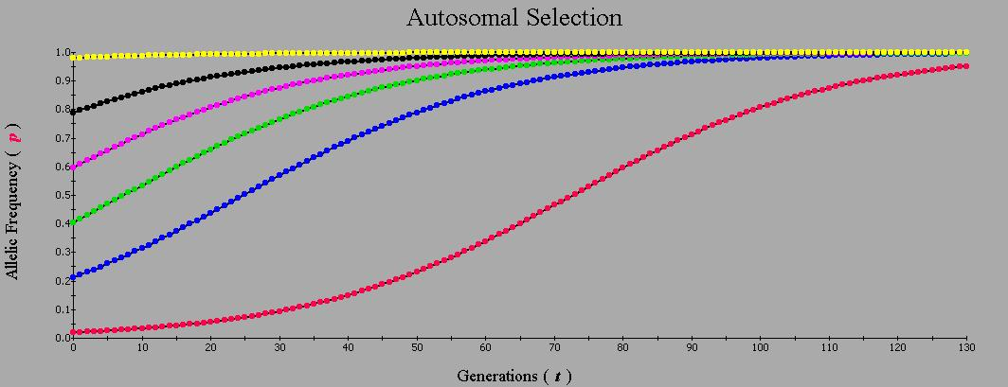
This plot shows how the allele frequency of p changes over time. If the allele ends up going to 1 or 0 then it fixes. In this graph, the allele frequency of p has six initial frequencies but all eventually increase to almost 1, so do not end up fixing but reach an equilibrium before 1.
Plot of Δp vs. p:
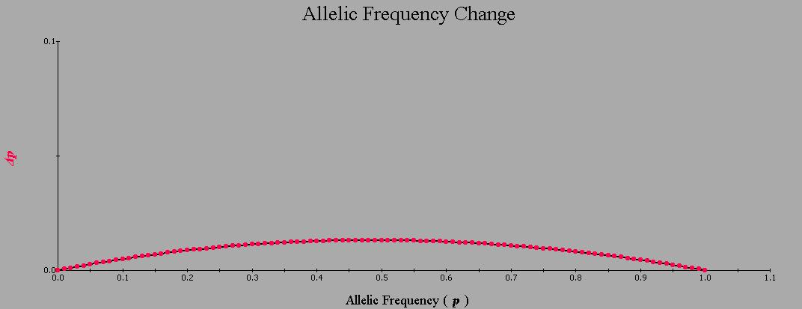
This plot shows the change in allele frequency over a single generation as a function of allele frequency for directional selection.

Plot of w vs p
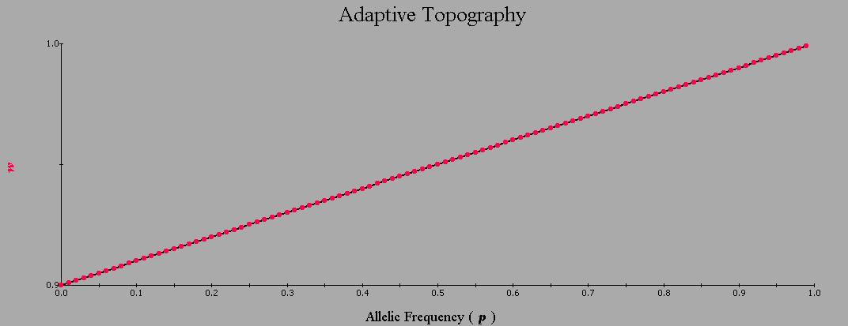
This plot shows mean population fitness plotted against the allele frequency of p. The mean fitness is shown to increase as the frequency of the A allele increases as it is the dominant allele in this example and so its frequency will increase.
Plot of genotype vs. t.
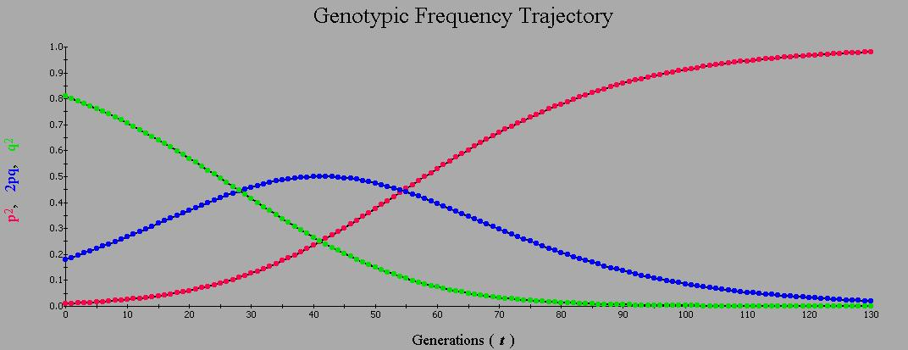
This plot shows the change in genotype frequencies over time, in this scenario 130 generations. The genotype frequency of p² increases to almost 1, the genotype frequency of q² goes to almost 0, and the genotype frequency of the heterozygote, 2pq eventually decreases to almost 0 as well.
b. selection against a recessive allele: W_{AA}=1; W_{Aa}=1; W_{aa}=0.9
Plot of p vs. t
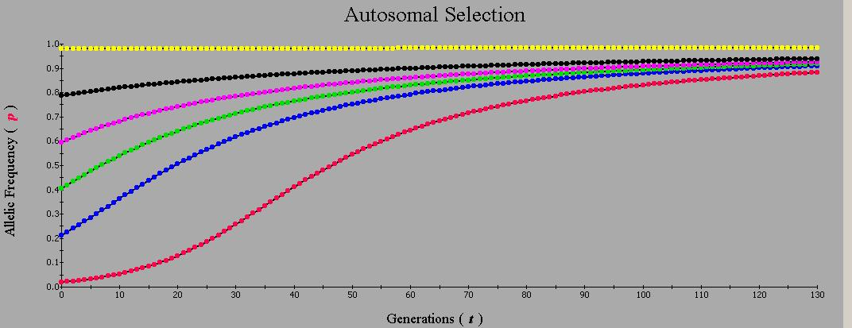

Plot of Δp vs. p:
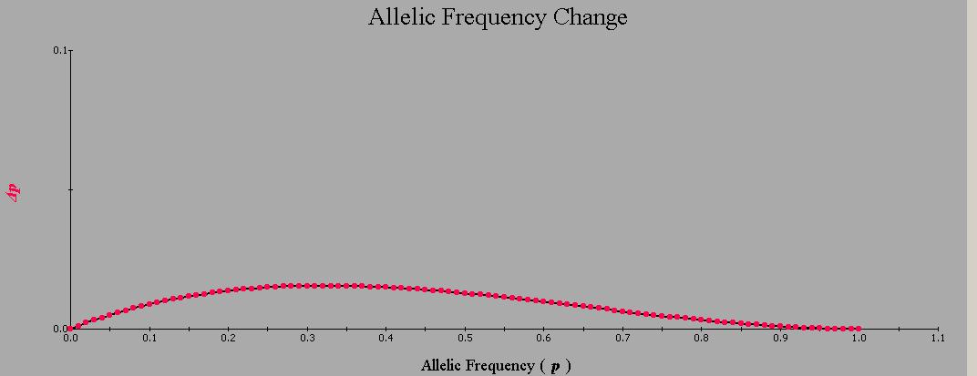
Plot of w vs. p
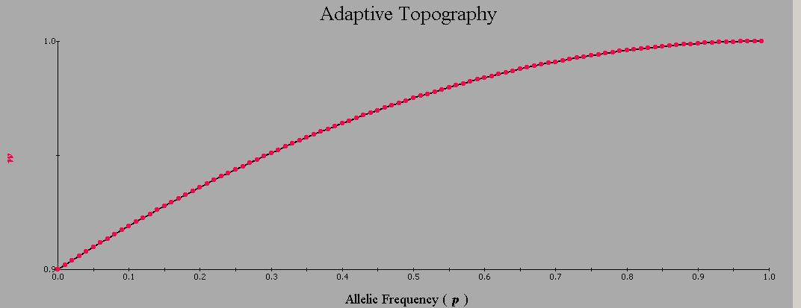
Plot of genotype vs. t
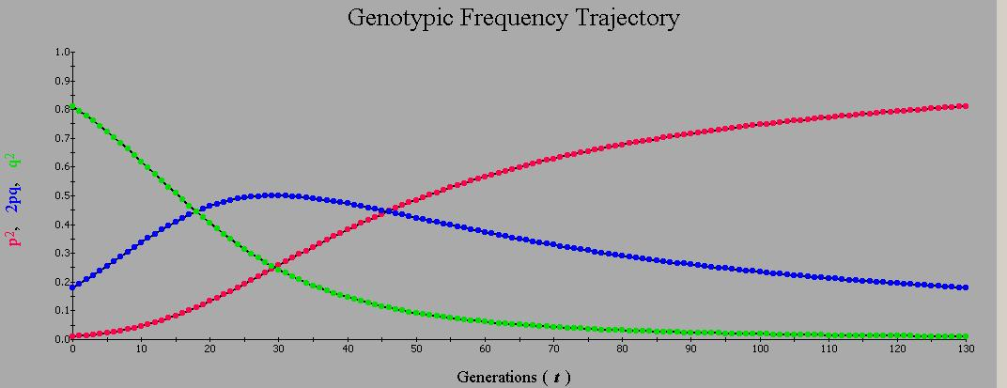

i) The selection coefficient or S_{aa} is equal to 0.10 and h will be equal to 0 as a is fully recessive
ii) As allele frequencies change under selection, population mean fitness will increase until it eventually reaches 1. The maximum mean fitness here is the equal to the equilibrium allele frequency, as the maximum mean fitness is approximately 1 and the maximum mean fitness is also 1.
iii) No, most of the alleles do not fix. As the A allele approaches 1 it slows, however it will not fix at 1 as the a allele will not completely disappear from the population. The a allele will be retained in heterozygotes, as the fitness of the heterozygotes is the same fitness as the AA individuals. The heterozygotes will ‘shelter’ the a alleles from selection and so A will never fix.
iv) Natural selection will still not purge the a allele if the recessive allele fitness is=0 as the heterozygotes will still ‘shelter’ the little a allele, as the fitness of the heterozygotes remains unchanged. Inbreeding would increase selections ability to purge a deleterious recessive allele as smaller populations have an increased homozygosity which will make it easier for the recessive allele to be purged, as the amount of heterozygotes will be declining and the heterozygotes ‘sheltered’ the a allele.

c. Selection against a codominant allele
Plot of p vs. t
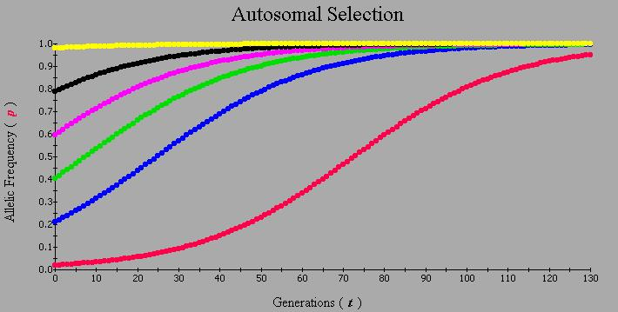
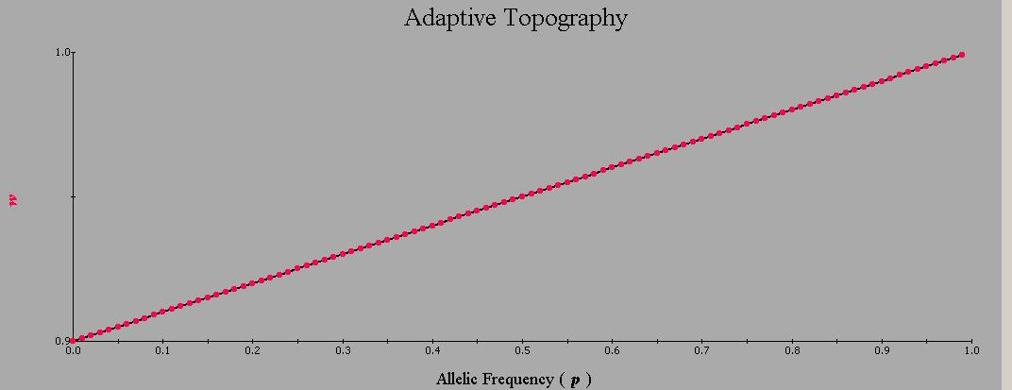

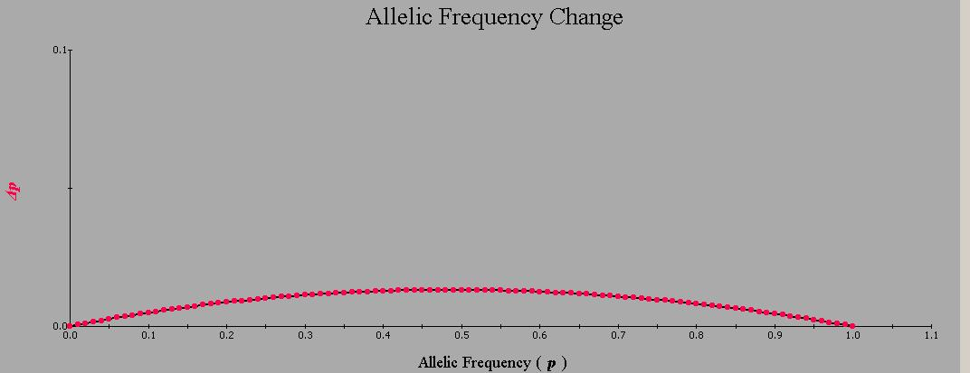
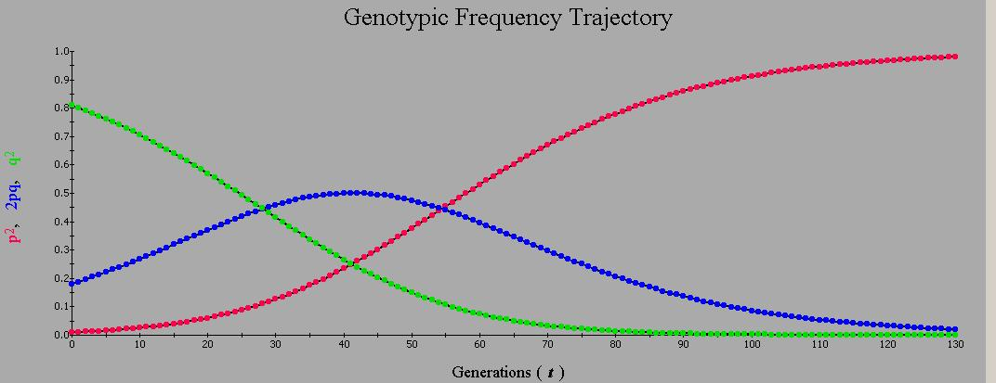
i) The selection coefficient or S_{aa} is equal to 0.1 and h will be equal to 0.5.
ii) The A allele will eventually fix, as shown in this plot it comes close to fixing but does not quite fix. The reason this would fix compared to the dominant example before is that now the heterozygotes are at a disadvantage and no longer have the same fitness as the dominant genotype like they did before and so this will eventually result in the a allele fixing at 0 and the A allele fixing at 1.
iii) Heterozygotes increase in frequency in the first 40 generations because the frequency of p also increases, however once it approaches the maximum of 0.5 it begins to decline as p is still increasing and so the heterozygosity has to decline.

d) Selection for heterozygotes: W_{AA}=0.4; W_{Aa}=1; W_{aa}=0.8
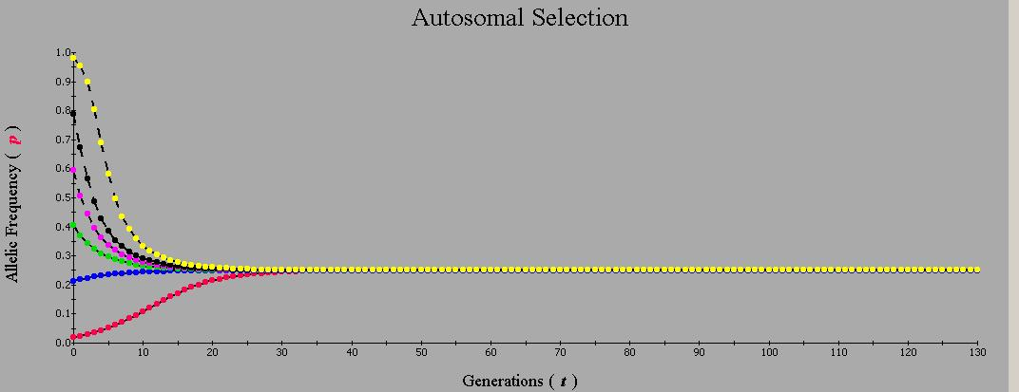

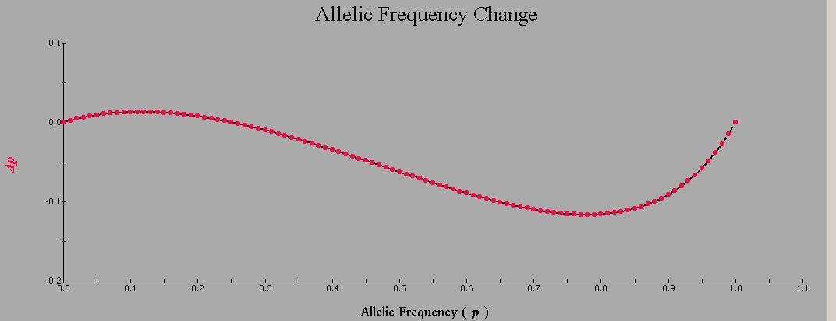

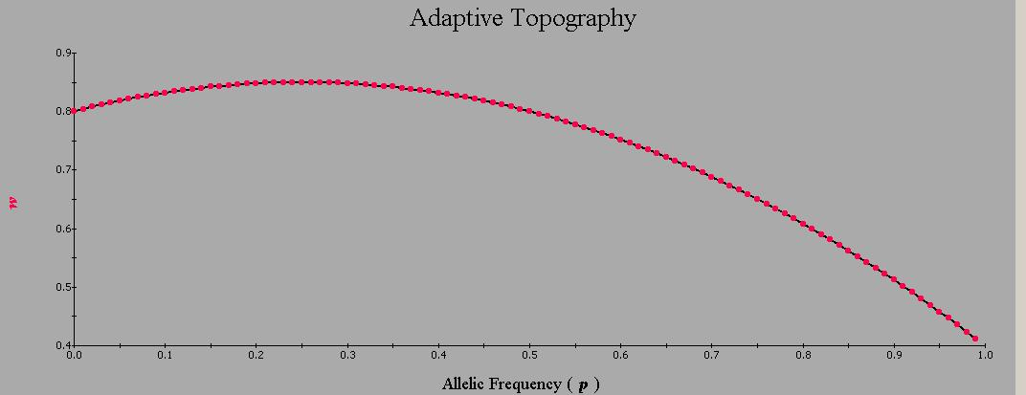

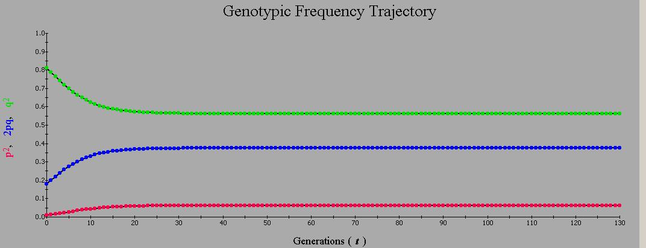
i) There is three equilibria, two are unstable and one is stable. A positive value of p is a unstable equilibria and a negative value of p is a stable equilibria.
ii)

Using the internal (polymorphic) equation, p =0.25
iii) If heterozygosity superiority was common in wild populations then genetic variability would increase because neither of the alleles would be fixed and so it would both A and a alleles would be seen in greater variation.

e) selection against heterozygotes: wAA = 1; wAa = 0.8; waa = 0.9
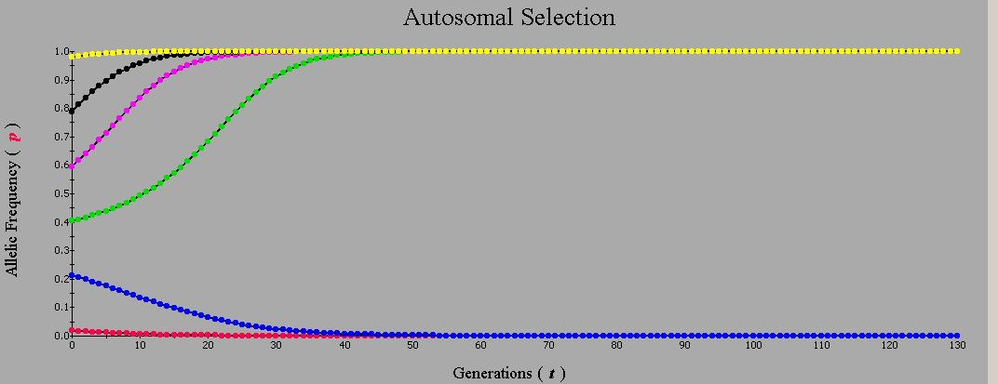

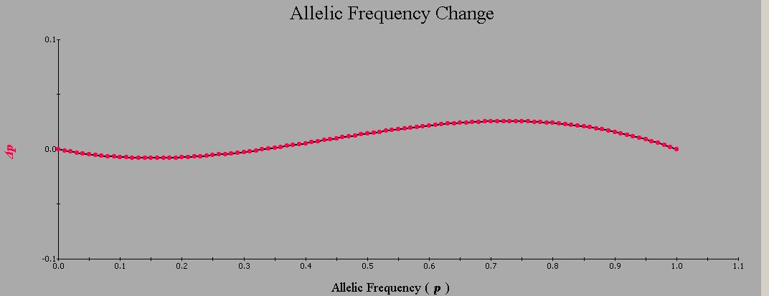
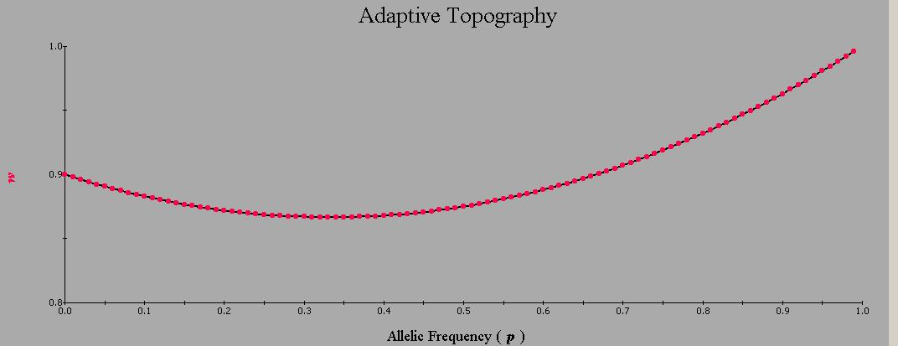
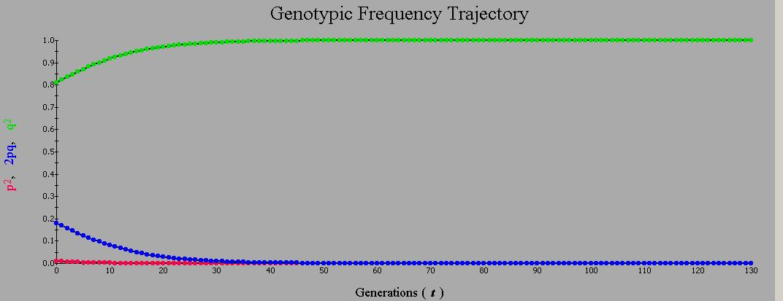
i) Initial allele frequencies above p=0.5 all lead to fixation of the AA homozygote while all other initial allele frequencies below 0.5 leads to fixation of the aa homozygote.

ii)

p= 0.333
iii) Natural section changes genotype frequencies in a way that increases the population mean fitness meaning that it is driving the population towards its maximum mean fitness.

2.
a) If A and B have had the same substitution rate since they split from X, the expected number of substitutions present between X and A should be the same as the number of substitutions that are between X and B. The relative rate test uses an outgroup, C, to compare to these substitutions and then utilizes a chi square test to test the null hypothesis of rate constancy.

b) When B=C (but not A), this occurs 4 times.
When A=C (but not B), this occurs 6 times.

Expected number of different sites = (4+6)/2
= 5

Chi Square Test
df = 1

X² = (4-5)²/5 + (6-5)²/5
= 0.4

Calculated p-value = 0.5271

Since this value is less than the critical value and the associated p-value is >0.05, we accept the null hypothesis that the rates are constant.

3. K = - 3/4ln(1-4/3p)
= - 3/4ln[1-(4/3)(1/3)]
= 0.4408

t = K/2K
= 0.4408/(2)(0.01)
= 22 years

1983 – 22 = 1961

Therefore, this virus last shared a common ancestor in 1961.

4. The neutral theory of molecular evolution proposes that at the molecular level most evolutionary changes and most of the variation within and between species is not caused by natural selection but by random drift of mutant alleles that are neutral.
It has five main predictions: 1) the probability at time t that a neutral allele eventually fixes is equal to its frequency at time t, 2) at mutation-drift equilibrium, neutral mutants are fixed at rate μ per generation, 3) the average time between neutral substitutions is equal to 1/μ, 4) for newly arisen mutations, the average time to fixation is 4Ne(1-p)/p ln(1-p) and 5) if each neutral nutation creates a new allele (infinite-alleles model) then at mutation-drift equilibrium the expected homozygosity=1/(4Neμ +1) and so larger populations should have higher heterozygosities.
One empirical observation that is inconsistent with neutral theory’s predictions is that in nature much less heterozygosity is seen then is predicted under neutral theory. Neutral theory predicts larger populations should have more heterozygosity or increasing heterozygosity with population size, but the heterozygosity is often far less then it should be.
Another empirical observation that is inconsistent with the neutral theory is that after viewing more protein sequence data since the first tests of the molecular clock, there is much more variation in rate then previously thought. The molecular clock for amino acids is significantly ‘overdispersed’ meaning that the index of dispersion is greater then 1 when it should be equal to 1.

