Week 1: What is Research?
- Research
  - A structured process for gathering and synthesizing facts and theories.
    - Systematic and objective
    - Valid and reliable
    - Scientific method
    - Dynamic and creative
    - Examines condtions and outcomes
    - To improve methods at practice
    - In an ethical way
  - Quality:
    - The extant that a study tries to minimizing bias
  - Quantity:
    - # of studies that address the research question?
  - Consistency:
    - Similar findings for studies with different or same design.
- Critical appraisal – quality of the study
  - Validity
  - Results
  - Relevancy
- Nursing research
  - Relates to care/outcomes
  - Supports nursing practice
  - Links education, theory, and practice
- Research themes
  - Health issues
    - Illness
  - Health services
    - Risk conditions
  - Health promotion
    - Risk factors

- Levels of Evidence: Four quantitative Three qualitative

- Process:
  - Identify the research problem
    - Review literature
    - Identify variable
    - State hypothesis and specify purpose
      - Design protocol
        - Collect data
          - Analyze data
            - Interpret findings
              - Report findings
                - Go back to Identify research problem, or
                - Go back to review literature
- Research article components:
  - Abstract
    - Key points, quick review
  - Introduction
    - Research question
  - Literature review
    - Provides context
  - Methods
    - Who, what, where, when, why, how?
  - Results
    - What was found
  - Discussion
    - Context
  - References

Week 2: Ethics
- Case studies:
  - Tuskegee Syphilis study
    - 600 poor black illiterate men
    - Some received placebo, some given meds
      - Men didn’t know and were still sexually active
    - Subjected to spinal taps and autopsy as a requirement
  - Sterilzation in Auschwitz
  - Jewish Chronic Disease Study
  - Milgrim Experiment
    - Experiment of obedience
      - 65% went all the way
      - We are all susceptible of doing these things
        - Disconnect with what we think and what we do
  - Stanford Prison Experiment:
    - Guards and prisoners
      - By day 6 cancelled due to unethicality.
    - Nursing implications: People come seeking care and are vulnerable.
- Code of ethics:
  - 1948 – Nuremberg Code
  - 1964 – Declaration of Helsinki
  - 1979 – Belmont Reports
  - 1997 – Good Clinical Practice: Consolidated Guidelines Health Canada
  - 1998 – Tri-Council Policy Statement: Ethical Conduct for Research Involving Humans
    - SSHRC
    - CIHR
    - NSERC
  - Memorandum of Understanding
- Canadian Code of ethics in Nursing Research:
  - 1983 – Ethical Guidelines for Nurses in Research Involving Human Participants
  - 2002 – Ethical Research Guidelines for Registered Nurses
  - TCPS 2—2nd edition of Tri-Council Policy Statement: Ethical Conduct for Research Involving Humans
- CNA 5 human rights:
  - Self-determination
  - Privacy
  - Anonymity and confidentiality
  - Fair treatment
  - Protection from discomfort and hoarm
- Informed consent:
  - Legal principle
  - Voluntary/free
  - Full disclosure
  - Eligible/coprehendible
    - Participation
    - Risk/benefit
    - Withdrawal
    - Confidentiality
    - Contact person
- Quantitative | - Qualitative
- Title of research study  - Institution  - Principal Investigator (PI)  - Co-Investigators/Collaborators  - Sponsor/funding  - Introduction to study  - Background and study purpose  - Study design  - Risks related to participation in study  - Benefits to participation in study  - Voluntary participation  - Confidentiality  - Questions about the study  - Consent | - Title of research study  - PI  - Co-investigators  - Research Assistants  - Contact person  - Information pertaining to study including study purpose  - Risks related to participation in study  - Benefits related to participation in study  - Confidentiality  - How data will be handled  - Compensation  - Participation  - Feedback and publication  - Contact information  - Consent
- Research Ethics Board
  - Panels that review research protocols
  - Required by Tri-Council
    - 5 Members (both sexes)
    - Two professionals relevant to research
    - One professional relevant to ethics
    - One community member with no affiliation to the institution
  - The more vulnerable your group is, the longer the ethics review process will take.
- Funding organizations:
  - Canadian Foundation for Healthcare Improvement (CFHI)
  - Canadian Institutes for Health Research (CIHR)
  - Canadian Association for Nursing Research
  - Canadian Nurses Foundation (CNF)
  - Consortium for Nursing Research and Innovation
  - Social Sciences and Humanities Research Council (SSHRC)
  - International Development Research Centre (IDRC)
  - Health Canada
- International Research Priorities:
  - Eradicate extreme poverty and hunger
  - Achieve universal primary education
  - Promoted gender equality and empower women
  - Reduce child mortality health
  - Improve maternal health
  - Combat HIV/AIDS, malaria, and other diseases – as of late, ebola
  - Ensure environmental sustainability
  - Develop a global partnership for development
- What can nursing research do?
  - Assist systems issues
  - Health related change and improvement
  - Advocacy and political action
- Sources of Knowledge
  - Tradition
  - Authorities
  - Personal experience
  - Trial and eroor
  - Intuition
  - Logical reasoning
  - Disciplined
- Sources of nursing knowledge
 | Qualitative/Constructivist | Quantitative/Positivist
Nature of research | Individual-based  Subjective | Population-based  Objective
Reality | Multiple realities | One scientific truth
Context | Enriched details of specific time/place | Generalizable to others
Goals | Describe and understand | Describe, explain, predict
Values | Woven in | Not applicable (detracting)
Researcher’s voice | Active | Neutral, observer
Methods | Dialogue | Experimental or quazi-experimental
  - Constructivist – To build and put together. Qualitative research is a constructivist paradigm.
  - Positivist: To be positive. A scientific truth. Bias must be removed here.
- Principles of research use
  - Assess – issue and evidence
  - Diagnose – will it work (here)? Risk/benefit?
  - Plan – based on research/best practices
  - Implement – team buy-in/change theory
  - Evaluate – impact on client care, cost.
- Research utilization vs Evidence informed practice
  - Research utilization:
    - Knowledge dissemination/translation, how scientific knowledge is moved into practice settings. What components are taken up? Implementation guidelines. What we are able to argue and what is done in practice (huge gap). Lots of research doesn’t get used. Waste of millions of dollars. How will the research findings make it into practice BEFORE we fund you.
  - Evidence Informed practice: taking everything into consideration (including research utilization).
    - Using research as a component of your care.
    - Uses case reports and expert opinions
    - Guidelines:
      - Date (out of date?)
      - Authors (experts?)
      - Clearly written
        - PICOT
          - Population
          - Intervention
          - Comparison
          - Outcome
          - Time
        - Level of evidence
        - Research retrieval
        - References
      - Reviewed
      - Tested
  - Issues:
    - Assumes people want to change
    - Fails to account for contextual/cultural intertia
    - RU – extremely slanted toward empirical studies
    - Change can be slow
      - Lack of evidence
      - Slowness of context
      - Competing interests
    - Behaviours can change before law does
- Clinical interpretation:
  - Identify issue
  - Collect best evidence
  - Critically appraise and synthesize evidence
  - Integrate evidence, clinical expertise, patient preferences and values
  - Evaluate the practice decision or change

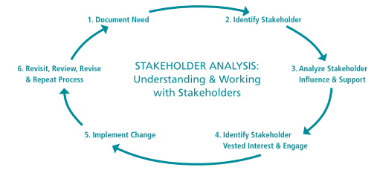

Week 3 – Literature Review/Hypothesis
- Literature review
  - A process that the researcher will engage in during the entire process of the study.
  - Cyclical process
    - Idea
    - Brainstorm
    - Review evidence (lit review)
    - Identify variables
    - Research question – PICO(T)
      - Problem
      - Intervention
      - Control
      - Outcome
      - Time
    - Hypothesis
  - Organized critique of important scholarly literature
  - Supports and guides study
  - Why?
    - Consumer
      - Learn current knowledge
      - New practice/protocol/guideline development
    - Researcher
      - Understand research problem
      - Determine strengths and weaknesses
      - Determine need for replication/refinement
- Quantitative Literature Review
  - Background
  - Theoretical or conceptual framework
  - Research question/hypopthesis
  - Design and methods
  - Interpretation
  - Implications
- Qualitative Literature Review
  - Phenomenological research: compares findings to enhance knowledge
    - Chair example, what is the essence of the chair. Different people have different experiences, of grief for example, regardless of how it is caused, is common between all of the participants.
  - Grounded theory: constantly compares literature with the data being generated
    - May not look at the research before starting the study. Most closely aligned with quantitative research.
  - Ethnographic: more conceptual than data based; provides a framework for the study
    - Always interested in culture – ICU culture, rave culture, etc. How do these people come together and make traditions.
  - Case study: conceptual and data-based literature are embedded in the report
    - Review research to see what is conceptual
  - Historical: literature review is the source of data
    - Analysis, where did this come from? Go back and trace through research literature.
- Conducting a literature search:
  - Research/review question
  - Identify key variables, terms
  - Search electronic databases (& others)
  - Review titles, abstracts – weed out irrelevant
  - Retrieve possibly relevant – review articles – weed out irrelevant
  - Summarize & critique
  - Synthesize information
  - Develop conclusions / recommendations
- Types of Reviews:
  - Systematic
    - A methodology – uses rigorous and explicit parameters to identify, appraise and summarize studies
    - Aim – offer the best available evidence for clinical decision making and policy making.
    - 2 types:
      - Quantitative: meta-analysis/statistical
      - Qualitative: do not use statistical methods
      - Can be from qualitative or quantitative studies
      - Meta-synthesis
  - Critical
    - Typical of review presented in research papers
    - Less comprehensive
  - Other
- Framing the Quantitative question:
  - P – Population – should be very detailed
  - I – Intervention – what we are introducing into the scenario to try and change the result
  - C – Counter intervention/comparison – status quo or nothing
  - O – outcome – expected to find
  - T – time – in what timeframe will the outcome happen in.
- Framing the Qualitative question:
  - P – population
  - S – Situation
- Hypothesis
  - A best guess or prediction about what a researcher expects to find with regard to the relationship between two or more variables.
  - Directional: The direction of the relationship between the variables
  - NO HYPOTHESIS IN QUALITATIVE RESEARCH
  - Paradigm
    - A paradigm is our world view. How we think about the world.
    - The type of research somebody does generally stems from somebody’s world view (paradigm)
    - what is to be observed and scrutinized
    - the kind of questions that are supposed to be asked and probed for answers in relation to this subject
    - how these questions are to be structured
    - how the results of scientific investigations should be interpreted
    - Major paradigms
      - Post-positivist
      - Interpretative/constructivist
  - Research problem?
    - Something, someone has determined is an issue that they want to look at.
  - Purpose
    - More focused than the problem
    - Sets out the aims or goals
  - Types of hypotheses
    - Research or statistical (null)
      - Null (statistical) predicts no difference or relationship exists
        - Basis for statistical testing in research
      - Research hypothesis opposite of null – specifics/predicts a relationship
    - Directional or non-directional
      - Directional
        - Direction for effect specified
          - Improve, detract (adjectives)
      - Non-directional
        - No specific direction for effect but association is stated
          - Differ, etc.
    - Simple or complex
      - Simple
        - Cause-effect relationship only between dependent and independent variables
      - Complex
        - More complicated causal pathway, more variables.
  - Hypothesis
    - Directional (or non)
      - X will increase/ decrease/change Y
    - NOT in qualitative
    - NOT in exploratory
    - May need to deduce from analysis, results, discussion
    - May be statistical
    - Critique
      - Directly related to research question?
      - Variables identified?
      - Variables measureable/ observable?
      - Testable?
      - Directional?
  - Question
    - Non-directional
      - X is associated with Y
    - What is/ or is there a relationship between X & Y?
    - All types of research
    - May need to deduce from analysis, results, discussion
    - Critique
      - Introduce promptly?
      - State clearly?
      - Express relationship between variables?
      - Specify population?
      - Significance identified?
      - Feasibility addressed?

Week 4: Conceptual and Theoretical Frameworks
- Definitions:
  - Paradigm: a way of thinking about the world.
  - Ontology: originates from Greek “to be”. What is true? What exists? What is real?
  - Epistemology: driven by ontological beliefs: what is the relationship between the researcher and what can be known? How objective can this be?
  - Methodology: specific and practice based: driven by O and E. How do we discover knowledge?
  - Reality: Realism vs. Relativism: Aesthetic Knowing is underpinned in being able to see the value of both realities.
    - Realism (Quantitative): believing in the “real” to explain the relationship between the variables. Real is outside of us. Scientific method/deductive reasoning. The “truth” that is objective, static, and measurable. Context-free generalizations. Cause and effect laws. Research that converges on the truth. Reductionist and deterministic approaches.
    - Relativism (Qualitative): what is real is a matter of perception. Searches for meaning rather than truth. “Truths” are subjective, dynamic, and contextual. Knowledge that is contextual. Multiple truths that may conflict but are still true. Perceptions or truths that may change with time. Consensus sought in research findings. Searching for a meaning in their research by going back to the participant and asking if their conclusions resonate with them.
  - Positivism:
    - Ontology: Realism: One reality exists that can be found.
    - Epistemology: Dualist and Objective
    - Methodology: Experimental leading to decontextualized results.
    - Leading to modernism: research, science, and tech will help develop the world through understanding of the true nature of the world. Post-modernism is the understanding that reality has too many different views and perspectives. Not possible to define social phenomenon. A movement away from traditional school of thought based on a distrust.
  - Post-positivism: supporting or rejecting the null hypothesis.
    - Ontology: Critical realism: ‘truth’ exists but it cannot be accurately detected. Since we are not perfect, we cannot find the absolute truth.
    - Epistemology: Modified dualist and objective
    - Methodology: Modified experimental and interpretive research. By refining how an experiment is designed, we can get closer to the truth. Recognize and control the influence that the background knowledge of the researcher has. Combination of quantitative and qualitative. Instead of proving hypotheses, they are falsified.
    - One truth, we will never find it, but we can improve our methods of investigation by designing better research. Closer to understanding the universal generalizable truth. Researchers want to ensure that researcher bias doesn’t play a role in research, and want their research to be replicated. Very objective.
    - Research focus: facts, variables, linear relationships (cause and effect), theories, laws
    - Research purpose: to describe, explain, predict, test
    - Research question: what? What is the relationship? If x then what?
  - Constructivist:
    - Ontology: Relativism: realities are co-constructed.
    - Epistemology: interactive/transactional and subjective with co-created findings
    - Methodology: Qualitative, interpretative, and logical with a well described text. Gathering data through dialogue.
    - Interactive consensus of the research findings. What we discover and count as knowledge about a phenomenon is co-constructed by the researcher and the participants. See emerging themes, then go back to participants and ask them if their themes resonate with them. Negotiating new knowledge. Multiple truths and realities.
    - Research focus: experience, social interaction, human nature, meaning
    - Research purpose: to explore, understand, make sense of
    - Research question: What is the nature of? What is going on here? How?
  - Critical Theory:
    - Ontology: Historical realism. What you know is shaped by historical, time period, location.
    - Epistemology: Transactional and subjective findings that are influenced by values.
    - Methodology: Dialogue based and logical.
    - Understanding historical context is essential. Focused on using research as a form of emancipation. Ideologically driven research. Invested in changing these conditions. Different resources create different realities.
    - A realist ontology with a relativist epistemology. Conditions in which people exist and through research, we can change this. Emancipatory. Social justice, change status quo. How and when an event takes place is shaped by historical realism.
    - Research focus: social injustice, historical patterns, hegemony, oppression.
    - Research purpose: to critique, emancipate, transform
    - Research Question: What is going wrong? This is wrong, so how do we change it?

Item/Question | POST-POSITIVISM | CRITICAL THEORY | CONSTRUCTIVISM (INTERPRETIVE)
ONTOLOGY | A material world does exist.  Imperfect understanding of external/material world | Reality is constructed by those with the most power at particular points in history.  Reality is shaped by numerous social, political, economical and cultural forces. | Reality is constructed by individual perception.  There exists no absolute truth or validity.
EPISTEMOLOGY | Researchers are naturally biased.  Objectivity is the ultimate goal. | Transaction between researcher and participants. | Context is not emphasized.  Research emphasizes the meaning ascribed to human experiences.
RESEARCHER VALUES | All attempts are made to exclude research bias. Influence denied. | Research bias is recognized as potentially influential. | Influence is limited with reflection and bracketing.
METHODOLOGY | Experimental, quasi-experimental, non-experimental, qualitative. | Intersectionality, institutional ethnography, feminist grounded theory | Phenomenology, ethnography, grounded theory,
AIM OF INQUIRY | Explanation, prediction and control | Critique, change and reconstructed reality and emancipation | Understanding and reconstructed reality
CONTEXT | Biographical | Historical, social, and political | Time and place
- Frameworks: How a researcher is conceptualizing the variables. How do the concepts relate to one another? Apples and oranges. Scaffolding of the research.
  - Frameworks – FOUND AT THE END OF THE INTRODUCTION
    - Help us understand the problem
    - Different frameworks for different aspects of problem
    - More than one framework may be relevant to problem
      - and…may lead to alternative findings
    - Allow researchers to build on / contradict others’ work
  - Concepts: abstract descriptions of phenomena.
    - Can be words or mental images. Important for communication. Concepts are important because I need to know what concept the participants are working with. Different researchers will explain concepts differently. Development: specific methods; methods chosen are based on beliefs about reality; beliefs about concepts shaped how we interact. Researcher might be interested between exploring the relationship between their concepts of two variables.
  - Models: Show relationships between concepts.
    - Generally qualitative. Not ‘proven’.
  - Theories: Quantitative evidence.
    - A proposed relationship between concepts. Considered more ‘proven’ than models. The more research that supports a theory, the better it is.
  - Theories and concepts are the lenses.
    - They magnify area of interest
    - Research illuminates one part
  - Conceptual Framework: Connection of concepts that the researcher is saying. Defined by the researchers. May be informed by previous research. Connecting concepts to previous research.
    - Connection of concepts by researcher
    - Not as solid or supported.
    - Seeking to be validated.
    - Shows up more often in quantitative research.
  - Theoretical Framework: Why does the problem exist. Informed by previous research. Lit review, looking at various theories about why the phenomenon is the way it is. Guides the research.
    - Theory of why the problem exists
    - Guides the research
    - Provides structure for the concepts that exist.
    - Helps us understand why a given phenomenon is occurring.
    - Informs research question.
    - Writing about theoretical framework:
      - Background
      - Methods
      - Discussion
  - Assessing framework
    - Identified?
    - Consistent with nursing perspective/values?
    - Appropriate to subject of research
    - Concepts and variable defined appropriately
    - Background
    - Link framework, concepts, and how measured
    - Results compared to framework
- Ladder of abstraction:
  - Abstract
    - Worldview
    - Framework
    - Theories
    - Concepts
    - Variables
  - Contrete
- Theories
  - Grand
    - All inclusive, conceptual, meta-paradigm
  - Mid-range
    - Links practice and research
  - Micro-range
    - Situation-specific
  - In Quantitative
    - Theoretical framework
    - Hypothesis test
    - Results that support or refute hypothesis
    - Discussion fit of results to theory
  - In Qualitative
    - Theory may be used to frame the problem or question
    - Literature review may be organized by theory
    - Implication should be linked
  - Grounded theory is a theory that is developed from the ground up. The theory did not exist before the data was collected.
- Conceptual definition
  - Dictionary/culturally accepted word/phrase
- Operational definition
  - How to measure it.
ITEM | DEFINITION
Theoretical framework | A structure of concepts, theories, or both. It is based on a philosophical or theorized belief or understanding of why the phenomenon under study exists.
Conceptual framework | A structure of concepts, theories or both that used to construct a map for the study (review or qualitative).
Theory | A set of interrelated concepts that provides a systematic view (not review!) of a phenomenon.
Model | A symbolic representation of a set of concepts that is created to depict relationships (multiple concepts).
Concept | Image or symbolic representation of an abstract idea.
Variables | The elements that can be observed through senses.
Conceptual definition | Conveying general meaning of the concept.
Operational definition | Specifies how the concept will be measured: that is, what instruments will be used to capture the essence of the variable.
Hypothesis | Tentative statement of relationship between two or more variables that can be empirically test (prediction).

Week 5 – Qualitative Research
METHODOLOGY | CONSTRUCTIVIST/  INTERPRETIVE | CRITICAL SOCIAL THEORY
PHENOMENOLOGY | (true) Phenomenology | Critical/dialectical phenomenology
GROUNDED THEORY | GT method | Feminist Grounded Theory  Critical Realist GT
ETHNOGRAPHY | ethnography | Critical ethnography  Institutional ethnography  Public ethnography
HISTORICAL RESEARCH | Historical research | Historical-critical (sociological)
PAR | Qualitative Inquiry | PAR  Community-based PR (CBPR)
CASE STUDY | Case Study | Critical Case Study
OTHER METHODOLOGIES | Symbolic interactionism | Intersectionality  Feminist qualitative research  Critical humanism & queer theory
- Research question
  - Researcher’s area of interest (experience of the world) sparks a research question. Something feels like it could be done to improve something else. Develops a focus, gets participants, and see how it aligns with other work that is going on. This allows for challenging their research and informing it.
  - Consists of:
    - Researcher
    - Research focus
    - Research participants
    - Research context
  - Influenced by:
    - the population and situation/scenario (PS)
    - the qualitative approach
    - the larger ontology and subsequently, the methodology
    - the method and analysis
- Paradigms and how they relate to research methods
  - Positivism = sometimes qualitative, mostly quantitative
  - Constructivism = always qualitative
  - Critical theory = equally both.
- Qualitative:
  - Systematic
  - Interactive
  - Subjective
  - Naturalistic setting
  - Discovery oriented, descriptive &/or interpretive
  - Text = data
  - Makes the world of others visible
    - How is the social world understood, experienced, produced, and constituted?
- Research: Hierarchy
  - Worldview - paradigm
    - Epistemology
    - Ontology
    - Axiology
      - Theoretical lens - theories the researcher is bringing to understand a phenomenon in a certain way. A theoretical lens guides a study. Helps researcher orient themselves.
        - Narrative
        - Phenomenology
        - Grounded theory
        - Ethnography
        - Participatory action research
          - Methods, analysis and interpretation, dissemination
  - Approach + method = methodology
- Methodologies
  - Phenomenology
    - Nature of design: human experience
    - Research questions: what is the human experience of…?
      - What is the lived experience…
      - What does it mean…
    - Describe phenomenon
    - Appearance of things
    - Lived experience
    - Theorists: Know their names. Key in identifying phenomenological study EXAM “We used a:
      - Husserl
        - Focuses on rich detailed descriptions of the lived world
      - Heidegger
        - Expands description to understanding achieved through searching for the relationships and meanings of a phenomena.
      - Hermeneutic
        - Establish context and meaning for what people do – constructing the reality on the basis of their interpretations of data.
    - Present new insights
    - Deepen human understanding
    - 5 key points:
      - Intensive dialogue
      - Based on critique of positivism
      - Interpretation of life
      - Share a common world
      - Bracketing – aware of and examine their own prejudices and values
  - Grounded theory
    - Nature of design: Social interaction processes
    - Research question: How does this social group interact to…?
      - How do…
    - Develop theory based on observations
    - Most closely aligned with quantitative.
    - Very procedurally guided. Step by step.
    - Develop a theory from the ground up
    - Social interaction processes
    - Key constructs and concepts uncovered.
    - Uncover key constructs and concepts
    - Theoretical sampling is very important: very loose set of questions and adjust the questions for the next interview and so on, and then intentionally select participants who are experts on the types of themes that are emerging. AS IT IS GENERATED.
      - Theoretical saturation: gather participants until no new themes emerge.
        - Makes the assumption that the research has an end. Could you ever know the absolute truth? Closely related to quantitative.
    - Terminology:
      - Constant comparative: terminology often used in Grounded theory.
      - Data collection.
      - Ground up.
      - Emerging theory.
      - Method: where we recruit the participants. Online – SAMPLING: Non-probability. Convenience.
      - Continually modified interview questions based on initial data collection.
      - Coding
      - Glaser and Strauss.
      - Credibility: very detailed. Audit trail is very important in grounded theory (in all qualitative)
    - Founders:
      - Glaser and Strauss
      - Corbin
    - Evolution: bracketing shouldn’t happen – Charman and Wuest
    - Not trying to be generalizable. Generating a theory which then may or may not be generalizable in a quantitative study.
  - Ethnography
    - Nature of design: cultural patterns
    - Research question: how does this cultural group express their pattern of…?
    - Participatory observation & interviews
    - Explore a culture or sub-culture
    - Uncover: values, beliefs, norms, rituals, practices artifacts, unique ways of being, seeing and doing.
    - Describe the culture for others
    - Enhance human understanding & appreciation of other cultures.
    - Pioneered by anthropologists
    - Emic perspective
      - The insider’s view of the world
    - Etic perspective
      - The view of the researcher
    - Leaders in the field:
      - Mead
      - Scotch
      - Agar
      - Leineger
      - Kleinman
      - Thomas (critical ethnography)
      - Usher (critical ethnography)
      - Smith (institutional ethnography)
  - Historical research
    - Nature of design: past
    - Research question: how did this historical event influence today?
    - Understanding the past through collection, organization, and critical appraisal of facts.
    - 3 frameworks:
      - Biographical history: an exploration of prevailing values and beliefs in a particular period by examining everyday events of an individual
      - Social history: an exploration of the prevailing values and beliefs in a particular period by examining everyday events of society
      - Intellectual history: an exploration of the ideas of a particular individual or a group of people
    - 2 criticisms
      - External criticism: validity of documents – the authenticity of the data source is judged (data sources are indeed what they seem to be)
      - Internal criticism: judging the reliability and consistency of information within the historical document. (sense of context and time/era is necessary)
  - Participatory action research (PAR)
    - Nature of design: Working with people
    - Research question: What community practices can improve the health of this group of people?
    - Working with people to improve the present
    - Focuses on practical problems that are particular to a practice setting or community.
    - Use of focus groups, surveys etc.
    - Engage stakeholders
    - Uncover new facts or insights
    - Describe or interpret data with participants
    - Enhance human understanding
    - Evaluate the process to ensure changes have desired effect
    - Community-based participatory research
      - Change or action is an intended outcome
      - Look, think, act
  - Case studies
    - Nature of design: Unique stories
    - Research question: What are the details and complexities of the story of…?
    - Method:
      - Studying the peculiarities and the commonalities of a specific case over time to provide an in-depth description of the essential dimensions and processes of the phenomena.
    - Can have both qualitative and quantitative data
    - 2 types:
      - Intrinsic case study:
        - Undertaken to have a better understanding of THAT case
      - Instrumental case study:
        - Pursuit of insight into an issue or wanting to challenge some generalization.
    - Discourse analysis
      - How we come to talk about phenomenon. How phenomenon is represented, by what we talk about and write about.

Week 6 – Qualitative Sampling, Recruitment and Analysis
- Sampling
  - Less interested in representative sample, but still need to find people to participate that fit the picture.
  - Probability – quantitative
  - Non-probability – qualitative
    - Not a lot of equal opportunity for people to participate
    - Convenience
    - Quota
    - Purposive – intentional
      - Hand pick typical elements using specific criteria
      - Useful if small sample numbers in rare diseases
      - Inclusion and exclusion criteria
    - Network/snowball
      - Useful for hard to find elements
      - Find participants then have participants name others they know with same condition
    - Theoretical: grounded theory
- Sample size
  - Depends on methodology
  - Data saturation is getting the same information from people and no new themes emerging.
- Non-probability sampling
  - What tradition/method of qualitative research would best fir the research problem and/or research questions?
    - Phenomenology – lived experience (purposive)
    - Ethnography – key/general informants (snowball/purposive)
    - Grounded theory – key informants, documents (purposive, theoretical, snowball)
- Recruitment
  - Evaluate the strategies the researchers went and recruited the participants.
  - Ethical? Who will this method be leaving out? Different tactics of recruitments is possible to decrease this.
  - Natural fit?
  - Importance?
- Data Collection
  - Interviews:
    - Structured:
      - Easier to see an emerging theme. Comparing apples to apples. E.g. asking the same 10 questions to participants.
    - Semi-structure:
      - Allows you to more authentically follow where the researcher wants to go. How they get to the theme may vary within participants. Not comparing.
    - Unstructured:
      - e.g. narrative inquiry (story). May start with one question. And they continue to follow the lead of the participant.
    - Advantages:
      - How much time will it take (depth)? Focus group is effective in time; also, you are able to bounce what one person shares with somebody else.
    - Disadvantages:
      - Focus group (disadvantage is that often sacrifice depth, can’t ensure confidentiality, people who like to talk may derail the conversation).
      - Desirability bias: idealized version of yourself and saying what you think the researcher wants you to say.
      - Interviewer bias
  - Observation:
    - Letting the participants know that they are under watch. Ethical. Found typically in Ethnography. You can find it in any of the methodologies however, when participant observation is missing from ethnography, there is a problem.
    - Depends which methodology and which method the interviewer is using.
  - Documents and media:
    - historical and ethnography typically.
- Data analysis:
  - Recorded interviews, transcribed
  - Data is mounted to a computer software to assist analysis
  - Observation data can be written as memos/notes
  - Collection of other materials that are important to the research study
  - Phenomenology:
    - Sensitive readings
    - Identification of shifts in the participant’s thoughts
    - Significant phrases that speak to the essence of the phenomenon
    - Grouping together of segments
    - Preliminary synthesis
    - Final synthesis (essence)
      - What makes the experience be what it is.
  - Grounded theory:
    - Systematic record keeping
    - Open/axial coding
    - Constant comparison
      - Compare analysis to data, and new emerging data
      - Data collection – data analysis –theory generation (iterative and ongoing)
    - Collapse and merge categories/themes
    - Determine relationship between categories
  - Ethnography:
    - Search for domains – or symbolic categories
    - Identification of themes
    - Emerging themes tied directly to the culture being explored
    - Deeper level insights about the way people experience actions within a culture are generated.
- Analysis
  - Data reduction
    - Thematic analysis
    - Coding and codes
  - Difference between phenomenology, enthographyh, and grounded theory
    - Abstraction – dealing with ideas rather than events
      - Phenomenology
        - When does abstraction occur?
          - Not until one has the data
        - Where does abstraction come from?
          - Themes and meanings in accounts, texts
        - How is abstraction done?
          - Deep immersion, focus, thorough reading
        - What is being sought?
          - Describe the essence of the phenomenon
      - Ethnography
        - When does abstraction occur?
          - Prior knowledge of site, situation
        - Where does abstraction come from?
          - Knowledge of social and economic setting
        - How is abstraction done?
          - Rich description
        - What is being sought?
          - Identify themes and patterns in culture
      - Grounded theory
        - When does abstraction occur?
          - From data, but informed by previous theories.
        - Where does abstraction come from?
          - Categories derived from data
        - How is abstraction done?
          - Theoretical sensitivity
        - What is being sought?
          - Identify a core category and theory grounded in data
    - Themes and subthemes
    - Similar analysis techniques but are subtly different
- Rigour
  - Is it credible?
  - Can it be audited?
  - How well does it fit with participants reality

Week 8 - Introduction to Quantitative Research
- Interested in Describing, comparing, measuring the effect or relationship between two or more variables.
- Different types:
- Descriptive: We might survey our post op patients about pain to generate descriptive statistics about their assessment of pain.
- Exploratory: To explore, findings can be tested. Underpins and sets the stage for causal research.
- Causal: Testing the findings.
  - Required to make a causal statement
    - X precedes Y
    - X and Y are correlated
    - Everything is controlled or eliminated
- Methods/methodologies:
  - Prediction
    - make some degree of certainty that the findings would happen again if replicated.
  - Survey/questionnaries
  - Existing frameworks
  - Theory testing
  - Numberical (empirical)
  - Sampling and sample size
    - Core issues in reliability of data
    - a lot of time is taken for this. What are the strategies that they employ so that their sample is representative of the larger population. Have to have enough people.
  - Rigor
    - Reliability and validity
  - Objective
  - Deductive
- Methodologies
  - Experimental
  - Quasi-experimental
  - Non-experimental research appropriate for use
- Design:
  - Acts like a skeleton
  - When? Single point in time? Longitudinal?
  - Where? Different environments?
  - Control for biases
  - Direct analysis
    - Statistical
  - Elements:
    - Objectively conceptualized
    - Accurate
    - Feasible
    - Control
      - Goal – maximize results, decrease errors, control pre-existing conditions
    - Internally valid
    - Externally valid
  - Experimental design
    - Gold standard of research.
    - Includes
      - Intervention that is controlled or delivered
      - Experimental and control group
      - Random assignment
- Randomization
  - Random assignment: to groups (internal validity issue) – equals extraneous variables in both groups
  - Random selection: from population to sample (external validity issue) – equals extraneous variables in the sample that are true for the population
- Terminology:
  - Variable
    - Independent variable
      - Interventions or presumed cause
    - Dependent variable
      - Outcome or presumed effect
    - Extraneous variable or covariate
      - Alternative or other possible causes
      - Control by:
        - Utilizing a homogenous sample
        - Random assignment
        - Minimize threats to internal validity
        - Using experimental design
  - Control
    - Measures used to
      - Decrease error
      - Increase probability/accuracy of findings
  - Setting
    - Natural setting: uncontrolled, real life
      - Don’t encourage a response. More comfortable, easier to get the truth out of the situation. Hard to control extraneous variable.
    - Partially controlled: manipulated or modified
      - Pick from a selected predetermined setting that the participants can choose.
    - Highly controlled: artificial environment
      - Lab setting.
- Validity:
  - Design
    - Internally valid
      - Has to do with how the participants are assigned to control or experimental group. Must equalize and randomize the participants. When we deliver the intervention, the outcome is due to the variable in the study rather than a weighted control/experimental group. Random assignment.
    - Externally valid
      - How the researcher samples so the results of the study can be extended back out and generalize to the larger population. Random selection.
  - Instrument
    - Reliability
      - Consistent measurements
    - Validity
      - Correct tool for measurement
      - Internal: rule out other explanations other than dependent variable outcome due to independent variable
      - External: are the findings generalizable to other populations?
  - Statistical
    - Type I error (alpha): false positive
    - Type II error (beta): false negative
- Threats to validity: Internal influences external validity
  - Internal:
    - History – time and context
    - Maturation – natural changes during study
    - Testing – being tested changes outcome
    - Instrumentation – inter-rater differences, failure of instrument
      - Inter-rater: Two or more researcher are getting different results when they measure. Way that the raters are generating their data.
    - Selection – Bias, Small sample
    - Mortality – Differential loss from groups
  - External
    - Selection effects – Population of interest?
    - Reactivity – natural reactions being studied
    - Measurement effects – actual act of being tested affects outcome
  - Designs that control threats:
    - Experimental (e.g. RCT)
      - Gold standard; control most threats
    - Quasi-experimental
      - Control some threats
    - Non-experimental
      - May control some threats
    - Descriptive
      - May control some threats
- Designs:
  - Are participants randomly assigned?
    - Yes
      - Experimental (e.g. RCT)
    - No
      - Is there a control group OR more than one measurement?
        - Yes
          - Quasi-experimental:
        - No
          - Non-experimental: Non experimental is that there is no manipulation of any independent variable.
  - Experimental design
    - Threats
      - Selection effects
      - Attrition/mortality
      - Control for:
        - Selection bias
        - History
        - Testing
        - Instrumentation
        - Measurement effects
    - Strengths
      - Establish causality/causal direction
      - Control
    - Limitations
      - May be difficult to implement
      - Generalizability may be low
        - External validity
      - Not ethical for some conditions
    - Classic
    - RCT
    - Solomon four
    - After-only
      - When no pre exists
  - Quasi-experimental design
    - Threats to validity
      - Selection bias
      - Selection effects
      - Attrition/mortality
      - May/may not control for:
        - History
        - Testing
        - Instrumentation
        - Measurement effects
    - Strengths
      - Establish causality/causal direction
      - Control
    - Limitations
      - Cannot make clear cause and effect statements
      - May be difficult to implement
      - Generalizability may be low
        - External validity
      - Not ethical for some conditions
    - Classic
    - Non-equivalent control - When randomization step is deleted
    - One group - When control group is deleted (pre-test – post-test)
    - Time series
  - Non-experimental design
    - A lot of survey research and longitudinal data. Comparing and watching the results over time.
    - Classic
    - Cross sectional
      - Strengths
        - Fast
        - Less expensive
        - Large number of participants
        - Large number of variables
      - Limitations
        - No causal association
        - Threat to validity
          - Selection bias
    - Prospective (longitudinal cohort)
      - Strengths
        - Time line established (exposure before outcome)
        - Large number of participants
        - Large number of variables
      - Limitations
        - Very expensive, long term follow up needed
        - Large loss to follow up possible
        - Threat to validity
          - Selection bias
          - History
          - Instrumentation
          - Testing
      - If you delete a control group this becomes a descriptive study
    - Retrospective
      - Go backwards to ask about exposure
      - Strengths
        - Fewer participants
        - Large number of variables
      - Limitation
        - Very difficult to find adequate control group
        - Threats to validity
          - Recall bias
          - Selection effects
- Causation vs correlation vs relationship
  - Causal relationship
    - Time/temporality – cause must precede effect
    - Makes sense biologically/plausibility
    - Dose-response
    - Consistent/strength of association
  - Association (general relationship)/correlation (linear relationship)
    - Statistical
    - Needs corroborating research
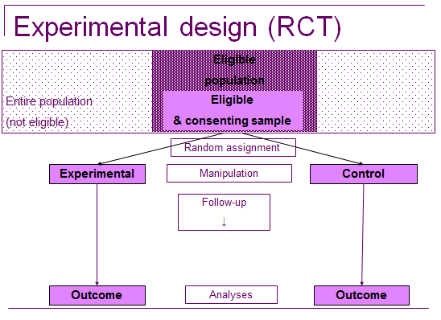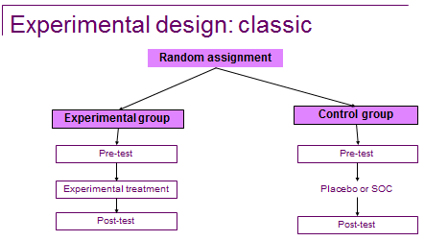
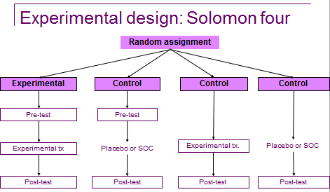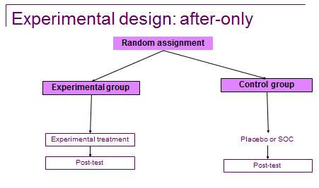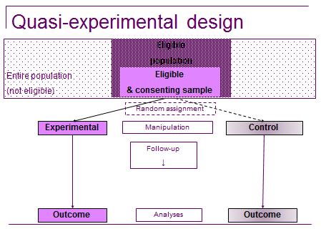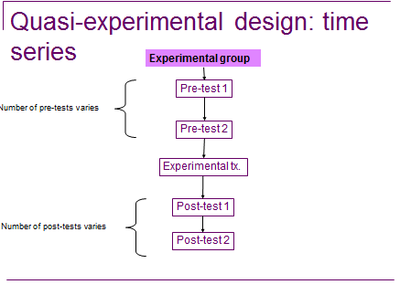
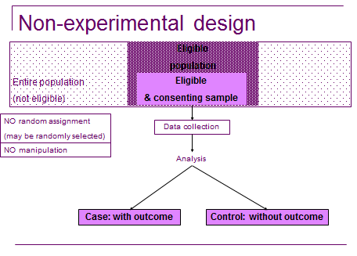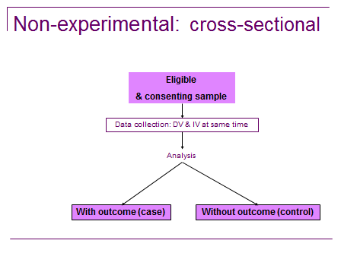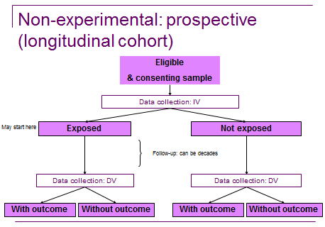

Week 9 – Quantitative Research
- Terminology
  - Population – all possible subjects
  - Target population – all possible subjects who meet eligibility criteria
  - Sampling – sample selection
  - Sample – a subset of subjects
  - Element – one subject
- Sampling
  - Produce a representative group of participants to generalize to population of interest
  - People in these categories
    - People
    - Places
    - Time
  - Heterogeneous
    - Extraneous factors common
    - Diverse participants
  - Homogeneous
    - Similar participants
    - Eligibility criteria allows for a more homogeneous sample
- Probability Sampling strategies
  - Simple random
    - Need a sampling frame
    - Each element has equal and independent probability
    - Uses a random number generator
    - Is the basis for statistical inference
  - Systematic
    - Needs sampling frame
    - Uses the frame’s order (numbered, age, alpha, etc.) to locate element
      - Pick every 10th etc.
    - Faster than simple but may introduce bias
  - Stratified random
    - Needs a sampling frame
      - Complete, have strata/grouping of interest to researcher
    - Divide sampling frame into strata then choose random sample
    - Complicated and expensive, but representative
    - Proportional stratified
      - Number chosen from each strata is proportional
  - Cluster
    - If sampling frame of each element is not available, we could use stages of random sampling.
    - Convenient, efficient
    - Higher sampling error/bias possible and require more complicated analysis
    - Region city hospital worker = 4 stages.
      - Choose same number of participants from each.
- Non-Probability Sampling strategies
  - Convenience
    - Use elements available at time and place of study
    - Does not require sampling frame
    - Can be fast and efficient but may not provide representative sample
  - Quota
    - Researcher sets quotas for number of elements from specific strata
    - Ensures adequate elements from strata but cannot ensure unbiased sample
    - Subgroup your population and then collect people based on probability of each population. Not random.
  - Purposive
    - Studying a very specific rare disease. Directed by purpose of study.
  - Network/snowball
    - Participants can provide references to other participants.
  - Theoretical
    - Based on theory or framework. Sample is directed by theory.
Sampling Strategy | Ease of drawing a representative sample | Risk of bias
NONPROBABILITY SAMPLE
Convenience | Very easy | Greater than in any other sampling strategy
Quota | Relatively easy | Contains an unknown source of bias that affects external validity
Purposive | Relatively easy | Bias increases with greater heterogeneity – maximal variation
Network | Can be easy if the network is accessible | Minimal if a thorough sampling plan is developed
Theoretical | Requires a two-stage process; can be prolonged | Minimal if a thorough sampling plan is developed
PROBABILITY
Simple random | laborious | low
Stratified random | Time-consuming | low
Cluster | Less time consuming than simple or stratified sampling | Subject to more sampling errors than simple or stratified sample
Systematic | More convenient and efficient than is simple, stratified or cluster sampling | Bias in form of nonrandomness can be inadvertently introduced
- Sampling Bias: Threats to validity
  - Selection bias
    - Sampling strategies (external)
    - If participant characteristics raise possible alternate explantion (internal)
  - Attrition
    - Loss from groups (internal)
  - Selection
    - Effect of being studied (internal)
    - Not representative (external)
  - Sampling error:
    - Standard deviations tell you how diverse is the group. The smaller the SD is, the more homogeneous group.
    - Can be outliers.
- How to control for sampling bias/error:
  - Randomization
    - Random selection
      - From population to sample (external)
      - Extraneous variables are true for the population
    - Random assignment
      - to groups (internal)
      - equals extraneous variables in both groups
  - Matching – retrospective/cohorts
    - To reach pre-set smple size for groups
    - Ensure that important variables comparable in sample
    - Often necessary for cluster sampling
    - Harder to find elements/participants if matching
  - Estimate sample size using power analysis
    - Power is a function of alpha, effect size, and sample size
      - Power refers to the probability that your measure/test/study will find a statistically significant difference (between groups and/or pre and post tests) when such a difference actually exists.
      - In other words, power is the probability that you will reject the null hypothesis when you should (and thus avoid a Type II error or Beta).
      - Power = (1 – beta)
    - Power commonly set at 0.8
    - Alpha commonly set at 0.05 or 0.01
    - Effect size – based upon pilot studies or literature review
      - Refers to the magnitude of the impact of the independent variable on the outcome variable
      - How big a difference the intervention made
      - Small – requires larger sample size
      - Medium – requires medium sample size
      - Large – requires smaller sample size
    - Sample size - # subjects required to ensure adequate power
      - Estimated a priori to determine number of elements
        - If too small can result in type II error
        - If too large, unnecessary costs

  - Overestimate sample size to account for drop out

- Data collection:
  - Biological or physiological
    - Physical, anatomical, chemical, or microbiological
    - Advantages
      - Objective, precise, and sensitive
    - Disadvantages
      - Can be invasive, expensive, hard to obtain; may need special training; may cause reactive effects
  - Observational
    - Quantitative needs to be objective. When you observe and you don’t focus enough, then there is a huge bias. You must have a checklist.
    - Concealed/not concealed and with/without intervention
    - Advantage:
      - Ideal for complex interactions and measuring people’s actions/reactions
    - Disadvantages:
      - Ethics, reactivity, observer bias
  - Questionnaires
    - Face to face, phone, paper and pencil, electronic/web-based
    - Advantages
      - Fast, economical, variety, anonymous
    - Disadvantages
      - Breadth vs depth, response rates, recall bias, social desirability bias, incomplete items
  - Records or available data
    - Medical records, admin data, death certificates, census
    - Advantages
      - Usually inexpensive, historical
    - Disadvantages
      - Availability, ethics, bias, missing data
  - Interviews
    - Structured, semi-structured, unstructured
    - Advantage
      - Depth of information, clarification, focus groups
    - Disadvantage
      - Expensive, social desirability bias, interviewer bias, extensive training of interviewer, inter-rater reliability, reactivity
- Measurement error:
  - Systematic
    - Work to minimize systematic error due to poor instructions, poor reliability and validity of measures
  - Random
    - Can do nothing about this
- Instruments
  - Reliability
    - Stability
      - Test-Retest Reliability – test participants on the same questionnaire twice.
    - Internal consistency
      - Reliability as Internal Consistency – one test and that test measures one concept. Should be .8, .7 is acceptable.
    - Equivalence
      - Equivalent-Forms Reliability – test participants on a two different questionnaires.
      - Inter-rater Reliability – ensuring that both observers are observing the same things.
  - Validity
    - The extent to which an instrument measures what it designed to measure
    - Construct – Must be reported and talked about. All questions should measure what you are trying to find out. Don’t be off topic.
      - Hypothesis testing
      - Convergent and divergent validity
      - Contrasted groups
      - Factor analysis
    - Criterion – Predictor. How will you behave in the future?
      - Concurrent validity
      - Predictive validity
    - Content – Is it valid? If you are testing math, you should not test science.
      - Content validity
      - Face validity
  - Validity vs. reliability
    - Validity is about the appropriateness of a test
    - Reliability is about the consistency of the scores produced
- Sensitivity and Specificity
  - Important for screening instruments
    - Sensitivity: ability to identify a case correctly
    - Specificity: ability to screen out the case correctly

Week 11 – Quantitative Research: Analysis
- Data analysis
  - Capture variability (variance)
  - Describe data
    - Data reduction
    - Measures of association
  - Discover meaning and relationships
  - Explore biases in data
  - Test hypothesis
  - Describe the data (to the reader) - Frequency of occurrences in a variable
- Statistical analysis – between and across variables
  - Descriptive Statistic Analysis
    - Data reduction: to summarize or describe the characteristics of a set of data.
      - Frequency, mean, mode, range.
  - Inferential Statistic Analysis
    - Measures of association: assist in generalizing findings from a sample to a larger population.
      - Regression, correlation, t-test, f-test, multivariate testing.
- Results
  - Analyzing the research data
  - Visualizing the relationship between variables
  - Results/findings
    - Are provided in text and through the use of tables and figures
    - Should reflect the objectives, questions and/or hypothesis tested.
      - Negative (unsupported)
      - Positive (supported
      - Statistical differences presented
  - Interpretation
    - Take into account the studies:
      - Aims
        - So, so what, so what now? You should be able to ask these questions and these should be answered in the interpretation.
      - Theoretical underpinning
        - If there is a theory behind the test, how is it brought back in? Does it correlate with the theory or is something different?
      - Existing body of related research
        - How is their conversation about the literature talking about how it relates to their findings? Not the same as literature review. They bring the literature back and tell you how they extended what we knew, and how they filled that gap. This is why it is important.
      - Limitations of the adopted research methods
        - Limitations are necessary. Helps the reader find the significance of the results section
      - Credibility and accuracy of the results
      - Meaning of the results
      - Importance of the results
      - Generalization of the results
      - Implications for practice, theory, and/or research.
    - Could be in discussion, interpretation, or implications.
- Discussion
  - Interpretation of results
    - Contrast and compare with previous knowledge, hypotheses
    - Interpret and discuss results – give meaning – relate back to literature review, theoretical framework, hypothesis, research problem.
    - Pulls everything together
  - Can express opinions
  - Must express importance
    - Meaning/implication for practice
  - Strengths and limitations
    - State validity and reliability issues
    - Related to reliability and validity of instruments, internal and external validity of study
    - Maybe related to sampling strategy or data collection method
  - Suggestions for future research
    - Based on results
    - Just one study, many more to be done to build body of evidence.
  - Conclusions/implications/recommendations
    - Clinical significance (vs. statistical)
- Critiquing study measures:
  - Are all measures clearly identified & described?
  - Is the rationale for their choice outlined?
  - Were methods used appropriate to research problem?
  - Were methods used appropriate to the setting / situation?
  - Was data collection the same for all subjects?
  - Are the reliability & validity of measurement tools adequate?
- Probability sampling:
  - Minimizes sampling error (difference between a sample’s representativeness and population’s known or unknown characteristics)
  - Random sampling balances characteristics of those included in the study (success depends on a sufficiently large sample)
    - *** Equal and independent opportunity *** golden rule of probability sampling
    - *** Not Equal and independent opportunity *** nonprobability sampling
  - Sampling bias occurs when sample not representative of population
    - Who was included in that sample?
    - What was the source of recruitment into the study?
    - How were the subjects recruited?
    - Which people were approached to be in the study?
    - What were the inclusion and exclusion criteria for the sample? What were the demographics of the sample?
    - Was the assignment of patients to treatments randomized?
      - What method was used? Does it ensure that all participants have the same chance of being assigned to any of the groups?
    - Was the randomization concealed?
      - Allocation concealment (so as not to influence recruitment behaviour)
      - Ideal: sequentially numbered, sealed, opaque envelopes
    - Was follow-up sufficiently long and complete?
      - Must be long enough that sufficient numbers of participants actually experience the outcome of interest
      - Are those “lost to follow-up” accounted for?
    - Were patients randomized in the groups to which they were initially randomized?
    - Were patients, clinicians, outcome assessors, and data analysts unaware of patient allocation?
      - Blinding
        - What do the authors of this chapter purport is the gold standard?
    - Were participants in each group treated equally except for the intervention being evaluated?
      - Co-intervention
        - What is this?
      - Contamination
    - Were the groups similar at the start of the trial?
      - Imbalances existing after randomization
        - Why is this important?
          - Small sample size
          - How do you conclude if it is a valid test? Who would you use the evidence on?
          - When do you stop?
- Mean and Standard Deviation
  - Mean is the “average value” from a data set
    - It is a single number summary for a mass of data points which allows for easy comparison between groups
    - However, it is sensitive to extreme scores
  - Standard Deviation (SD) is the most common measure of variance
    - SD describes how far the values stray from the Mean
    - A small SD will have scores closer to the Mean, while data with a large SD will have scores scattered over a wider range around the mean
    - As we all know, smaller is better
- The p Value
  - A mistake some researchers make is claiming there is a difference between their groups when there is not one
  - This is called Type I Error
  - To help combat this, statistical results will present an alpha level, which is the probability of making this error
  - If we can produce a small enough alpha level, we can be more confident that there is no Type I Error, and therefore, the difference we have observed is a true difference
  - The alpha level is denoted with a p value
  - A typical value would be p < .05
  - “the probability that the difference occurred by chance or randomly, is only 5%”
  - “we are 95% sure the difference is a true difference”
  - p < .01 p < .001 p < .0001 p < .06 p < .10
  - The long-held minimum threshold for acceptance is 95% or p < .05
  - Any result that achieves this threshold is considered statistically significant
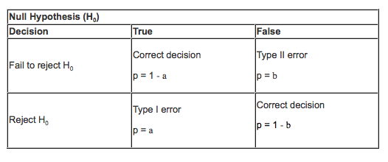
    - There is enough information to suggest that the differences observed cannot be due to chance alone
- False negatives
  - What about the opposite: False-Negatives?
  - In this case, we conclude the treatment or intervention has no effect, when in reality, it does
  - This is called Type II Error (also known as beta)
  - Power in a study 1-beta
- Confidence Intervals
  - Instead of p-values, many studies are now reporting confidence intervals.
  - Confidence intervals also help us understand whether a study finding is statistically significant or not
  - The benefit of confidence intervals is that they help us to interpret the clinical significance of the findings as well
  - When we observe a difference between the Intervention and Control Groups, the Confidence Interval asks “What is the range of differences between the two groups within which the true difference may actually lie?”
  - Confidence intervals can tell us:
    - 1) Is the difference between groups significant?
    - 2) What is the precision of the study finding?
    - 3) What is the clinical significance of the study findings?
- Usefulness and applicability
  - Are your patients and the participants in the study similar?
  - Is the treatment feasible (cost of implementation, including the training and skills required to implement it)?
  - Did the researcher consider all clinically important outcomes (harms and benefits)?
  - Also consider: What are the patient’s values and preference?

Week 12 – Mixed Methods
- Study design
  - What do we want to study?
    - Refine the research problem
  - Quantitative or Qualitative?
    - 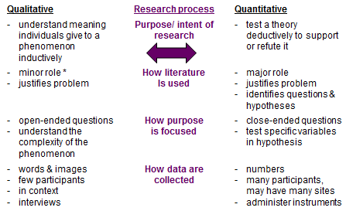
    - 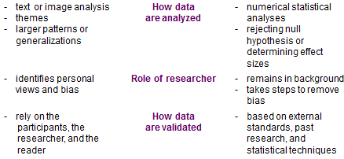
  - When to use?
    - Qualitative
      - Advantages
        - Better understanding of given phenomenon
        - Understanding lived experience required
        - When values, subjectivism, and richness of context are important
      - Disadvantages
        - Personal interpretation by researchers
        - Findings not generalizable beyond study participants
        - Rigor
          - Bias
            - does the researcher identify?
          - Credibility
            - prolonged engagement, persistent observation, peer debriefing, member checks
            - triangulation, crystallization, searching for disconfirming evidence
          - Auditability
            - inquiry audit
          - Fittingness
            - asks are results applicable and meaningful?
    - Quantitative
      - Advantages
        - Specific quantification of data, numbers required (e.g. Prevalence rates)
        - Explore large number of variables efficiently (e.g. Survey)
        - Specific hypothesis or intervention to be tested
        - Want to generalize to larger group/s
      - Disadvantages
        - Unknown (or limited) context and setting in which participants provide data
        - Participant voices are not directly heard
        - Researcher in background, his/her biases not discussed
      - Statistics
        - Descriptive statistics
          - Levels of measurement – nominal, ordinal, interval, ratio
          - Measures of central tendency – mean, median, mode, skewed
          - Measures of spread or dispersion – range, variance, standard deviation, standard error, percentile
          - Measures of reliability – test-retest, inter-rater, intra-rater
          - Measures of validity – content, construct, etc.
        - Inferential Statistics
          - Hypothesis testing – null
          - Probability (p-value)
          - Level of significance and power – alpha and beta
          - Significance - practical or clinical versus statistical
    - Data analysis comparison
      - 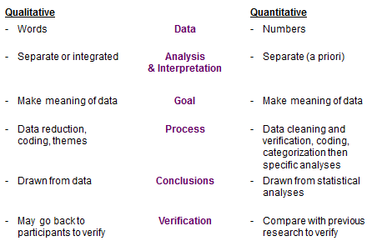
- Mixed methods
  - Popular in health research.
  - The lived experience doesn`t always explain why that phenomenon occurs.
  - How –
    - within one study or across a program of research
  - Why –
    - provides more comprehensive evidence, richer perspective
    - answers questions qualitative or quantitative alone could not
    - encourages collaboration
    - efficient use of time, resources
  - Philosophical assumptions as well as qualitative and quantitative methods.
  - Collecting, analyzing and mixing both quantitative and qualitative data in a single study or a series of studies.
  - Better understanding of research problems than either approach alone.
  - CAN MIX METHODS BUT NOT PARADIGMS
    - Multi-method <--------------------->Integrated methods
      - * Mixed method designs can vary tremendously in the literature
      - **Tend to be along a continuum – ranging from using methods in isolation to integrating methods
      - *** It is not enough to simply collect and analyze quantitative and qualitative data – they need to be MIXED in order to form a more complete picture of the research problem.
  - The philosophical underpinning of most mixed methods is pragmatism.
    - NOT WORLD VIEW OF THE RESEARCHER
    - What is the best question regarding this phenomenon?
  - Mixing data:
    - Merge
      - Quantitative results qualitative
    - Connect
      - Quantitative qualitative results
    - Embed
      - Quantitative + qualitative results
  - Single or multiple studies:
    - Single study:
      - Quantitative results qualitative
    - Multiple studies:
      - Study 1 Study 2 Study 3 results
  - Triangulation
    - Triangulation has evolved as a strategy for ensuring data accuracy (more than one data source to present findings) to an opportunity to more fully address the complex nature of the human experience.
    - Triangulation is the expansion of research strategies in single or multiple studies to enhance diversity, enrich understanding and accomplish specific goals.
    - 5 types:
      - Data triangulation
        - The way the data is collected is different (methods)
      - Investigator triangulation
        - her brought in on the same study interpret the data differently
      - Theory triangulation
        - Different theories
      - Methodological triangulation
        - Different methodologies
      - Interdisciplinary triangulation
        - Different disciplines coming together
  - Examples:
    - 1) small, preliminary, qualitative data providing information useful for the development of a larger quantitative study.
    - 2) limited use of quantitative methods to guide the researcher in a larger qualitative project.
    - 3) qualitative methods used to interpret results from quantitative study.
    - 4) quantitative methods used to confirm results from qualitative study.
    - 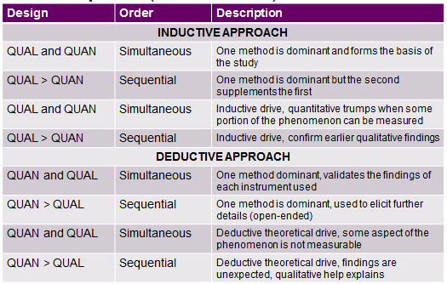
  - Considerations:
    - Controversy surround the appropriateness of combining qualitative and quantitative approaches and methods.
    - Trojan horse for post-positivism (tend to favor forms of analysis associated with positivism)
  - Critiquing mixed methods:
    - Consider the purpose of the study (inductive or deductive) – does it seem reasonable?
    - The concepts being compared comparable?
    - Are the approaches congruent?
    - Does the described approach make sense?
    - How do the authors justify their approach? Does the phenomenon warrant mixed methods?
    - Do the authors adhere to their paradigmatic assumptions?
  - Terminology indicating mixed methods:
    - Qualitative and quantitative
    - Data collected concurrently
    - Equal weight
- Knowledge Translation (KT): Translation is the term used because the language of a researcher and the community are different.
  - KT is a dynamic and iterative process that includes synthesis, dissemination, exchange and ethically-sound application of knowledge to improve health, provide more effective health services and products and strengthen the health care system.
  - Takes place within complex system of interactions between researchers and knowledge users.
  - Defined:
    - Synthesis: the contextualization and integration of research findings of individual research studies within the larger body of knowledge on the topic.
    - Dissemination: identifying the appropriate audience and tailoring the message and medium to the audience.
    - Exchange: the interaction between the knowledge user and the researcher, resulting in mutual learning.
    - Ethically-sound application: consistent with ethical principles and norms, social values, as well as legal and other regulatory frameworks.
  - Activities:
    - Tradition KT Activities
    - Conferences
    - Peer to peer presentations
    - Publications in peer-reviewed journals
    - Poster presentations
    - Hospital in-services
    - Workshops
  - Integrated KT strategies: When research is partnered with other stakeholders to make meaning out of research findings.
    - Policy briefs/ Calls to Action
    - Policy-maker collaboration
    - Community symposiums/town halls
    - Media outlets
    - Artistic interpretations (theatre-based research)
    - KT grants

