Chapter 7: BUSINESS DRIVEN INFORMATION SYSTEMS
- Databases and data warehouses are at the centre of all information systems discussed in this course
- Databases store the information necessary for day to day transactions (operational level)
- Data Warehouses store information for analysis and decision making (management and strategic levels)
- Bit: Smallest unit of data; binary digit (0,1)
- Byte: Group of bits representing a single character
- Field(column): group of characters, representing an attribute or characteristic or property
- Record(row): group of related fields, describes an entity (e.g., person, event, place) about which information is stored
- File(table or entity class): group of related records of the same type
- Database: group of related files

- Data are raw facts that describe the characteristics of an event.
- Information is data converted into a meaningful and useful context.
- Information granularity – refers to the extent of detail within the information (fine and detailed or coarse and abstract): Levels, Formats, Granularities

- Before databases we had flat files with the following problems
  - Data redundancy: same data stored in more than one location
  - Program-Data Dependence: changes in programs required changes to the data
  - Lack of Flexibility: only routine reports, hard to obtain ad-hoc reports
  - Poor security: little knowledge of who is accessing or making changes to the data
  - Lack of data sharing: no sharing of data between different applications or parts of the organization

- Transactional data encompasses all of the data contained within a single business process or unit of work; primary purpose is to support the performing of daily operational tasks.
- Analytical information encompasses all organizational information; primary purpose is to support the performing of higher-level analysis tasks.
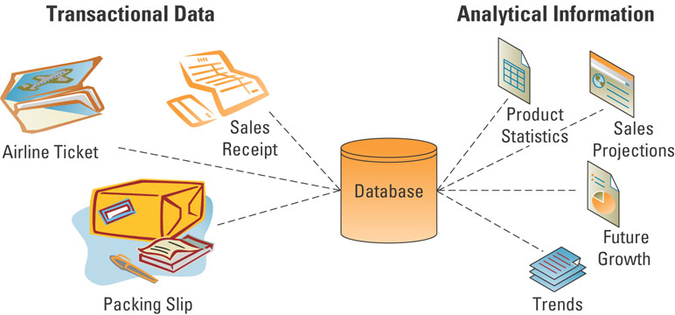
Low Quality Information Example:
- Missing info
- Incomplete info
- Inaccurate info
- Probable duplicate info
- Potential wrong info

High Quality Information Example:
- Accurate: is the name spelled correctly?
- Complete: is the address complete (street, city, province, postal code)?
- Consistent: does the total field equal the total of the individual fields?
- Unique: are there any duplicate customers?
- Timely: is information updated weekly, daily, or hourly?

A database:
- maintains information about various types of objects (inventory), events (transactions), people (employees), and places (warehouses)
- it is a collection of data organized to serve several applications efficiently
Database models include:
- Hierarchical database model – information is organized into a tree-like structure (using parent/child relationships) in such a way that it cannot have too many relationships
- Network database model – a flexible way of representing objects and their relationships
- Relational database model – stores information in the form of logically related two-dimensional tables

Entity : ROWS in tables : a person, place, thing, transaction, or event about which information is stored

- Entity class (table) – a collection of similar entities
  - Example CUSTOMER, ORDER, ORDER LINE, DISTRIBUTOR, and PRODUCT entity classes

- Attributes (fields): columns – characteristics or properties of an entity class
    - Example attributes for CUSTOMER entity include(Customer ID,Customer Name,Contact Name,Phone)

- Primary keys and foreign keys identify the various entity classes (tables) in the database:
  - Primary key – a field (or group of fields) that uniquely identifies a given entity in a table
  - Foreign key – a primary key of one table that appears as an attribute in another table and acts to provide a logical relationship between the two tables

- Database advantages from a business perspective include:
  - Increased flexibility
  - Increased scalability and performance
  - Reduced redundancy
  - Increased integrity (quality)
  - Increased security

A well-designed database should:
- Handle changes quickly and easily
- Provide users with different views
- Have only one physical view
  - Physical view – deals with the physical storage of information on a storage device
- Have multiple logical views
  - Logical view – focuses on how users logically access information

A database must scale to meet increased demand, while maintaining acceptable performance levels:
- Scalability – refers to how well a system can adapt to increased demands
- Performance – measures how quickly a system performs a certain process or transaction

Databases reduce:
- Redundancy – the duplication of information or storing the same information in multiple places
(Inconsistency is one of the primary problems with redundant information)

- Information integrity : measures the quality of information
- Integrity constraint :rules that help ensure the quality of information
  - Relational integrity constraint – rule that enforces basic and fundamental information-based constraints
  - Business-critical integrity constraint – rule that enforces business rules vital to an organization’s success and often requires more insight and knowledge than relational integrity constraints

- Increased Security: Information is an organizational asset and must be protected
  - Databases offer several security features including:
    - Password – provides authentication of the user
    - Access level – determines who has access to the different types of information
    - Access control – determines types of user access, such as read-only access

Database management systems (DBMS) – software through which users and application programs interact with a database
- Indirect Interactions: UserProgram(Marketing, Accounting, Manufacturing) DBMS Database
- Direct Interaction: Users DBMS Database

Integrating Data Among Multiple Databases:
- Integration – allows separate systems to communicate directly with each other
  - Forward integration – takes information entered into a given system and sends it automatically to all downstream systems and processes
  - Backward integration – takes information entered into a given system and sends it automatically to all upstream systems and processes

Data warehouse – a logical collection of information – gathered from many different operational databases – that supports business analysis activities and decision-making tasks
- The primary purpose of a data warehouse is to aggregate information throughout an organization into a single repository for decision-making purposes
- extend the transformation of data into information
- The data warehouse provided the ability to support decision making without disrupting the day-to-day operations

- Extraction, transformation, and loading (ETL) – a process that extracts information from internal and external databases, transforms the information using a common set of enterprise definitions, and loads the information into a data warehouse
- Data mart – contains a subset of data warehouse information

Multidimensional Analysis:
(Cube – common term for the representation of multidimensional information)
- Databases contain information in a series of two-dimensional tables
- In a data warehouse and data mart, information is multidimensional; it contains layers of columns and rows
  - Dimension : a particular attribute of information

- Information cleansing or scrubbing – a process that weeds out and fixes or discards inconsistent, incorrect, or incomplete information.

*BI= Business Intelligence

Data Mining:
- Data mining – the process of analyzing data to extract information not offered by the raw data alone
  - Data-mining tool : uses a variety of techniques to find patterns and relationships in large volumes of information & infers rules that predict future behaviour and guide decision making
- Common forms of data-mining analysis capabilities include:
  - Cluster analysis
    - a technique used to divide an information set into mutually exclusive groups such that the members of each group are as close together as possible and the different groups are as far apart as possible)
    - CRM systems depend on cluster analysis to segment customer information and identify behavioural traits

  - Association detection
    - reveals the degree to which variables are related and the nature and frequency of these relationships in the information
    - Market basket analysis – analyzes such items as Web sites and checkout scanner information to detect customers’ buying behaviour and predict future behaviour by identifying affinities among customers’ choices of products and services

  - Statistical analysis
    - performs such functions as information correlations, distributions, calculations, and variance analysis
    - Forecast – predictions made on the basis of time-series information
    - Time-series information – time-stamped information collected at a particular frequency

CHAPTER 8: HELPING ORGS ACCESS, SHARE & USE INFO

- Organizations create and use teams, partnerships, and alliances (internally w/ employees & externally w/ other orgs) to:
  - Undertake new initiatives
  - Address both minor and major problems
  - Capitalize on significant opportunities

Information partnership – occurs when two or more organizations cooperate by integrating their IT systems, thereby providing customers with the best of what each can offer
- The Internet has dramatically increased the ease and availability for IT-enabled organizational alliances and partnerships

Organizations form alliances and partnerships with other organizations based on their core competency:
- Core competency – an organization’s key strength, a business function that it does better than any of its competitors
- Core competency strategy – organization chooses to focus specifically on its core competency and forms partnerships with other organizations to handle nonstrategic business processes

- Collaboration system: An IT-based set of tools that supports the work of teams by facilitating the sharing and flow of information
  - Collaboration solves specific business tasks such as telecommuting, online meetings, deploying applications, and remote project and sales management
  - Two categories of collaboration:
    - Unstructured collaboration (information collaboration) - includes document exchange, shared whiteboards, discussion forums, and e-mail
    - Structured collaboration (process collaboration) - involves shared participation in business processes such as workflow in which knowledge is hardcoded as rules

Content management system (CMS) – provides tools to manage the creation, storage, editing, and publication of information in a collaborative environment
- Document management system (DMS)
- Digital asset management system (DAM) (binary rather than text files)
- Web content management system (WCM)

- Workflow – defines all the steps or business rules, from beginning to end, required for a business process
- Workflow management system :facilitates the automation and management of business processes and controls the movement of work through the business process
  - Messaging-based workflow system – sends work assignments through an e-mail system
  - Database-based workflow system – stores documents in a central location and automatically asks the team members to access the document when it is their turn to edit the document

Groupware Systems: software that supports team interaction and dynamics including calendaring, scheduling, and videoconferencing
- Advantages:
  - Facilitating communication, reducing travel cost, enabling telecommunication, sharing expertise, saving time & cost in coordinating group work, facilitating group prob solving

- Knowledge management (KM) – involves capturing, classifying, evaluating, retrieving, and sharing information assets in a way that provides context for effective decisions and actions
- Knowledge management system (KMS) – supports the capturing, organization, and dissemination of knowledge (“know-how”) throughout an organization
  - Explicit knowledge – consists of anything that can be documented, archived, and codified, often with the help of IT
  - Tacit knowledge - knowledge contained in people’s heads
    - The following are two best practices for transferring or recreating tacit knowledge
      - Shadowing – less experienced staff observe more experienced staff to learn how their more experienced counterparts approach their work
      - Joint problem solving – a novice and expert work together on a project

- Knowledge management systems include:
  - Knowledge repositories (databases)
  - Expertise tools
  - E-learning applications
  - Discussion and chat technologies
  - Search and data-mining tools

- Finding out how information flows through an organization
  - Social networking analysis (SNA) – a process of mapping a group’s contacts (whether personal or professional) to identify who knows whom and who works with whom
  - SNA provides a clear picture of how employees and divisions work together and can help identify key experts

Enterprise Portals: single-point Web browser interfaces used within an organization to promote the gathering, sharing, and dissemination of information throughout an enterprise
- Content Space: provides access to corporate data & info
- Communication Space: Provides channels for conversion
- Coordination Space: facilitates work flow and work routines
Features:
- Publishing facility
- Automatic indexing facility
- Subscription facility
- Intelligent agents

Potential of Enterprise Portals
  - Facilitate knowledge creation, distribution, and use Promote Collaboration; Portals must comprise three distinct areas to be effective

CHAPTER 9: PART 1: INFORMATION ETHICS: PRIVACY

- Morals define personal character
- Ethics stress a social system in which those morals are applied. We have social ethics, company ethics, professional ethics

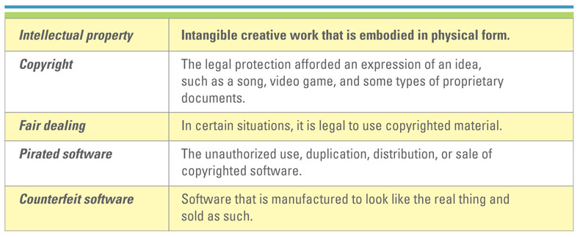
  - Privacy – the right to be left alone when you want to be, to have control over your own personal possessions, and not to be observed without your consent (ethical issue)
  - Confidentiality – the assurance that messages and information are available only to those who are authorized to view them
Primary Reasons Privacy Issues reduce trust for E-business:
- Loss of personal privacy
- 37% of internet users are more inclined to purchase product that has privacy policy
- Effective privacy and security would convert more internet users to buyers

Information ethics - concerns the ethical and moral issues arising from the development and use of information technologies, as well as the creation, collection, duplication, distribution, and processing of information itself (with or without the aid of computer technologies).

Monitoring :tracking people’s activities by such measures as number of keystrokes, error rate, and number of transactions processed
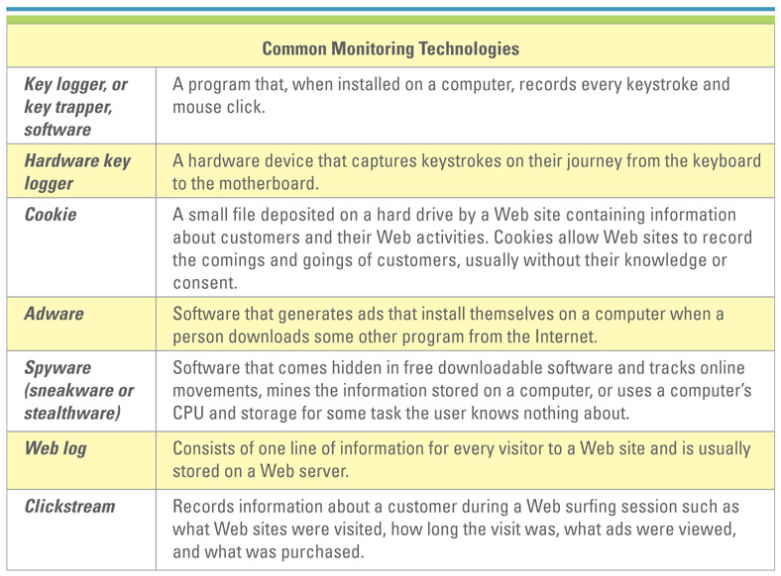

- Information privacy - concerns the legal right or general expectation of individuals, groups, or institutions to determine what and how much info about them is communicated to others.

- Personal Information Protection and Electronic Documents Act (PIPEDA) is a Federal act that applies to all organizations

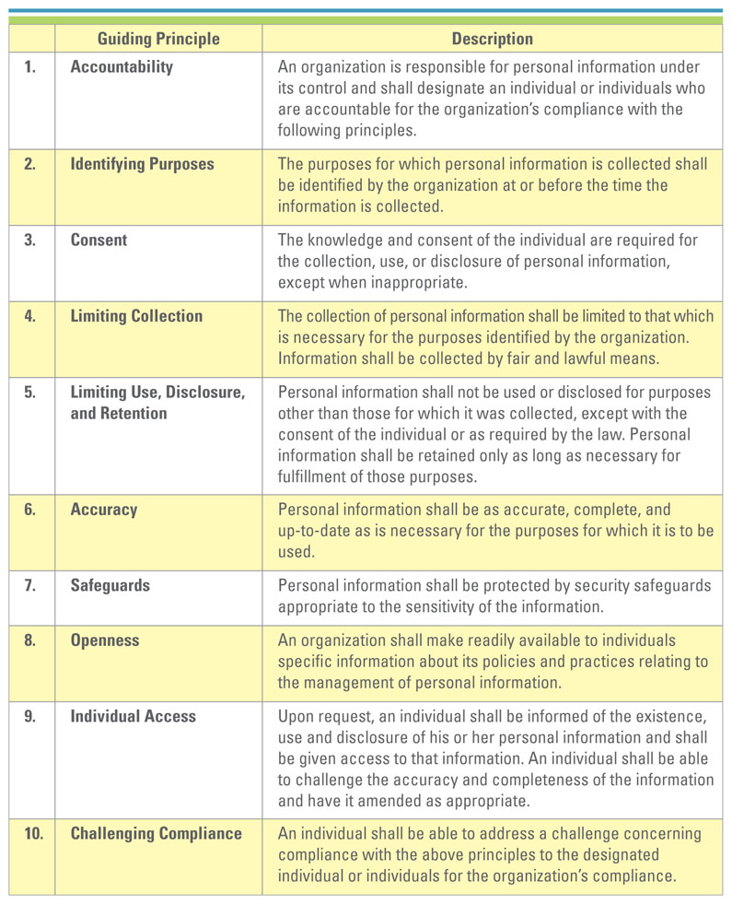

- Organizations strive to build a corporate culture based on ethical principles that employees can understand and implement
- 6 Principles for ethical information management:
  - Info is a valuable corporate asset & should be managed as one like cash
  - CIO is steward of corporate info and is responsible for managing it over its life cycle
  - CIO responsible for
    - controlling access to and use of info
    - preventing inappropriate destruction of info
    - Bringing technological knowledge to the development of info managemtn practices and policies
    - Partnering with executives to develop & execute orgs info management policies.

- Ethical computer use policy – contains general principles to guide computer user behaviour
- The ethical computer user policy ensures all users are informed of the rules & consent to abide by the rules

Information privacy policy guidelines:
- Adoption and implementation of a privacy policy
- Notice and disclosure
- Choice and consent
- Information security
- Information quality and access

- Acceptable use policy (AUP) – a policy that a user must agree to follow in order to be provided access to a network or to the Internet ( not to mailbomb, break security, send spam, etc.)
  - usually contains a no repudiation clause: a contractual stipulation to ensure that e-business participants do not deny (repudiate) their online actions
Email Privacy Policy: details extent emails can be read by others; defines who legit email users are; explains backup for deleted emails.
Internet Use Policy: contains general principles to guide proper use of internet
Anti Spam Policy : email users will not send unsolicited emails
Employee Monitoring Policy: states how, where and when company monitors employees.
Chapter 9 PART 2: INFORMATION SECURITY
Inside Risk:
- 38% of security incidents originate inside the org.
- Hackers normally use “social engineering”: using ones social skills to trick them into revealing credentials.
Information Security:
First line of defense: People (biggest issue is not a technical issue, but a people issue)
-insiders
-social engineering
- Information Security Policies: identify the rules required to maintain information security
- Information Security Plans: details how an organization will implement the information security policies
- Develop IS policies
- Communicate policies
- Identify critical information assets and risks
- Test and reevaluate risks
- Obtain stakeholder support

Second Line of Defence: Technology
- There are three primary information technology security areas:
  - Authentication and authorization
    - Authentication: method for confirming users’ identities (ID/password, smart card, Biometrics : the identification of a user based on a physical characteristic, such as a fingerprint, iris, face, voice, or handwriting)
    - Authorization: process of giving someone permission to do or have something
  - Prevention and resistance
    - Downtime can cost an organization anywhere from $100 to $1 million per hour
    - Technologies available to help prevent and build resistance to attacks include:
      - Content filtering: orgs use software that filters content to prevent the transmission of unauthorized information
      - Encryption: scrambles information into an alternative form that requires a key or password to decrypt the information
      - Firewalls: hardware and/or software that guards a private network by analyzing the information leaving and entering the network

  - Detection and response: used to mitigate the damage if prevention and resistance strategies fail and there is a security breach (e.g. antivirus software)

- Security threats to e-business include:
  - Elevation of privilege
  - Hoaxes
  - Malicious code
  - Spoofing
  - Spyware
  - Sniffer
  - Packet tampering

CHAPTER 10: SYSTEM DEVELOPMENT
System Development Challenges:
- Time & cost
- Organizational changes associated with new IS
- Deciding when and how to use new IS
- It is hard to establish the information requirements of the organization
- New IS should evolve as the organization and its business evolve
- New IS should meet employee needs to help an organization become more productive; otherwise it may damage productivity
System Development Life Cycle:
- Overall process for developing IS:

1) Planning: involves establishing a high-level plan of the intended project and determining project goals
  - Primary planning activities include
    - Identify and select the system for development
    - Assess project feasibility
    - Develop the project plan (a guiding force behind on-time delivery of a complete and successful system)
2) Analysis: involves analyzing user requirements and refining project goals into defined functions of the intended system, Primary analysis activities include:
    - Business Requirements
    - Create process diagrams: Process modeling – graphically representing the processes that capture, manipulate, store, and distribute information between a system and its environment
    - Buy vs Build analysis: time to market; availability of corporate resources; corporate core competencies (more it wants to build technical core =less likely to buy)
3) Design: involves describing the desired features and operations of the system including screen layouts, business rules, process diagrams, pseudo code, and other documentation
    - Primary design activities include:
      - Design the IT infrastructure
      - Design system models

4) Development: involves taking all of the detailed design documents from the design phase and transforming them into the actual system
    - Primary development activities include:
      - Develop the IT infrastructure
      - Develop the database and programs

5) Testing: involves bringing all the project pieces together to test for errors, bugs, and interoperability, in order to verify that the system meets all the business requirements defined in the analysis phase

6) Implementation - involves placing the system into production so users can begin to perform actual business operations with the system
    - Primary implementation activities include:
      - Write detailed user documentation
      - Determine implementation method
      - Provide user training
    - There are 4 primary implementation methods
      - Parallel (old and new used at same time)
      - Plunge (Direct) (one is discontinued for the next)
      - Phased (parts of new are implemented over time)
      - Pilot (entire system is used in one location)

7) Maintenance: involves performing changes, corrections, additions, and upgrades to ensure the system continues to meet the business goals
Types:
  - Adaptive - making changes to meet new business requirements
  - Corrective - repairs defective systems
  - Perfective - making changes to enhance the system (e.g., processing performance)
  - Preventive - making changes to reduce the chance of future system failures

Methodology: is a set of policies, procedures, standards, processes, practices, tools, techniques and tasks that people apply to technical and management challenges

- There are a number of different software development methodologies including:
  - Waterfall
  - Agile
    - Rapid application development (RAD): (rapid prototyping; actively involves system users) emphasizes extensive user involvement in the rapid and evolutionary construction of working prototypes of an IS
    - Extreme programming methodology
    - Rational unified process (RUP) methodology
    - Scrum methodology
  - Participatory design methodology: promotes the active involvement of users in the development process (needs are better matched, higher user trust and acceptance)

- Primary principles for successful agile software development include:
  - Slash the budget
  - If it doesn’t work, kill it
  - Keep requirements to a minimum
  - Test and deliver frequently
  - Assign non-IT executives to software projects

- Insourcing (in-house-development) - a common approach using the professional expertise within an organization to develop and maintain the organization's IS
- Outsourcing - an arrangement by which one organization provides a service(s) for another
  - Outsourcing challenges include: Contract length; Difficulties in getting out of a contract; Problems in foreseeing future needs & in re-forming an internal IT department after the contract is finished; Competitive edge; Effective and innovative use of IT can be lost when using an outsourcing service provider; Confidentiality ; Scope definition ; Scope creep (i.e., scope expands by the addition of new features to an already approved feature list) is a common problem with outsourcing agreements

CHAPTER 11: ENTERPRISE ARCHITECTURE
Enterprise architecture - includes the plans for how an organization will build, deploy, use, and share its data, processes, and IT assets
Enterprise architect (EA) - a person grounded in technology, fluent in business, a patient diplomat &provides the important bridge between IT and the business
- Primary Goals: reduce costs/improve productivity, improve customer satisfaction, create competitive adgvt, generate growth & new revenue, optimize supply chain.

- Data architecture identifies where and how important data, like customer records, is maintained and secured.
- Infrastructure architecture includes the hardware, software, and telecommunications equipment that, when combined, provide the underlying foundation to support the organization’s goals.
- Application architecture determines how applications integrate and relate to each other.

Back Up & Recovery:
- Backup - an exact copy of a system’s information
- Recovery - the ability to get a system up and running in the event of a system crash or failure and includes restoring the information backup
  - Fault tolerance - a computer system designed that in the event a component fails, a backup component or procedure can immediately take its place with no loss of service.
  - Failover - a backup operational mode in which the functions of a computer component (such as a processor, server, network, or database) is assumed by secondary system components when the primary component becomes unavailable through either failure or scheduled down time

Disaster Recovery:
- Disaster recovery plan - a detailed process for recovering information or an IT system in the event of a catastrophic disaster such as a fire or flood
- Disaster recovery cost curve - charts (1) the cost to the organization of the unavailability of information and technology and (2) the cost to the organization of recovering from a disaster over time
Hot site - a separate and fully equipped facility where the company can move immediately after a disaster and resume business
Cold site - a separate facility that does not have any computer equipment, but is a place where employees can move after a disaster
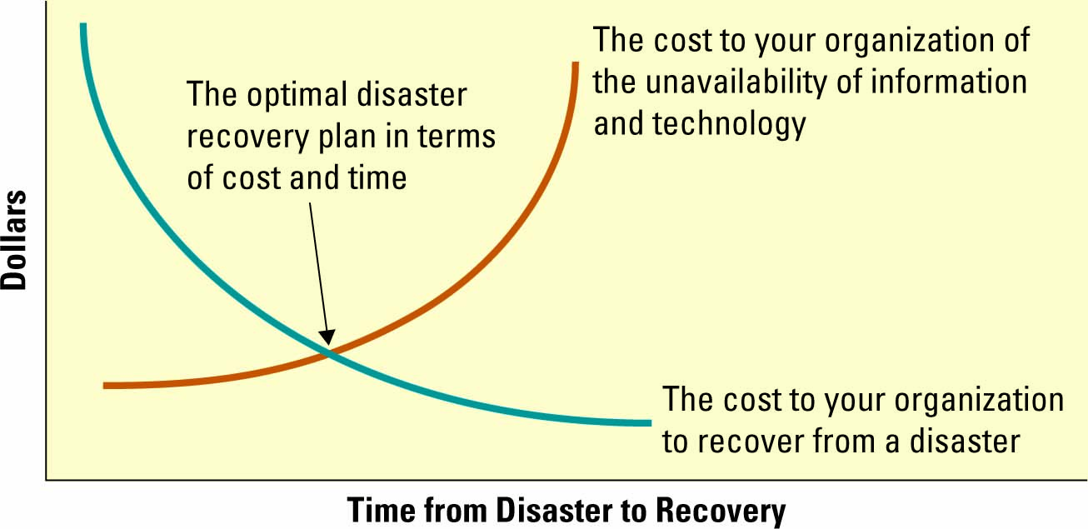

Security: A good data architecture includes:
  - A strong data security plan
  - Managing user access
  - Up-to-date antivirus software and patches

- Infrastructure Architecture: includes the hardware, software, and telecommunications equipment that, when combined, provide the underlying foundation to support the organization’s goals.

- Five characteristics of adaptable systems:
  - Flexibility – systems must meet all types of business changes
  - Scalability – refers to how well a system can adapt to increased demands
  - Reliability – ensures all systems are functioning correctly and providing accurate information
  - Availability – addresses when systems can be accessed by employees, customers, and partners
  - Performance – measures how quickly a system performs a certain process or transaction in terms of efficiency IT metrics of both speed and throughput

Application architecture - determines how applications integrate and relate to each other
- Interoperability - the capability of two or more computer systems to share data and resources, even though they are made by different manufacturers

- Web Services: contains a repertoire of Web-based data and procedural resources that use shared protocols and standards permitting different applications to share data and services
    - Event - detect threats and opportunities and alert those who can act on the information
    - Service - more like software products than they are coding projects, must appeal to a broad audience, must be reusable to have an impact on productivity
- Open system - a broad, general term that describes nonproprietary IT hardware and software made available by the standards and procedures by which their products work, making it easier to integrate them
    - Allow systems to seamlessly share information
    - Capitalize on enterprise architectures
    - Eliminate proprietary systems and promote competitive pricing

Architecture Trends becoming requirements for all businesses:
  - Service-oriented architectures (SOA): business-driven IT architectural approach that support integrating a business as linked, repeatable tasks or services.
    - The key technical concepts of SOA are:
      - Services – a business task
      - Interoperability – sharing of data and resources
      - Loose coupling – joining together or disassembling of services
  - Virtualization
  - Grid computing: is an aggregation of geographically dispersed computing, storage, and network resources, coordinated to deliver improved performance, higher quality of service, better utilization, and easier access to data.
  - Cloud computing: is a form of client/server computing operating over the Internet where the term “cloud” is used as a metaphor for the term “Internet”.

CHAPTER 12: NETWORK, TELECOMMUNICATIONS & MOBILE TECHNOLOGY

Network components of a simple network:
- Network - a communications, data exchange, and resource-sharing system created by linking two or more computers and establishing standards, or protocols
- Telecommunication system - enables the transmission of data over public or private networks
- Data communication requires:
    - A message
    - A transmitter & a receiver: Computer, terminal, hardware in general
    - A medium : wired( cable or phone) or wireless (radio signal)
    - A protocol
- LAN (Local Area Network): A computer network that uses cables or radio signals to link two or more computers within a geographically limited area, generally one building or a group of buildings; networked office building usually contains a single LAN
- Wide Area Network (WAN) :Computer network that provides data communication services for business in geographically dispersed areas (such as across a country or around the world) ;The Internet is a WAN that spans the world
- Metropolitan Area Network (MAN) :A computer network that provides connectivity in a geographic area or region larger than that covered by a LAN, but smaller than the area covered by a WAN; A college may have a MAN that joins the different LANs across its campus

- Voice over IP uses IP (Internet Protocol) o transmit voice calls over long-distance telephone lines
(skype; uses “packet switching” instead of “circuit switching” (phones)

- Networking Characteristics:
  - Provides for the transparent exchange of data with suppliers, trading partners and customers.
  - Reliability and securely exchange info internally/externally
  - Allows end to end integration& provides msg delivery across multiple systems
  - Respond to high demands with scalable processing power and networking capacity

- Virtual private network (VPN) - a way to use the public telecommunication infrastructure (e.g., Internet) to provide secure access to an organization’s network
- Valued-added network (VAN) - a private network, provided by a third party, for exchanging information through a high capacity connection

- Mobile technology - means the technology can travel with the user, but it is not necessarily in real-time
- Wireless technology - gives users a live (Internet) connection via satellite or radio transmitters
- 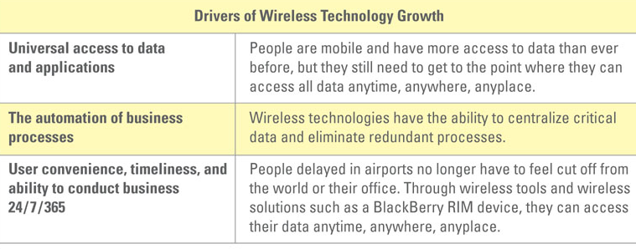
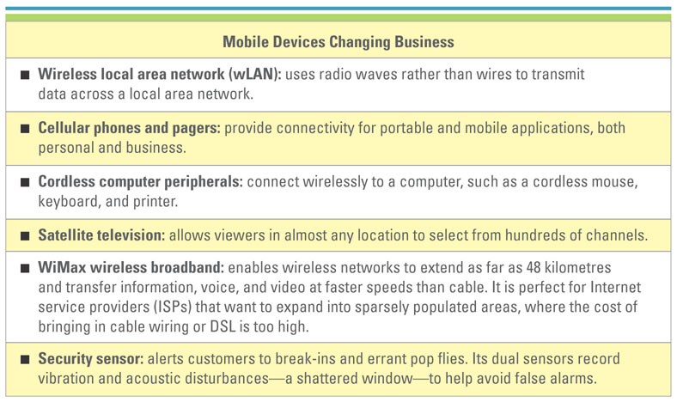

- Using Cellular Technologies In Business
  - Personal digital assistants (PDA) are small, handheld computers capable of entirely digital communications transmission.
  - Smartphone combines the functions of a cellular phone and a PDA in a single device.
  - Bluetooth is a telecommunications industry specification that describes how mobile phones, computers, and PDAs can be easily interconnected using a short-range wireless connection
- Using Satellite Technologies In Business
  - Location based services (LBS) are wireless mobile content services that provide location-specific data to mobile users moving from location to location.
  - Global position systems (GPS) is a constellation of 24 well-spaced satellites that orbit the Earth and make it possible for people with ground receivers to pinpoint their geographical location.
  - Geographic information system (GIS) is designed to work with data that can be shown on a map
- Using Wireless Technologies In Business
  - Wireless fidelity (wi-fi) – a means of linking computers using infrared or radio signals
    - Common examples of wireless devices include:
      - Cellular phones and pagers
      - Global positioning systems (GPS)
      - Cordless computer peripherals
      - Home-entertainment-system control boxes
      - Two-way radios
      - Satellite television
  - WiMAX is a telecommunications technology aimed at providing wireless data over long distances in a variety of ways

Radio Frequency Identification
- Radio frequency identification (RFID) - uses active or passive tags in the form of chips or smart labels that can store unique identifiers and relay this information to electronic readers
- RFID tag - contains a microchip and an antenna, and typically works by transmitting a serial number via radio waves to an electronic reader, which confirms the identity of a person or object bearing the tag

