Week 1
What is an organization?

- We define an organization in terms of four attributes:
- A social entity
  - People, their activities, and interactions
  - A collective with an identity
  - Goal-directed
  - An organization exists to achieve one or more purpose(s)
  - Collective goals versus sub-group or stakeholder goals
- A structured activity system
  - Division of activities and people into roles, departments/groups, cliques, communities, etc.
  - Coordination of activities through authority, relationships, teams, culture etc.
  - Linked to the external environment
  - Interacts with elements beyond its formal boundaries

- Organizational theory: How organizations function and how they affect and are affected by people and by the context in which they operate.
  - There are many different theories about how organizations function
  - Different theories provide different lenses through which to view and understand organizations as systems

Three Lenses for understanding Organizations as Systems

- The Formal Structure Lens
  - Organization as a formally designed system, like a machine built and operated for some specific purpose
  - Focus on formal division of labour, planned control & coordination, and task performance
- The Network Lens
  - Organization as a naturally evolving system, like a living organism that grows and adapts for survival
  - Focus on informal relationships to build community, solve problems, exercise influence, and coordinate informally.
- The Symbolic/Culture Lens
  - Organization as a cultural system, like a temple that represents a meaningful way to understand the world
  - Focus on symbolism and shared values & beliefs that constitute culture and foster group identity
Week 2
Organizational goals viewed through different lenses
- Culture/symbolic lens: Official goals/mission
  - Expressions of organization’s identity, its vision, its reason for existence.
- Key Activity: Symbolic Management
  - Establish general legitimacy
    - Acceptability of organizational purpose and right to operate
  - Create unity of effort
    - A common point of focus for collective effort
    - Build commitment
- Network lens: Stakeholder approach
  - What expectations do specific stakeholders have for organizational performance?
    - Parties that affect and are affected by organizations
  - Inside Stakeholders: Employees & Managers, owners
  - Outside Stakeholders: Customers, suppliers, communities, governments, etc. SH
  - Key activity: Stakeholder relationship management
  - Build support and legitimacy for specific expectations
- Formal Structure lens: Operative goals
  - What the organization and its divisions formally set out to do in attaining official goals
  - Detailed and measurable ends to be achieved through operations.
  - Key activity: Evaluate performance effectiveness
- Build Motivation: Encourage effort, challenge & reward
- Give Direction: Guide strategic decisions

Organizational Effectiveness
- A system outcome that answers the question: How well are we performing?
  - Are we achieving our goals?
  - How good are we at achieving our goals?
- Internal Approaches: Focus on how the organization performs inside its boundaries
  - Efficiency: Use of resources/productivity
  - Human relations: Internal well-being and harmony
- Resource Approach: Obtaining and managing inputs
- Goal Approach: Achievement of operative output goals
- Stakeholder Approach: Meet different stakeholder expectations.
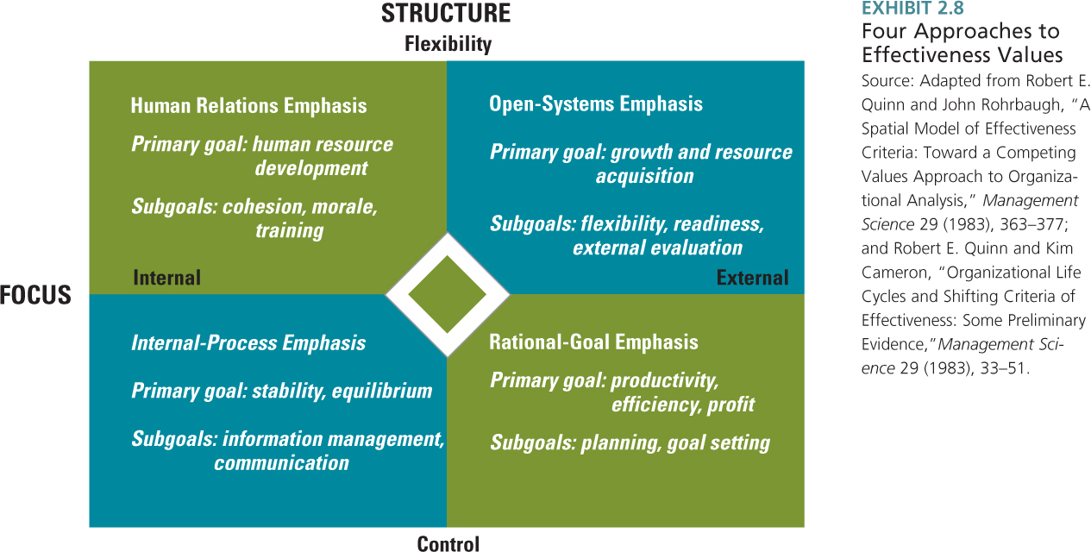
Organizational Effectiveness: The competing values model

Corporate Social Responsibility
- The Principle: Business organizations exist to create value and acceptable outcomes for all their stakeholders
- Exchange relationships:
  - With Society: Business is given the power to profit from producing goods/services in exchange for societal growth & development
    - Based on the trust that power is exercised responsibly
  - With specific stakeholders: Business maintains exchange of contributions and inducements
- Ethics considerations: Managers of organizations have an obligation to make choices that uphold right and prevent wrong in relationships with its stakeholders
  - Build ethical values into culture
  - Implement formal structures that promote ethical behavior
- From a business perspective, an organization prioritizes exchange with its important stakeholders
- Important Stakeholders have:
  - Power: A stakeholder who can achieve desired outcomes by
    - Force/threat (e.g., fines, sabotage)
    - Withholding material rewards (e.g., $, goods & services)
  - Legitimacy: A stakeholder with a socially acceptable claim
  - Urgency: A stakeholder whose claims demands immediate attention
    - From a societal perspective, a business organization meets the needs of the present in relation to all stakeholders and without compromising the ability of future generations to meet their needs
(Brundtland Commission, 1987)
- Sustainable corporate social performance is assessed in three spheres (triple bottom line):
  - Environment
  - Society
  - Economy
Friedmen vs Martin
- The Virtue Matrix of Corporate Social Responsibility
- A conceptual tool for thinking about CSR strategy
- Distinguishes between currently practiced CSR in the civil foundation and potential future CSR in the frontier.
- Civil foundation includes rule of law and societal norms:
  - CSR is instrumental because it is performed in response to legal prescription and normative obligation
  - Benefits societal stakeholders and shareholders
- Frontier includes voluntary initiatives:
  - CSR is intrinsic because it is performed for its own sake (i.e., it is the right or moral thing to do
  - Has no immediate payoff for shareholders or uncertain long-term pay-off.
  - Successful CSR actions in the strategic frontier lead to shareholder benefits, are copied by others, and may become part of the civil foundation

Week 3
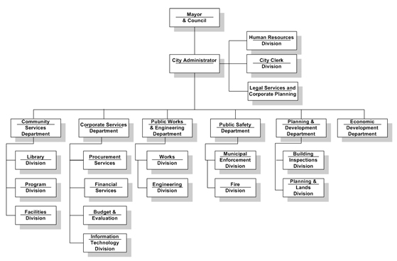
The Formal Structure Lens
- Organizations are a rational tool for achieving strategic management goals
- The system consists of a deliberate design for formal organizational structure
- Formal organization structure: The horizontal and vertical groupings of people, their activities and responsibilities (i.e., parts), and the formal subsystems and relationships to control and coordinate among those parts in the system as a whole
- Key theoretical proposition: Differences in organizational structure are explained by contingencies: Different structures are effective in different organizational environments and for different technologies, goals, or size.

Designing an organization: Division of Activities
- Division of activities into different parts
- The vertical division into hierarchical levels (parts)
    - Decision making: technical/factual or value/judgment
    - Centralization: Are judgment decisions made at higher or lower levels of the hierarchy?
    - Tall or flat h ierarchy of authority: how many levels in the hierarchy?
- The horizontal division into departments & subunits (parts)
    - Work tasks: common work responsibility Slide 6
    - Specialization: Are tasks subdivided into separate jobs or departments?
- Spatial differentiation: Different physical locations (parts)
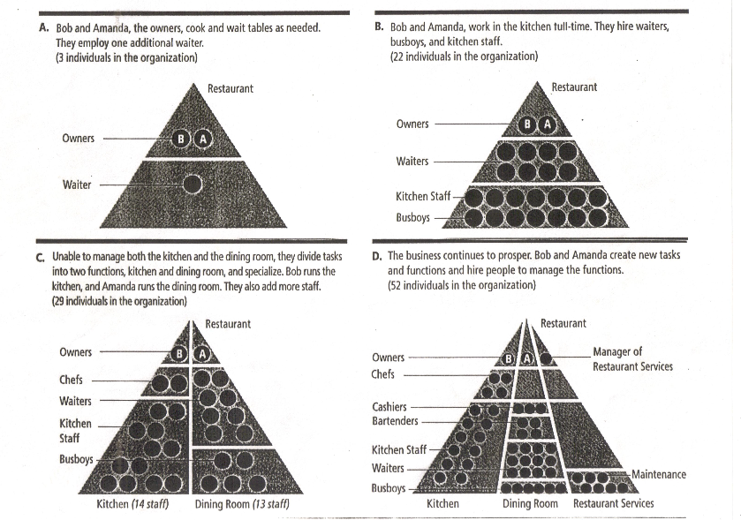
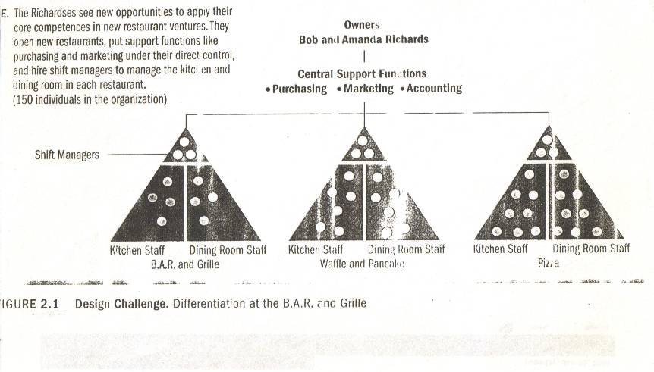

Designing an organization: Integration of Activities
- Integration of Activities
  - Coordination and control among divided activities is achieved through vertical and horizontal information linkages
- Vertical information linkages: Emphasis on control and predictability
  - Hierarchical referral (the chain of command)
  - Rules & Plans: Standardization and/or formalization of work process, skills, and/or inputs/outputs
  - Information systems: Reports, memos, & paperwork
  - Additional roles: Middle managers

- Horizontal information linkages: Emphasis on coordination
  - Information systems: Schedules & databases
  - Direct contact
    - Formal Positions: Liaison & integrator
    - Formal groups: Task-forces & teams

Organizational design options
- Organizational Design: How work activities and coordinating/control mechanisms are grouped into formal units that are strategically important and share a common task identity.
- Functional Structure: Grouping based on basic business functions
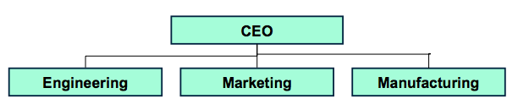
- Divisional Structure: Grouping based on primary outputs, customers, or geographic location

- 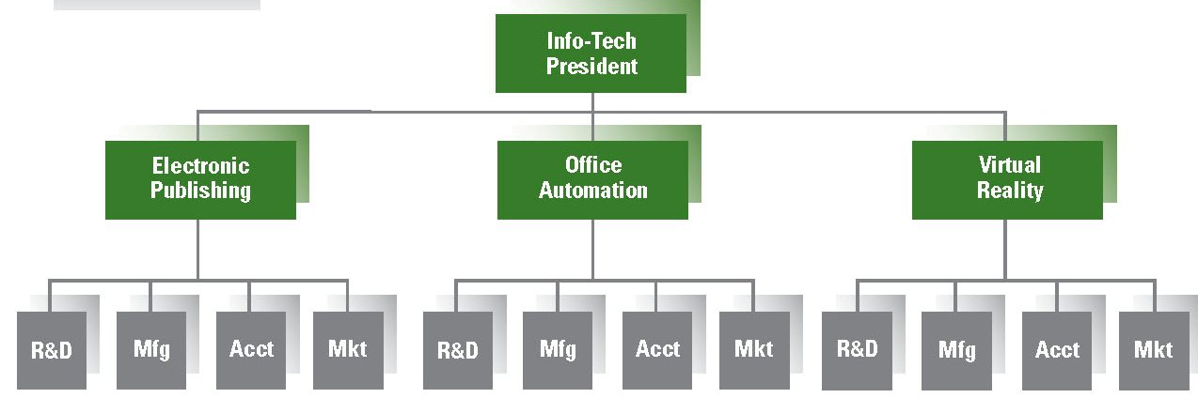

- Multi-focus Structure: Grouping based on combination of functions, outputs/location, and/or processes
            - Matrix Structure: Simultaneous grouping
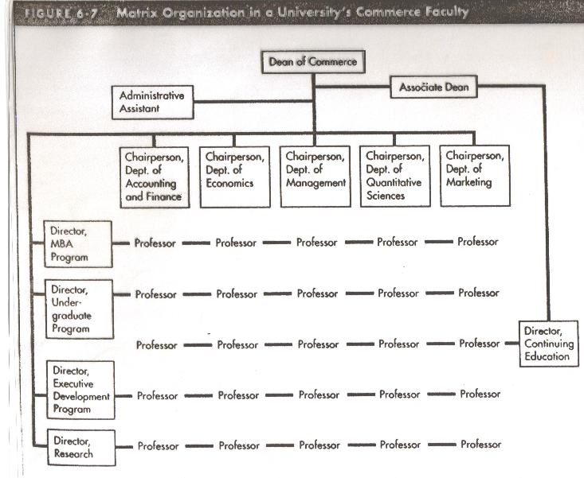
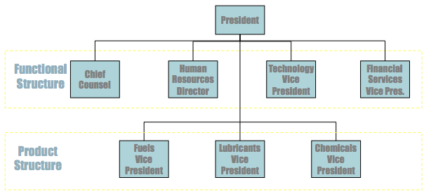
  - Hybrid Structure: Parallel grouping

Theory about organizational structure
- Balance between vertical control and horizontal coordination
  - Efficiency, stability & reliability as key system outcomes
    - Mechanistic system design/vertical organization
  - Flexibility, adaptation, & innovation as key system outcomes
    - Organic system design/horizontal organization chart
    - Designs in order of increasing focus on horizontal coordination:
  - Functional Structure
  - Divisional Structure
  - Hybrid Structure
  - Matrix Structure
  - Horizontal & Virtual Network Structure (see text)
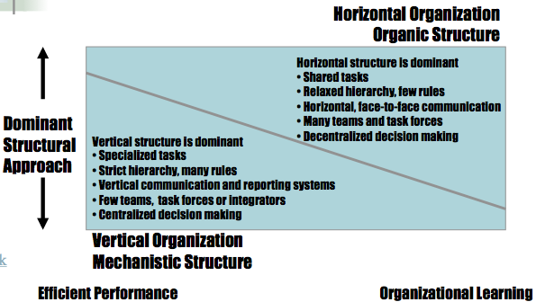

Week 4

The symbolic/culture lens of organizations
- An organization is a cultural system, consisting of assumptions, beliefs, and values
- Culture is manifest through symbols that identify meanings and express valued means/ends for members & stakeholders
- Symbolism is important because it helps people interpret events or objects that are ambiguous
  - Meaning is not given but made by people
  - “What is important is not what happens but what it means” (Bolman & Deal, 2003)

The Symbolic/culture Lens
- Key theoretical propositions:
  - To understand how an organization functions we must examine how its culture guides the actions and experiences of its members
  - Differences between organizations are due to a different feel created by assumptions, beliefs, and values
- Symbolic Management
  - Explaining and expressing meanings for organizational events, actions, and objects
  - Shaping an image of the organization in people’s head

Organizational Culture
- Definition: A set of beliefs, values, and assumptions that are shared by the members of an organization
- Unobservable Level of Culture:
- Organizational Values
  - Terminal values: Identify desired end states
  - Instrumental values: Identify desired modes of behavior
- Organizational Belief/Assumptions
  - A true “way of life” for organizational members
  - Taken-for-granted as real

- The observable level of culture
  - Visible artifacts: Practices, events, expressions, pictures, etc. are used to communicate and signal culture
  - Culture affects organizational coordination and control
  - Internalized conviction and value inspiration guide member behavior through self-discipline
  - Identification generates loyalty and commitment
  - Culture strength: Degree of agreement and depth of conviction about culture

Functions (system outcomes) of Organizational Culture
- Integration: Culture can facilitate working together and being a group
  - What are the criteria for organizational membership?
  - What does it take to get ahead?
  - What is our collective identity – “Who are we?”
  - Adaptation: Culture can facilitate achieving goals and dealing with outsiders
  - How do we achieve our purpose in the market?
  - What image of who we are do we want our key external stakeholders to have?

Observable Organizational Culture
- Norms & rules (ritual): Patterns of daily, routine activity.
  - “How things are done around here”
  - Expectations for normal behaviour, what to do to fit in
- Stories and Myths: Anecdotes about true or fictional events or people that circulate among organizational members.
  - Provide a “deep level” principle that demonstrates the correct way of acting or being
- Rites & Ceremonies: Elaborate events & activities that are deliberately planned, infrequent, and carried out in public.
  - Rite of Passage:
    - Facilitate role and status transitions
    - Example: Initiation
  - Rite of Enhancement:
    - Boost status perceptions and identities of members
    - Example: Annual awards night
  - Rite of Integration:
    - Encourage and revive feelings of common bond
    - Example: Office Christmas Party
  - NB: Rite of Renewal
- Some Considerations for organizing and interpreting the importance of rites and ceremonies:
  - Location/context of event may signal importance
  - Who is expected to speak and give out honors may signal importance
  - How does timing signal important milestones or events?
  - If outsiders are invited (e.g., spouses, clients), event symbolizes their contribution.
- Language: A unique jargon or non-verbal expressions
- Espoused Values:
  - Explicit expressions of organizational values (e.g., Mission statements, Annual Reports, websites)
  - Physical Symbols:
  - Graphical illustrations that represent important company attributes (e.g., corporate logos)
  - Physical structure & space: Buildings, offices

Organizational Culture and Formal Organizational Structure/Systems
- Compatibility: Culture and formal systems should reinforce and support each other
  - Formal structures should encourage the same behaviors and meanings as culture
- Examples of cultures/formal systems combinations (Daft & Armstrong, Chapter 10 – Exhibit 10.4)10.4
  - Perceived need of environment: Focus on stability (efficiency) or flexibility (adaptation)
  - Strategic orientation: Focus on internal or external competitive strengths
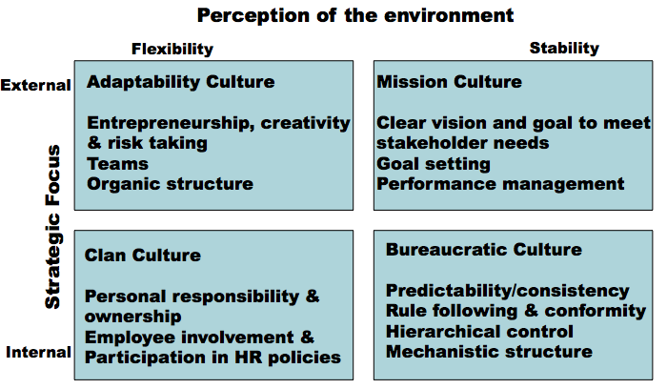
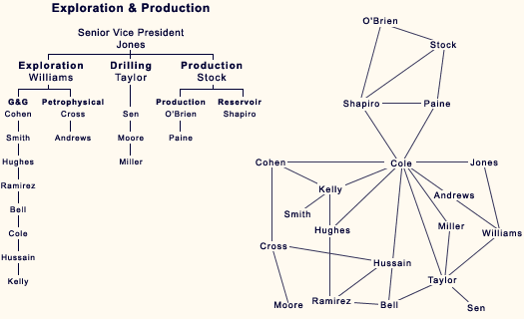
Week 5
The Social Networks Lens of Organizations
- Organizations are networks, or webs of relationships: ->
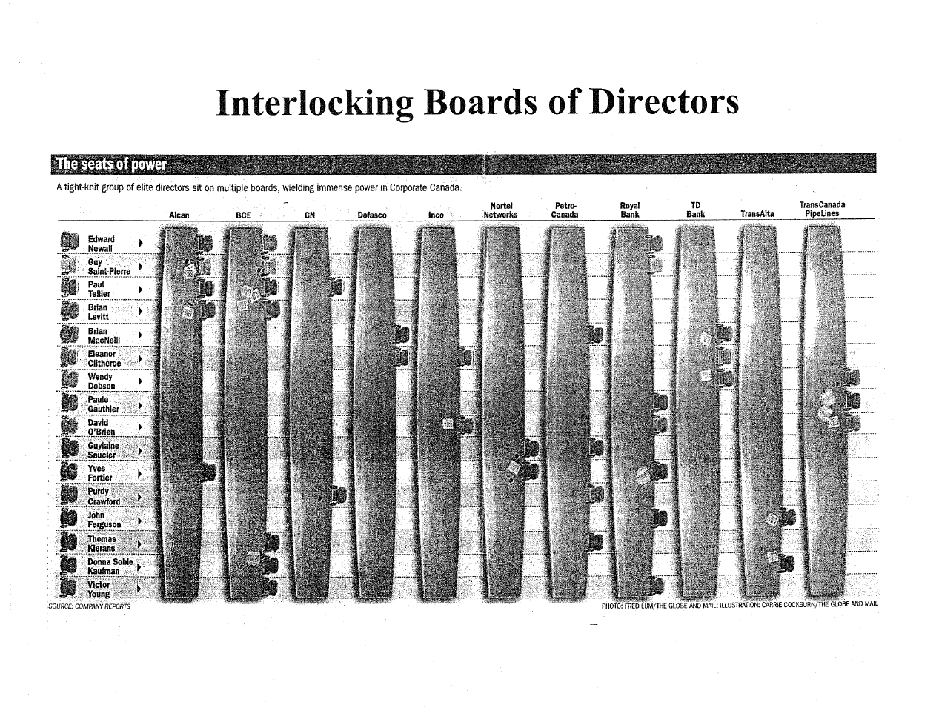
  - A network is a system comprising actors connected to each other by relationships and interactions
  - Organizational networks are studied within organizations and between organizations
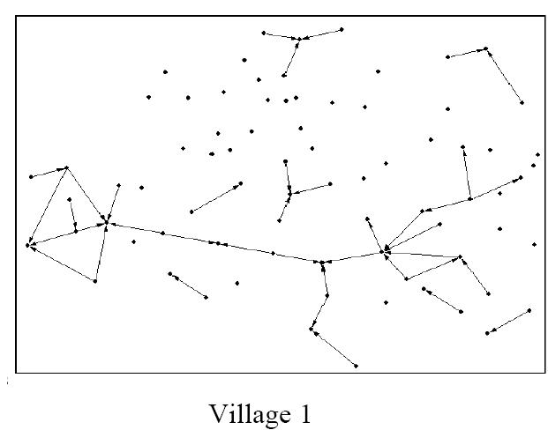
  - To understand an organization, we analyze the quality of relations, positions of actors, & shapes or composition of networks

The internal network: Formal and informal organization
- Formal Organizational Design:
  - The skeleton
  - Deliberate: Engineered, formal goal directed, rational
  - Impersonal positions, roles, and relations
  - Normative: What should take place & how
- Informal Organization of Networks:
  - The central nervous system
  - Spontaneous: Organic, fluid, and pragmatic
  - Personal positions, roles, and relationships
  - Behavioral: What actually takes place & how

Informal organization (networks) in action
- Lubricating the formal system
  - Quality of interpersonal relations in formal hierarchy
  - Horizontal interaction in team structures
  - Horizontal communication that cross-cut the formal structure
- Implementing new initiatives and change
  - Generating support and building coalitions
  - Resolving or mediating conflict across groups
- Generating social capital (see textbook, p. 355)
  - Developing norms and values for high quality of interaction and a common perspective among system members
    - Respect, trust, and goodwill
Informal Network in organizations: Common types of relationships
  - Advice: Flow of expertise & problem solving
  - Trust: flow of confidential/political information & mutual confiding
  - Communication flow of every-day information (work, gossip)
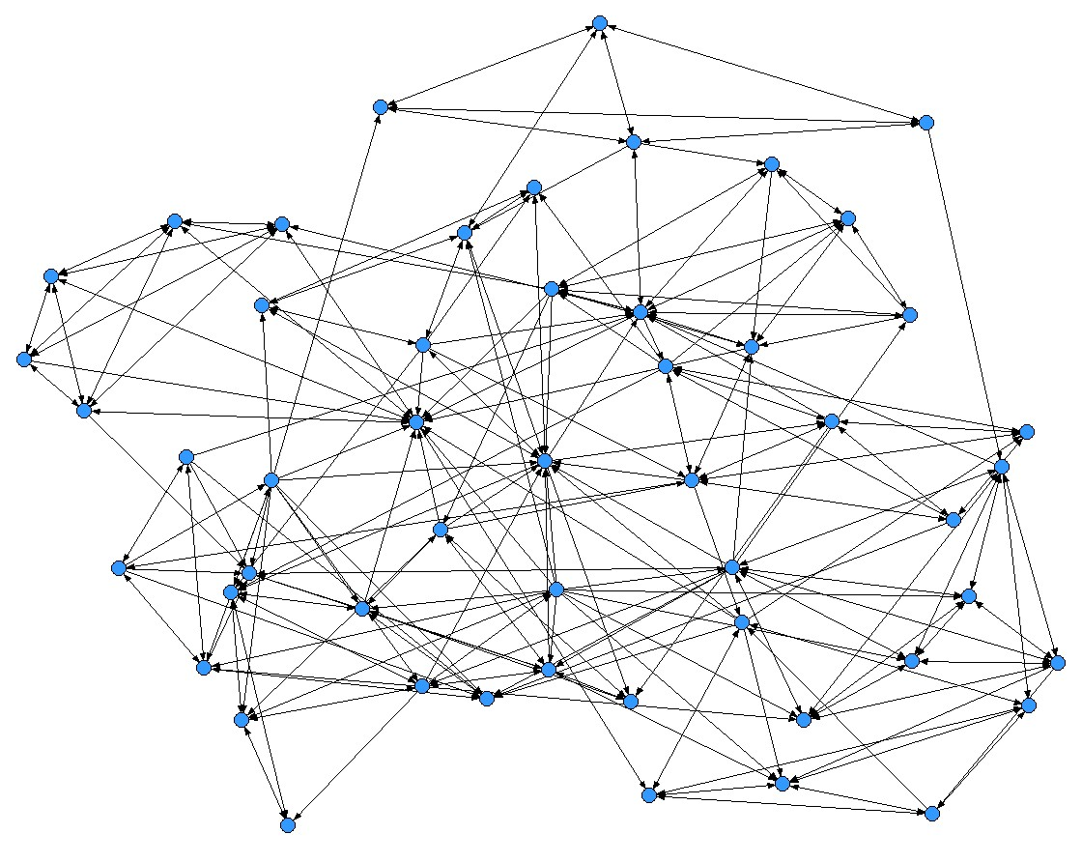
  - Friendship: flow of affect and social support

Analysis of structure in social networks at different levels
- Dyadic level: The quality of relationships
  - Closeness: Strong versus weak ties
    - Mutual trust, liking, & social obligation
    - Strong relations: Influence and communication quality
- Ego level: Network surrounding one person
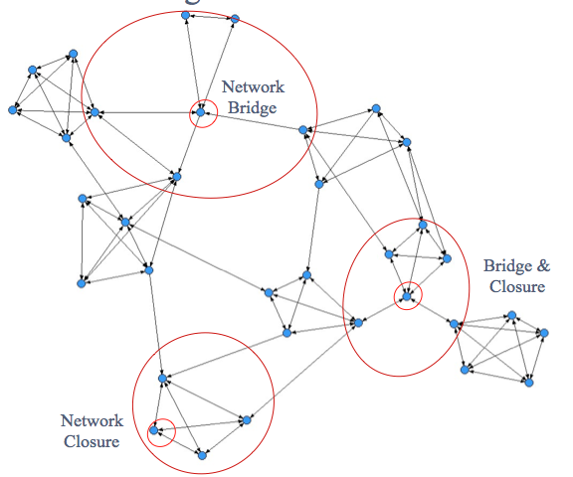
  - Network Shape: Closure (cohesion) or bridging
  - Closure: social capital
  - Bridging: Access to resources and new ideas
  - Power, influence, control
    - Controlling the flow of information
    - “Divide and conquer”

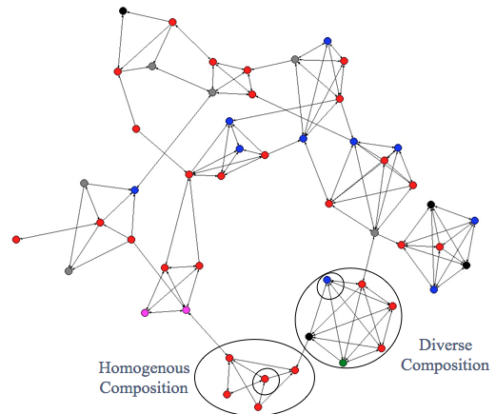
- Ego level: Network composition
  - Attribute profiles of network members
  - Diversity of members may generate new ideas but also make communication and coordination more difficult
  - Homogeneity of members may generate social capital but also produce tunnel vision and groupthink
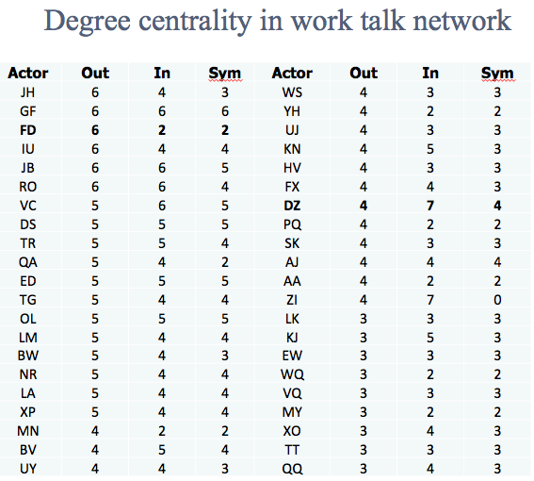
    - Ego level positions: Network centrality
  - The number of relationship choices made or received
    - Influential people in the network
    - Prestige, visibility, involvement

Analysis of structure in social networks
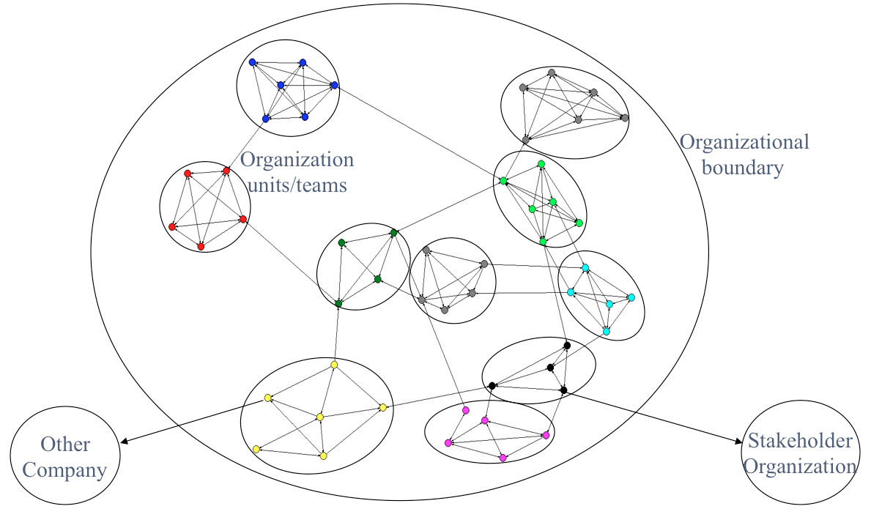
- Whole network level:
- All actors and all relationships
  - Network sub-groups
  - Formal horizontal design for learning and adaptability
    - Cohesive informal networks within groups
    - Bridges across groups
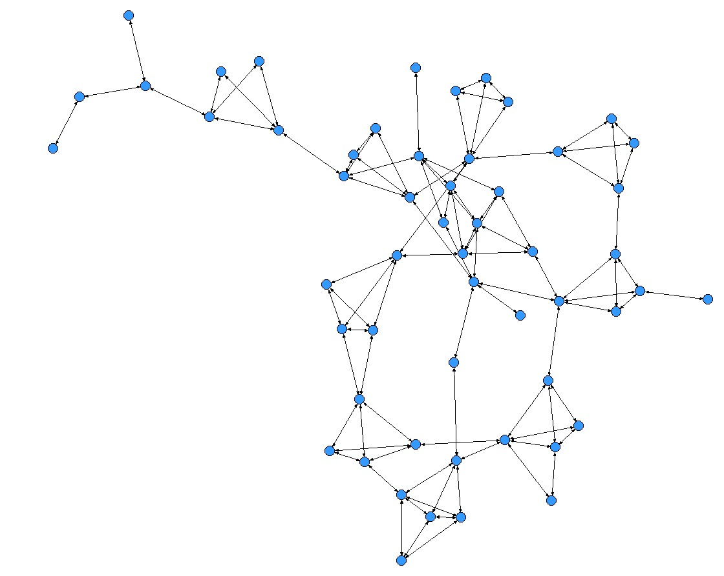
    - Bridges to the external to the organization
  - Silo subcultures (closure within subgroups but no bridges between them)
  - Reliance on bridge actors: Bow-ties

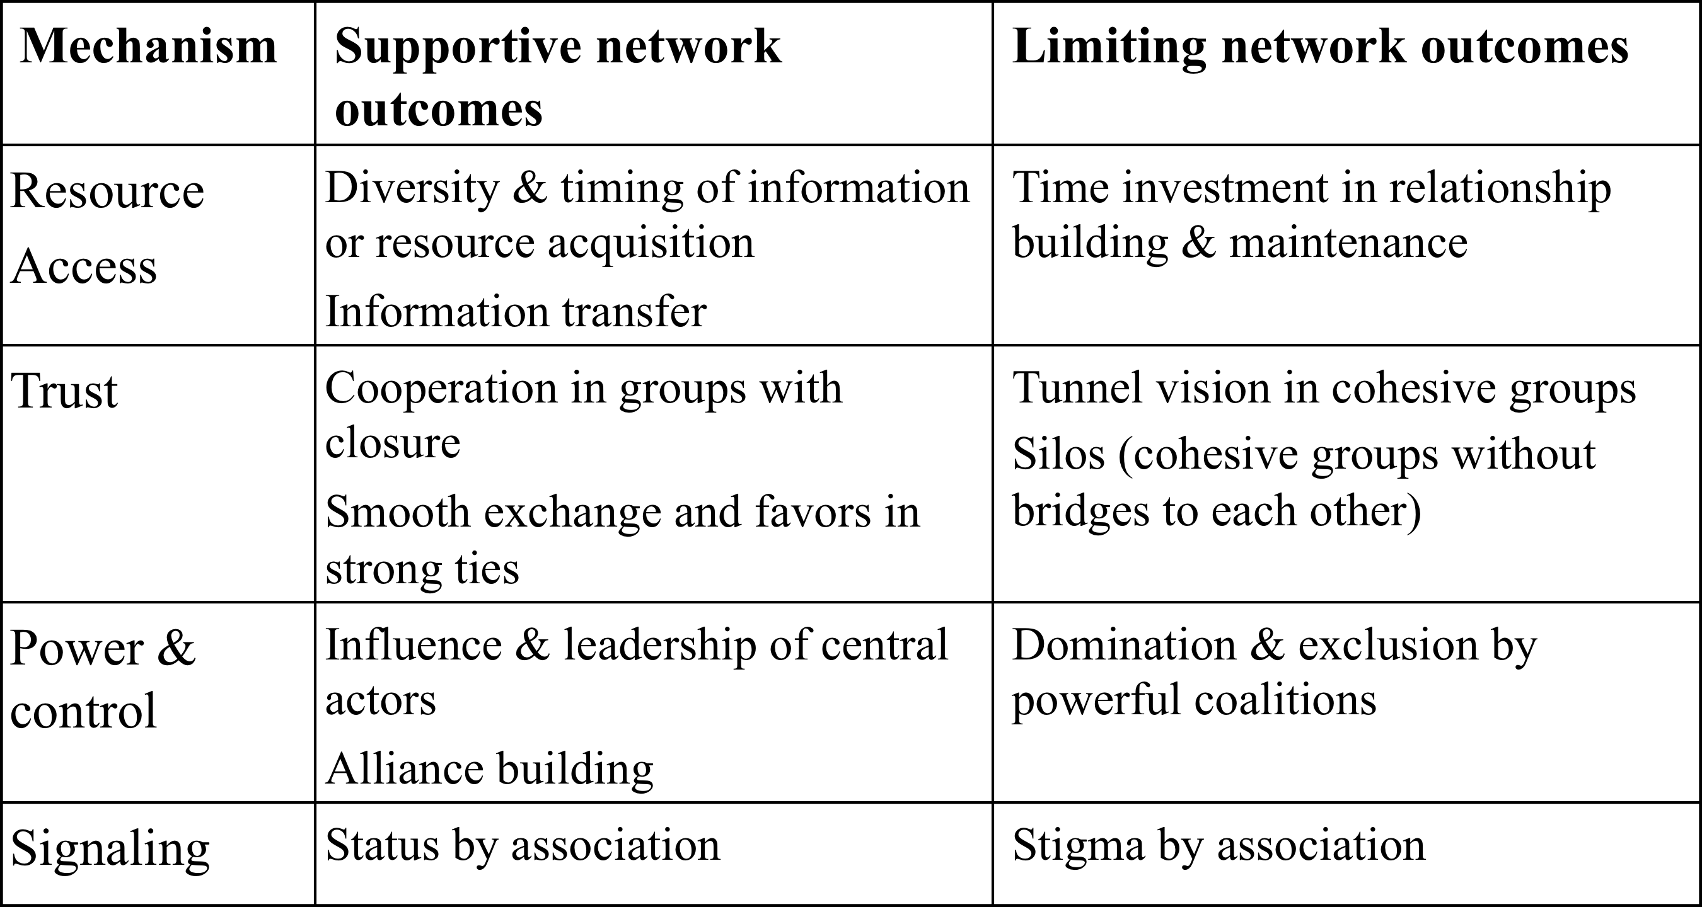
System Benefits and Drawbacks of Network Structures
- Social mechanisms in network structure can support or limit a system’s capacity for adaptation, performance and integration

