Poli 202 Notes
Lesson 2- Welcome to Canada

Terrestrial Eco-zones of Canada
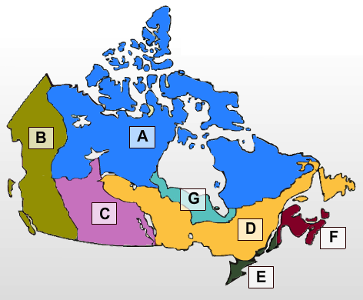
A The Artic
-Made up of two zones, the artic and the Taiga
-Taiga: composed of small trees
-Artic: almost no vegetation
-Migratory birds enter these zones when temperatures become mild.
-Insects multiply during short summer season
-Large mammals such as caribou live here
-50% of Canada’s oil located here
-Large rivers make it possible to construct power plants

B The Rockies and the Pacific Coast
-Characterized by large mountains -Agriculture found in valleys
-Northern parts resemble the Artic -Large wet forests on the pacific coast
-Ideal for foresting and mining -Various fish species that live off the coast

C The Prairies
-Long and flat -Northern part covered with large forests
-Composed of large plains -Most Canadian agriculture takes place here-Some of the largest oil sand deposits can be found here

D The Boreal Forest
-One of the largest forests in the World -Used to be main source of fur trade
-Contains large rivers good for dams and generation of hydro electricity
-Timber industry flourishes -Soil is not ideal for agriculture
-Contains various mineral deposits

E Mixedwood Plains
-Climate is relatively mild -Soil is fairly good (made it good for settling)
-Highly populated (50%) -Major commercial & industrial hub

F The Atlantic Maritimes
-Composed of hills covered by large forests
-Surrounded by water that is rich in fish species as well as offshore oil

G The Hudson Plains
-Contains Canada’s wetlands -Sparsely populated
-Gateway for earlier settlers wishing to trade fur in the north
-Very little human activity

What does a varied ecosystem means to Canada?
-Different natural resources are scattered throughout parts of the country
-These resources contribute to the creations of different economic sectors, which fluctuate in prosperity
-In turn, contributes to the uneven distribution of wealth, which inevitable affects the nature of Canadian politics

Canada’s Economy

GDP : All economic activities within the border of a country 1.299 Trillion
Unemployment: represents the proportion of adult citizens looking for work 6%

-Canada’s economy exports more than it imports.
-Most of Canada’s exports and imports are exchanged with on trading partner, the US.
-In comparison to other economies, Canada’s economy is small but UE is relatively low

Country | Canada | USA | The EU | China | Brazil
GDP | 1.299 | 12.31 | 14.66 | 7.64 | 1.892
UE | 6% | 5.1% | 8.5% | 4.6% | 9.3%

Sectors
-Canadian economy consists of multiple sectors, some of which contribute to GDP more than others.
-Regional economies are diversified to various degrees
-EX. The primary sector currently represents 30% of GDP, whereas at an earlier period in time, this sector used to play a bigger role.

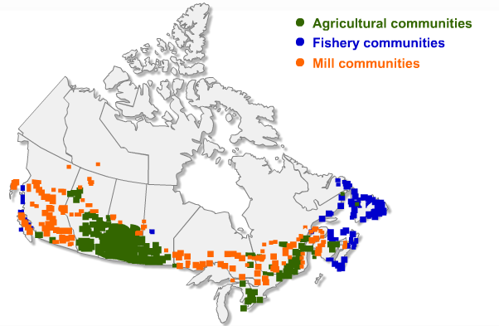
Canada’s Primary Sector Secondary Sector

-The secondary and tertiary sectors involve the transformation of natural resources and the provision of services. 70% of GDP
-Services have grown considerably
-Service sector located mainly in cosmopolitan areas in Ontario, Quebec, BC and Alberta

Regional Economies

- An important point to bear in mind is the different regions of the country, because of their varying resource distribution, depend more or less on different sectors of the economy.
-The inequalities this produces is a controversial topic in politics

Atlantic: Fishing has long been a major economic activity in the Atlantic region but unemployment in this region tends to increase during the winters. Furthermore, overfishing has forced the federal government to lower fishing quotas, which adds to unemployment in the region. Issues such as these often become political.

Quebec: The Quebec economy is more diverse than in Atlantic Canada and the lumber industry is one of the largest job suppliers in the northern part of Quebec. A variety of factors, however, have driven this industry into a state of crisis. Today, many mills are closing down, which means the loss of many jobs. Not surprisingly, this has become a political issue. Quebec also has large rivers that have great hydroelectric potential. Hydro-Quebéc, a Quebec Crown corporation, generates billions of dollars in revenues.
Quebec exports electricity throughout the continent’s eastern region. But because of environmental implications, each time a new hydroelectric project is considered it becomes a political issue.

Ontario: The Ontario economy is also fairly diverse but concentrated heavily in the secondary and tertiary sectors of the economy.
For example, a large proportion of all North American cars are made in Ontario. This represents close to a $100 billion industry. Indeed, more cars are made in Ontario than Michigan. Just recently, the near collapse of this industry became highly political.

The West: The economy in the West is based in large part on agriculture, fossil fuels and lumber. Most of Canada's agricultural sector is centered in the Prairies (Manitoba), and recent fluctuations in grain prices have stimulated some heated political debates.
Moreover, Alberta has the second largest oil reserve in the world. This industry is at the heart of current economic growth in the West and it too has become highly political because of its environmental implications.
Timber is another important part of the Western economy. However, similar to Quebec, the lumber industry in the west is in crisis, and this too has had significant political implications.

Regional Economic Summary

Region | West (BC-MB) | Ontario | Quebec (& NB) | Atlantic
UE | 5.1% | 7.5% | 8.1% | 9.3%
% of GDP | 36.7 | 37.1% | 19.6% | 6%
Variations in Canada’s regional economies mean that some parts of the country contribute more to GDP than others. It also means that some regions of the country have more unemployment than others.

Provincial Economies
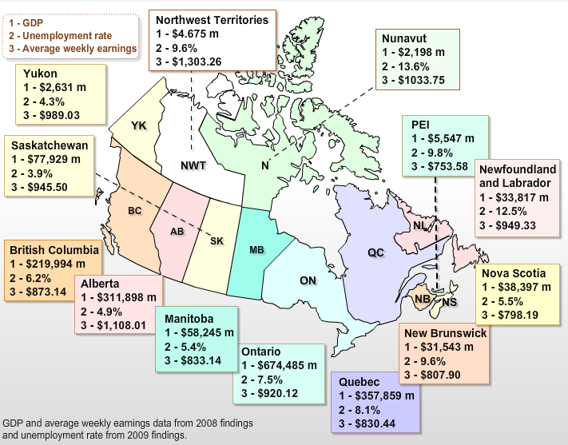

The trickle-down effect is that some provinces boast higher average weekly earnings than others. All of this has implications for Canadian politics, particularly when it comes to the sorts of concerns that arise and take precedence, attention and emphasis that politicians and political parties give to different parts of the country.
Canada’s Population Distribution
Canada is not densely populated as other societies

Country | Canada | USA | EU | Brazil | China
Size (Mil km²) | 9.970 | 9.826 | 4.32 | 8.55 | 9.596
Population (Mil) | 33 | 304 | 498 | 191 | 1.3
Pop. Density (ppl/km²) | 3.3 | 30.94 | 115.28 | 22.34 | 135.47

-Most of Canada’s population is concentrated in Quebec and Ontario, and this also has implications for Canadian politics.
-For instance, during election campaigns this affects where parties and party leaders campaign.
-It also affects where campaign promises are made and influences the values that get heard and considered by the federal government.

Population Concentration

1. Extended Golden Horseshoe (6,704,598)
-Most of population is concentrated in the 4 main areas.
-Consists of urban centers of Oshawa, TO, Hamilton, Oakville Burlington, and St. Cats
-Represents more than 20% of the country’s population
-Most of the immigrants in Canada arrive in this zone
2. Montreal & Adjacent Region (3,724,576)
-This area includes MTL and its extended suburbs
-2nd most densely populated area
-Receives fewer immigrants than Vancouver and TO
3. Lower Mainland & Southern Vancouver Island (2,706,873)
-More the 2/3 of BC’s pop is concentrated in this zone
- The main city in this area is Vancouver
-Other urban centers in this area include Abbotsford and Chilliwack on the mainland and victoria, Duncan, Nanaimo, and Parksville on Vancouver Island
4. Calgary-Edmonton Corridor (2,149,596)
-Has the largest growth rate of all four of the regions in the last 10 years
-The main source of this increase is migration from other provinces

Discussion Question: Does Canada's diverse environment, its economy and its population distribution make it more or less difficult to govern?

What does this story tell us about this week's lessons?
How might you relate this week's lessons to this story?
How do Canada's different regions interact economically?
Can you think of similar and recent stories involving conflict over natural resources?
There are a couple of similar stories involving conflict over natural resources that have occurred recently. First, the conflict of the Northern Gateway Pipeline and second the salmon fishing right off the pacific coast. The Northern Gateway Pipeline has less to do with the natural resource it’s self but the transportation of it cross-country. Enbridge Inc. wants to build a pipeline to the pacific in order to transport oil for export but for environmental and other reasons the BC government has had a difficult time accepting the agreement. In June of 2014 the “B.C. Environment Minister Mary Polak countered that four of her province’s five conditions for heavy oil projects remain unsatisfied.” (Hunter& Stueck, 2014). Without a direct method of transporting oil for export, Alberta government is losing profits on the sale of their natural resource.
Next, I recall reading about disputes over who owns the right to fish the salmon off the pacific coast. The issue arose as US ships were fishing salmon that were spawn from the rivers in BC while Canadian fisherman also caught salmon originating in Washington and Oregon. This interception of fish from opposite countries rivers was unavoidable but caused much political conflict between the US and Canada. In the end, the Canada-U.S. Pacific Salmon Treaty was establish where management plans were set to fisheries including articles such as “an obligation on the party that has disadvantaged the other party to propose ways to remedy the imbalance. The Treaty acknowledges "the desirability in most cases of reducing interceptions" (Emery, 1997).
This story of Quebec and Newfound Land’s dispute over the Churchill Falls power deal relates to lesson 2 in a way that shows that each region of Canada is geared to produce different resources that are shared and sold to build Canadian economy. In saying this, there are often disagreements as to who owns the rights to that resource, whether it be between provinces or even amongst the native peoples. It is theses inequalities and disputes that produce controversial topics in politics and also the need for political intervention in the use of Canada’s natural resources.

STUECK, W., & HUNTER, J. (2014, June 17). B.C. government to Northern Gateway pipeline proposal: ‘No’. The Globe and Mail. Retrieved January 10, 2015.Emery, C.

Claude Emery (1997). PACIFIC SALMON: THE CANADA-UNITED STATES DISPUTE. Retrieved January 10, 2015, from http://publications.gc.ca/Collection-R/LoPBdP/BP/bp429-e.htm

Lesson 3- In The Beginning

-Canada is culturally diverse and this diversity plays an important part in Canadian politics. -Understanding how this diversity has happened over time, through various historical experiences, and critical junctures, provides a better appreciation of contemporary Canadian politics and its underlying cleavage structure.

The First Peoples of Canada
-The early history of first peoples of Canada begins at the time of the Ice Age and its subsequent melting.
-“Aboriginal “ or “native” refers to the people who first populate the land
-This community contains several distinct groups with cultural backgrounds and ancestral lands

-In Canada, the aboriginals populate areas such as:
-the Plains -the Canadian Shield -the Maritimes
-the Great Lakes-St. Lawrence Seaway -the Southwestern Coast
-the Northwestern Coast -the Northwestern Interior
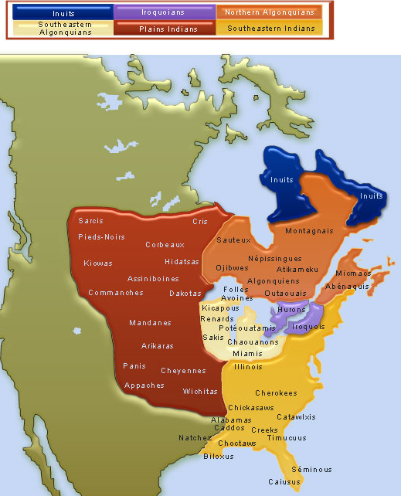

The Inuit
-Known as Inuk
-Homeland: Nunangat (land, water, & ice contained in the artic region)
- Population 59,440 (mostly in Nunavut and northern Quebec)
-Hunters and gatherers who moved seasonally
-Issues:
-lacked adequate housing and have suffered related health problems.
–more than 15,000 Inuit were living in over-crowded conditions
- live in households with more than one family.
-Living conditions and lack of access to healthcare partially contribute to an increase in chronic health conditions, including obesity, diabetes and respiratory infections.
-suicide prevention a key priority for continued cultural growth.
The Algonquin Indians
-The most populous and widespread native group
-Semi-nomadic, moving their camps from pace to place in search of food
-Travelled by foot, canoe, snowshoe and sled
-Social structure patriarchal Shaman held powerful place in Algonquin society
-Among first to make alliances with the French who adopted their methods of travel
-About 8000 Algonquin living in Canada organized in 10 separate First Nations, 9-QU 1-ON
The Iroquois
The Palins Indians
The Huron

European Influence and the Aboriginals
-The arrival of the Europeans changed the lives of the Native peoples forever.
-Many diseases such as measles, typhoid and small pox were brought to many tribes
-Rapid expansion of the fur trade increased conflict and war between aboriginal and European groups.
-Alcohol being exchanged for fur lead to alcoholism and domestic violence amongst first nations who were unaccustomed to their effects & can still be seen today
-As explorers expanded, natives were forced to move into small reserves and other regions, which dramatically affected their populations.
- In reserves, they depended on the European population for food
-Culture was seriously affected in the process which is a major point of contention today

Negatives
-Europeans sent missionaries to convert native populations to Christianity
-Residential schools were created to “civilize” native populations
-The above destroyed many aboriginal traditions and beliefs
-In recent times, government has tried to settle the wrong doings

Positives
Not everything was negative…
-Aboriginals shared their knowledge of the land and survival with Europeans
-Taught them to build canoes, use snowshoes and toboggans
-Showed them best routes for furs and navigation
-Also helped with sewing their mittens and leggings
-In return they received medicine, alternative food sources, and new technologies
There is still much to do to remedy the wrong doing done to the Aboriginals.

The Exploration of New France
-The French were among the fist Europeans to set foot in Canada.
-First settlements were at Port Royal, Acadia in 1605 and Quebec in 1608
-Exploited for its riches of fur and fish Economic benefit

-Later the French became serious about colonizing to ensure possession of the riches
-Establishment occurred in the early 17th century and was slow and painful
-France had their own turmoil at the homeland so resources were scarce in the new land
-Population growth was slow as fish and fur did not entice many
-The French sought to increase the population by giving chartered companies permission to exploit the land in return for the promise of increased settlement.

Couriers des bois
-The couriers des bois or runners of the forest were among the fist to come to the new world
-Brought over by chartered companies to populate, many became fur traders, hunters, and fisher instead of farmers
They associated with the natives. They were very similar to the natives in dress and in the way they fought. And like the natives, they too traveled by canoe and snowshoes. The coureurs des bois were vital to the colony. They explored unknown land. They extended New France’s boundaries. And they charted down their routes, which resulted in the mapping of North America. They also became wealthier through the fur trade.
-Eventually became frowned upon as it did not develop a strong foundation for sustained community life
1663
-King Louis XIV placed minister Jean Baptiste Cobert in charge of developing the land
-Together with Jean Talon, who was first intendant of New France, envisioned developing a colony that would be self reliant and capable of fostering agriculture and industries I the st Lawrence seaway.
-New France became a source of many resources that France needed to become self-sufficient and independent of other nations

-In order to build a self-sufficient colony, the Iroquois had to be controlled as constant raids and attacks hindered the hopes of building permanent residence
-Troops were sent to protect and take possession of the land
-Wars between aboriginals and Europeans cause much bloodshed
-Europeans were ultimately more successful

Increasing the Population
-Top Priority was increasing the population
-Marriage became very important for increasing the female population
-The King sent potential brides for veterans and bachelors
-Les Filles du roi
-Financial incentives were given to men and women who had lare families
-By the end of the 17th century population increased and a tradition of large families was established
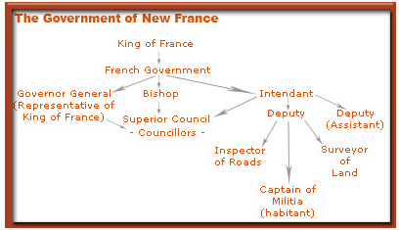
Government & Economy
-The governing body in New France was small
-Consisted of an elite group which included a governor, a bishop, and an intendant
-Economy describes as quasi-feudal, based on agriculture and the fur trade.
-With time, diversified and new industries like ship building were launched
-Bartering was the main mode of exchange

The Way of Life in New France
-Life was not easy
-Drought, insect invasions and hard rain ravaged their cops and destabilized operations.
-Long and harsh winters
-Building a colony from scratch required much time and teamwork- private initiative was not enough and needed all the government assistance they could get

Religion
-Clergymen and nuns were some of make the voyage to New France, responding to the spiritual needs of the settlers.
-Catholicism was the most prominent religion in the region
-Protestants and Jews were not welcome and thus few settled
- Even the slightest doubt about an immigrant’s religious affiliation necessitated the reiteration of their baptismal and communion vows at a confirmation ceremony conducted by the Bishop.

Settlement in the English Colonies
-First English settlers in North America began arriving during the 1600’s
-Settled eastern colonies that later became the US and the Atlantic provinces of CA
-Soon followed the Irish and the Scottish seeking to escape poor economic conditions in GB and acquire a greater religious freedom in a more liberal environment

-The role of the colonies was to compliment Britain’s economy and offer favorable balance of trade
-The colonies of the north, Newfoundland and Rupert’s Land concentrated on fishing and fur trade as their prime economic activity
-HBC was established in 1670 by the English to amass furs
-The Chartered company had a monopoly of the fur trade in Rupert’s around Hudson’s Bay
-Life was also hard for the English
-While many were trying to escape religious prosecution in the Old World, religion played a key role in the lives of most of the British Colonial settlers on the East Coast.
-Protestant religion was ingrained in the various settlements on the East Coast

Irish Immigrants
-The potato Famine was caused by fungus that attacked and ravaged the potato crops
-Led to poverty and starvation for the majority of Ireland
-It is estimated that most of the Irish either died of emigrated during famine

-An estimated 130,00 out of 200,00 Irish immigrants who attempted to flee perished while crossing the Atlantic or within the first year of arrival
-Many immigrants had to be quarantined
- Caring for the sick and weak and the large number of orphans and widows that the famine and voyage had produced led to the implementation of head taxes—10 to 20 shillings per person—to help cover the cost of caring for them upon their arrival.

-The new immigrants did not mirror the social, cultural or religious values of the majority
-Many settlers chose to settle in urban centers over rural communities and practiced Catholicism
-Their arrival in large numbers added to the already divers socio-cultural mix of the Country

Lesson 4- The Road to Confederation

-Throughout the 17th, 18th, and 19th century, the English, French and aboriginals became engaged in several conflicts.
-We will learn about the most significant of these early experiences and their consequences as they have substantial and long lasting effects on the formation of Canada, its people and their relations with one another

The Indian Wars of the Early 17th Century
-Took place in the early 17th century
-illustrated the uneasy relationship between the Europeans and aboriginals
-English & French allied certain groups in order to defend, protect, & advance colonization

-Certain French settlements were under steady attack from the Iroquois
-Eventually joined forces with the Huron and various Algonquin tribes to counter
-A long series of wars followed, giving the English an opportunity to unite with the Iroquois in hopes of eliminating the French and taking control of more land

-After many years of fighting the French managed to convince many aboriginal tribes to side with them against the English the Great Peace of Montreal
-Treaty signed between tribes and French in 1701
Forty native tribes, including the Iroquois, assembled in Montreal to declare peace not only with the French but also with rival tribes. More than a thousand representations from different tribes were present at the signing of this treaty. The treaty gave the French access to the interior of the continent and native allies in the event of a war against the English.
-This treaty neutralized the Iroquois
-By this time the English colonists had grown sufficient in populations and no longer needed the help of the Iroquois to fight the French

The War of the Spanish Succession
-Originally waged in Europe, it eventually spilled over to the French and English colonies
-Why: After the death of Charles II of Spain, who rightfully had claim to the throne?
-Who: His nephew of France or the Emperor of Austria’s second son Charles?
England, Prussia and Holland sided with Austria, while Bavaria and Spain sided with the French.
-Where: By 1701 battle had spread to the New World
1. The French and allies raided various English settlements in the 13 colonies and took control of Newfoundland
2. After 4 failed attempts, the English took control of Port Royal (current NS) (1710)
3.Ended in 1713 and the treaty of Utrecht was signed resulting in France giving up much of its land in North America- specifically, the Hudson’s Bay area, Newfoundland, and Acadia.
Result: -The French’s power in the Maritimes greatly depreciated
-They erected the fortress of Louisburg in cape Breton, which served as a protective stronghold

The Acadian Deportation
-The newly acquired Acadia posed a problem for the English, as it was primarily French
-The French colonists who lived in the region now found themselves under British control
-They agreed to remain neutral in future conflict and swore and oath to the British Crown- they lived in peace for 40 years (1730)
-English used Acadia mostly as a landing site for military deployment and protestant settlers
-Acadians developed their own distinct culture and a strong sense of independence
-At the beginning of the French and Indian War of 1754, the British government demanded that Acadians take an oath of allegiance to the Crown that included fighting against the French. Most of them refused.
-Resulted in forcible deportation of 6000 while many others were imprisoned or hid

Seven Years War (1756-1763)
-Had Global impact as both French and English sent massive forces in support of their colonies around the world (Britain sent more)
-Lasted 7 years and caused much destruction and grief to the parties involved
-Ended with the Treaty of Paris
-Most definitive battle was in 1759 at the Plains of Abraham in QC
-Wolfe defeated Montcalm
-Another decisive battle was the Battle of MTL in 1760
-England took over control of all colonies except two small island on east coast

The Conquest
-Critical time when French lost their power and authority in North America
-Former New France were now entirely governed by the English who did not share their language, religion, culture or traditions.
-Turned inward as a people in an attempt to protect themselves and formed close-knit communities that were weary of English
-Were eventually called Canadians which stems from the word village in Iroquois

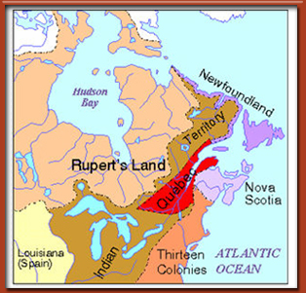
The Royal Proclamation (1763)
-Land was reorganized to appease the different grounds that could potentially cause future problems for Britain
-New France became Quebec and the “Canadians” had to take an oath to the Crown and abandon Catholic religion
-Many began to feel neglected by the British
-The redistribution of land was upsetting because the aboriginals had been given more land than they previously owned, but no additional land to the 13 colonies
-They had sacrificed much in the 7 years war and were angered at the ingratitude shown by the crown

The Quebec Act (1774)
-As the anger of the colonies intensified, by 1770 the crown feared revolt
-The crown wanted to ensure that if the 13 colonies were to revolt the colonies of the North would not join in an attempt to break from British Rule
-Particularly that the Canadians did not revolt
-As a result, they introduced the Quebec act in 1774
-Demonstrated that they respected the Canadians by meeting a few demands
-The crown would protect their religion, culture, law, territory and language
-Also proposed that the Province of Quebec be expanded, which meant better economic opportunities
-If traditional elites who formally governed the French were to pledge an oath to British they were allowed to keep their status
-As a result, the Canadian population had no reason to join the 13 colonies in American Revolution
-This also fueled the anger of the 13 colonies as Quebec was given more land

The American Revolution and the Loyalists
-The American Revolution redefined the role of the Crown in North America
-Affected the relationship between the English and the French
-Lead to the Canadian Confederation and redefined the borders and population distribution
-Pushed thousands of refugees from the 13 colonies to the northern colonies
-Among the details mentioned above, taxation without representation led to the War of Independence

-Led by George Washington, organized and fought the British who attempted to stop the revolution
-First attempted to seize Quebec and make its 14th colony
-France sent troops to help the 13 colonies combat the British
-In 1776, the 13 colonies declared independence from the Crown after a prolonged battled

Loyalists
-Not all Colonists who loved in the 13 colonies supported the revolution
-Many remained loyal to the crown and fled to remaining British Colonies
-As a result, the Northern colonies experienced a major increase in immigration.
-New homes were found in the Maritimes, Quebec and Ontario (estimated 80,000 ppl)

-Loyalists valued social order and authority and as such preferred imperial rule
-Others escaped slavery during the revolutionary war in hopes of a better life
-Many had imperial economic ties, which they relied on and needed to maintain

-Many changes came with the immigration of the loyalists
-Those who settled in Quebec introduced the notion of political representation in lawmaking assemblies- a concept that had been foreign to French-speaking inhabitants
-Helped spark the creation of New Brunswick and Cape Breton in 1784
-Arrival in Ontario helped establish a new society and influenced the eventual creation of Upper an Lower Canada in 1791

The Constitutional Act (1791)
-Divided the province of Quebec into Lower and Upper Canada
-Northern part of the Great Lakes, which was mostly populated by English and Loyalists became know as Upper Canada
-Predominantly French areas became known as Lower Canada
-Both had elected legislative assemblies but decision making powers remained with the Crown representative and his legal and executive advisors
-The British learned from the revolution that to have better control over the population they had to restrain control of political power

The 1837 & 1838 Rebellions
-Rebellions broke out in Upper and Lower Canada
-Resulted from the constitutional act, which failed to give elected assemblies in both colonies the ability to control their appointed councils that had decision-making power
-Since British Gov. failed to acknowledge the demands and grievances expressed by colonist, the population reverted to violence
-In lower Canada ethnic divides and poor treatment of the French majority by the English caused conflict and resentment.
-Upper Canada were aggravated by the domination of a ruling oligarchy (Governing by small group)

Lower Canada
-Dissatisfaction towards English governing elite, the Chateau Clique, was instrumental in creating political pressure and new political parties
-In 1830’s an economic crisis plunged many Canadian in Lower Canada to the edge of starvation fueled desire for change
-Dramatic increase in the number of immigrants from the British Isles, which brought disease that affected local population
-Increase the uneasiness and discontent felt by French toward English rule
-The Parti Patriote, a radical party borne out of the Parti Canadien, was founded in Lower Canada in 1826.
-Represented the demands of the French people and advocated for chance
-The British minority appealed to the governor to resist demands and neglect led to violence
-IN 1837, the British Government rejected all of the Patriotes demands and granted more power to the governor.
-Patriotes organized a boycott of British goods, held mass rallies across the colony and began to prepare for an armed insurrection which as know as the Rebellion of 1837

-Led by Louis-Joseph Papineau, a nationalist who had been elected as the Speaker of the Assembly and was the leader of the Parti Canadien (late Parti Patriote)
-First battle between British forces and the rebels was founght at St. Denis, where patriots defeated the government troops later were defeated at St. Charles and St. Eustache
-Patritoes were outnumbered. Failed to take into account the British Gov had dispatched troops all over Lower Canada and the English militants in the colony had taken up arms
-Many insurgents were captured and exiled, while others fled to the US.
-hundreds were wounded and killed
-in 1838, with the help of American sympathizers, the Patritotes plotted to spark uprising, but the uprising was weak and they failed to execute with success
-Second rebellion was quickly squashed by British
-Many imprisoned, killed, and deported.

Upper Canada
-Rebellion began under William Lyon Mackenzie.
-Reformers, who attempted to counter the corrupt Family Compact, demanded change in political patronage, education, economic policies and land grants.
-Demanded an end to the government favoritism of the Anglican Church and its supporters.
- Issued a draft constitution for Upper Canada, which resembled that of the United States. He also attempted to take control of the government in December of 1837. This rebellion lasted only a short amount of time and was not successful.

Lord Durham’s Report
-Lord Durham’s analysis and subsequent report of the cause of the rebellions had an immense impact on Canadian political history and French-English relations.
-Recommended the implementation of responsible government, the formation of a united Province of Canada that would bring together Upper and Lower Canada and the assimilation of French Canadians

-The report sought to make the political executive responsible to the elected assembly as a possible solution to the corrupt and incompetent governing elite in Upper Canada
-The proposed union of Lower and Upper Canada would attempt to ease ethnic tensions in Lower Canada by gradually assimilating the French
-Most of Lord Durham’s recommendations were accepted and the Act of Union was implemented in 1841
-Legislatures in both Lower and Upper Canada were abolished and the Province of Canada was established in their place.

Act of Union
-The Act of Union established a single Parliament with equal representation from each colony.
-Debt was consolidated and English was the official language in government.
-Contested by French Canadians and the family compact
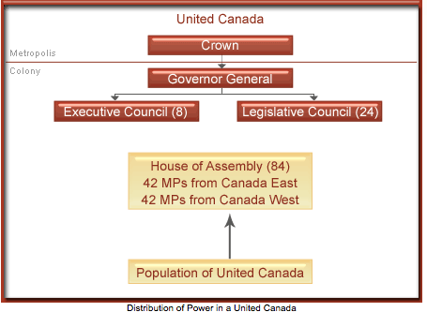
-Essentially Lower Canada’s culture and political traditions were sacrificed for those of Upper Canada
-Lower Canada, which was predominately French-speaking and had a larger population, was allocated the same number of seats as its Upper Canada counterparts.
-In time it was expected that French Canadians’ ability to defend their rights would be limited
-Created a deep wound among the French population
-In 1848, responsible government was granted by Britain to the North American colonies, which meant that government ministers would now have to command the support of the assemblies.

Lesson 5: Confederation and the Founding of Canada
Canadian Confederation began with an agreement between Nova Scotia, New Brunswick, Ontario and Quebec to form a union. There were many reasons for uniting together, protection from the US, increased trading capabilities, and the pursuit of other common goals.
Canada’s relationship with Britain and the United States has undoubtedly changed, have the original benefits of confederation persisted or have they diminished as time has passed?

Are the provinces more than ever leaning towards independence and self-sufficiency?

Issues in Quebec and Alberta highlight ongoing problems over shared resource and equalization payments.
Did Confederation result in the best possible scenario for the Canadian provinces?
How does Canada’s immigration policy effect national politics, employment opportunities and the economy?
How have these policies changed over time from confederation to 2012?
Choose one or a few of these questions to answer, and I encourage you to cite Canadian news sites of your own when answering the questions.

I'm not sure if anyone is aware but "The government of Quebec is preparing to launch a year-long policy review regarding its immigration process, beginning this Wednesday at the National Assembly in Quebec City." (http://www.canadavisa.com/news/entry/quebec-immigration-to-take-inspiration-from-canadian-model-26-01-15.html). This was posted to the Canada Visa website only a few days ago, it doesn't outline what the change is to come but it does say that Quebec was a system based on the "Canadian model" and that the "existing laws in Quebec are “really outdated”. This could be an interesting change in quebec that we will see in years to come!

