At altitude, the volume of diffused gas in the lung is decreased compared to sea level (Fick’s Law)

Anemia shifts the oxyhemoglobin dissociation curve downwards and to the right.
Step 3 of Transportation of Oxygen (O₂) and Carbon Dioxide (CO₂)
3. Transport of O₂ and CO₂ via the blood

Oxyhemoglobin Dissociation
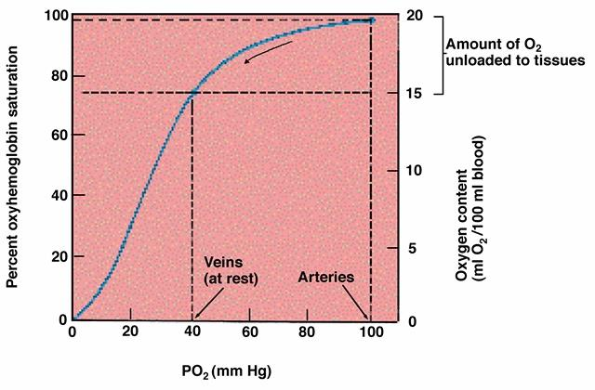

Partial pressure drops when tissue picks up oxygen, hemoglobin drops O₂ (e.g. exercise)

Effect of pH on HbO₂ dissociation curve

Bohr Effect
- Lower pH increases O₂ unloading
Active tissues
- Produce more acid; pH decreases in tissues
- Decreased pH causes shift to the right in saturation curve
- More O₂ is unloaded to tissues
- Minimal effect on O₂ loading in the alveoli

Effect of PCO₂ and Temperature on HbO₂ Dissociation Curve
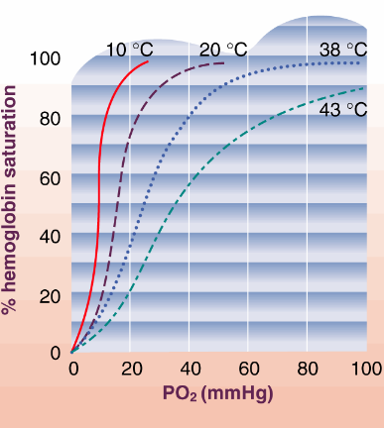
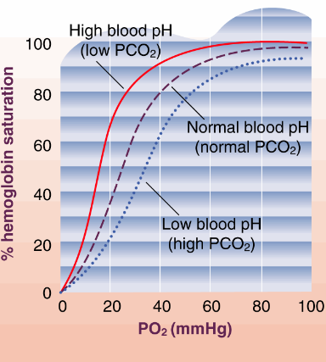

2,3-DPG and Carbon Monoxide

2, 3-diphosphoglycerate
- Produced within RBC under conditions of low O₂ such as anemia and high altitude
Binds loosely with Hb
- ↓ O₂ affinity
- Shifts O₂ dissociation curve down and right
Compensatory mechanism?
- Cardiopulmonary disorders
- High altitude dwellers
- Women

Carbon Monoxide
- Hemoglobin has greater affinity for carbon monoxide (CO) than for O₂
- Prevents O₂ from unloading
- Curve shifts to the left

Myoglobin
- Iron-based protein in muscle
- Intramuscular storage site for O₂
Mb + O₂ → MbO₂
- Binds and retains O₂ more readily than Hb at low PO₂
- Extra reserve for heavy exercise
- No Bohr effect

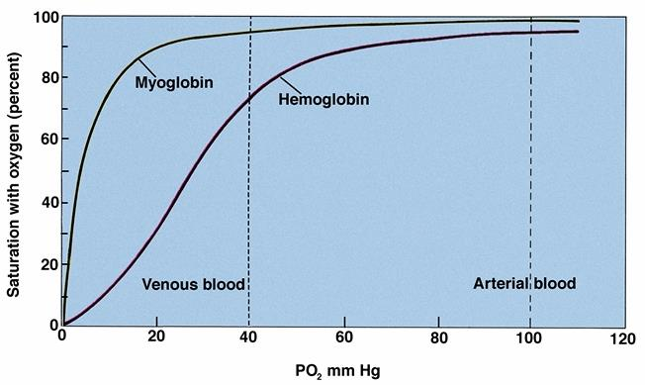
Dissociation Curves for Myoglobin and Hemoglobin

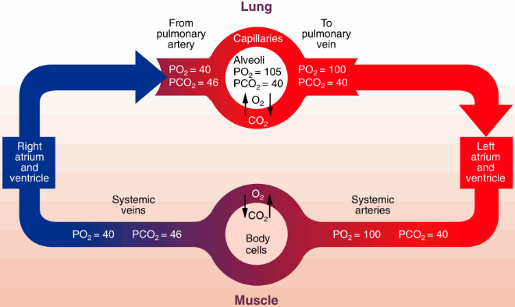
PO₂ and PCO₂ in blood

Oxygen Transport
Dissolved O₂ in blood plasma

For each mmHg of PO₂ → 0.003 ml of O₂ dissolved / 100 ml blood
- For PO₂ of 100 mmHg (sea-level) = 0.30 ml of O₂ dissolved / 100 ml blood
-  For cardiac output (Q) of 5 L/min (rest):
- Dissolved O₂ = 15ml (sea-level)
- 1-2% dissolved in plasma

O₂ bound to Hemoglobin
- HbO₂ (100% sat) contains 1.34 ml O₂ / g Hb
- [Hb] blood = 16 g / 100 ml
- SaO₂ = 100% sea-level
- 21.4 ml O₂ / 100ml of blood (sea-level)
- For cardiac output (Q) of 5 L/min (rest):
- 98% Bound to Hemoglobin

Carbon Dioxide Transport

Soda Pop and the Bends
CO₂ comes out of solution
- Soda carbonation = CO₂ dissolved at high pressures into water
- Open pop = release of CO₂ pressure = bubbling

The “Bends”
- If diver surfaces too quickly, N₂ will release like CO₂ in pop.
- N₂ dissolved into blood at high pressure
- Quick surfacing = N₂ bubbling out of solution
- Embolism can cause blocking of blood vessels, resulting in death

CO₂ Transport in Blood

Release of CO₂ from Blood
Copy figure

Effect of PO₂ on PCO₂ – Haldane Effect
Decreased PO₂ → More CO₂ blood

Respiratory Buffering
Maintenance of body’s pH
Hyperventilation, Breath-Hold
- Main urge to breathe comes from ↑ PCO₂
- Breathe out slightly to release CO₂, decreases urge to breathe a bit

The Ventilatory Response to Exercise
- More ventilation with heavier exercise

Ventilation during Exercise

Determining VT – V-slope

Ventilatory and Lactate Threshold

