- Blood flow is lowest in the capillaries (larger surface area)
- Total peripheral resistance – Resistance blood vessels give against flow in CV system
- Arterioles have the largest influence

Capillary Beds – “Vascular Shunt”
If muscle/organ doesn’t use much O₂
- ↑ in CO₂ and H⁺ ions (both ↑ blood flow)

Considering design and physiology, what are some adaptations due to training that can result in increased blood flow due to active tissues?
- ↑ Stroke Volume
- Stronger ventricles

Create more CO₂ to be able to decrease oxygen intake. Local factors determine if muscular bed is open or not.

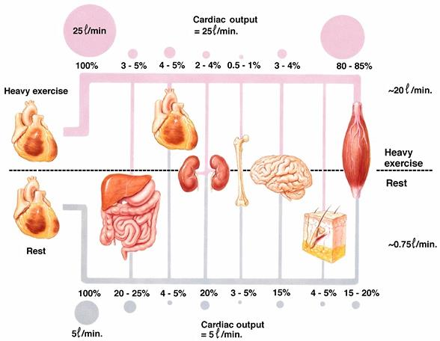
Redistribution of Blood Flow During Exercise

- 15-20% of cardiac output goes to skeletal muscles at rest
- During heavy exercise, capillary beds open up. 80-85% to muscles
- 25L/min used for all organs.

Blood Flow Redistribution
Competition for blood flow during exercise:
- Metabolic (active and inactive muscle)
- Systemic (digestive, excretory, liver)
- Ventilatory
- Thermoregulatory (transport, sweating)
Adequate blood flow is important

How does body integrate competing demands?
- Implications on exercise and environment?
- Firefighter – Heating up, can do less exercise → less blood flow to muscles.
- Best thing is to lower core temperature before exercising (for prolonging it)
- Set point – Critical temperature where exercise stops

3 major physiological responses that occur when you go for a run – Sweat, HR ↑, breathing becomes more laboured
- Sweat cools off body. Heat is byproduct of metabolism. Exercising creates excess heat.
- ↑ breathing – Need more oxygen

Critical Role of Blood
- 55% is plasma, 45% erythrocytes, <1% formed elements

How does iron deficiency or training influence oxygen transport?
- If iron deficient, less binding sites for oxygen. More blood flow needed.
- Training - ↑ oxygen delivery to capillaries

Oxygen Content of Blood
Dissolved O₂ in blood plasma
For each mmHg of PO₂ → 0.03ml of O₂ dissolved/L blood (Henry’s Law)

O₂ bound to Hemoglobin
HbO₂ (when 100% saturated) contains 1.34ml O₂ /g Hb
- Hb blood = 160g/L of blood
SaO₂=100% (@ sea-level)
- 214ml O₂/L of blood (sea-level)
- Total O₂ per L of arterial blood = 217mL

Two factors determine the amount of gas that dissolves in a fluid (Henry’s Law)
- Pressure differential between gas and that dissolved in fluid
- Solubility of gas in fluid
  - CO₂ has high solubility
- If partial pressure is the same as in fluid, gas will not dissolve.
- When you breathe in air high in O₂, it will go from gas → blood → hemoglobin

Hemoglobin
- Iron-containing globular protein
- Located in RBCs
- HHb₄ + 4O₂ ←→ HB₄O₈
- Requires no enzymes
- Depends entirely on gradient of PO₂ in solution

Oxygen Consumption (VO₂)
- The amount of oxygen used up by the tissues for oxidative phosphorylation (to create ATP) per minute

Fick’s Principle
- Difference in oxygen from arteriole minus venous blood

VO₂ = (art O₂ – ven O₂) x CO
VO₂ = (a-v) O₂ difference x CO
VO₂ x CO = a-v O₂ difference

Ven O₂ concentration = VO₂ x CO/art O₂ concentration
- Resting cardiac output is 5L/min, so what is venous blood O₂ concentration at rest?

Maximum Oxygen Consumption (VO₂ max)
VO₂ = (arterial-venous) O₂ difference x cardiac output
Arterial blood – 0.22L of O₂ in every L of blood
From every L going through capillaries, 0.16 L of O₂ is consumed
Venous system – 0.06L of O₂ left in every L of blood

Max CO is 42.3L of blood/min
VO₂ = (0.22L-0.06L) x 42.3L of blood/min
= 0.16L x 42.3L of blood/min = 6.768

VO₂ max
- How well lungs take up O₂
- Cardiac Output (L of blood/min)
- Oxygen intake
- Overall, how fit people are

If untrained person begins training, VO₂ max ↑
- More metabolic enzymes are able to use O₂ to create more ATP.

Q (Cardiac Output ml/min) = SV x HR

Maximal Oxygen Uptake
- Fick’s Principle: VO₂ = (a-v) O₂ difference × cardiac output
- VO₂max: Max capacity for O₂ consumption by body during maximal exertion
- Best measurement of cardiorespiratory endurance and aerobic fitness
- Increases with physical training
- Generally expressed relative to body weight, allowing comparisons to be made (ml·kg⁻¹·min⁻¹)
- Normally active untrained college-aged students = 38-42 ml · kg · min
- VO₂max declines in active people after age 25-30 by ~1% per year

VO₂max
- Submax test (to 85% of HR_{pred})
- Shorter
- 2 x 3min stages
- Equipment needed
- Bike/treadmill, stopwatch, HR monitor

VO₂max = (work/body mass x 1.8) + 7.0
- Assumptions
- Age predicted HR max
- Uses equations to estimate O₂ cost
- O₂ cost of workload similar for everyone
- Efficiency of movement

- (50ml/kg/min) / (1000ml/L) / (65kg) = 3.25 L/min
- If mass is 65kg, age is 20, CO₂ max would be 20.3125L/min.
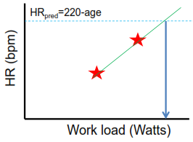
- SV_{max}= 0.1015625L.

