Section II - CV System: Vasculature
- During exercise, the SV of a trained individual increases, because EDV increases
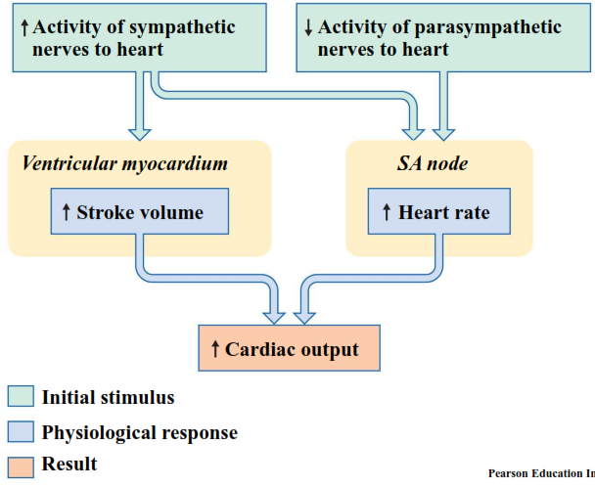

Control of Cardiac Output
Intrinsic | Extrinsic
Pacemaker cells (HR) | Neural (ANS)  - Sympathetic (NE) (HR+SV)  - Parasympathetic (ACh) (HR)
Starling’s Law (SV) | Hormonal  - Epinephrine (HR+SV)  - Thyroid hormone (SV)  - Insulin (SV) and glucagon (HR+SV)

Veins are holding tank for most of the blood (at rest)

Exercise will help you decrease your cholesterol, and help maintain your blood vessels
- However, it is much harder to get people to exercise on a regular basis, rather than getting an angioplasty operation

Coronary Heart Disease
- Limited circulation, heart lacks oxygen & nutrients to pump blood

Arteries | Veins
Carry blood away from heart | Carry blood back to heart
Usually round, thicker walls | Usually flattened/collapsed, thinner walls
↑ Blood Pressure | ↓ Blood Pressure
More collagen & elastic muscle | Mostly smooth muscle and collagen

Smooth muscle is involuntarily controlled, typically located in blood vessels and intestines

Arteries (“pressure reservoirs”)
- Fibrous collagen giving tissue strength
- Elastin – Elasticity
- 2 extra elastic bands aiding with recoil
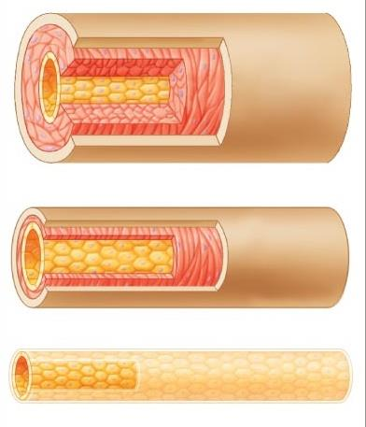
Structure and Function of Arteries

Arterial system
- From heart to capillaries, arteries change
Artery
- From elastic arteries
- To muscular arteries
- To arterioles
Arteriole
- To capillaries
Capillary
Elastic Arteries
- Large vessels (Aorta, pulmonary trunk)
- Tunica media: Elastic fibers, few muscle cells
- Elasticity help absorb pulse waves
(pressure reservoir)
- Capable of sustaining high pressure

Aneurysm
- Failure in elastic wall of artery
- Resultant bulge resembles a bubble in the wall of a tire
- Bursting can result in catastrophic blowout
- Happens most often in the Circle of Willis

Muscular Arteries
- Medium size
- Tunica media = few elastic fibres, many muscle cells
- Provides structural integrity to vessels that are the primary distributor to organs and tissues

Arterioles
- Small
- No tunica externa
- Tunica media = 2 layers of smooth muscle
- Change diameter in response to sympathetic or endocrine stimulation
- Vasoconstriction or Vasodilation
Fenestrated & Continuous Capillaries
- Smallest
- Only vessels that allow exchange across vessel walls
- No tunica media or externa

Capillaries
- Dense network surrounding or near cells
- Single layer of endothelial cells
- Huge cross area = loss of pressure
- Extremely narrow
- 7-10 microns, ~1 RBC diameter
- Slow blood velocity – long transit time
- Favours gas exchange (Fick principle)

Capillary Beds (capillary plexus)
- Connect an arteriole and a venule
- Thoroughfare channels (metarterioles)
- Direct capillary connections between arterioles and venules
- Controlled by smooth muscle segments
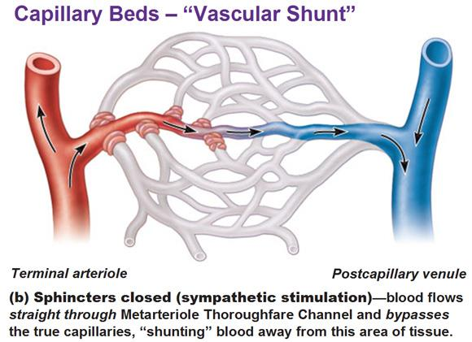

Sphincters help to metabolize.
- If CO₂ rises, H ions, or O₂ increases in capillary bed, some sphincters open up

Arteriovenous Anastomoses
- In the hand, blood flow is regulated by the AVAs (Arteriovenous Anastomoses)
- Body is warm: AVAs open
- Blood flows from arteries through AVA’s to superficial veins
- Body cools: AVAs close
- Blood flow drastically reduced due to increased sympathetic activity
- The remaining flow will return to the body core through deep veins (close to arteries)

Everest tragedy
- Climber lost hands and nose to frostbite

Vein Categories
Venules | Medium-sized | Large
Very small veins | Thin media, few smooth muscle cells | All 3 tunicas
Collect blood from capillaries | Tunica externa with longitudinal bundles of elastic fibers | Thick externa, thin media

Veins
- Collect blood from capillaries in tissues and organs, and return blood to heart
- Larger diameter, contains large volume, blood reservoir (‘capacitance vessels’, 65%)
- Low pressure
- Less muscular, thinner walls, highly distensible
- Venous return mechanisms?
- Valves aid in venous blood return
- Skeletal muscle pump

Varicose veins
Twisted, large veins (often in legs), valves don’t work properly. Blood can flow backwards

Venous Return
- Blood transport requires fluid (venous) return. What factors influence rate of venous return?
- Venoconstriction and blood flow distribution
- Blood volume
- Muscle & respiratory pump
- Dynamic (not isometric) exercise
- Posture

Respiratory Pump
- Inspiration
- Decreases pressure in thoracic cavity
- Increases pressure in abdominal cavity
- Pressure on veins in abdominal cavity creates gradient, favouring blood movement to thoracic cavity
- Increases central venous pressure
- Increases venous return

Man fainting
- Hot, sweating (loss of fluid), BV decreases.
- If BP is too low, brain will not get enough oxygen

Considering design and physiology, what are some adaptations due to training that can result in increased blood flow to active tissues?

