Hemodynamics

- If SA node is defective, AV node will take over, and the HR will decrease
- Conduction begins with SA node → atria → AV node → ventricles. It cannot skip from atria to ventricles, because we have a fibrous skeleton.

- Systole & Diastole – Typically talking about ventricles
- Atrial systole – Short, compared to rest of the time the atria contracts

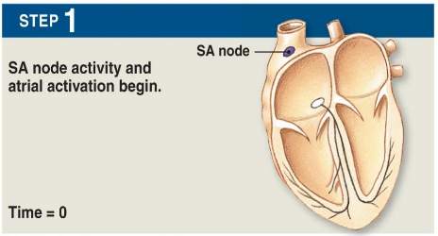
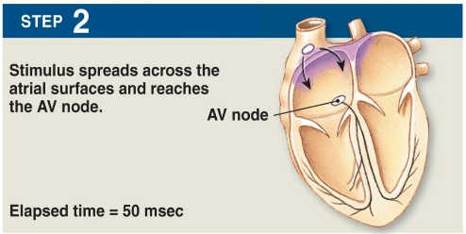

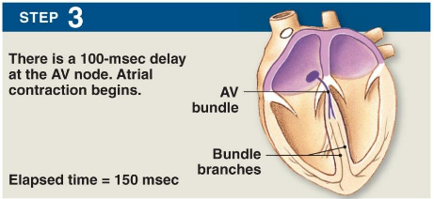
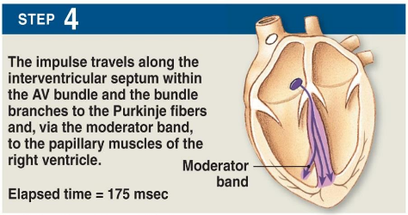

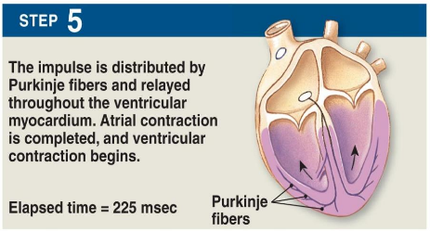

- Ventricular filling is half passive. Venous return to heart (passive), followed by atrial systole.
- If pressure in ventricles is greater than in atria, valves open and blood leaves. When blood leaves, pressure drops

- Blue – blood deoxygenated
- Red – blood oxygenated

During phase 2, both valves are closed.

Check 2 figures from the presentation (pressure graphs)

Push out in one stroke – Stroke volume
Stroke Volume – Ejection Fraction/Available Blood (About 60%)
Stroke Volume = Cardiac Output x HR

Cardiac Output – Blood pumped by the heart in a minute

60-80 is normal resting HR

Always include inputs during calculation

Q (Cardiac Output mL/min) = HR (b/min) x SV Stroke Volume (mL/min)

Cardiac Output, Stroke Volume, Heart Rate
Stroke Volume At rest (Q = 5L/min)
At world record Q (42.3L/min) (Maximum exercise)
SV = 5000mL/60b per min = 83.33mL
SV = 42300mL/60b per min = 211.5mL

To maintain Q = 5L/min , what happens to HR if person is tilted downwards?

↑ EDV and SV, ↓ HR, CO is unchanged

Control of Cardiac Output
Changes in Heart Rate
- Pacemaker cells (100 bpm)
- Neural control (ANS)
- Sympathetic (NE)
- Parasympathetic (ACh)
- Hormonal control
- Epinephrine (from adrenal medulla)
- Thyroid hormones
- Insulin and glucagon (pancreas)

Factors Affecting Cardiac Output
- Heart Rate: Determined by SA node firing frequency
- SA node intrinsic firing rate = 100/min
- No extrinsic control on heart: HR = 100
- SA node under control of ANS and hormones
- Rest: PNS dominates: HR = 75
- Excitement: SNS takes over: HR increases

Heartbeat every 0.8s. Parasympathetic potential hyperpolarizes the MP.
60/ 0.8s = 75

- Changes in Stroke Volume

Starling’s Law
- The more stretch is exerted on the myocardium, the stronger the contraction
- An increase in EDV (venous return) increases the strength of contraction, which increases SV

Control of Cardiac Output
EDV – Preload (Load before systole)
Afterload
- Pressure in aorta during ejection

What factors affect CO change during PA, and how?

HR with Training
- No real change in max HR
- ↓ HR @ rest and submax
- ↑ vagal (parasympathetic) tone
- Point of diminishing returns

SV in trained individuals – More contractility, ejection fraction, increased SV

↑ max SV with training
- ↑ ventricular chamber volume
- ↑ filling (EDV)
- ↑ blood volume
- ↑ venous return (muscle pump)
- ↓ HR (submax) = ↑ filling time
- ↑ emptying
- ↑ myocardial thickness = ↑ force
- ↑ contractility

Vascular System and Cardiac Output
- Likely not a limiter to Q max

Much of capillary bed unused at rest
- 5mL/100g muscle
- Constricted during rest
- Removal of constriction during exercise

